Supplementary information S1 Acid-free double stain solution adapted from: Walker & Kimmel, 2006; Kapralova, 2014.
( * ) = optional

Fixation
Embryos or larvae were fixed in 4% paraformaldehyde and stored in 100% Methanol at -20.
- Transfer the embryos to 100% (or 96%) Ethanol (and rock at room temperature for 10 minutes.*)

Staining
Embryo (for larvae, skip to step 4):
- Add 1 ml of acid-free Alcian blue, and 10ul of Alizarin red to each microfuge tube (mix before adding larvae), and rock at room temperature overnight

Bleaching
- Remove the staining solution and add 1ml of water, mixby inversion and remove (x2*)
- Add 1 ml of the bleaching solution and incubate for 20 minutes at room temperature with the lids open. ## no rocking
- (Add 1ml of water and mix by inversion*)

Clearing
- Add 1 ml of a solution of 25% glycerol and rock at room temperature for 3 days for hatching (H) samples, or 4 days for first feeding (FF)
- Replace with 1 ml of 50% glycerol and rock for 3 or 4 days for H and FF, respectively
- Replace with 1 ml of 80% glycerol and rock for 3 or 4 days for H and FF, respectively

Photography
- Prepare a solution of methylcellulose (2% for H, 3% for FF) and pour a specified amount into a petri-dish
- Lay individual in methylcellulose so that the ventral surface points up to the camera and position accordingly

Storage
In a solution of 80% glycerol at 4°C.

Preparation of solutions

Alcian blue stock (0.4% Alcian blue in 70% ethanol)
For 100ml:
- 0.04g of Alcian blue powder
- Dissolve in 50% ethanol, incubated and stirred at 37°C
- Add 95% ethanol and water to obtain final concentration

Alcian blue for sampling (part A)
- Take 25ml of dH20 and dissolve 60 mM MgCl₂ (0,57126 g of MgCl₂); shake
- Add 5ml of Alcian blue stock solution (0.4% in 70% ethanol)
- Add 70ml 95% ethanol

Alizarin red (part B)
0,5% Alizarin red S powder dissovled in dH20.
Acid- free double stain solution contains 10µl of 0.5%Alizarin red (part B) and 1 ml of Alcian blue (part A) which are mixed just prior to staining. (Part A and B can be stored at room temperature (separately) for several months for up to a year.)

Bleaching solution
Mixed an equal volume of 3% H₂O₂ and 2% KOH to give final concentration 1,5% H₂O₂ and 1% KOH. NB: never use weak concentration of H₂O₂ as this will oxidise and will lower in concentration

Methylcellulose (2% for 100ml)
- Heat up ~30mL 1xPBS in a beaker (~20s in microwave, the liquid should be very hot but not boiling)
- Place ~70mL 1xPBS in a beaker, put the beaker on ice to cool
- Weigh out 2g of methylcellulose powder, add to the hot 1xPBS
- Stir until all powder is fully suspended, solution should look cloudy
- Add ice cold 1xPBS (70mL) to the cloudy methylcellulose solution. Place entire beaker on ice and keep stirring for 2 hours - days (The solution will be very thick and gel like, so the stir bar may not spin in circles at this point, instead it will just keep shaking).
- Make aliquots and store at 4 °C

Table S1 Procrustes ANOVA of shape differences between replicated craniofacial measurements of Arctic charr embryos.
Hatching (H)
Effect | SS | MS | Df | F | P
Individual | 0.5948 | 0.0002 | 2960 | 4.89 | <.0001
Side | 0.0240 | 0.0003 | 74 | 7.9 | <.0001
Ind*Side | 0.1217 | 0.0000 | 2960 | 5.08 | <.0001
Placement | 0.0479 | 0.0000 | 5920 | 4.05 | <.0001
Replicate | 0.0239 | 0.0000 | 11988
Total | 0.8123 |  | 23902
First feeding (FF)
Individual | 1.0598 | 0.0002 | 6512 | 7.11 | <.0001
Side | 0.0615 | 0.0008 | 74 | 36.31 | <.0001
Ind*side | 0.1490 | 0.0000 | 6512 | 2.07 | <.0001
Placement | 0.1441 | 0.0000 | 13024 | 3.18 | <.0001
Replicate | 0.0912 | 0.0000 | 26196
Total | 1.5056 |  | 52318
Calculation of measurement error due to digitising error, placement of individuals as well as calculating variation due to fluctuating and directional asymmetry.
Individual, variation attributable to actual differences between individuals after the effects of object symmetry and measurement error had been removed; Side, i.e. directional asymmetry, the average difference between the two sides of symmetry; Ind*Side, i.e. fluctuating asymmetry, the variability between left and right sides among individuals; Placement, variation due to placement of individuals in petri-dish; Replicate, variation due to digitising error.
SS, sum of squares. MS, mean squares. Df, degrees of freedom. F, F-statistic.

Table S2 Partial least square (PLS) results from analysis of covariance in Arctic charr (Salvelinus alpinus).

 | Craniofacial shape (Block 2)
 | Size |  |  |  | No size
 | H |  | FF |  | H |  | FF
Relative gene expression (Block 1) | r_{PLS} | P | r_{PLS} | P | r_{PLS} | P | r_{PLS} | P
Growth | 0.71 | NS | 0.22 | NS | 0.39 | NS | 0.15 | NS
Skeletal | 0.47 | NS | 0.15 | NS | 0.51 | NS | 0.16 | NS

PLS examining covariance between craniofacial shape (block 1) at two early life-stages (H, hatching and FF, first feeding) and relative expression of 14 candidate genes related to craniofacial development (block 2).
NS, non-significant; r_{PLS,} multivariate correlation coefficient; P, P-values based on 10,000 permutations under the null hypothesis of independence between both blocks of variables.
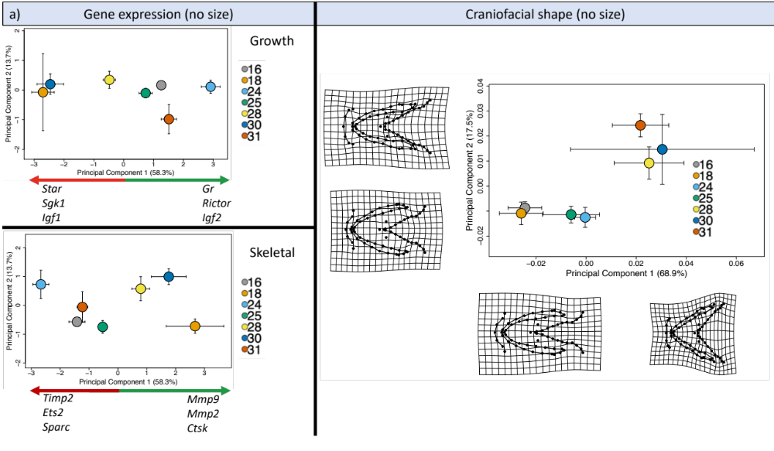
Figure S1 Craniofacial shape and relative gene expression using mean data for Arctic charr (Salvelinus alpinus), without size.

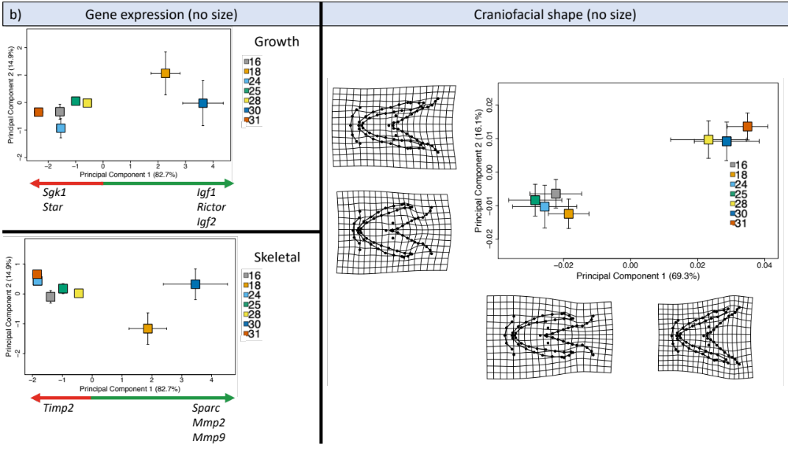

Principal components analysis (PCA) plots showing both relative gene expression (for growth and skeletal related genes) and ventral craniofacial shape variation attributed to family in the brown Arctic charr morph from lake Vatnshlíðarvatn, at a) hatching (H), and b) first feeding (FF). Coloured shapes and associated standard error bars correspond to mean shape of offspring within a family. Green and red arrows show those genes indicated with the highest PCA loadings at the positive (green) and negative (red) extremes of the PC axes, with the top three genes (where applicable) listed from the highest to lowest loadings. Deformation grids at the extremes of both axes represent the amount of shape change, with two-fold magnification.
Figure S2 Craniofacial shape and relative gene expression using individual data for Arctic charr (Salvelinus alpinus)

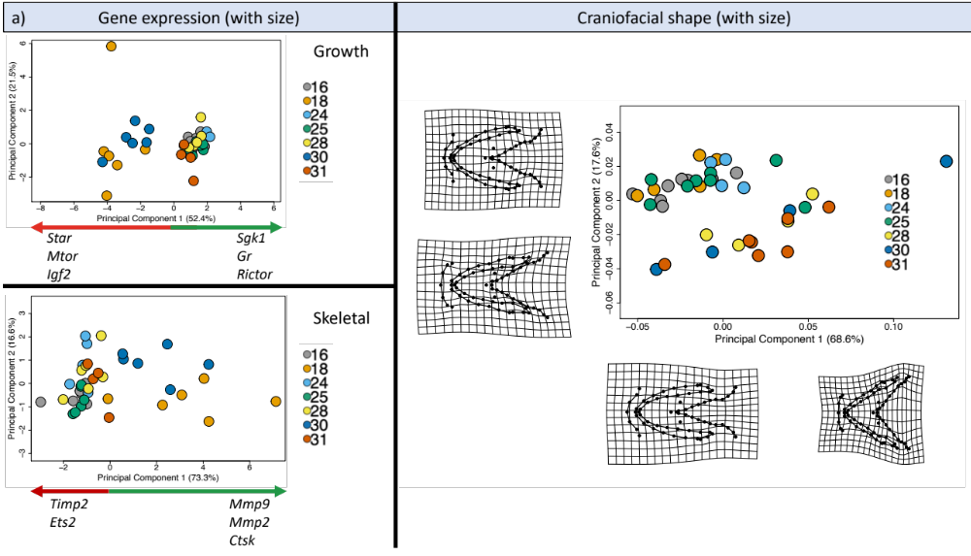

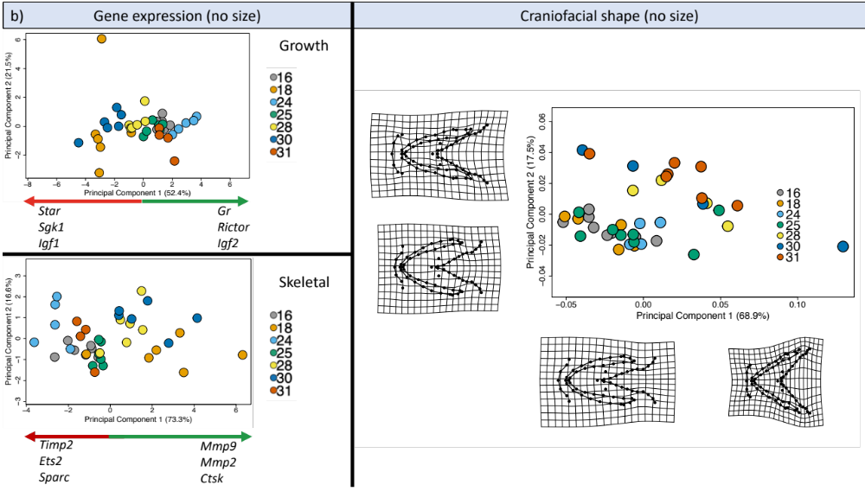

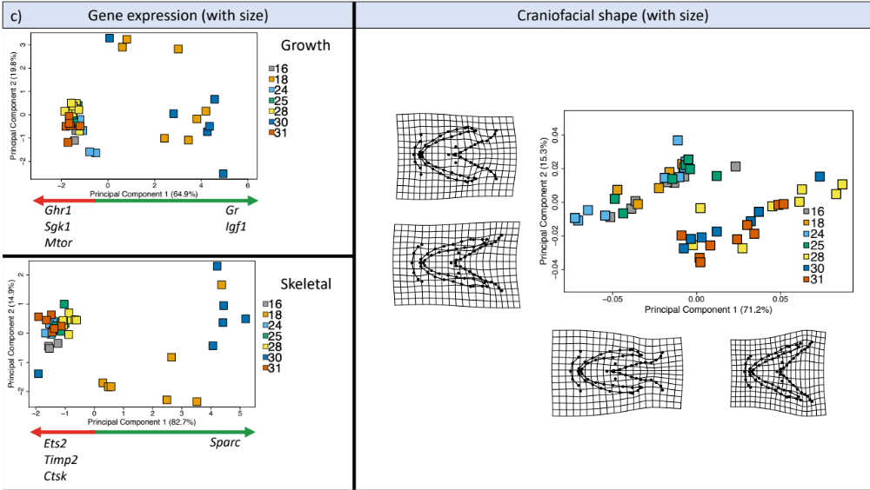

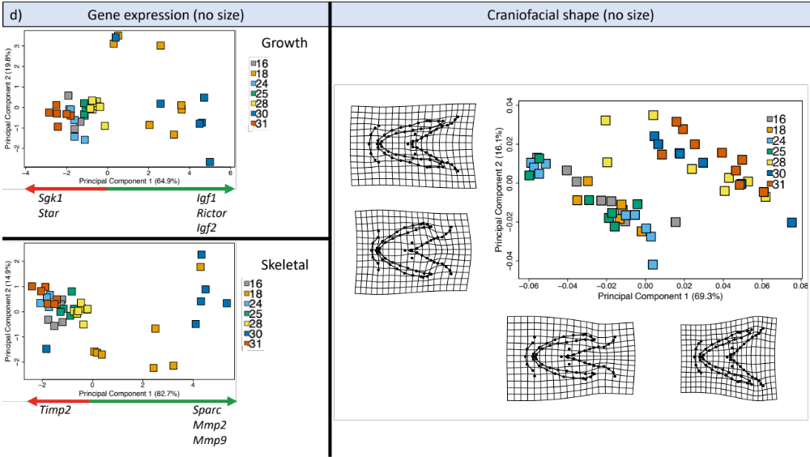

Principal components analysis (PCA) plots showing both relative gene expression (for growth and skeletal related genes) and ventral craniofacial shape variation attributed to family in the brown Arctic charr morph from lake Vatnshlíðarvatn at hatching (H) and first feeding (FF). a) H with offspring size; b) FF with offspring size; c) H without offspring size; and d) FF without offspring size. Coloured shapes and associated standard error bars correspond to mean shape of offspring within a family. Green and red arrows show those genes indicated with the highest PCA loadings at the positive (green) and negative (red) extremes of the PC axes, with the top three genes (where applicable) listed from the highest to lowest loadings. Deformation grids at the extremes of both axes represent the amount of shape change, with two-fold magnification.

