Supplemental Material
Table S1. A subset of data to be collected from the heavy-duty trucks
Vehicle and Engine Information | ECU Data | GPS Data
Vocational use  Vehicle type  Axle configuration  Vehicle model year  VIN number  Vehicle weight and GVW  Engine makes  Engine size  Engine model  Engine model year  Fuel capacity  Photos Survey (see Appendix B for details) | Vehicle speed  Engine horsepower  Engine RPM  Fuel rate  Exhaust temperature at DPF  Odometer reading  Engine percent load  Engine percent torque  Reference engine torque  Engine intake manifold temp  Engine out temperature Engine coolant temperature  Engine oil temperature  Aftertreatment intake NOx  Aftertreatment outlet NOx  Aftertreatment outlet NH3 | Speed  Latitude  Longitude  Altitude  Date & time  No. of satellites fixed  Fix quality  Position dilution of precision  Engine on/off

Table S2. A subset of data to be collected from the heavy-duty trucks
Truck ID | Engine Model Year | Manufacturer | Engine Family | Standard Cert. (g/bhp-hr) | Mileage | Displacement (L) | Torque  Ib-ft @RPM | Max power (HP) | Aftertreatment
231 | 2010 | Detroit | ADDXH14.8EED | 0.15 | 117625 | 14.8 | 1550@1240 | 455 | ECM, TC, CAC, EGR, OC, PTOX, SCR-U
275 | 2010 | Detroit | ADDXH12.8FED | 0.14 | 667289 | 12.8 | 1250@1240 | 370 | ECM, TC, CAC, EGR, OC, PTOX, SCR-U
215 | 2010 | Detroit | ADDXH14.8EED | 0.15 | 118930 | 14.8 | 1550@1240 | 455 | ECM, TC, CAC, EGR, OC, PTOX, SCR-U
271 | 2010 | Detroit | ADDXH14.8EED | 0.15 | 112434 | 14.8 | 1550@1240 | 455 | ECM, TC, CAC, EGR, OC, PTOX, SCR-U
232 | 2010 | Detroit | ADDXH14.8EED | 0.15 | 113896 | 14.8 | 1550@1240 | 455 | ECM, TC, CAC, EGR, OC, PTOX, SCR-U
222 | 2010 | Detroit | ADDXH12.8FED | 0.14 | 700197 | 12.8 | 1250@1240 | 370 | ECM, TC, CAC, EGR, OC, PTOX, SCR-U
276 | 2011 | Detroit | BDDXH12.8FED | 0.13 | 619625 | 12.8 | 1350@1240 | 350 | DOI, TC, CAC, ECM, EGR, OC, PTOX, SCR-U
214 | 2011 | Detroit | BDDXH14.8EED | 0.17 | 852039 | 14.8 | 1550@1240 | 455 | DOI, TC, CAC, ECM, EGR, OC, PTOX, SCR-U
227 | 2011 | Detroit | BDDXH12.8FED | 0.13 | 669176 | 12.8 | 1350@1240 | 350 | DOI, TC, CAC, ECM, EGR, OC, PTOX, SCR-U
225 | 2011 | Detroit | BDDXH12.8FED | 0.13 | 768718 | 12.8 | 1350@1240 | 350 | DOI, TC, CAC, ECM, EGR, OC, PTOX, SCR-U
207 | 2011 | Detroit | BDDXH12.8FED | 0.13 | 775237 | 12.8 | 1350@1240 | 350 | DOI, TC, CAC, ECM, EGR, OC, PTOX, SCR-U
263 | 2011 | Cummins | BCEXH0912XAP | 0.25 | 931022 | 14.9 | 1750@1200 | 407 | DDI, TC, CAC, ECM, EGR, OC, SCR-U, PTOX
213 | 2011 | Cummins | BCEXH0912XAP | 0.25 | 598762 | 14.9 | 1750@1200 | 407 | DDI, TC, CAC, ECM, EGR, OC, SCR-U, PTOX
228 | 2012 | Detroit | CDDXH12.8FED | 0.17 | 328628 | 12.8 | 1650@1240 | 500 | DDI, TC, CAC, ECM, EGR, OC, PTOX, SCR-U. AMOX
260 | 2012 | Detroit | CDDXH12.8FED | 0.17 | 185178 | 12.8 | 1650@1240 | 500 | DDI, TC, CAC, ECM, EGR, OC, PTOX, SCR-U. AMOX
230 | 2012 | Detroit | CDDXH14.8EED | 0.17 | 405643 | 14.8 | 1550@1240 | 455 | DDI, TC, CAC, ECM, EGR, OC, PTOX, SCR-U. AMOX
224 | 2012 | Detroit | CDDXH12.8FED | 0.17 | 491185 | 12.8 | 1650@1240 | 500 | DDI, TC, CAC, ECM, EGR, OC, PTOX, SCR-U. AMOX
209 | 2012 | Detroit | CDDXH12.8FED | 0.17 | 567579 | 12.8 | 1650@1240 | 500 | DDI, TC, CAC, ECM, EGR, OC, PTOX, SCR-U. AMOX
242 | 2012 | Detroit | CDDXH12.8FED | 0.17 | 536643 | 12.8 | 1650@1240 | 500 | DDI, TC, CAC, ECM, EGR, OC, PTOX, SCR-U. AMOX
248 | 2012 | Detroit | CDDXH12.8FED | 0.17 | 413625 | 12.8 | 1650@1240 | 500 | DDI, TC, CAC, ECM, EGR, OC, PTOX, SCR-U. AMOX
267 | 2012 | Detroit | CDDXH12.8FED | 0.17 | 502402 | 12.8 | 1650@1240 | 500 | DDI, TC, CAC, ECM, EGR, OC, PTOX, SCR-U. AMOX
235 | 2012 | Detroit | CDDXH12.8FED | 0.17 | 410392 | 12.8 | 1650@1240 | 500 | DDI, TC, CAC, ECM, EGR, OC, PTOX, SCR-U. AMOX
239 | 2012 | Detroit | CDDXH14.8EED | 0.17 | 970109 | 14.8 | 1550@1240 | 455 | DDI, TC, CAC, ECM, EGR, OC, PTOX, SCR-U. AMOX
250 | 2012 | Detroit | CDDXH12.8FED | 0.17 | 283117 | 12.8 | 1650@1240 | 500 | DDI, TC, CAC, ECM, EGR, OC, PTOX, SCR-U. AMOX
238 | 2012 | Detroit | CDDXH12.8FED | 0.17 | 476076 | 12.8 | 1650@1240 | 500 | DDI, TC, CAC, ECM, EGR, OC, PTOX, SCR-U. AMOX
241 | 2012 | Detroit | CCEXH0912XAP | 0.25 | 669917 | 14.9 | 1750@1200 | 407 | DDI, TC, CAC, ECM, EGR, OC, SCR-U. PTOX
205 | 2012 | Cummins | CCEXH0912XAP | 0.25 | 312768 | 14.9 | 1750@1200 | 407 | DDI, TC, CAC, ECM, EGR, OC, SCR-U. PTOX
236 | 2013 | Cummins | DCEXH0912XAT | 0.22 | 196621 | 14.9 | 1750@1000 | 461 | DDI, TC, CAC, ECM, EGR, OC, SCR-U. PTOX
266 | 2013 | Cummins | DCEXH0912XAT | 0.22 | 276390 | 14.9 | 1750@1000 | 461 | DDI, TC, CAC, ECM, EGR, OC, SCR-U. PTOX
237 | 2013 | Cummins | DCEXH0912XAT | 0.22 | 603917 | 14.9 | 1750@1000 | 461 | DDI, TC, CAC, ECM, EGR, OC, SCR-U. PTOX
212 | 2013 | Detroit | DDDXH12.8FED | 0.17 | 758892 | 12.8 | 1250@1240 | 370 | DDI, TC, CAC, ECM, EGR, OC, TC, CAC, ECM, EGR, OC,
246 | 2013 | Paccar | DPCRH12.9M01 | 0.12 | 428110 | 12.9 | 1650@ 1425 | 485 | ECM. PTOX, EGR, SCR-U, OC, DDI, TC, CAC
223 | 2014 | Paccar | EPCRH12.9M01 | 0.17 | 244005 | 12.9 | 1650@ 1425 | 485 | ECM. PTOX, EGR, SCR-U, OC, DDI, TC, CAC
256 | 2014 | Cummins | ECEXH0912XAT | 0.22 | 703444 | 14.9 | 1750@1000 | 461 | DDI, TC, CAC, ECM, EGR, OC, PTOX, SCR-U.
219 | 2014 | Detroit | EDDXH12.8FED | 0.17 | 279851 | 12.8 | 1250@1240 | 370 | DDI, TC, CAC, ECM, EGR, OC, PTOX, SCR-U. AMOX
264 | 2014 | Navistar | ENVXH07570SB | 0.12 | 343954 | 12.4 | - | 365 | DDI, TC(2), CAC(2), ECM, EGR, OC, PTOX, SCR-U
265 | 2015 | Navistar | FNVXH07570SB | 0.14 | 280011 | 12.4 | - | 365 | DDI, TC(2), CAC(2), ECM, EGR, OC, PTOX, SCR-U
229 | 2015 | Detroit | FDDXH14.8EAD | 0.09 | 811294 | 14.8 | 1550@1240 | 455 | DDI, TC, CAC, ECM, EGR, OC, PTOX, SCR-U. AMOX
201 | 2015 | Detroit | FDDXH14.8EAD | 0.09 | 512426 | 14.8 | 1550@1240 | 455 | DDI, TC, CAC, ECM, EGR, OC, PTOX, SCR-U. AMOX
252 | 2015 | Detroit | FDDXH14.8EAD | 0.09 | 555798 | 14.8 | 1550@1240 | 455 | DDI, TC, CAC, ECM, EGR, OC, PTOX, SCR-U. AMOX

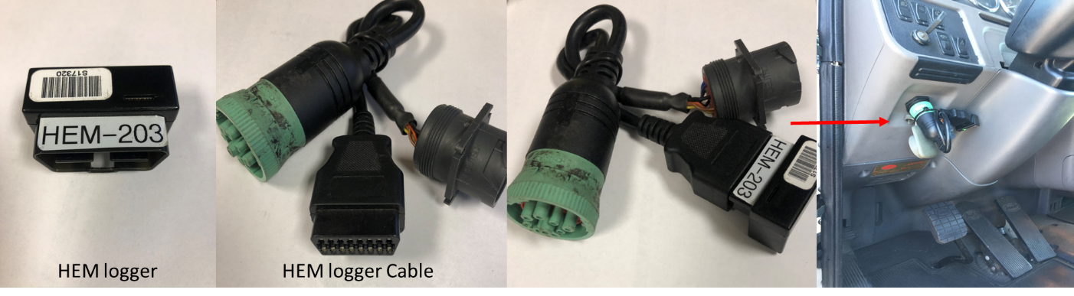Figure S1. HEM data logger utilized for monitoring program and installation location

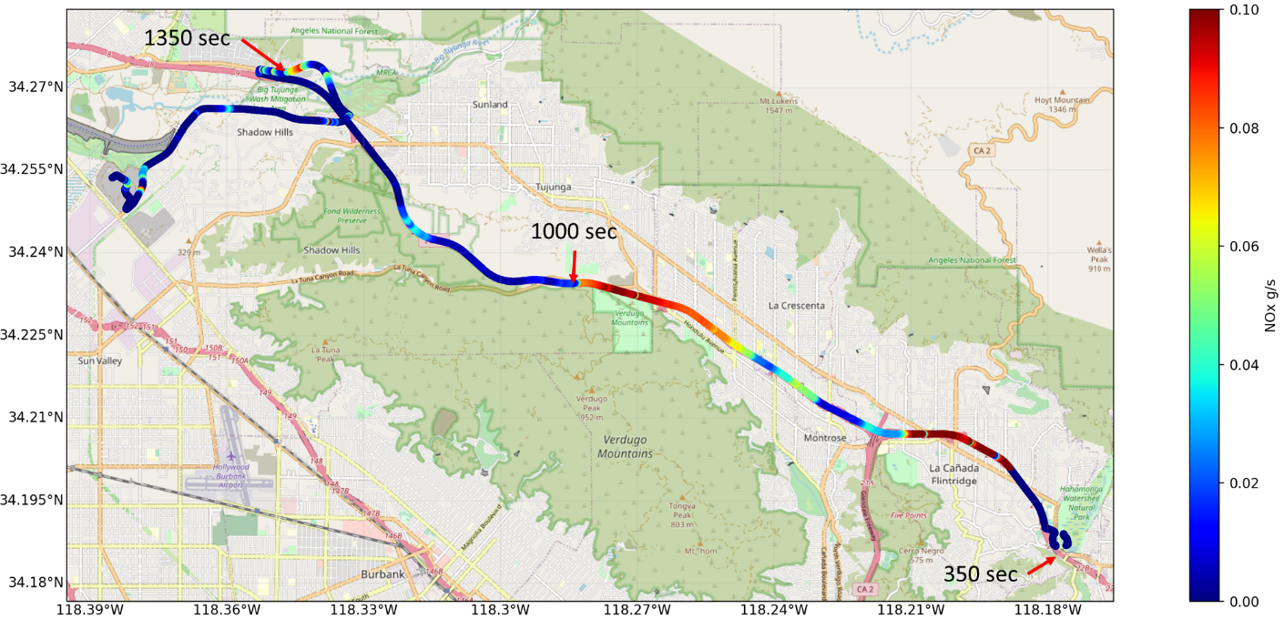
Figure S2a: Distribution of NOx emissions over the Test Route from DG to SPS

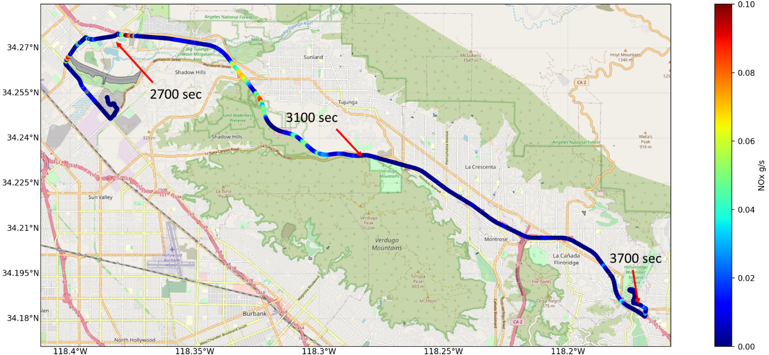
Figure S2b: Distribution of NOx emissions over the Test Route from SPS to DG

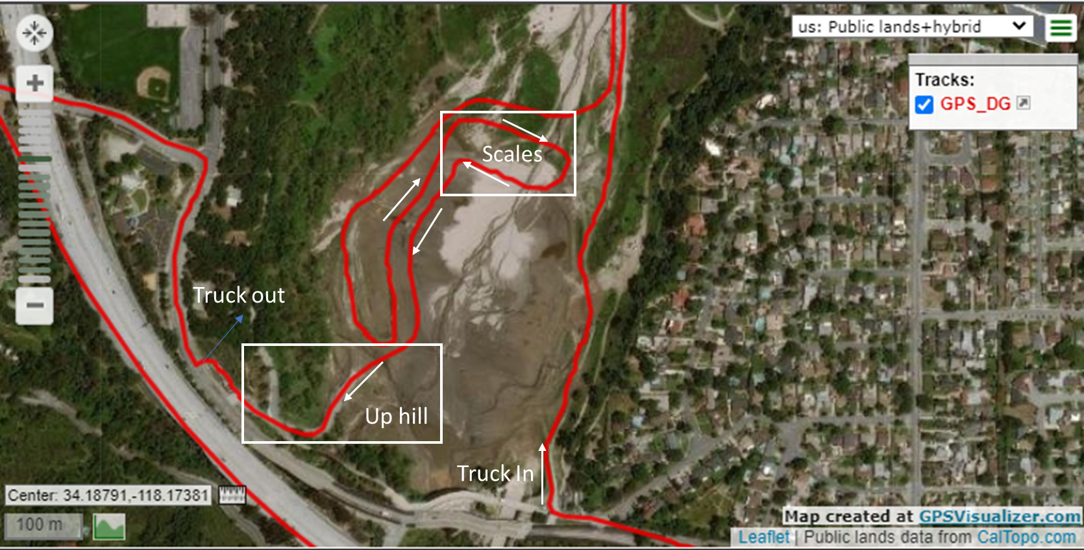
Figure S3a. Typical Pathway through the Devil’s Gate Reservoir During the October Campaign
Figure S3b. Typical Pathway through the Devil’s Gate Reservoir During the August Campaign

