Supporting Information

Effects of Presenilin-1 Familial Alzheimer’s Disease Mutations on γ-Secretase Activation for Cleavage of Amyloid Precursor Protein

Hung N. Do^{1,#}, Sujan Devkota^{2,#}, Apurba Bhattarai¹, Michael S. Wolfe^{2,*}, and Yinglong Miao^{1,*}

¹Center for Computational Biology and Department of Molecular Biosciences; ²Department of Medicinal Chemistry, School of Pharmacy, University of Kansas, Lawrence, Kansas 66047

# These authors contributed equally to this work
*To whom correspondence should be addressed: mswolfe@ku.edu and miao@ku.edu

Figure S1. Time courses of distances between PS1 residues D257 (atom Cγ) and D385 (atom Cγ) (A), PS1 residue D385 (protonated oxygen) and APP L49 (carbonyl oxygen) (B), PS1 residue D385 (protonated oxygen) and APP T48 (carbonyl oxygen) (C) in the WT γ-secretase.
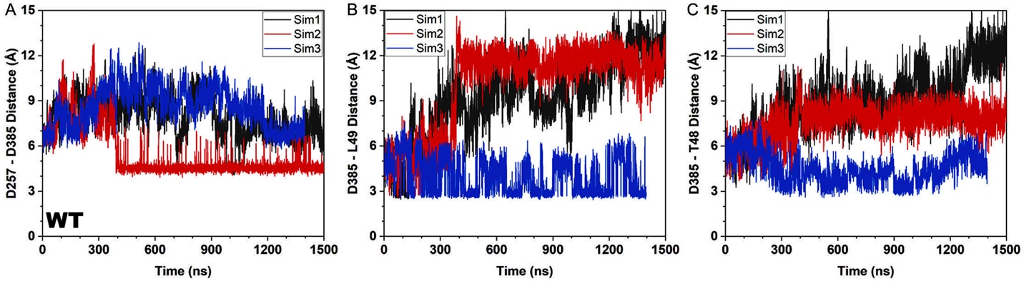

Figure S2. Time courses of distances between PS1 residues D257 (atom Cγ) and D385 (atom Cγ) (A and D), PS1 residue D385 (protonated oxygen) and APP residue L49 (carbonyl oxygen) (B and E), PS1 residue D385 (protonated oxygen) and APP residue T48 (carbonyl oxygen) (C and F) in the L286V (A-C) and P117L (D-F) PS1 FAD mutant γ-secretase.
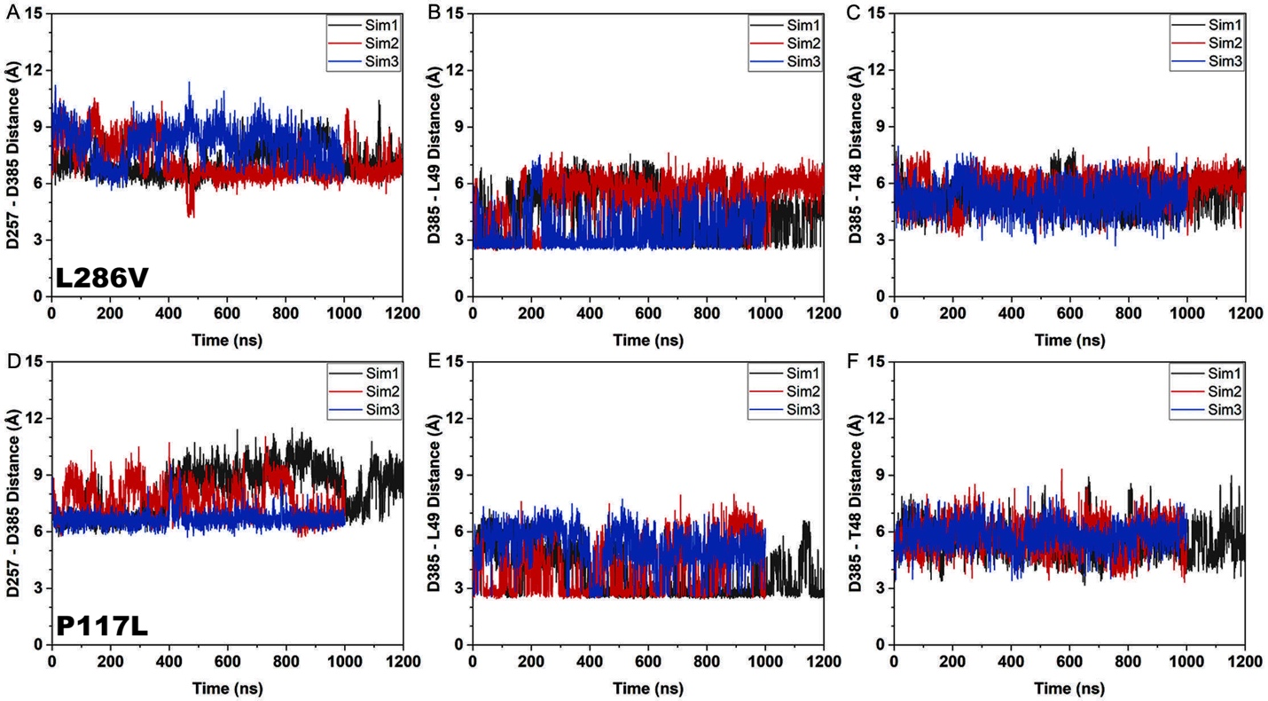

Figure S3. Time courses of distances between PS1 residues D257 (atom Cγ) and D385 (atom Cγ) (A and D), PS1 residue D385 (protonated oxygen) and APP residue L49 (carbonyl oxygen) (B and E), PS1 residue D385 (protonated oxygen) and APP residue T48 (carbonyl oxygen) (C and F) in the G384A (A-C) and I143T (D-F) PS1 FAD mutant γ-secretase.
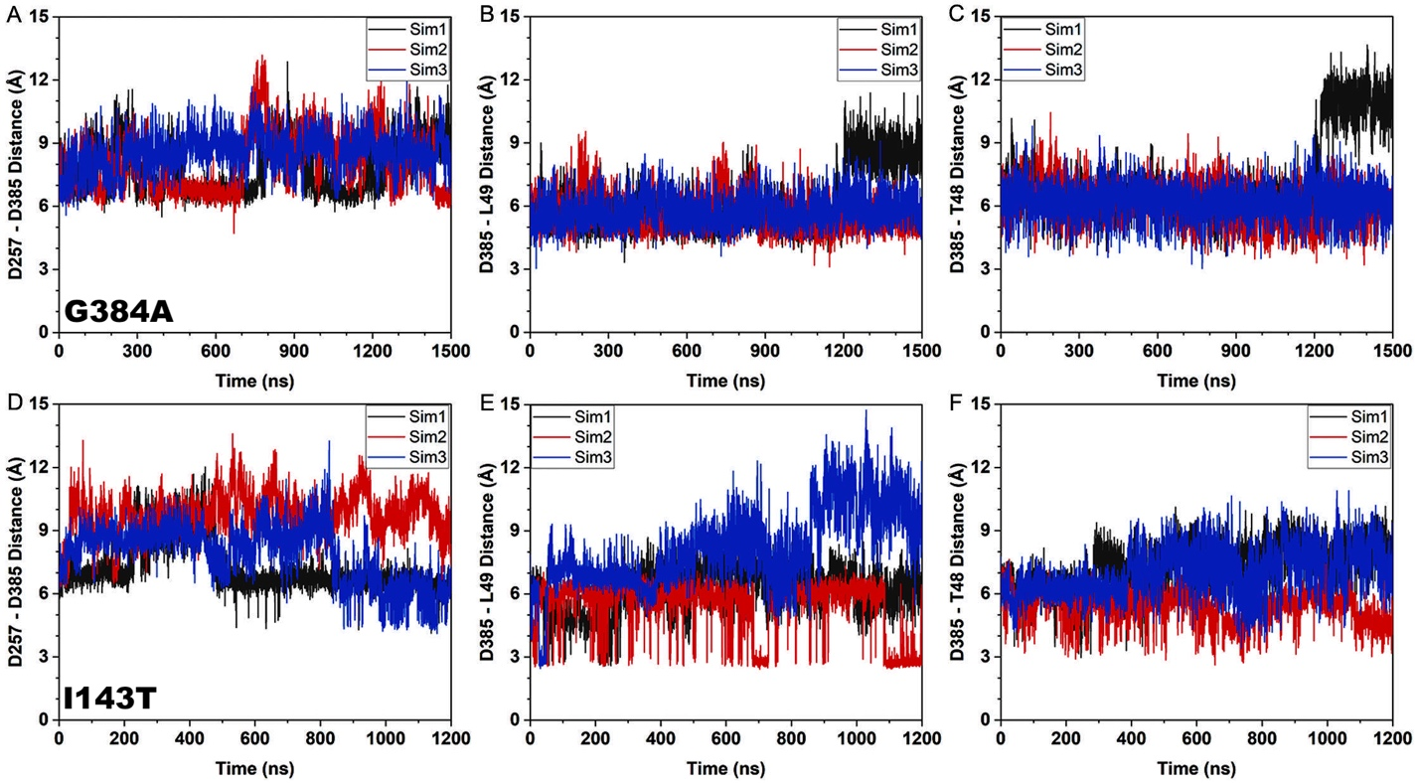

Figure S4. Time courses of distances between PS1 residues D257 (atom Cγ) and D385 (atom Cγ) (A and D), PS1 residue D385 (protonated oxygen) and APP residue L49 (carbonyl oxygen) (B and E), PS1 residue D385 (protonated oxygen) and APP residue T48 (carbonyl oxygen) (C and F) in the L166P (A-C) and L435F (D-F) PS1 FAD mutant γ-secretase.
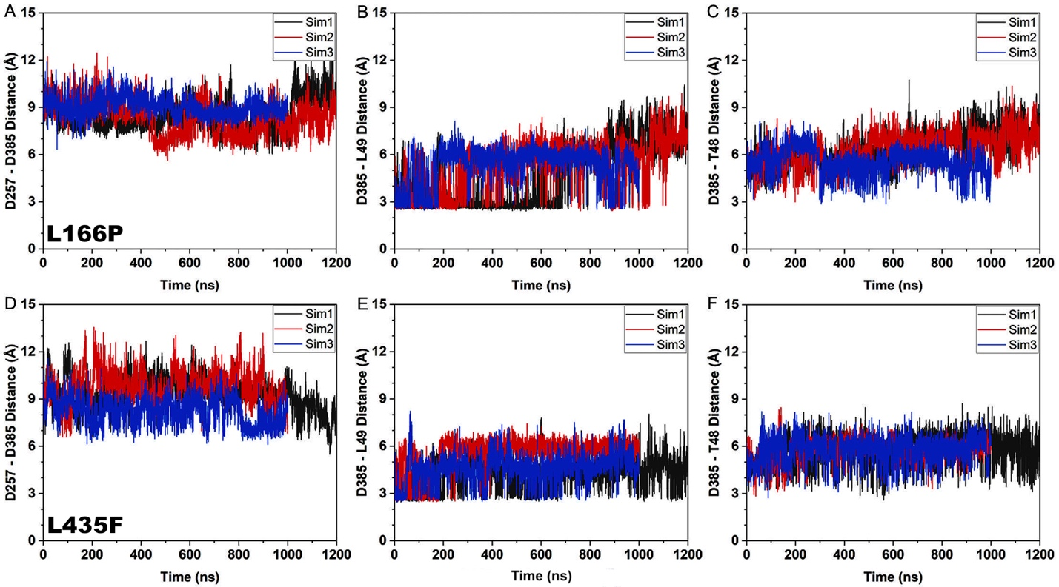

Figure S5. Intermediate low-energy conformational states of WT and PS1 FAD mutant γ-secretase compared to “Active” WT conformation. The “Inhibited” (A), “I1” (B), “I2” (C), “I3” (D), “I4” (E), and “I5” (F) low-energy conformational state compared to “Active” WT conformational state. The transmembrane domains 1 to 9 are labeled TM1–TM9.
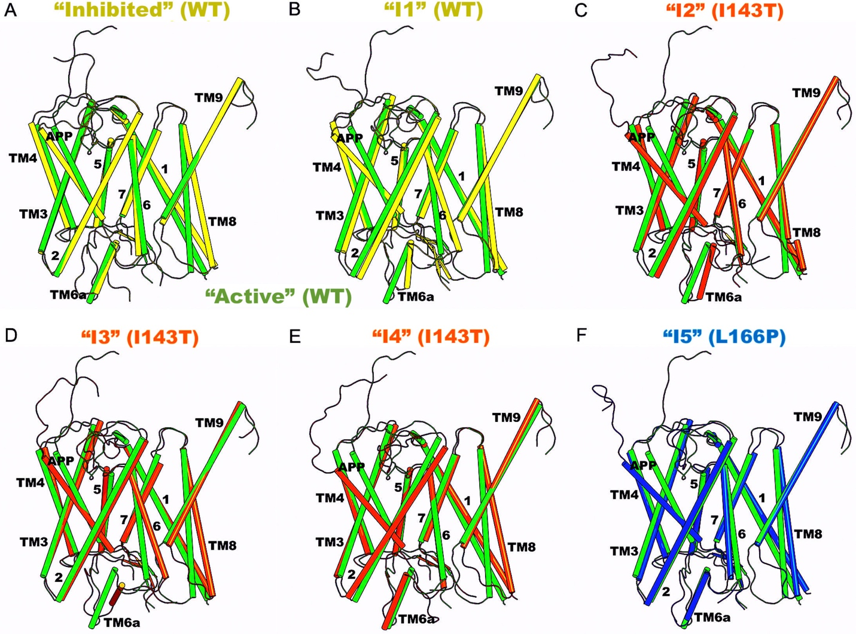

Figure S6. Conformations of the APP substrate in the intermediate low-energy conformational states of WT and PS1 FAD mutant γ-secretase compared to “Active” WT conformation.
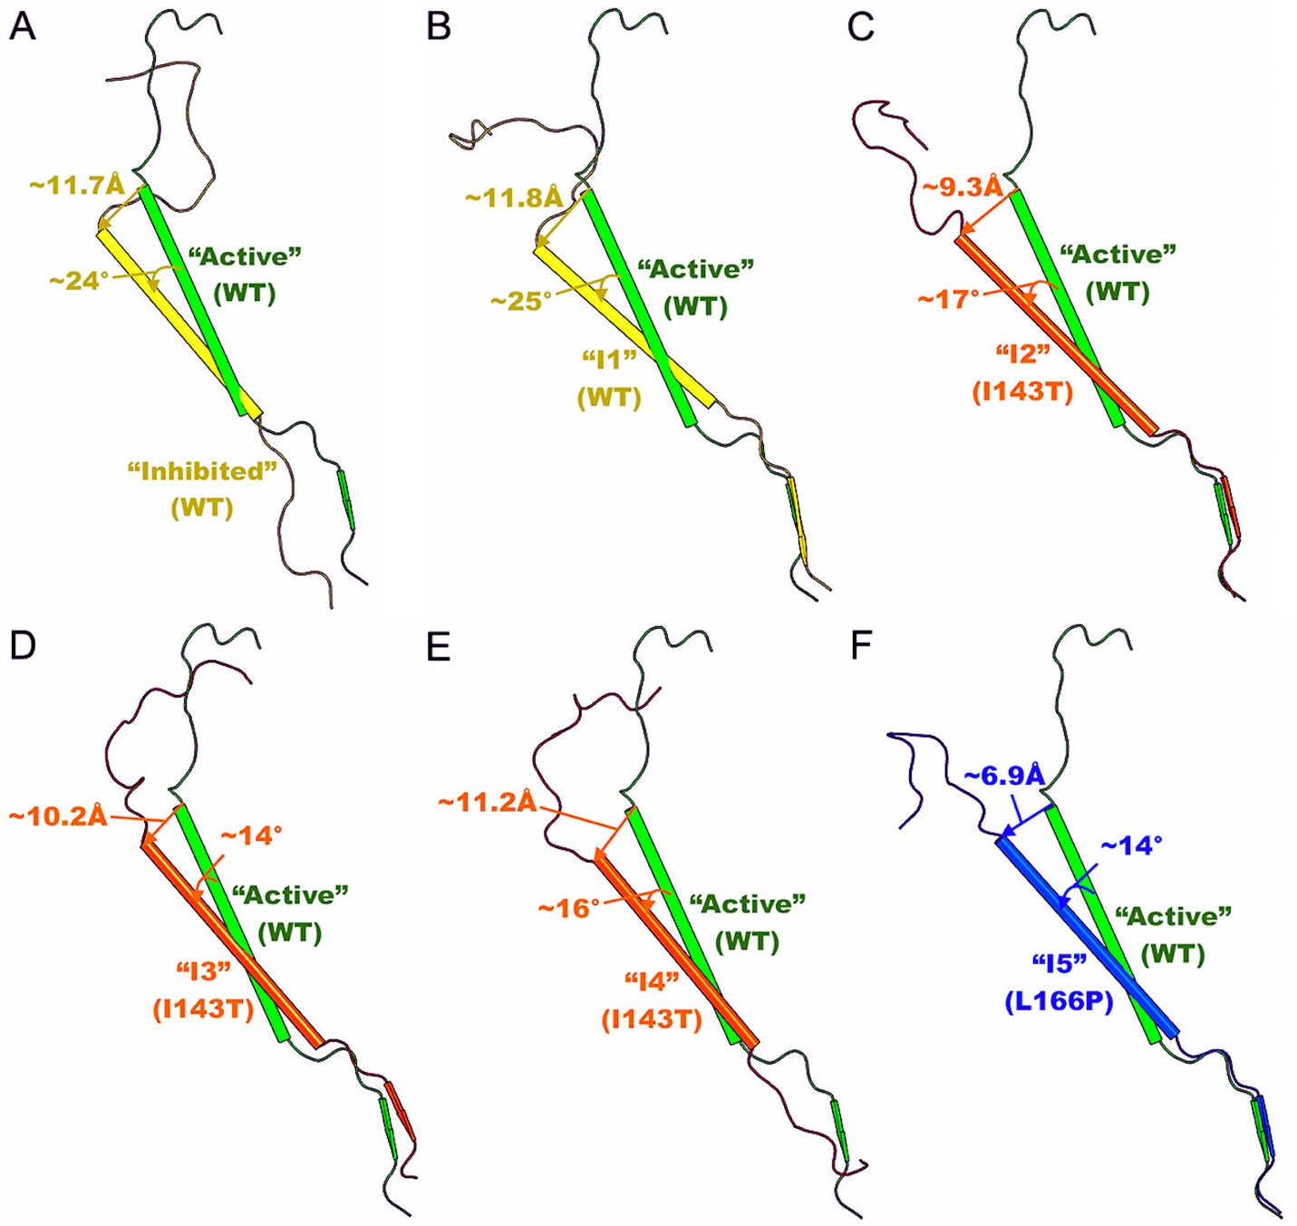

Figure S7. Conformations of TM6a, TM7, and APP in the intermediate low-energy conformational states of WT and PS1 FAD mutant γ-secretase compared to “Active” WT conformation.
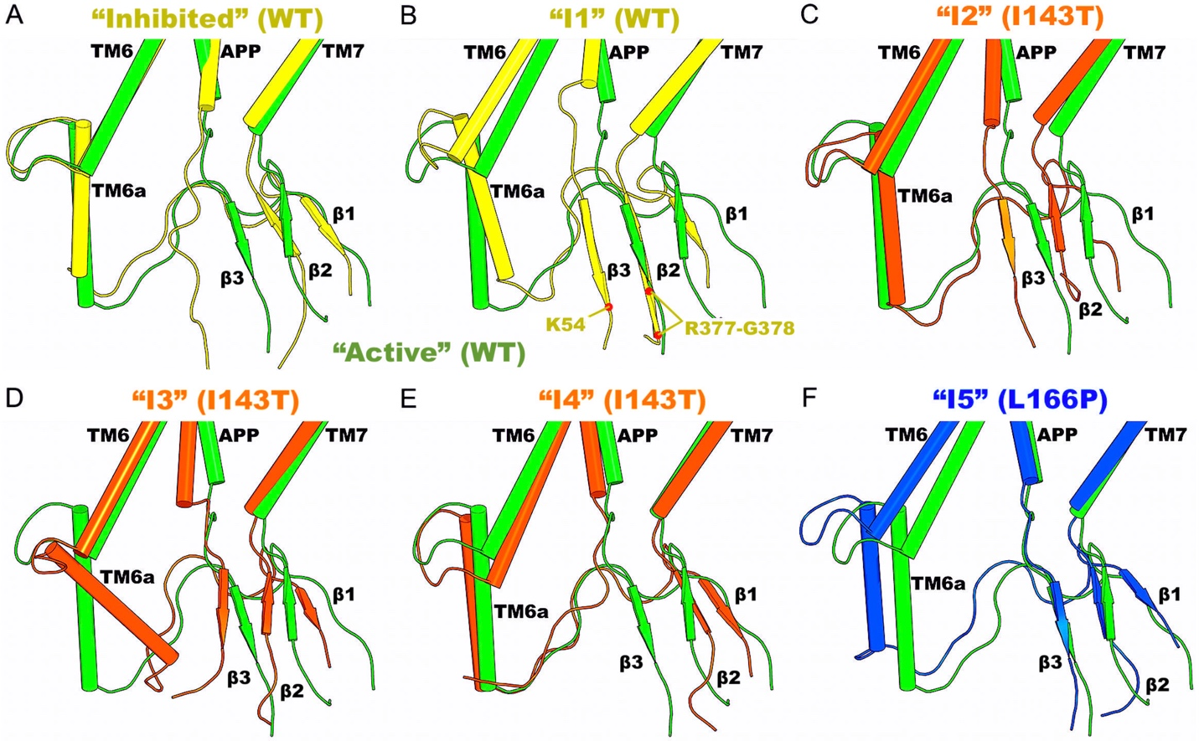

Figure S8. Conformations of TM8 in the intermediate low-energy conformational states of WT and PS1 FAD mutant γ-secretase compared to “Active” WT conformation.
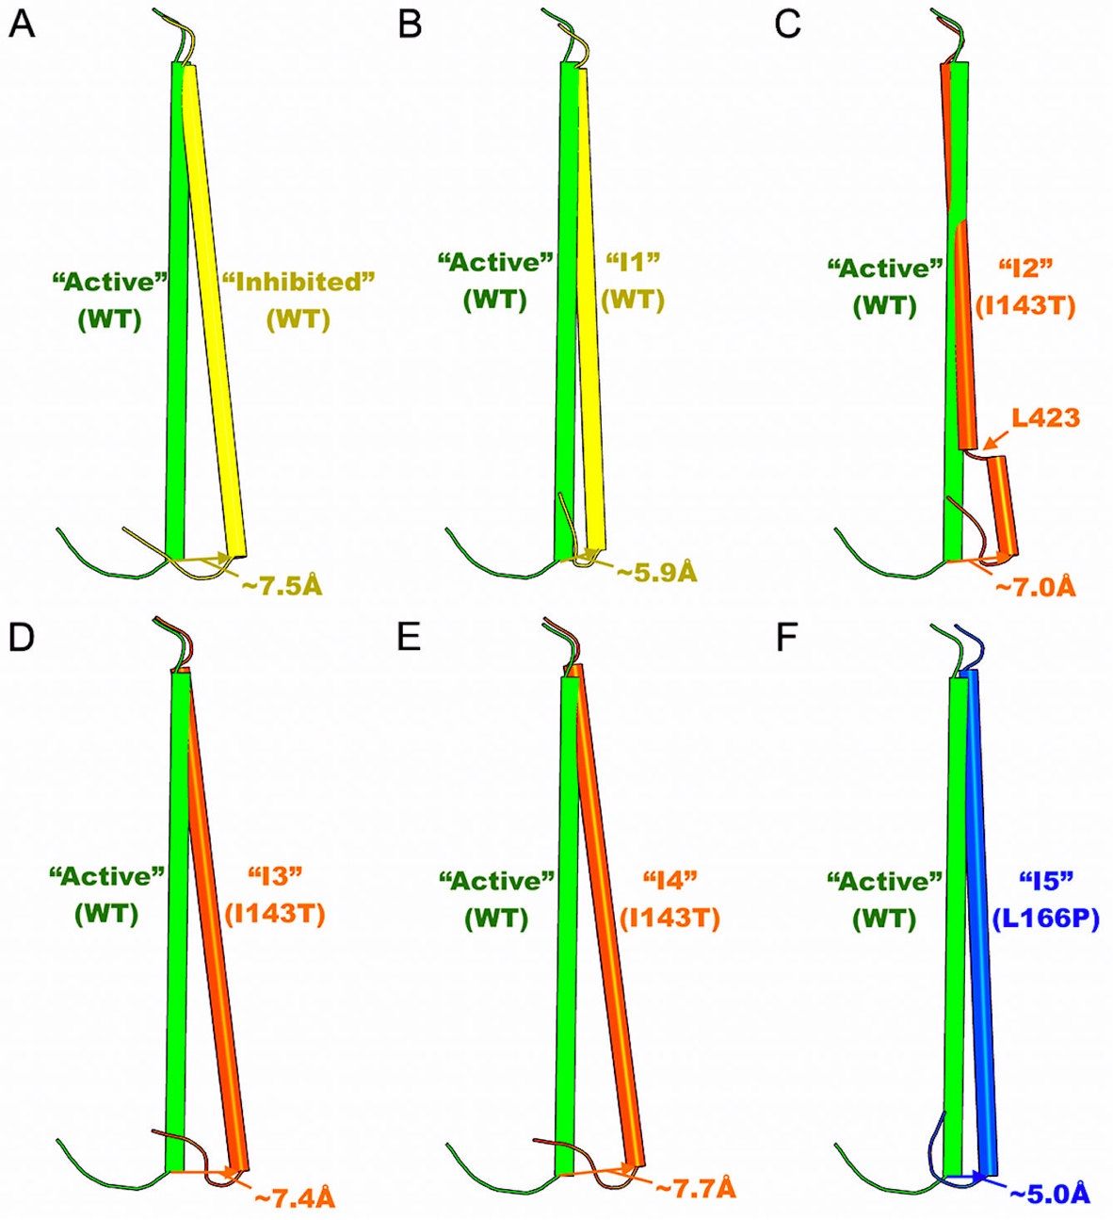

Figure S9. Time courses of the APP secondary structures in the WT PS1 calculated from the other two independent GaMD simulations apart from the one plotted in Figure 5.
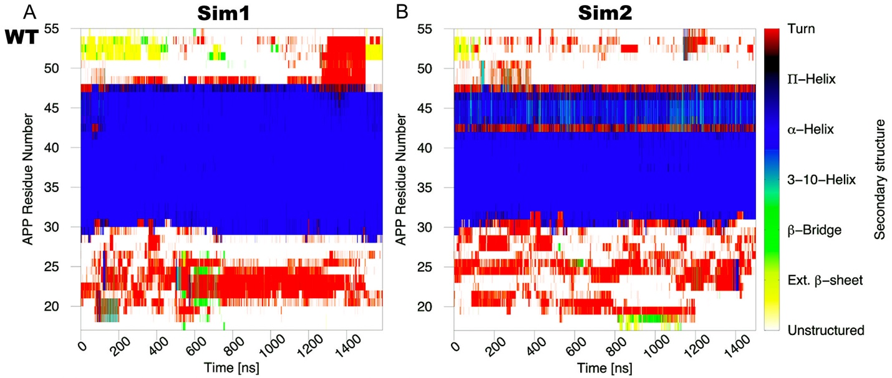

Figure S10. Time courses of the APP secondary structures in the L286V (A-B) and P117L (C-D) PS1 calculated from the other independent GaMD simulations apart from the ones plotted in Figure 5.
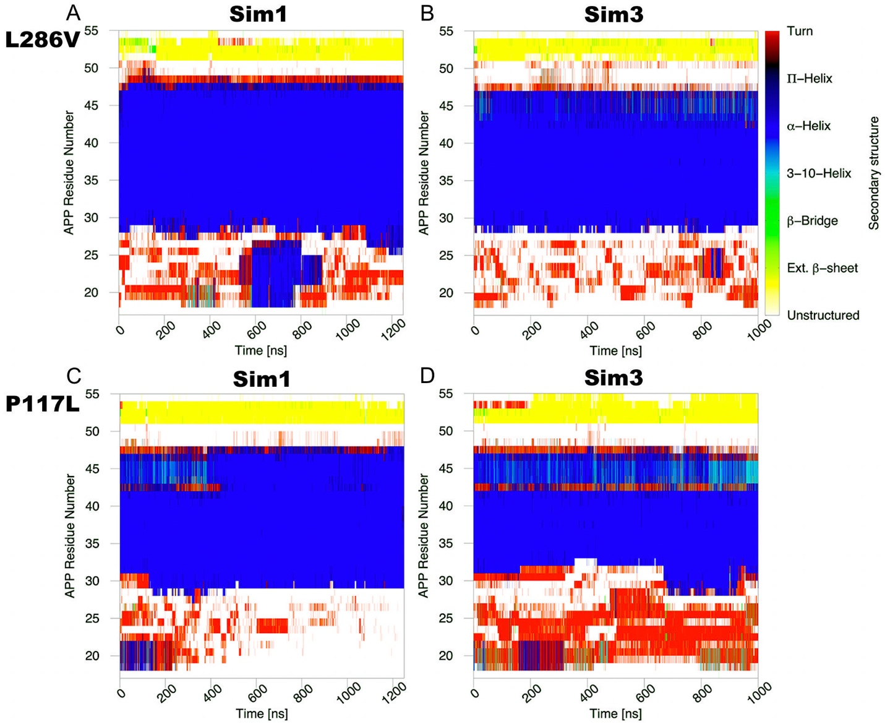

Figure S11. Time courses of the APP secondary structures in the G384A (A-B) and I143T (C-D) PS1 calculated from the other independent GaMD simulations apart from the ones plotted in Figure 5.

Figure S12. Time courses of the APP secondary structures in the L166P (A-B) and L435F (C-D) PS1 calculated from the other independent GaMD simulations apart from the ones plotted in Figure 5.
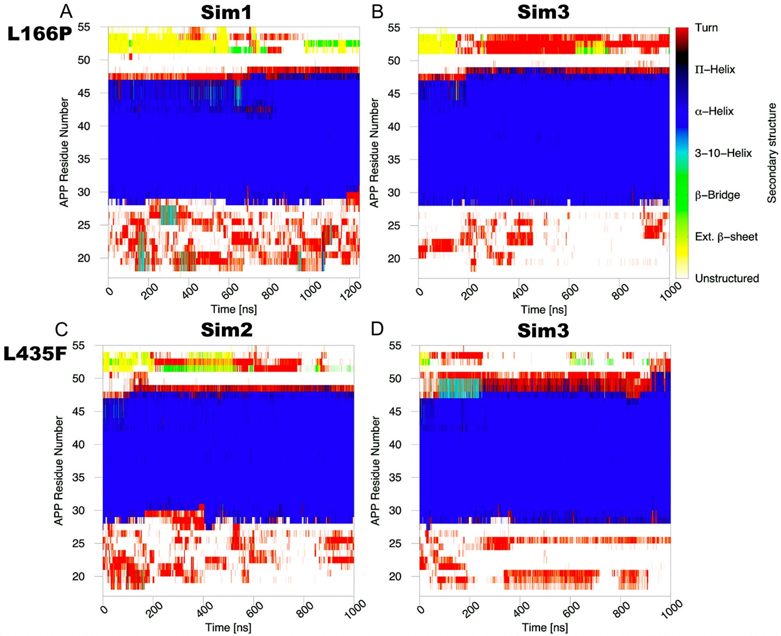

Table S1. pKa values of D257 and D385 in the starting structure (PDB: 6IYC) and low-energy conformational states from GaMD simulations as calculated using PROPKA3^{1,2} at pH 7.0.
System | pKa(D257) | pKa(D385)
Starting structure | 7.95 | 8.80
“Active” (WT) | 5.58 | 9.75
“Active” (L286V) | 5.97 | 10.11
“Active” (P117L) | 6.26 | 8.97
“Inhibited” (WT) | 4.73 | 10.10
“I1” (WT) | 5.56 | 7.05
“I2” (I143T) | 5.81 | 8.78
“I3” (I143T) | 3.56 | 7.78
“I4” (I143T) | 5.58 | 7.19
“I5” (L166P) | 4.97 | 9.61
Table S2. Summary of GaMD simulations performed on the APP-bound γ-secretase complexes, including WT, P117L, I143T, L166P, G384A, L435F, and L286V PS1 FAD mutant γ-secretase.
System | Method | Simulation Length  (ns) | Boost Potential  (kcal/mol)
WT | GaMD_Dual | 2 x 1500 (Sim1-2);  1 x 1400 (Sim3) | 13.54 ± 4.31
P117L | GaMD_Dual | 1 x 1250 (Sim1);  2 x 1000 (Sim2-3) | 11.29 ± 4.04
I143T | GaMD_Dual | 3 x 1250 (Sim1-3) | 13.97 ± 4.37
L166P | GaMD_Dual | 2 x 1250 (Sim1-2);  1 x 1000 (Sim3) | 14.75 ± 4.47
G384A | GaMD_Dual | 3 x 1500 (Sim1-3) | 13.83 ± 4.35
L435F | GaMD_Dual | 1 x 1250 (Sim1);  2 x 1000 (Sim2-3) | 14.02 ± 4.39
L286V | GaMD_Dual | 2 x 1250 (Sim1-2);  1 x 1000 (Sim3) | 14.11 ± 4.41

Table S3. List of amino acid residues constituting the S1’, S2’, and S3’ subpockets in the WT “Active”, L286V “Active”, P117L “Active”, and L166P “I5” low-energy conformations of γ-secretase. The residues that are within 5 Å of APP substrate residues P1’, P2’, and P3’ are listed in the table.
System | S1’ |  | S2’ |  | S3’
“Active” (WT) | I287  K380  L381  G382  D385^{TM7} |  | L85^{TM1}  V379  K380  L381  G382  D385^{TM7} | Y389^{TM7}  T421^{TM8}  L422^{TM8}  L425^{TM8}  L432  A434 | T281  I287  G378  V379  K380  L381
“Active” (L286V) | D257^{TM6}  L268^{TM6a}  L271^{TM6a}  V272^{TM6a}  L282  I287  K380  L381 | G382  D385^{TM7}  A431  A434 | L85^{TM1}  V379  K380  L381  G382  D385^{TM7}  Y389^{TM7}  L418^{TM8} | T421^{TM8}  L422^{TM8}  L425^{TM8}  A431  L432  P433  A434  L435 | T281  L282  I287  V379  K380  L381  L425^{TM8}  A431
“Active” (P117L) | D257^{TM6}  L268^{TM6a}  R269^{TM6a}  L271^{TM6a}  V272^{TM6a}  I287  K380  L381 | G382  D385^{TM7} | R269^{TM6a}  V272^{TM6a}  V379  K380  L381  G382  D385^{TM7}  Y389^{TM7} | L418^{TM8}  T421^{TM8}  L422^{TM8}  L425^{TM8}  A434  L435  S438^{TM9} | R269^{TM6a}  L271^{TM6a}  V272^{TM6a}  A275^{TM6a}  Q276^{TM6a}  I287  G378  V379 | K380  L381  G382
“I5” (L166P) | D257^{TM6}  I287  K380  L381  G382  D385^{TM7} |  | L85^{TM1}  V379  K380  L381  G382  D385^{TM7} | Y389^{TM7}  L418^{TM8}  L422^{TM8}  A434  L435  S438^{TM9} | I287  G378  V379  K380  L381  G382
References
1 Sondergaard, C. R., Olsson, M. H. M., Rostkowsi, M. & Jensen, J. H. Improved Treatment of Ligands and Coupling Effects in Empirical Calculations and Rationalization of pKa values. Journal of Chemical Theory and Computation 7, 2284-2295 (2011).
2 Olsson, M. H. M., Sondergaard, C. R., Rostkowsi, M. & Jensen, J. H. PROPKA3: consistent treatment of internal and surface residues in empirical pKa predictions. Journal of Chemical Theory and Computation 7, 525-537 (2011).

