A Strep A vaccine demand and return on investment forecast to inform industry R&D prioritization decisions

Supplementary Materials

Donald R Walkinshaw^{1,}*, Meghan EE Wright¹, Marni Williams¹, Tanya MF Scarapicchia¹, Jean-Louis Excler², Ryan E Wiley¹, Anne E Mullin¹

¹ Shift Health, Toronto, Canada
² International Vaccine Institute, Seoul, Republic of Korea
* Corresponding Author: dwalkinshaw@shifthealth.com

Timing of Introduction Country-by-Country Results

Table S-1. Income group level (or Gavi-eligibility) and year of introduction for each country in the MPC Global Rollout, MPC Staged Rollout and DCVM Staged Rollout scenarios.
Country | Income Group/Gavi-eligibility | MPC Global Rollout | MPC Staged Rollout | DCVM Staged Rollout
Afghanistan | Gavi | 2043 | 2043 | 2043
Albania | Upper middle income | 2036 | 2036 | 2036
Algeria | Upper middle income | 2037 | 2037 | 2037
Angola | Lower middle income | 2039 | 2039 | 2039
Antigua and Barbuda | High income | 2038 | 2043 | 2043
Argentina | Upper middle income | 2038 | 2038 | 2038
Armenia | Upper middle income | 2033 | 2033 | 2033
Australia | High income | 2034 | 2039 | 2039
Austria | High income | 2040 | 2045 | 2047
Azerbaijan | Upper middle income | 2037 | 2037 | 2037
Bahamas, The | High income | 2038 | 2043 | 2043
Bahrain | High income | 2036 | 2041 | 2041
Bangladesh | Gavi | 2038 | 2038 | 2038
Barbados | High income | 2037 | 2042 | 2042
Belarus | Upper middle income | 2039 | 2039 | 2039
Belgium | High income | 2036 | 2041 | 2043
Belize | Upper middle income | 2039 | 2039 | 2039
Benin | Gavi | 2040 | 2040 | 2040
Bhutan | Lower middle income | 2039 | 2039 | 2039
Bolivia | Lower middle income | 2038 | 2038 | 2038
Bosnia and Herzegovina | Upper middle income | 2042 | 2042 | 2042
Botswana | Upper middle income | 2033 | 2033 | 2033
Brazil | Upper middle income | 2038 | 2038 | 2038
Brunei Darussalam | High income | 2039 | 2044 | 2044
Bulgaria | Upper middle income | 2036 | 2036 | 2038
Burkina Faso | Gavi | 2035 | 2035 | 2035
Burundi | Gavi | 2035 | 2035 | 2035
Cabo Verde | Lower middle income | 2037 | 2037 | 2037
Cambodia | Gavi | 2039 | 2039 | 2039
Cameroon | Gavi | 2041 | 2041 | 2041
Canada | High income | 2034 | 2039 | 2043
Central African Republic | Gavi | 2042 | 2042 | 2042
Chad | Gavi | 2045 | 2045 | 2045
Chile | High income | 2038 | 2043 | 2043
China | Upper middle income | 2039 | 2039 | 2039
Colombia | Upper middle income | 2036 | 2036 | 2036
Comoros | Gavi | 2038 | 2038 | 2038
Congo, Dem. Rep. | Gavi | 2042 | 2042 | 2042
Congo, Rep. | Gavi | 2038 | 2038 | 2038
Costa Rica | Upper middle income | 2036 | 2036 | 2036
Côte d'Ivoire | Gavi | 2038 | 2038 | 2038
Croatia | High income | 2040 | 2045 | 2047
Cuba | Upper middle income | 2039 | 2039 | 2039
Cyprus | High income | 2038 | 2043 | 2045
Czech Republic / Czechia | High income | 2040 | 2045 | 2047
Denmark | High income | 2038 | 2043 | 2045
Djibouti | Gavi | 2038 | 2038 | 2038
Dominican Republic | Upper middle income | 2038 | 2038 | 2038
Ecuador | Upper middle income | 2038 | 2038 | 2038
Egypt, Arab Rep. | Lower middle income | 2039 | 2039 | 2039
El Salvador | Lower middle income | 2038 | 2038 | 2038
Equatorial Guinea | Upper middle income | 2043 | 2043 | 2043
Eritrea | Gavi | 2035 | 2035 | 2035
Estonia | High income | 2036 | 2041 | 2043
Eswatini | Lower middle income | 2033 | 2033 | 2033
Ethiopia | Gavi | 2041 | 2041 | 2041
Fiji | Upper middle income | 2033 | 2033 | 2033
Finland | High income | 2036 | 2041 | 2043
France | High income | 2036 | 2041 | 2045
Gabon | Upper middle income | 2040 | 2040 | 2040
Gambia, The | Gavi | 2038 | 2038 | 2038
Georgia | Upper middle income | 2035 | 2035 | 2035
Germany | High income | 2034 | 2039 | 2043
Ghana | Gavi | 2035 | 2035 | 2035
Greece | High income | 2036 | 2041 | 2043
Grenada | Upper middle income | 2039 | 2039 | 2039
Guatemala | Upper middle income | 2038 | 2038 | 2038
Guinea | Gavi | 2045 | 2045 | 2045
Guinea-Bissau | Gavi | 2038 | 2038 | 2038
Guyana | Upper middle income | 2035 | 2035 | 2035
Haiti | Gavi | 2042 | 2042 | 2042
Honduras | Lower middle income | 2038 | 2038 | 2038
Hungary | High income | 2038 | 2043 | 2045
Iceland | High income | 2038 | 2043 | 2043
India | Lower middle income | 2035 | 2035 | 2035
Indonesia | Lower middle income | 2042 | 2042 | 2042
Iran, Islamic Rep. | Upper middle income | 2038 | 2038 | 2038
Iraq | Upper middle income | 2038 | 2038 | 2038
Ireland | High income | 2036 | 2041 | 2043
Israel | High income | 2036 | 2041 | 2041
Italy | High income | 2034 | 2039 | 2043
Jamaica | Upper middle income | 2038 | 2038 | 2038
Japan | High income | 2038 | 2043 | 2043
Jordan | Upper middle income | 2041 | 2041 | 2041
Kazakhstan | Upper middle income | 2038 | 2038 | 2038
Kenya | Gavi | 2035 | 2035 | 2035
Kiribati | Lower middle income | 2033 | 2033 | 2033
Korea, Dem. People's Rep. | Gavi | 2041 | 2041 | 2041
Korea, Rep. | High income | 2037 | 2042 | 2042
Kuwait | High income | 2036 | 2041 | 2041
Kyrgyz Republic | Gavi | 2038 | 2038 | 2038
Lao PDR | Lower middle income | 2040 | 2040 | 2040
Latvia | High income | 2036 | 2041 | 2043
Lebanon | Upper middle income | 2041 | 2041 | 2041
Lesotho | Gavi | 2038 | 2038 | 2038
Liberia | Gavi | 2038 | 2038 | 2038
Libya | Upper middle income | 2038 | 2038 | 2038
Lithuania | High income | 2036 | 2041 | 2043
Luxembourg | High income | 2036 | 2041 | 2043
Madagascar | Gavi | 2038 | 2038 | 2038
Malawi | Gavi | 2035 | 2035 | 2035
Malaysia | Upper middle income | 2039 | 2039 | 2039
Maldives | Upper middle income | 2039 | 2039 | 2039
Mali | Gavi | 2038 | 2038 | 2038
Malta | High income | 2039 | 2044 | 2046
Mauritania | Gavi | 2038 | 2038 | 2038
Mauritius | Upper middle income | 2035 | 2035 | 2035
Mexico | Upper middle income | 2039 | 2039 | 2039
Micronesia, Fed. Sts. | Lower middle income | 2036 | 2036 | 2036
Moldova | Lower middle income | 2036 | 2036 | 2036
Mongolia | Lower middle income | 2037 | 2037 | 2037
Montenegro | Upper middle income | 2043 | 2043 | 2043
Morocco | Lower middle income | 2035 | 2035 | 2035
Mozambique | Gavi | 2038 | 2038 | 2038
Myanmar | Gavi | 2039 | 2039 | 2039
Namibia | Upper middle income | 2036 | 2036 | 2036
Nepal | Gavi | 2039 | 2039 | 2039
Netherlands | High income | 2038 | 2043 | 2045
New Zealand | High income | 2034 | 2039 | 2039
Nicaragua | Lower middle income | 2035 | 2035 | 2035
Niger | Gavi | 2038 | 2038 | 2038
Nigeria | Lower middle income | 2040 | 2040 | 2040
North Macedonia | Upper middle income | 2040 | 2040 | 2040
Norway | High income | 2036 | 2041 | 2041
Oman | High income | 2038 | 2043 | 2043
Pakistan | Gavi | 2040 | 2040 | 2040
Panama | High income | 2038 | 2043 | 2043
Papua New Guinea | Lower middle income | 2039 | 2039 | 2039
Paraguay | Upper middle income | 2038 | 2038 | 2038
Peru | Upper middle income | 2038 | 2038 | 2038
Philippines | Lower middle income | 2044 | 2044 | 2044
Poland | High income | 2038 | 2043 | 2045
Portugal | High income | 2038 | 2043 | 2045
Qatar | High income | 2036 | 2041 | 2041
Romania | Upper middle income | 2042 | 2042 | 2044
Russian Federation | Upper middle income | 2039 | 2039 | 2039
Rwanda | Gavi | 2035 | 2035 | 2035
Samoa | Upper middle income | 2043 | 2043 | 2043
São Tomé and Principe | Lower middle income | 2033 | 2033 | 2033
Saudi Arabia | High income | 2036 | 2041 | 2041
Senegal | Gavi | 2035 | 2035 | 2035
Serbia | Upper middle income | 2038 | 2038 | 2038
Seychelles | High income | 2035 | 2040 | 2040
Sierra Leone | Gavi | 2035 | 2035 | 2035
Singapore | High income | 2038 | 2043 | 2043
Slovak Republic / Slovakia | High income | 2038 | 2043 | 2045
Slovenia | High income | 2038 | 2043 | 2045
Solomon Islands | Lower middle income | 2035 | 2035 | 2035
Somalia | Gavi | 2045 | 2045 | 2045
South Africa | Upper middle income | 2035 | 2035 | 2035
South Sudan | Gavi | 2045 | 2045 | 2045
Spain | High income | 2036 | 2041 | 2045
Sri Lanka | Upper middle income | 2040 | 2040 | 2040
St. Lucia | Upper middle income | 2038 | 2038 | 2038
St. Vincent and the Grenadines | Upper middle income | 2039 | 2039 | 2039
Sudan | Gavi | 2037 | 2037 | 2037
Suriname | Upper middle income | 2042 | 2042 | 2042
Sweden | High income | 2038 | 2043 | 2045
Switzerland | High income | 2038 | 2043 | 2043
Syrian Arab Republic | Gavi | 2047 | 2047 | 2047
Tajikistan | Gavi | 2039 | 2039 | 2039
Tanzania | Gavi | 2038 | 2038 | 2038
Thailand | Upper middle income | 2041 | 2041 | 2041
Timor-Leste | Lower middle income | 2041 | 2041 | 2041
Togo | Gavi | 2038 | 2038 | 2038
Tonga | Upper middle income | 2035 | 2035 | 2035
Trinidad and Tobago | High income | 2037 | 2042 | 2042
Tunisia | Lower middle income | 2040 | 2040 | 2040
Turkey | Upper middle income | 2038 | 2038 | 2038
Turkmenistan | Upper middle income | 2037 | 2037 | 2037
Uganda | Gavi | 2035 | 2035 | 2035
Ukraine | Lower middle income | 2043 | 2043 | 2043
United Arab Emirates | High income | 2035 | 2040 | 2040
United Kingdom | High income | 2033 | 2038 | 2043
United States | High income | 2033 | 2038 | 2045
Uruguay | High income | 2038 | 2043 | 2043
Uzbekistan | Lower middle income | 2035 | 2035 | 2035
Vanuatu | Lower middle income | 2037 | 2037 | 2037
Venezuela, RB | Upper middle income | 2044 | 2044 | 2044
Vietnam | Lower middle income | 2043 | 2043 | 2043
Yemen, Rep. | Gavi | 2040 | 2040 | 2040
Zambia | Gavi | 2038 | 2038 | 2038
Zimbabwe | Gavi | 2035 | 2035 | 2035

Timing of Introduction Analysis Results
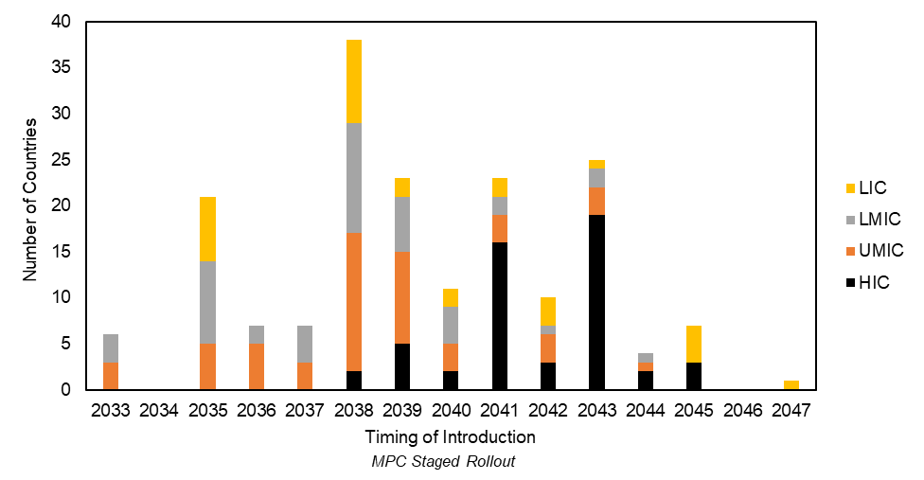
Figure S-1. Overview of timing of introduction in the public market (national immunization program; NIP), segmented by country-income level group for the MPC Staged Rollout scenario (base case timeline).
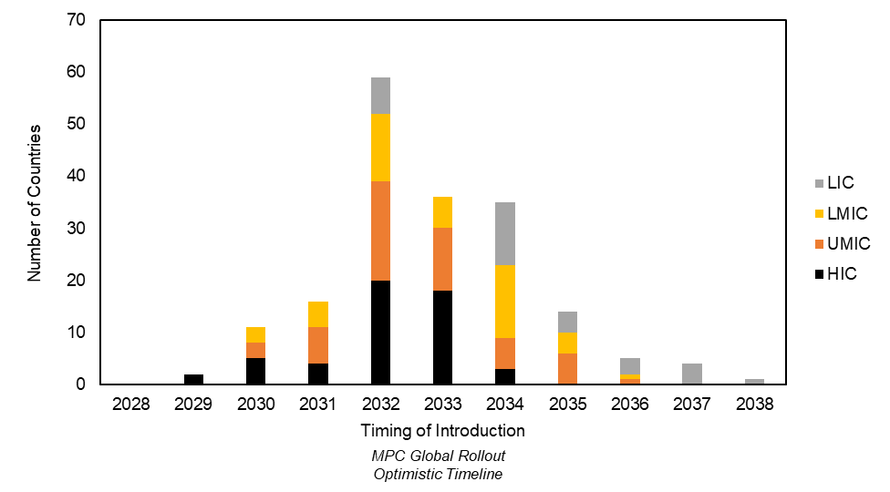
Figure S-2. Overview of timing of introduction in the public market (national immunization program; NIP), segmented by country-income level group for the MPC Global Rollout scenario under the Optimistic Timeline scenario.
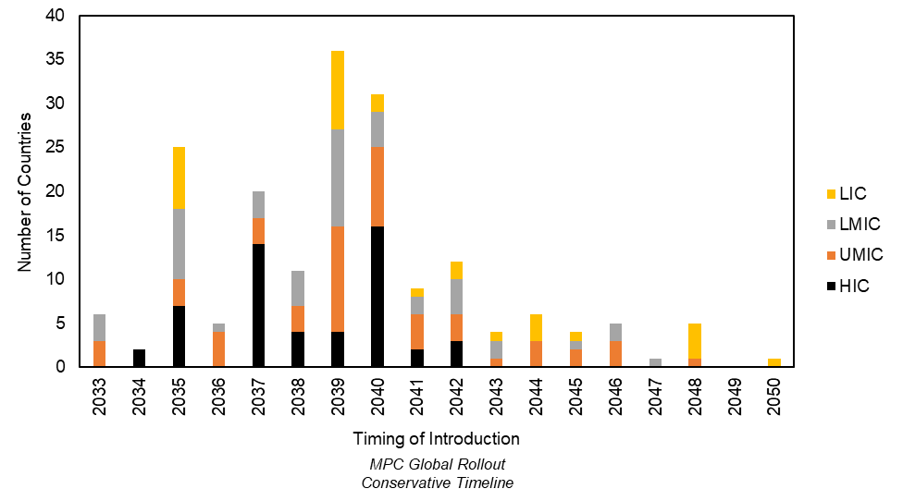
Figure S-3. Overview of timing of introduction in the public market (national immunization program; NIP), segmented by country-income level group for the MPC Global Rollout scenario under the Conservative Timeline scenario.

Demand and Financial Forecasts

Table S-2. Overview of year 12 vaccine demand and financial forecasts for the MPC Global Rollout vs. MPC Staged Rollout scenarios (infant immunization program, Base Case timeline).
 | MPC Global Rollout | MPC Staged Rollout
Year 12 Annual Demand (number of doses) | 298M | 286M
Year 12 Annual Revenue | $3.9B | $3.1B
Year 12 Annual Profit | $2.9B | $2.3
Year 12 Gross Profit Margin | 75% | 71%
Year 12 NPV | $2.5B | $1.3B

Table S-3. Overview of year 12 vaccine demand and financial forecasts for the MPC Global Rollout scenario with Base Case, Optimistic and Conservative timelines (infant immunization program).
 | Base Case Timeline | Optimistic Timeline | Conservative Timeline
Year 12 Annual Demand (number of doses) | 298M | 370M | 189M
Year 12 Annual Revenue | $3.9 | $4.4B | $2.5
Year 12 Annual Profit | $2.9 | $3.2B | $1.9B
Year 12 Gross Profit Margin | 75% | 73% | 76%
Year 12 NPV | $2.5B | $6.7B | $1.5B

