Supplemental figures:
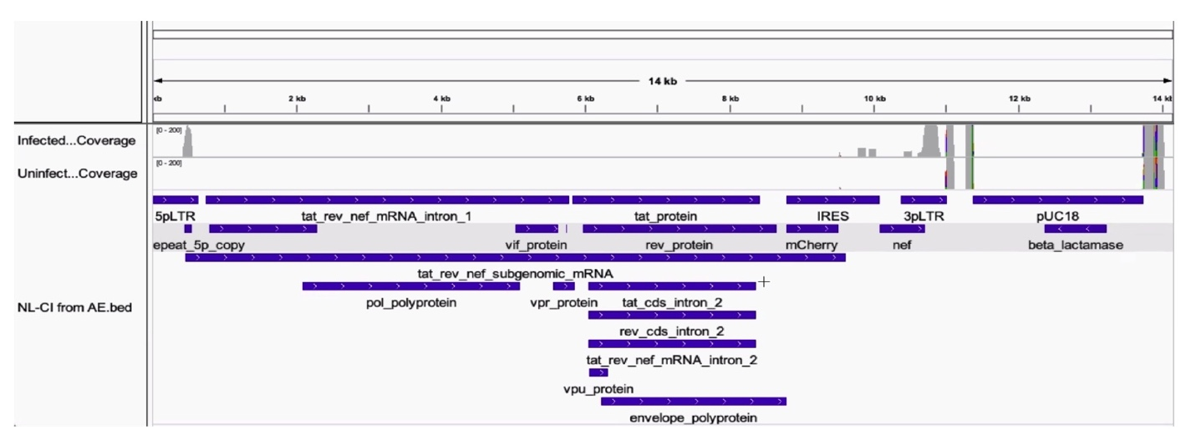
Supplemental Figure 1. The map of the HIV-1_{NL-CI} genome (61) shows that sequencing reads were aligned. Using a joint GRCh38-2020-A Human reference and a custom HIV reference whose regions with known features are marked as exonic, the pipeline grouped and de-duplicated reads mapped to the transcriptome using 10X cellular barcodes and UMIs (Unique Molecular Identifiers), and feature-barcode matrices summarize the counts.

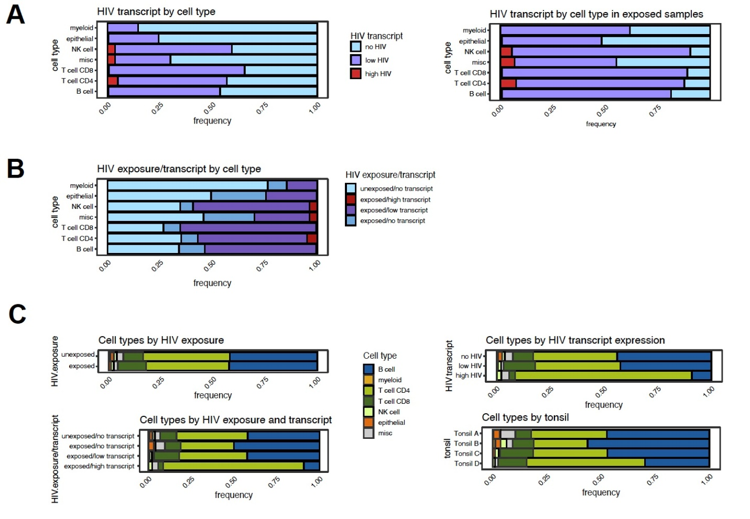

Supplemental Figure 2. Distribution of HIV exposure and transcripts by cell type. A. HIV transcripts are plotted by group (“no HIV,” “low HIV,” “high HIV”) by cell type in all conditions (left) and HIV-exposed samples (right). B. HIV exposure and transcript group by cell type. C. Cell types by HIV exposure and HIV exposure/transcript (left) and cell types by HIV transcript group and tonsil donor (right).

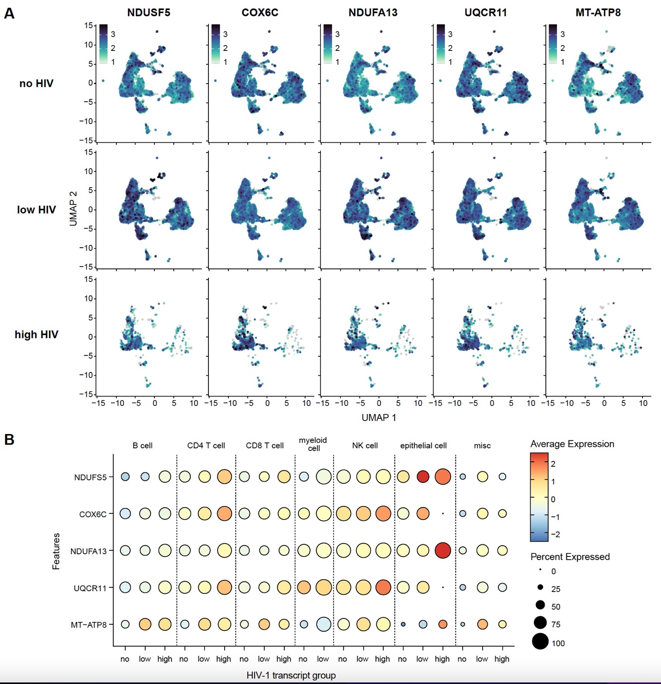

Supplemental Figure 3. Oxidative phosphorylation gene expression in cell subsets. (A) NDUFS5, COX6C, NDUFA13, UQCR11, and MT-ATP8 are expressed in UMAP embedding split by HIV transcript groups. (B) Dot plot showing HIV and oxidative phosphorylation gene expression (rows) across cell types and HIV transcript groups (columns).

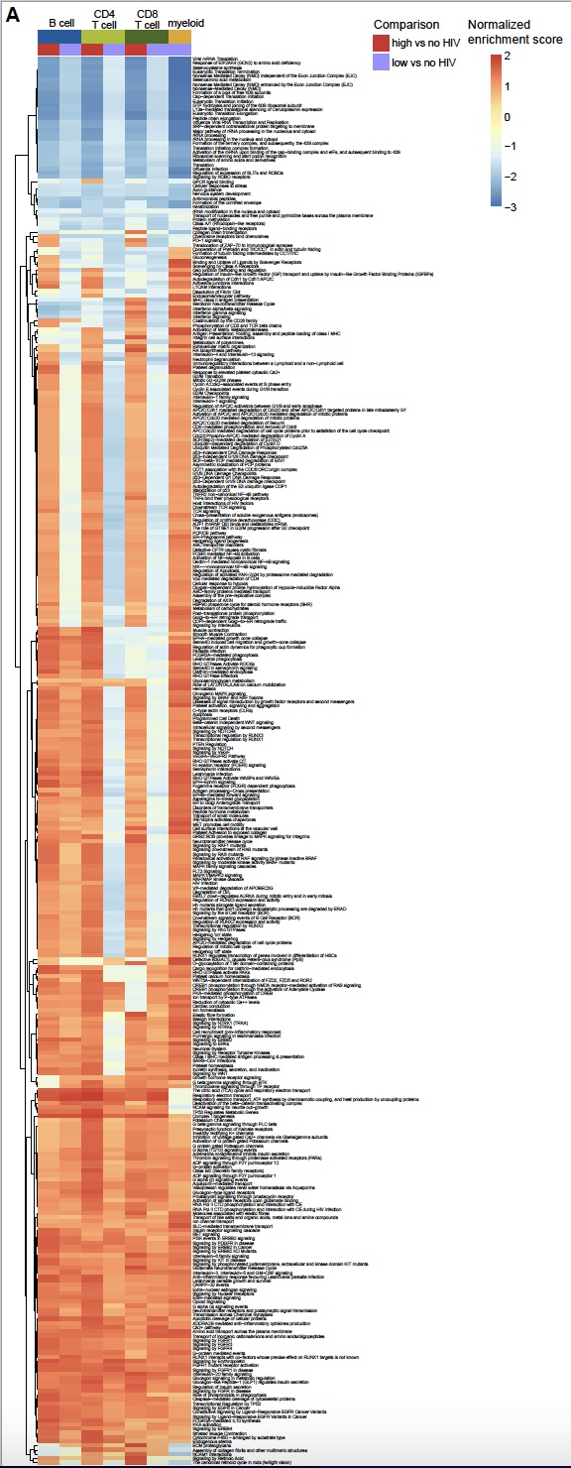
Supplemental Figure 4. Heatmap of cell types comparing pathway analysis comparing transcript groups (“high HIV” vs. “no HIV” and “low HIV” vs. “no HIV”) in each cell type with complete annotation (as shown in Figure 6G). Normalized enrichment scores are shown for the indicated pathways comparing B cells, CD4⁺ T cells, CD8⁺ T cells, and myeloid cells by comparing expression patterns in the “High vs. no HIV” (red) or “Low vs. no HIV” (purple) groups.

