Supplement: A high-quality blue whale genome, segmental duplications, and historical demography
Yury V. Bukhman*, Phillip A. Morin, Susanne Meyer, Li-Fang Chu, Jeff K. Jacobsen, Jessica Antosiewicz-Bourget, Daniel Mamott, Maylie Gonzales, Cara Argus, Jennifer Bolin, Mark E. Berres, Olivier Fedrigo, John Steill, Scott A. Swanson, Peng Jiang, Arang Rhie, Giulio Formenti, Adam M. Phillippy, Robert S. Harris, Jo Wood, Kerstin Howe, Bogdan M. Kirilenko, Chetan Munegowda, Michael Hiller, Aashish Jain, Daisuke Kihara, J. Spencer Johnston, Alexander Ionkov, Kalpana Raja, Huishi Toh, Aimee Lang, Magnus Wolf, Erich D. Jarvis, James A. Thomson*, Mark J.P. Chaisson*, Ron Stewart*

*Corresponding authors

Manual curation

A. 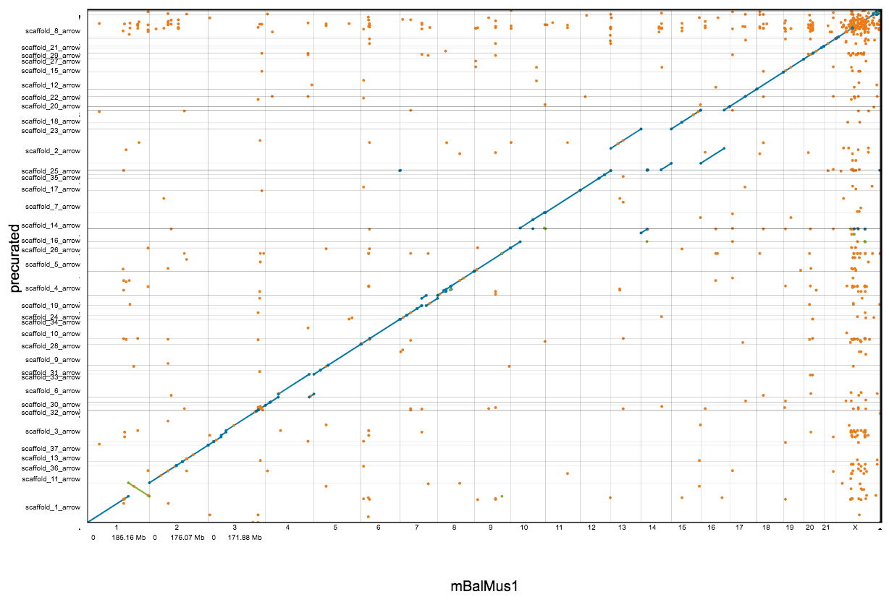
B. 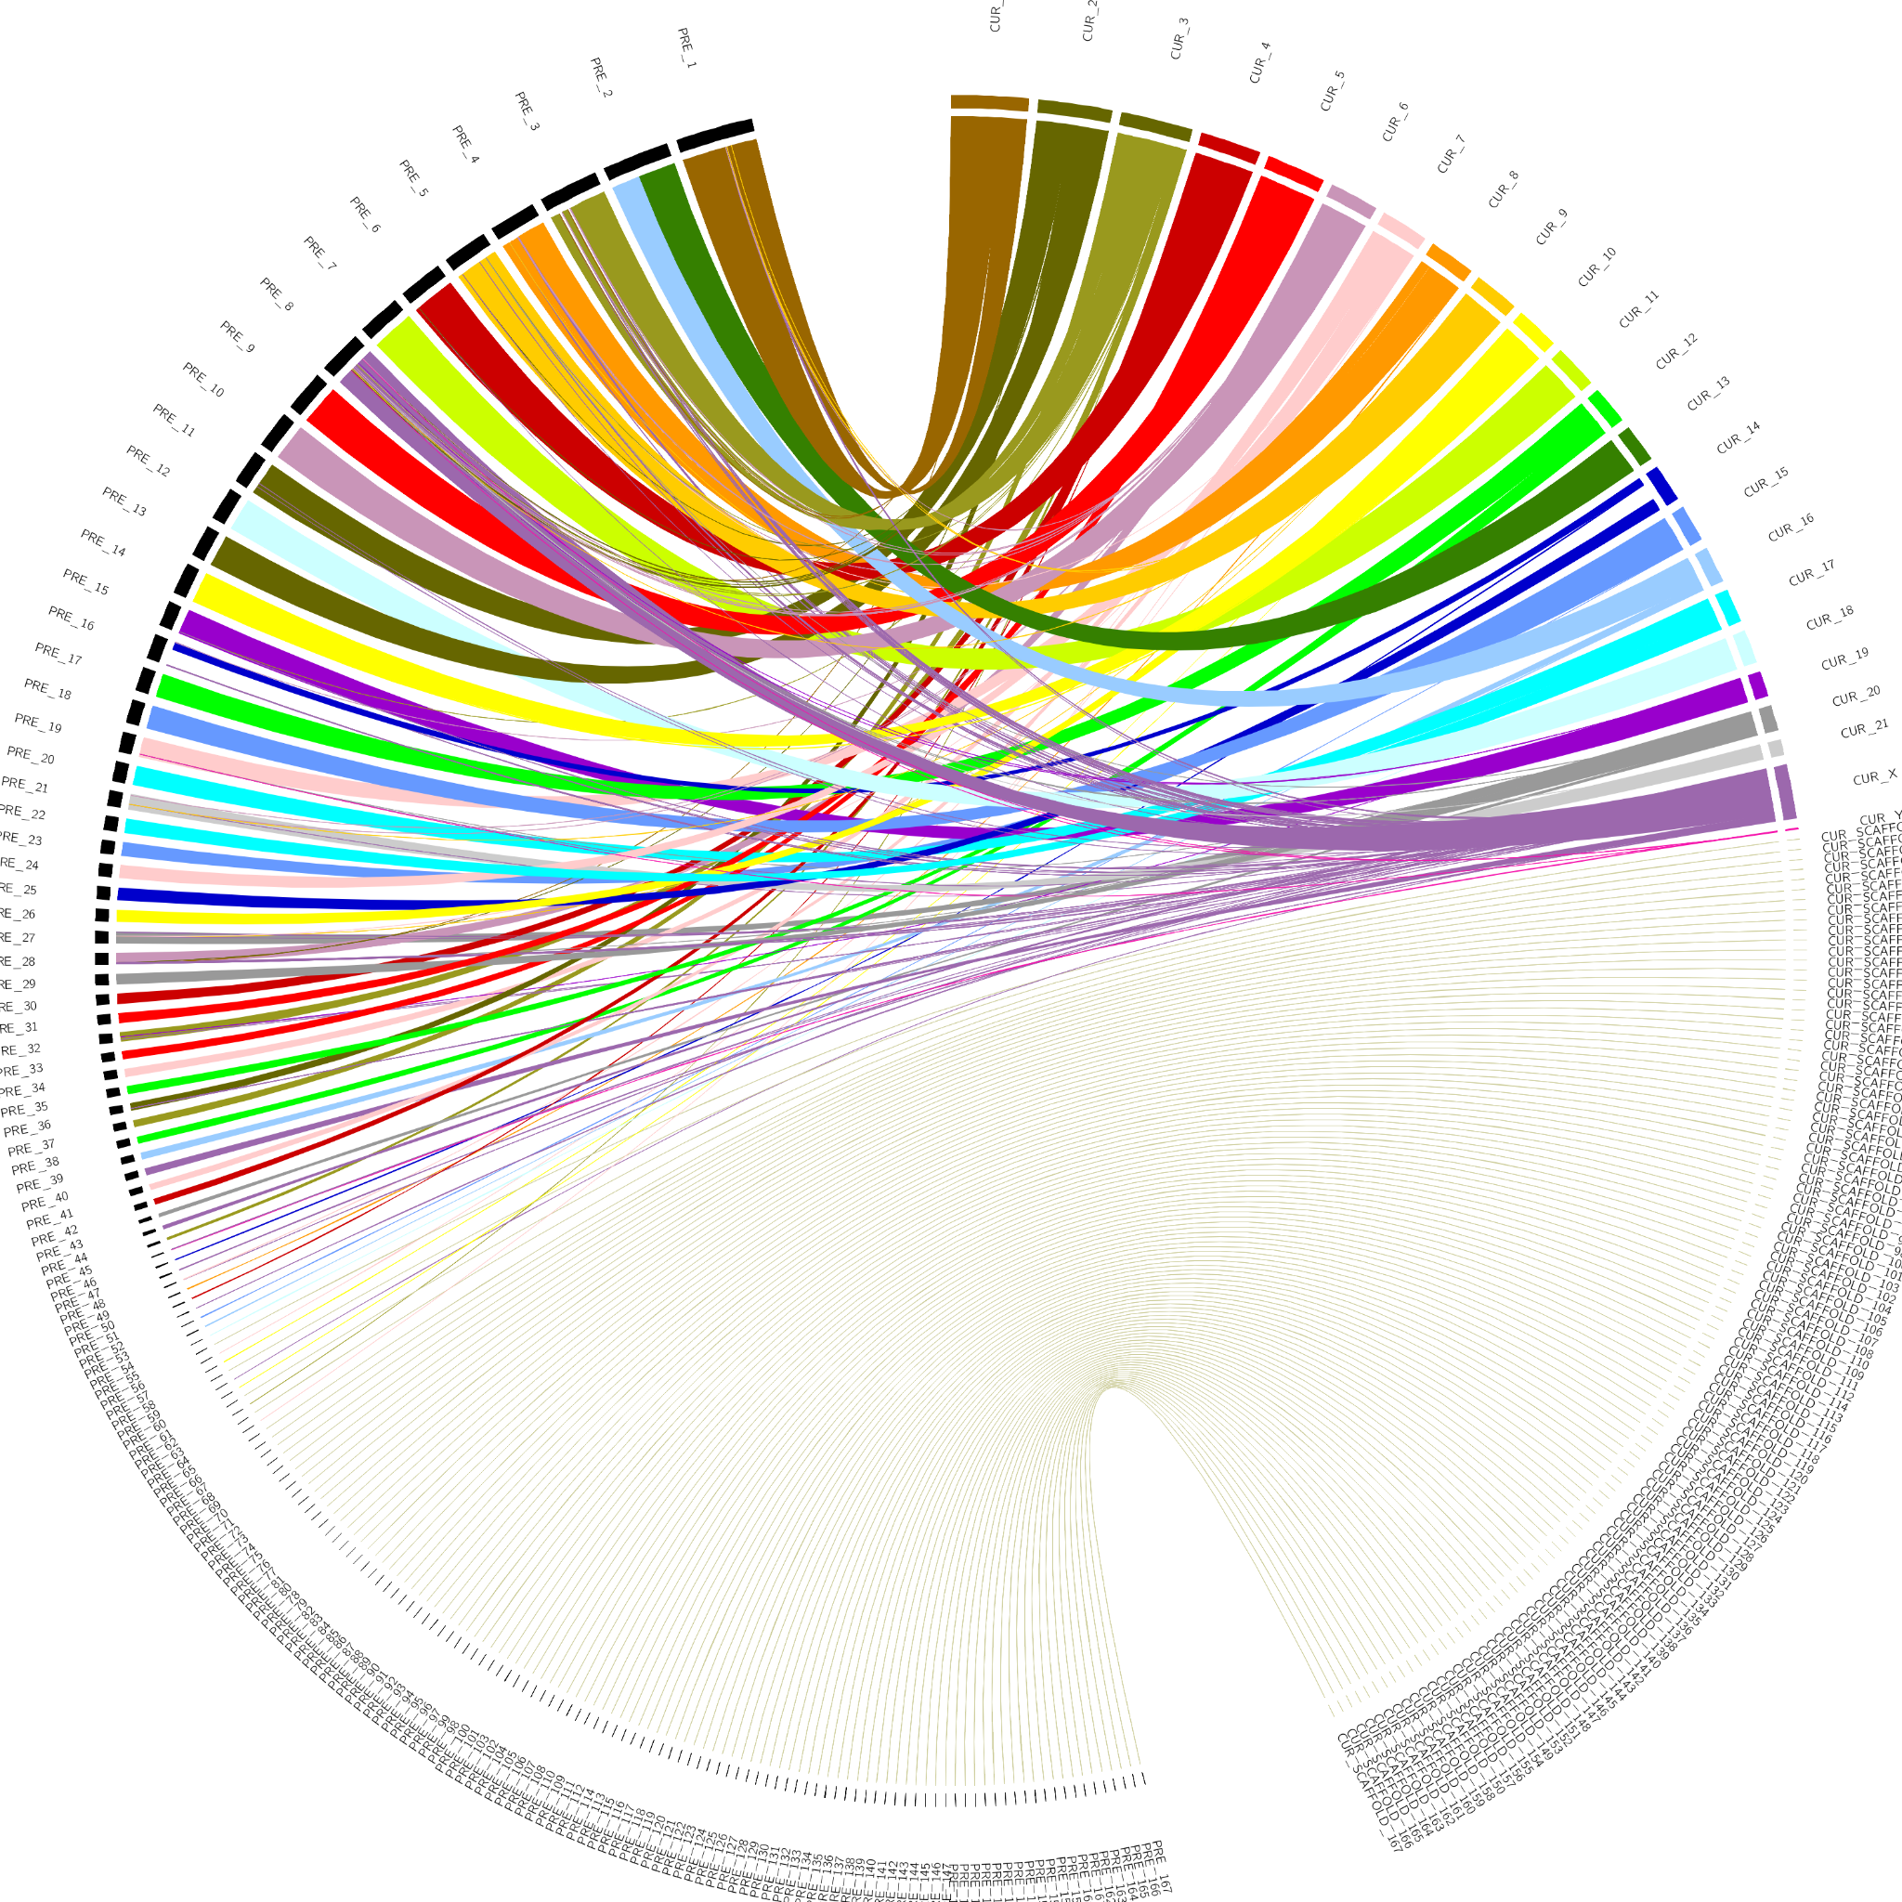
Supplementary Figure S1. Manual curation
A. Dot plot showing blue whale genome assembly before and after curation on vertical and horizontal axis respectively
B. Circos plot showing blue whale genome assembly before curation on the left and after curation on the right

Mitogenome assembly
We have assembled the blue whale mitogenome using the mitoVGP pipeline (Formenti et al. 2021; Rhie et al. 2021). This assembly is highly consistent with the Genbank reference sequence for the blue whale (MF409242.1). The two sequences have the same length (16,403 bp) with 99.76% identity, and no repeated motifs of significant length or duplicated genes are present. Differences are single or dinucleotides and can therefore be interpreted as individual SNPs. Mitos2 annotation of the mitogenome assembly generated no significant warning. The genes most affected by SNPs include the first ribosomal RNA gene (rrnS), nad2, nad5 and the control region.

Partial assembly of the Y chromosome
The blue whale whose genome is reported here is a male. However, assembling mammalian Y chromosomes is challenging due to their high repeat content and the presence of a large region of homology to the X chromosome, known as the pseudoautosomal region or PAR. We were able to identify a large, 132 MB scaffold, super-scaffold 8, as the X chromosome. Consistent with having a single copy of the X chromosome, this super-scaffold had two-fold lower coverage than most of the assembly throughout most of its length. It also had a region of normal coverage near the 5’ end, corresponding to the PAR (Supplementary Figure S2.A). The PAR tends to have normal coverage because reads from both X and Y chromosomes map to this region. Additionally, super-scaffold 8 was homologous to the human X chromosome throughout most of its length (Supplementary Figure S2.B).

Karyotyping indicated that the Y chromosome was, as expected, only a fraction of X in size (Supplementary Figure S2.C). We were initially unable to annotate it due to our inability to find a high-confidence match to the SRY gene, a widely used mammalian Y chromosome marker. SRY was, however, identified in our alternative, 10X-based assembly, where it is located on a 11.3 MB scaffold that also encompasses the PAR, as shown in Supplementary Figure S2.D-E. In the final version of our assembly, we split off a ~2.4 MB region off the 5’ end of super-scaffold 8 and designated it super-scaffold 23, a partial chromosome Y.

A. 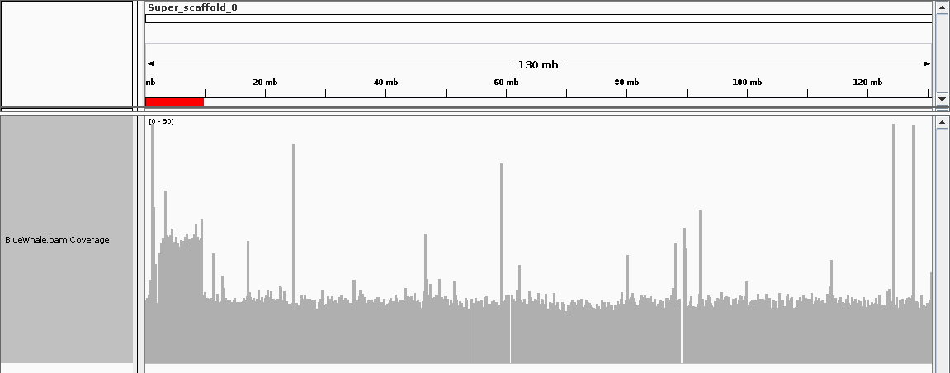 | B. 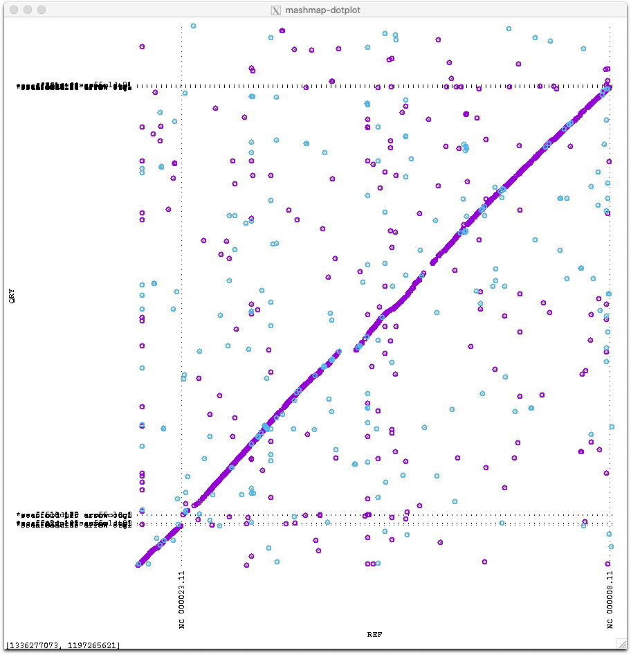
C.
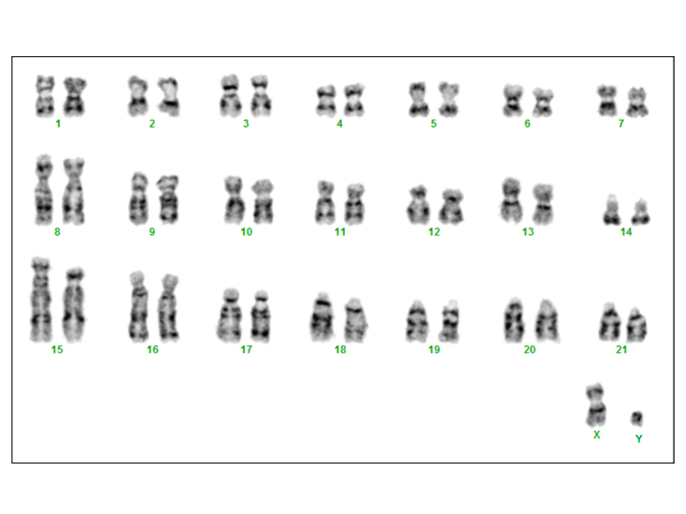
D. 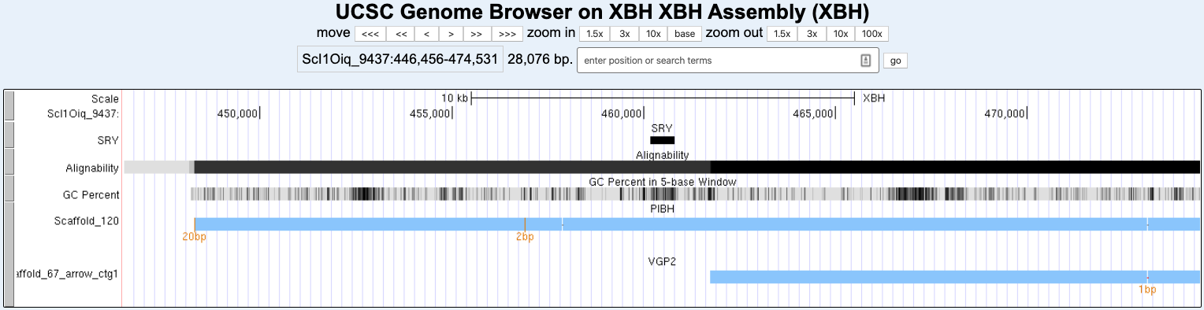 | E. 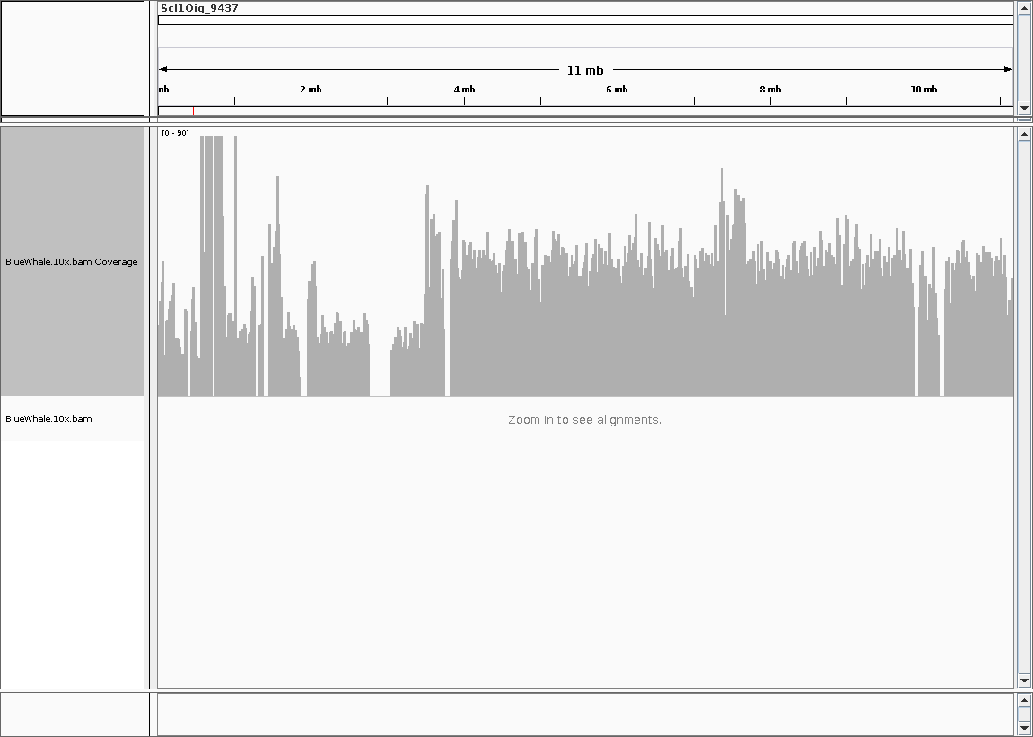
Supplementary Figure S2. Sex chromosomes.
A. Blue whale super-scaffold 8 coverage plot in IGV. The scaffold is shown before a ~2.4 MB segment was split off from the 5’ end to be designated as super-scaffold 23, the putative partial Y chromosome. A region thought to correspond to the PAR and the Y chromosome is highlighted. This region aligns to scaffold 9437 in the 10X-based assembly
B. MashMap dot plot shows that blue whale super-scaffold 8 is homologous to human X chromosome
C. Blue whale karyotype
D. Cactus alignment of 10X-based (XBH2), alternative PacBio-based (PIBH), and VGP assemblies in the region that contains SRY. XBH2 serves as the reference
E. 10X-based (XBH2) assembly scaffold 9437 coverage plot in IGV. The SRY gene is marked in red. The higher-coverage region on the right, between 3.5 and 11 Mbp, is PAR

Spurious GHR duplication in 10X-based assembly

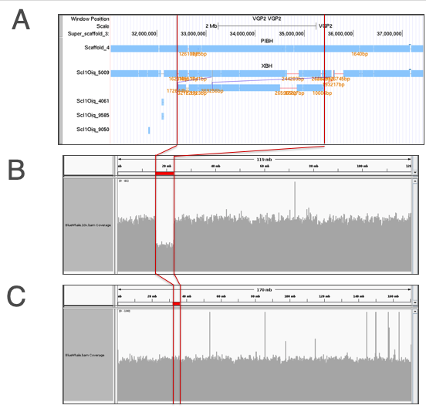
Supplementary Figure S3. Spurious duplication of the growth hormone receptor (GHR) in the 10X-based assembly
A.Cactus alignment of alternative assemblies. VGP assembly selected as reference. XBH is the 10X-based assembly. PIBH is an alternative PacBio-based draft assembly
B.10X-based assembly (XBH) scaffold 5009 coverage plot. Duplicated region is highlighted
C.VGP assembly super-scaffold 3 coverage plot. Highlighted region aligns to XBH2 duplication

Genome size

A.
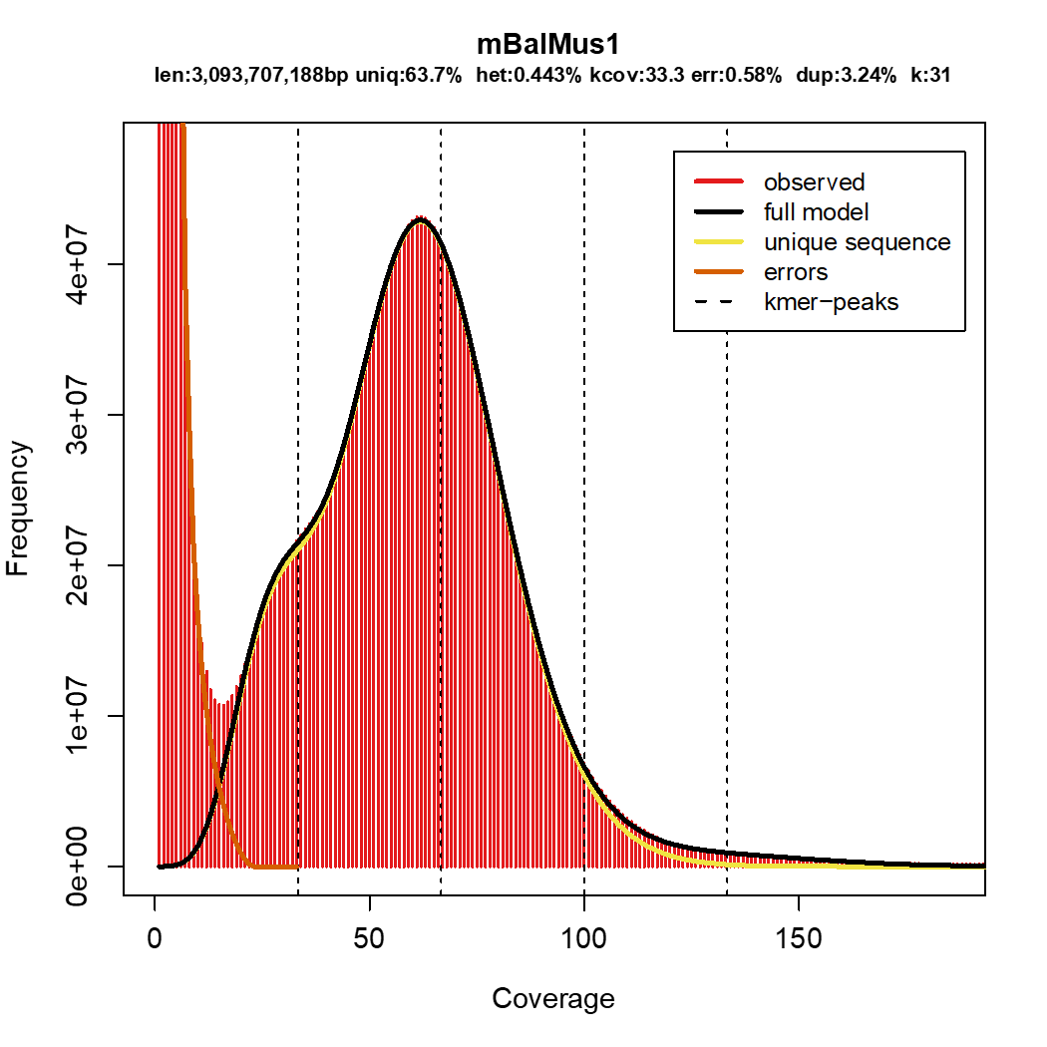
B.
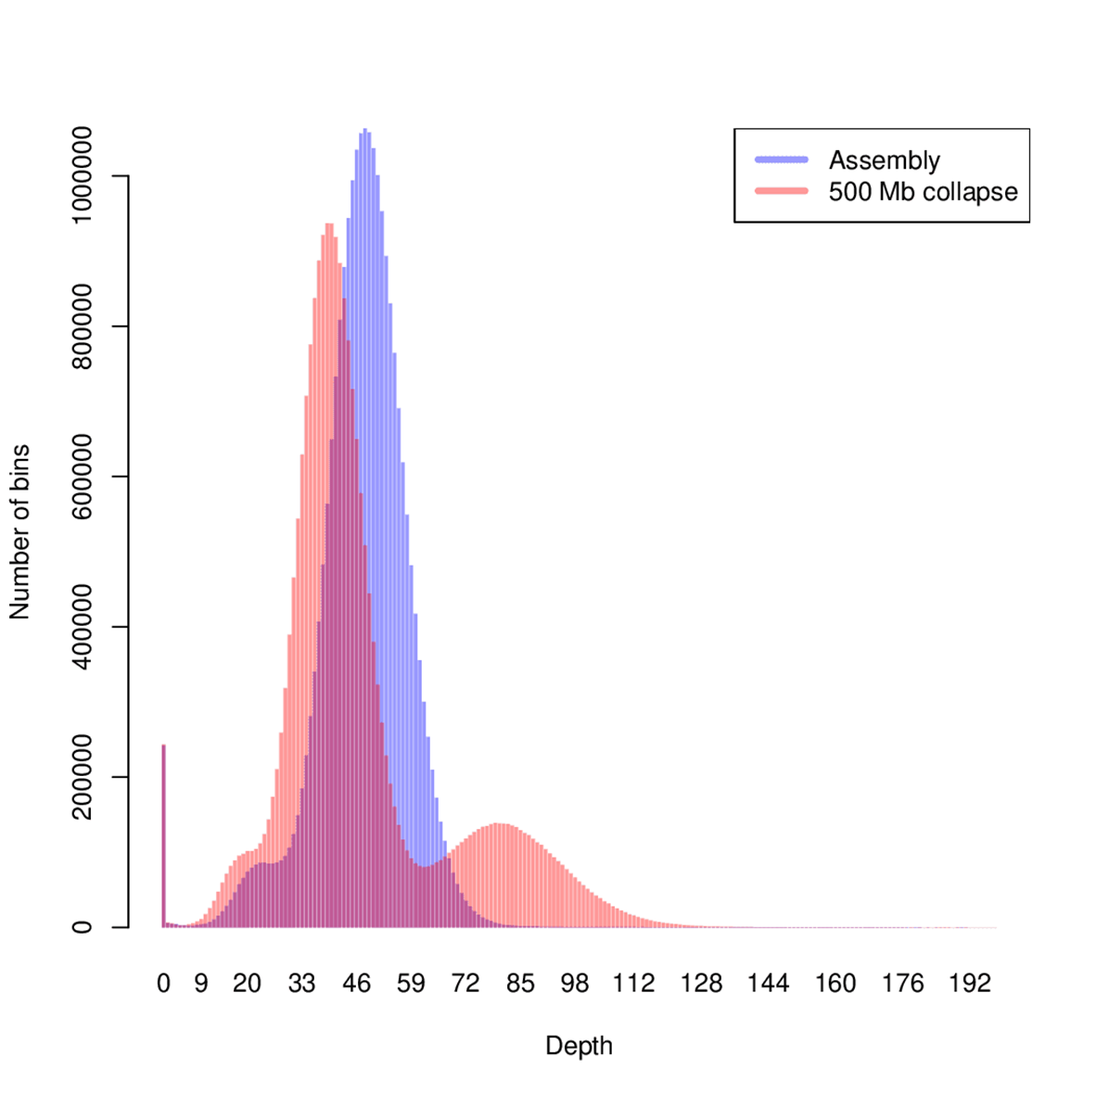
C.
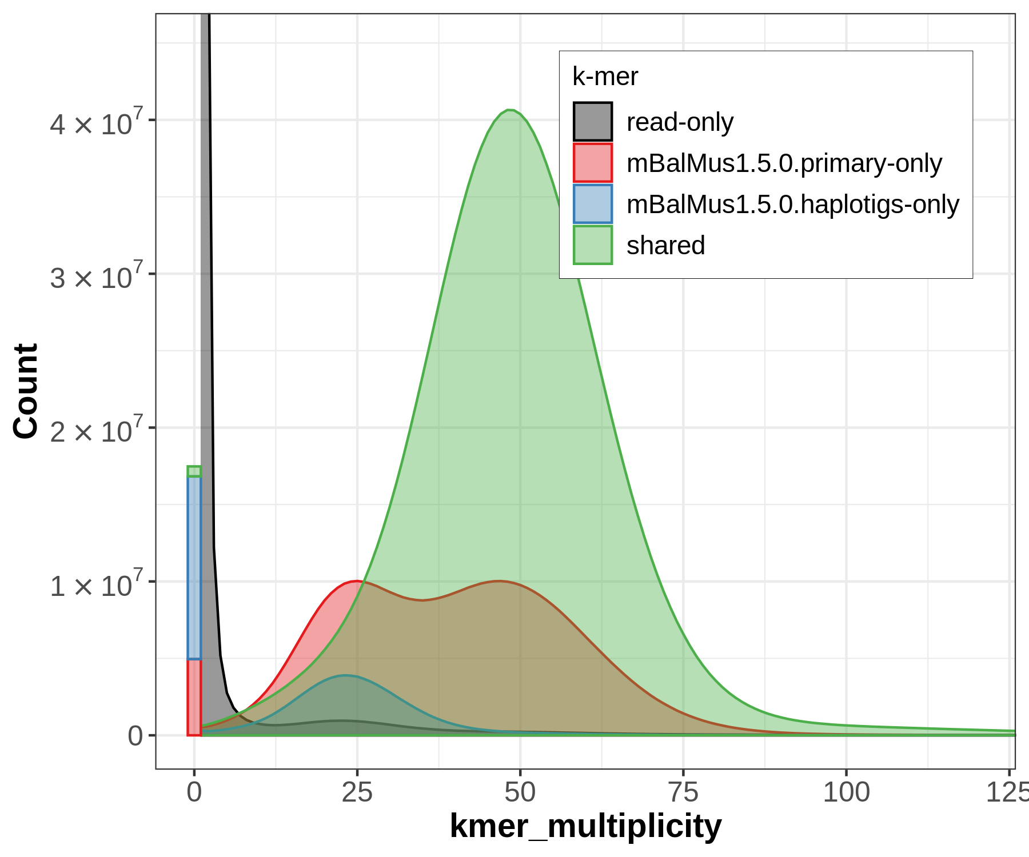
Supplementary Figure S4. Genome size
A. 31-mer frequency plot and GenomeScope model
B. Effect of a simulated 500 MB collapsed duplication on read depth histogram. The histogram without the simulated collapsed duplication is shown in blue and with it in red.
C. K-mer spectra plot generated by the merqury software (Rhie et al. 2020)

Segmental duplications

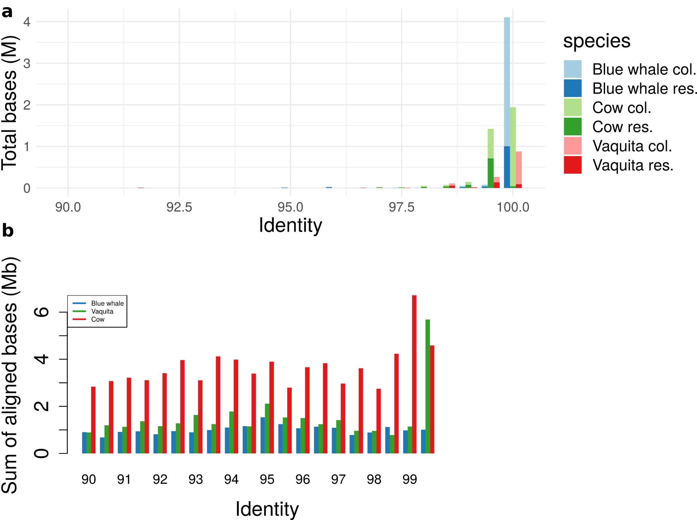
Supplementary Figure S5. Segmental duplications. The segmental duplications were measured by the total amount of duplicated bases overlapping coding sequences (a) and according to the segmental duplication detection software sedef (b). When considering resolved duplications (b), there is an increase in number of duplications in recent history in both cow and vaquita. However, when considering duplicated genes that are collapsed in any assembly and inferred by read depth, there is a roughly two-fold increase in number of duplicated bases in blue whale compared to vaquita, and four-fold compared to cow. This indicates a large recent burst in duplicated genes in blue whale, even if they are not entirely resolved in the assembly.

XRCC1 read coverage

A. 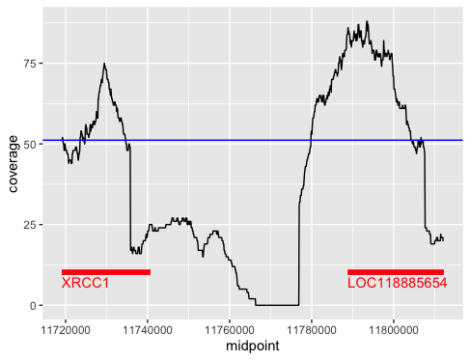 | B. 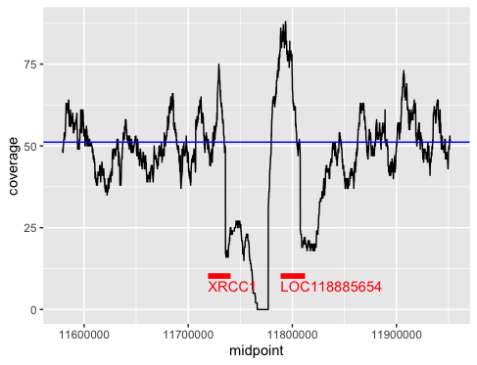
C. 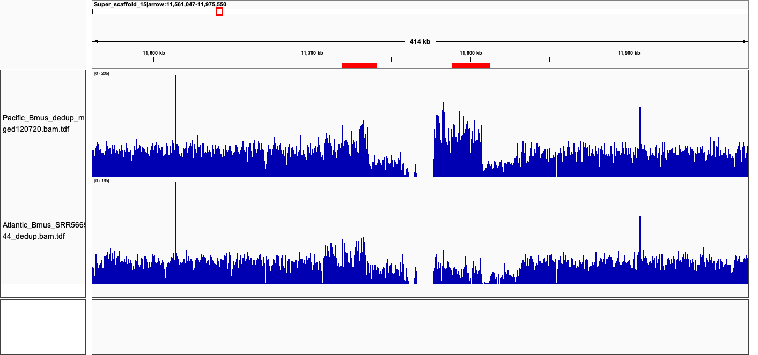
Supplementary Figure S6. XRCC1 read coverage. A. Binned PacBio coverage data. B. Same as A, zoomed-out. C. Illumina coverage data in the Pacific blue whale from this study (top) and Atlantic from (Árnason et al. 2018) (bottom), computed using igvtools and visualized in IGV (Robinson et al. 2011)

Synteny dot plots of CDK20 and CHRNB1 in blue whale vs. vaquita

A.
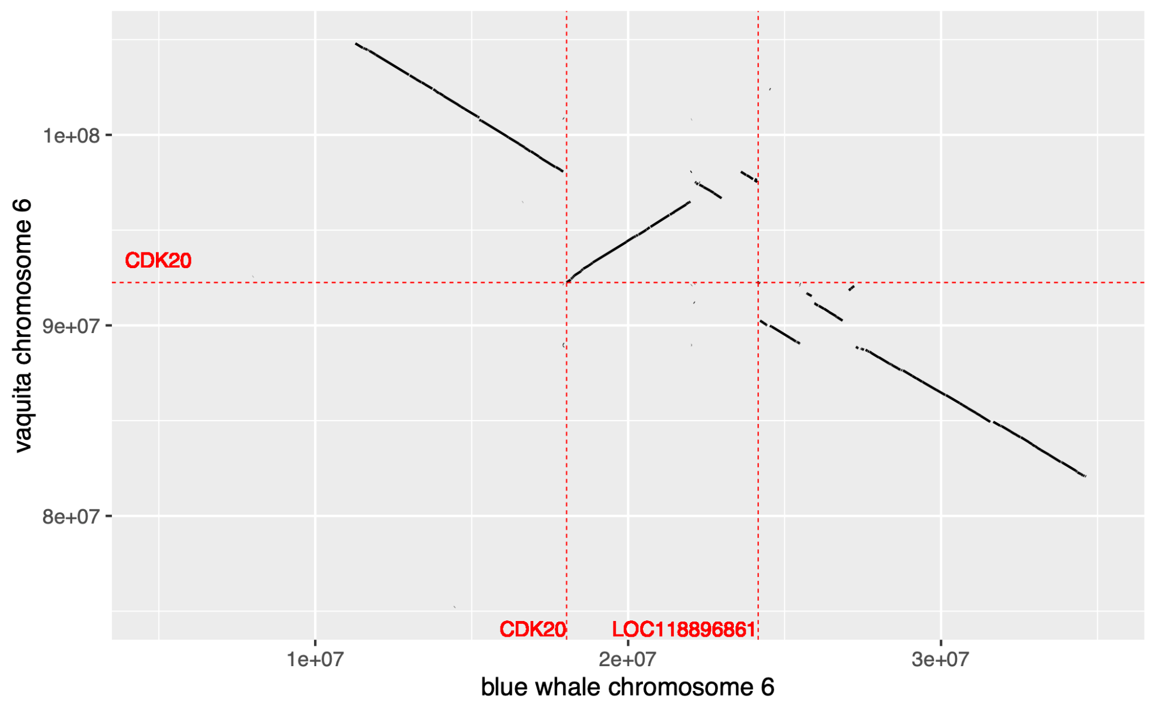
B.
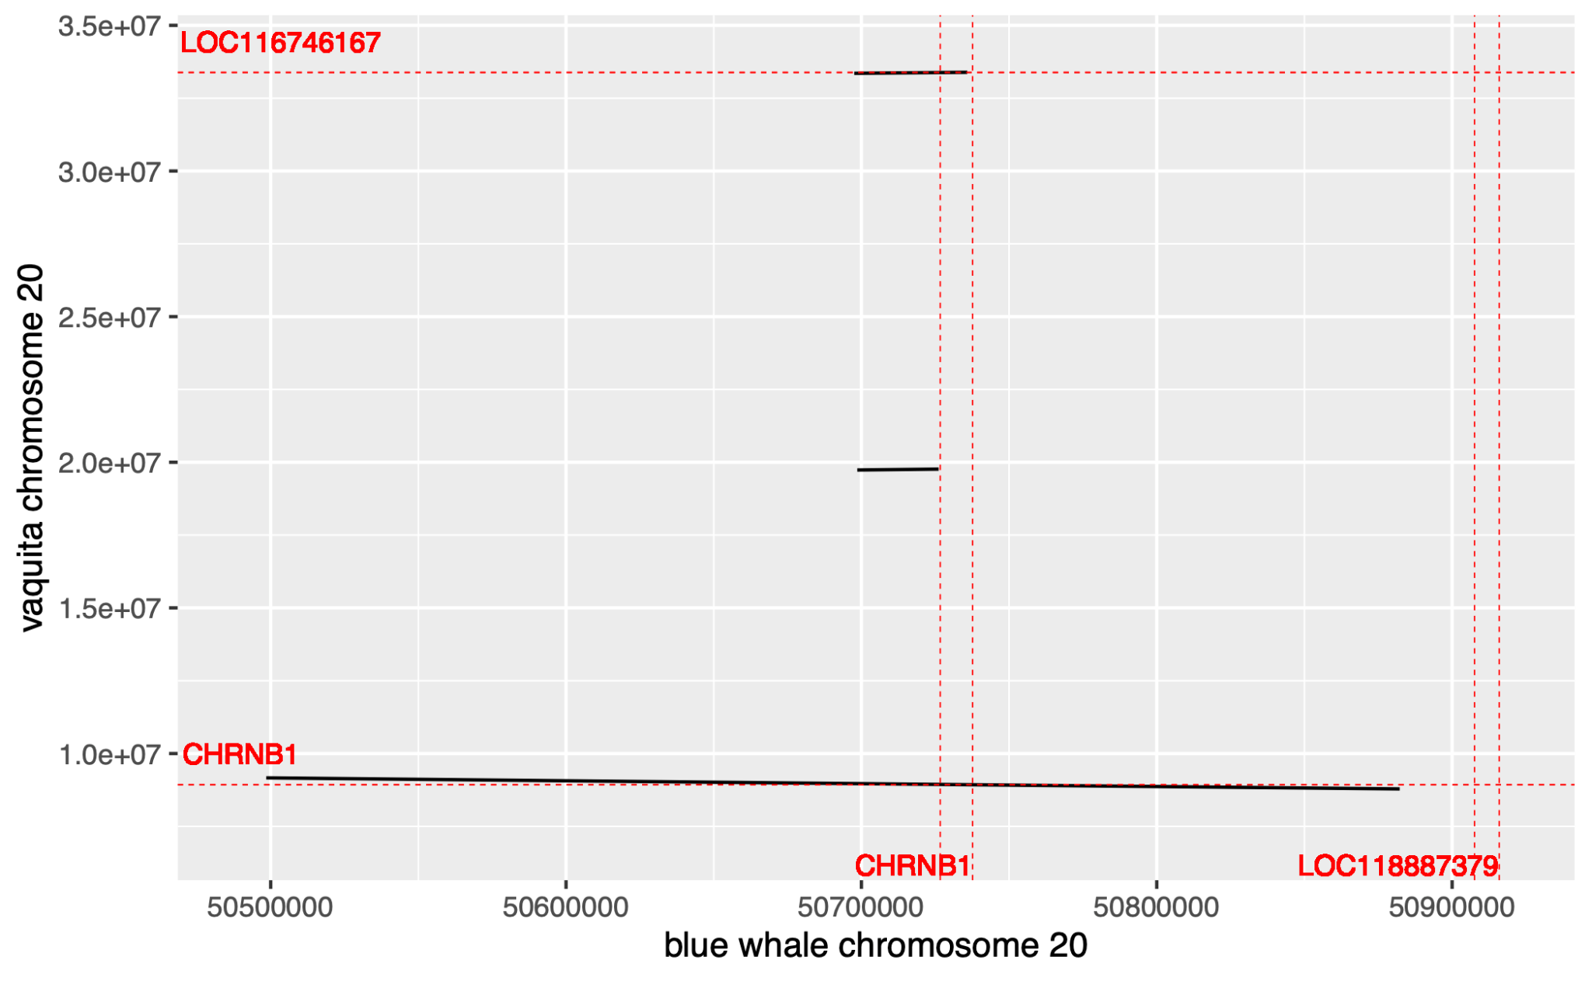
Supplementary Figure S7. Synteny dot plots of example genes. A. A synteny plot of the genomic regions containing CDK20 in blue whale and vaquita. Locations of CDK20 genes are marked by dashed red lines. B. A synteny plot of genomic regions containing CHRNB1 in blue whale and vaquita. 5′ and 3′ ends of CHRNB1 genes are marked by dashed red lines. The starts and ends of the two genes can be distinguished in blue whale, but not vaquita, due to the two copies’ close proximity in the former and a large distance between them in the latter

Population history supplementary figures

A.
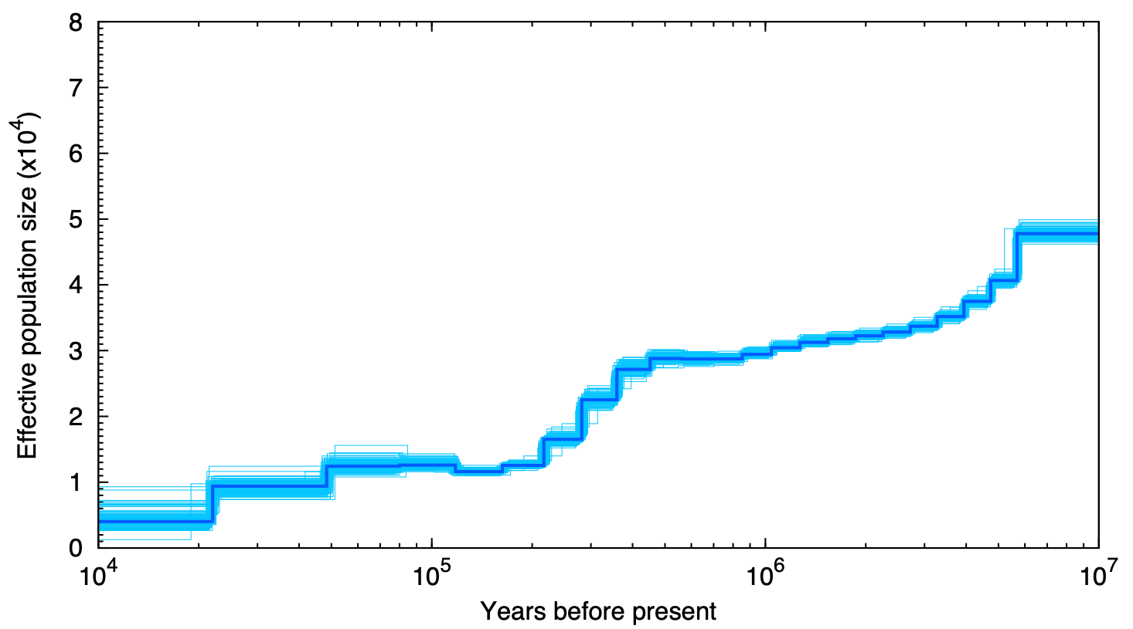
B.
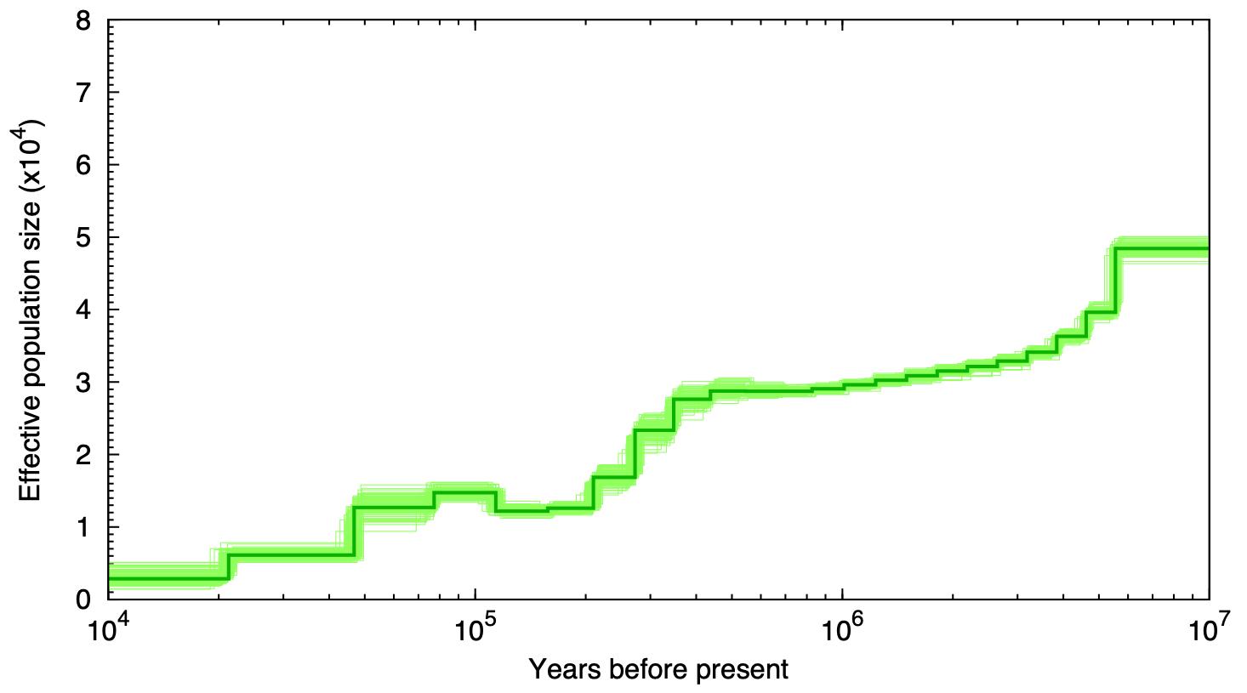
Supplementary Figure S8. Individual PSMC plots for Pacific and Atlantic blue whales. Short read data mapped to the reference genome, and repeats masked. 100 bootstrapped plots included. The generation time for blue whale (30.8 years) was used with the average substitution rate for mysticetes (1.58E-08 substitutions/site/generation; Jackson et al., 2009). A. Pacific (PSMC atomic intervals: all intervals >10). B. Atlantic (PSMC atomic intervals: intervals 62-63 <10 (7.4, 5.9))

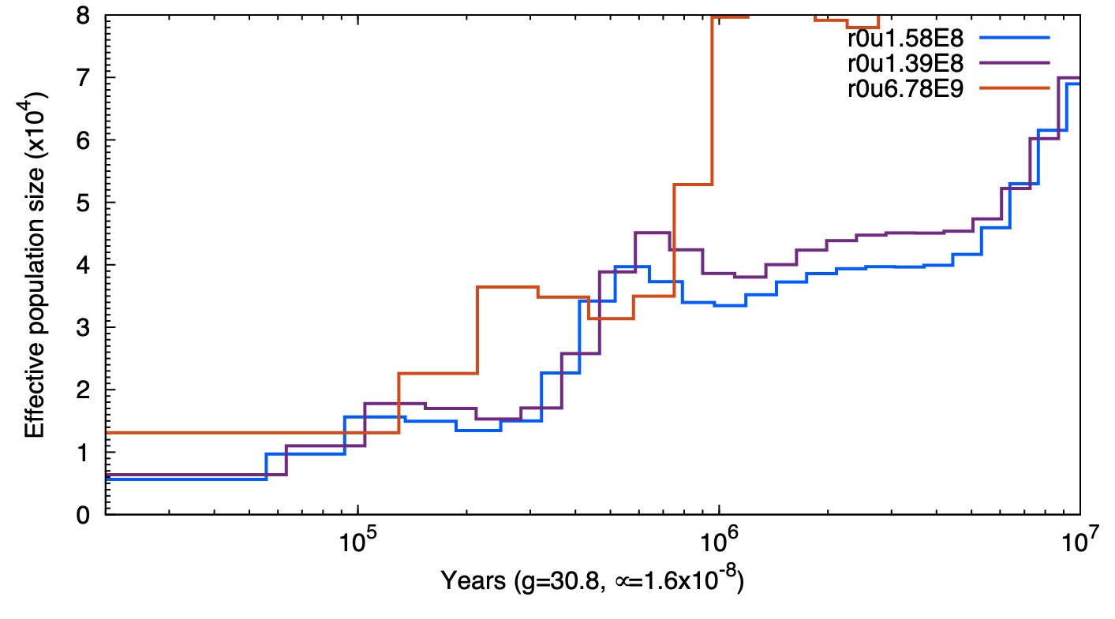
Supplementary Figure S9. Effect of different mutation rates on plot of PSMC results. The mutation rates used were the mean value for mysticetes from (Jackson et al. 2009) (1.5878E-08 substitutions/site/generation); the lowest rate from (Jackson et al. 2009), used by (Árnason et al. 2018) (1.3978E-08 substitutions/site/generation); and the mean rate for mysticetes as determined by (Dornburg et al. 2012) (6.78E-09 substitutions/site/generation). The slower mutation rates have the result of shifting the plot to the right (older) and up (larger population sizes).

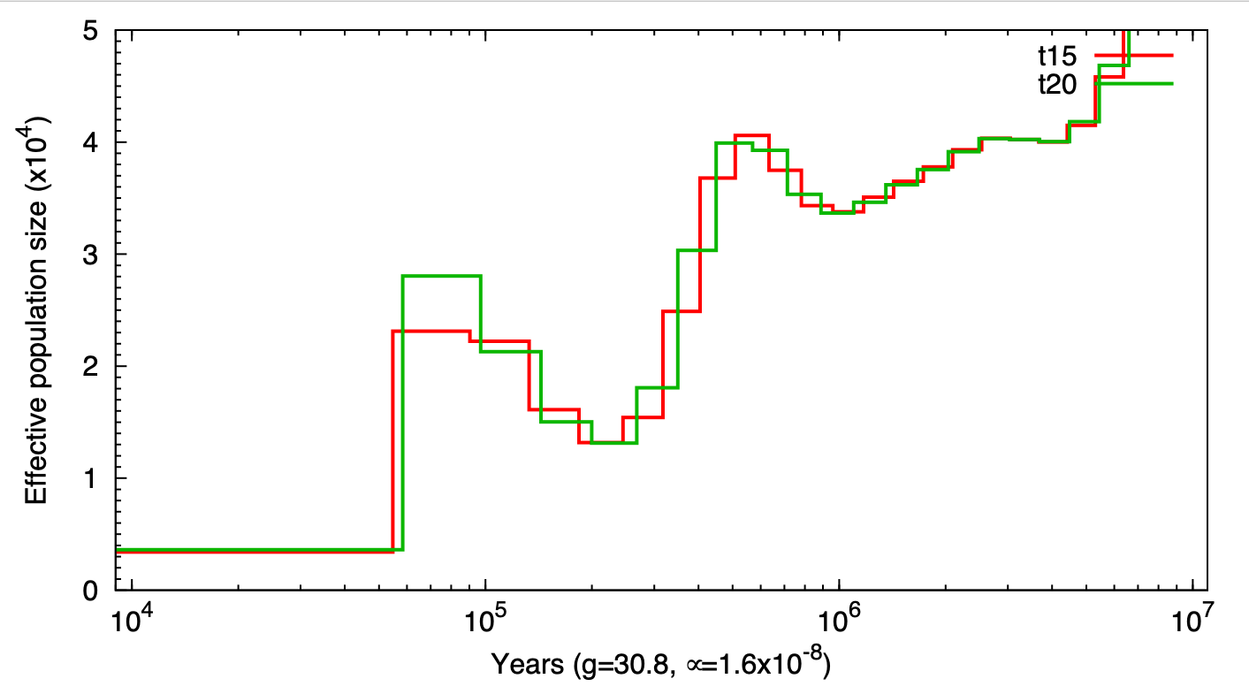
Supplementary Figure S10. Effect of different maximum coalescent times (15 vs. 20) on plot of PSMC results (for Atlantic blue whale).

References
Árnason, Úlfur, Fritjof Lammers, Vikas Kumar, Maria A. Nilsson, and Axel Janke. 2018. “Whole-Genome Sequencing of the Blue Whale and Other Rorquals Finds Signatures for Introgressive Gene Flow.” Science Advances 4 (4): eaap9873. https://doi.org/10.1126/sciadv.aap9873.
Dornburg, Alex, Matthew C. Brandley, Michael R. McGowen, and Thomas J. Near. 2012. “Relaxed Clocks and Inferences of Heterogeneous Patterns of Nucleotide Substitution and Divergence Time Estimates across Whales and Dolphins (Mammalia: Cetacea).” Molecular Biology and Evolution 29 (2): 721–36. https://doi.org/10.1093/molbev/msr228.
Formenti, Giulio, Arang Rhie, Jennifer Balacco, Bettina Haase, Jacquelyn Mountcastle, Olivier Fedrigo, Samara Brown, et al. 2021. “Complete Vertebrate Mitogenomes Reveal Widespread Repeats and Gene Duplications.” Genome Biology 22 (1): 120. https://doi.org/10.1186/s13059-021-02336-9.
Jackson, J. A., C. S. Baker, M. Vant, D. J. Steel, L. Medrano-González, and S. R. Palumbi. 2009. “Big and Slow: Phylogenetic Estimates of Molecular Evolution in Baleen Whales (Suborder Mysticeti).” Molecular Biology and Evolution 26 (11): 2427–40. https://doi.org/10.1093/molbev/msp169.
Rhie, Arang, Shane A. McCarthy, Olivier Fedrigo, Joana Damas, Giulio Formenti, Sergey Koren, Marcela Uliano-Silva, et al. 2021. “Towards Complete and Error-Free Genome Assemblies of All Vertebrate Species.” Nature 592 (7856): 737–46. https://doi.org/10.1038/s41586-021-03451-0.
Rhie, Arang, Brian P. Walenz, Sergey Koren, and Adam M. Phillippy. 2020. “Merqury: Reference-Free Quality, Completeness, and Phasing Assessment for Genome Assemblies.” Genome Biology 21 (1): 245. https://doi.org/10.1186/s13059-020-02134-9.
Robinson, James T., Helga Thorvaldsdóttir, Wendy Winckler, Mitchell Guttman, Eric S. Lander, Gad Getz, and Jill P. Mesirov. 2011. “Integrative Genomics Viewer.” Nature Biotechnology 29 (1): 24–26. https://doi.org/10.1038/nbt.1754.

