A novel bacterial β-N-acetyl glucosaminidase from Chitinolyticbacter meiyuanensis possessing transglycosylation and reverse hydrolysis activities
Alei Zhang, Xiaofang Mo, Ning Zhou, Yingying Wang, Guoguang Wei, Jie Chen, Kequan Chen*, Pingkai Ouyang
State Key Laboratory of Materials-Oriented Chemical Engineering, College of Biotechnology and Pharmaceutical Engineering, Nanjing Tech University, Nanjing, 211800, P.R. China
*Corresponding author: Tel.: +86-138-1418-0652
E-mail address: kqchen@njtech.edu.cn

Table S1 Strains, plasmids, and primers used in this study
Strain, plasmid,  or primer | Descriptionª | Source
Strains  E.coli DH5α  E.coli BL21(DE3)  Strain SYBC-H1 | ϕ80dlacZΔM15 Δ(lacZY-argF)U169 deoR recA1 endA1 hsdR17(r_{k}⁻ m_{k}⁺) supE44 thi-1 gyrA96 relA1  F⁻ ompT hsdS_{B}(r_{B}⁻m_{B}⁻) gal dcm (DE3)  Wild type, isolated from soil | Invitrogen  Novagen  This study
Plasmids  pMD19-T simple  pET28a(+)  pMD19-CmNAGase  pET28a(+)-CmNAGase | E.coli cloning vector; Amp^{r}  E.coli expression vector,T7 RNA polymerase gene promoter and terminator; Kan^{r}  pMD19-T simple derivate, containing the CmNAGase gene from SYBC-H1 strain  7.1-kb pET28a(+) derivate carrying the CmNAGase gene | TaKaRa  Novagen  This study  This study
Primers  F1  R1 | GAATTCCATATGATGAGCCGTCCCGCCGGATC  TCCGCTCGAGTCAGGCGCCCACCTGCACCG
ªUnderlined sequences within the primers are the NdeI and XhoI restriction sites. Amp^{r}, ampicillin resistance; Kan^{r}, kanamycin resistance.

Table S2 Purification of recombinant CmNAGase.
Purification method | Total activity  (U) | Total protein  (mg) | Specific activity (U/mg) | Purification (fold) | Recovery yield (%)
Crude enzyme | 60,604.2 | 19.2 | 3,156.5 | 0 | 100
Ni–NTA resin | 48,786.4 | 10.4 | 4,878.6 | 1.5 | 80.5

Table S3 Half-lives of recombinant CmNAGase.

Temperature (ºC) | Half-life (h)
 | 13.0 ± 0.82
  30
 | 9.5 ± 0.35
  35
40 | 6.3 ± 0.39
 | 0.6 ± 0.01
  45
Fig. S1 Multiple alignments of the catalytic domain in CmNAGase with other GH20 NAGases from different sources. Similar sequences are marked by boxes and identical sequences are highlighted in red and yellow. The H/N-X-A/C/G/M-D-E-A/I/L/V motifs are marked with a black box. The conserved substrate binding and catalytic residues are marked with a red hashtag. Secondary structural elements (i.e., alpha helix [α], beta sheet [β], random coil [ƞ], and beta turn [T]) are marked on the CmNAGase sequence. WP_018749679: NAGase from Chitiniphilus shinanonensis (WP_018749679); BAA92145: NAGase from Aeromonas sp. 10S-24 (accession no. BAA92145); 1C7T_A : NAGase from Serratia marcescens (PDB no. 1C7T_A); P13670: NAGase from Vibrio harveyi (accession no. P13670); NP_719056: NAGase from Shewanella oneidensis MR-1 (accession no. NP 719056); BAB17855: NAGase from Alteromonas sp. O-7 (accession no. BAB17855); YP_444514: NAGase from Salinibacter ruber DSM 13855 (accession no. YP_444514); ZP_01460692 NAGase from Stigmatella aurantiaca DW4/3-1.

Fig. S2 The domain and structure prediction of CmNAGase. a) The conserved domain of CmNAGase. b) The prediction of the 3D structure of CmNAGase. Yellow color, CHB_HEX domain; Blue color, Glyco_hydro_20b domain; Green color, Glyco_hydro_20 domain; Red color, CHB_HEX C_1 domain; Gray color, unknow region. c) The active sites of CmNAGase. D508 and E509 were the active residues.

Fig. S3 SDS-PAGE analysis of recombinant CmNAGase. Lane M, protein molecular mass maker; lane 1 and lane 2, 20 μg and 60 μg of soluble protein extracted from E. coli cells overexpressing His6-CmNAGase; lane 3, 40 μg of CmNAGase purified by His6-tag affinity chromatography.

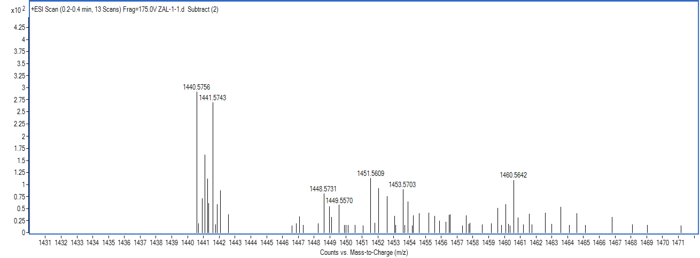
Fig. S4 Mass spectrum of new peak (~16.0 min) after (GlcNAc)₆ in HPLC spectra.

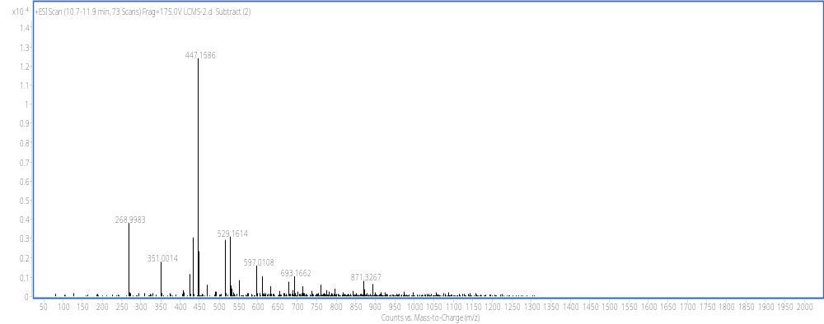
Fig. S5 Mass spectrum of peak 2 (~10.9 min) in HPLC spectra.

