Plant Growth Regulation Online Resources.
Differential gene expression analysis of the resprouting process in Pinus canariensis provides new insights into a rare trait in conifers.
Authors: Víctor Chano, Oliver Gailing, Carmen Collada, Álvaro Soto
The following Electronic Supplementary Material is available for this article:
- Online Resource Figure S1. Description of the sample collection. a) R0, b) R1 and c) R2.
- Online Resource Figure S2. Distribution of GO terms associated to resprouting DEGs.

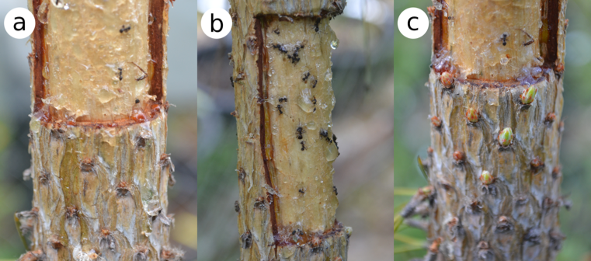
Online Resource Figure S1. Description of the sample collection. a) R0, b) R1 and c) R2.
.
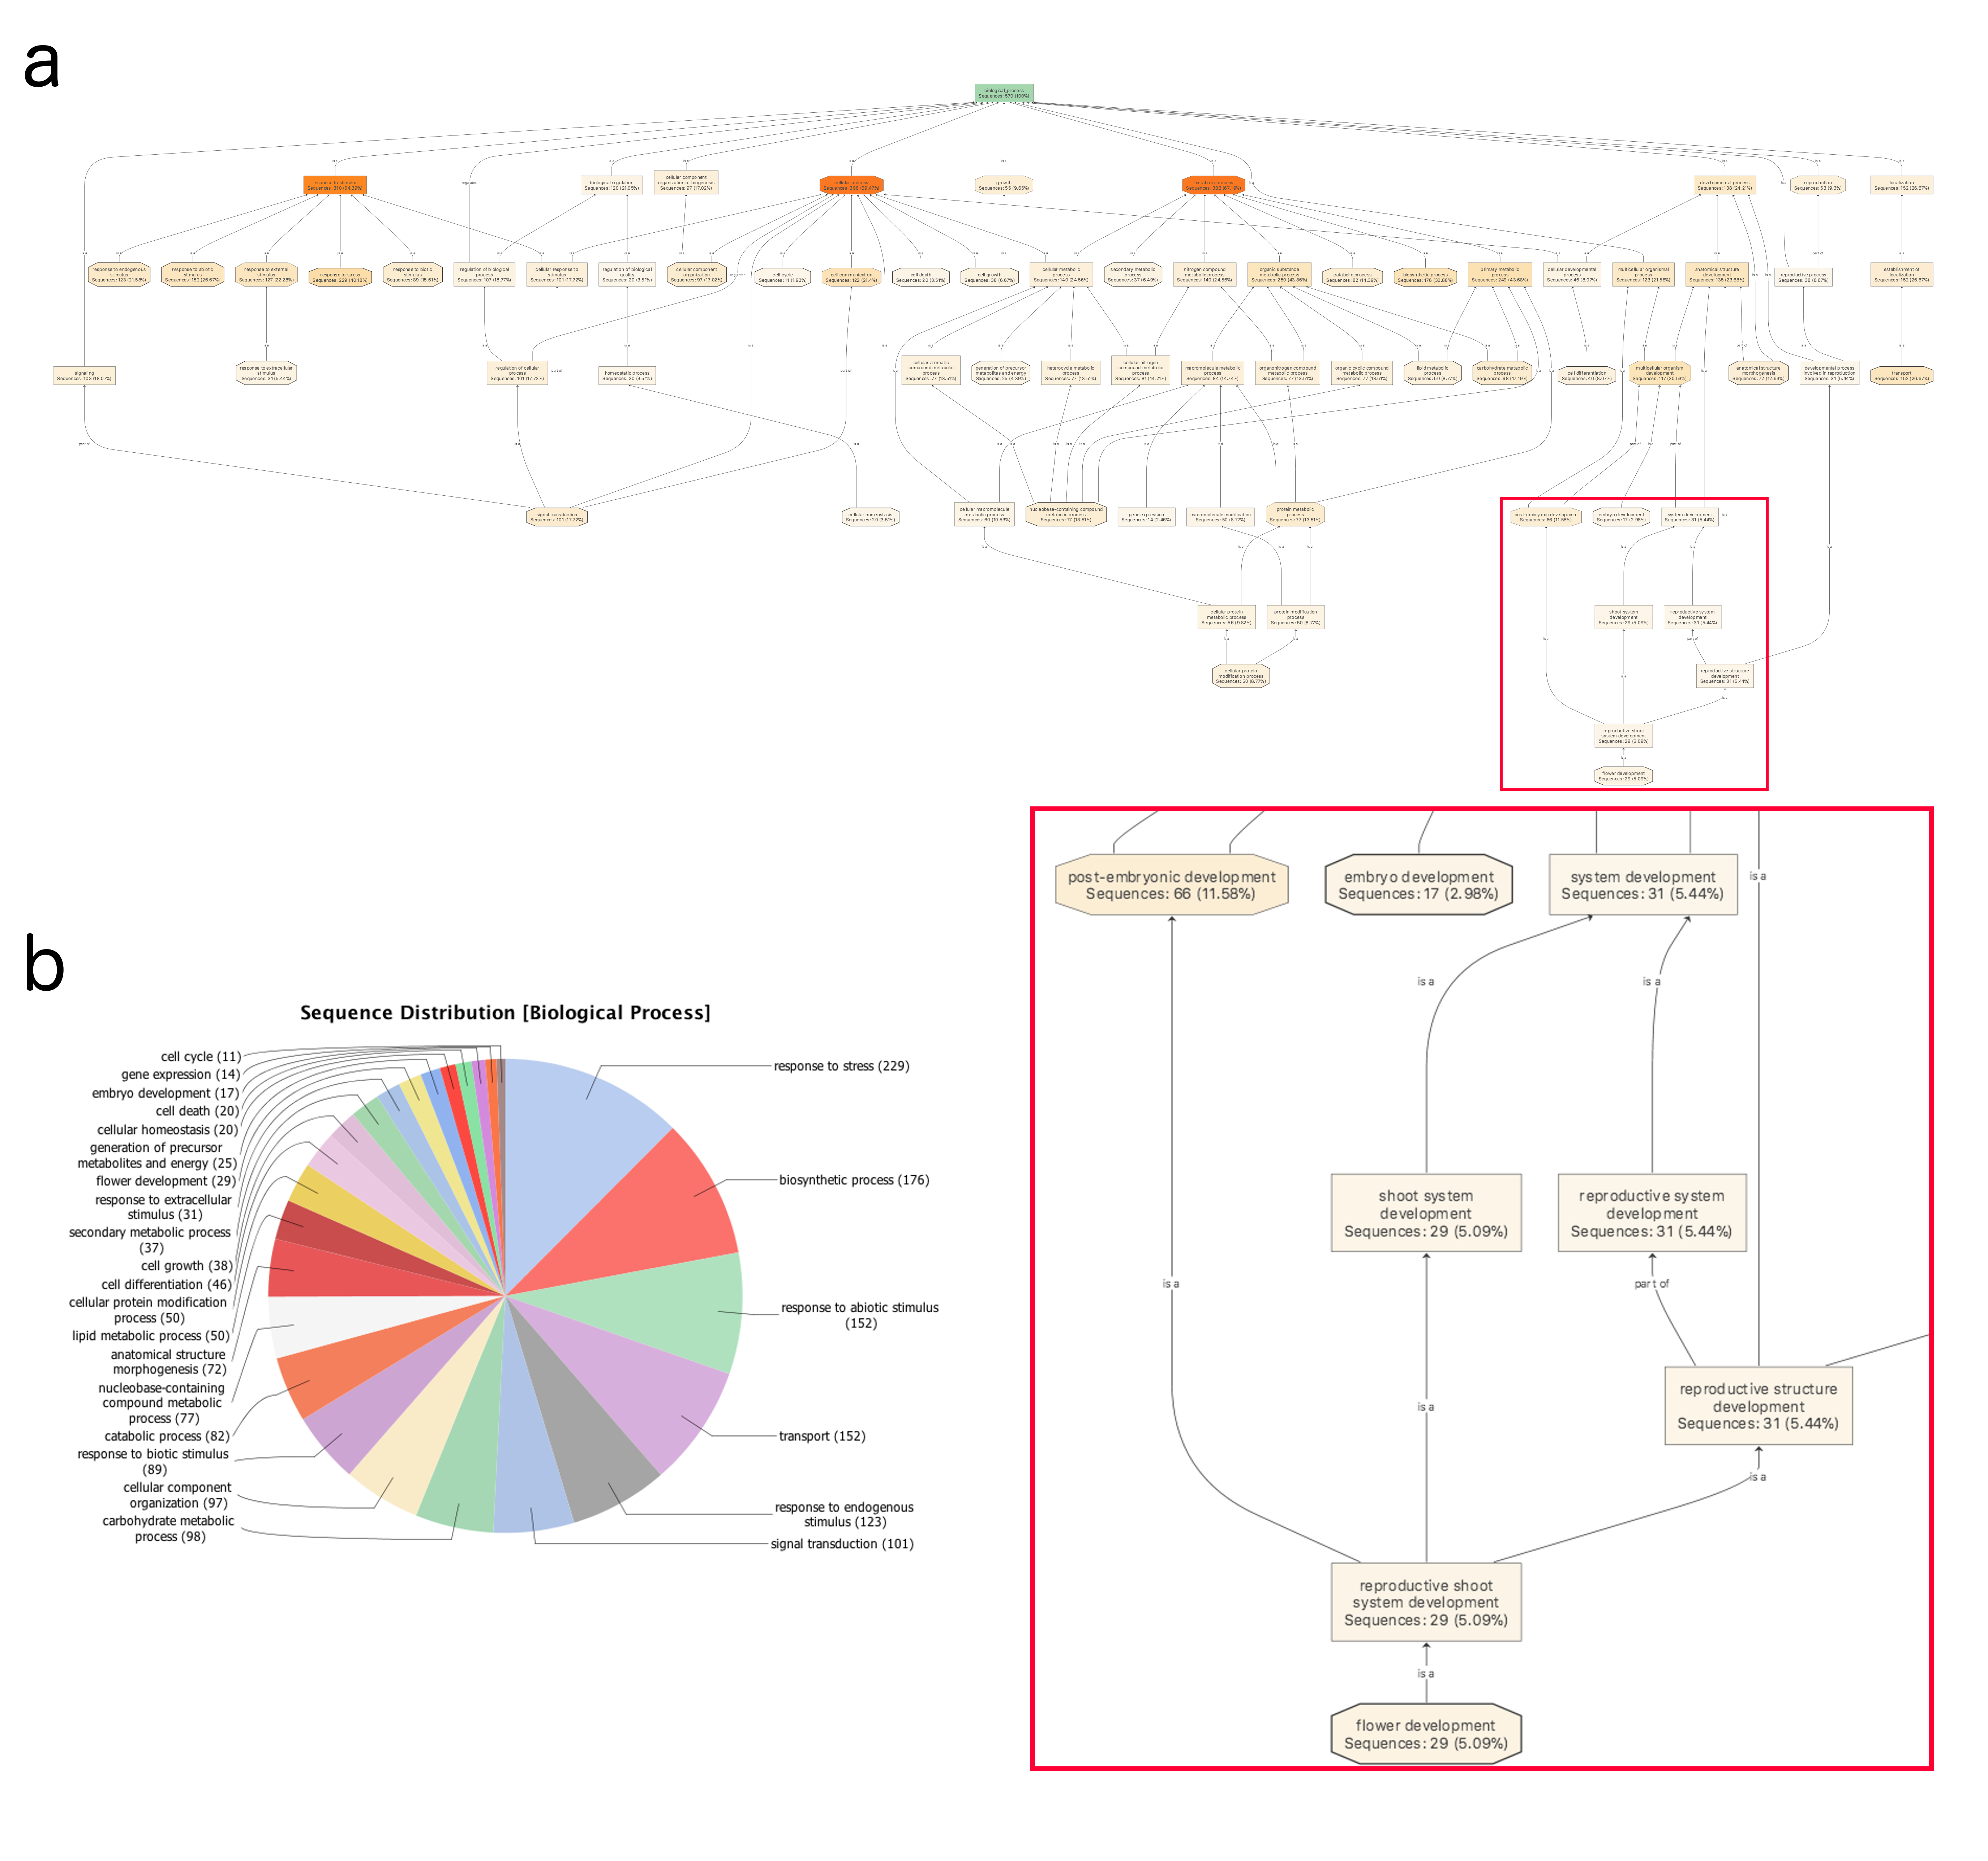
- Online Resource Figure S2. Distribution of GO terms associated to resprouting DEGs. a) Combined Graph of Biological Process GO terms. Those GOs related to lateral organogenesis, such as “shoot system development”, are expanded (red square). b) Functional categorization of GO terms in multilevel pie chart, with the lowest node per branch.

