Supplementary information
Influence of carbon electrode thickness and spacing on capacitive deionization performance
Kunchaya Thungsuai, Nuttaporn Pimpha, and Saowaluk Chaleawlert-umpon*
National Nanotechnology Center, National Science and Technology Development Agency,
Thailand Science Park, Pathum Thani 12120, Thailand
*E-mail: saowaluk@nanotec.or.th

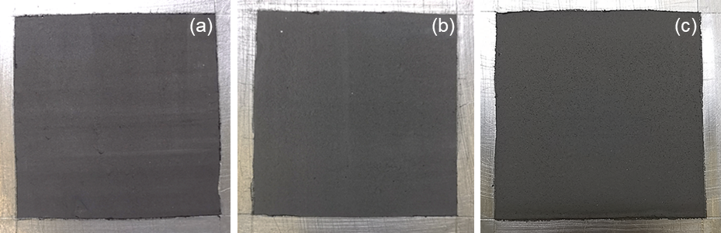
Fig. S1 Images of the carbon electrodes with various thicknesses: (a) E-323 (323 μm), (b) E-640 (640 μm), and (c) E-820 (820 μm).

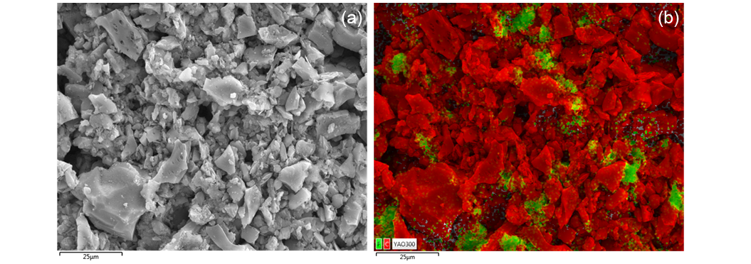
Fig. S2 SEM images (a) the E-820 and (b) SEM-EDX mapping with C and F elements.

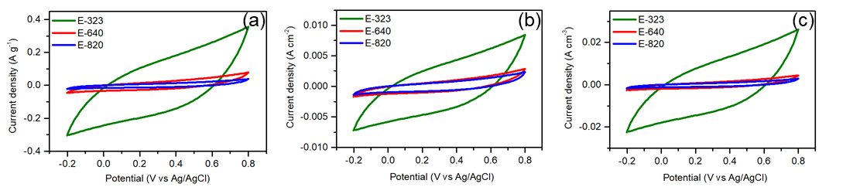
Fig. S3 CV profiles with (a) mass, (b) area, and (c) volume density of the electrodes measured in a 0.5 M NaCl solution at a scan rate of 10 mV s⁻¹.
Fig. S3 presents the CV profiles of different electrode thicknesses in terms of a current with mass, area, and volume density. The E-323 exhibited a largest area under all terms.

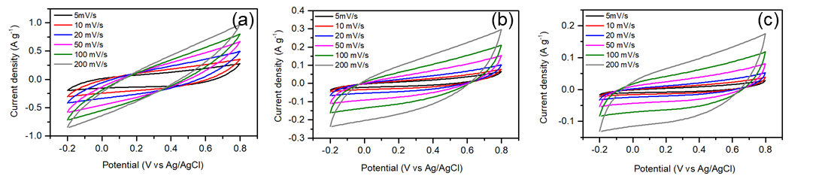
Fig. S4 CV curves of the E-323 (a), E-640, and (c) E-820 electrodes with a various scan rate measured in a 0.5 M NaCl solution.
Fig. S4 presents the CV curves against scan rates of the electrodes in a 0.5 M NaCl solution. All showed a rectangular shape with a slight deviation with a high scan rate range. The CV curves of the E-323 electrode had a larger area than those of the other electrodes.
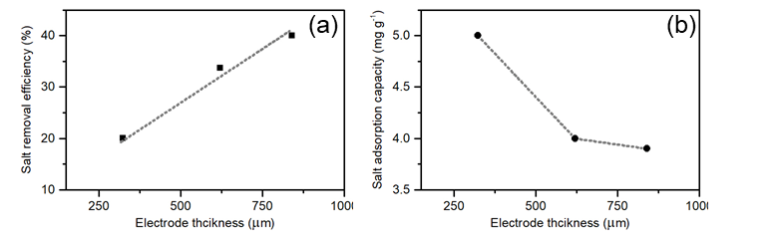
Fig. S5 Salt removal efficiency (a) and salt adsorption capacity (b) as a function of the electrode thickness.

Table S1 Pore textural properties of the PAC and the three electrodes.
Sample | SSA_{BET} (m² g⁻¹) | V_{total} (cm³ g⁻¹) | V_{micro} (cm³ g⁻¹) | V_{meso} (cm³ g⁻¹)
PAC | 1,155 | 0.49 | 0.44 | 0.05
E-323 | 380 | 0.20 | 0.15 | 0.05
E-640 | 480 | 0.23 | 0.18 | 0.05
E-820 | 574 | 0.27 | 0.22 | 0.05

