Supplementary information for manuscript:

Artificial Molecular Network (AMoNet): graph learning for cancer survival prediction from targeted sequencing
Loïc Verlingue^{1,2,3,4*}, Christophe Massard², Laurence Calzone¹ and Emmanuel Barillot^{1*}
¹ INSERM U900, Institut Curie, PSL, 26 rue d’Ulm, 75005 Paris, France
² DITEP (Drug Development Unit), Gustave Roussy, 114 rue Edouard Vaillant, 92800 Villejuif, France.
³ Centre Léon Bérard, 28 Prom. Léa et Napoléon Bullukian, 69008 Lyon
⁴ INSERM U1030, Gustave Roussy, 114 rue Edouard Vaillant, 92800 Villejuif, France.
*To whom correspondence should be addressed.

Supplementary Introduction
Homeostasis in biology
Homeostasis rules out the equilibrium of most biological systems, for example human cells and their interactions. Homeostasis is characterized by robust maintenance of the cell functions (such as the filtration by hepatocytes, contraction of cardiomyocytes, etc...) under certain conditions. Robustness relies on a natural resistance to some external stimulus either by filtering it or diluting its effect in the systems, by several means. Biological systems’ architectures are necessary for homeostasis ¹.
Homeostasis is a foundation of multicellular organisms. Multicellular organisms (such as humans) are “semi-close” systems where protein production and activities are enclosed within cells, activities of cells are enclosed within organs and specialized organs communicate with each other through interfaces and other compartments (such as the plasma). This multistep compartmentalization consequently encloses the signals in multiple homeostatic systems, and filters signals heading outwards.
In practice, even if some diseases can be influenced by specific inputs - such as chronic sugar intake for type 2 diabetes (T2D) - the relations between inputs and outputs are nevertheless relatively sparse and nonlinear: for example sustained sugar intake is barely used to predict the heterogeneity of T2D complications. Conversely, stopping excessive sugar intake will not reverse T2D complications immediately and completely ².
Concerning cancers, most risk factors such as exposure to carcinogens (smoke, UV lights, among others) are considered as triggers but are too few to be reliably used to predict the heterogeneity of cancers and outcomes: for example smoke is a major risk factor for a wide range of cancers such as lung, head and neck, bladder, among others, that have very heterogeneous phenotypes and outcomes.
If inputs have limited influences on stable biological systems, inputs can be preferably seen as triggers for change: providing sufficient energy to get out of the strong stable state of the system ³. Inputs therefore poorly relate to the fate of the system. Again, there is too few information in such high “energy” inputs to efficiently predict the heterogeneous outcomes of the system. Most drastic changes in organisms and acquired diseases thus rely on the modifications of homeostatic systems, passing through a phase of instability and then finding new equilibrium, leading to heterogeneous outcomes. In the context of sparse input data and heterogeneity of outcomes, the prediction task with classical statistical models is therefore theoretically difficult. Using known architectures ruling out the behavior of biological systems could influence new machine learning approaches. Graph models are a type of model architecture influenced by know graphs networks, and can thus provide useful bias to the predictions.
Prior-knowledge and machine learning
Mathematical models of molecular systems have long been used to understand and predict biological mechanisms such as cancer development ⁴ ⁵. Mathematical modeling strategies usually use either prior-knowledge approaches (i.e. bottom-up, mechanistic modeling, human intelligence) or data-driven approach (i.e. top-down, machine learning, artificial intelligence) ⁶. The main advantage of prior-knowledge approaches is interpretability of the model and for data-driven approaches is prediction performance. Here we advocate for a mixt approach to improve understanding of cancer behaviors and efficacy to predict the effect of molecular alterations.
Prior-knowledge modeling usually relies on detailed descriptions of biological systems to build and simulate mechanistic models ⁷. Hopefully many of the biological mechanisms in human physiology have been described recently ⁸ ⁹ ¹⁰ ¹¹. The limit of such approach is that multicellular organisms rely on large and complex systems. For example, given the 20k human proteins, the whole protein-protein interaction (PPI) network encompasses millions of possibilities. Also some biological knowledge can usually be lacking in parts of big systems. Simulating big mechanistic models can also be computationally challenging. It is even worse when inferring unknown parameters of the model ⁷.
Recent developments of machine learning have focused on training millions of parameters (i.e. deep learning) ¹². Prediction performance of deep learning models usually scales with the number of training data ¹³. In the clinic, the number of patients with molecular data in homogeneous cohorts (unique type of cancer and homogeneous follow-up) is usually scarce, which limits the performance of integrative analysis ¹⁴. A solution is to constrain models architectures on prior-knowledge and train it with deep learning methods to learn unknown parameters. This should increase the bias of deep models and thus improve combinatorial generalization ¹⁵. Moreover it should improve computational scalability of the training and interpretation of optimized models.
Application to cancer molecular alterations
Features that sustain cancer systems are many: risk factors (for e.g. smoking), random mutations ¹⁶ and new (non-homeostatic) equilibrium characterized by evolving and complex molecular alterations ¹⁷ ³ ¹⁸. These genomic alterations modify the stability of the system and can lead to very heterogeneous and non-linear phenotypes.
Nevertheless, important cancer driver genes can, alone, influence spontaneous outcome and lead to efficient targeted treatment effect ¹⁹. The biggest success stories of personalized cancer medicine rely, to date, on direct inhibition of single mutations with strong driver effects (ERBB2, EGFR, and BRAF among others). A limit is that most of oncogenes-targeted therapies result in secondary resistance mechanisms ²⁰. Resistance mechanisms often rely on gatekeeper or bypass mechanisms that take advantage of the molecular network to recover cancer cell hallmarks.
There should be an advantage to take into account several gene alterations, compared to single gene alteration, to better predict patients’ prognostic and hopefully treatment effect. Nevertheless, linking whole cancer molecular alterations to the anti-tumor effects of a large collection of targeted drug treatments in cell lines has shown very limited prediction efficacy with classical machine learning methods but has improved with deep learning methods ²¹ ²² ²³. An important challenge persists to use targeted sequencing in the clinic, such as for survival prediction.
Comparison with published approaches
There is a clear majority of papers published with models using gene expressions as input compared to gene mutations for cancer prognosis estimation. Many papers used integrative gene expression for survival prediction of lung adenocarcinomas with machine learning methods, with various performance results ²⁴ ²⁵ ²⁶. A paper designed a SVM model with 85-gene mutations as input to predict two prognostic groups during the first 3 years of follow up (deceased versus alive patients), excluding censored patients, from 371 TCGA lung adenocarcinoma patients. Feature selection was performed on the same cohort (exposing to data leakage) and cross validation AUC was 0.846 ²⁷. Another paper used Cox model with prior feature selection method to compute somatic mutation signatures and achieved a log rank test p-value = 0.0101 for the lung adenocarcinoma cohort ²⁸.
Concerning network-based machine learning approaches, a graph model for prognosis prediction of pan-tumor TCGA cohort achieved modest performance, with median cross validation C-index = 0.5 – 062 ²⁹. Another paper has used ovarian cancer from Xena Public Data Hubs and preprocessed the data with graph diffusion to perform hierarchical clustering and decipher a group of good prognosis with log rank p-value = 0.008 ³⁰. Conversely, papers that have used gene expression data as input are many with various performance up to an AUC = 0.8 for a result on a sub-group on cross validation ³¹ ³² ³³.
Supplementary Material and Methods
AMoNet R package was built with standard S3 functions such as simulate(), predict(), plot(), and main functions such as build.AMoNet() and train.AMoNet(). The package comes with vignettes, full documentation and publically available code (Supplementary figure 1).
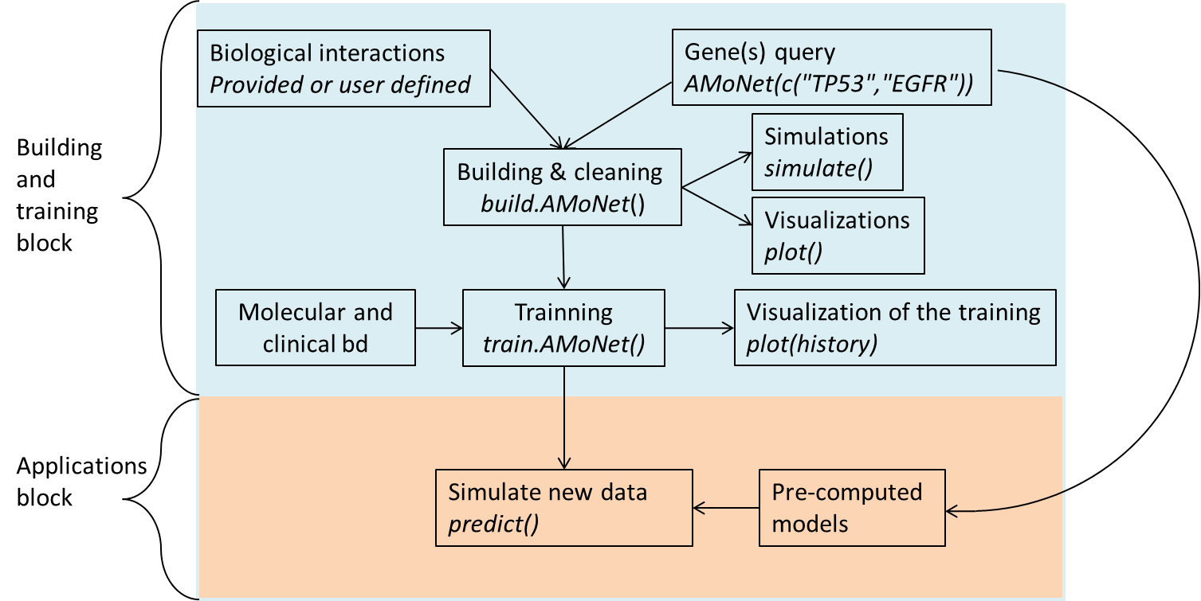
Supplementary Figure 1: R AMoNet package organization with functions
Building molecular networks in AMoNet
Building various types of molecular networks is automatic given user-defined parameters such as biological functions and/or lists of genes. A network is built from public biological interaction databases and public gene sets, available in AMoNet package. Adding a phenotype and an outcome layer to the molecular network are simply controlled by two arguments in the build.AMoNet() function. The user can also choose to load ready-to-use models.
- From biological interaction and gene lists to AMoNet
Molecular networks are built from public directed biological interaction databases available in the package ⁸ ⁹ ¹⁰ ¹¹. The molecular network is then connected to phenotypes, called the “phenotype layer” that is built from known gene sets ³⁴ ³⁵. Connections are directed from proteins present in the network to the node corresponding to the gene list name (the “phenotype”) without recurrent influence. If argument “RestrictedBase” is set to TRUE, it uses the gene lists to further restrict the input “InteractionBase” for building. “RestrictedBuilding” is another option to filter out genes with no recurrences in the network per iteration. Finally, the user can add an output layer (“outcome layer”) that represents patients’ survival probabilities simply by setting argument “Interval” to user-defined time intervals.
Doing so, levels of representation/abstraction are gradually increased: 1) the molecular network is very detailed at the level of the proteins; 2) the phenotype layer integrates known biological phenotypes and 3) the outcome layer represents survival (Supplementary figure 2). Such representation allows using AMoNet on various tasks (prediction of gene expression, phenotype or outcome) with architecture influenced by multilayer regulation of human physiology.

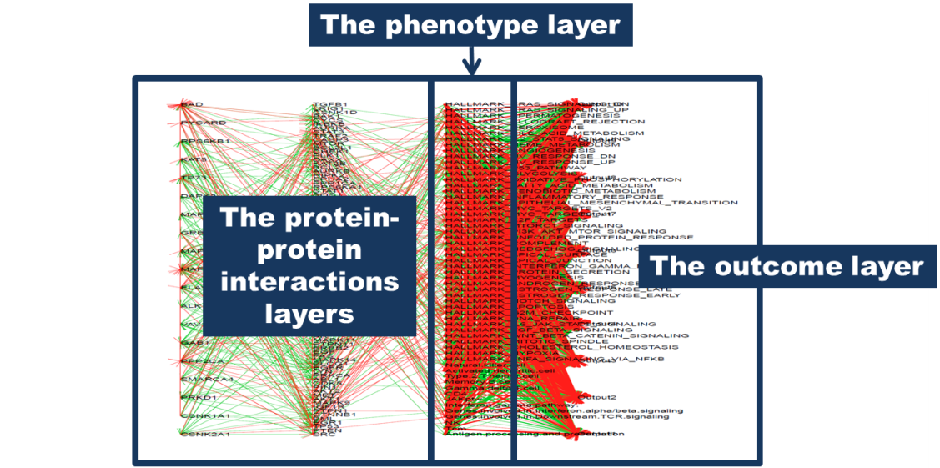
Supplementary Figure 2: architecture of the molecular network used in AMoNet paper.
This network was automatically built from the interactions between TP53, MTOR and EGFR, with building restricted to feedbacks and input database restricted to the phenotype database (gene sets available in the package). It is composed of 162 species and 104 genes or proteins. AMoNet architecture can link a biological interaction network to additional layers: an optional phenotype layer (derived from gene sets) and an optional outcome layer that represents time intervals. See vignette “AMoNet_overview” for code.
- Functions used for the building procedure
  - Formats of database used for building
The bases format (biological interaction and gene sets) are the following: source biological entities as first column (named “source_hgnc”), interaction type as second column (named “interaction_directed_signed”, containing the two variables: “ACTIVATE” or “INHIBIT”) and targets as third column (named “target_hgnc”).
  - The biological interaction layers
In AMoNet package, the first step is to initialize AMoNet with the name of biological entity (ies) (gene(s) or protein(s) such as TP53, EGFR and MTOR in supplementary figure 2). This list serves to extract all related interactions from the base biological interaction. The resulting network is automatically pruned: nodes without incoming edges or without target interactions are suppressed. The next step consists in finding and integrating all the new biological entity in the network from the base biological interaction. These 2 steps are run iteratively until the size of the network stabilizes, i.e., as long as removed nodes can unveil new partially connected nodes (for code see inner function NetBuilding() called by build.AMoNet()).
Parameters used to direct the search within the biological interaction database need to be set:
1) The number of connections to explore from a given protein (by default is 1, meaning that it takes the species directly connected to the gene query) (argument “nblayers”);
2) The minimal number of connections required to keep a node in the network (argument “MinConnect”). When a node is discarded, its sources and targets are automatically replaced by the product of the Boolean relations between input(s) and output(s). For example in case of double inhibition, the new edge will be activation;
3) A parameter specifying if at each iteration the network keeps only the new nodes with already a partner in the network at the previous time step (argument “RestrictedBuilding”);
4) A parameter that restricts the size of the biological interaction to only the genes directly related to the phenotype layer (argument “RestrictedBase”, together with the “MECA” argument used to select the corresponding gene sets).
These parameters have an impact on the size of the final network. This can be useful to build small networks and improve interpretability, increase computational speed, or obtain a cell type specific model, among other advantages. The combination of parameters can lead to a great variety of networks tailored to the needs of the user (supplementary figure 2).
  - The phenotype layer
Building the phenotype layer uses a gene set database, either provided by the user or using the default one in the package. Default gene set database comprises hallmarks of cancer from msigdb and immune gene sets from LM22 ³⁴ ³⁵.
  - The outcome layer
The outcome layer is optionally built given the user-defined number of units required as outputs (argument “Interval”). The name “Interval” comes from the specific ability of AMoNet models to handle and learn from survival in the form of discrete time (i.e. intervals, detailed in the Survival Loss paragraph).
  - Initialization
During the building phase, weights are initialized and stored in the AMoNet object. Options to set the type of weights is the type of optimizer that will be used for training (argument “Optimizer”) and the type of unit used (either vanilla or LSTM, Boolean argument “LSTM”). Distribution of weights initialization values are controlled with the arguments: “MeanWinit”, “SdWinit”. A scaling option to use Xavier initialization is performed by default.
AMoNet Simulation
- How the molecular network architecture influences the computations
The architecture of classical neural networks (i.e multilayer perceptron, MLP) is based on fully connected directed acyclic graphs (DAG). Outputs are computed by a forward matrix calculation and corrections of outputs’ errors are computed by correcting parameters w and b with back propagation of the gradients (see Learning paragraph). Convolution neural networks vary from MLP in its calculation and dimensions, but share the same fully connected DAG architectures. AMoNet vary from these neural networks architectures as it is based on sparsely connected graph with recurrences.
In AMoNet, the units (or nodes) correspond to biological entities such as genes, proteins, biological complexes or phenotypes (potentially including cell, organ, organism’s behaviors, and organism’s survival). Connections (or edges) in the network represent interactions between proteins, influences of proteins’ activities on phenotypes, among other types. AMoNet models are therefore sparsely connected because of the configuration of molecular network (based on biological interaction networks), and recurrent because of the presence of feedbacks in biological signal flow ⁶. For example, a signal initiated by the EGFR protein on the cell membrane diffuses up to ERK through a scaffold of other proteins, and ERK itself can inhibit EGFR activity thus stopping the source of the signal ³⁶. In AMoNet interactions are directed and signed. Protein A can either activate or inhibit protein B with or without being itself influenced by protein B (supplementary figure 2). Interactions can be either positives (positive weights, activations) or negatives (negative weights, inhibitions). This is a proxy to real biochemical interaction.
AMoNet thus constrains the models to be close to the known biological structures. Using prior-knowledge graph structures supposed to drive relational inductive bias during learning that has been proposed as a generalization advantage ¹⁵. In Systems Biology, simulation of mathematical models build from molecular networks usually relies on iterative updates of the nodes’ and/or model’s activities. Update formalisms often used are Boolean, Bayesian or quantitative differential equation computation ⁶ ³⁷ ³⁸ ⁷. Simulation of large molecular networks is classically computationally requiring with these formalisms. AMoNet thus proposes adaptation of classical neural networks feed-forward updates to simulation of Systems Biology model.
- Unit update formalisms
  - Vanilla update formalism
Feed forward computation of neural networks usually relies on running iteratively functions enclosed in layers of nodes of the DAG, also called node or units updates ³⁹. Classical nodes’ updates in neural network are defined by the following linear equation:
$z=w*x+b$ (eq. 1)
activated by a nonlinear function. The most frequently used non-linear activating functions are sigmoid, tanh, ReLU or modified ReLU which are implemented in AMoNet package and can be user defined. In eq 1, the parameters to optimize are w and b (see Learning paragraph).
  - Advanced formalisms
The classical learning methods for most neural networks are gradient descent-based. In very deep neural networks or in recurrent neural networks, the diffusion of the gradients throughout the network can expose to the risk of vanishing and exploding gradients. Among several methods (gradient clipping or ReLU activation function), the design of advanced unit update functions has been proposed such as LSTM or GRU ⁴⁰. LSTM units have been implemented in AMoNet and can be used at the discretion of the user (parameter “LSTM” set to TRUE or FASLE).
- AMoNet simulation method
The recurrences (translating feedbacks in biological signaling pathways, transcription regulations or cell-cell interactions) imply that the activity of a downstream node can influence the activity of an upstream node (as exemplify by the EGFR signaling pathway described above). If it is assumed that at time$t_{0}$, a node B is updated by node A, and at time $t_{+1}$, node B influences the update of node A and/or of upstream nodes, then at time $t_{+2}$, the state of node B is thus updated by the state of node A, etc. Such pattern can also be less direct (with multiple intermediate nodes), referred to as circuits in the network, influencing the global network activities.
With such feedbacks, the value of the outputs of the network can vary in time. Stable activities of nodes are usually reached by iterative updates (i.e., a simulation). Stable activities are called attractors. Attractors are composed either by stable states or limit cycles ⁶ (supplementary figure 3).
Stable states of nodes activities are reached at time $t_{+n}$ when new steps of nodes’ updates do not modify the node activities anymore. Limit cycles can be identified when some nodes’ activities are oscillating. Identifying such stable states or oscillations is relevant when simulating molecular network models: they can be used to represent the equilibrium (homeostasis) of biological systems. This is a major difference with fully connected DAG, where single feed-forward propagation is sufficient to compute stable node activities.
Classically, updates of the model can be performed synchronously, or asynchronously. In AMoNet we introduce semi-asynchronous updates to improve computation speed. Synchronous updates assume that all nodes of the model are updated all at once at each step. This strategy has the advantage of being computationally cheap but is conceptually far from known biological behaviors. With asynchronous updates, nodes are updated one at the time. This strategy is supposed to be closer to most biological signaling mechanisms (such as described with EGFR signaling pathway, which activates proteins one by one).
The semi-asynchronous simulation framework benefits from the analysis of the network architecture to improve computational speed with matrix multiplication (from synchronous update) but keeps the theoretical advantage of asynchronous updates. To do so, the network is organized in layers, defined by the order of the nodes reached from the back-propagation of the signal, starting from the outputs of the network. During a simulation, the update is thus performed layer by layer starting from the farthest nodes up to the outputs. Each node of a layer is updated synchronously (with matrix multiplication) before updating the next layer, iteratively (such as performed in a step of feed-forward computation with a MLP). The type of simulation strategy (parameters "LAYER","ASYNC","SYNC" in the train.AMoNet() function), and the number of iterations can be set by the user (parameter “MinSteps”). To obtain the stable states of the model, enough iteration are needed. Calculations are vectorized to efficiently support batch simulations of the model. This is particularly convenient and efficient to compute the learning and predictions of large models in AMoNet.
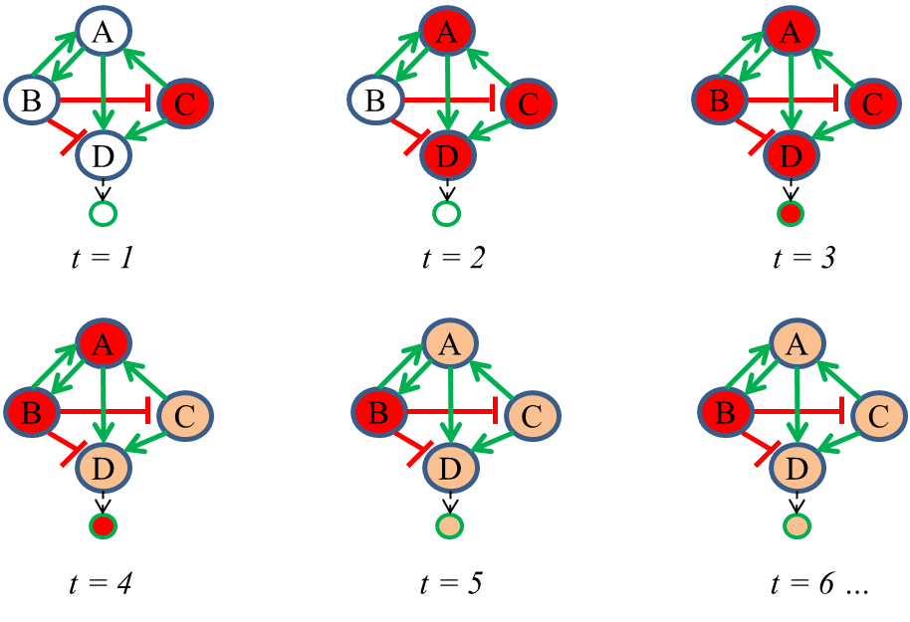
Supplementary Figure 3: illustration of asynchronous update of in a toy model.
Node C is initiated in an active state (for e.g. C = 1) and all other nodes are initialized inactive (A = B = D = output = 0). Activation function is sigmoid [0-1], and the activities of the nodes diffuse in the network up to a stable state, not reached here within the 6 iterations represented.
- AMoNet predictions
AMoNet predictions rely on the activity of a user selected node at stable state. The nodes can be genes’ activities, phenotypes’ activities or outcome measures. For outcome measures, one or multiple output nodes’ activities can be used. AMoNet uses multiple output nodes to represent time intervals and each outcome node corresponds to a probability (probability that the event appear at the corresponding time interval).
Given the architecture and formalism of AMoNet, activities of nodes are relatively independent of the initial states when nodes are updated iteratively up to their stable states. This is relevant with properties of homeostatic systems. To model the influence of inputs on the outputs, it is therefore relevant to simulate perturbation(s) of the system. It therefore influences the activities of output nodes, conserving non-linearity of predictions and adding information of the node’s position in the graph. One way is to force node activity value independently of the influence of the network. We used this procedure to model the effect of gene alterations (such as mutations) on the outcome layer of AMoNet (Supplementary figure 4).

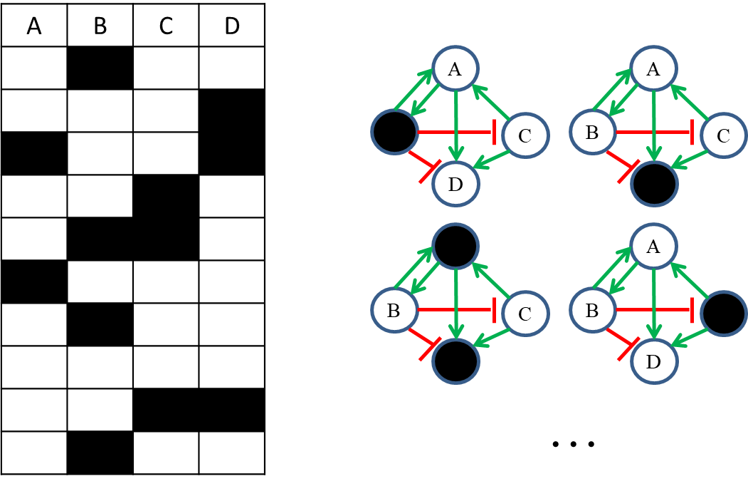
Supplementary Figure 4: A sparse matrix representing mutations in 4 genes for 10 examples.
This type of data is used to perturb the graph model. During simulations, a perturb node keeps its activity independently of its incoming influences. The model simulated with perturbations is used to for individual predictions.
Learning / Training
- Loss
In deep learning, the error made by the predictions of the model compared to the true values is calculated by a loss function or cost function. The loss function $L(θ)$ is calculated given model’s parameters θ (here the weights w and bias term b). The aim of the training is to minimize this loss: $\min_{θ}{L(θ)}$. It implies that the loss function is usable by the optimization algorithm. Popular optimization algorithms in deep learning are gradient-based optimizers based on first order derivations of the functions of the model (see paragraph Gradient descent and back propagation). A popular loss function used in gradient-based optimizers with continuous target values is the mean square error (MSE), implemented in AMoNet. MSE is defined by $L(θ)= MSE= \frac{1}{n} \sum_{i=1}^{n}{{(h_{θ}(x_{i})-{\hat{Y}}_{i})}^{2}}$and its derivate form is:
$$\frac{∂L}{∂X}=\frac{2}{n}*\sum_{i=1}^{n}{(h_{θ}\left(x_{i}\right)-{\hat{Y}}_{i})}$$
With θ the parameters of the model, $n$ the number of training examples, $h_{θ}\left(x_{i}\right)$ the prediction of the model for the $i$^{th} example and ${\hat{Y}}_{i}$ the target value (i.e. true value, ground truth) for the $i$^{th} example.
- Survival Loss
Survival data are 2 dimensional: time (follow-up) and status (alive = 1, deceased = 0). Censored events are examples where no event has occurred (for e.g. a patient still alive) at the end of the study. The time to censoring is relatively arbitrary and its raw value could compromise the good training of a model. In the other hand, censored examples can be very informative (at least if the observation period is important), and discarding it could drastically decrease the number of training examples, which is usually deleterious in deep learning performances. This leads to challenges in the design of a loss function to minimize.
A classical loss function used in shallow models (such as the Cox model) is partial log likelihood that has the advantage of using a single vector of target values ⁴¹. On the other hand with partial log likelihood, censoring has little contribution to loss function (because the function includes multiplication by censoring status). Moreover with Cox-model approaches, several assumptions should be respected such as proportional hazards, independence of events and constancy of predictors’ strength over time, which are often difficult to assess ⁴². Finally, attempts to use this method to train deep learning models have led to modest results for high dimensional molecular data ⁴³.
We have developed and implemented an approach to train a deep learning model on survival data inspired by other applications using discrete time intervals ⁴⁴. Follow-ups were transformed into time intervals and a probability of survival [0-1] was computed for each interval. The values of the censored patients in the non-observed time intervals were inferred from the non-parametric estimation of the survival probability of the cohort given by the Kaplan-Meier function.
Follow up were divided into $l$ intervals (user defined), and values correspond to the discrete survival probabilities 0 or 1 (no event = 1, event = 0) for patient in observed intervals. The values of the censored patients in the non-observed time intervals were inferred from the non-parametric estimation of the survival probability of the cohort given by the Kaplan-Meier function. The cohort-based survival probability function $S(t_{l})$ is the probability that survival is longer than time interval $t_{l}$, calculated using the classical Kaplan-Meier estimator in a discrete time fashion with:
$S(t)= \prod_{l:t_{l}≤t}{(1-\frac{d_{l}}{n_{l}})}$,
where $t_{l}$ is the relative time interval (i.e. interval of time between two events or censoring), $d_{l}$ the number of events (i.e., deaths) that happened at time $t_{l}$ and $n_{l}$ the individuals known to have survived (have not yet had an event or been censored) up to time $t_{l}$ ⁴⁵.
With this discrete time survival matrix, learning on survival data becomes a sequential regression task. The model can thus learn individual survival probability for real-time intervals and the distribution of $S(t)$ for censored time intervals, thus MSE can be used as loss function.
- Gradient descent and backpropagation
Minimizing the loss function with $\min_{θ}{L(θ)}$ corresponds to optimizing the parameters$θ$ (the weights w₁,w₂,…,w_{n}) and the bias terms (b₁, b₂, ..., b_{n}). Classical optimizers in deep learning use improved gradient descent algorithms such as Momentum, RMSprop, ADAM ⁴⁶. Gradient descent is based on the propagation in the computational graph of the gradients of the loss function. To compute all the partial derivatives $\frac{∂L}{∂θ_{i}}$ relative to each weight wᵢ and bias b_{i} in the model, a classical approach is to use back propagation of the first order derivative of the loss function $\frac{∂L}{∂X}$ based on the chain rule. Each parameter $θ_{i}$ is then corrected by subtraction of its gradient and multiplied by the user-defined learning rate (figure 4):
$θ_{i updated}≔ θ_{i}- \frac{∂L}{∂θ_{i}}*learning rate$.
We have adapted gradient descent with back propagation to train AMoNet models. To this end we propagate the gradients within a reverse version of the molecular network also called adjoint network ⁴⁷. The parameters are thus updated once for a single backpropagation through the whole graph network. Such step can be performed iteratively thus leading to a kind of “back simulation”, equivalent to diﬀerentiating the derivatives in order to obtain higher derivatives (Supplementary figure 5 and 6). Default method in AMoNet is first order derivative (a single backpropagation within the model).
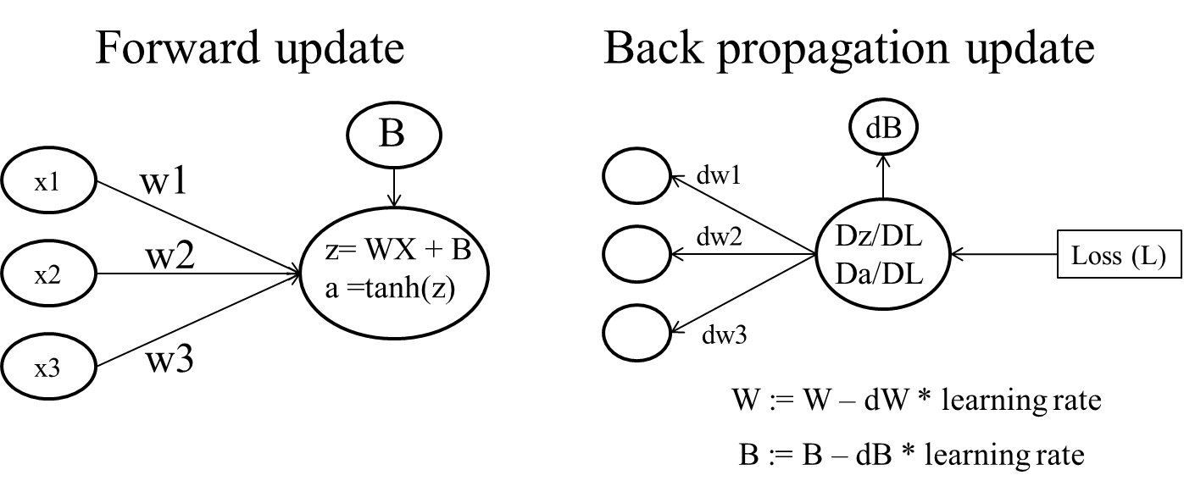
Supplementary Figure 5: updates formalisms for simulation and backpropagation of the gradients.
Weights (w), bias terms (b), derivative (d and D) and update sign (:=).
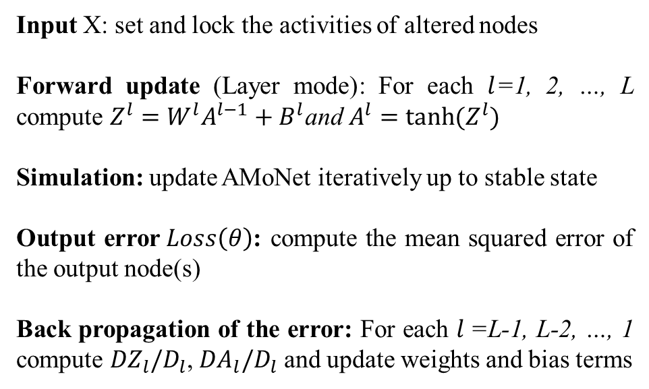
Supplementary Figure 6: pseudo code of AMoNet simulation and back propagation, in layer (L) mode.
Weights $\left(W\right)$ and bias terms $(B)$ correspond to the model parameters$(θ)$.
- Regularization
The loss function $L(θ)$ can be penalized in $L_{p}\left(θ\right)$ by adding a penalty term which is classically the Euclidian norm of the weights ($\left|W\right|$) of the layer (L1N or Lasso), or the Frobenius norm of the weights (${\left\|W\right\|}_{2}$) of the layer (L2N, or Ridge) ⁴⁸. This penalty term is multiplied by the regularization parameter lambda ($λ$) that can be optimized for specific task and data. In AMoNet these regularizations have been implemented and the choice between L1N, L2N or elastic net is controlled by a parameter alpha ($α)$, set between 1 and 2 (1 for L1N regularization, set to 2 for L2N regularization) and defined by the following formula:
$$L_{p}\left(θ\right)= L\left(θ\right)+\left(2-α\right)*λ*\left|W\right|+\left(α-1\right)*λ*{\left\|W\right\|}_{2}$$
Such regularization influences the learning step in a way that it minimizes the learned weights of the model. This usually improves the generalization of linear and non-linear models to independent cohorts. This hyper-parameter and others are described in Supplementary Table 1.
Type of hyper-parameter | options | Name in AMoNet functions | Description
Network building | Number of layers | nblayers | Number of layers from the gene queries to explore within the interaction database (number of search steps).
Network building | number of minimal connection | MinConnect | Filters the network with a minimal value of connections to keep a node.
Network building | Weights initialization | MeanWinit, SdWinit | The mean value and the standard deviation of the normal distribution used to initiate the weights.
Simulation | Number of iterations of the simulation | nsim | Number of simulation steps (i.e iterations), ideally set to achieve stable states of AMoNet activities.
Simulation | Unit update formalism | Logic | The update function used for the simulations. Choices are: "Sigmoid" (default), "Boolean","tanh" or "ReLU".
Simulation | Type of simulation (layer based, asynchronous, synchronous) | Mode | The type of simulation to perform. Choices are: "LAYER" (layer based, default), "ASYNC" (asynchronous update), "SYNC" (synchronous update).
Simulation | Value to multiply to alterations (mutations) | ValMut | Multiplicative factor for the effect of mutations.
Learning | Number of sample per mini batches | MiniBatch | Number of sample per mini batches. For batch learning, use MiniBatch = total nb of examples.
Learning | Learning rate | learning_rate | Value of the learning rate.
Learning | Gradient clipping | gradClipping | Maximum values allowed for gradients otherwise clipped.
Learning | Number of iterations for the learning | iteration | Number of iterations, corresponding to epochs, i.e. one path through the full data.
Optimizer | Type of optimizer | Optimizer | Options are "Adam", "Momentum", "RMSprop" or NULL. NULL corresponds to gradient descent.
Optimizer | Optimizers parameters | beta1 and beta2 | beta1 value modulates the speed of Momentum, and beta2 value the speed of RMSprop. Both can be tuned for Adam.
Optimizer | Regularization | alpha, lambda | Alpha: regularization term to choose between L1N (Lasso), L2N (Ridge) or L1N + L2N (Elastic Net) regularization.  Lambda: regularization value for Lasso, Ridge or Elastic Net.
Supplementary Table 1: Overview of hyper-parameters implemented in AMoNet
Data
- Type of data
  - Simulated data
We artificially generated examples with mutations in EGFR and TP53 to train AMoNet models on differential survival impact of these two genes frequently mutated in lung cancers. For the “Basic workflow” paragraph we have generated 2 patients one with TP53 = -1 (loss of function) and EGFR = 1 (gain of function) and the other with all genes wild type. For the “Mini batch training” paragraph we have generated 150 examples, adding random noise (sd=0.8) to survival probabilities and same genes alterations for half of the group. Labels to predict were single output survival probability: 0.4 for mutated examples and 0.8 for wild type examples.
  - TCGA data
The LoadcBioportal()function from AMoNet automatically loads TCGA data from the cBioportal database using the R API (https://www.cbioportal.org/). For gene mutation data, a list of genes is given to the function that returns a mutation matrix. Mutations in cBioportal come with inference of functional pathogenicity, classified as “pathogenic”, “unknown pathogenicity” and “nonpathogenic” i.e. polymorphism. We assigned for these 3 classes the factors 1, 0.6 and 0.3 to simulate the effect of these alterations. Survival data in months and survival status are also retrieved with this function, given parameters of tumor type. For example in the TCGA lung adenocarcinoma paragraph, we have set the parameter “Organ=luad” (“Organ=lung” retrieve both luad and lusc tumor types). TCGA studies with missing survival data are removed.
- Data filtering and processing
DNA-based genomics data in TCGA often used WES. AMoNet models doesn’t encompass all gene analyzed in WES, but only a subset, given by user-selected AMoNet architecture. Moreover, selecting only a subset of genes exposes to the risks of including patients with no molecular alteration found or big groups of patients with similar mutations profiles. Criteria for patient selection were: groups of patients with less than 5% similar molecular profiles, and follow-up duration of more than 40% of the cohort follow-up for censored (living) patients. To limit compression of the events in early time intervals (due to outsiders or very long follow up of living patients) we have censored long survivors, defined by the top 5% of the cohort, at the last time interval.
- Data split
For simulated data, and lung cohort only, the aim was to show the capacity of AMoNet to learn, therefore no data split was performed. For all tumor TCGA data, split was 70% train and 30% validation. The validation cohort was used to evaluate the performance of the model on unseen data. This was further used to train learning hyperparameters.
- Input data
AMoNet is designed for sparse matrices inputs filled with numeric values corresponding to the nodes altered in the network for each sample. Nodes are in column and samples are in rows. Nodes without alterations are filled with “NA” or “NaN”. Any values can be used to represent altered nodes (Supplementary Figure 4). Mutations can be encoded either as binary values (for example: 1 when mutated, NA when no mutations are detected) or continuous values (for example using functional impact scores). In this study we used cBioportal functional inference of gene mutations in 3 classes. Positive or negative values were automatically assigned for oncogenes or tumor suppressor genes from the CGS database (provided in AMoNet and using the MutMatToList() function) ⁴⁹. When values are [0-1] they are multiplied by a parameter (“ValMut”) in order to be higher or lower than the [0-1] range of sigmoid ordinates, arbitrarily set to 100 in this study.
- Output data
TCGA survival data was downloaded from cBioportal. Time was in months. Time and status were transformed into one dimensional time intervals with survival probabilities. For censored time intervals the survival probabilities were inferred from the cohort-based Kaplan Meier survival probability function (paragraph survival loss). More generally, output data to train AMoNet can be any value corresponding to any node of the network.
Supplementary results
- AMoNet building
AMoNet model building is flexible, resulting in various models’ sizes and types. For example we have generated 100 AMoNet models with random selection of genes and every models obtained were different from each other. AMoNet building can be specified on biological functions such as hallmarks of cancer or immune cell types. We have thus also generated a single AMoNet model from every one of the 129 gene sets available in the R package (object “names_MECA” of the function build.AMoNet()) and again every models obtained were different from each other.
- AMoNet training
An AMoNet model can be trained with the train.AMoNet() function (vignette “AMoNet_overview”). The minimum data required is the pre-built AMoNet model (AMoNet object), the labels in the form of a matrix with the examples in columns and the names of the nodes to be learned in row (argument ‘y’), and the alteration(s) of the model in a matrix with same format as the label matrix (with the examples in columns and the names of the nodes to be learned in row, argument ‘MUT’). During training, visualizations can be activated (argument ‘Visualize’), such as the evolution of predictions during learning or the gate activities in case of LSTM unit update (Supplementary Figure 7 and vignette “MiniBatch”).
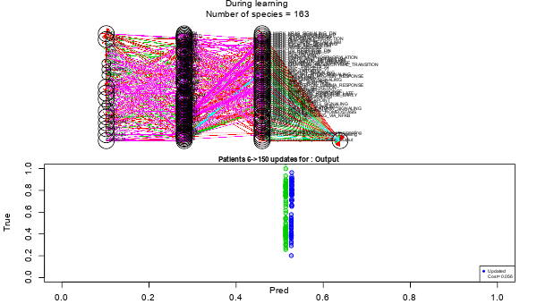
Supplementary Figure 7: gif of the learning phase of AMoNet.
Upper panel represents the AMoNet graph, colors given by the sign of the interaction (green = activation, red = inhibition, purple= change from inhibition to activation, and blue = from activation to inhibition) and size of the edge given by the bias term values. Lower panel represents the predictions of the output node in the x axis, and the true values in the y axis.
- Primary lung adenocarcinomas from TCGA
Vignette “AMoNet_TCGA” shows the building, data preparation, training and predictions of patients’ survival from their genomic analysis. We have built the same AMoNet model than other vignettes from MTOR, TP53 and EGFR genes. We have loaded TCGA data for lung adenocarcinoma from cBioportal. After filtering out patients harboring unique types of associations of molecular alterations corresponding to the 104 genes-related species present in the network, 74 patients remained (from the 133 patients, most of removed patients harboring a single mutation in TP53 or KRAS). In this vignette all the cohort was used for training with the aim to demonstrate the feasibility of training AMoNet on survival data, on a local computer with limited resources. Parameters used for the training were: iteration = 100, learning_rate = 0.01, MinStepsForward=10, Optimizer = NULL, alpha = 0, lambda = 0, Parallelize = T, no_cores = 2, ValMut = 100, adaptive_iStates = F, MiniBatch = 1000. The training C-index was 0.77. The training procedure can be plotted easily (Supplementary Figure 8)
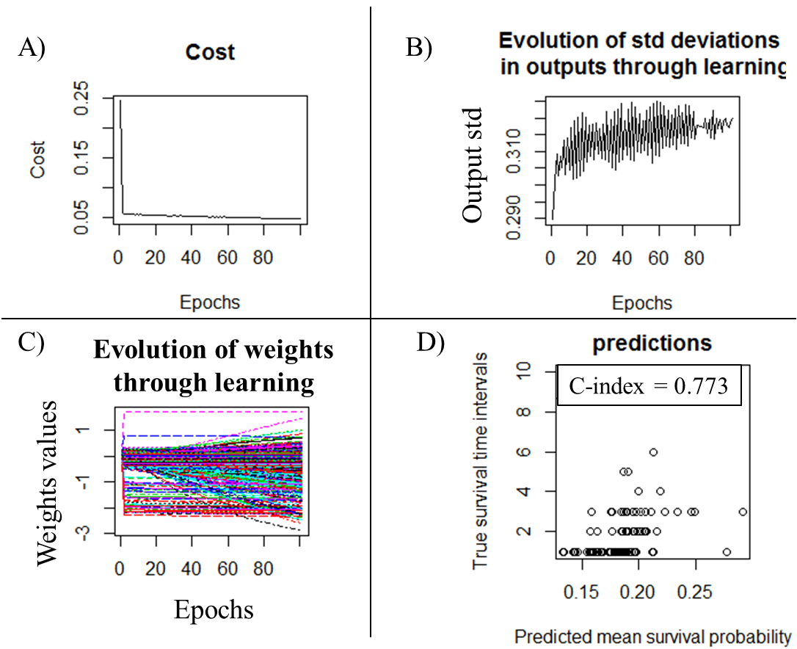
Supplementary Figure 8 : learning and performance on the lung adenocarcinoma TCGA cohort.
A) learning curve, B) output standard deviation (std) curve, C) weights curves and C) predictions.
In the main text, results of hyper parameter grid search for this cohort of patients are presented. Hyper-parameter search concerned lambda value for L2N regularization, the learning rate and the number of patients in the training set. There were 38 different models trained on different cohort splits as long as the number of patients in the cohort was a hyper parameter. Across hyper-parameters, only low lambda values were related to higher validation performance (Supplementary Figure 9A). Of note high learning rate values were related to the 4 best performing models but that were also those with limited number of patients. Best validation C-index with a decent number of patient was 0.77 (MSE = 0.09) with only 39 patients for training and 17 patients for validation, with a L2N lambda value of 0.2533793 and with learning rate of 0.07564633. Nevertheless most models had a validation C-index around 0.5 which demonstrate the importance of hyper-parameter search for efficient AMoNet training and generalization.
Interpretation of the model is facilitated by the architecture of AMoNet. Here we chose to present the relation of the phenotype layer to the outcome layer (Supplementary Figure 9B). This helps evaluating what the model has learned in comparison to know biological behaviors. For example top 5 gene lists positively related to improved outcome were: interferon gamma response, IL6-JAK-STAT pathway, allograph rejection hallmark, apoptosis hallmark and hedgehog signaling. In lung cancers interferon and IL6 signaling have specifically been studied and related to improved outcome, spontaneous or under immunotherapy ⁵⁰. Activity of apoptosis pathway is also highly related to outcome ⁵¹. Finally hedgehog also seems to positively relates to outcome in lung adenocarcinomas ⁵². Conversely over activation of PIK3CA-AKT-MTOR pathway is known to relate to worse outcome as learned in trained AMoNet for lung adenocarcinoma ⁵³ ⁵⁴.
A)
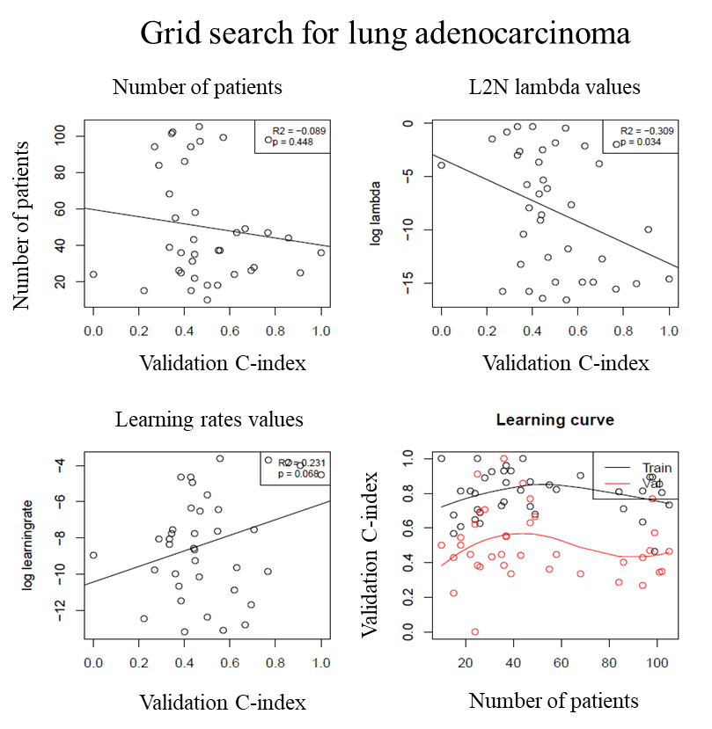
B)
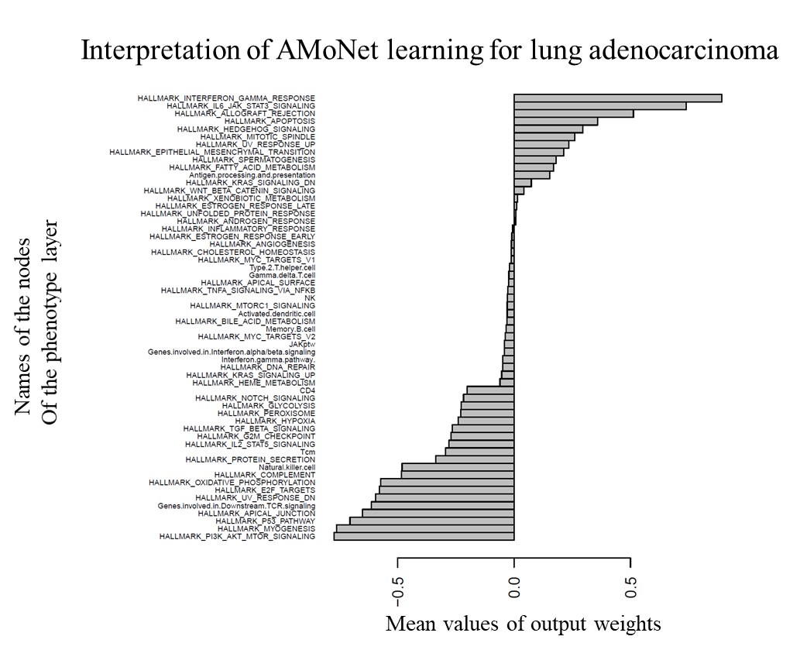
Supplementary Figure 9: Grid search and interpretation for the lung adenocarcinoma TCGA cohort.
A) Results of a grid search and learning curves from the training of 38 AMoNet models on the lung adenocarcinoma cohort. Validation performances are represented by the C-index. Different patient numbers were used to compute the learning curve. Numbers corresponds to those downloaded before filtering and training/validation split. No relation has been identified between patient numbers validation performance (p = 0.45), nor training. There was a negative correlation between the Lambda value for L2N (L2 normalization, i.e. ridge) and validation performance (Pearson correlation with the logarithm transformation of lambda, p = 0.03). There was no significant relation with the learning rate.
B) Interpretation of the model. The antepenultimate layer (phenotype layer) is composed of nodes representing gene lists. They are plotted by the mean of their output weights (i.e. W of the edges connected to the output layer).
- Multi organ TCGA
  - With AMoNet
There were 3615 patients in cBioportal for the studies: blca_mskcc_solit_2014 & blca_mskcc_solit_2012, blca_tcga_pub_2017, blca_plasmacytoid_mskcc_2016, blca_tcga_pub, brca_metabric, brca_tcga_pub2015, brca_tcga_pub, coadread_tcga_pub, coadread_mskcc, hnsc_tcga_pub, luad_tcga_pub, lusc_tcga, hnsc_mdanderson_2013. There were 346 patients with no survival data or follow up of censored patients at less than 40% of the total cohort follow up. Moreover, 2771 patients had no mutation or mutation profile found in more than 5% across tumor types (Supplementary Figure 10). After filtering, 498 patients remained for analysis. The training cohort comprised 348 patients and the validation cohort 150 patients. Hyper parameter search concerned learning rate and lambda value for L2N penalization. A total of 49 models were trained. There were a significant negative relation between learning rate and the validation performances (Supplementary Figure 11). There was no relation with lambda values. Best model achieved a validation C-index of 0.62 (and MSE = 0.04).
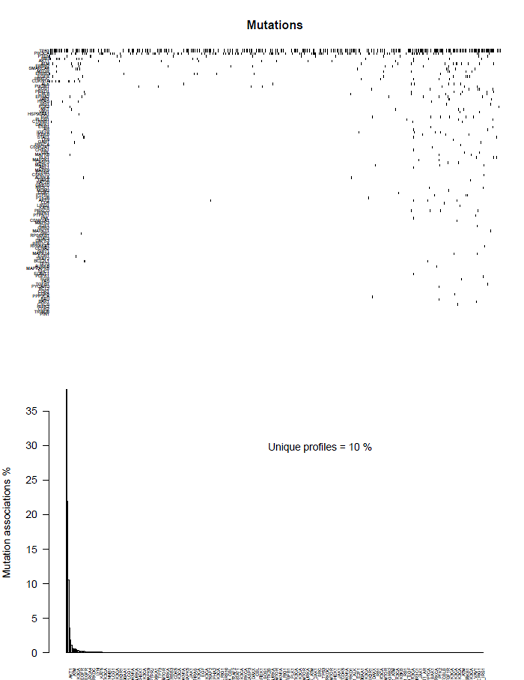
Supplementary Figure 10: Description of molecular data
A) Matrix of the patient mutations with genes in row and patients in columns. Unit colored in black correspond to the presence of a mutation, and white unit correspond to wild type gene. It confirms that targeted sequencing analysis provide very sparse input matrix for modeling.
B) Histogram of the frequencies of association of molecular alterations per patient. Around 40% of patients have only mutations in TP53. As long as a model cannot predict differential survival between patients with unique information, these examples are filtered out.

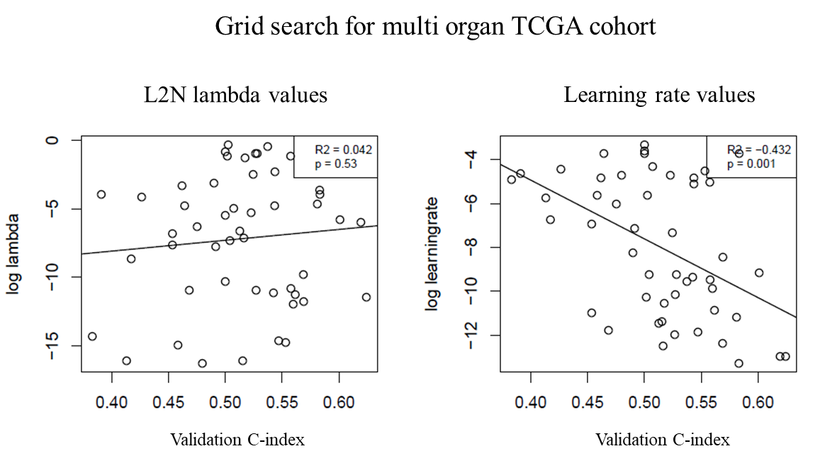
Supplementary Figure 11: Results on the validation set of AMoNet training on multi organ TCGA cohort.
Validation C-indexes are represented versus the hyper parameters lambda or learning rate. Pearson correlation (R2) and p values (p) were calculated for the log transformation of both hyper parameters
  - with MLP
A multi-layer perceptron (fully connected DAG) was built with R interface to Keras (https://keras.rstudio.com/index.html) (Vignette “MLP_TCGA”). Hyper parameters used are described in the main text. The code to build and train the model is available in the vignette. Results show a high training performance (C-index = 0.73, MSE = 0.008) but low validation performance (C-index = 0.56, MSE = 0.06) on the same cohort split (Supplementary Figure 12).
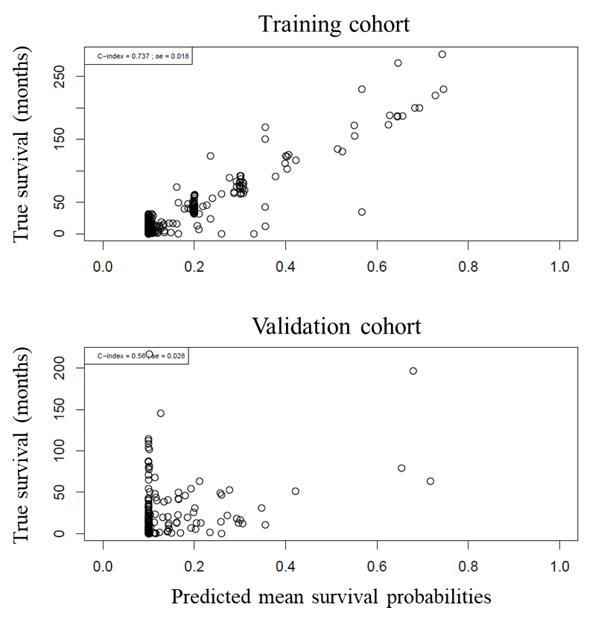
Supplementary Figure 12: training and validation performance of a MLP trained on the multi organ TCGA cohort.
Three hidden layers, MLP hyper parameters were similar to the best AMoNet model plus a dropout effect of 0.4 on each hidden layers. There was a clear overfitting on the training cohort, suggesting a penalization effect of the graphical architecture of AMoNet model.
Supplementary discussion
AMoNet can be trained on various types of data including survival data. By coupling Systems Biology and Deep Learning methods, AMoNet provides fast, effective and interpretable training of large, recurrent, directed and sparsely connected graph networks. This architecture is inspired by biological systems, necessary for homeostasis and altered in many diseases. We have thus exemplified the use of AMoNet on cancer applications. In cancer care, targeted sequencing is frequently performed but no integrative use of the results is done for clinical decision, because of it is a highly difficult task both for humans and for machine learning.
Most applications to date have used WES data to model survival of patients in tumor specific TCGA cohorts with evaluation on (cross-) validation cohorts (supplementary introduction). With 22k gene, WES limits the risk of groups of patients with similar molecular profiles ⁵⁵. Conversely, the high number of covariates and parameters increases the risk of overfitting and difficulty to interpret the data. Overall prognostic prediction from WES has low generalization performance (when evaluated), with concordance index less than 0.65 ²⁹.
With AMoNet we aimed at using only targeted sequencing to perform survival prediction, which is in principle limited by the few information available in such analysis. With the trade-off of using large models to increase information, we developed AMoNet to achieve the lightest computation for the simulation of large model, a classically difficult task when using ODE for example ⁷. Even with stringent filtering of the data, AMoNet achieved modest generalization performance on a pan-tumor type cohort. Conversely, even with few number of examples but from a more homogeneous cohort (lung adenocarcinoma), AMoNet could achieve interesting performance. Classically deep learning models improve with the number of examples, and training on small datasets is a challenging objective ¹³. It is possible that using prior biological knowledge in the model architecture helped the generalization performance because of bias toward know behaviors during learning ¹⁵. More applications to other domains could help confirming this observation, and release of AMoNet R package can make it feasible.
AMoNet and other models could improve their performance on cancer survival prediction by integrating clinical information. With AMoNet, it would be challenging to find prior knowledge of the relation between clinical variables and gene alterations, but future developments of the biological and clinical field may fill this gap. Nevertheless, we and others have shown that performance is higher in tumor type restricted cohorts suggesting that such information (organ of origin) may be already present within molecular profiles. In this perspective, AMoNet automatic building procedure could be used to estimate most relevant biological mechanisms for specific cohort of patients.
Supplementary figures and tables
Supplementary Figure 1: R AMoNet package organization with functions 4
Supplementary Figure 2: architecture of the molecular network used in AMoNet paper. 5
Supplementary Figure 3: illustration of asynchronous update of in a toy model. 9
Supplementary Figure 4: A sparse matrix representing mutations in 4 genes for 10 examples. 10
Supplementary Figure 5: updates formalisms for simulation and backpropagation of the gradients. 12
Supplementary Figure 6: pseudo code of AMoNet simulation and back propagation, in layer (L) mode. 12
Supplementary Figure 7: gif of the learning phase of AMoNet. 16
Supplementary Figure 8 : learning and performance on the lung adenocarcinoma TCGA cohort. 17
Supplementary Figure 9: Grid search and interpretation for the lung adenocarcinoma TCGA cohort. 19
Supplementary Figure 10: Description of molecular data 20
Supplementary Figure 11: Results on the validation set of AMoNet training on multi organ TCGA cohort. 21
Supplementary Figure 12: training and validation performance of a MLP trained on the multi organ TCGA cohort. 22
Supplementary Table 1: Overview of hyper-parameters implemented in AMoNet 14
References
1. Homeostasis. Wikipedia (2020).
2. Verlingue, L. et al. A comprehensive approach to the molecular determinants of lifespan using a Boolean model of geroconversion. Aging Cell (2016) doi:10.1111/acel.12504.
3. Huang, S., Ernberg, I. & Kauffman, S. Cancer attractors: A systems view of tumors from a gene network dynamics and developmental perspective. Semin Cell Dev Biol 20, 869–876 (2009).
4. Altrock, P. M., Liu, L. L. & Michor, F. The mathematics of cancer: integrating quantitative models. Nature Reviews Cancer 15, 730–745 (2015).
5. Hamis, S., Powathil, G. G. & Chaplain, M. A. J. Blackboard to Bedside: A Mathematical Modeling Bottom-Up Approach Toward Personalized Cancer Treatments. JCO Clinical Cancer Informatics 1–11 (2019) doi:10.1200/CCI.18.00068.
6. Barillot, E., Calzone, L., Hupe, P., Vert, J.-P. & Zinovyev, A. Computational Systems Biology of Cancer. vol. 2013 (2013).
7. Calzone, L., Barillot, E. & Zinovyev, A. Logical versus kinetic modeling of biological networks: applications in cancer research. Current Opinion in Chemical Engineering 21, 22–31 (2018).
8. Kuperstein, I. et al. Atlas of Cancer Signalling Network: a systems biology resource for integrative analysis of cancer data with Google Maps. Oncogenesis 4, e160 (2015).
9. Okuda, S. et al. KEGG Atlas mapping for global analysis of metabolic pathways. Nucleic Acids Res. 36, W423-426 (2008).
10. Licata, L. et al. SIGNOR 2.0, the SIGnaling Network Open Resource 2.0: 2019 update. Nucleic Acids Res. (2019) doi:10.1093/nar/gkz949.
11. Türei, D., Korcsmáros, T. & Saez-Rodriguez, J. OmniPath: guidelines and gateway for literature-curated signaling pathway resources. Nature Methods 13, 966–967 (2016).
12. Shoeybi, M. et al. Megatron-LM: Training Multi-Billion Parameter Language Models Using Model Parallelism. arXiv:1909.08053 [cs] (2020).
13. Banko, M. & Brill, E. Scaling to Very Very Large Corpora for Natural Language Disambiguation. in Proceedings of the 39th Annual Meeting on Association for Computational Linguistics 26–33 (Association for Computational Linguistics, 2001). doi:10.3115/1073012.1073017.
14. Lawrence, M. S. et al. Discovery and saturation analysis of cancer genes across 21 tumour types. Nature 505, 495–501 (2014).
15. Battaglia, P. W. et al. Relational inductive biases, deep learning, and graph networks. arXiv:1806.01261 [cs, stat] (2018).
16. Tomasetti, C. & Vogelstein, B. Variation in cancer risk among tissues can be explained by the number of stem cell divisions. Science 347, 78–81 (2015).
17. Hanahan, D. & Weinberg, R. A. Hallmarks of Cancer: The Next Generation. Cell 144, 646–674 (2011).
18. Jamal-Hanjani, M. et al. Tracking the Evolution of Non-Small-Cell Lung Cancer. N. Engl. J. Med. 376, 2109–2121 (2017).
19. Romond, E. H. et al. Trastuzumab plus adjuvant chemotherapy for operable HER2-positive breast cancer. N. Engl. J. Med. 353, 1673–1684 (2005).
20. Rotow, J. & Bivona, T. G. Understanding and targeting resistance mechanisms in NSCLC. Nat. Rev. Cancer 17, 637–658 (2017).
21. Iorio, F. et al. A Landscape of Pharmacogenomic Interactions in Cancer. Cell 166, 740–754 (2016).
22. Costello, J. C. et al. A community effort to assess and improve drug sensitivity prediction algorithms. Nat. Biotechnol. 32, 1202–1212 (2014).
23. Baptista, D., Ferreira, P. G. & Rocha, M. Deep learning for drug response prediction in cancer. Brief. Bioinformatics (2020) doi:10.1093/bib/bbz171.
24. Jiang, N. & Xu, X. Exploring the survival prognosis of lung adenocarcinoma based on the cancer genome atlas database using artificial neural network. Medicine (Baltimore) 98, e15642 (2019).
25. Wan, Y.-W., Beer, D. G. & Guo, N. L. Signaling pathway-based identification of extensive prognostic gene signatures for lung adenocarcinoma. Lung Cancer 76, 98–105 (2012).
26. Li, Y.-Y. et al. Genome-scale analysis to identify prognostic markers and predict the survival of lung adenocarcinoma. J. Cell. Biochem. 119, 8909–8921 (2018).
27. Yu, J. et al. LUADpp: an effective prediction model on prognosis of lung adenocarcinomas based on somatic mutational features. BMC Cancer 19, 263 (2019).
28. Menor, M. et al. Development of somatic mutation signatures for risk stratification and prognosis in lung and colorectal adenocarcinomas. BMC Med Genomics 12, (2019).
29. Le Morvan, M., Zinovyev, A. & Vert, J.-P. NetNorM: Capturing cancer-relevant information in somatic exome mutation data with gene networks for cancer stratification and prognosis. PLoS Comput. Biol. 13, e1005573 (2017).
30. Zhang, W., Chien, J., Yong, J. & Kuang, R. Network-based machine learning and graph theory algorithms for precision oncology. npj Precision Oncology 1, 1–15 (2017).
31. Mallik, S. & Zhao, Z. Graph- and rule-based learning algorithms: a comprehensive review of their applications for cancer type classification and prognosis using genomic data. Brief Bioinform 21, 368–394 (2020).
32. Li, C. & Li, H. Network-constrained regularization and variable selection for analysis of genomic data. Bioinformatics 24, 1175–1182 (2008).
33. Gliozzo, J. et al. Network modeling of patients’ biomolecular profiles for clinical phenotype/outcome prediction. Sci Rep 10, 3612 (2020).
34. Subramanian, A. et al. Gene set enrichment analysis: a knowledge-based approach for interpreting genome-wide expression profiles. Proc. Natl. Acad. Sci. U.S.A. 102, 15545–15550 (2005).
35. Gentles, A. J. et al. The prognostic landscape of genes and infiltrating immune cells across human cancers. Nat. Med. 21, 938–945 (2015).
36. Dienstmann, R., De Dosso, S., Felip, E. & Tabernero, J. Drug development to overcome resistance to EGFR inhibitors in lung and colorectal cancer. Mol Oncol 6, 15–26 (2012).
37. Fröhlich, F. et al. Efficient Parameter Estimation Enables the Prediction of Drug Response Using a Mechanistic Pan-Cancer Pathway Model. Cell Syst 7, 567-579.e6 (2018).
38. Traynard, P., Tobalina, L., Eduati, F., Calzone, L. & Saez-Rodriguez, J. Logic Modeling in Quantitative Systems Pharmacology. CPT Pharmacometrics Syst Pharmacol 6, 499–511 (2017).
39. LeCun, Y., Bengio, Y. & Hinton, G. Deep learning. Nature 521, 436–444 (2015).
40. Donahue, J. et al. Long-term Recurrent Convolutional Networks for Visual Recognition and Description. arXiv:1411.4389 [cs] (2014).
41. Cox, D. R. Regression Models and Life-Tables. Journal of the Royal Statistical Society: Series B (Methodological) 34, 187–202 (1972).
42. Wang, P., Li, Y. & Reddy, C. K. Machine Learning for Survival Analysis: A Survey. arXiv:1708.04649 [cs, stat] (2017).
43. Ching, T., Zhu, X. & Garmire, L. X. Cox-nnet: An artificial neural network method for prognosis prediction of high-throughput omics data. PLoS Comput. Biol. 14, e1006076 (2018).
44. Biganzoli, E., Boracchi, P., Mariani, L. & Marubini, E. Feed forward neural networks for the analysis of censored survival data: a partial logistic regression approach. Stat Med 17, 1169–1186 (1998).
45. Kaplan, E. L. & Meier, P. Nonparametric Estimation from Incomplete Observations. Journal of the American Statistical Association 53, 457–481 (1958).
46. Sutskever, I., Martens, J., Dahl, G. & Hinton, G. E. On the importance of initialization and momentum in deep learning. in ICML (2013).
47. Campolucci, P., Uncini, A. & Piazza, F. A Signal-Flow-Graph Approach to On-line Gradient Calculation. Neural Computation 12, 1901–1927 (2000).
48. Hoerl, A. E. & Kennard, R. W. Ridge Regression: Biased Estimation for Nonorthogonal Problems. Technometrics 12, 55 (1970).
49. Sondka, Z. et al. The COSMIC Cancer Gene Census: describing genetic dysfunction across all human cancers. Nature Reviews Cancer 18, 696–705 (2018).
50. Fehrenbacher, L. et al. Atezolizumab versus docetaxel for patients with previously treated non-small-cell lung cancer (POPLAR): a multicentre, open-label, phase 2 randomised controlled trial. Lancet 387, 1837–1846 (2016).
51. Singhal, S., Vachani, A., Antin-Ozerkis, D., Kaiser, L. R. & Albelda, S. M. Prognostic Implications of Cell Cycle, Apoptosis, and Angiogenesis Biomarkers in Non–Small Cell Lung Cancer: A Review. Clin Cancer Res 11, 3974–3986 (2005).
52. Hwang, J. et al. The effects of sonic hedgehog signaling pathway components on non-small-cell lung cancer progression and clinical outcome. World J Surg Oncol 12, 268 (2014).
53. Wang, L. et al. PIK3CA mutations frequently coexist with EGFR/KRAS mutations in non-small cell lung cancer and suggest poor prognosis in EGFR/KRAS wildtype subgroup. PLoS ONE 9, e88291 (2014).
54. Zhang, L., Shi, L., Zhao, X., Wang, Y. & Yue, W. PIK3CA gene mutation associated with poor prognosis of lung adenocarcinoma. Onco Targets Ther 6, 497–502 (2013).
55. Campbell, P. J. et al. Pan-cancer analysis of whole genomes. Nature 578, 82–93 (2020).

