Coconut endocarp shell ash (CESA): a non-conventional catalyst for green synthesis of 2-amino-4H-benzochromenes
Sandip P. Patil, Sachinkumar K. Shinde, Suresh S. Patil*
Synthetic Research Laboratory, PG Department of Chemistry, PDVP College, (Affiliated to Shivaji University, Kolhapur) Tasgaon, Sangli (MS), India-416312
*Corresponding author, Email: sanyujapatil@yahoo.com

Electronic Supplemental Information (ESI)

Sr. No. | Table of Contents | Pages
1 | FTIR, ¹H and ¹³C NMR spectroscopic data of all products | 1-7
2 | FTIR, ¹H and ¹³C NMR spectra of selected products of 2-amino-4H-benzochromenes. | 8-23

SPECTRAL DATA
- Spectral data of synthesized compounds 4a-p and 5a-l

3-amino-1-phenyl-1H-benzo[f]chromene-2-carbonitrile (4a)
FTIR (KBr, ν cm⁻¹): 1230, 1410, 1582, 2350, 2885, 3079, 3334, 3428 cm⁻¹;
¹H NMR (400 MHz, DMSO-d₆): δ (ppm): 5.29 (1H, s, CH), 6.94 (2H, s, NH₂ ), 7.12–7.27 (7H, m, Ar-H), 7.32–7.45 (4H, m, Ar-H), ppm; ¹³C NMR (100 MHz, DMSO-d₆): δ 38.04, 57.88, 115.64, 116.73, 120.40, 123.57, 124.86, 126.53, 126.93, 127.01, 128.41, 128.64, 129.43, 130.12, 130.78, 145.65, 146.78, 159.64 ppm; Mass: 298.11 [M+].
3-amino-1-(4-chlorophenyl)-1H-benzo[f]chromene-2-carbonitrile (4b)
FTIR (KBr, ν cm⁻¹): 1587, 1643, 2188, 3067, 3317, 3403 cm⁻¹; ¹H NMR (400 MHz, DMSO-d₆):δ 5.35 (1H, s, CH), 7.01 (2H, brs, NH₂), 7.19-7.46 (6H, m, Ar-H), 7.79-7.95 (4H, m, Ar-H)ppm; ¹³C NMR (100 MHz, DMSO-d₆): δ 37.35, 57.44, 115.13, 116.77, 120.29, 123.51, 124.97, 127.14, 128.49, 128.66, 128.82, 129.67, 130.03, 130.81, 131.16, 144.64, 146.79, 159.70 ppm; Mass: 332.07 [M+].
3-amino-1-(4-hydroxyphenyl)-1H-benzo[f]chromene-2-carbonitrile (4c)
FTIR (KBr, ν cm⁻¹): 808, 1088, 1231, 1407, 1510, 1651, 2189, 3448 cm⁻¹;
¹H NMR (400 MHz, DMSO-d₆): δ 5.16 (1H, s, CH), 6.63 (2H, d, J=6.3 Hz, Ar-H), 6.87 (2H, s, NH₂), 6.98 (2H, d, J=6.3 Hz, Ar-H ), 7.29-7.45 (4H, m, Ar-H ), 7.83–7.91 (2H, m, Ar-H), 9.24 (1H, s, Ar-H) ppm; ¹³C NMR (100 MHz, DMSO-d₆): δ 37.35, 58.40, 115.30, 116.13, 116.73, 120.58, 123.67, 124.79, 126.89, 127.97, 128.36,129.19, 130.18, 130.78, 136.20, 146.63, 155.91, 159.47 ppm; Mass: 314.11 [M+].
3-amino-1-(4-methoxyphenyl)-1H-benzo[f]chromene-2-carbonitrile (4d)
FTIR (KBr, ν cm⁻¹): 3428, 3358, 2189, 1658, 1580, 1512, 1394, 1231, 1182, 1022, 802, 754 cm⁻¹; ¹H NMR (400 MHz, DMSO-d₆): δ 3.65 (3H, s, OCH3), 5.18 (1H, s, CH), 6.65 (2H, d, J=6.3 Hz, Ar-H), 6.80 (2H, s, NH₂), 6.90 (2H, d, J=6.3 Hz, Ar-H ), 7.21-7.48 (4H, m, Ar-H ), 7.82–7.92 (2H, m, Ar-H) ppm; ¹³C NMR (100 MHz, DMSO-d₆): δ 35.42, 55.85, 59.30, 114.82, 117.34, 118.76, 122.45, 122.68, 123.22, 126.06, 128.28, 128.72, 129.78, 132.80, 133.45, 151.89, 158.50, 162.22 ppm; Mass: 328.12 [M+].
3-amino-1-p-tolyl-1H-benzo[f]chromene-2-carbonitrile (4e)
FTIR (KBr, ν cm⁻¹): 809, 1000–1304, 1406, 1588, 1647, 2195, 3056, 3318, 3408 cm⁻¹; ¹H NMR (400 MHz, DMSO-d₆):δ 2.33 (3H, s, CH₃), 5.20 (1H, s, CH), 6.61 (2H, d, J=6.3 Hz, Ar-H), 6.85 (2H, s, NH₂), 6.84 (2H, d, J=6.3 Hz, Ar-H ), 7.22-7.49 (4H, m, Ar-H ), 7.80–7.93 (2H, m, Ar-H) ppm; ¹³C NMR (100 MHz, DMSO-d₆): δ 21.28, 38.54, 58.21, 116.56, 117.88, 121.48, 124.52, 125.12, 127.28, 127.23, 128.40, 129.65, 129.32, 130.48, 131.68, 136.10, 143.34, 147.58, 159.78 ppm; Mass: 312.13 [M+].
3-amino-1-(4-nitrophenyl)-1H-benzo[f]chromene-2-carbonitrile (4f)
FTIR (KBr, ν cm⁻¹): 1231, 1345, 1415, 1514, 1654, 2187, 2318, 2931,3449 cm⁻¹; ¹H NMR (400 MHz, DMSO-d₆): δ 5.58 (1H, s, CH), 6.89 (2H, s, NH₂), 7.03–7.09 (1H, m, Ar-H), 7.11–7.18 (2H, m, Ar-H), 7.41–7.52 (2H, m, Ar-H), 7.61 (2H, d, J=8.1 Hz, Ar-H), 7.65–7.68 (1H, m, Ar-H), 7.71 (2H, d, J=8.1 Hz, Ar-H) ppm; ¹³C NMR (100 MHz, DMSO-d₆): δ 35.42, 56.31, 113.69, 113.56, 115.58, 116.45, 118.19, 119.38, 121.49, 122.50, 122.81, 124.12, 126.87, 127.37, 128.02, 131.27, 133.44, 142.89, 156.09 ppm; Mass: 343.1 [M+].
3-amino-1-(4-cyanophenyl)-1H-benzo[f]chromene-2-carbonitrile (4g)
FTIR (KBr, ν cm⁻¹): 1590, 1658, 2190, 2226, 3304, 3448 cm⁻¹; ¹H NMR (400 MHz, DMSO-d₆): δ 5.52 (1H, s, CH), 6.56 (2H, brs, NH₂), 7.35 (1H, d, J =8.3 Hz, Ar-H), 7.42–7.47 (2H, m, Ar-H), 7.49-7.72 (4H, m, Ar-H), 7.81–7.95 (2H, m, Ar-H), 7.98 (2H, d, J = 8.3 Hz, Ar-H) ppm; ¹³C NMR (100 MHz, DMSO-d₆): δ 36.43, 58.80, 110.48, 114.38, 116.78, 118.32, 119.04, 123.49, 125.22, 127.32, 128.36, 128.74, 130.18, 130.54, 131.58, 132.60, 147.39, 150.93, 159.93 ppm; Mass: 323.11 [M+].
3-amino-1-(4-cyanophenyl)-1H-benzo[f]chromene-2-carbonitrile (4h)
FTIR (KBr, ν cm⁻¹): 1574, 1742, 2190, 3354, 3478 cm⁻¹; ¹H NMR (400 MHz, DMSO-d₆): δ 5.43 (s, 1H, CH), 6.39 (2H, brs, NH₂), 7.36 (2H, d, J = 8.2 Hz, Ar-H), 7.40–7.49 (2H, m, Ar-H), 7.63 (2H, d, J = 8.2 Hz, Ar-H), 7.81–7.99 (4H, m, Ar-H) ppm; ¹³C NMR (100 MHz, DMSO-d₆) δ 35.98, 58.84, 114.70, 116.78, 119.27, 122.68, 123.62, 125.22, 125.70, 127.32, 127.89, 128.12, 128.68, 130.10, 130.52, 131.47, 147.29, 149.76, 159.85 ppm; Mass: 366.1 [M+].
3-amino-1-(2,4-dichlorophenyl)-1H-benzo[f]chromene-2-carbonitrile (4i)
FTIR (KBr, ν cm⁻¹): 1403, 1655, 2197, 2320, 3315, 3458 cm⁻¹; ¹H NMR (400 MHz, DMSO-d₆): δ 5.70 (1H, s, CH), 7.08 (2H, s. NH2), 7.25-7.50 (5H, m, Ar-H), 7.56-7.62(2H, m, Ar-H), 7.92-7.97(2H, m, Ar-H) ppm; ¹³C NMR (100 MHz, DMSO-d₆): δ 34.84, 55.73, 114.12, 116.78, 119.66, 122.51, 125.08, 127.53, 128.44, 128.73, 128.89, 129.96, 130.07, 130.76, 131.43, 131.96, 132.05, 141.67, 147.15, 159.85 ppm; Mass: 366.03 [M+].
3-amino-1-(3-bromophenyl)-1H-benzo[f]chromene-2-carbonitrile (4j)
FTIR (KBr, ν cm⁻¹): 1406, 1551, 1652, 2182, 2984, 3347, 3453 cm⁻¹; ¹H NMR (400 MHz, DMSO-d₆): δ 5.37 (1H, s, CH), 7.04 (2H, s, NH₂), 7.15–7.49 (6H, m, Ar–H), 7.83-7.96 (4H, m, Ar–H) ppm; ¹³C NMR (100 MHz, DMSO-d₆): δ 37.45, 57.31, 114.92, 116.76, 120.18, 121.85, 123.46, 125.02, 126.05, 127.22, 128.49, 129.49, 129.54, 129.76, 129.97, 130.78, 130.97, 146.82, 148.34, 159.79 ppm; Mass: 376.02 [M+].
3-amino-1-(2-bromophenyl)-1H-benzo[f]chromene-2-carbonitrile (4k)
FTIR (KBr, ν cm⁻¹): 861, 954, 1070, 1128, 1238, 1410, 1584, 1630, 1658, 2192, 3134 cm⁻¹; ¹H NMR (400 MHz, DMSO-d₆): δ 5.71 (1H, s, CH), 7.04 (2H, s, NH₂), 7.11-7.48 (4H, m, Ar-H), 7.63-7.97 (6H, d, J=6.5 Hz, Ar-H) ppm; ¹³C NMR (100 MHz, DMSO-d₆): δ 56.48, 115.10, 116.38, 119.74, 121.81, 122.68, 125.16, 127.34, 128.60, 128.65, 128.72, 129.68, 130.12, 130.04, 130.67, 132.78, 144.49, 147.18, 159.90 ppm; Mass: 376.02 [M+].
3-amino-1-(2-chlorophenyl)-1H-benzo[f]chromene-2-carbonitrile (4l)
FTIR (KBr, ν cm⁻¹): 1032, 1244, 1398, 1468, 1589, 2357, 3040,3428 cm⁻¹;
¹H NMR (400 MHz, DMSO-d₆): δ 5.59 (1H, s, CH), 6.57 (2H, brs, NH₂), 7.07-7.35 (4H, m, Ar-H), 7.47–7.67 (6H, m, Ar-H) ppm; ¹³C NMR (100 MHz, DMSO-d₆): δ 54.41, 113.70, 114.34, 114.69, 115.06, 116.14, 118.05, 119.40, 119.79, 121.23, 122.62, 123.64, 125.35, 127.98, 129.04, 131.60, 131.84, 133.56, 144.23, 155.78 ppm; Mass: 332.07 [M+].
3-amino-1-(2-bromo-5-fluorophenyl)-1H-benzo[f]chromene-2-carbonitrile (4m)
FTIR (KBr, ν cm⁻¹): 1028, 1237, 1400, 1463, 1591, 1657, 2190, 2918, 3341, 3448 cm⁻¹; ¹H NMR (400 MHz, DMSO-d₆): δ 5.71 (1H, s, CH), 7.09 (2H, s. NH2), 7.24-7.50 (5H, m, Ar-H), 7.55-7.62(2H, m, Ar-H), 7.91-7.98 (2H, m, Ar-H) ppm; ¹³C NMR (100 MHz, DMSO-d₆): δ 34.80, 55.72, 114.10, 116.78, 119.69, 122.51, 125.09, 127.54, 128.49, 128.79, 128.84, 129.92, 130.09, 130.76, 131.40, 131.98, 132.02, 141.69, 147.19, 159.87 ppm; Mass: 394.01[M+]
2-amino-4-phenyl-4H-benzo[h]chromene-3-carbonitrile (5a)
FTIR (KBr, ν cm⁻¹): 1276, 1378, 1474,1614, 2359, 3064, 3390, 3472 cm⁻¹;
¹H NMR (400 MHz, DMSO-d₆): δ (300 MHz, DMSO-d6) d (ppm): 5.49 (1H, s, CH), 6.72 (2H, brs, NH₂), 7.14-7.33 (5H, m, Ar-H), 7.52–7.65 (4H, m, Ar-H), 7.88-8.31 (2H, m, Ar-H) ppm; ¹³C NMR (100 MHz, DMSO-d₆): δ 55.58, 117.34, 117.82, 121.09, 122.22, 124.36, 125.67, 126.03, 126.27, 127.84, 128.05, 130.50, 132.62, 134.68, 136.18, 141.80, 149.26, 155.75 ppm; Mass: 298.11[M+].
2-amino-4-(4-chlorophenyl)-4H-benzo[h]chromene-3-carbonitrile (5b)
FTIR (KBr, ν cm⁻¹): 1184, 1268, 1386, 1478, 1634, 2376, 3069, 3393, 3488 cm⁻¹; ¹H NMR (400 MHz, DMSO-d₆): δ 5.18 (1H, s, CH), 6.80 (2H, brs, NH₂), 7.23 (2H, d, J= 7.4 Hz) 7.32-7.48 (2H, m, Ar-H), 7.56 (2H, d, J= 7.4 Hz), 7.68-7.72 (2H, m, Ar-H), 7.87–7.97 (2H, m, Ar-H) ppm; ¹³C NMR (100 MHz, DMSO-d₆): δ 55.41, 113.27, 114.32, 114.68, 118.78, 119.02, 119.30, 123.32, 125.42, 128.05, 128.27, 129.09, 132.24, 133.87, 135.81, 137.85, 145.90, 155.68 ppm; Mass: 332.07 [M+].
2-amino-4-(4-hydroxyphenyl)-4H-benzo[h]chromene-3-carbonitrile (5c)
FTIR (KBr, ν cm⁻¹): 1408, 1509, 1641, 2192, 3180,3306, 3448 cm⁻¹; ¹H NMR (400 MHz, DMSO-d₆): δ 4.76 (1H, s, CH), 6.58-6.82 (2H, m, Ar-H), 7.04 (2H, s, NH₂), 7.13 (2H, d, J= 6.6 Hz), 7.53-7.64 (3H, m, Ar-H), 7.87 (2H, d, J= 6.6 Hz), 8.22 (1H, d, J=6 Hz, Ar-H), 8.78 (1H, s, bs, OH) ppm; ¹³C NMR (100 MHz, DMSO-d₆): δ 56.59, 63.91, 113.35, 115.69, 118.31, 120.09, 120.53, 120.64, 122.71, 123.63, 126.26, 126.51, 126.58, 127.60, 132.56, 136.61, 142.46, 145.79, 146.55, 159.94 ppm; Mass: 314.11 [M+].
2-amino-4-(4-methoxyphenyl)-4H-benzo[h]chromene-3-carbonitrile (5d)
FTIR (KBr, ν cm⁻¹): 1254, 1462, 1592, 2350, 2939, 3058,3418 cm⁻¹; ¹H NMR (400 MHz, DMSO-d₆): δ 3.39 (3H, s, OCH₃), 4.92 (1H, s, CH), 6.81 (2H, brs, NH₂), 7.27 (2H, d, J=6.8 Hz, Ar-H), 7.35 (2H, d, J=6.8, Ar-H ), 7.58–7.65 (4H, m, Ar-H), 7.83–7.91 (2H, m, Ar-H) ppm; ¹³C NMR (100 MHz, DMSO-d₆): δ 55.38, 55.61, 111.90, 113.38, 115.02, 116.18, 116.84, 118.41, 118.78, 119.03, 123.89, 125.34, 126.28, 128.52, 131.32, 135.78, 142.19, 145.65, 155.69 ppm. Mass: 328.12 [M+].
2-amino-4-p-tolyl-4H-benzo[h]chromene-3-carbonitrile (5e)
FTIR (KBr, ν cm⁻¹): 1137, 1380, 1432, 1588, 1657, 2218, 3269, 3393 cm⁻¹;
¹H NMR (400 MHz, DMSO-d₆): δ 2.29 (3H, s, CH₃), 4.59 (1H, s, CH), 6.88 (2H, s, NH₂), 7.08 (1H, d, J= 8.0 Hz, Ar-H), 7.14–7.25 (4H, m, Ar-H), 7.35–7.42 (3H, m, Ar-H), 7.68 (1H, d, J= 8.0 Hz, Ar-H), 8.05 (1H, d, J= 8.0 Hz, Ar-H) ppm; ¹³C NMR (100 MHz, DMSO-d₆): δ 31.32, 43.62, 55.89, 119.70, 120.23, 122.06, 122.72, 123.89, 124.10, 125.68, 126.22, 127.33, 128.68, 130.44, 132.67, 133.84, 141.88, 145.24, 160.20 ppm. Mass: 312.13 [M+].
2-amino-4-(4-nitrophenyl)-4H-benzo[h]chromene-3-carbonitrile (5f)
FTIR (KBr, ν cm⁻¹): 1103, 1344, 1510, 1650, 2186,3356, 3453 cm⁻¹; ¹H NMR (400 MHz, DMSO-d₆): δ 5.15 (1H, s, CH), 7.11 (2H, d, J= 6.6 Hz, Ar-H), 7.29 (2H, s, NH₂), 7.53-7.68 (4H, m, Ar-H), 7.90 (2H, d, J= 6 Hz, Ar-H), 8.18-8.27 (2H, m, Ar-H) ppm; ¹³C NMR (100 MHz, DMSO-d₆): δ 55.18, 116.58, 120.06, 120.70, 122.70, 124.02, 124.17, 125.87, 126.79, 126.99, 127.69, 128.99, 132.86, 142.91, 146.47, 152.91, 160.28 ppm; Mass: 343.1 [M+].
2-amino-4-(4-cyanophenyl)-4H-benzo[h]chromene-3-carbonitrile (5g)
FTIR (KBr, ν cm⁻¹): 1632, 1650, 2178, 2229, 3043, 3345, 3438 cm⁻¹; ¹H NMR (400 MHz, DMSO-d₆): δ 5.18 (1H, s, CH), 6.64 (2H, brs, NH₂), 7.14 (2H, d, J = 8.2 Hz, Ar-H), 7.55-7.69 (4H, m, Ar-H), 7.78 (2H, d, J = 8.2 Hz, Ar-H), 7.89- 8.31 (2H, m, Ar-H) ppm; ¹³C NMR (100 MHz, DMSO-d₆) d 35.81, 58.40, 111.79, 117.43, 119.22, 119.51, 121.68, 124.46, 125.55, 126.67, 127.60, 127.38, 128.35, 129.88, 133.50, 134.12, 144.26, 151.78, 161.07 ppm; Mass: 323.11 [M+].
2-amino-4-(4-(trifluoromethyl)phenyl)-4H-benzo[h]chromene-3-carbonitrile (5h)
FTIR (KBr, ν cm⁻¹): 1604, 1637, 1674, 2180, 3335,3487 cm⁻¹; ¹H NMR (400 MHz, DMSO-d₆): δ 5.11 (1H, s, CH), 6.57 (2H, brs, NH₂), 7.16 (2H, d, J = 8.5 Hz, Ar-H), 7.54–7.70 (4H, m, Ar-H), 7.92 (2H, d, J = 8.5 Hz, Ar-H), 8.32 (2H, m, Ar-H) ppm; ¹³C NMR (100 MHz, DMSO-d₆): δ 57.90, 117.07, 119.02, 120.79, 123.23, 124.30, 125.44, 125.49, 125.58, 125.70, 126.02, 126.52, 126.80, 127.34, 128.42, 128.71, 133.48, 143.42, 150.23, 160.30 ppm; Mass: 366.1 [M+].
2-amino-4-(2,4-dichlorophenyl)-4H-benzo[h]chromene-3-carbonitrile (5i)
FTIR (KBr, ν cm⁻¹): 1102, 1406, 1589, 1663, 2188, 3326, 3450 cm⁻¹; ¹H NMR (400 MHz, DMSO-d₆): δ 5.41 (1H, s, CH), 6.98 (2H, d, J= 6.3 Hz, Ar-H), 7.23 (2H, s, NH₂), 7.27-7.39 (2H, m, Ar-H), 7.56-7.66 (3H, m, Ar-H), 7.88 (1H, d, J=2.7 Hz, Ar-H), 8.25 (1H, d, J=6 Hz,Ar-H) ppm; ¹³C NMR (100 MHz, DMSO-d₆): δ 37.80, 54.46, 115.97, 119.91, 120.70, 122.59, 124.13, 125.26, 126.74, 126.93, 127.65, 128.11, 129.12, 132.44, 132.57, 132.86, 132.93, 141.19, 143.02, 160.32 ppm; Mass: 366.03 [M+].
2-amino-4-(3-bromophenyl)-4H-benzo[h]chromene-3-carbonitrile (5j)
FTIR (KBr, ν cm⁻¹): 1101, 1376, 1467, 1652, 2189, 3341, 3447 cm⁻¹; ¹H NMR (400 MHz, DMSO-d₆): δ 4.96 (1H, s, CH), 7.11-7.31 (2H, m, Ar-H), 7.21 (2H, s, NH₂), 7.42-7.66 (6H, m, Ar-H), 7.89-8.25 (2H, m, Ar-H) ppm; ¹³C NMR (100 MHz, DMSO-d₆): δ 55.66, 117.17, 120.23, 120.68, 121.89, 122.69, 124.05, 125.97, 126.72, 126.86, 127.67, 129.86, 130.20, 130.99, 132.75, 142.75, 148.34, 160.23 ppm; Mass: 376.02 [M+].
2-amino-4-(2-bromophenyl)-4H-benzo[h]chromene-3-carbonitrile (5k)
FTIR (KBr, ν cm⁻¹): 752, 854, 958, 985, 1068, 1120, 1258, 1365, 1638, 1632, 2208, 3130 cm⁻¹; ¹H NMR (400 MHz, DMSO-d₆): δ 5.47 (1H, s, CH), 6.85 (2H, s, NH₂), 7.01-7.34 (5H, m, Ar-H), 7.58–7.67 (3H, m, Ar-H), 7.85-8.25 (2H, m, Ar-H) ppm; ¹³C NMR (100 MHz, DMSO-d₆): δ 55.08, 116.52, 120.60, 120.67, 122.41, 122.64, 124.18, 125.20, 126.56, 126.82, 127.54, 128.45, 129.12, 131.68, 132.62, 132.88, 142.72, 143.90, 160.4 ppm; Mass: 376.02 [M+].
2-amino-4-(2-chlorophenyl)-4H-benzo[h]chromene-3-carbonitrile (5l)
FTIR (KBr, ν cm⁻¹): 1190, 1284, 1370, 1489, 1619, 2364, 3056, 3392 cm⁻¹;
¹H NMR (400 MHz, DMSO-d₆): δ 5.54 (1H, s, CH), 6.59 (2H, s, NH₂), 7.03- 7.34 (3H, m, J=1.2, Ar-H), 7.48–7.59 (5H, m, Ar-H), 7.64–7.69 (2H, m, Ar-H) ppm; ¹³C NMR (100 MHz, DMSO-d₆): δ 54.52, 112.58, 112.80, 114.74, 115.02, 115.70, 117.59, 118.25, 119.05, 123.73, 123.80, 125.42, 126.94, 129.38, 131.26, 133.62, 133.86, 137.54, 145.78, 158.96 ppm; Mass: 332.07 [M+].

- Spectra of some representative synthesized compounds
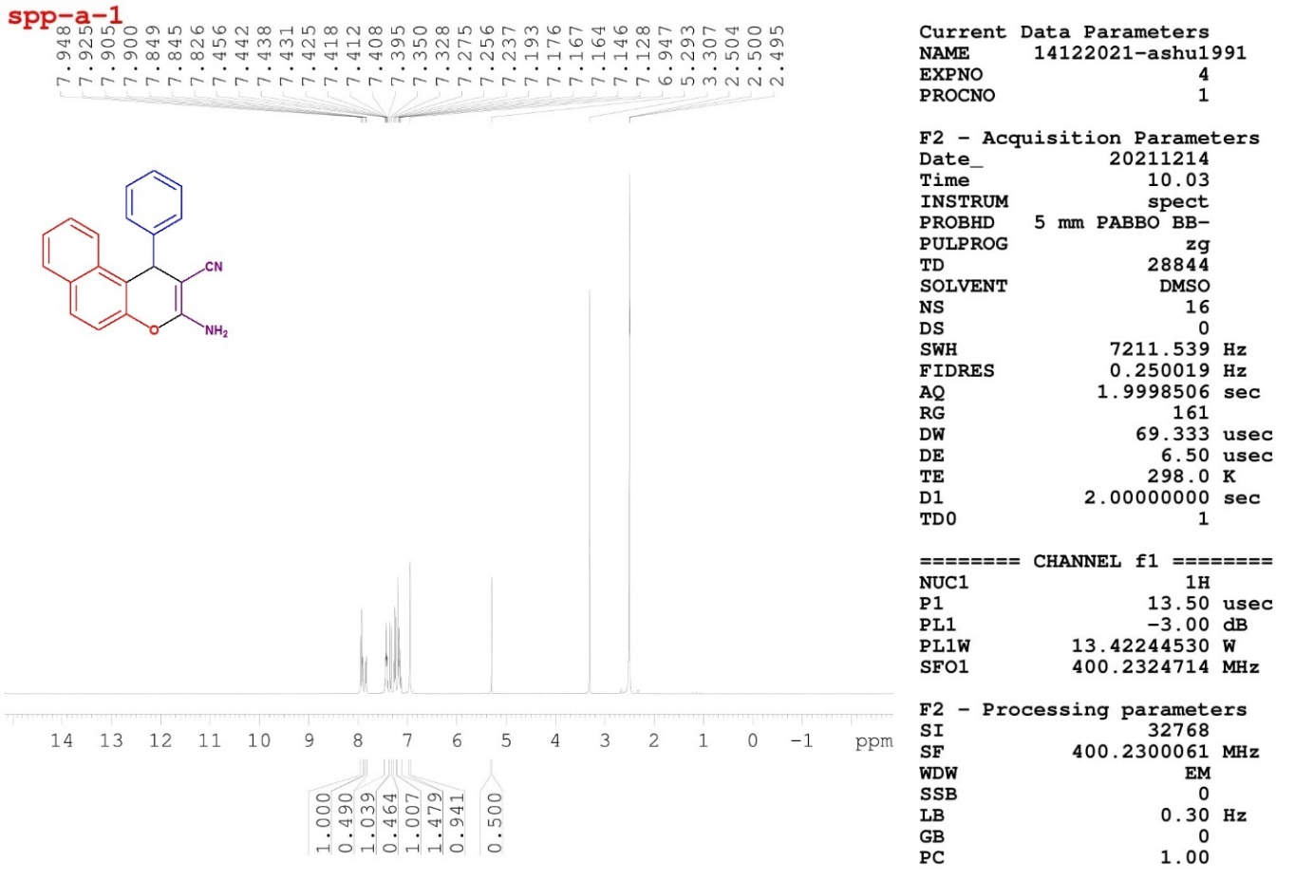
Fig.1 ¹H-NMR spectra of compound 4a
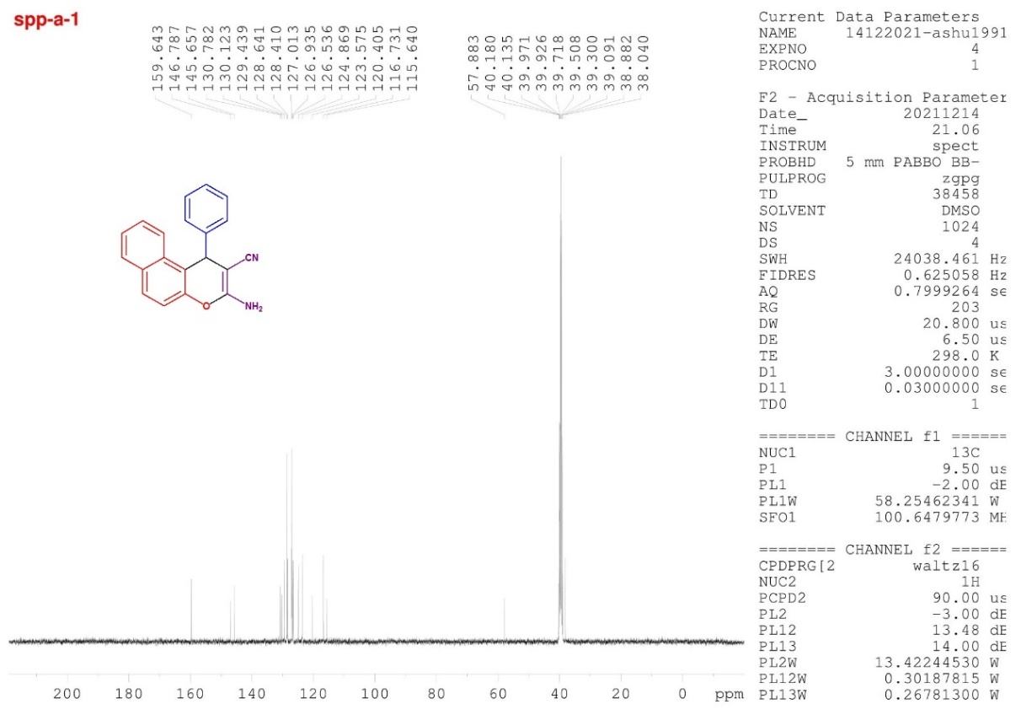

Fig.2 ¹³C-NMR spectra of compound 4a

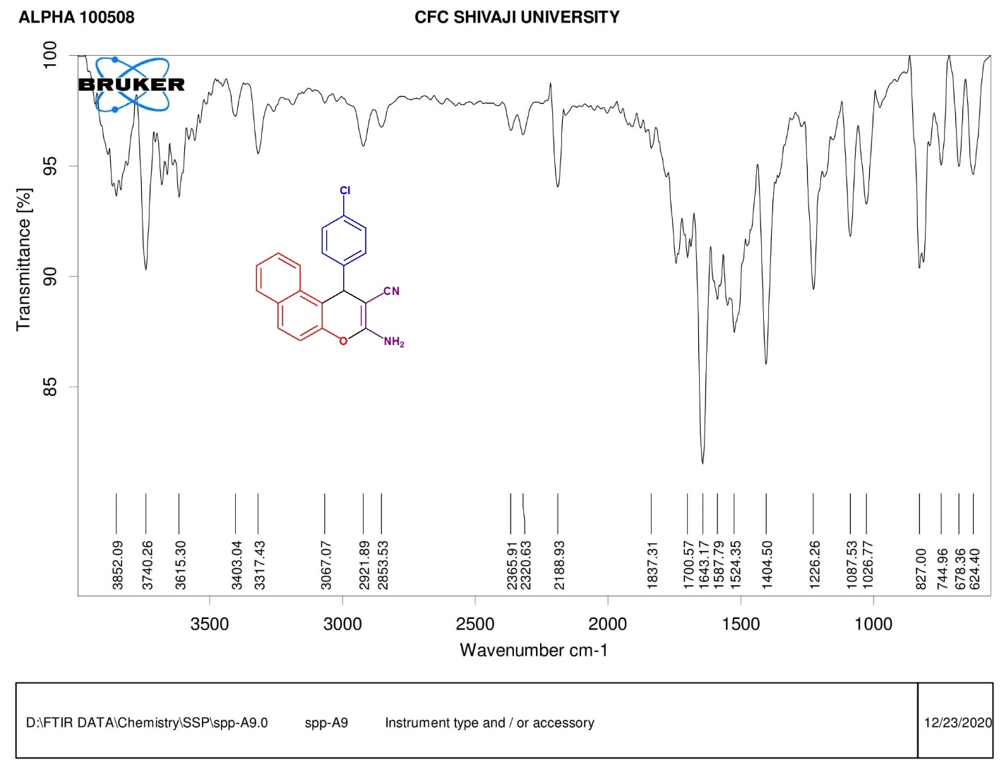
Fig.3 FTIR spectra of compound 4b
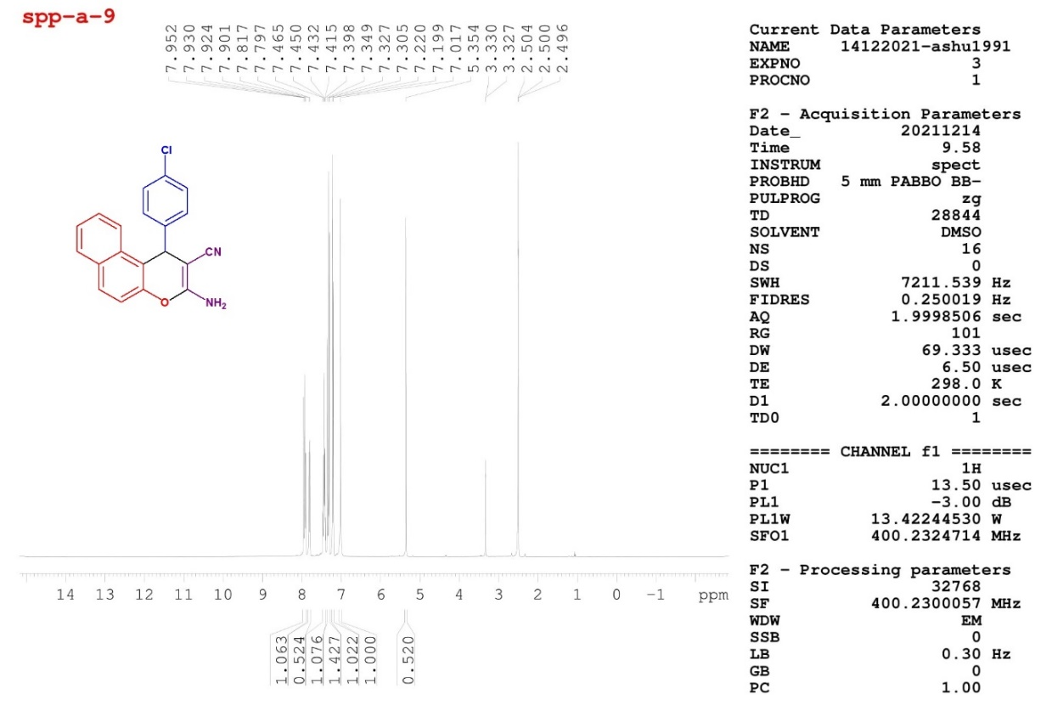
Fig.4 ¹H-NMR spectra of compound 4b
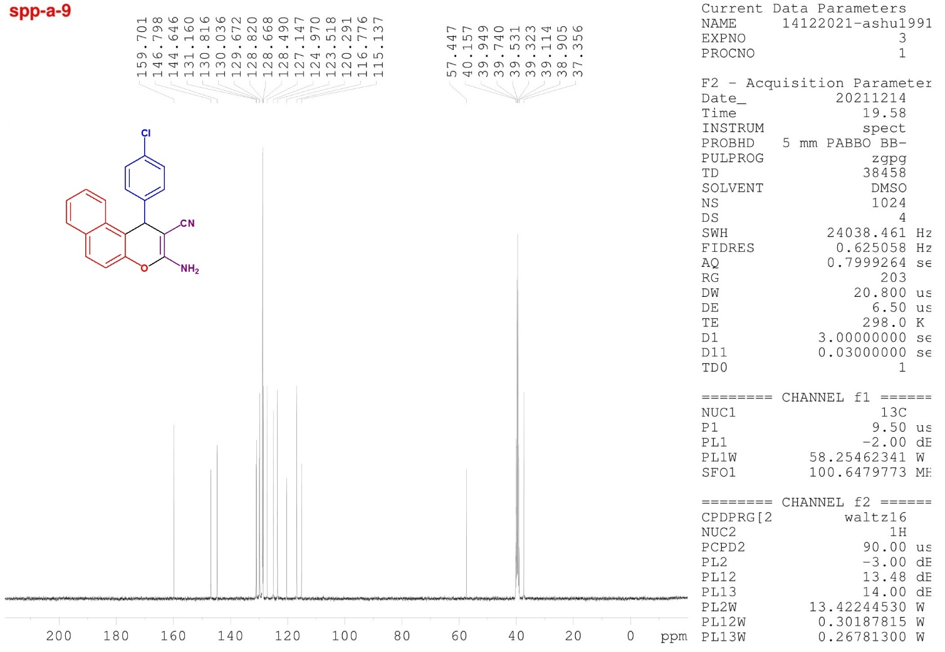

Fig. 5 ¹³C-NMR spectra of compound 4b
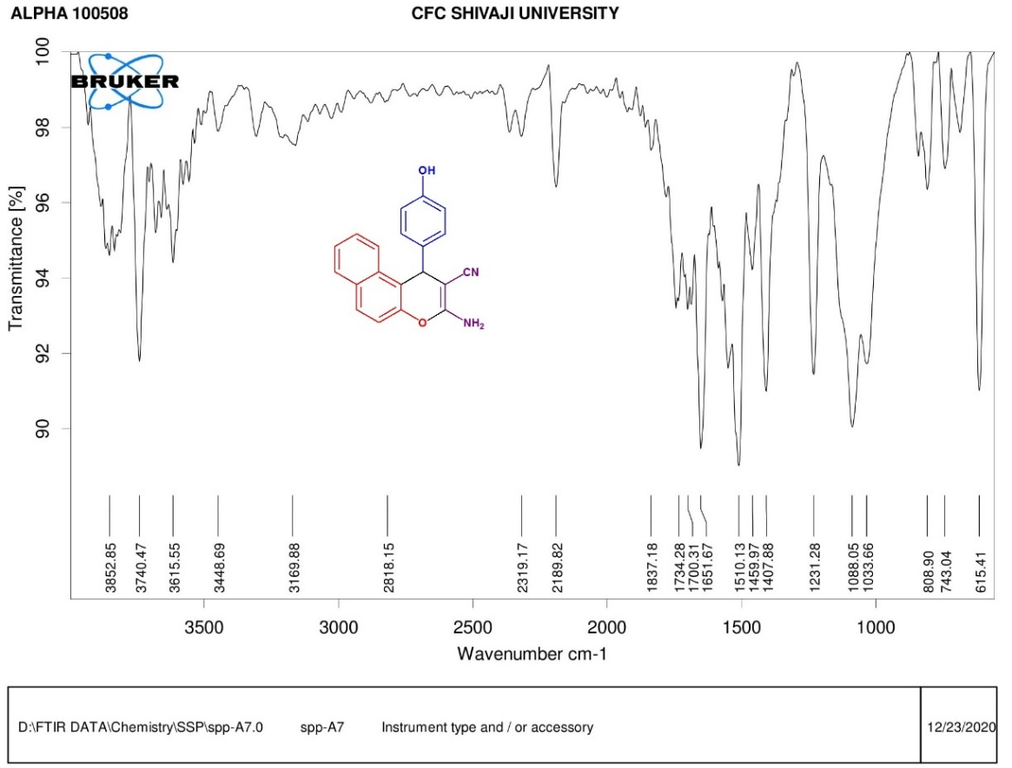
Fig. 6 FTIR spectra of compound 4c

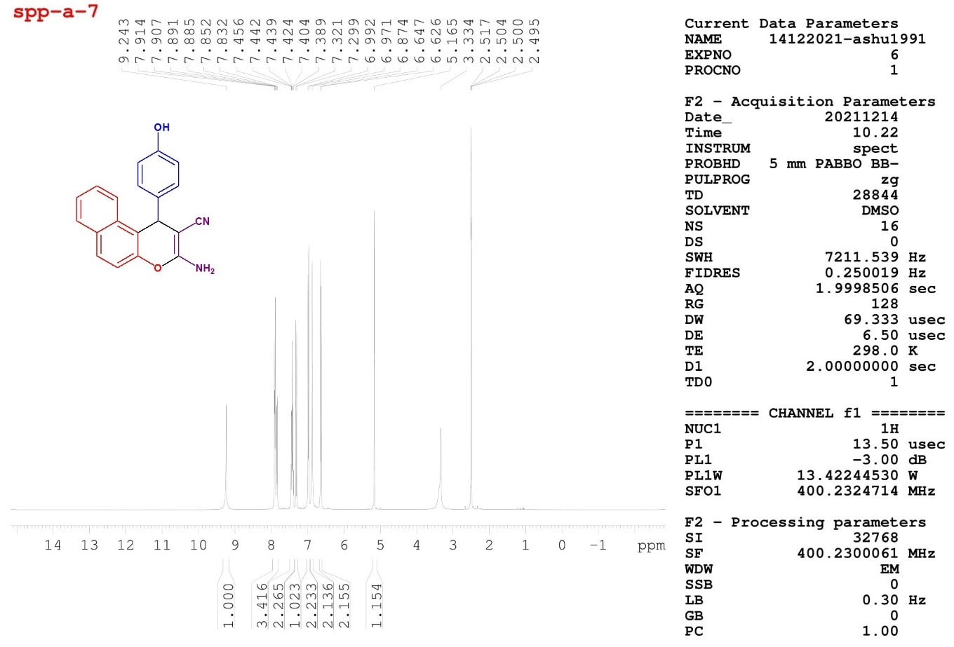
Fig.7 ¹H-NMR spectra of compound 4c
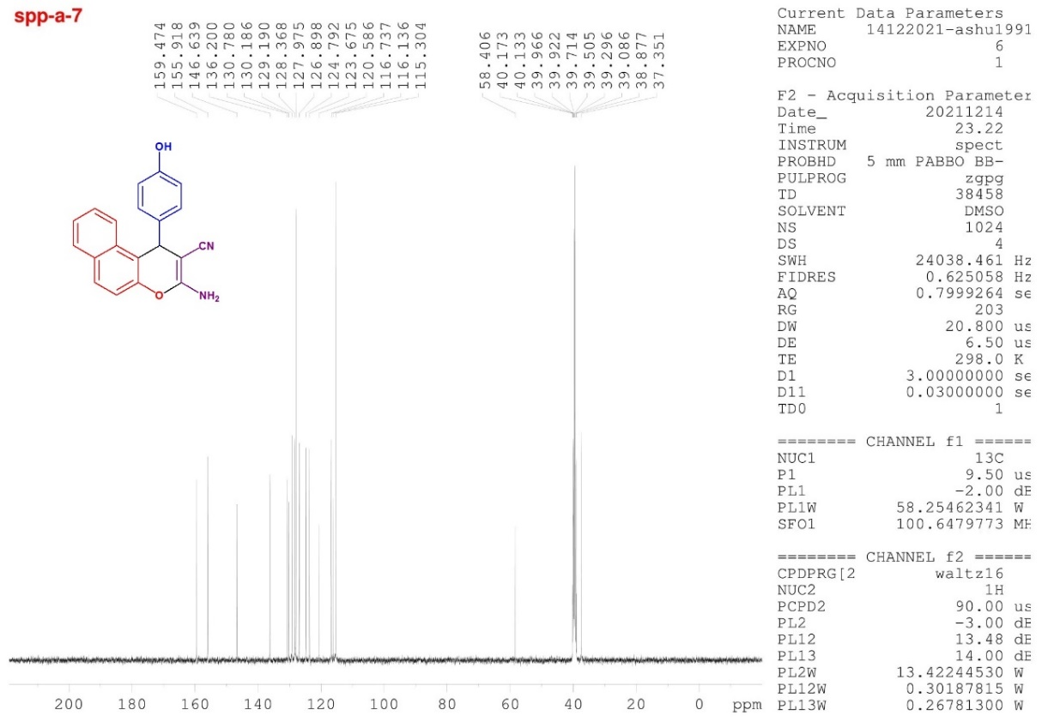

Fig.8 ¹³C-NMR spectra of compound 4c

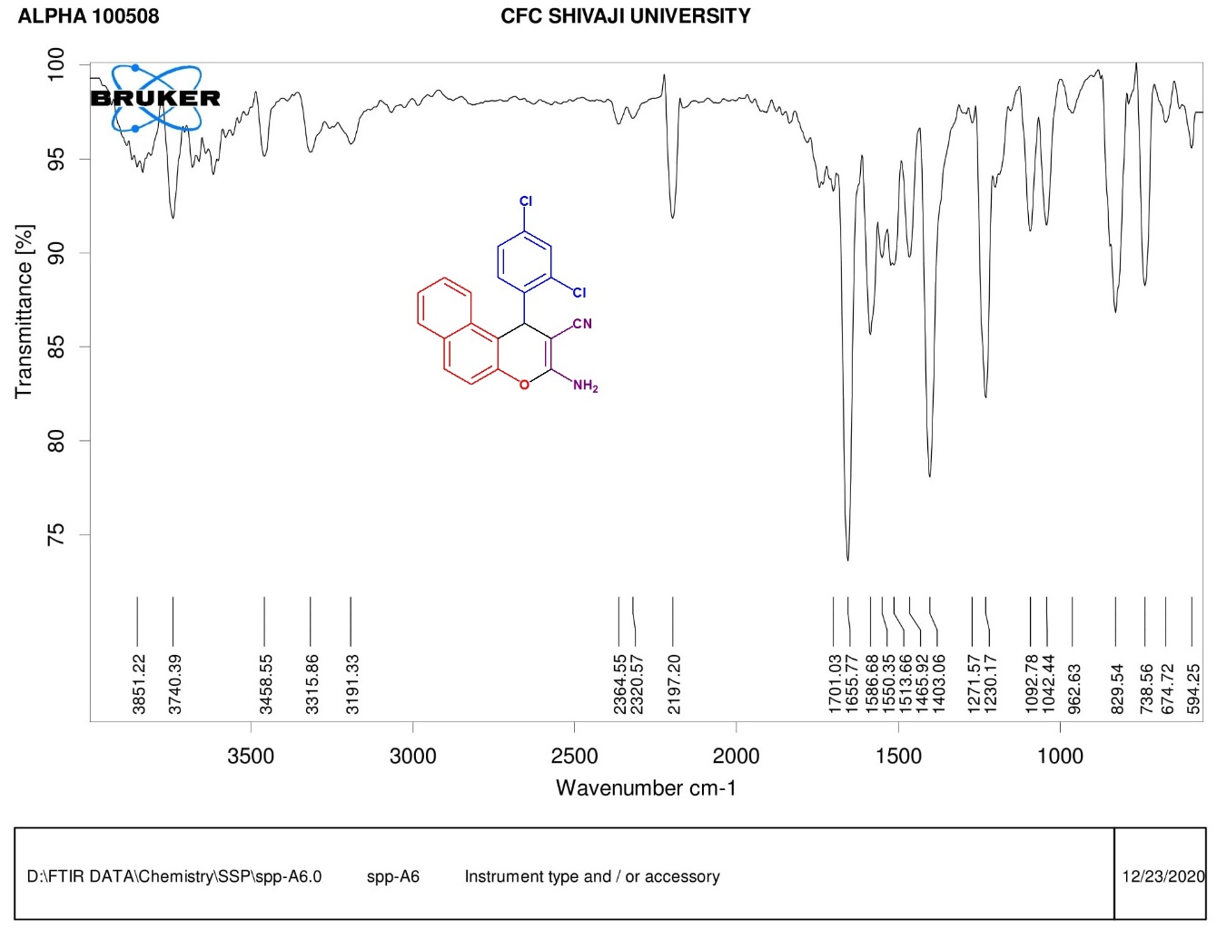
Fig.9 FTIR spectra of compound 4i
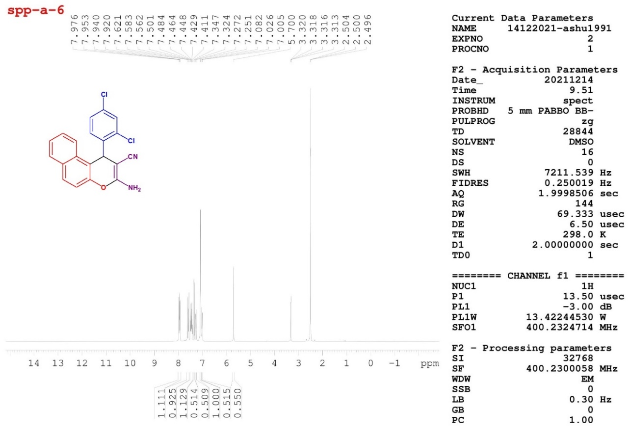
Fig.10 ¹H-NMR spectra of compound 4i
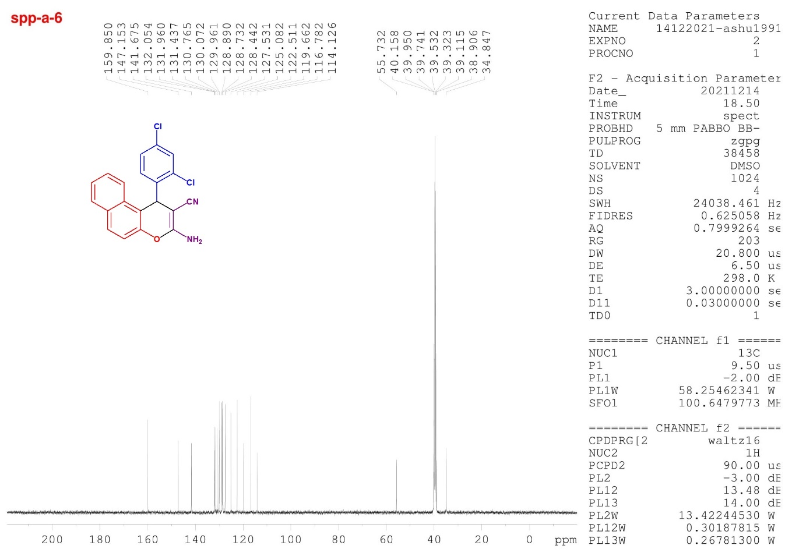

Fig.11 ¹³C-NMR spectra of compound 4i
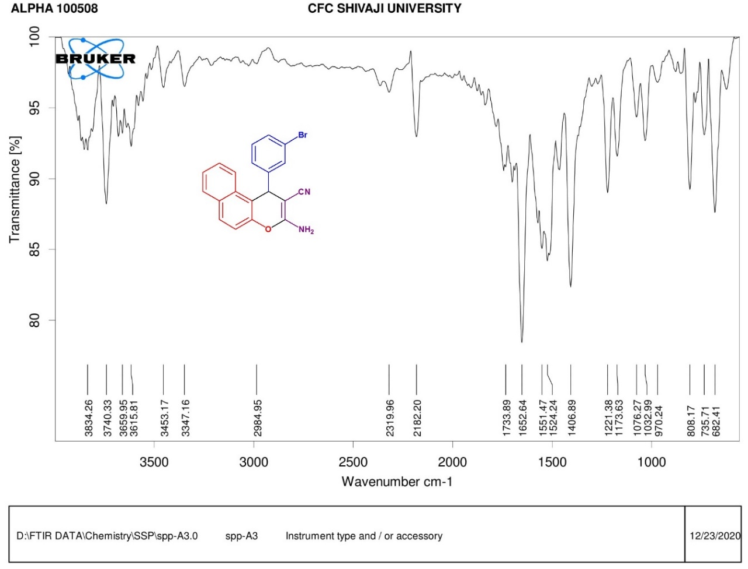
Fig.12 FTIR spectra of compound 4j
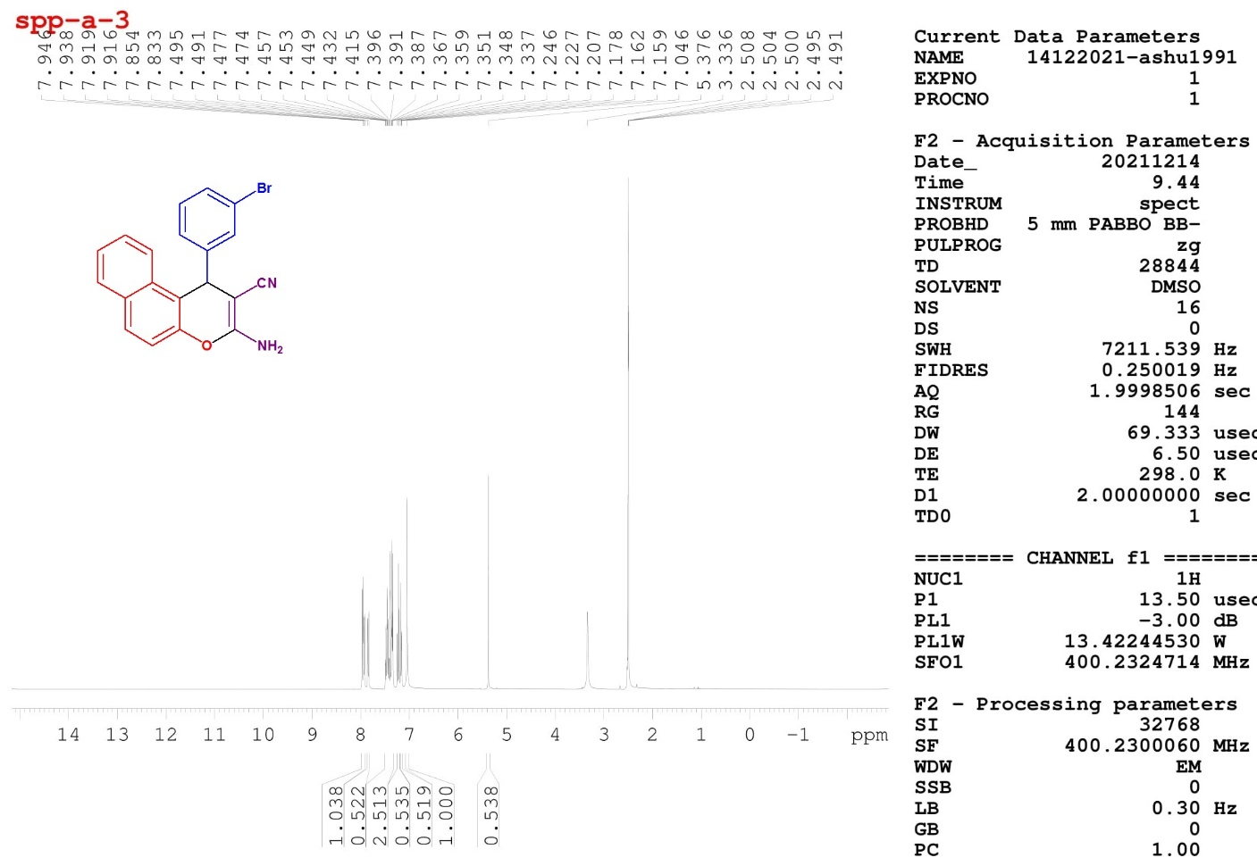
Fig.13 ¹H-NMR spectra of compound 4j
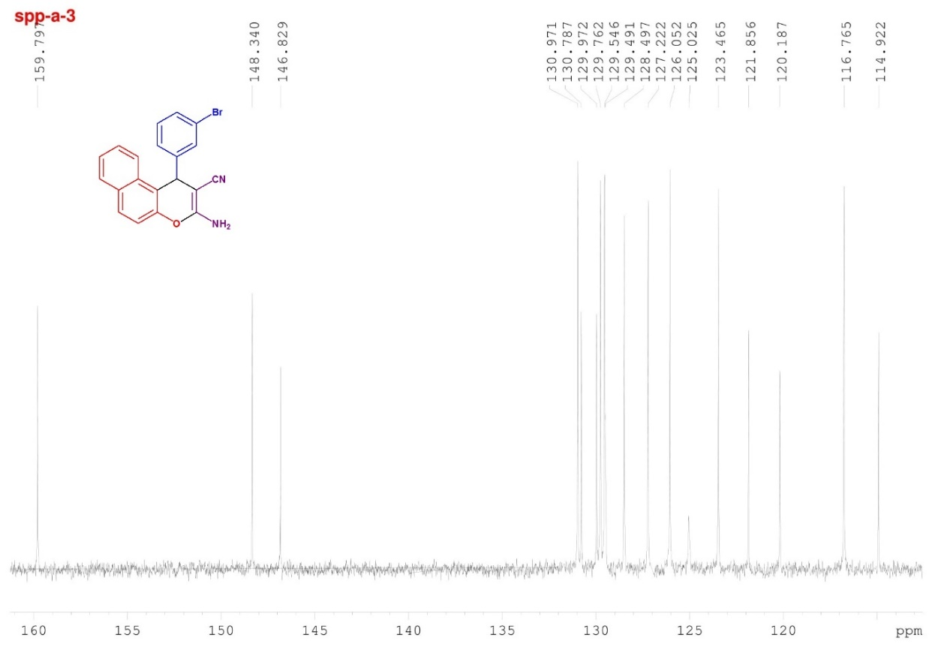

Fig.14 ¹³C-NMR spectra of compound 4j

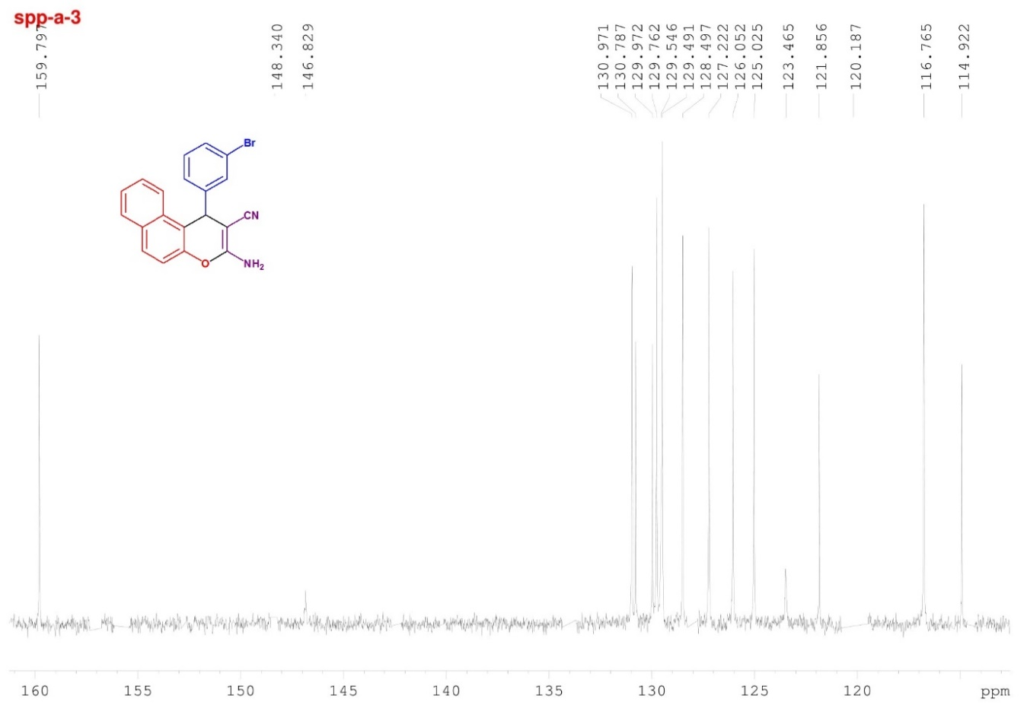

Fig.15 ¹³C-NMR spectra of compound 4j
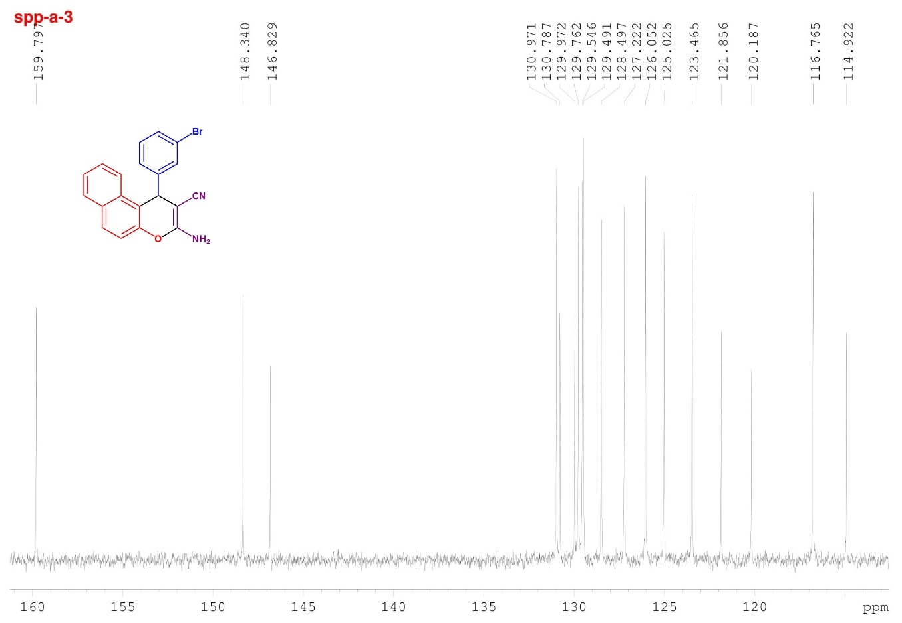

Fig.16 ¹³C-NMR spectra of compound 4j

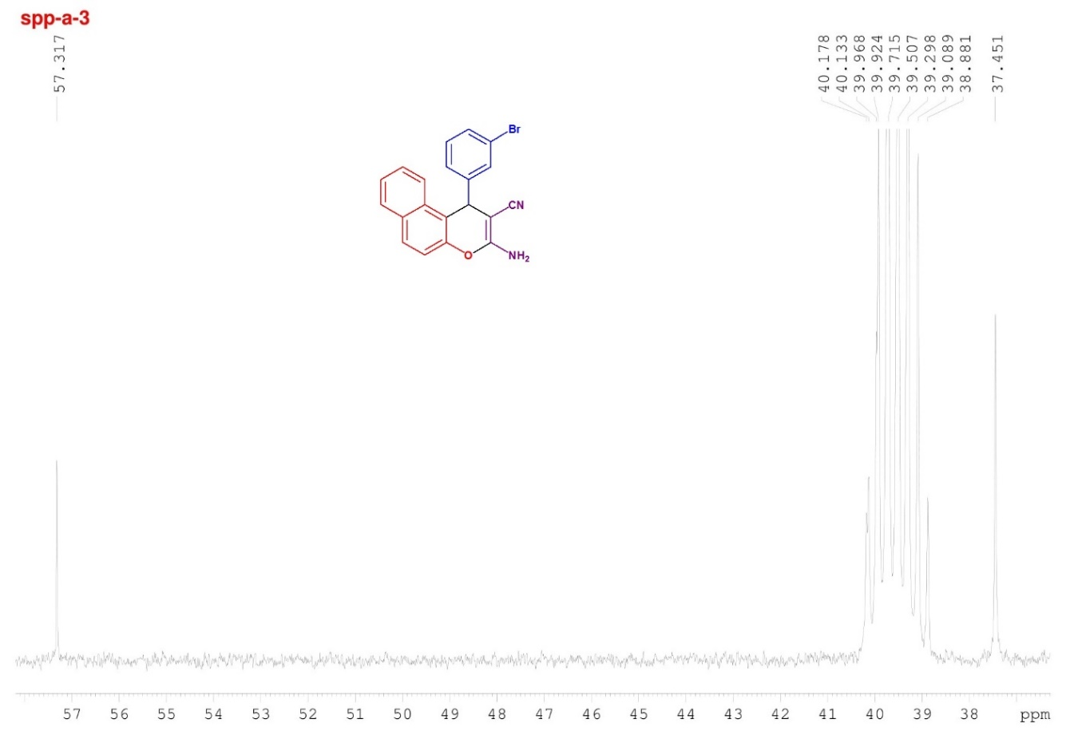

Fig.17 ¹³C-NMR spectra of compound 4j

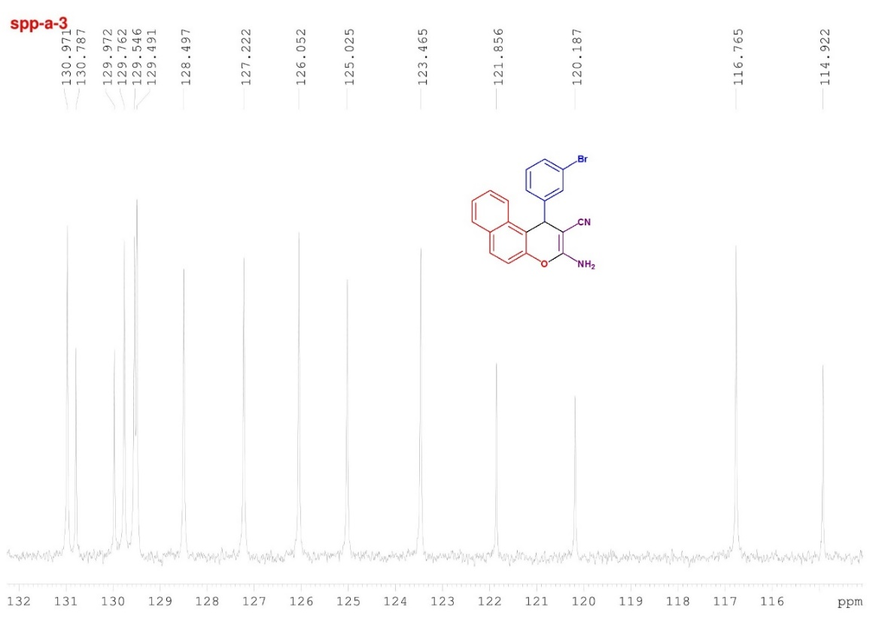

Fig.18 ¹³C-NMR spectra of compound 4j

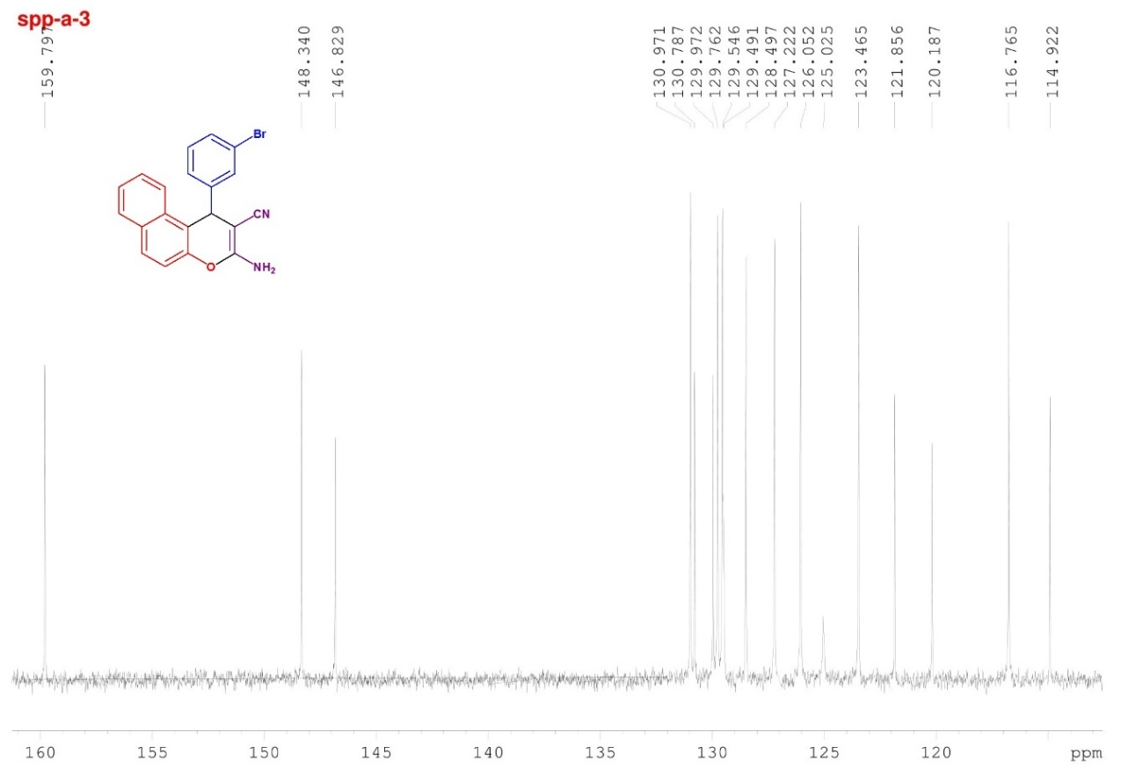

Fig.19 ¹³C-NMR spectra of compound 4j

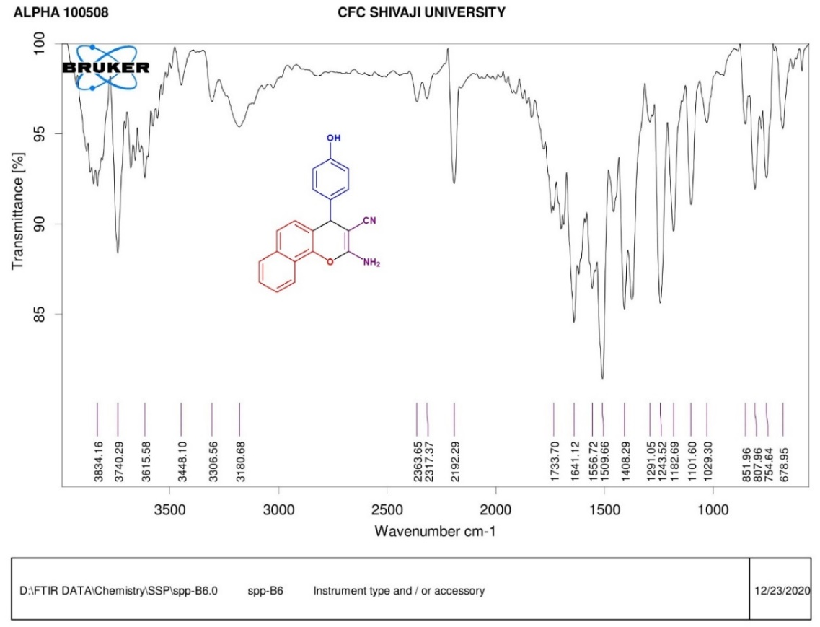
Fig.20 FTIR spectra of compound 5c
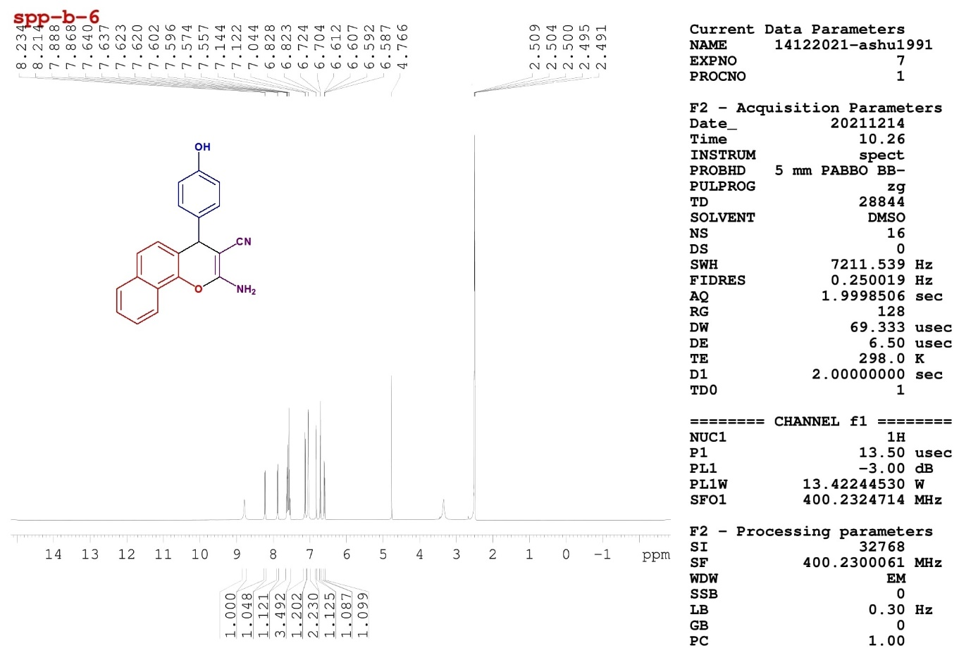
Fig.21 ¹H-NMR spectra of compound 5c
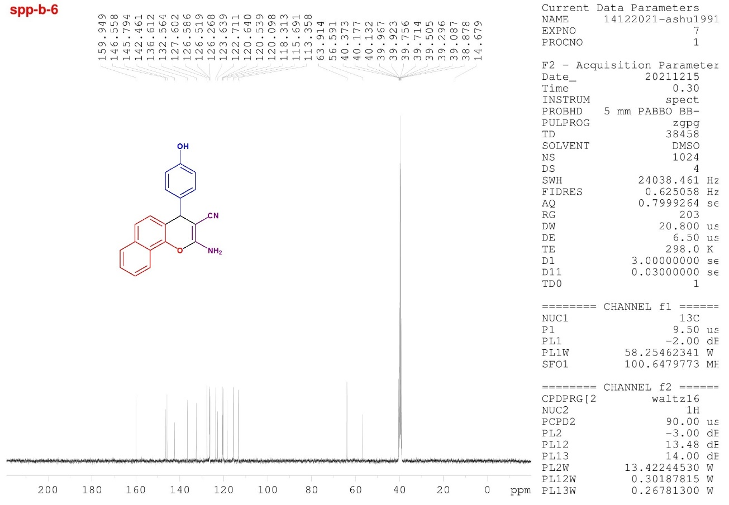

Fig.22 ¹³C-NMR spectra of compound 5c

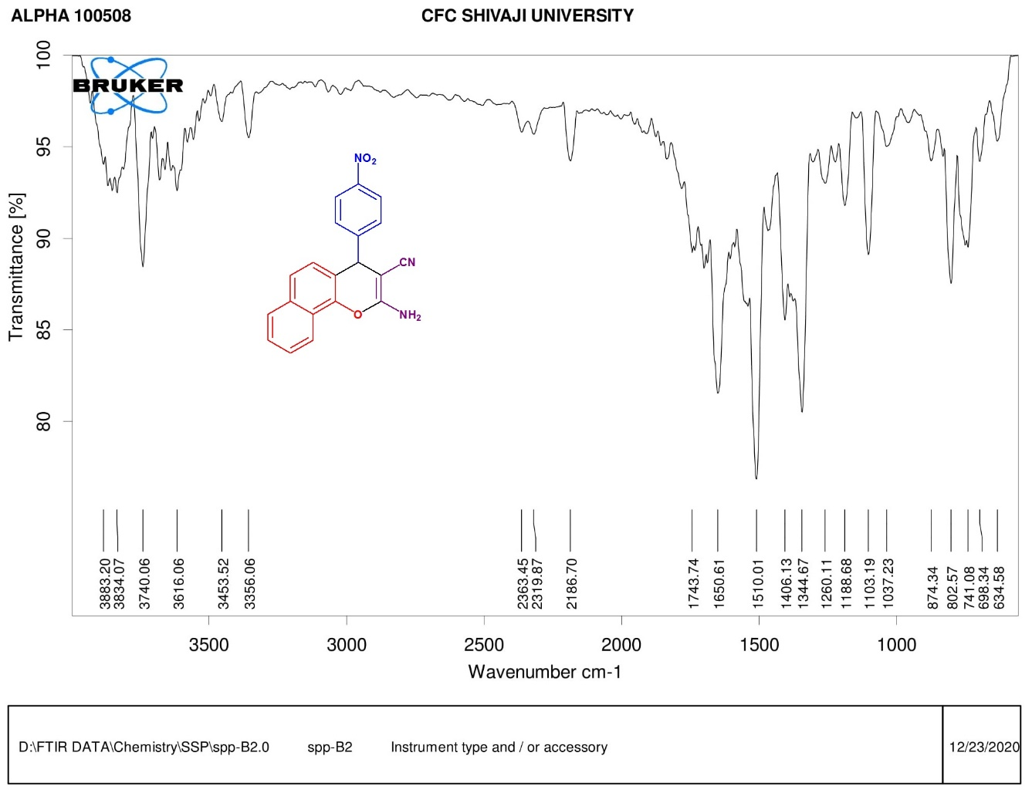
Fig.23 FTIR spectra of compound 5f
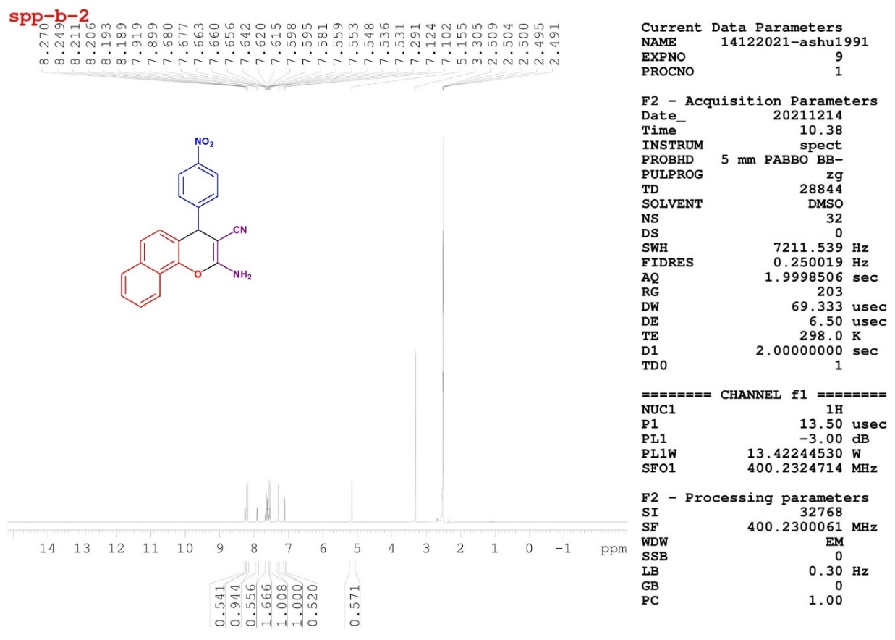
Fig.24 ¹H-NMR spectra of compound 5f
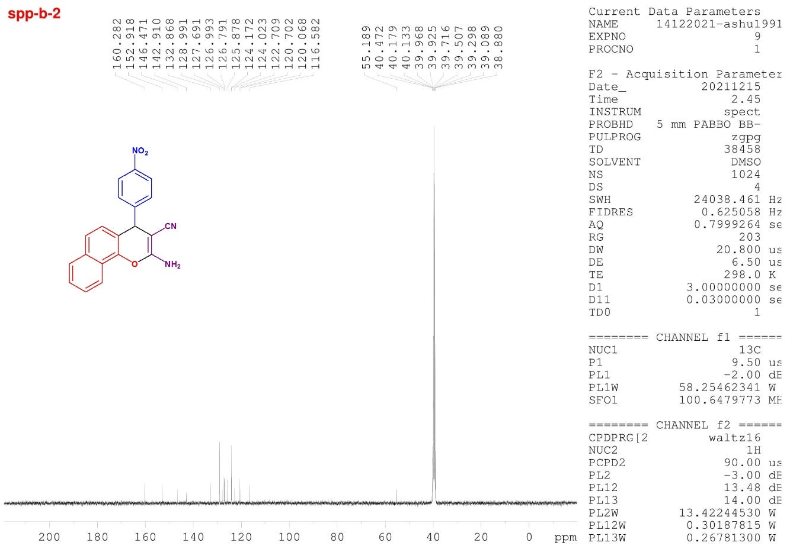

Fig.25 ¹³C-NMR spectra of compound 5f
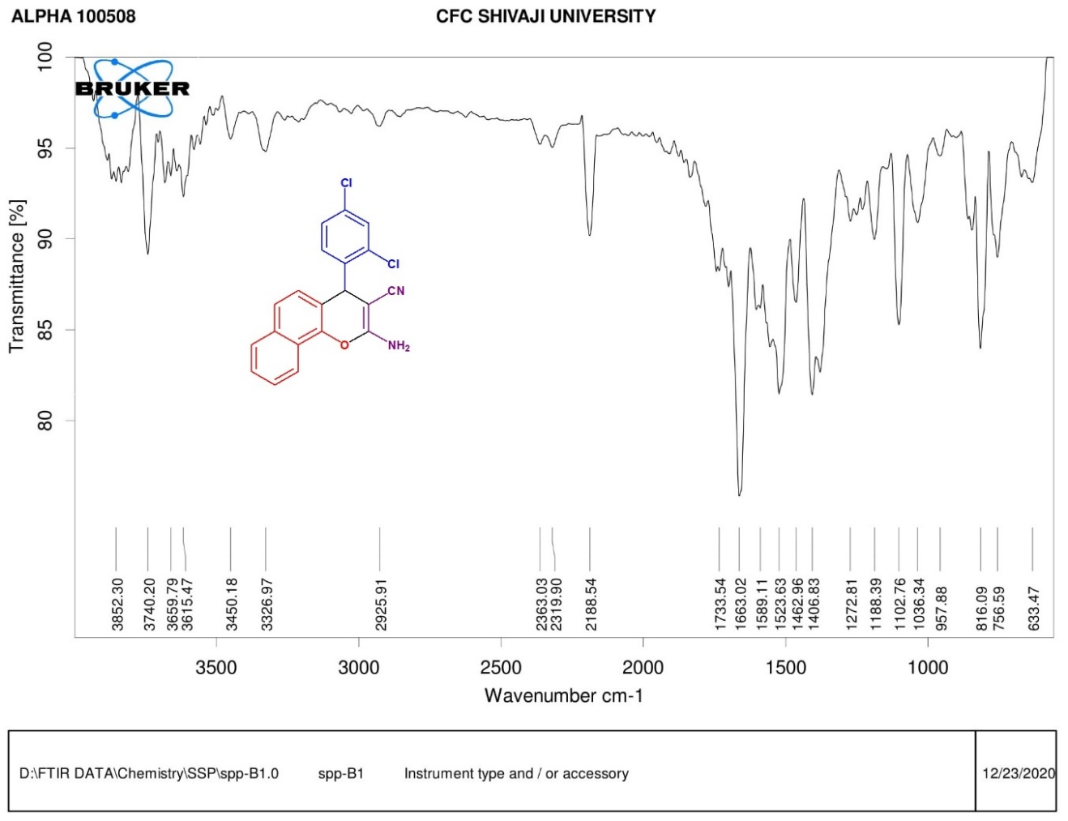
Fig.26 FTIR spectra of compound 5i

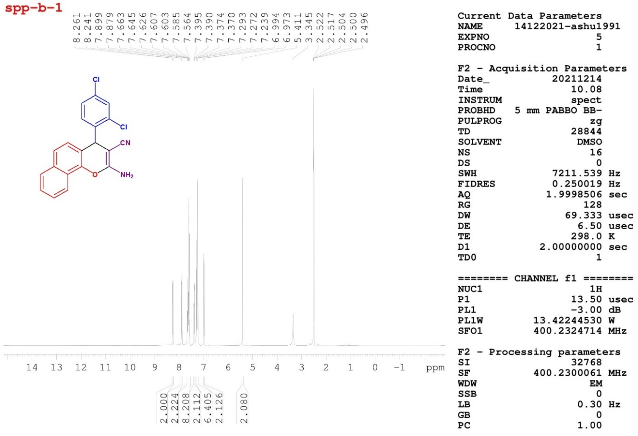
Fig.27 ¹H-NMR spectra of compound 5i
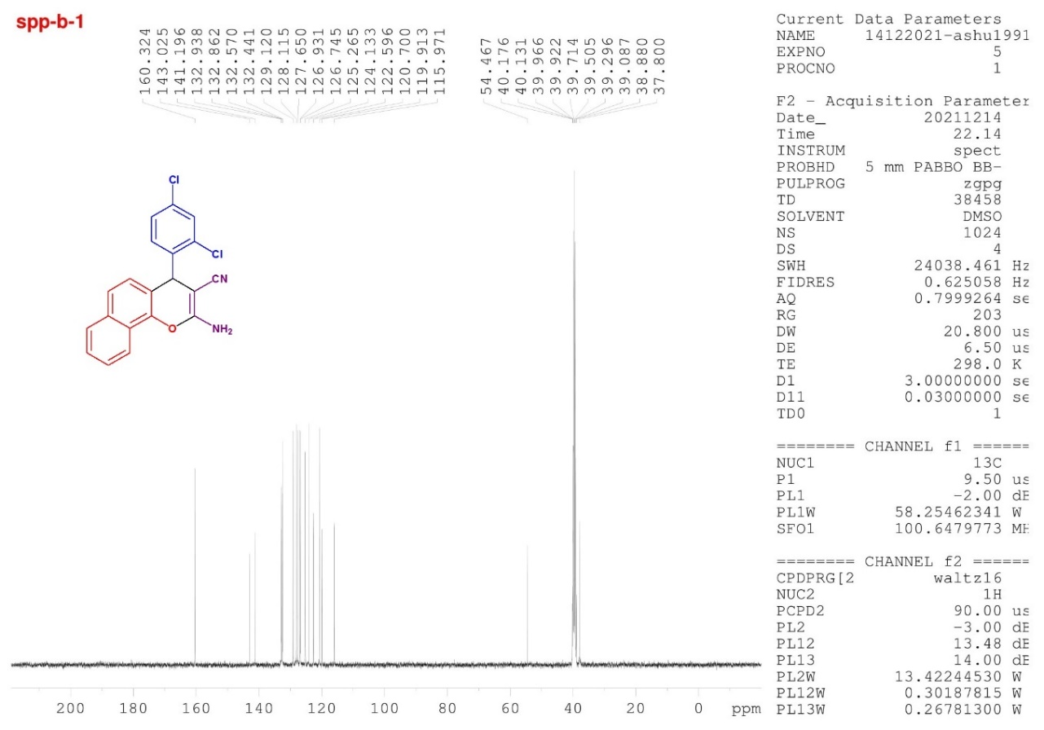
Fig.28 ¹³C-NMR spectra of compound 5i

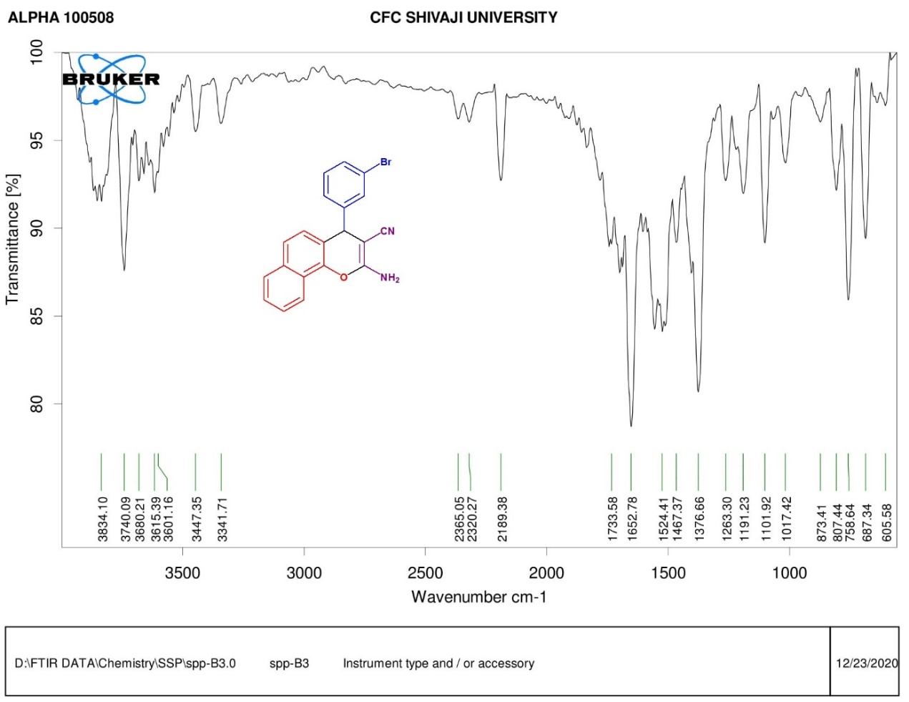
Fig.29 FTIR spectra of compound 5j
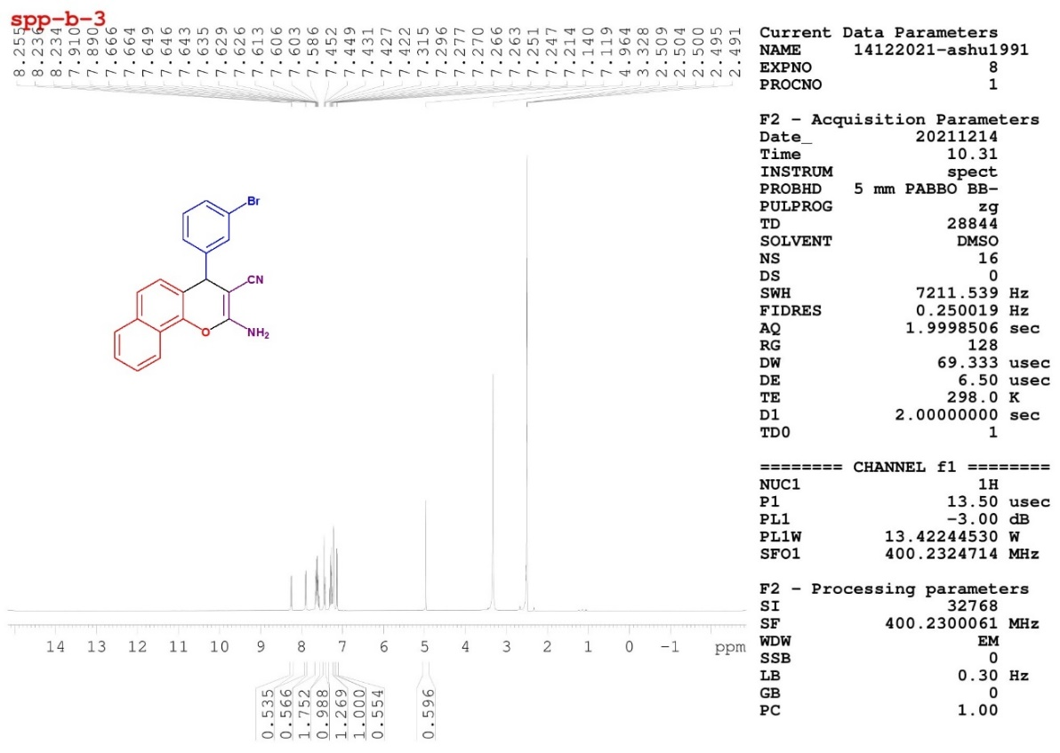
Fig.30 ¹H-NMR spectra of compound 5j

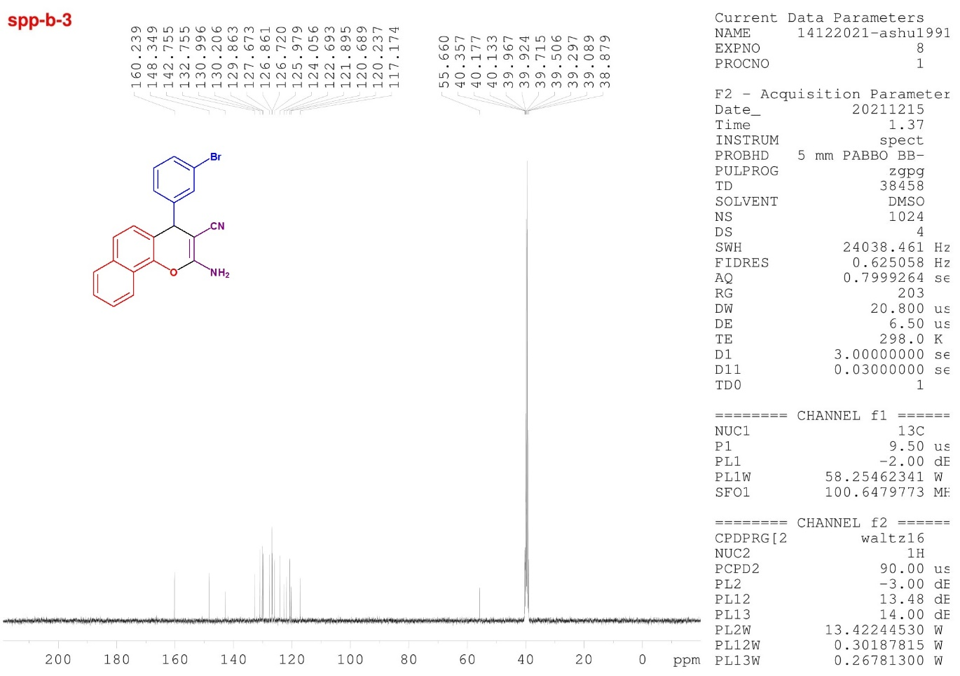

Fig.31 ¹³C-NMR spectra of compound 5j

