Supplementary figure 1
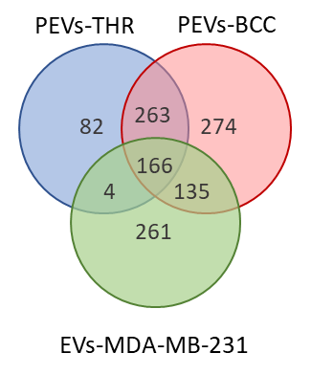
Figure S1
Venn diagram of proteins identified by LC-MS in PEVs samples and in MDA-MB-231 cell derived-extracellular vesicles (EVs-MDA-MB-231).

