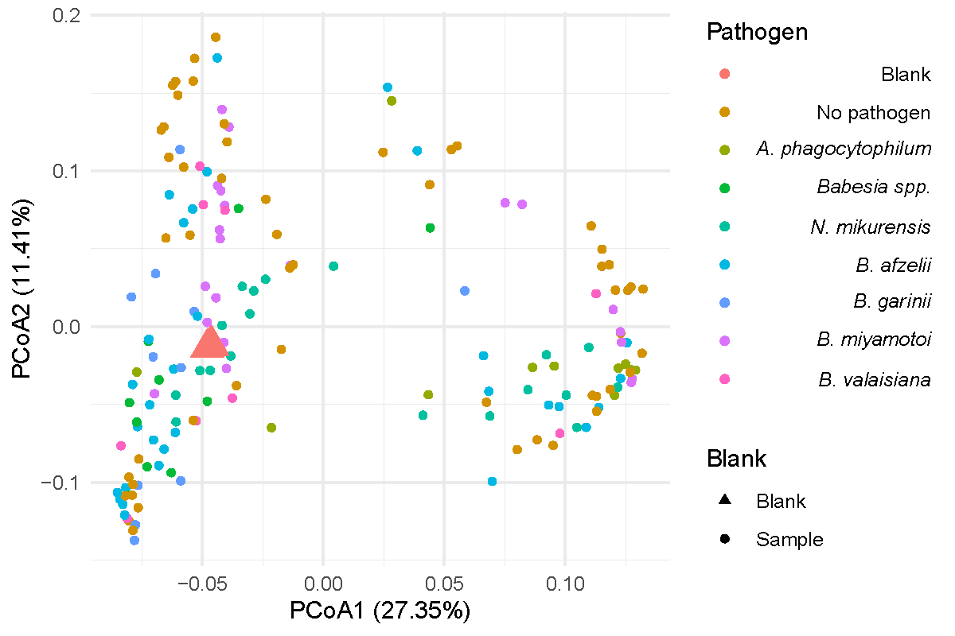

Figure S2. Principal Coordinate Analysis of Bray-Curtis dissimilarities for tick microbiomes compared to blanks. Counts were not corrected for 16S rRNA load. Individual ticks were screened for pathogens, pooled per pathogen, and subsequently subjected to microbiome analysis. Each sample colour reflects a pathogen. Three negative controls (blanks) are shown as a red triangle and group with many tick samples due to their similarity.

