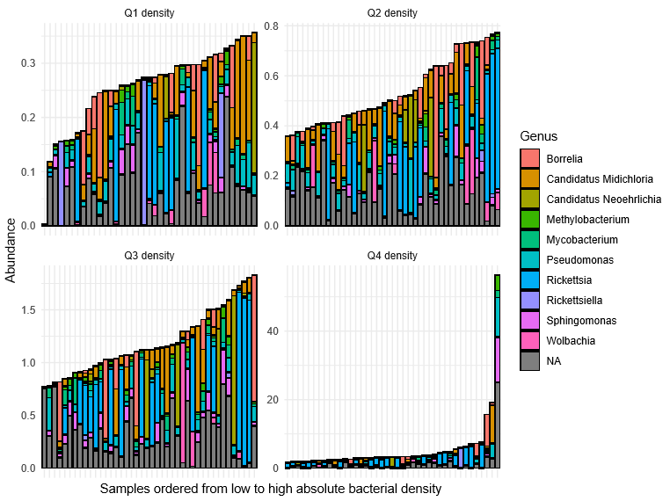

Figure S1. Abundances of the most abundant taxa, separated by quartiles of absolute bacterial density (16S rRNA content in ng/µL). The remaining taxa were binned in the synthetic ‘Other’ taxon. All abundances are scaled by the bacterial density. The genus Pseudomonas was also highly abundant in negative controls.

