Observation of a strong synergetic effect in the interfacial water response of binary mixtures of ionic and non-ionic surfactants
Sanghamitra Sengupta¹†, Rahul Gera¹†, Colin Egan^{2†}, Uriel N. Morzan², Jan Versluis¹, Ali Hassanali², Huib J. Bakker¹.
¹AMOLF, Science Park 102, 1098 XK, Amsterdam, Netherlands
²Condensed Matter and Statistical Physics Centre, International Centre for Theoretical Physics, Strada Costiera 11, 34151, Trieste, Italy.
Corresponding author’s email: s.sengupta@amolf.nl
†The authors have contributed equally to the work.

Supplementary Information
- HDVSFG spectra of pure SDS on bare water.
- Effects of heating on interfacial structural degradation.
- Comparison of decompositions of free energy profiles into enthalpic and entropic components for both systems simulated.
- Energy decomposition of DS⁻ adsorption to air-C₁₂E₆-water interface vs bare air-water interface.
- Raw average potential energy data illustrating the averaging method.

SI 1: HDVSFG spectra of pure SDS solutions at the water interface
The HDVSFG spectra were collected from the interface from pure SDS solutions in water. The concentrations of the SDS solutions that are shown here are the same as those used in the main manuscript in figure 2. We observed a steady increase in the water signal with increasing SDS concentration from 700 nM (red) to 70 µM (dark grey). No asymmetric CH₃ band at 2960 cm⁻¹ was observed indicating that in these concentrations of bulk SDS a packed monolayer doesn’t form, unlike the binary mixture data.
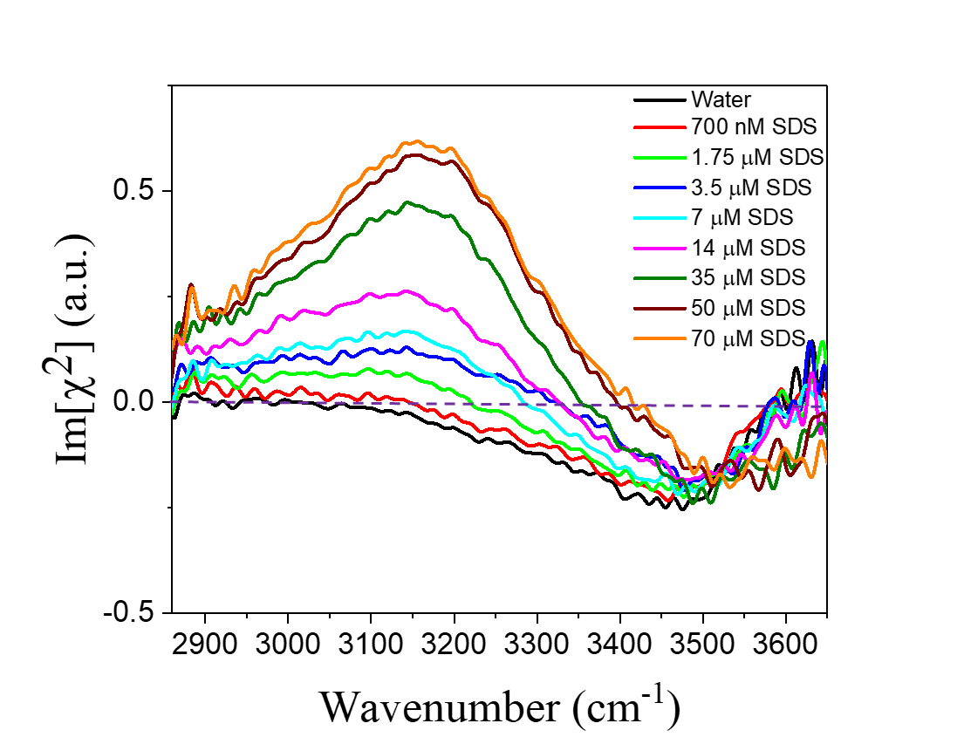
Figure 1: Heterodyne detected spectra of pure SDS solutions of different concentrations varied from 700 nM to 70 µM. The spectra showed a steady increase in the water signal with increasing SDS concentration.

SI 2: Effects of heating on interfacial structural degradation
We have controlled the infrared (IR) power and reduced it to 5 mW from 8 mW to check that any heat-induced effects are observed on the interface of the binary mixture. Instead of an entire range of concentrations, we chose 70 µM SDS in presence of 70 µM C₁₂E₆ and compared the result with 70 µM C₁₂E_{6.} The concentration of 70 µM of SDS was chosen due to a significant increase in water signal compared to the 70 µM C₁₂E₆. Also, compared to the lower SDS concentrations, at this concentration more SDS molecules are expected to be at the surface and hence more prone to show any heat-induced effect if any. Each sample data are an average of three individual spectrums acquired for 90 seconds each. We haven’t observed any change in spectral features or within the concentration series, which indeed proves that there is no heat-induced effect for the binary mixture between the 5 mW to 8 mW IR pulse power range. Additionally, the ~ 3 times increase in the water signal between 70 µM C₁₂E₆ with and without 70 µM SDS remained the same for both 5 mW and 8 mW experimental conditions.
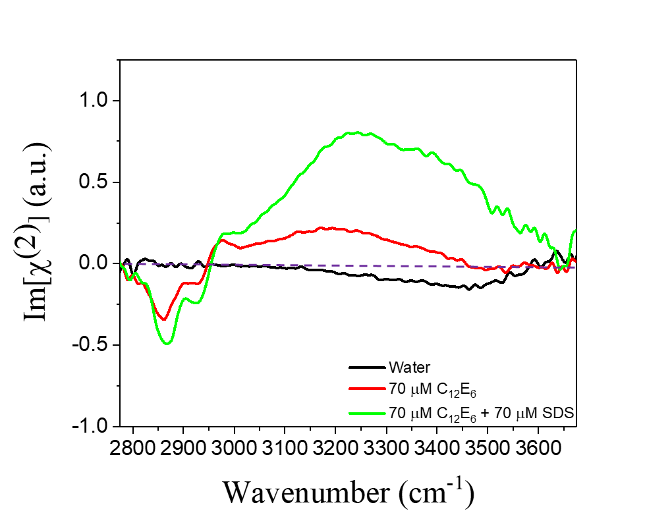

Figure 2: HDVSFG spectra of pure water (black spectrum), 70 µM C₁₂E₆ (red spectrum), and 70 µM C₁₂E₆ plus 70 µM SDS (green spectrum) collected at 5 mW infrared power. The spectra don’t show any substantial change in the shape and the relative intensity ratio between red and green spectra.

SI 3: Comparison of decompositions of free energy profiles into enthalpic and entropic components for both systems simulated.
The figures below depict the decomposition of free energy changes calculated from the MD simulation results for both SDS adsorption on the bare-water interface (left) and the water-C₁₂E₆ interface (right). In both the panels the blue, green, and orange curves represent the free energy change, potential energy, and +TS for DS⁻ adsorption process at C₁₂E₆ at CMC and bare-water interfaces respectively. The panels show that the free energy change for DS⁻ adsorption at the C₁₂E₆ is much more negative/attractive compared to bare water ( -45 k_{B}T).

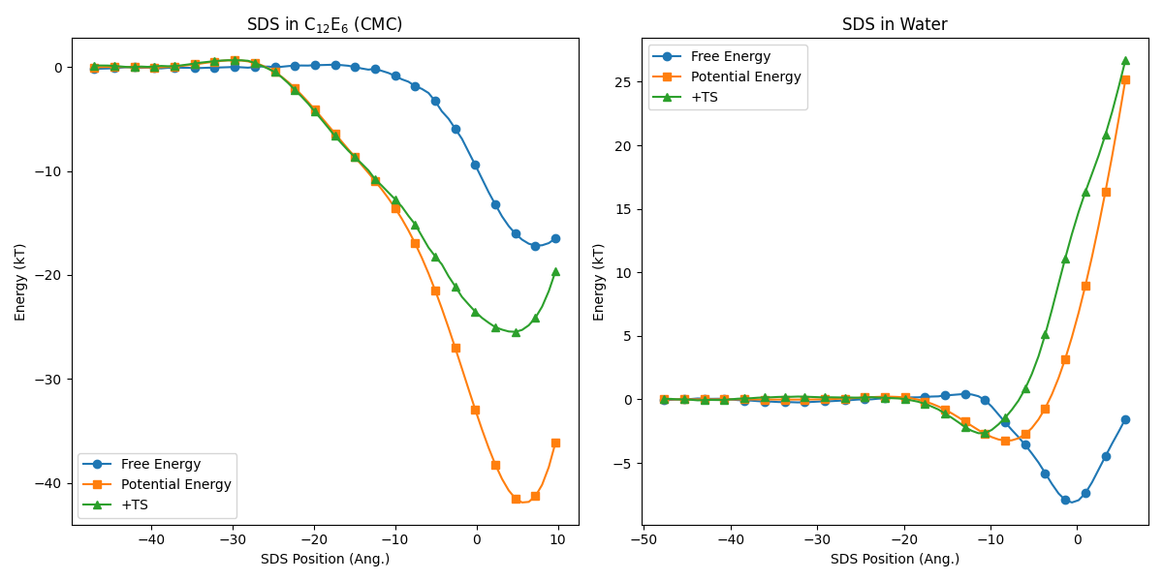
Figure 3: Comparison between free energy decompositions into enthalpic and entropic components for the DS⁻ ion adsorbing to the air-C₁₂E₆-water interface (left) and DS⁻ adsorbing to the bare air-water interface (right).

SI 4: Energetics breakdown of DS⁻ adsorption to air-C₁₂E₆-water interface vs bare air-water interface.
The two panels show the decompositions of the $ΔE$ due to moving DS⁻ from the bulk water phase to the air-C₁₂E₆-water interface (top panel) and the bare air-water interface (bottom panel). A negative $ΔE$ for a given energy term corresponds to an attractive component of the total system energy that drives DS⁻ to the interface from the bulk. For the calculations of $ΔE=E_{\text{int}}-E_{\text{bulk}}$ for each term, the corresponding $E_{\text{bulk}}$ was taken as the average potential energy over the range where the free energy is constant, and $E_{\text{int}}$ was calculated as an ensemble average over the interfacial region with the (normalized) Boltzmann weight $p\left(x\right)∝\text{exp}[-F\left(x\right)/k_{B}T]$, where $F(x)$ is the free energy along the DS⁻ position computed with umbrella sampling.
The various decomposition terms are organized into solvent-solvent (vv) and solute-solvent (uv) components, with water, C₁₂E₆, and Na⁽⁺⁾ corresponding to the solvent, and DS⁻ corresponding to the solute. The sum of the solvent-solvent and the sum of the solute-solvent components are each shown as well. The black bars correspond to the total system $ΔE$, representing the total change in enthalpy as a result of DS⁻ adsorption to each interface.

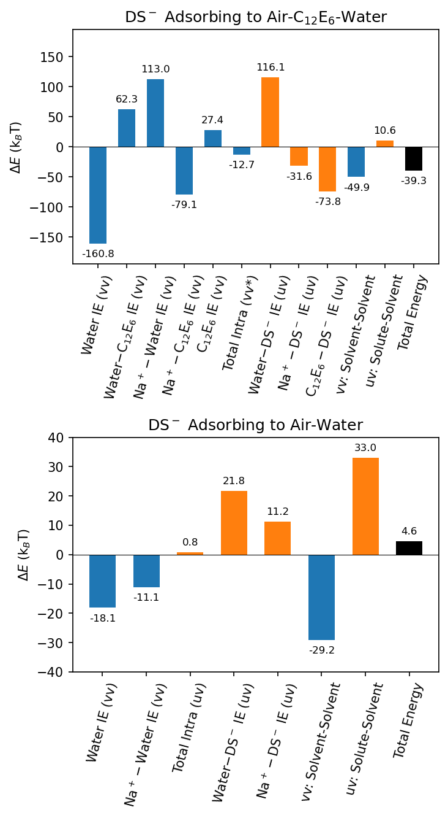
Figure 4: The top panel shows the decompositions for the total energy of DS⁻ adsorption to the air-C₁₂E₆-water interface and the bottom panel depicts the same for the bare air-water interface. The resultant value for the total energy (black bars) for the first process is -39.3 k_{B}T which is more negative or attractive compared to the later adsorption process is +4.6 k_{B}T.

SI 5: Raw average potential energy data illustrating the averaging method.

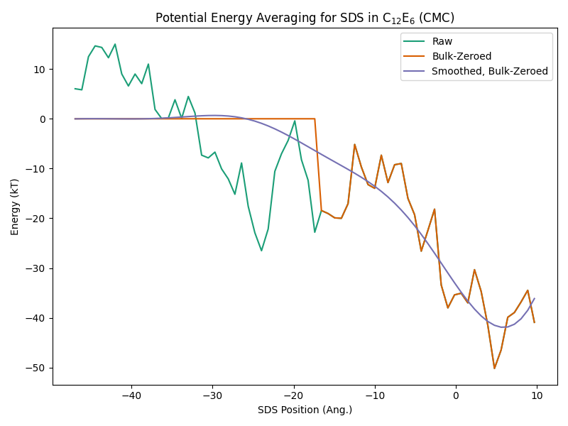
Figure 5: Average total system potential energy as a function of DS⁻ ion position relative to the Gibbs dividing interface for DS⁻ adsorbing to the air-C₁₂E₆-water interface. The green curve shows the raw data (averaged into 70 bins), and the orange curve shows the raw data with the bulk values zeroed to the average bulk value (i.e. the potential energy is averaged over all windows in which the free energy is flat), and the purple curve shows the smoothed “Bulk-Zeroed” data using the Savitzky-Golay filter with 3rd-degree polynomials and a window length of 1.31 nm.

