Plasma GAS6 Predicts Mortality Risk in Acute Heart Failure Patients: Insights from the DRAGON-HF trial
Teng Ma^{1,2*}, Rongrong Huang^{1*}, Yangbo Lv³, Yifan Liu¹, Xin Pan⁴, Jia Dong⁵, Di Gao⁶, Zeyu Wang¹, Fenglei Zhang², Chunxi Yan², Sang-Bing Ong^{7,8,9,10}, Yang Su¹, Dachun Xu^{1,2#}

SUPPLEMENTARY MATERIAL

Supplementary Table 1 Univariate Cox regression between variables and clinical outcomes.
 | 95% CI | P value
All cause death
GAS6 | 1.18(1.13,1.22) | <0.001
NTproBNP | 2.15(1.91,2.42) | <0.001
TnT | 1.26(1.18,1.34) | <0.001
CRP | 1.19(1.08,1.32) | <0.001
Age | 1.05(1.04,1.07) | <0.001
Sex | 0.85(0.63,1.14) | 0.27
BMI | 0.93(0.89,0.97) | <0.001
Smoking | 0.98(0.7,1.38) | 0.91
Hypertension | 0.96(0.71,1.28) | 0.76
Diabetes | 1.41(1.06,1.87) | 0.02
Arterial Fibrillation | 0.68(0.48,0.96) | 0.03
eGFR | 0.97(0.97,0.98) | <0.001
Diuretics | 3.84(2.75,5.36) | <0.001
Spironolactone | 2.49(1.85,3.34) | <0.001
Cardiovascular death
GAS6 | 1.19(1.13,1.24) | <0.001
NTproBNP | 2.36(2.04,2.73) | <0.001
TnT | 1.29(1.19,1.39) | <0.001
CRP | 1.22(1.08,1.39) | <0.001
Age | 1.04(1.02,1.06) | <0.001
Sex | 0.85(0.59,1.23) | 0.39
BMI | 0.93(0.88,0.98) | 0.01
Smoking | 1.01(0.67,1.53) | 0.97
Hypertension | 0.93(0.65,1.34) | 0.7
Diabetes | 1.69(1.2,2.4) | <0.001
Arterial Fibrillation | 0.67(0.44,1.02) | 0.06
eGFR | 0.97(0.96,0.98) | <0.001
Diuretics | 5.17(3.29,8.11) | <0.001
Spironolactone | 2.73(1.88,3.95) | <0.001

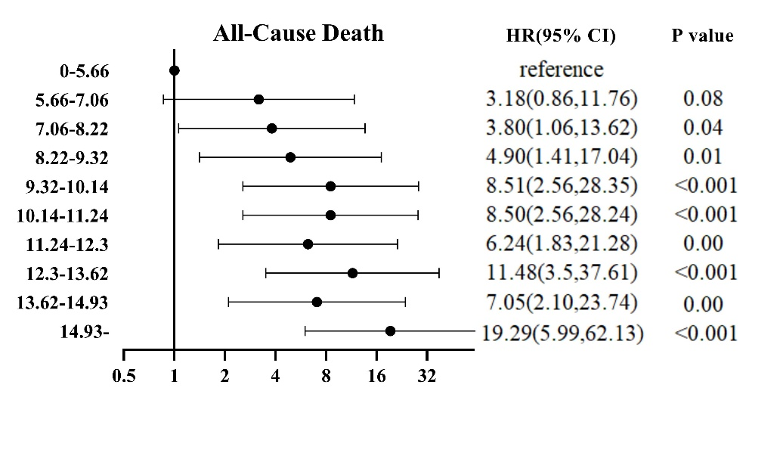
Supplementary Figure 1 Hazard Ratios for All-Cause Death or Cardiovascular death According to GAS6 Deciles
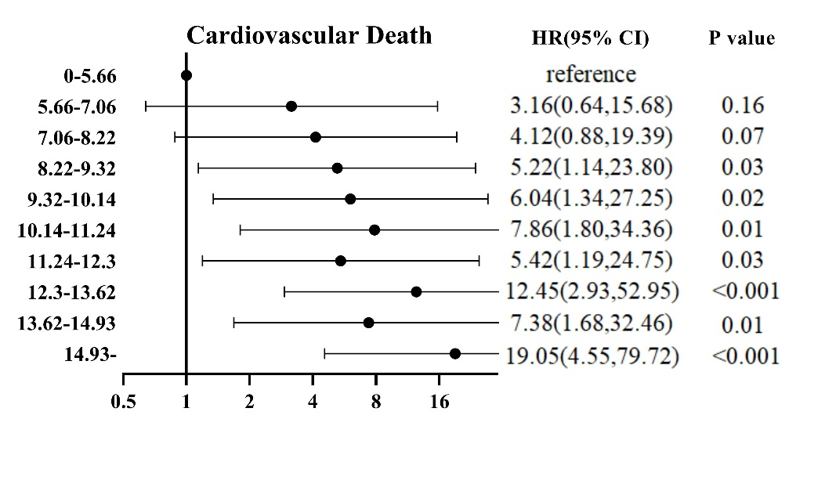
(A)
(B)

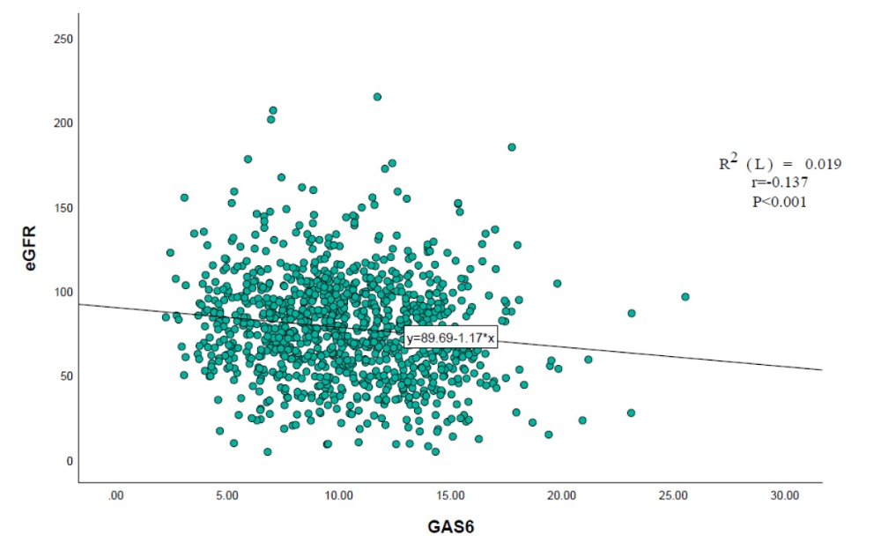
Supplementary Figure 2: Correlations between GAS6 and eGFR levels in the whole population indicated by scatter plot.

