Table 1. List of selected Meteorological Stations used for collection of observational data
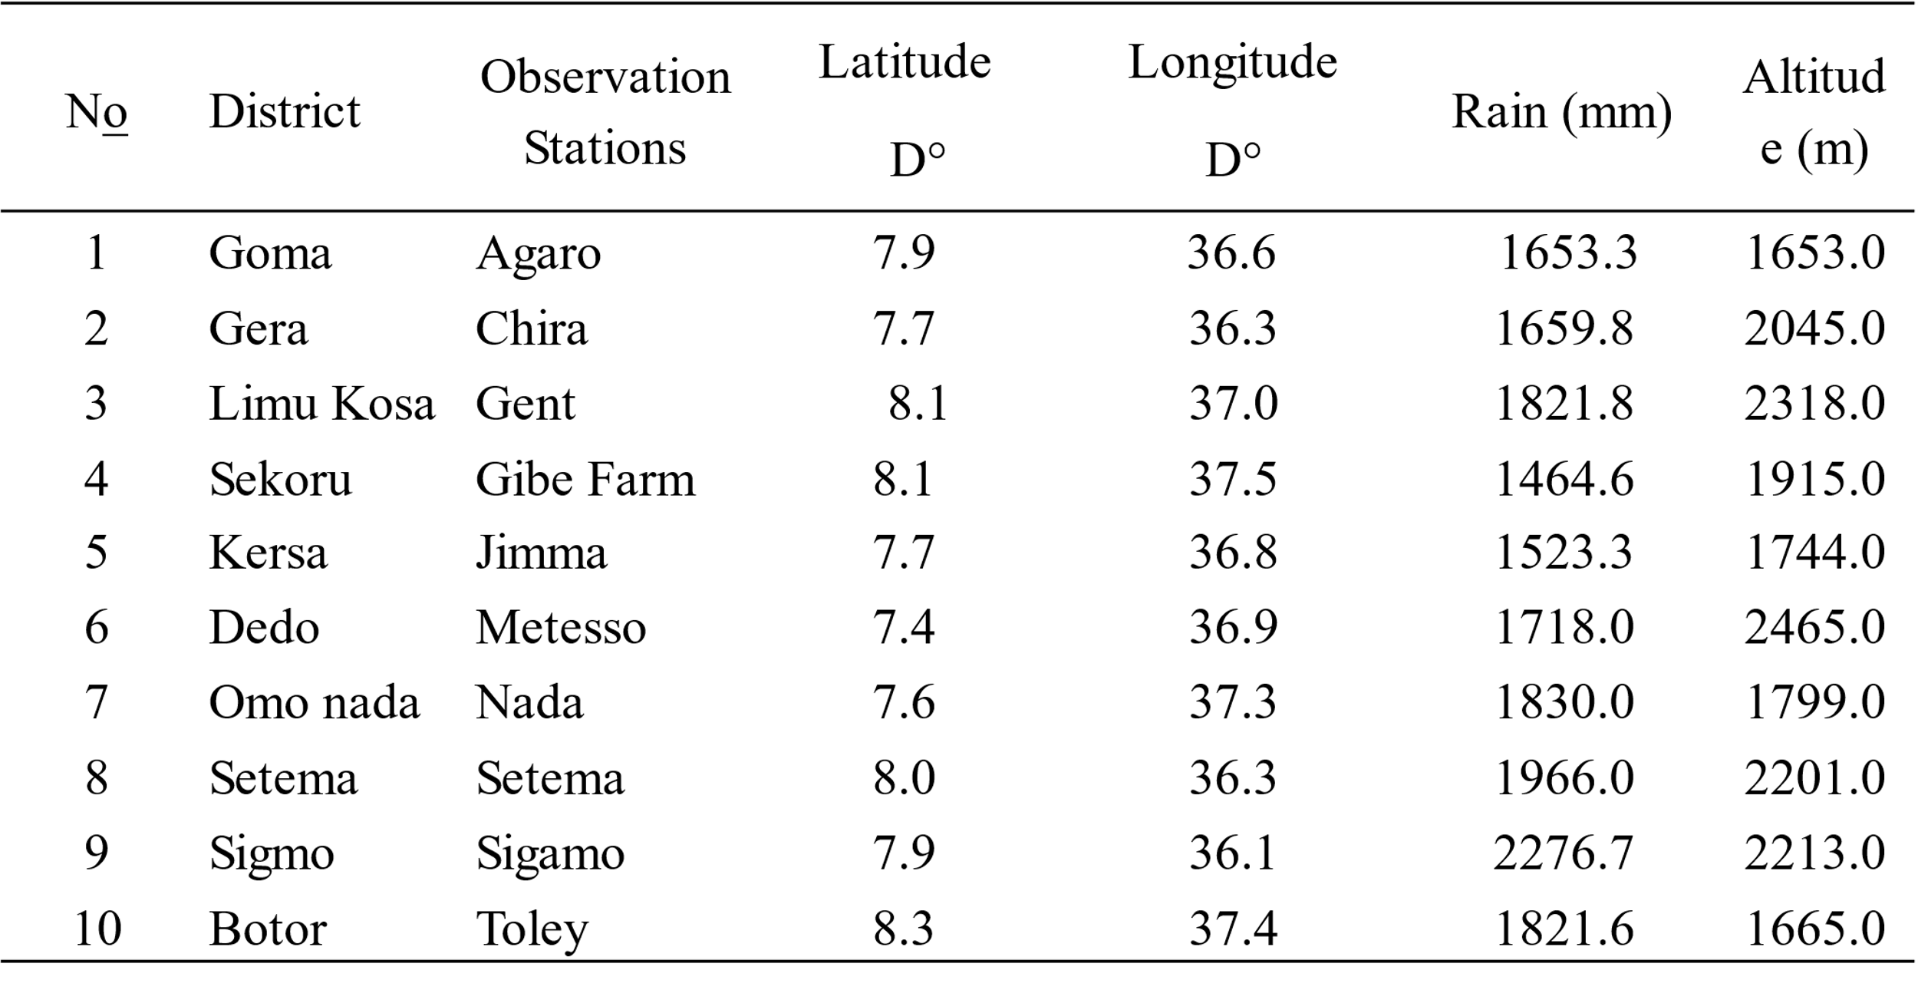
Table 2 List of selected agroclimatic extreme indicators during the period of 1991-2020
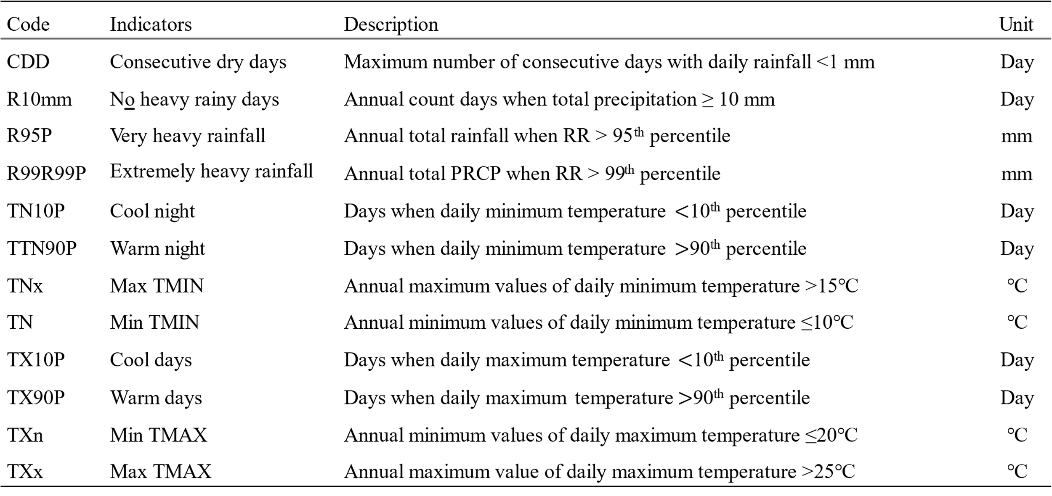
Source: Zhang et al (2018)

Table 3 Descriptive statistics results summary of extreme agroclimatic indicators (1991-2020)
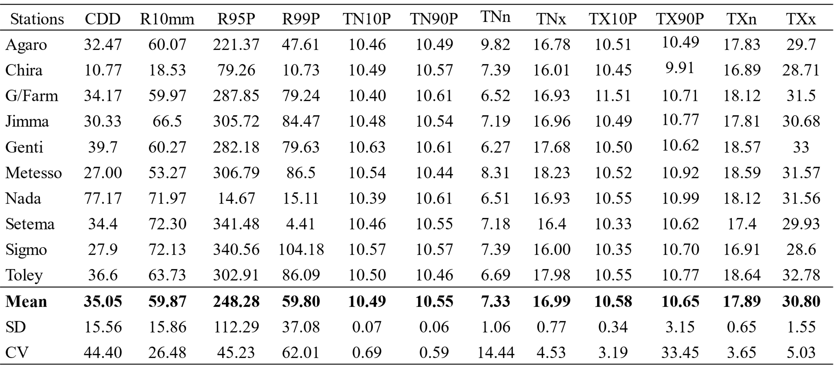

Table 4. Trend analysis results of agroclimatic extreme indicators from 1991-2020
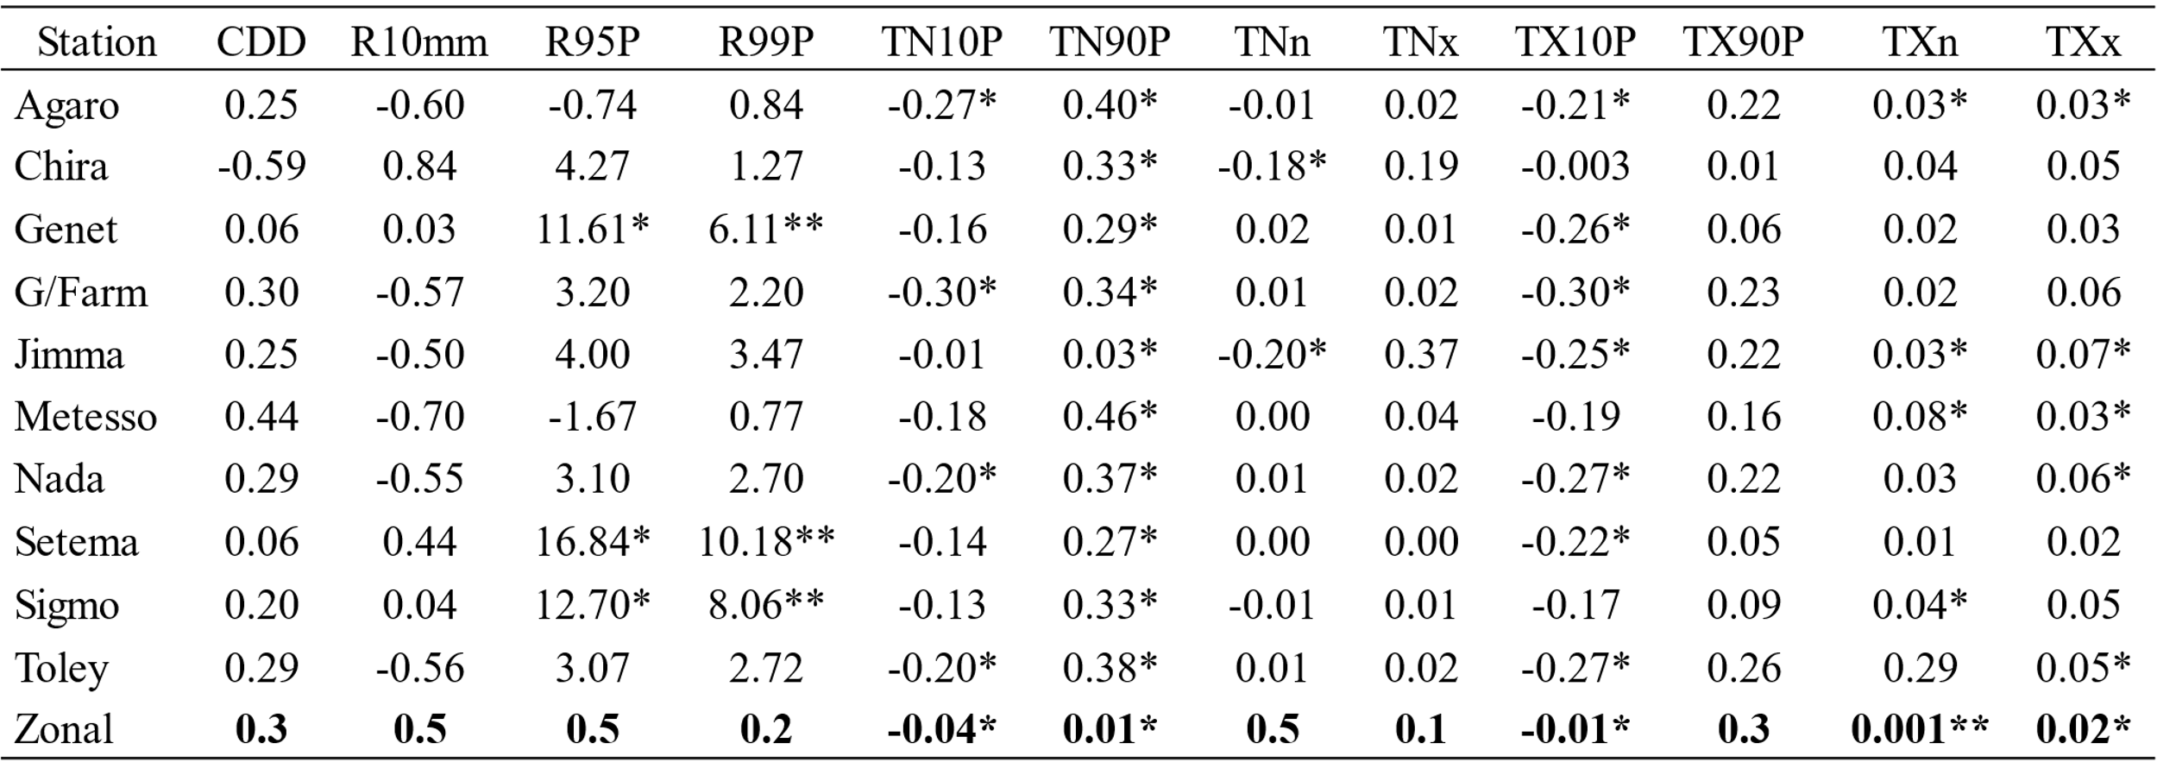
Note: that the symbols * and ** denote increasing or decreasing trends in the indices at = 0.05 and 0.01, respectively.

