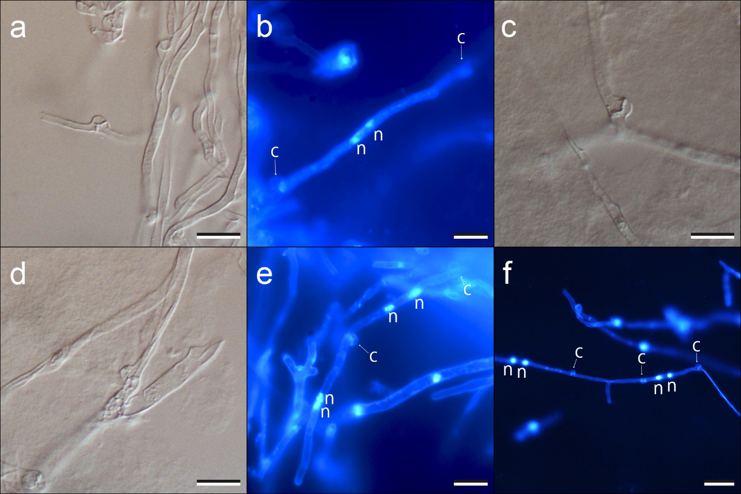
Fig. S5. Light and fluorescent microscopic photographs focusing on fertilized hyphae in mon-mon mating tests. a, b Mating among the ROF group (ROF3 × ROF4). c, d, e Crossing among the ROC and ROF groups (c, ROF1.1 × BOR3; d, e ROF1.1 × ROC1). f Mating among H. boreorepandum (BOR1 × BOR3). Strain code for mating tests is shown in Table 4. C, clamp connection. N, nuclear. Bars: a–e = 10 µm; f = 20 µm.

