Supplemental Material Table of Contents:

Figure S1. Patient Flow Diagram

Figure S2A&B. Receiver operating characteristic curve of Edmonton Symptom Assessment System-revised Depression scores against moderate/severe depression defined by Patient Health Questionnaire-9 scores ≥10 for Patients on Dialysis (n=422) (A) and Kidney Transplant Recipients (n=326) (B) separately.

Figure S3A&B. Visual Representation of True Positive, True Negative, False Positive and False Negative for Edmonton Symptom Assessment System-revised Depression cut-off scores of 2 (A) and 5 (B) in a theoretical cohort of 100 patients.

Figure S4. Post-test probability of positive (+) and negative (-) tests for Edmonton Symptom Assessment System-revised Depression Item cut-off score of 2 for the entire cohort of patients on dialysis and kidney transplant recipients who completed Edmonton Symptom Assessment System-revised Depression (n=748).

Figure S5A&B. Receiver operating characteristic curve of Edmonton Symptom Assessment System-revised Anxiety scores against moderate/severe anxiety defined General Anxiety Disorder -7 scores ≥10 for Patients on Dialysis (n=440) (A) and Kidney Transplant Recipients (n=329) (B) separately.

Figure S6A&B. Visual Representation of True Positive, True Negative, False Positive and False Negative for Edmonton Symptom Assessment System-revised Anxiety cut-off scores of 4 (A) and 5 (B) in a theoretical cohort of 100 patients

Figure S7. Post-test probability of positive (+) and negative (-) tests for Edmonton Symptom Assessment System-revised Anxiety Item cut-off score of 4 for the entire cohort of patients on dialysis and kidney transplant recipients who completed Edmonton Symptom Assessment System-revised Anxiety (n=769).

Table S1. Threshold analysis for ESASr-D scores against moderate/severe depression (PHQ-9 Score ≥10) for Kidney Transplant Recipients Only (n=326)

Table S2. Threshold analysis for ESASr-D scores against moderate/severe depression (PHQ-9 Score ≥10) for Patients on Dialysis Only (n=422)

Table S3. Threshold analysis for ESASr-A scores against moderate/severe anxiety (GAD-7 Score ≥10) for Kidney Transplant Recipients Only (n=329)

Table S4. Threshold analysis for ESASr-A scores against moderate /severe anxiety (GAD-7 Score ≥10) for Patients on Dialysis Only (n=440)

Figure S1. Patient Flow Diagram

Included in Study
n=931
(n=456 kidney transplant recipients, n=475 patients on dialysis)

Excluded Patients: n=1181
Declined Participation: n=1,119
Incomplete Measures n=286

Potentially Eligible Patients Approached:
n=3,517

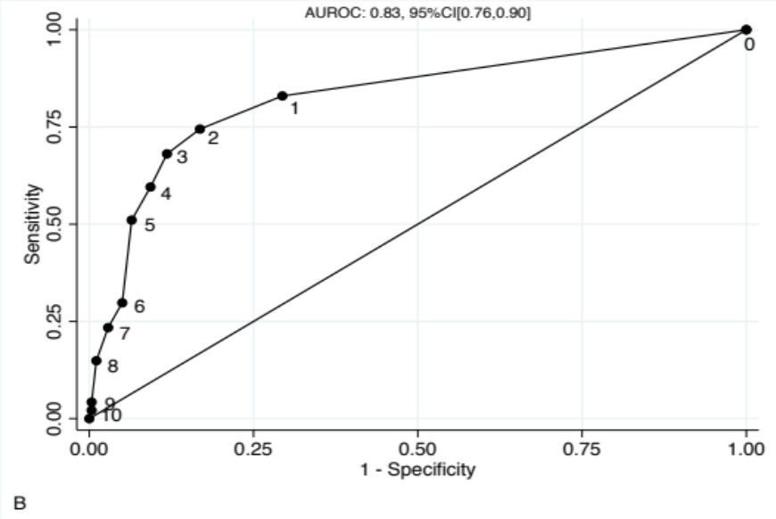
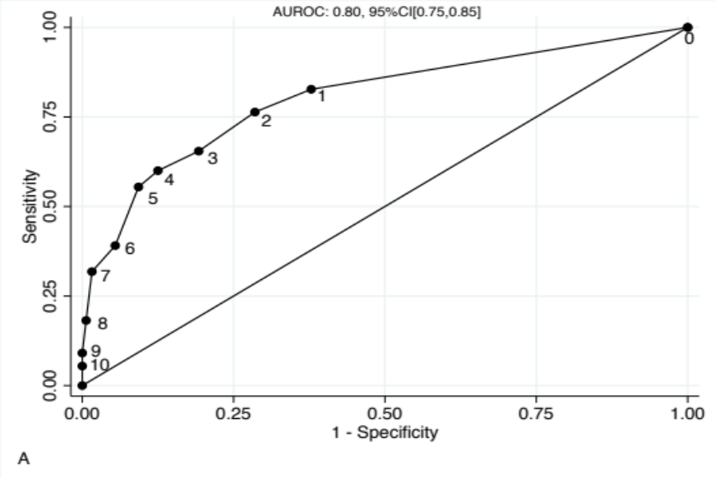

Figure S2A&B. Receiver operating characteristic curve of Edmonton Symptom Assessment System-revised Depression scores against moderate/severe depression defined by Patient Health Questionnaire-9 scores ≥10 for Patients on Dialysis (n=422) (A) and Kidney Transplant Recipients (n=326) (B) separately. Labelled points represent specific scores for Edmonton Symptom Assessment System-revised Depression. AUROC= 0.80, 95%CI: [0.75-0.85] for patients on dialysis, and area under ROC=0.83, 95%CI: [0.76-0.90] for the kidney transplant cohort, respectively.

Abbreviations: AUROC, Area under Receiver operating characteristic curve; CI, Confidence Interval.
Figure S3A. Visual Representation of True Positive, True Negative, False Positive and False Negative for a theoretical sample of 100 patients using ESASr-D cut-off score of 2 based on a prevalence of depression of 30% and sensitivity (76%) and specificity (77%) derived from study results for the entire cohort.

Abbreviations: ESASr-D; Edmonton Symptom Assessment System-revised Depression Item; TP, True positive; TN, True negative; FP, False positive; FN, false negative

Figure S3B. Visual Representation of True Positive, True Negative, False Positive and False Negative for a theoretical sample of 100 patients using ESASr-D cut-off score of 5 based on a prevalence of depression of 30% and sensitivity (54%) and specificity (92%) derived from study results for the entire cohort.

Abbreviations: ESASr-D; Edmonton Symptom Assessment System-revised Depression Item; TP, True positive; TN, True negative; FP, False positive; FN, false negative

Figure S4. Post-test probability of positive (+) and negative (-) tests for Edmonton Symptom Assessment System-revised Depression Item cut-off score of 2 for the entire cohort of patients on dialysis and kidney transplant recipients who completed Edmonton Symptom Assessment System-revised Depression (n=748). The shaded region represents the 20-40% range for the prevalence of depression in patients with end-stage kidney disease.

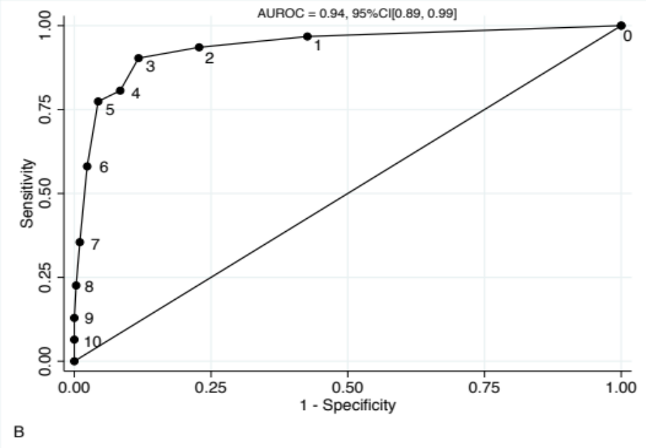
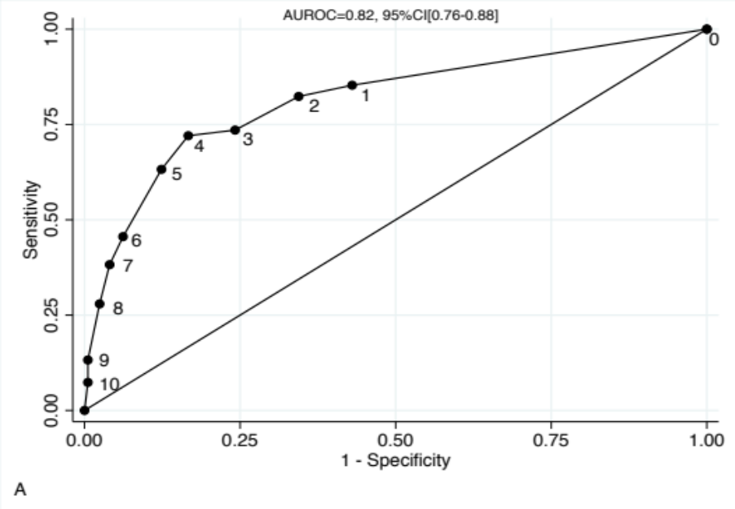

Figure S5A&B. Receiver operating characteristic curve of Edmonton Symptom Assessment System-revised Anxiety scores against moderate/severe anxiety defined General Anxiety Disorder -7 scores ≥10 for Patients on Dialysis (n=440) (A) and Kidney Transplant Recipients (n=329) (B) separately. Labelled points represent specific scores for Edmonton Symptom Assessment System-revised Anxiety. Area under ROC=0.82, 95%CI: [0.76-0.88] for patients on dialysis, and area under ROC=0.94, 95%CI: [0.89-0.99] for the kidney transplant cohort, respectively.

Abbreviations: AUROC, Area under Receiver operating characteristic curve; CI, Confidence Interval.

Figure S6A. Visual Representation of True Positive, True Negative, False Positive and False Negative for a theoretical sample of 100 patients using ESASr-A cut-off score of 4 based on a prevalence of depression of 30% and sensitivity (75%) and specificity (87%) derived from study results for the entire cohort .

Abbreviations: ESASr-A; Edmonton Symptom Assessment System-revised Anxiety Item; TP, True positive; TN, True negative; FP, False positive; FN, false negative

Figure S6B. Visual Representation of True Positive, True Negative, False Positive and False Negative for a theoretical sample of 100 patients using ESASr-A cut-off score of 5 based on a prevalence of depression of 30% and sensitivity (68%) and specificity (91%) derived from study results for the entire cohort .

Abbreviations: ESASr-A; Edmonton Symptom Assessment System-revised Anxiety Item; TP, True positive; TN, True negative; FP, False positive; FN, false negative

Figure S7. Post-test probability of positive (+) and negative (-) tests for Edmonton Symptom Assessment System-revised Anxiety Item cut-off score of 4 for the entire cohort of patients on dialysis and kidney transplant recipients who completed Edmonton Symptom Assessment System-revised Anxiety (n=769). The shaded region represents the 10-50% range for the prevalence of anxiety in patients with end-stage kidney disease.

Table S1. Threshold analysis for ESASr-D scores against moderate/severe depression (PHQ-9 Score ≥10) for Kidney Transplant Recipients Only (n=326)

Cut off | Sensitivity | Specificity | LR+ | LR- | TP | TN | FP | FN | PPV | NPV | Youden's J
>=0 | 100% | 0% | 1.00 |  | 47 | 0 | 279 | 0 | 0.14 | - | 0.00
>=1 | 83% | 71% | 2.82 | 0.24 | 39 | 197 | 82 | 8 | 0.32 | 0.96 | 0.54
>=2 | 74% | 83% | 4.42 | 0.31 | 35 | 232 | 47 | 12 | 0.43 | 0.95 | 0.58
>=3 | 68% | 88% | 5.76 | 0.36 | 32 | 246 | 33 | 15 | 0.49 | 0.94 | 0.56
>=4 | 60% | 91% | 6.39 | 0.45 | 28 | 253 | 26 | 19 | 0.52 | 0.93 | 0.50
>=5 | 51% | 94% | 7.91 | 0.52 | 24 | 261 | 18 | 23 | 0.57 | 0.92 | 0.45
>=6 | 30% | 95% | 5.94 | 0.74 | 14 | 265 | 14 | 33 | 0.50 | 0.89 | 0.25
>=7 | 23% | 97% | 8.16 | 0.79 | 11 | 271 | 8 | 36 | 0.58 | 0.88 | 0.21
>=8 | 15% | 99% | 13.85 | 0.86 | 7 | 276 | 3 | 40 | 0.70 | 0.87 | 0.14
>=9 | 4% | 100% | 11.87 | 0.96 | 2 | 278 | 1 | 45 | 0.67 | 0.86 | 0.04
>=10 | 2% | 100% | 5.94 | 0.98 | 1 | 278 | 1 | 46 | 0.50 | 0.86 | 0.02

Abbreviations: ESASr-D; Edmonton Symptom Assessment System-revised Depression Item; PHQ-9, Patient Health Questionnaire-9;
LR, Likelihood ratio; TP, True positive; TN, True negative; FP, False positive; FN, false negative; NPV: Negative Predictive Value; Positive Predictive Value
Table S2. Threshold analysis for ESASr-D scores against moderate/severe depression (PHQ-9 Score ≥10) for Patients on Dialysis Only (n=422)

Cut off | Sensitivity | Specificity | LR+ | LR- | TP | TN | FP | FN | PPV | NPV | Youden's J
>=0 | 100% | 0% | 1.00 |  | 110 | 0 | 312 | 0 | 0.26 | - | 0.00
>=1 | 83% | 62% | 2.19 | 0.28 | 91 | 194 | 118 | 19 | 0.44 | 0.91 | 0.45
>=2 | 76% | 71% | 2.68 | 0.33 | 84 | 223 | 89 | 26 | 0.49 | 0.90 | 0.48
>=3 | 65% | 81% | 3.40 | 0.43 | 72 | 252 | 60 | 38 | 0.55 | 0.87 | 0.46
>=4 | 60% | 88% | 4.80 | 0.46 | 66 | 273 | 39 | 44 | 0.63 | 0.86 | 0.48
>=5 | 55% | 91% | 5.97 | 0.49 | 61 | 283 | 29 | 49 | 0.68 | 0.85 | 0.46
>=6 | 39% | 95% | 7.17 | 0.64 | 43 | 295 | 17 | 67 | 0.72 | 0.81 | 0.34
>=7 | 32% | 98% | 19.85 | 0.69 | 35 | 307 | 5 | 75 | 0.88 | 0.80 | 0.30
>=8 | 18% | 99% | 28.36 | 0.82 | 20 | 310 | 2 | 90 | 0.91 | 0.78 | 0.18
>=9 | 9% | 100% |  | 0.91 | 10 | 312 | 0 | 100 | 1.00 | 0.76 | 0.09
>=10 | 5% | 100% |  | 0.95 | 6 | 312 | 0 | 104 | 1.00 | 0.75 | 0.05

Abbreviations: ESASr-D; Edmonton Symptom Assessment System-revised Depression Item; PHQ-9, Patient Health Questionnaire-9;
LR, Likelihood ratio; TP, True positive; TN, True negative; FP, False positive; FN, false negative; NPV: Negative Predictive Value; Positive Predictive Value

Table S3. Threshold analysis for ESASr-A scores against moderate/severe anxiety (GAD-7 Score ≥10) for Kidney Transplant Recipients Only (n=329)

Cut off | Sensitivity | Specificity | LR+ | LR- | TP | TN | FP | FN | PPV | NPV | Youden's J
>=0 | 100% | 0% | 1.00 |  | 31 | 0 | 298 | 0 | 0.09 | - | 0.00
>=1 | 97% | 57% | 2.27 | 0.06 | 30 | 171 | 127 | 1 | 0.19 | 0.99 | 0.54
>=2 | 94% | 77% | 4.10 | 0.08 | 29 | 230 | 68 | 2 | 0.30 | 0.99 | 0.71
>=3 | 90% | 88% | 7.69 | 0.11 | 28 | 263 | 35 | 3 | 0.44 | 0.99 | 0.79
>=4 | 81% | 92% | 9.61 | 0.21 | 25 | 273 | 25 | 6 | 0.50 | 0.98 | 0.723
>=5 | 77% | 96% | 17.75 | 0.24 | 24 | 285 | 13 | 7 | 0.65 | 0.98 | 0.731
>=6 | 58% | 98% | 24.72 | 0.43 | 18 | 291 | 7 | 13 | 0.72 | 0.96 | 0.56
>=7 | 35% | 99% | 35.25 | 0.65 | 11 | 295 | 3 | 20 | 0.79 | 0.94 | 0.34
>=8 | 23% | 100% | 67.29 | 0.78 | 7 | 297 | 1 | 24 | 0.88 | 0.93 | 0.22
>=9 | 13% | 100% |  | 0.87 | 4 | 298 | 0 | 27 | 1.00 | 0.92 | 0.13
>=10 | 6% | 100% |  | 0.94 | 2 | 298 | 0 | 29 | 1.00 | 0.91 | 0.06

Abbreviations: ESASr-A; Edmonton Symptom Assessment System-revised Anxiety Item; GAD-7, Generalized Anxiety Disorder-7;
LR, Likelihood ratio; TP, True positive; TN, True negative; FP, False positive; FN, false negative; NPV: Negative Predictive Value; Positive Predictive Value

Table S4. Threshold analysis for ESASr-A scores against moderate /severe anxiety (GAD-7 Score ≥10) for Patients on Dialysis Only (n=440)

Cut off | Sensitivity | Specificity | LR+ | LR- | TP | TN | FP | FN | PPV | NPV | Youden's J
>=0 | 100% | 0% | 1 |  | 68 | 0 | 372 | 0 | 0.15 | - | 0.00
>=1 | 85% | 57% | 1.98 | 0.26 | 58 | 212 | 160 | 10 | 0.27 | 0.95 | 0.42
>=2 | 82% | 66% | 2.39 | 0.27 | 56 | 244 | 128 | 12 | 0.30 | 0.95 | 0.48
>=3 | 74% | 76% | 3.04 | 0.35 | 50 | 282 | 90 | 18 | 0.36 | 0.94 | 0.49
>=4 | 72% | 83% | 4.32 | 0.34 | 49 | 310 | 62 | 19 | 0.44 | 0.94 | 0.554
>=5 | 63% | 88% | 5.11 | 0.42 | 43 | 326 | 46 | 25 | 0.48 | 0.93 | 0.509
>=6 | 46% | 94% | 7.37 | 0.58 | 31 | 349 | 23 | 37 | 0.57 | 0.90 | 0.39
>=7 | 38% | 96% | 9.48 | 0.64 | 26 | 357 | 15 | 42 | 0.63 | 0.89 | 0.34
>=8 | 28% | 98% | 11.55 | 0.74 | 19 | 363 | 9 | 49 | 0.68 | 0.88 | 0.26
>=9 | 13% | 99% | 24.62 | 0.87 | 9 | 370 | 2 | 59 | 0.82 | 0.86 | 0.13
>=10 | 7% | 99% | 13.68 | 0.93 | 5 | 370 | 2 | 63 | 0.71 | 0.85 | 0.07

Abbreviations: ESASr-A; Edmonton Symptom Assessment System-revised Anxiety Item; GAD-7, Generalized Anxiety Disorder-7;
LR, Likelihood ratio; TP, True positive; TN, True negative; FP, False positive; FN, false negative; NPV: Negative Predictive Value; Positive Predictive Value

