Supplementary Materials for
An integrated oxygen electrode derived from flexible single-wall carbon nanotube film for rechargeable Zn-Air batteries produced by electro-polymerization

Yu Meng^{1,2}, Yi-Ming Zhao^{1,2}, Jin-Cheng Li³, Chao Shi¹, Lili Zhang¹, Peng-Xiang Hou^{1,} *, Chang Liu^{1,}*, Hui-Ming Cheng^{1,4}
¹ Shenyang National Laboratory for Materials Science, Institute of Metal Research, Chinese Academy of Sciences, Shenyang 110016, China.
² School of Materials Science and Engineering, University of Science and Technology of China, Hefei 230026, China.
³ Faculty of Chemical Engineering, Yunnan Provincial Key Laboratory of Energy Saving in Phosphorus Chemical Engineering and New Phosphorus Materials, Kunming University of Science and Technology, Kunming 650500, China.
⁴ Faculty of Materials Science and Energy Engineering/Institute of Technology for Carbon Neutrality, Shenzhen Institute of Advanced Technology, Chinese Academy of Sciences, Shenzhen 518055, PR China.
*Corresponding Author: cliu@imr.ac.cn (C. Liu) or pxhou@imr.ac.cn (P.X. Hou)
Supplementary Figures
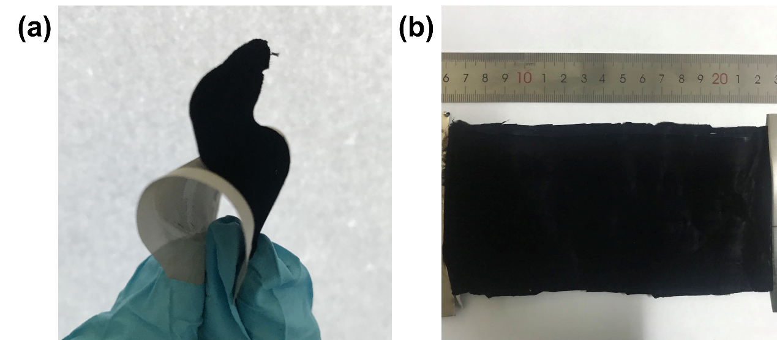
Fig. S1 Optical photograph of a a freestanding SWCNT film and b a large-area SWCNT film.

Fig. S2 CV curves of the electro-polymerization process.

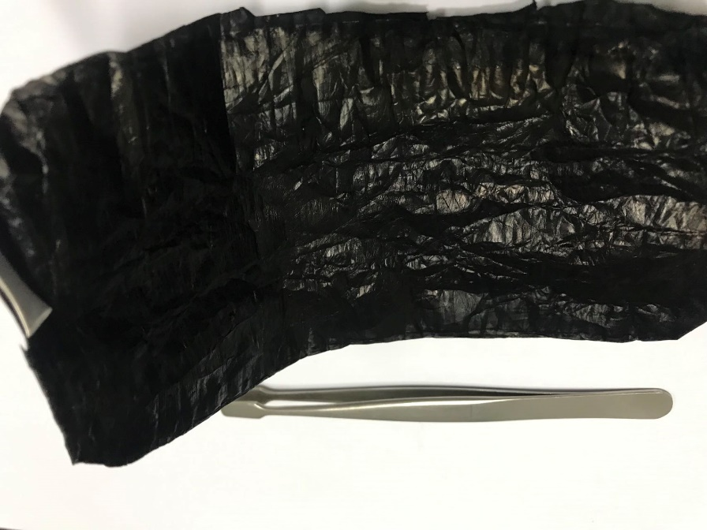
Fig. S3 Optical photograph of a PPy-SWCNT film.

Fig. S4 Typical stress-strain curves of a N/C-SWCNT film and commercial CFP.

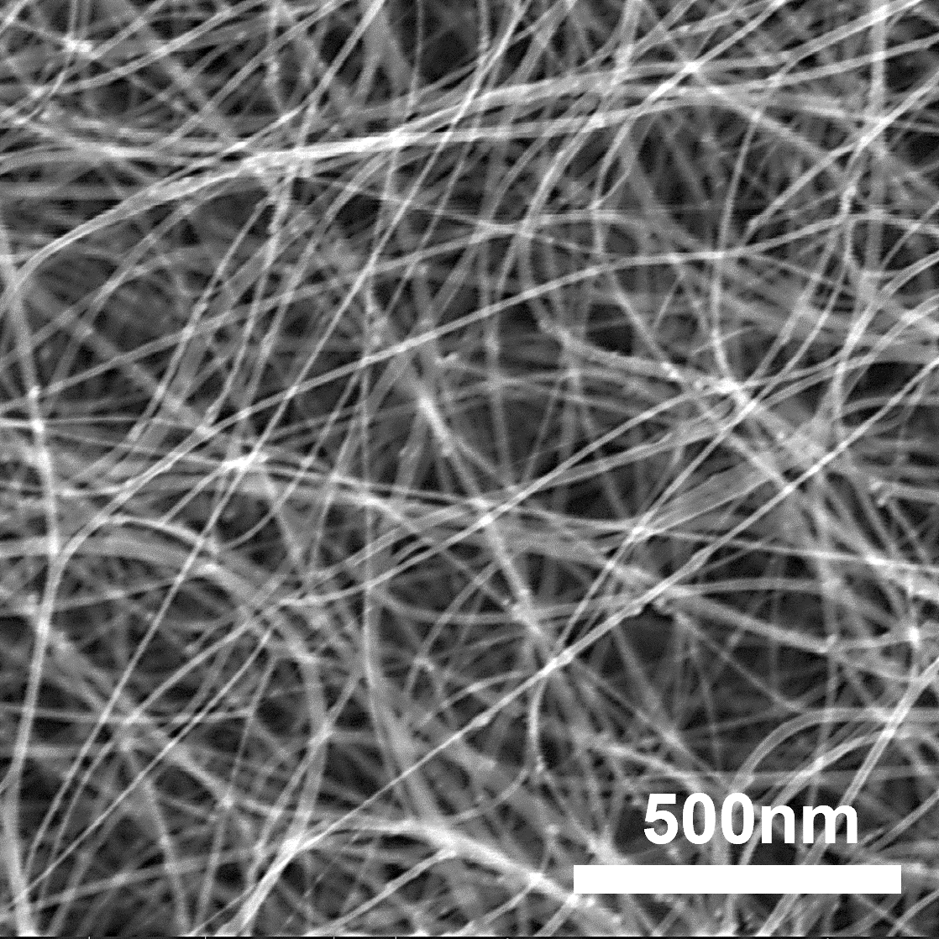
Fig. S5 SEM image of a SWCNT film.

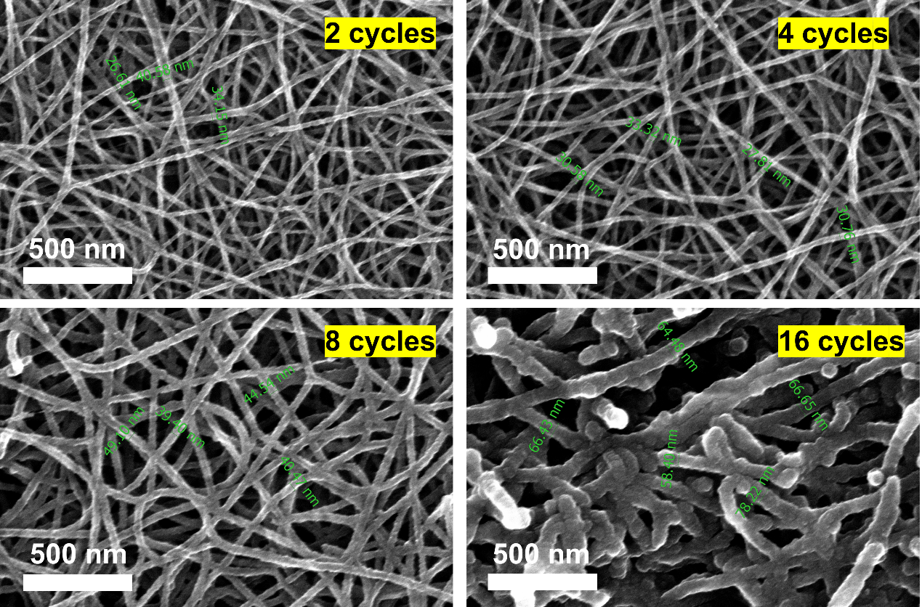
Fig. S6 SEM images of PPy-SWCNT films prepared with different number of electro-polymerization cycles.

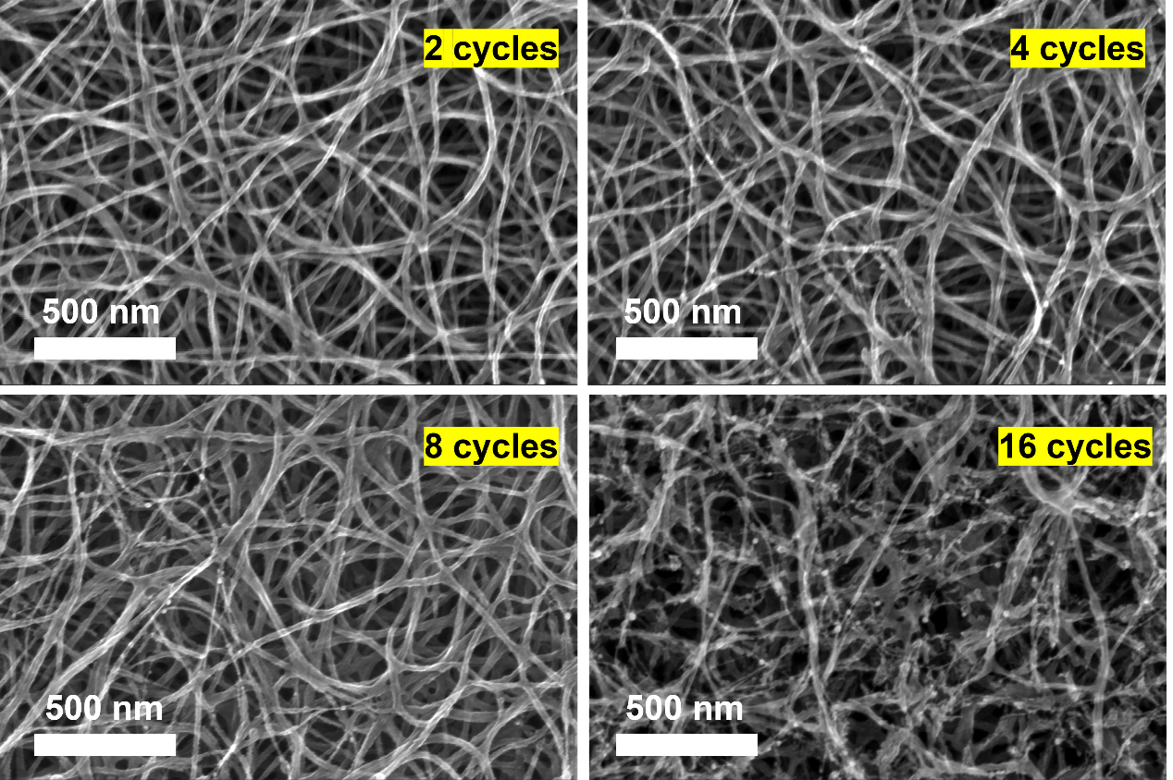Fig. S7 SEM images of N/C-SWCNT films prepared with different number of electro-polymerization cycles.

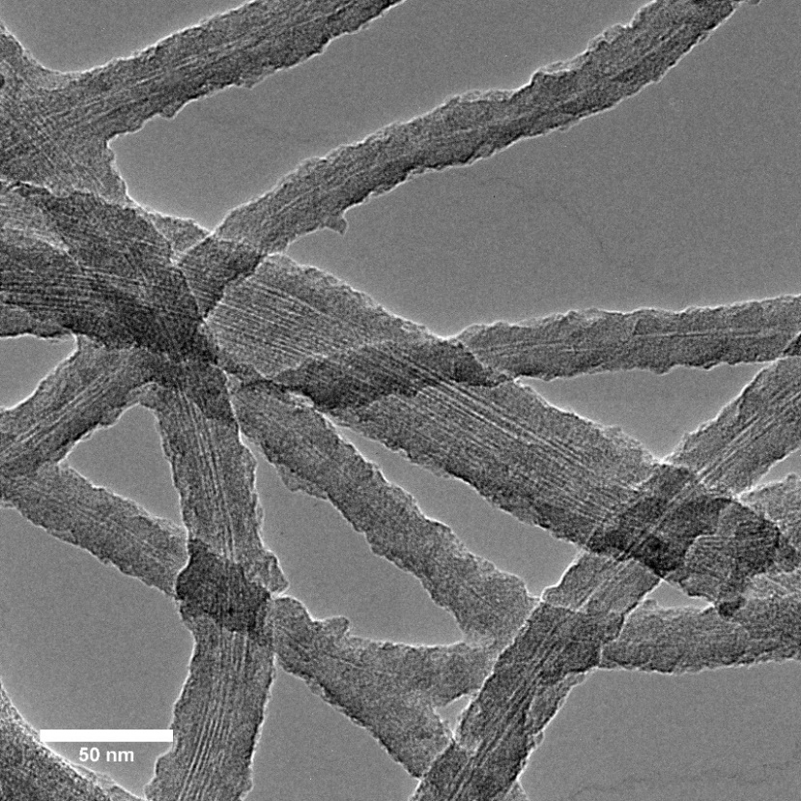
Fig. S8 TEM image of a PPy-SWCNT film synthesized with 8 electro-polymerization cycles.

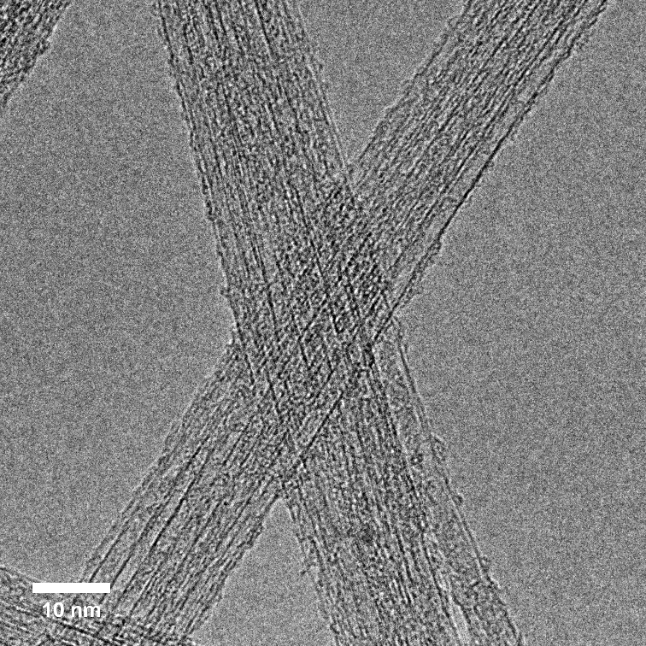
Fig. S9 High-resolution TEM image of the as-prepared SWCNTs.

Fig. S10 Raman spectra of a N/C-SWCNT film and commercial CFP.

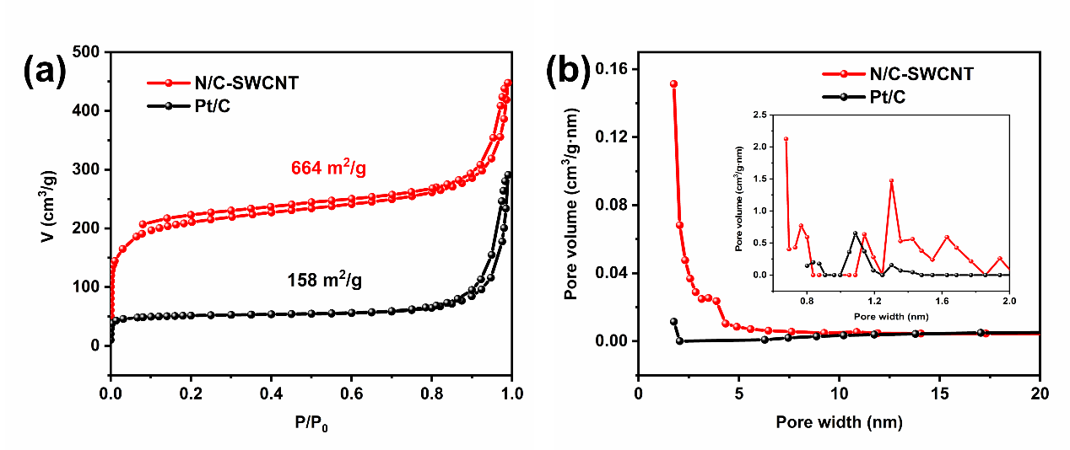
Fig. S11 a Nitrogen adsorption-desorption isotherms of a N/C-SWCNT film and Pt/C. b BJH pore size distributions of N/C-SWCNT and Pt/C, the inset is the micropore size distribution derived from the adsorption-desorption isotherms based on density functional theory.

Fig. S12 N1s curves of the PPy-SWCNT prepared with 8 electro-polymerization cycles.
Fig. S13 N contents of PPy-SWCNT and N/C-SWCNT prepared with different number of electro-polymerization cycles.
Fig. S14 (a) ORR polarization curves of N/C-SWCNT prepared with different number of electro-polymerization cycles.
Fig. S15 ORR polarization curves of SWCNT, PPy-SWCNT and N/C-SWCNT.
Fig. S16 Tafel plots derived from the ORR polarization curves of N/C-SWCNT and Pt/C catalyst.
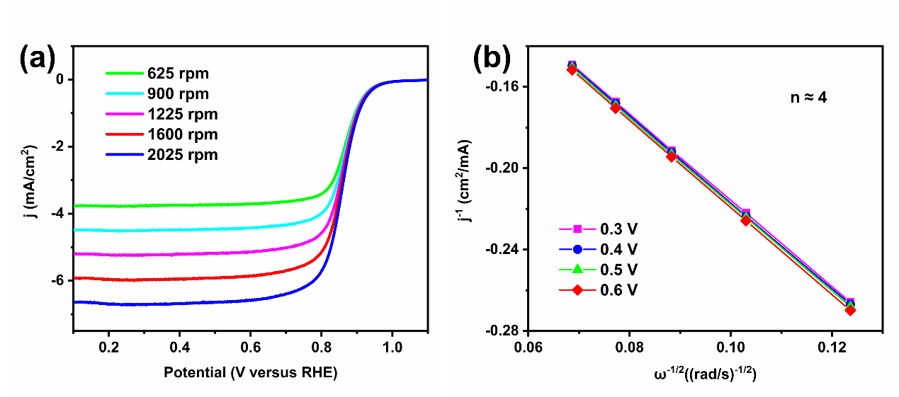
Fig. S17 a RDE voltammograms of a N/C-SWCNT film at various rotation speeds. b K-L plots of a N/C-SWCNT film at various potentials.

Fig. S18 Tafel plots derived from OER polarization curves of a N/C-SWCNT film and Ir/C catalyst.

Supplementary Table 1.
A summary of the ORR and OER performance of various oxygen electrodes
Sample | Materials | E_{j=10} | E_{1/2} or E_{j=-3} | △E | Reference
O-NGM-800 | Oxygen-enriched vacancies in nitrogen-doped carbon | 1.69 | 0.86 | 0.83 | ¹
NCN-1000-5 | N doped ultrathin carbon nanosheets | 1.64 | 0.82 | 0.82 | ²
PCP-800 | Pyridinic and graphitic nitrogen-enriched carbon paper | 1.67 | 0.89 | 0.78 | ³
N-CNSP | nitrogen-enriched carbon nanospheres | 1.63 | 0.85 | 0.78 | ⁴
NOGB-800 | N, O-codoped graphene nanorings-integrated boxes | 1.63 | 0.84 | 0.79 | ⁵
NPC-"Cs" | N, P-codoped carbon nanosphere | 1.57 | 0.85 | 0.72 | ⁶
BRC_{AC}850₂ | ATR residue (ATRR)-derived porous carbon | 1.68 | 0.85 | 0.83 | ⁷
BNPC-1100 | dual-doped porous carbon by pyrolyzing a metal organic framework | 1.55 | 0.803 | 0.75 | ⁸
NMGF | N-doped mesoporous graphene framework | 1.664 | 0.714 | 0.95 | ⁹
DN-UGNR | defect-rich N-doped ultranarrow graphene nanoribbons | 1.742 | 0.808 | 0.934 | ¹⁰
S, S′-CNT_{1000 °C} | Sulfur-Doped Carbon Nanotube–Graphene Nanolobes | 1.58 | 0.79 | 0.79 | ¹¹
N/C-SWCNT | N-doped porous carbon wrapped SWCNT film | 1.62 | 0.86 | 0.76 | This work
Supplementary Table 2
A summary of the performance of liquid Zn–air batteries fabricated using various electrocatalysts.
Catalyst | Material | Peak power density (mW/cm²) | Specific capacity (mAh/g) @ discharge current density (mA/cm²) | Stability @ cycling current density (mA/cm²) | Discharge-charge Voltage gap (V) | Reference
o-CC-H2 | Defective graphene on carbon fiber | 91 | 707 @ 20 | 26 h @ 2 | 0.92 | ¹²
DN-CP@G | N-doped graphene on carbon fiber | 135 | 591 @ 20 | 250 cycles @ 5 | 0.95 | ¹³
SilkNC/KB | defect-rich and nitrogen-doped nanocarbon | 91.2 | 614.7@20 | 33 h @10 | 0.81 | ¹⁴
N-S-Cs-900 | N–S-codoped mesoporous carbon on CNT | 136.3 | - | 24h @ 10 | 1.478 | ¹⁵
NKCNPs-900 | defect-rich and N-doped carbon | 131.4 | - | 575 cycles @ 10 | - | ¹⁶
N-CNSP | Edge nitrogen-enriched carbon nanospheres | 160 | - | 150 h @ 5 | 0.97 | ⁴
BRC_{AC}850₂ | ATR residue (ATRR)-derived porous carbon | 48.6 | 743 @ 10 | 220 h @ 10 | - | ⁷
N-GDY-900 | N doped graphdiyne | 84 | 693 @ 10 | 300 h @ 5 | 0.91 | ¹⁷
NPSCSs | N, P, S tri-doped hollow carbon nanospheres | 120.5 | - | 45 h @ 10 | 1.453 | ¹⁸
PCP-800 | Pyridinic and graphitic nitrogen-enriched carbon paper | 207 | - | 67 h @ 25 | - | ³
N/C-SWCNT | N-doped porous carbon  wrapped SWCNT | 180 | 810 | 100 h @ 10 | 0.77 | This work
Supplementary note 1
Preparation of the working electrode
N/C-SWCNT film, PPy-SWCNT film, SWCNT film: The catalytic film was cut into squares with specific areas. It was then carefully attached to a glassy carbon working electrode to evaluate the oxygen electrocatalytic performance. Ethanol was immediately dripped onto its surface to make the film adhere to the glassy carbon. After drying at room temperature, the film was firmly attached to the glassy carbon.
Pt/C and Ir/C: A commercial Pt/C catalyst (20 wt% Pt, Alfa Aesar) and a commercial Ir/C catalyst (20 wt% Ir, Alfa Aesar) were used as the benchmarks to evaluate the ORR and OER performances, respectively. Typically, 5 mg Pt/C (or Ir/C) was dispersed in 1.0 ml of ethanol containing 0.05% Nafion to prepare a catalytic ink. 0.01 ml of the ink was uniformly loaded on the RDE electrode (diameter 5.61 mm), with the amount loading being 0.2 mg/cm². The preparation of the Ir/C electrode was identical.
Supplementary note 2
Preparation of aqueous rechargeable Zn-Air batteries
A polished zinc plate was used as the anode and a mixed solution of KOH (6.0 mol/L) and Zn(CH₃COO)₂ (0.2 mol/L) was used as the electrolyte. A Ni foam (current collector), a N/C-SWCNT film (catalytic layer) and a carbon cloth (gas diffusion layer) were assembled by simple compressing to act as the cathode. The active window area was 1 cm². For comparison, a Pt/C-Ir/C liquid Zn-Air battery was also assembled by loading Pt/C and Ir/C on a carbon cloth with a mass ratio of 1:1. The total concentration of the Pt/C-Ir/C catalyst was 0.2 mg/cm².
Preparation of solid-state Zn-Air batteries
Homemade solid-state flexible Zn-Air batteries were assembled by using a polished Zn plate as the anode, gel as the electrolyte, a N/C-SWCNT film as both the catalyst layer and the gas diffusion layer, and Ni foam as the current collector. For the gel electrolyte preparation, 5 g polyvinyl alcohol (PVA) was added to 50 g deionized water while stirring and then treated at 90℃ for 2 hours. 5 ml of the solution containing 18 mol/L KOH and 0.2 mol/L ZnCl₂ were added to the PVA solution drop by drop. After stirring for 1 hour, the solution was poured onto a glass plate. The film was kept in a freezer at -20 ℃ for over 12 hours, and then thawed at room temperature.
Supplementary note 3
Characterization
The morphology and structure of the electrocatalysts were characterized using field emission-scanning electron microscopy (SEM, FEI Verios G4), transmission electron microscopy (TEM, Tecnai F20, 200 kV), aberration-corrected TEM (ACTEM, Tian Themis, FEI, 200 kV), X-ray photoelectron spectroscopy (XPS, Escalab 250, Al Kα), Raman spectroscopy (Jobin-Yvon Labram HR800, 633 nm laser), and dynamic mechanical analysis (DMA, TA Q800).
Electrochemical measurements
Electrochemical measurements were conducted on an electrochemical analysis station (CHI-760E, China; Bio-Logic, VSP-300, France). An Ag/AgCl electrode and a Pt wire were used as the counter and reference electrodes, respectively. All potential values were converted to potential values that refer to a reversible hydrogen electrode (RHE) according to E (versus RHE) = E (versus Ag/AgCl) + 0.059pH + 0.197. A rotating disk electrode with a glassy carbon disk (5.61 mm in diameter) and a rotating ring-disk electrode with a glass carbon disk (5.61 mm in diameter) were used as the substrates for the working electrodes. The linear scan voltammogram (LSV) curves in this work were corrected with iR compensation.
Supplementary note 4
Calculation of electron transfer number
The scan rate for RDE and RRDE measurements was 5 mV/s. For RDE tests, the polarization curves were collected at disk rotation rates of 625, 900, 1225, 1600, and 2025 rpm. To calculate the number of electrons transferred (n), we analyzed the kinetic parameters based on the Koutecky–Levich equation:
$$\frac{1}{J}=\frac{1}{J_{L}}+\frac{1}{J_{K}}=\frac{1}{Bω^{1/2}}+\frac{1}{J_{K}}$$
$$B=0.62nFC_{0}(D_{0})^{2/3}ν^{-1/6}$$
$$J_{K}=\frac{1}{nkFC_{0}}$$
where $J$ is the measured current density, $J_{K}$ and $J_{L}$ are the kinetic- and diffusion-limiting current densities, $ω$ is the angular velocity, $F$is the Faraday constant ($F=96500$C/mol), $C_{0}$ is the bulk concentration of O₂ in the electrolyte ($C_{0}=1.26×10^{-6}$mol/cm³), $D_{0}$ is the diffusion coefficient of O₂ in the electrolyte ($D_{0}=1.93×10^{-5}$cm²/s), $ν$ is the kinematic viscosity of the electrolyte ($ν=1.009×10^{-2}$cm²/s), and is the electron-transfer rate constant. For the Tafel plot, the kinetic current was calculated from the mass-transport correction of RDE by:
$$J_{K}=\frac{J_{L}×J}{(J_{L}-J)}$$
For the RRDE measurements, the polarization curves were collected at a disk rotation rate of 1600 rpm. The potential of the ring was set at 0.3 V (versus Ag/AgCl) in 0.1 M KOH. The collection efficiency of the RRDE (N) was 0.37. The peroxide yield (HO₂⁻%) and the electron transfer number (n) were calculated as follows:
$$H{O_{2}}^{-}\%=200×\frac{I_{r}/N}{I_{d}+I_{r}/N}$$
$$n=4×\frac{I_{d}}{I_{d}+I_{r}/N}$$
where Id is the disk current and Ir is the ring current.

References:
1. Wang, M., Wang, W., Qian, T., Liu, S., Li, Y., Hou, Z., Goodenough, J. B., Ajayan, P. M. & Yan, C. Oxidizing Vacancies in Nitrogen-Doped Carbon Enhance Air-Cathode Activity. Adv. Mater. 31, 1–2 (2019).
2. Jiang, H., Gu, J., Zheng, X., Liu, M., Qiu, X., Wang, L., Li, W., Chen, Z., Ji, X. & Li, J. Defect-rich and ultrathin N doped carbon nanosheets as advanced trifunctional metal-free electrocatalysts for the ORR, OER and HER. Energy Environ. Sci. 12, 322–333 (2019).
3. Ji, H., Wang, M., Liu, S., Sun, H., Liu, J., Qian, T. & Yan, C. Pyridinic and graphitic nitrogen-enriched carbon paper as a highly active bifunctional catalyst for Zn-air batteries. Electrochim. Acta 334, 135562 (2020).
4. Zong, L., Wu, W., Liu, S., Yin, H., Chen, Y., Liu, C., Fan, K., Zhao, X., Chen, X., Wang, F., Yang, Y., Wang, L. & Feng, S. Metal-free, active nitrogen-enriched, efficient bifunctional oxygen electrocatalyst for ultrastable zinc-air batteries. Energy Storage Mater. 27, 514–521 (2020).
5. Hu, Q., Li, G., Li, G., Liu, X., Zhu, B., Chai, X., Zhang, Q., Liu, J. & He, C. Trifunctional Electrocatalysis on Dual-Doped Graphene Nanorings–Integrated Boxes for Efficient Water Splitting and Zn–Air Batteries. Adv. Energy Mater. 9, 1–9 (2019).
6. Li, P., Jang, H., Zhang, J., Tian, M., Chen, S., Yuan, B., Wu, Z., Liu, X. & Cho, J. A Metal-Free N and P-Codoped Carbon Nanosphere as Bifunctional Electrocatalyst for Rechargeable Zinc-Air Batteries. ChemElectroChem 6, 393–397 (2019).
7. Li, Q., He, T., Zhang, Y. Q., Wu, H. Q., Liu, J. J., Qi, Y. J., Lei, Y. P., Chen, H., Sun, Z. F., Peng, C., Yi, L. Z. & Zhang, Y. Biomass Waste-Derived 3D Metal-Free Porous Carbon as a Bifunctional Electrocatalyst for Rechargeable Zinc-Air Batteries. ACS Sustainable Chem. Eng. 7, 17039–17046 (2019).
8. Qian, Y., Hu, Z., Ge, X., Yang, S., Peng, Y., Kang, Z., Liu, Z., Lee, J. Y. & Zhao, D. A metal-free ORR/OER bifunctional electrocatalyst derived from metal-organic frameworks for rechargeable Zn-Air batteries. Carbon 111, 641–650 (2017).
9. Wang, H.-F., Tang, C. & Zhang, Q. Template growth of nitrogen-doped mesoporous graphene on metal oxides and its use as a metal-free bifunctional electrocatalyst for oxygen reduction and evolution reactions. Catal. Today 301, 25–31 (2018).
10. Zhang, J., Sun, Y., Zhu, J., Gao, Z., Li, S., Mu, S. & Huang, Y. Ultranarrow Graphene Nanoribbons toward Oxygen Reduction and Evolution Reactions. Adv. Sci. 5, 1–7 (2018).
11. El-Sawy, A. M., Mosa, I. M., Su, D., Guild, C. J., Khalid, S., Joesten, R., Rusling, J. F. & Suib, S. L. Controlling the Active Sites of Sulfur-Doped Carbon Nanotube-Graphene Nanolobes for Highly Efficient Oxygen Evolution and Reduction Catalysis. Adv. Energy Mater. 6, 1–12 (2016).
12. Wang, H. F., Tang, C., Wang, B., Li, B. Q., Cui, X. & Zhang, Q. Defect-rich carbon fiber electrocatalysts with porous graphene skin for flexible solid-state zinc–air batteries. Energy Storage Mater. 15, 124–130 (2018).
13. Hang, C., Zhang, J., Zhu, J., Li, W., Kou, Z. & Huang, Y. In Situ Exfoliating and Generating Active Sites on Graphene Nanosheets Strongly Coupled with Carbon Fiber toward Self-Standing Bifunctional Cathode for Rechargeable Zn–Air Batteries. Adv. Energy Mater. 8, 1–9 (2018).
14. Wang, C., Xie, N. H., Zhang, Y., Huang, Z., Xia, K., Wang, H., Guo, S., Xu, B. Q. & Zhang, Y. Silk-Derived Highly Active Oxygen Electrocatalysts for Flexible and Rechargeable Zn-Air Batteries. Chem. Mater. 31, 1023–1029 (2019).
15. Xing, L., Song, C. & Kong, A. N–S-codoped mesoporous carbons from melamine-2-thenaldehyde polymers on carbon nanotubes for oxygen reduction and Zn-air batteries. J. Solid State Chem. 287, 121348 (2020).
16. Wang, Q., Lei, Y., Zhu, Y., Wang, H., Feng, J., Ma, G., Wang, Y., Li, Y., Nan, B., Feng, Q., Lu, Z. & Yu, H. Edge Defect Engineering of Nitrogen-Doped Carbon for Oxygen Electrocatalysts in Zn-Air Batteries. ACS Appl. Mater. Interfaces 10, 29448–29456 (2018).
17. Lu, T., Hu, X., He, J., Li, R., Gao, J., Lv, Q., Yang, Z., Cui, S. & Huang, C. Aqueous/solid state Zn-air batteries based on N doped graphdiyne as efficient metal-free bifunctional catalyst. Nano Energy 85, (2021).
18. Tao, X., Zhang, Q., Li, Y., Lv, X., Ma, D. & Wang, H. guo. N, P, S tri-doped hollow carbon nanosphere as a high-efficient bifunctional oxygen electrocatalyst for rechargeable Zn-air batteries. Appl. Surf. Sci. 490, 47–55 (2019).

