Supporting Information
Polyoxometalate-based Heterojunction with NIR Light-facilitated photocatalytic W⁶⁺/W⁵⁺ redox cycling for Enhanced Bacteria-Infected Wound Healing
Mingzhu Lv^{1, 2#}, Zhou Xu^{3#}, Yuan Yong^{1, 2*}, Huan Wang^{1, 2}, Chenghui Liu^{1, 2}, Qiqi Xu^{1, 2}, Guobo Du⁵, Jiani Xie⁶, Yong You^{1, 2}, Jiangwei Xiao^{3*}, Guohui Jiang^{4*}
1. Key Laboratory of Pollution Control Chemistry and Environmental Functional Materials for Qinghai-Tibet Plateau of the National Ethnic Affairs Commission, School of Chemistry and Environment, Southwest Minzu University, Chengdu 610041, China.
2. Key Laboratory of General Chemistry of the National Ethnic Affairs Commission, School of Chemistry and Environment, Southwest Minzu University, Chengdu 610041, China.
3. The Department of Gastrointestinal Surgery, The First Affiliated Hospital of Chengdu Medical College, Faculty of medicine, Chengdu, 610500, China.
4. Department of Neurology, Affiliated Hospital of North Sichuan Medical College, Institute of neurological diseases, North Sichuan Medical College, Nanchong, 637000, China.
5. Department of Oncology, Affiliated Hospital of North Sichuan Medical College, Nanchong, 637000, China.
6. College of Pharmacy and Biological Engineering, Chengdu University, Chengdu, 610106, China.
# These authors contributed equally.
Corresponding Authors:
*E-mail: yongy1816@163.com; xiaojiangwei@126.com; neurodoctor@163.com

Fig. S1 Zeta potential analysis of aqueous solution of GdP₅W₃₀, WS₂ and GdP₅W₃₀@WS₂.

Fig. S2 Thermogravimetric analysis (TGA) curve of GdP₅W₃₀@WS₂.

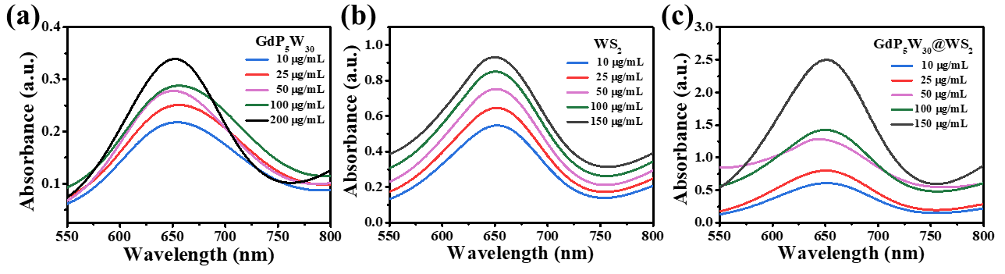
Fig. S3 UV-vis absorption spectra of a GdP₅W₃₀, b WS₂ and c GdP₅W₃₀@WS₂ NCs with different concentrations (10, 25, 50, 100 and 150 μg/mL) in the presence of H₂O₂ (10 mM) and TMB (1 mM) in HAc/NaAc buffer (pH 4.0), respectively.

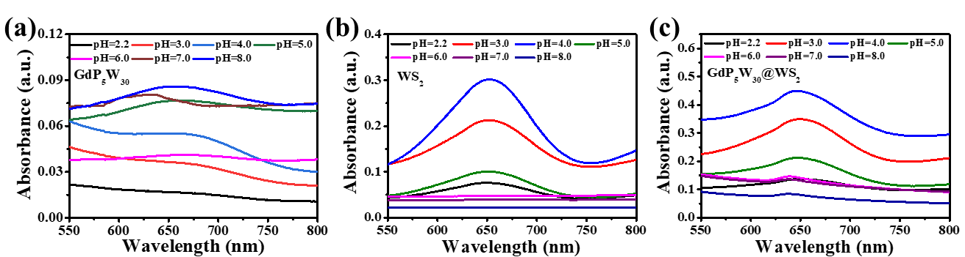
Fig. S4 UV-vis absorption spectra of a GdP₅W₃₀ (50 μg/mL), b WS₂ (50 μg/mL) and c GdP₅W₃₀@WS₂ NCs (100 μg/mL) reacted with H₂O₂ (10 mM) and TMB (1 mM) at pH 2.2, 3.0, 4.0, 5.0, 6.0, 7.0 and 8.0, respectively.

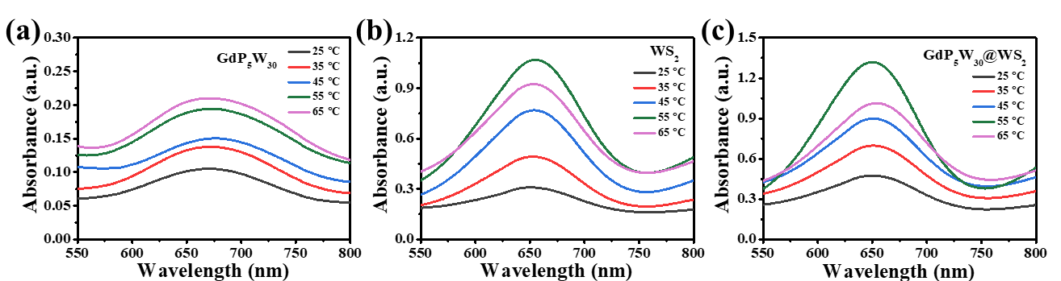
Fig. S5 UV-vis absorption spectra of a GdP₅W₃₀ (50 μg/mL), b WS₂ (50 μg/mL) and c GdP₅W₃₀@WS₂ (100 μg/mL) in the presence of H₂O₂ (10 mM) and TMB (1 mM) in PBS solution (pH 4.0) at different reaction temperature (25, 35, 45, 55 and 65 °C), respectively.

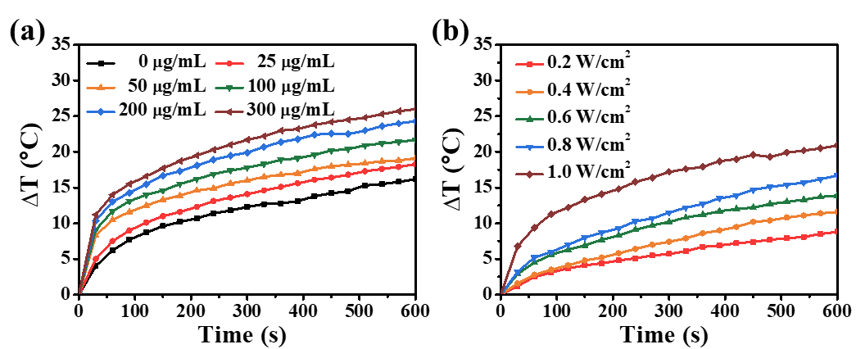
Fig. S6 a The photothermal heating curves of GdP₅W₃₀@WS₂ aqueous solution with various concentrations under an 808 nm laser (1.0 W/cm²) for 10 min. b The photothermal heating curves of GdP₅W₃₀@WS₂ aqueous solution (100 μg/mL) under 808 nm laser at a series of different power densities for 10 min.

Fig. S7 Temperature evaluation of GdP₅W₃₀@WS₂ aqueous solution (100 μg/mL) over two NIR laser (1.0 W/cm²) on/off cycles.

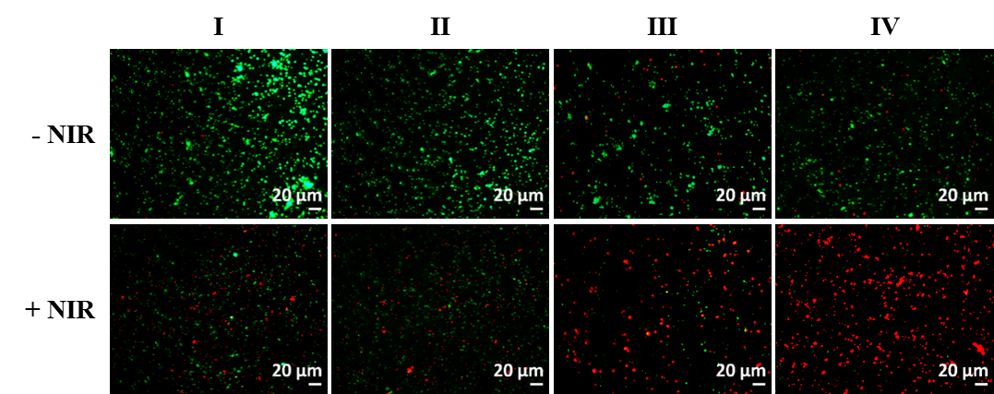
Fig. S8 Live/dead staining photographs of S.aureus after exposed to (I) Control, (II) H₂O₂, (III) GdP₅W₃₀@WS₂, (IV) GdP₅W₃₀@WS₂ + H₂O₂. Conditions: All groups requiring 808 nm irradiation were irradiated for 10 min under a power density of 1.0 W/cm².

