Supporting Information
Rodent model preclinical assessment of PEGylated block copolymer targeting cognition and oxidative stress insults of Alzheimer’s disease
Sutapa Som Chaudhury¹, Mridula Nandi^{2٢}, Krishna Kumar³, Bhuban Ruidas¹, Tapas Kumar Sur⁴, Parash Prasad⁵, Saikat Chakrabarti³, Priyadarsi De², Jaya Sil¹, Chitrangada Das Mukhopadhyay^{1*}
¹Centre for Healthcare Science and Technology, Indian Institute of Engineering Science and Technology, Shibpur, Howrah-711103, West Bengal, India
²Department of Chemical Sciences, Indian Institute of Science Education and Research Kolkata, Mohanpur, West Bengal- 741246, India
³Structural Biology and Bioinformatics division, CSIR-Indian Institute of Chemical Biology, IICB TRUE building, CN 6, Sector V Salt Lake, Kolkata-700091, West Bengal, India
⁴Department of Pharmacology, R.G Kar Medical College and Hospital, Kolkata-700004, West Bengal, India
⁵CSIR-Indian Institute of Chemical Biology, 4, Raja Subodh Chandra Mallick Road, Jadavpur, Kolkata-700032, West Bengal, India
^{٢}Present address: Department of Chemical and Biomolecular Engineering, University of Delaware, Newark, Delaware 19716, United States.

Results
Synthesis and characterization of Fluorescein Isothiocyanate (FITC) functionalized block copolymer PEG-b-P(LVF-HEMA)
Initially, the approx. molecular weight of the boc-protected polymer PEG-b-P(Boc-LVF-EMA) i.e., the un-tagged INH was calculated as 19400 D through GPC (Fig. S1 and Table S1). Later, fluorescein isothiocyanate (FITC)-tagging of the block copolymer was checked via ¹H NMR spectra (Scheme 1, inset). Also, UV-Vis and fluorescence spectra of both un-tagged and tagged PEG-b-P(LVF-HEMA) was recorded. UV-vis measurements of un-tagged PEG-b-P(LVF-HEMA) in H₂O showed peaks at 258 and 264 nm corresponding to n-π* of carbonyl and π−π* transition of phenyl (Fig. S2a) respectively. Another peak at 309 nm corresponds to the trithiocarbonatefunctionality (coming from the chain transfer agent (CTA) fragment) at the polymer chain end [1]. On tagging with FITC, peaks characteristic of FITC at 454 and 484 nm were observed along with that of the polymer. Fluorescence measurement of the block copolymer FITC tagged PEG-b-P(LVF-HEMA) gave a strong emission band at 522 nm from the dye unit. The corresponding untagged PEG-b-P(LVF-HEMA) does not give any emission band which confirms successful synthesis of FITC modified PEG-b-P(LVF-HEMA) (Fig. S2b). For block copolymer PEG-b-P(LVF-HEMA), the transition pH was determined around the physiological pH viz. pH 7.4 (Fig. S3). This signified the stability and solubility of the tagged-block copolymer would not hamper up to the physiological pH value.
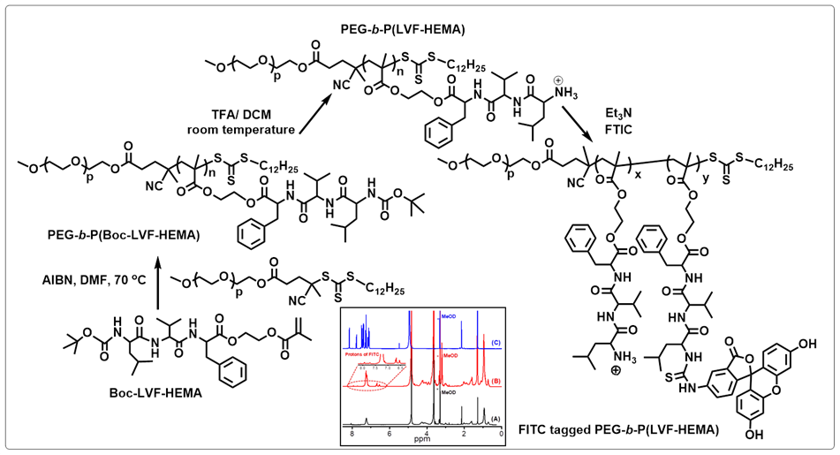
Scheme S1: Synthesis of FITC functionalized block copolymer (I).¹H NMR spectra of (A) PEG-b-P(LVF-HEMA), (B) FITC-tagged PEG-b-P(LVF-HEMA) and (C) FITC have shown in the inset.
Fig.S1. Detection of molecular weight of boc-protected polymer PEG-b-P(Boc-LVF-EMA) through GPC.
Polymer | Conv.  (%) | M_{n,GPC}^{d}  (g/mol) | Ð^{d} | M_{n,theo}^{e}  (g/mol)
PEG-b-P(Boc-LVF-EMA) | 75 | 19400 | 1.06 | 14200
Table S1. Approximate molecular weight of boc-protected polymer PEG-b-P(Boc-LVF-EMA).
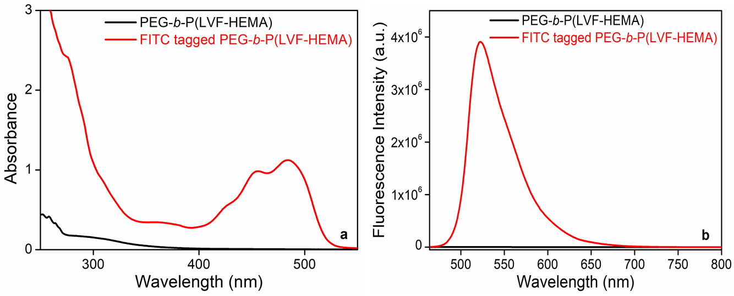
Fig.S2. UV-Vis (a) and fluorescence spectra (b) of untagged and FITC-tagged PEG-b-P(LVF-HEMA) (INH) (concentration: 1 mg/ml).
Fig.S3. Plots of % Transmittance versus pH at 25 ºC of PEG-b-P(LVF-HEMA) (concentration: 1 mg/ml).
Cellular toxicity of the inhibitor
The FITC-conjugated inhibitor (INH) was proved to be non-toxic even at a high concentration of 50 µM in SHSY5Y neuroblastoma cells. The IC₅₀ values were determined at 50 µM and 60 µM in SHSY5Y and U87 cell lines, respectively.
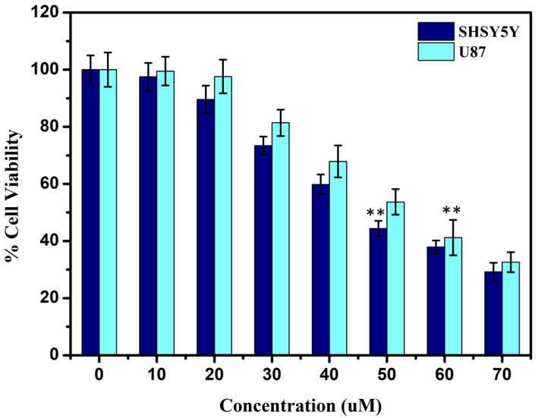
Fig.S4. Histogram showing % cell viability at the increasing concentration of FITC-conjugated inhibitor with respect to the untreated SHSY5Y and U87 cells, obtained in MTT assay. The IC-50 values denoted a significant difference from the control (P< 0.01).
Monitoring the body weight of the experimental animals
The changes in the body weight of the experimental animals were monitored throughout the study and it was observed that the untreated AD group has shown a constant decrease in the body weight as compared to the sham group. The level of significance in this decrease was even significant at * p<0.05 on day 28. Also, the inhibitor-treated AD rats have shown a progress to maintain a healthy body weight.
Body weight (g)
 | Day 1 | Day 14 | Day 28
Normal Control (sham) | 172.3±2.04 | 182±3.05 | 191.3±1.66
Control (Test drug, INH-treated) | 171.5±1.50 | 182±2.60 | 192±3.25
Untreated AD | 170.8±3.11ª | 174.8±3.11ª | 180±3.12^{a*}
AD + Treated 0.1% | 172.1±2.58^{b} | 179±2.43^{b} | 184.3±2.76^{b}
AD + Treated 0.2% | 172.5±3.35^{b} | 180.6±3.28^{b} | 188.5±2.81^{b}
Table S2. Change in body weight of the experimental animals during the whole study. N=6; Mean ± SE; Paired t-test; a=sham vs. AD; b=AD vs. Treated; * p<0.05
FITC-tagging and presence of inhibitor (INH) in rat brain
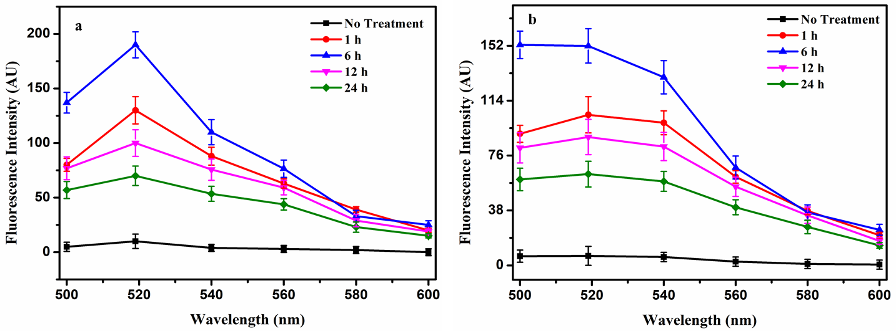
Fig.S5. The presence of the FITC-tagged inhibitor was traced in the mice brain with the aid of fluorescence emission of INH in rat brain supernatant (a). The fitted curve represents the optimized fluorescence emission (b).
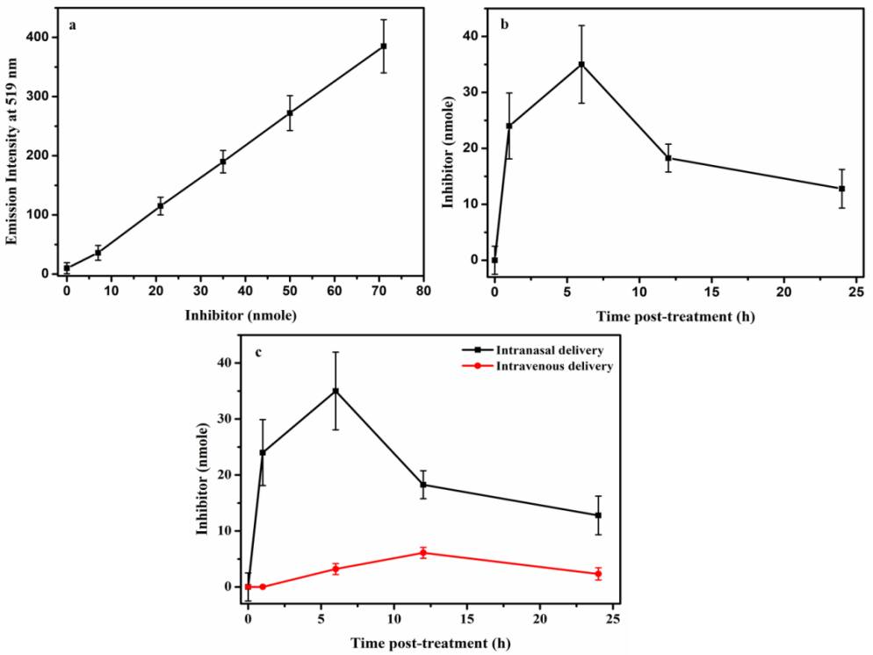
Fig.S6. (a) Calibration curve of fluorescence emission at 519 nm vs. inhibitor amount, and (b) the amount of INH detected in mice brain after final dosing. (c) A comparison of efficiency between the intranasal drug delivery and the intravenous drug delivery of inhibitor.
Acute toxicity study
It was observed that INH showed 100% mortality (3/3) within 24 hour at the mouse dose of 150 µg which is equivalent to 7.5 mg/kg. The respiratory distress was noted immediately followed by salivation, tremor, convulsion and death within 4 h. At the mouse dose of 100 µg (7.5 mg/kg), 66.6% mortality was observed within 48 h of drug administration. No other abnormalities were observed. At the mouse doses of 80-20 µg there was no mortality seen even after 14 days (Table S3).
I2 | Dose/mouse | µg /kg | Dead / Total |  |  |  |  | Dead% | Corrected*  % | Probit
 |  |  | Day 1 | Day 2 | Day 3 | Day 7 | Day 14
1 | 20 µg | 1000 | 0/3 | 0/3 | 0/3 | 0/3 | 0/3 | 0 | 8.33 | 3.611
2 | 40 µg | 2000 | 0/3 | 0/3 | 0/3 | 0/3 | 0/3 | 0 | 8.33 | 3.611
3 | 80 µg | 4000 | 0/3 | 0/3 | 0/3 | 0/3 | 0/3 | 0 | 8.33 | 3.611
4 | 100 µg | 5000 | 0/3 | 2/3 | 2/3 | 2/3 | 2/3 | 66.6 | 66.6 | 5.428
5 | 150 µg | 7500 | 3/3 | - | - | - | - | 100 | 99 | 7.33
Table S3. Acute toxicity study of INH: there was no death occurred up to day 14 for the dose 80 µg or 4000 µg/kg and a significant 100% death at the dose 150 µg or 7500 µg/kg.
Therefore, 50% lethal dose (LD₅₀) of INH was predicted between 80 µg to 100 µg in mice. The log dose of 7500 µg/kg is 3.8750; 5000 µg/kg is 3.6989; 4000 µg/kg is 3.6020; 2000 µg/kg is 3.3010 and 1000 µg/kg is 3. The corrected percentage death was transformed to probits. The probit values were plotted against log doses, and the dose corresponding to probit 5 or 50% was determined. The intranasal LD₅₀ value of test drug, INH in mice was found to be 3650 µg/kg or 73 µg mouse dose.

Fig.S7. The probit value Vs log dose graph showing the corrected percentage death for toxic dose calculation.

In silico modeling of the inhibitor
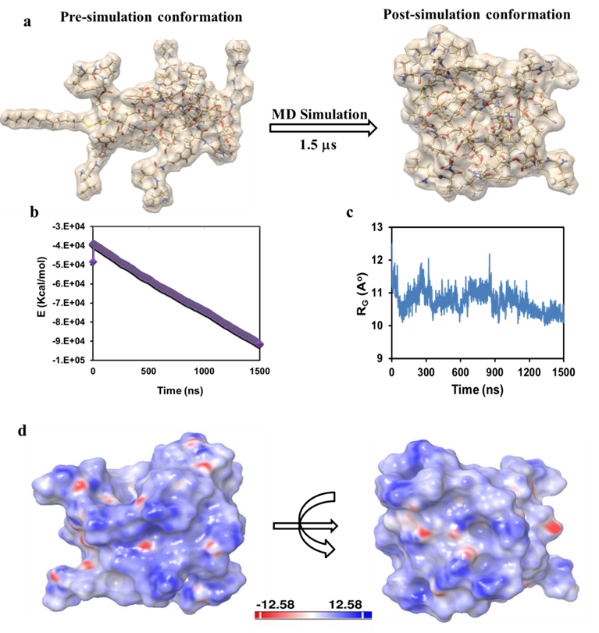
Fig. S8: Molecular dynamics (MD) simulation presenting a: Pre and post simulation 3D structure of PEGylated compound, b: Energy plot of the ensemble structures, c: Compactness (radius of gyration) plot of the compound, and d: Surface charge distribution of the post simulation structure.
Structure | Volume (Å³) | Geometrical diameter (Å) | Geometrical radius (Å) | Geometrical shape coefficient
Before simulation | 4459 | 29.99 | 0.79 | 36.88
After simulation | 4367 | 28.79 | 0.53 | 53.21
Table S4: Comparison of structural properties between the pre and post-simulated structures
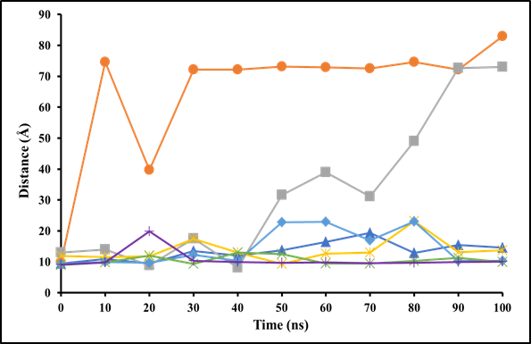
Fig. S9. Distance between the interacting interface of fibril structure of Aβ₄₂ peptide (PDB ID: 5KK3) in pre and post molecular dynamics simulation. Centers of mass of the interface forming 9 + 9 chain units (chain A-I and chain J-R, respectively) of Aβ₄₂ fibril structure were calculated and their respective distances were calculated and compared for pre and post MD simulation (0th and 100th ns structures). Distance trajectories are shown in blue color for simulation without ligand (blues) while in orange, grey, yellow, cyan, green, and purple color ligands were placed near chain A, chain R, chain J, chain I, upper side, lower side, respectively. Aβ₄₂ fibril structure (5KK3) and the ligand (PEGylated compound) are shown in cartoon and stick representations, respectively.
Experimental Procedure
Synthesis and characterization of fluorescein isothiocyanate (FITC) functionalized block copolymer PEG-b-P(LVF-HEMA)
A typical reversible addition-fragmentation chain transfer (RAFT) polymerization reaction was carried out with the starting material tert-butyloxycarbonyl (Boc)-protected leucine-valine-phenylalanine (LVF)-ethyl methacrylate (EMA) (1 g, 1.69 mmol), polyethylene glycol- cyclodextrin polymers (PEG_{5K}-CDP) (458.20 mg, 0.08 mmol), azobisisobutyronitrile (AIBN) (1.4 mg, 8.52 μmol), and dimethylformamide (DMF) (5.8 g) taken in a septa sealed vial and following the protocol reported elsewhere [2, 3]. For the deprotection of the boc group, the resulting 1.02 g boc-protected polymer PEG-b-P(Boc-LVF-EMA) was dissolved in 10 ml dichloromethane (DCM) with 9 ml trifluoroacetic acid (TFA) slowly added to it in stirring condition for 5 h at room temperature. The deprotected polymer PEG-b-P(LVF-EMA) was finally precipitated in cold diethyl ether and dried under vacuum for 8 h at 35°C. Then, functionalization of –NH₂ containing copolymers by FITC was done following a previously reported procedure [4]. Briefly, the copolymer PEG-b-P(LVF-EMA) (0.610 g, 0.10 mmol) was dissolved in 25 ml methanol, and to this solution, triethylamine (Et₃N) (5.2 mg, 0.05mmol) was added drop wise and stirred for 30 min. FITC (20 mg, 0.05mmol) was then added to the reaction mixture and was stirred for 24 h at room temperature (Scheme S1). The organic solvent was reduced under pressure and precipitated from methanol. The precipitate was dissolved in acetone and reprecipitated from methanol. The FITC functionalized block copolymer (inhibitor, INH) was reprecipitated four times from acetone/hexanes and dried under vacuum at 35°C.
The FITC tagging of the block copolymers was confirmed by ¹H NMR spectra (Bruker Avance III 500 MHz spectrometer), UV-visible spectroscopic measurements (Perkin-Elmer Lambda35 spectrophotometer), and fluorescence measurements (Fluoromax-3 spectrofluorimeter from Horiba JobinYvon). The phase transition pH of INH was determined by turbidity measurements using UV-visible spectroscopy. The toxicity of INH was checked at the cellular level (in SHSY5Y and U87 cells) with the aid of 3-(4,5-dimethylthiazol-2-yl)-2,5-diphenyltetrazolium bromide (MTT) reduction assay.
Determination of phase transition pH
After Boc-group deprotection the block copolymer PEG-b-P(LVF-HEMA) is expected to be pH responsive on account of the reversible protonation/deprotonation of the side chain primary amino group [5]. For measurement of phase transition pH, the % transmittance (%T) of aqueous solution of block copolymer (2.0 mg/ml) was recorded at wavelength (λ) = 500 nm within the pH range 3-8 at 25°C. The initial pH of copolymer solution in HPLC water was recorded and then pH was gradually increased using 0.1 M NaOH solution. The % T was recorded at 500 nm for all the solutions adjusted to different pH values. The pH at which % T reduced to 50% is considered the transition pH.
MTT assay
The cellular toxicity of INH was tested via the reduction of 3-(4,5-dimethylthiazol-2-yl)-2,5-diphenyltetrazolium bromide (MTT) dye at a concentration range from 10-100 µM. Briefly, cells were seeded in 96 well plates at a density of 10,000 cells per well in 100 µl high glucose complete DMEM media and allowed to grow for 24 h under 5% CO₂ at 37 °C. After 24 h the medium was replaced with that containing the pre-incubated treatment as stated above. Again after 24 h incubation in the same condition, 10 µl MTT reagent (5 mg/ml in PBS) was added in each well and allowed to incubate for 4 h at 5% CO₂ at 37 °C. Then 85 µl medium was removed from each well and the resulting insoluble formazan was dissolved in 50 µl DMSO. This was allowed to stand for 10 minutes at the CO₂ incubator at 37 °C and the absorbance was measured with the aid of a spectrophotometric microplate reader at 570 nm wavelength. The medium without cells was taken as a blank and subtracted as background from each sample. Absorbance spectra in 3-(4,5-dimethylthiazol-2-yl)-2,5-diphenyltetrazolium Bromide (MTT) reduction assays were recorded using a BioRad iMarkTM microplate reader.
Animal maintenance
All the animals were maintained thoroughly accordance to the animal welfare guidelines briefly as follows.
Environmental conditions
Air conditioned rooms with 10-15 air change per hour, temperature between 20-25 ºC, relative humidity 30-65% and artificial fluorescent illumination cycle set to 12 h light and 12 h dark.
Animal husbandry
Group housed in polypropylene cages with stainless steel grill top, facilities for food and water bottle, and bedding of clean paddy husk for mice and rats. Standard pellet diet for mice and rats were maintained. Food supplied two times a day regularly with cleaned bottled hospital supplied drinking water. Food was withdrawn according to study protocol.
Acute toxicity study
Determination of the acute toxicity is the initial step to evaluate the toxic nature of a drug candidate. This test ensures the level of health hazard likely to arise from a short exposure of any drug in living system. To establish the dosage regimen of INH, the female Swiss albino mice with body weight between 20-25 g were selected in 5 groups (N=3) and after acclimatization for 15 days at laboratory they were given the drug ranging from 10 µg/10 µl to 150 µg/10 µl in each nostrils with the aid of a pipettor in a non-anesthetized mode as described below. The animals were screened for the behavioral observation parameters related to clinical signs of toxicity, incidence of mortality, and signs of intoxication for 14 days following the OECD guidelines [6] (Table S4).
 | Animal No: | Day 1 |  |  |  |  |  | Day
 |  | 10min | 30 min | 1 h | 2 h | 4 h | 6 h | 2 | 3 | 4 | 5 | 6 | 7 | 8 | 9 | 10 | 11 | 12 | 13 | 14
1 | Somatomotor activity
2 | Ataxia
3 | Tremor
4 | Convulsions
5 | Writhing
6 | Straub
7 | Catalepsy
8 | Inclined plane test
9 | Pupils
10 | Ptosis
11 | Reaction to touch
12 | Pinnal reflex
13 | Corneal reflex
14 | Righting reflex
15 | Piloerection
16 | Cyanosis
17 | Salivation
18 | Analgesia
19 | Lacrymation
20 | Diarrhoea
21 | Stereotypy
22 | Muricidal activity
23 | Respiration
24 | Coma
25 | Mortality
Table S5. Behavioral observation parameters related to clinical signs of toxicity: standard flow sheet. N=3; Observing criteria were scored as: present / absent or as increase/decrease.
Intracerebroventricular (ICV) administration of colchicine
Test groups of animals were induced chemically to develop AD by an ICV administration of colchicine (15 µg/5 µl solution of artificial cerebrospinal fluid, ACSF) following surgery with stereotaxic apparatus (Harvard Apparatus, USA). For this purpose, the rats were anesthetized with thiopental sodium (45 mg/kg, i.p injection) and positioning the head in the stereotaxic frame, a midline sagittal incision was made in the scalp [7]. Following this, two holes were drilled in the skull for the placement of the injection cannula into both the lateral cerebral ventricles. A Hamilton micro syringe was positioned in this injection cannula and kept in place for 2 min for the complete diffusion of the injected solution and to prevent pressure-induced damage. The coordinates for the ICV cannula implants were 0.8 mm posterior to bregma, 1.8 mm lateral to the sagittal suture and 3.6 mm beneath the cortical surface [8]. The normal control (Sham) and INH-treated control groups were received equal concentration of ACSF (ACSF in mmol/l; 147 NaCl, 2.9 KCl, 1.6 MgCl₂, and 2.2 dextrose). After careful removal of the cannula, the holes in the skull were filled up with dental cement and the scalp was closed with a suture. Gentamicin (5 mg/kg) was applied intraperitoneally to all upto 13th day for the prevention of sepsis. During postoperative period, the animals were taken special care to provide food and water inside the cage and housed in a group of two with soft bedding.
Study design and schedule
After acclimatization in the laboratory condition, the healthy Wistar rats were divided into five groups as mentioned in the main manuscript. Except the sham group and the INH-treated control group the test groups were induced AD by ICV administration of colchicine and observed for 2 weeks for progression of AD. The treated groups were received the inhibitor at the prefixed daily doses after 2 week of colchicine administration and continued for another 2 weeks. The behavioral and cognitive improvements and biochemical, neurochemical and histopathological/immunohistochemical assessments were conducted in schedule time as given below.
Day: 0 | Behavioral study: training for open field and closed field studies
Day: 1 | Surgery, ICV administration of colchicine
Day: 1-13 | Post-operative care
Day: 14-28 | Treatment period
Day: 19 | Behavioral study: passive avoidance
Day: 20 | Behavioral study: passive avoidance, elevated plus maze (EPM) and water maze
Day: 21 | Behavioral study: EPM and water maze
Day: 27 | Behavioral study: passive avoidance
Day: 28 | Behavioral study: open field, closed field, EPM, water maze, and Y-maze
Day: 29 | Sacrifice and brain dissection of the rats.
Table S6. Experimental study design
During the acquisition of AD model and the consecutive improvement of the experimental rats, the body weight of the animals was continuously monitored and noted down.
Transmucosal nasal drug delivery
For a non-anesthetized/awake mode of intranasal or transmucosal nasal delivery, the rats were acclimated to handling for 7 days to ensure a proper body position during delivery and to avoid the anxiety reactions after dosing. During dosing, the rats were held in the palm with a grip in their scruff and turning them onto their back, so that the neck and chin of the rats remain flat and parallel to the floor (the chin was close to a 180° angle with the neck as much as possible). In this position, each rat was given the dose slowly at a nostril using a pipettor at 45° angle near the rat’s nostril. Finally, the rat was held for 15 sec in the same position at its back and then released and repeated for dosing in another nostril. For transmucosal nasal delivery, the inhibitor was solubilized in 20 mM PBS, pH 5.5, and administered to the drug-treated groups at the doses of 10 µg/10 µl and 20 µg/10 µl for each nostril daily for 14 days. The ‘Sham’ group received the same amount of PBS. Also, the INH-treated control group has received the 10 µg/10 µl dose of INH in each nostril daily for 14 days.
Drug absorption in the brain
The FITC-tagged inhibitor (INH) was traced for its presence in rat brains after the transmucosal nasal delivery following a modified protocol reported elsewhere [9]. Briefly, 10 nmole of INH was given to 3 months old female nulliparous Wistar rats (1 group, N=3) for three consecutive days daily to enhance the detectable fluorescence emission. The animals were sacrificed after 1 h, 6 h, 12 h, and 24 h of completing the final (3rd) dose. Then, the brains were processed following a perfusion and subsequent homogenization via sonication on ice. After that, the brain homogenates were centrifuged at 21000 g for 20 min at cold and the supernatant was collected and volume made up to 1.0 ml with homogenization buffer. The presence of INH in brain supernatant was quantified through the emission of fluorescence between 500 nm and 600 nm with the excitation spectra of 446 nm. Results were represented as mean ± SD (N=3).
Intravenous drug delivery for comparison with the intranasal delivery
The efficiency of the intranasal delivery of the FITC-tagged inhibitor was assessed through a comparison between the intranasal and intravenous (IV) administration of same amount of the inhibitor and following similar methods as described above. Briefly, 10 nmole of INH was given to 3 months old female nulliparous Wistar rats (1 group, N=3) for three consecutive days daily via IV injection through the tail vain to avoid an anesthesia and anesthesia related complications on neurological behaviors. For this purpose, the female Wistar rats were restrained with the help of a mechanical restraint device and the tail protruding outside. While keeping on a heating pad and after wiping the tail with antiseptic solution, the rats were injected with INH at the tail vain. After completing the final (3rd) dose at day 3, the animals were sacrificed at 1 h, 6 h, 12 h, and 24 h time point of the final dosing. Then, the brains were processed following a perfusion and subsequent homogenization via sonication on ice. After that, the brain homogenates were centrifuged at 21000 g for 20 min at cold and the supernatant was collected and volume made up to 1.0 ml with homogenization buffer. The presence of INH in brain supernatant was quantified through the emission of fluorescence between 500 nm and 600 nm with the excitation spectra of 446 nm. Results were represented as mean ± SD (N=3).
Behavioral studies
Open-field activity
Plywood-made square open-field apparatus of 61 cm × 61 cm with high walls of 61 cm was chosen for this study. The apparatus was painted white except for the 6 mm thick black lines, which divided the floor into 16 squares. The study was done following a modified protocol by Xing et al. on 1 day before ICV injection and day 28 after injection [10]. Each animal was placed in the apparatus for 5 min, and the ambulation, rearing and self-grooming were noted to understand the locomotor behavior of the experimental animals.
Closed-field activity
To observe gross behavioral activity, the animals were placed in a square (30 cm) closed arena equipped with infrared light-sensitive photocells (digital photoactometer, Sentwin, India) [11]. The animals were observed for 5 min on one day before and day 28 after ICV colchicine injection, and the values were expressed as counts/5min.
Y-Maze test
The willingness of the experimental animals to explore a new environment was tested on day 28 post ICV injection by a three-arm horizontal Y-maze forming an angle of 120 degrees with the dimensions of 24 inch length, 6 inch width, and 12 inch height. The floor and walls of the maze were constructed with black polyvinyl plastic. After placing in one of the arm compartments, each rat was allowed to move freely until its tail completely enters another arm. For each animal, this test was carried out for 5 min, and the apparatus was cleaned with 5% alcohol and allowed to dry between two sessions. The sequence of arm entries was recorded manually. The arms were labeled as ‘A’, ‘B’ and ‘C’, and an actual alternation in the movement was considered when a rat entered into all three arms on consecutive choices, i.e., ABC, BCA, or CAB but not CAC, BAB, or ABA. The spontaneous alternation (%) was derived following the equation below [12].
% Alternation = [(Number of alternations)/(Total number of arm entries ̶ 2)× 100.
Elevated plus maze test
The acquisition of memory was tested on day 20 after colchicine administration with an elevated plus maze [13]. The maze used in the study was consisted of two opposite 50 cm × 10 cm black open arms crossed with two closed walls of the same dimensions and 40 cm height. The arms were connected with a 10 cm × 10 cm central square, and the entire maze was elevated to a height of 50 cm from the floor. The animal was placed individually at one end of the open arm facing away from the central square, and the time taken by the animal to move from the open arm to the closed one was recorded as the initial transfer latency (ITL). Before returning to the home cage and following the measurement of ITL, the animal was allowed to explore the maze for 20 s. On failure to enter the enclosed arm within 90 s, the animal was guided on the back into one of the enclosed arms, and the ITL was recorded as 90 s. Retention of memory was assessed by repeating the test on day 21 and day 28 and was termed as the first retention transfer latency (1st RTL) and second retention transfer latency (2nd RTL), respectively.
Step-down latency passive avoidance test
On day 19, after ICV injection, rats were placed on a fixed central platform of a rectangular Plexiglas box with an electrified grid floor where they received an electric shock of 20 V on stepping down the platform [14]. After 3 consecutive training with a 1 h interval each, the acquisition step-down latency (SDL) was recorded at the final training session without giving a shock. The experiment was repeated on the next day (day 20), and day 27 without giving shock and the respective times taken for the rat to step down were measured and defined as the first and second retention latency. The SDL was taken as 5 min where the animal did not step down in this cut-off period.
Morris water maze test
For testing the acquisition and retention of a spatial navigation capability of the experimental animals, the Morris water maze task was performed following a modified protocol by Zhang et al. [15]. Rats were trained to swim to reach a 6 × 6 inch movable platform mounted on a column and placed 1 inch above the water level in a circular pool of dimensions 2 feet diameter × 3.5 feet height, filled with milk-mixed opaque water (28 ± 2 ºC) to a depth of 1.5 feet. The animals received a 4 trials-training session with a trial interval of 6-10 min on day 20, where the starting positions were different for every trial. The latency to find the escape platform was recorded up to a threshold of 3 min on the defeat of which the animal was placed back to the platform where it remained for 15 s. At the end of each trial, the rat was returned to its home cage. During the experiment, the platform was fixed in the center of the pool, and the minimum time taken by a rat to reach the platform was recorded as the initial acquisition latency (IAL). Following 24 h (day 21) and 7 days (day 28) after IAL, a rat was randomly released facing the wall of the pool and tested for the retention of the response. The time taken to reach the hidden platform on day 21 and day 28 following colchicine injection was noted as first retention latency (1st RL) and second retention latency (2nd RL).
Biochemical tests
After completing the study, on day 29, succeeding the colchicine injection, all animals were sacrificed by decapitation. The cerebral cortex and hippocampus were dissected out, and the cerebellum was discarded following the immediate removal of the brain from the skull. The brain parts were put on ice and then rinsed with ice-cold isotonic saline. A brain homogenate (10% w/v) in 0.1 M phosphate buffer (pH 7.4) was centrifuged at 10,000 g for 15 min and aliquots of the supernatant were separated for the biochemical estimations as well as for profiling the neurotransmitters.
Acetylcholinesterase (AchE) activity
Acetylcholinesterase (E.C 3.1.1.7) activity was assessed by Ellman’s method following a standard protocol [16]. Briefly, 0.1 ml aliquot of the brain homogenate was further diluted with 2.4 ml phosphate buffer (0.1 M, pH 8.0) and mixed thoroughly with 0.1 ml of 0.01 M DTNB. The absorbance spectrum was measured at 412 nm, and the stable peak was recorded as the basal reading. Then, 0.02 ml of 0.075 M acetylcholine iodide was added, and a change in absorbance was recorded with respect to the basal value. Change in absorbance per min was thus determined, and the results were expressed as AChE in µM/mg protein.
Lipid peroxidation profiling
The degree of lipid peroxidation in the brain tissue samples was determined by measuring the amount of malondialdehyde (MDA) following Buege and Aust [17]. In brief, 0.9 ml of thiobarbituric acid (TBARS, 0.375%) solution was added to 0.1 ml of tissue homogenate and heated at 90 °C for 30 min. The reaction mixture was cooled and centrifuged at 5,000 rpm for 10 min. The optical density of MDA present in the supernatant was measured spectrophotometrically at 532 nm. The concentration of MDA in respect to the total protein present in tissue (µg MDA/mg protein) was determined with the aid of a standard curve.
Reduced glutathione (GSH) measurement
Following Ellman’s standard protocol, the concentration of reduced glutathione in brain tissue homogenate was determined spectrophotometrically [18]. Briefly, 0.1 ml of the tissue homogenate was chelated with 0.6 ml of 20 mM EDTA solution and incubated at 4 ºC for 10 min. After that, 0.5 ml of distilled water and 0.25 ml of 10% TCA were mixed with the solution and subjected to centrifugation at 5,000 rpm following incubation for 5 min at room temperature. To 1 ml of this supernatant, 2 ml of 0.4 M Tris buffer and 0.1 ml of 0.1 M 5,5´-dithio-bis-(2-nitrobenzoic acid) (DTNB) was added and incubated for 3 min at room temperature prior to the measurement of optical density at 412 nm wavelength. The concentration was determined by plotting a standard curve against reduced GSH and expressed as mM of GSH/mg of protein.
Superoxide dismutase (SOD) activity
Phenazinemethosulphate (PMS) and nicotinamide adenine dinucleotide (NADH) form a complex that generates superoxide radicals. The addition of nitro blue tetrazolium (NBT) into the reaction forms purple-colored formazan [19]. To assess the superoxide dismutase activity in the brain homogenate sample, 0.1 ml of 186 µM PMS was mixed with 1.2 ml of sodium pyrophosphate buffer (0.052 mM; pH 8.3), 1 ml of distilled water, and 0.2 ml of tissue homogenate and briefly kept in the dark for 90 s at room temperature. The reaction was immediately stopped by adding 1 ml of glacial acetic acid, and the chromogen was measured spectrophotometrically at 560 nm wavelength. The concentration of SOD was calculated from a standard curve and plotted with respect to the amount of protein (U/mg protein) present in the tissue.
Catalase activity
Catalase activity was estimated following the standard method [20]. In brief, 0.05 ml supernatant from the brain tissue homogenate was taken in 3 ml of hydrogen peroxide phosphate buffer. This reaction mixture was scan spectrophotometrically for any change in absorbance at 240 nm for 2 min at every 30 s interval. The catalase activity was expressed in terms of micromoles of H₂O₂ decomposed per min per mg of protein.
Histopathology of brain sections
The brain tissue samples from the frontal and hippocampus were taken and fixed in 10% neutral buffered formalin and embedded in paraffin. These paraffin-embedded tissue samples were cut into 5 µm thick sections with the aid of microtome and affixed onto slides. Following a deparaffinization with xylene and ethanol, the tissue sections were stained with hematoxylin-eosin and visualized under a light microscope for the histological study (Leica, Germany) [20].
Determination of reactive oxygen species (ROS) level and pro and anti-inflammatory cytokines in U87 cell line
The level of ROS was determined with the aid of 2ʹ,7ʹ-Dichlorofluorescein diacetate (DCF-DA) which upon oxidation converts into the fluorescent dye 2ʹ,7ʹ-Dichlorofluorescein (DCF). Cells were seeded into a 96 well black wall plate and treated with different concentrations of Aβ₄₂ (15 µM) (the IC50 value of Aβ₄₂ fibril was 15µM), (Aβ₄₂+Inhibitor) (1:1, 15 µM each), and only inhibitor (15 µM) for 24 h. For measuring the changes in ROS the inhibitor was used without any FITC tag to avoid interference in green fluorescence emission zone. After treatment, cells were washed with ice-cold PBS and then incubated in 10 µM DCF-DA dye (diluted in serum-free DMEM from a stock solution of 1mM concentration) for 30 min at 37 ºC at dark. The resulting fluorescence was recorded using a fluorescence microplate reader (Biotech, USA) with the excitation and emission wavelength of 485 nm and 538 nm, respectively [21].
Besides, the treated cells were washed with ice-cold PBS and collected as PBS-cell suspension in separate FACS tubes after trypsinization for flow cytometry. These cells were then incubated with 10 µM DCF-DA for 30 min in the dark and analyzed in a flow cytometer. The mean fluorescence intensity data were plotted.
Quantitative assessment of pro and anti-inflammatory cytokines viz. TNF-α, TGF-β, IL-6, and IL-10 were done through enzyme-linked immunosorbent assay (ELISA) using separate kits (RAB0476, RAB0460, RAB0306, and RAB0244 from Sigma Aldrich) and following manufacturer’s protocol. Briefly, 1×10⁴ cells were seeded in each well of provided 96 well ELISA plate and grown overnight at 37 ºC and 5% CO₂ in DMEM media with 10% FBS. The cells were treated separately with Aβ₄₂ (15 µM), Aβ₄₂+INH (1:1, 15 µM each), and INH (15 µM) for 24 h at 37 ºC and 5% CO₂. Prior to the assay, the cell culture media were discarded by flipping the microplate upside down and tapping gently. After 3 times washing with 200 µl each 1X wash buffer-A, 100 µl fixing solution was added to each well and incubated for 20 min at RT. Again, following the washing step with wash buffer-A, 200 µl of 1X quenching buffer was added to each well and incubated at RT for 20 min. Next, 4X washing step with wash buffer-A preceded the addition of 200 µl 1X blocking buffer into each well and followed an incubation at 37 ºC for 1 h. After washing with 1X wash buffer-B for 3 times, 50 µl of the 1X primary antibody was added to each well and allowed to incubate for 2 h at RT. This was followed by 4X washing with wash buffer-B and subsequent addition of 50 µl 1X HRP-conjugated secondary antibody to each well. After 1h incubation at RT, the wells were again washed with wash buffer-B 4 times. Finally, 100 µl of TMB substrate was added to each well and incubated for 30 min at RT in the dark. Lastly, 50 µl stop solution was added into each well, and the absorbance was recorded at 450 nm wavelength.
Measurement of mitochondrial membrane potential and cellular mitochondrial bioenergetics
For measuring the mitochondrial membrane potential, cells were treated with Aβ₄₂ (15 µM) and a 1:1 molar ratio of Aβ₄₂ and the inhibitor (15 µM each) along with the inhibitor itself (15 µM) for 12 h at 37 ºC and 5% CO_{2.} Prior to the incubation with JC-1 stain, the treated cells were washed with ice-cold PBS and collected in PBS following trypsinization. The cell suspensions were incubated at 37 ºC for 20 min with 1 µl JC-1 stain added to each FACS tube. Following this, the cells were analyzed in a FACS for the ratio of red to green cells.
Cellular mitochondrial bioenergetics viz. mito-stress was analyzed by calculating the oxygen consumption rate (OCR) in the U87 cell line via the Seahorse XFe24 extracellular flux analyzer (Seahorse Bioscience, USA). Briefly, 1.5-2×10⁴ cells were seeded in an XFe24 plate with one blank well per row. On reaching confluence, the cells were treated with different concentrations of Aβ₄₂ (15 µM), Aβ₄₂+INH (15 µM: 15 µM, and 15 µM: 30 µM), and the inhibitor itself (15 µM) at 37 ºC in a CO₂ incubator for 12 h. The culture media were then washed off and replaced with XF base media (Seahorse Bioscience) supplemented with glutamine and glucose prior to the incubation at 37 ºC for 60 min in a non-CO₂ incubator. Finally, the OCR was recorded after the injection of mitochondrial respiratory inhibitors, namely oligomycin, carbonyl cyanide-4-(trifluoromethoxy)-phenylhydrazone (FCCP) and rotenone/antimycin A respectively, through the drug injection ports. The data were normalized with respect to the protein content of each treatment following protein estimation by the Lowry method [22].
In silico molecular dynamics simulation
The 113 unit stretch of PEG along with 10 unit side-chain tripeptide viz. ‘LVF’ was simulated using the smile formula to obtain the 3D structure of the compound. The structural stability and dynamics of this 3D structure were analyzed through 1.5 µs long MD simulation. Molecular dynamic (MD) simulation was performed using the Desmond simulation package [23]. The OPLS_2005 force field parameters were used to generate the coordinates and topology of the molecule [24, 25]. The system was solvated with TIP3P water, and counter ions were added to neutralize the charge [26]. Orthorhombic periodic boundary conditions were defined to specify the shape and size of the simulation box buffered at 10 Å distances. A hybrid method combining the steepest decent and the limited-memory Broyden-Fletcher-Goldfarb-Shanno (LBFGS) algorithm was used for minimizing the system [27]. Further, the system was equilibrated in NVT followed by NPT conditions using the default protocol of Desmond. Finally, the production run was performed at 300K temperature and 1 atmospheric pressure with a time step of 2 fs for 1.5 μs. The temperature and pressure of the NPT ensemble were regulated by using the Nose-Hoover Chain thermostat and Martyna-Tobias-Klein barostat, respectively [28, 29]. The RESPA integrator was used for integrating the equations of motion [30].
COCCOCCOC(CCC(C)(C#N)CC(C)(CC(C)(CC(C)(CC(C)(CC(C)(CC(C)(CC(C)(CC(C)(CC(C)(CC(SC(SCCCCCCCCCCCC)=S)(C)C(OCCOC(C(NC(C(C(C)C)NC(C(CC(C)C)[NH3+])=O)=O)CC1=CC=CC=C1)=O)=O)C(OCCOC(C(NC(C(C(C)C)NC(C(CC(C)C)[NH3+])=O)=O)CC2=CC=CC=C2)=O)=O)C(OCCOC(C(NC(C(C(C)C)NC(C(CC(C)C)[NH3+])=O)=O)CC3=CC=CC=C3)=O)=O)C(OCCOC(C(NC(C(C(C)C)NC(C(CC(C)C)[NH3+])=O)=O)CC4=CC=CC=C4)=O)=O)C(OCCOC(C(NC(C(C(C)C)NC(C(CC(C)C)[NH3+])=O)=O)CC5=CC=CC=C5)=O)=O)C(OCCOC(C(NC(C(C(C)C)NC(C(CC(C)C)[NH3+])=O)=O)CC6=CC=CC=C6)=O)=O)C(OCCOC(C(NC(C(C(C)C)NC(C(CC(C)C)[NH3+])=O)=O)CC7=CC=CC=C7)=O)=O)C(OCCOC(C(NC(C(C(C)C)NC(C(CC(C)C)[NH3+])=O)=O)CC8=CC=CC=C8)=O)=O)C(OCCOC(C(NC(C(C(C)C)NC(C(CC(C)C)[NH3+])=O)=O)CC9=CC=CC=C9)=O)=O)C(OCCOC(C(NC(C(C(C)C)NC(C(CC(C)C)[NH3+])=O)=O)CC%10=CC=CC=C%10)=O)=O)=O
Fig S10: The smile formula of the PEGylated block copolymer with 113 units of PEG attached at a stretch and to this 10 units of side chain tripeptide viz “LVF” are attached via a chain transfer reagent CDP (4-Cyano-4-[(dodecylsulfanylthiocarbonyl)sulfanyl] pentanoic acid).

References
1. Kumar S, Roy SG, De P (2012) Cationic methacrylate polymers containing chiral amino acid moieties: controlled synthesis via RAFT polymerization. Polym Chem 3:1239–1248
2. Som Chaudhury S, Sannigrahi A, Nandi M, et al (2019) A Novel PEGylated Block Copolymer in New Age Therapeutics for Alzheimer’s Disease. Mol Neurobiol 56:6551–6565. https://doi.org/10.1007/s12035-019-1542-1
3. Kumar S, Acharya R, Chatterji U, De P (2014) Controlled synthesis of β-sheet polymers based on side-chain amyloidogenic short peptide segments via RAFT polymerization. Polym Chem 5:6039–6050. https://doi.org/10.1039/C4PY00620H
4. Kumar S, Maiti B, De P (2015) Carbohydrate-Conjugated Amino Acid-Based Fluorescent Block Copolymers: Their Self-Assembly, pH Responsiveness, and/or Lectin Recognition. Langmuir 31:9422–9431. https://doi.org/10.1021/acs.langmuir.5b02245
5. Nandi M, Maiti B, Srikanth K, De P (2017) Supramolecular Interaction-Assisted Fluorescence and Tunable Stimuli-Responsiveness of l-Phenylalanine-Based Polymers. Langmuir 33:10588–10597. https://doi.org/10.1021/acs.langmuir.7b02431
6. OECD (2009) Test No. 403: Acute Inhalation Toxicity
7. Veerendra Kumar MH, Gupta YK (2002) Intracerebroventricular administration of colchicine produces cognitive impairment associated with oxidative stress in rats. Pharmacol Biochem Behav 73:565–571. https://doi.org/10.1016/s0091-3057(02)00838-9
8. Paxinos G, Watson CRR, Emson PC (1980) AChE-stained horizontal sections of the rat brain in stereotaxic coordinates. J Neurosci Methods 3:129–149. https://doi.org/https://doi.org/10.1016/0165-0270(80)90021-7
9. Cheng Y-S, Chen Z-T, Liao T-Y, et al (2017) An intranasally delivered peptide drug ameliorates cognitive decline in Alzheimer transgenic mice. EMBO Mol Med 9:703–715. https://doi.org/10.15252/emmm.201606666
10. Xing Y, Hou J, Meng Q, et al (2015) Novel antidepressant candidate RO-05 modulated glucocorticoid receptors activation and FKBP5 expression in chronic mild stress model in rats. Neuroscience 290:255–265. https://doi.org/https://doi.org/10.1016/j.neuroscience.2015.01.044
11. Davenport JW, Hagquist WW, Rankin GR (1970) The symmetrical maze: An automated closed-field test series for rats. Behav Res Methods Instrum 2:112–118. https://doi.org/10.3758/BF03211017
12. Lee G-Y, Lee C, Park GH, Jang J-H (2017) Amelioration of Scopolamine-Induced Learning and Memory Impairment by α-Pinene in C57BL/6 Mice. Evidence-Based Complement Altern Med 2017:4926815. https://doi.org/10.1155/2017/4926815
13. Sharma AC, Kulkarni SK (1992) Evaluation of learning and memory mechanisms employing elevated plus-maze in rats and mice. Prog Neuro-Psychopharmacology Biol Psychiatry 16:117–125. https://doi.org/https://doi.org/10.1016/0278-5846(92)90014-6
14. Gupta R, Gupta LK, Mediratta PK, Bhattacharya SK (2012) Effect of resveratrol on scopolamine-induced cognitive impairment in mice. Pharmacol Reports 64:438–444. https://doi.org/10.1016/S1734-1140(12)70785-5
15. Zhang L, Fang Y, Lian Y, et al (2015) Brain-Derived Neurotrophic Factor Ameliorates Learning Deficits in a Rat Model of Alzheimer’s Disease Induced by Aβ1-42. PLoS One 10:e0122415
16. Ellman GL, Courtney KD, Andres V, Featherstone RM (1961) A new and rapid colorimetric determination of acetylcholinesterase activity. Biochem Pharmacol 7:88–95. https://doi.org/https://doi.org/10.1016/0006-2952(61)90145-9
17. Buege JA, Aust SD (1978) Microsomal lipid peroxidation. Methods Enzymol 52:302–310. https://doi.org/10.1016/s0076-6879(78)52032-6
18. Ellman GL (1959) Tissue sulfhydryl groups. Arch Biochem Biophys 82:70–77. https://doi.org/10.1016/0003-9861(59)90090-6
19. Sharma P, Tripathi A, Tripathi PN, et al (2019) Design and development of multitarget-directed N-Benzylpiperidine analogs as potential candidates for the treatment of Alzheimer’s disease. Eur J Med Chem 167:510–524. https://doi.org/https://doi.org/10.1016/j.ejmech.2019.02.030
20. Liu Y, Wu Y-M, Yu Y, et al (2015) Curcumin and resveratrol in combination modulate drug-metabolizing enzymes as well as antioxidant indices during lung carcinogenesis in mice. Hum Exp Toxicol 34:620–627. https://doi.org/10.1177/0960327114551396
21. Amri F, Ghouili I, Amri M, et al (2017) Neuroglobin protects astroglial cells from hydrogen peroxide-induced oxidative stress and apoptotic cell death. J Neurochem 140:151–169. https://doi.org/https://doi.org/10.1111/jnc.13876
22. Ruidas B, Sur TK, Pal K, et al (2020) Herbometallic nano-drug inducing metastatic growth inhibition in breast cancer through intracellular energy depletion. Mol Biol Rep 47:3745–3763. https://doi.org/10.1007/s11033-020-05467-7
23. Bowers KJ, Chow DE, Xu H, et al (2006) Scalable Algorithms for Molecular Dynamics Simulations on Commodity Clusters. In: SC ’06: Proceedings of the 2006 ACM/IEEE Conference on Supercomputing. p 43
24. Jorgensen WL, Maxwell DS, Tirado-Rives J (1996) Development and Testing of the OPLS All-Atom Force Field on Conformational Energetics and Properties of Organic Liquids. J Am Chem Soc 118:11225–11236. https://doi.org/10.1021/ja9621760
25. Kaminski GA, Friesner RA, Tirado-Rives J, Jorgensen WL (2001) Evaluation and Reparametrization of the OPLS-AA Force Field for Proteins via Comparison with Accurate Quantum Chemical Calculations on Peptides. J Phys Chem B 105:6474–6487. https://doi.org/10.1021/jp003919d
26. Mark P, Nilsson L (2001) Structure and Dynamics of the TIP3P, SPC, and SPC/E Water Models at 298 K. J Phys Chem A 105:9954–9960. https://doi.org/10.1021/jp003020w
27. Saputro DRS, Widyaningsih P (2017) Limited memory Broyden-Fletcher-Goldfarb-Shanno (L-BFGS) method for the parameter estimation on geographically weighted ordinal logistic regression model (GWOLR). AIP Conf Proc 1868:40009. https://doi.org/10.1063/1.4995124
28. Nosé S (1984) A unified formulation of the constant temperature molecular dynamics methods. J Chem Phys 81:511–519. https://doi.org/10.1063/1.447334
29. Martyna GJ, Tobias DJ, Klein ML (1994) Constant pressure molecular dynamics algorithms. J Chem Phys 101:4177–4189. https://doi.org/10.1063/1.467468
30. Tuckerman M, Berne BJ, Martyna GJ (1992) Reversible multiple time scale molecular dynamics. J Chem Phys 97:1990–2001. https://doi.org/10.1063/1.463137

