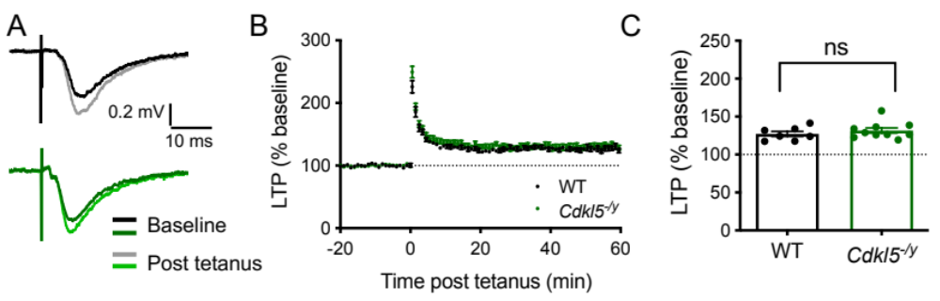
Supplemental Figure 1. Hippocampal LTP in adult (10-12 weeks) Cdkl5^{-/y} rats. A - Representative WT (upper) and Cdkl5^{-/y} (lower) fEPSP traces before (baseline) and after (post tetanus) LTP induction. B - Time-course showing long term potentiation (LTP) in the hippocampal CA1 induced by two trains with 100 pulses at 100Hz (20 seconds apart. C – LTP in the final 10 minutes of the recording relative to baseline (WT n = 7 rats; Cdkl5^{-/y}: n = 9 rats; ns p>0.05 Two tailed T test, dots represent animal averages).

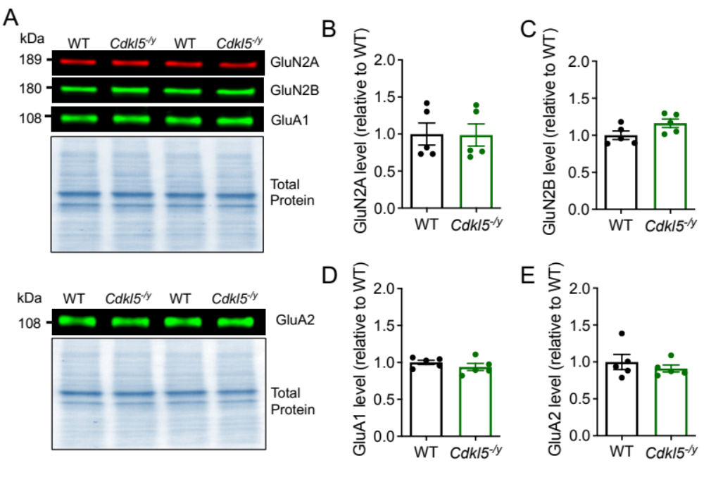

Supplemental Figure 2. NMDAR and AMPAR subunit expression in hippocampal synaptosome preparations of P14 Cdkl5^{-/y} rats. A – Representative Western blots for GluN2A, GluN2B, GluA1 and GluA2 with respective Total Protein staining. B-E - Quantification of protein expression relative to WT and normalised to total protein (relative to WBs shown in A). All p values > 0.05, WT n = 5 rats; Cdkl5^{-/y}: n = 5 rats, data shown as mean ± SEM

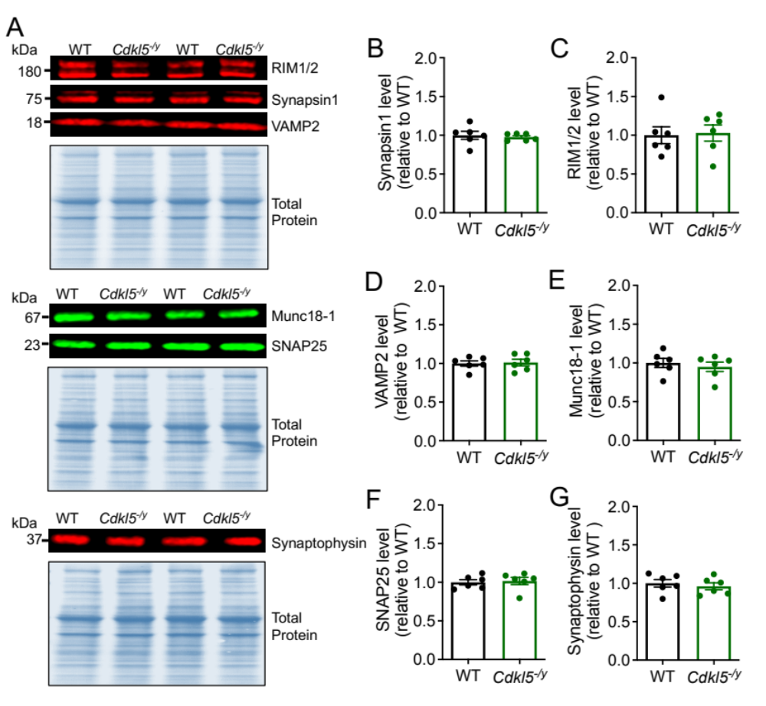

Supplemental Figure 3. Expression of presynaptic proteins in hippocampal synaptosome preparations of P28-35 Cdkl5^{-/y} rats. A – Representative Western blots for presynaptic proteins with respective Total Protein staining. B-G Quantification of protein expression relative to WT and normalised to total protein (relative to WBs shown in A) All p values > 0.05, WT n = 6 rats; Cdkl5^{-/y}: n = 6 rats, data shown as mean ± SEM

.

