Atorvastatin Improves Cisplatin Sensitivity Through Modulation of Cholesteryl Ester Homeostasis in Breast Cancer Cells
Diandra Zipinotti dos Santos¹, Isabella dos Santos Guimaraes², Mariam F. Hakeem-Sanni³, Blake J. Cochran⁴, Kerry-Anne Rye⁴, Thomas Grewal⁵, Andrew J. Hoy ^{3#}, Leticia B.A. Rangel^{1,6#}
¹ Biotechnology Program/RENORBIO, Health Sciences Center, Federal University of Espirito Santo, Vitoria, ES, Brazil
² Division of Clinical Research, Research Center, Instituto Nacional de Cancer, Rio de Janeiro, Brazil
³ School of Medical Sciences, Charles Perkins Centre, Faculty of Medicine and Health, The University of Sydney, Sydney, New South Wales, Australia.
⁴ School of Medical Sciences, Faculty of Medicine, University of New South Wales, Sydney, New South Wales, Australia
⁵ School of Pharmacy, Faculty of Medicine and Health, The University of Sydney, Sydney, New South Wales, Australia
⁵ Biochemistry Program, Health Sciences Center, Federal University of Espirito Santo, Vitoria, ES, Brazil
⁶Department of Pharmaceutical Sciences, Federal University of Espirito Santo, Vitória, Brazil

Supplementary Data

Figure S1: Effect of combined CDDP and ATV treatment on apoptotic rates in MCF-7 and MDA-MB-231 cell lines.
(A) MCF-7 and (B) MDA-MB-231 cells treated without ATV (control), 0.1 µM ATV, 0.1 µM (IC₅₀) ATV (top panels), or 2 µM CDDP alone, 2 µM CDDP + 0.1 µM ATV or 2 µM CDDP + 5 µM ATV (bottom panels). Flow cytometric analysis results are shown after treatment for 48 h.
Figure S2: Effect of cholesterol deprivation on cholesterol esterification.
Incorporation of radiolabeled oleate into CE in MCF-7 and MDA-MB-231 cells. BC cells were plated and cultivated in standard culture medium for 24h and then radiolabeled oleate was added and incorporation into CE was determined. Two-Way ANOVA multiple comparisons test was used. Error bars represent the mean ± SD, n = 3, *p <0.05, **p <0.005, ***p <0.0001.

Figure S3: Effect of ATV on ACAT-1 expression.
MCF-7 and MDA-MB-231 cell lines were cultivated in DMEM containing FBS overnight, followed by ATV treatment (0.1µM, 1µM or 10µM) for 48h. A representative immunoblot of ACAT-1 and 14-3-3 (loading control) proteins is shown (n=3).
Figure S4: Breast cancer cell morphology.
(A) MDA-MB-231 and (B) MDACR. MDACR cells have distinct morphological changes exposed to CDDP (indicated by the red arrow). Cell morphology was analyzed in a Zeiss Observer Z1 microscope, and all images were acquired by Axio-Vision Rel. 4.8 software (Carl Zeiss). Magnification 10x. The scale bars are 10 mm.

Figure S5: Analysis of cross-resistance to paclitaxel and doxorubicin in MDA-MB-231 and MDACR cells.
MDA-MB-231 and MDACR cells were treated with (A) paclitaxel (concentration 0.001 - 10 μM) and (B) doxorubicin (0.1 -100μM) for 48h. IC₅₀ values calculated by nonlinear regression of log(inhibitor) vs. response using least squares as fitting method in a 4 parameters calculation with variable slope. IC₅₀ represents loss of 50% cell viability. Results are expressed as percentage of control (untreated cells). Error bars represent the mean ± SD, n = 3, *p <0.05, **p <0.005, ***p <0.0001.

Figure S6: Comparison of ATV sensitivity in MDA-MB-231 and MDACR cells.
Cells were treated with ATV (0.001 - 10 μM) for 48h. IC₅₀ values calculated by nonlinear regression of log(inhibitor) vs. response using least squares as fitting method in a 4 parameters calculation with variable slope. IC₅₀ represents loss of 50% of viability. Results were expressed as percentage of control (untreated cells). Error bars represent the mean +/- SD, n = 3, *p <0.05, **p <0.005, ***p <0.0001.

Figure S7: Intracellular free cholesterol content in MCF-7 and MDA-MB-231 cells.
BC cells were plated and cultivated in standard FCS-containing medium for 24h and then cholesterol content was determined with the Amplex® Red Cholesterol Assay Kit. Two-tailed unpaired t-test was used for statistical significance analysis of comparison between the two cell lines. *p < 0.05

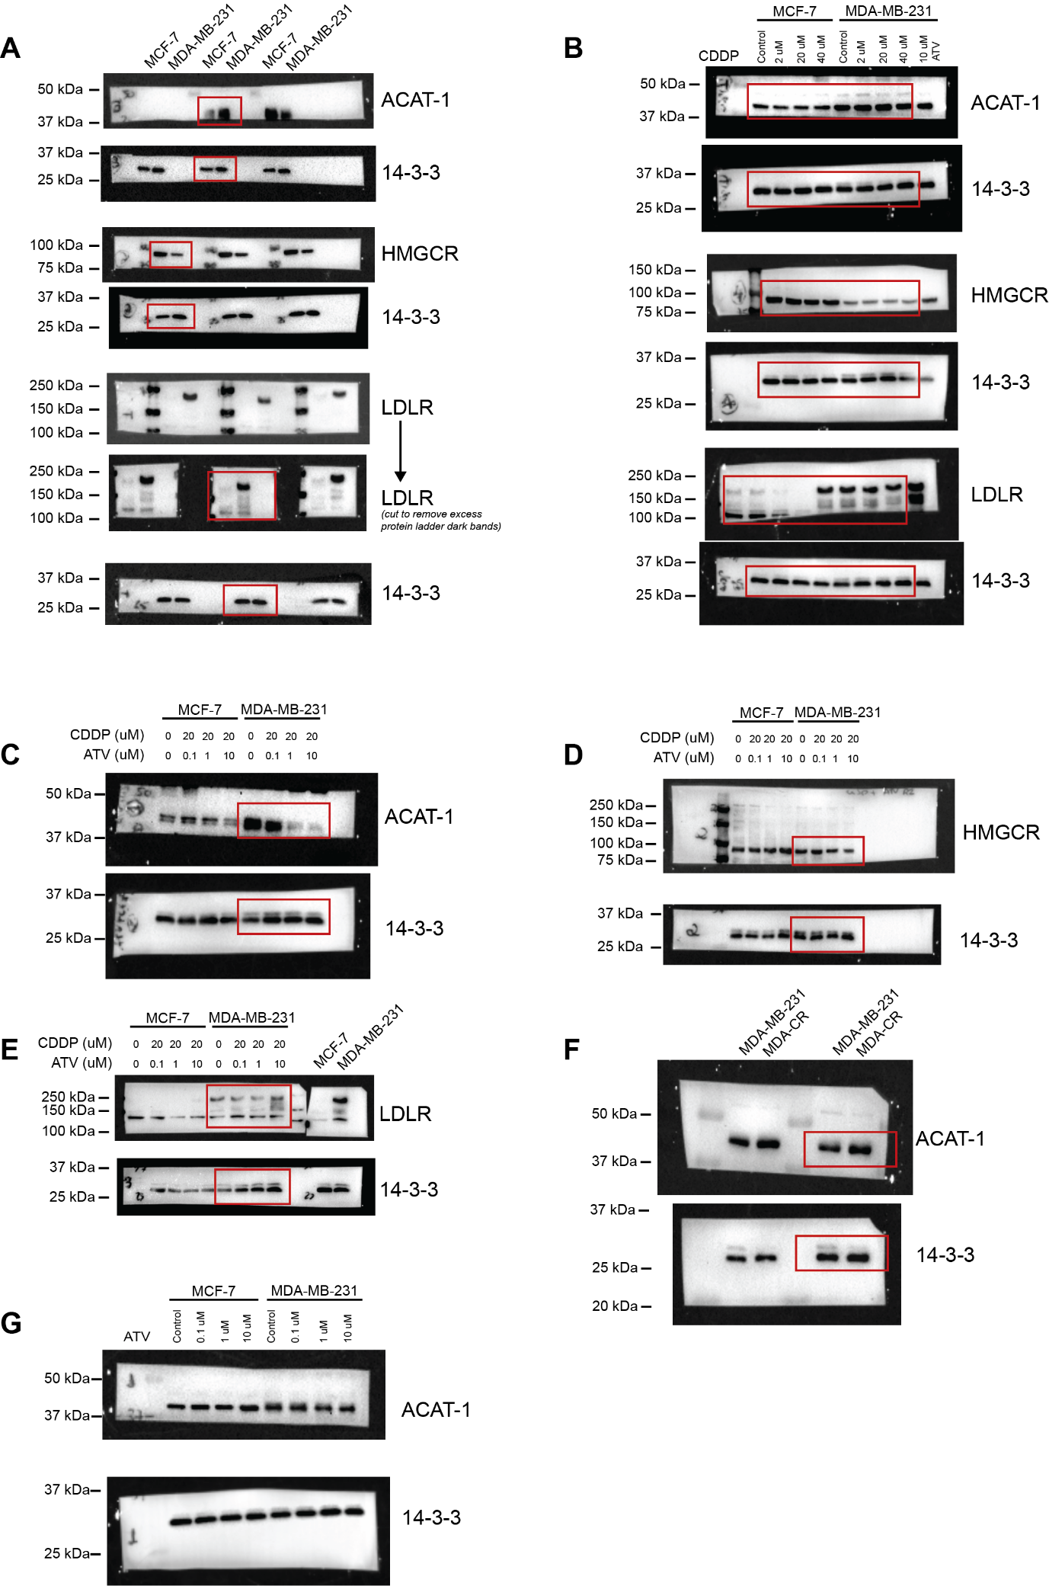Figure S8: Immunoblots used as representative blots assembled in various figures of the manuscript.
(A) and (B) show the full immunoblot used to assemble Figure 5A and 5B, respectively. (C), (D) and (E) show the full immunoblot used to assemble Figure 6C, 6D and 6E, respectively. (F) shows the full immunoblot used to assemble Figure 7B. (G) show the full immunoblot used to assemble Figure S3. All other figures were detected using ECL and Bio-Rad ChemiDoc System. Red boxes indicate the cropped portion of each immunoblot shown in the corresponding main figures. Paired membranes are evident by common labelling on the membrane; for example, (A) ACAT-1 and 14-3-3 have “3” on the left, similarly HMGCR and 14-3-3 pair have “2”.

