
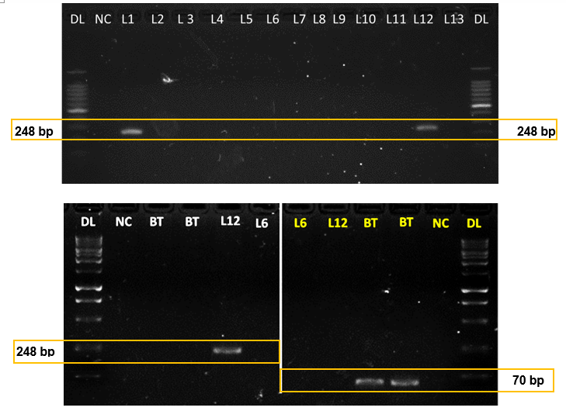
15001000
900
800
700
600

500
400

300

200

100

1500

1000
900
800
700
600
500
400
300

200
100

15001000
900
800
700
600

500
400

300

200

100

1500

1000
900
800
700
600
500
400
300

200
100

Fig. S1 Specificity of Lpla (248 bp) and BTplcR (70 bp) primer on Lactobacillus plantarum and Bacillus thirungiensis. Electrophoresis of the 248- and 70-bp PCR products in a 2% agarose gel obtained from cultures of LAB strains and B. thuringiensis. Lanes: DL, 100-bp DNA ladder; NC, negative control (nuclease-free water); L1, L. plantarum LAB1; L2, Pseudococcus.acidilactici LAB2; L3, P. pentosaceus LAB3; L4, P. acidilactici LAB4; L5, P. acidilactici LAB15; L6, P. acidilactici LAB6; L7, P. pentosaceus LAB7; L8, P. pentosaceus LAB8; L9, L. fermentum LAB9; L10, Lactobacillus sp LAB10.; L11, Lactobacillus sp. LAB11; L12, LAB12; L13, L. paracasei LAB13; BT, B thirungiensis.

a)
b)
Fig. S2 Efficiency of the multiplex PCR system for detection of the normaliser gene (BTplcR) and the target gene (Lpla) a) the normaliser Gene (BTplcR) and b) the target gene (Lpla). Standard curves of the serial dilutions of the reaction mixtures (per 25 µL) were obtained by plotting C_{T} values as linear function of the log₁₀ CFU. The efficiency (E; %) was calculated by the equation (10^{-1/slope}-1) × 100%. Each point represents mean + SD of three independent repetitions.

