Supplementary Information

Table S1 Patient characteristics and clinical outcomes of UHR and FEP cohorts
Characteristic |  | UHR  N= 609 | FEP  N=643
Age at intake | Median (Q1-Q3) | 17 (15, 20) | 20 (18, 22)
Gender
Female | n (%) | 317 (52%) | 201 (31%)
Male | n (%) | 273 (45%) | 434 (68%)
Non-binary | n (%) | 14 (2.3%) | 5 (0.8%)
Sexual orientation | n (%)
Heterosexual/straight | n (%) | 397 (65%) | 443 (73%)
Other | n (%) | 188 (31%) | 167 (27%)
First Nations | n (%) | 54 (8.9%) | 52 (8.3%)
CALD | n (%) | 82 (13%) | 161 (26%)
BPRS-Psychosis | Median (Q1-Q3) | 8 (6, 10) | 9 (6, 1)
BPRS-Negative | Median (Q1-Q3) | 5 (3, 7) | 5 (3, 8)
K10 | Median (Q1-Q3) | 32 (25, 38) | 24 (17, 30)
SOFAS | Median (Q1-Q3) | 56 (50, 65) | 55 (50, 65)
Missing data for UHR include 1 for age at intake, 5 for gender, 24 for sexual orientation, 10 for ATSI, 11 for CALD, 143 for BPRS-psychosis, 143 for BPRS-negative, 71 for K10 and 20 for SOFAS. Missing data for FEP include 3 for gender, 33 for sexual orientation, 15 for ATSI, 25 for CALD, 172 for BPRS-psychosis, 172 for BPRS-negative, 113 for K10 and 49 for SOFAS. Acronyms: CALD- culturally and linguistically diverse. BPRS- Brief psychosis rating scale. SOFAS- social and occupational functioning assessment scale. K10- Kessler 10 scale of psychological distress. UHR- ultra-high risk. FEP- first episode psychosis

(A) | 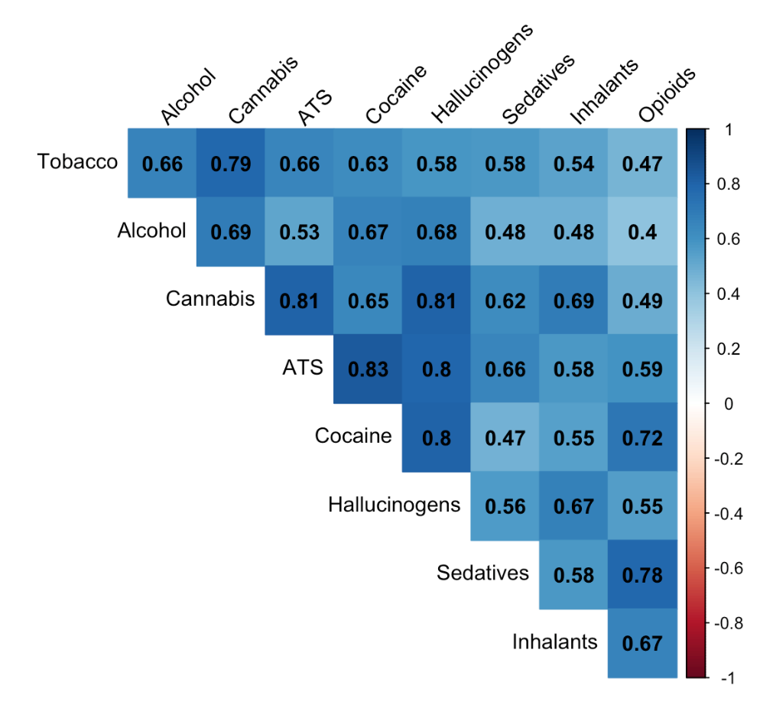
(B) | 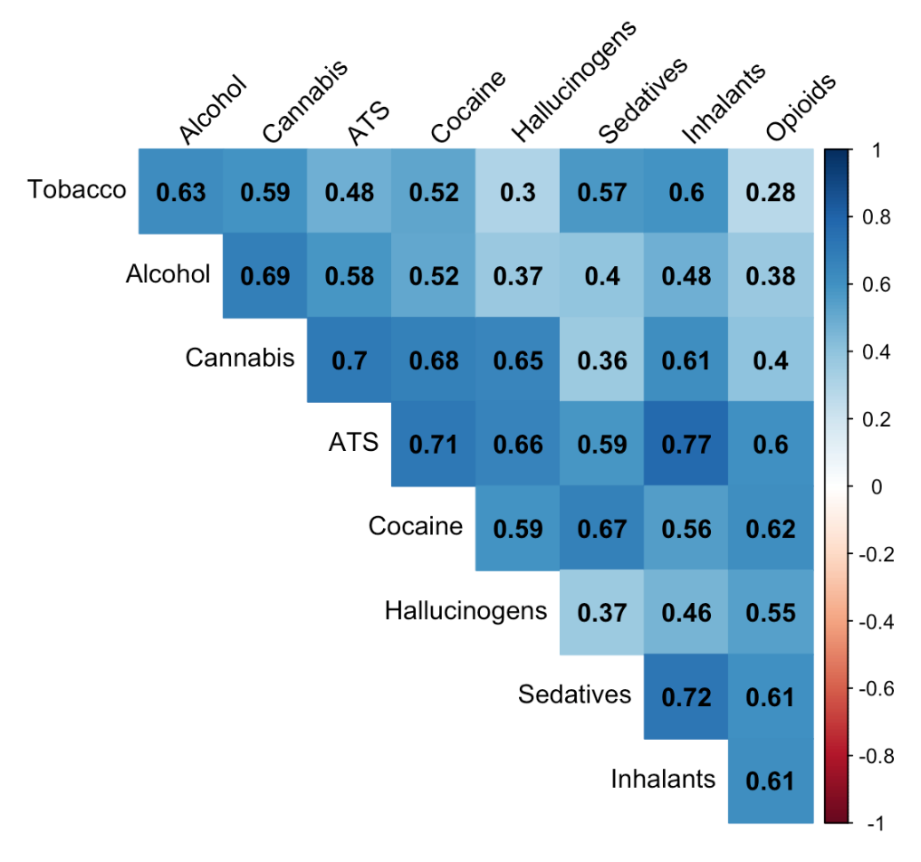
Figure S1 Tetrachoric correlations ($r_{t}$) between use of different substance for (A) UHR cohort and (B) FEP cohort

