Appendix 1 .Search strategies

Date | 26th January 2020
Research Topic | Nurses’ challenges and coping strategy in caring for dying children in China
Search Strategy | Keywords/concepts | Synonyms/alternative terminology
Search Strategy | Challenge | challenges or barriers or difficulties or issues or problems or limitations or obstacles
Search Strategy | Coping strategy | coping strategies or coping skills or coping or cope
Search Strategy | Dying children | Death of a child or pediatric palliative care or dying infant or dying child
Limits and Type of material required | 2010 -2020
Limits and Type of material required | English language
Limits and Type of material required | Full text
Databass searched | Academic Search Complete
Databass searched | CINAHL Complete
Databass searched | Health Source: Nursing /Academic Edition
Databass searched | MEDLINE
Databass searched | MEDLINE Complete

Appendix 2: Flow chart
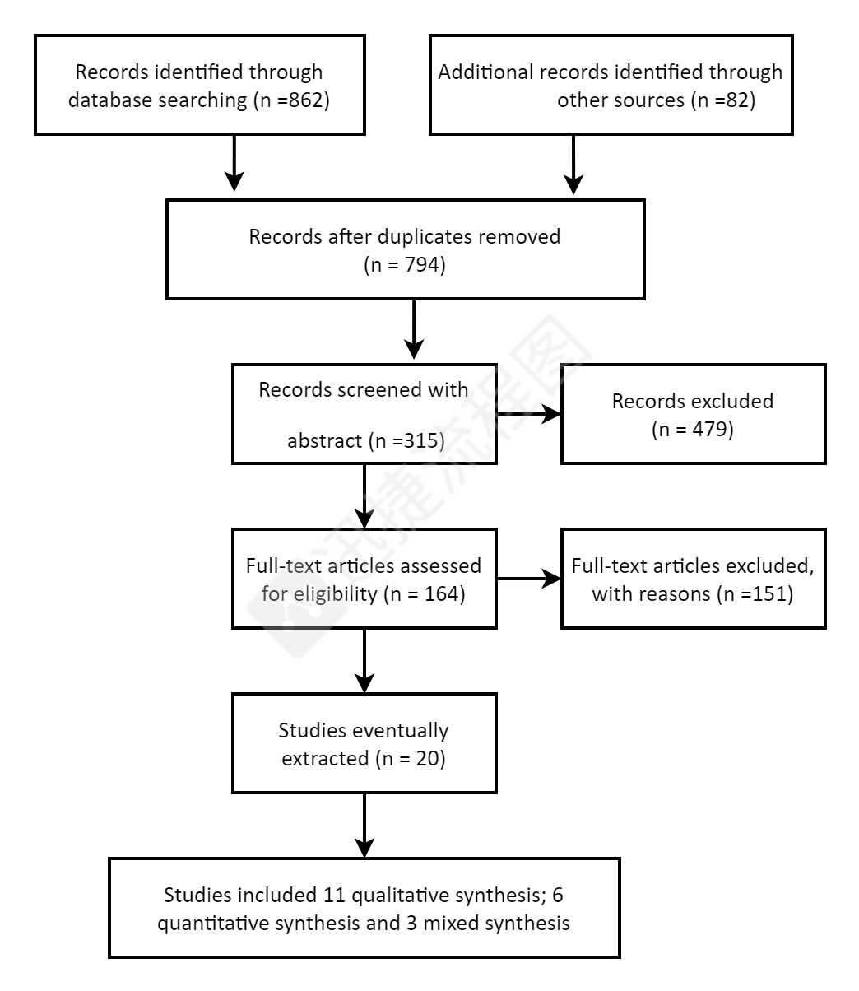
Appendix 3: The characteristic of participants for Experience Of Pediatric Nurses In Nursing Dying Children - A Qualitative Study
participants | gender | Age | Working years | Original department | Marital status | Qualification | Children
N1. | female | 41 | 21 | pediatric | Married | Junior college | 2
N2. | female | 38 | 12 | pediatric | Married | Junior college | 1
N3. | female | 30 | 8 | pediatric | Married | Undergraduate | 2
N4. | female | 28 | 7 | pediatric | Married | Undergraduate | 1
N5. | female | 49 | 31 | Neonatology | Married | Junior college | 1
N6. | female | 38 | 20 | Neonatology | Married | Junior college | 1
N7. | female | 27 | 6 | Neonatology | Married | Undergraduate | 1
N8. | female | 25 | 3 | Neonatology | Married | Undergraduate | 0
N9. | female | 42 | 22 | Emergency | Married | Junior college | 1
N10. | female | 37 | 25 | Emergency | Divorced | Junior college | 1

Appendix 4. The interview questions for Experience Of Pediatric Nurses In Nursing Dying Children - A Qualitative Study
What do you feel when you take care of dying children?
What are your unique feelings about taking care of or rescuing such children?
How do you overcome or relieve this emotion?
Would you like to talk how to relieve this stress?
In this case, what do you think is the biggest challenge for you? How do you deal with this challenge? What ways or behaviors or people could help you overcome these challenges?
What do you think is the difference between taking care of dying children and other children?
What do you think of the impact of this experience on your work or life?
Can you describe the most stressful situation you have in taking care of such children? What was the situation?
Would you please tell me more?

Appendix 5 Themes and sub-themes extracted from the analysis of the findings
Theme | Sub-themes
Stressors | i) Negative emotions
Stressors | ii）Helpless
Stressors | iii) Question the rescue behavior
Stressors | iv）Fear of communication
Stressors | V）Lack of workforce for night rescue
Stress Consequences | i) Compassion fatigue
Stress Consequences | ii) Burnout
Stress Consequences | iii) Changes in life attitudes
Coping strategies | ii) Self-regulation of coping strategies
 | ii) Leadership approval and no accountability

