SUPPLEMENTAL MATERIAL
Supplemental Table 1
The mRS score[2]
Score | Meaning
0 | No symptoms
1 | No significant disability despite symptoms. Able to carry out all usual duties and activities.
2 | Slight disability. Unable to carry out all previous activities, but able to look after own affair without assistance.
3 | Moderate disability. Requiring some help, but able to walk without assistance.
4 | Moderately severe disability. Unable to walk without assistance and unable to attend to own bodily needs without assistance.
5 | Severe disability. Bedridden, incontinent, and requiring constant nursing care and attention.
6 | Death

Supplemental Table 2
Frequency distribution of mRS scores at six weeks determined by the physician or based on a structured interview or self-assessment.
mRS | Physician  (n = 59) | Structured interview  (n = 59) |  | Physician  (n=56) | Self-assessment  (n = 56)
0 (no symptoms) | 8 (13.6%) | 5 (8.5%) |  | 7 (12.5%) | 8 (14.3%)
1 (no significant disability, despite symptoms) | 23 (39.0%) | 10 (16.9%) |  | 24 (42.9%) | 1 (1.8%)
2 (slight disability) | 19 (32.2%) | 31 (52.5%) |  | 11 (19.6%) | 25 (44.6%)
3 (moderate disability) | 6 (10.2%) | 10 (16.9%) |  | 8 (14.3%) | 14 (25.0%)
4 (moderately severe disability) | 2 (3.4%) | 2 (3.4%) |  | 3 (5.4%) | 0
5 (severe disability) | 1 (1.7%) | 1 (1.7%) |  | 3 (5.4%) | 8 (14.3%)

Patients that had either the physician mRS score or the mRS score from structured interview or self-assessment missing were excluded from analysis. Patients that had the structured interview or self-assessment more than 14 days after the assessment of the physician were excluded, since it is not guaranteed that a difference in mRS score is caused by a difference in scoring rather than by a change in health status.

Supplemental Figure 1
Study design

Abbreviations: aSAH: aneurysmal subarachnoid hemorrhage; EQ-5D-5L: EuroQoL-5D-5L; GPE: global perceived effect; mRS: modified Rankin Scale; SS-QoL: Stroke Specific Quality of Life scale.

Supplemental Figure 2
Frequency distribution of the mRS score (0-3) assessed with a structured interview and EQ-5D-5L across mRS scores
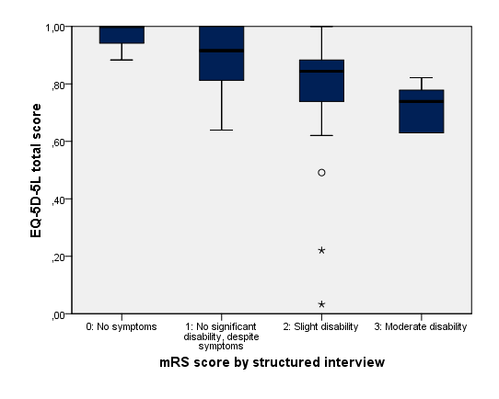

Note: the thick horizontal bar in the boxes represents the median for each mRS level. The ends of the boxes represent the first and third quartiles. The vertical line represents the minimum and maximum score (inside 1.5 IQR). The open dots represent outliers (outside 1.5IQR) and the asterisks represent extreme values (outside 3 IQR). Higher mRS scores indicate worse disability, higher scores on the EQ-5D-5L indicate better function.
Abbreviations: EQ-5D-5L: EuroQoL-5D-5L; IQR: interquartile range; mRS: modified Rankin Scale.

Supplemental Figure 3
Frequency distribution of the mRS score (0-3) assessed with a structured interview and SS-QoL total score and subscores across mRS scores
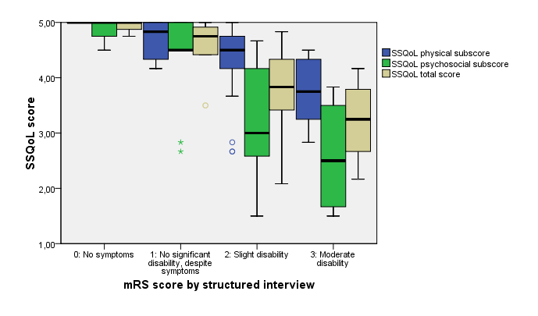

Note: the thick horizontal bar in the boxes represents the median for each mRS level. The ends of the boxes represent the first and third quartiles. The vertical line represents the minimum and maximum score (inside 1.5 IQR). The open dots represent outliers (outside 1.5IQR) and the asterisks represent extreme values (outside 3 IQR). Higher mRS scores indicate worse disability, higher scores on the SS-QoL indicate better function.
Abbreviations: IQR: interquartile range; mRS: modified Rankin Scale; SS-QoL: Stroke Specific Quality of Life scale.

Supplemental Figure 4
Frequency distribution of the mRS (score 0-3) with self-assessment or physician assessment and SS-QoL total score, psychosocial subscore, and physical subscore six weeks after aSAH
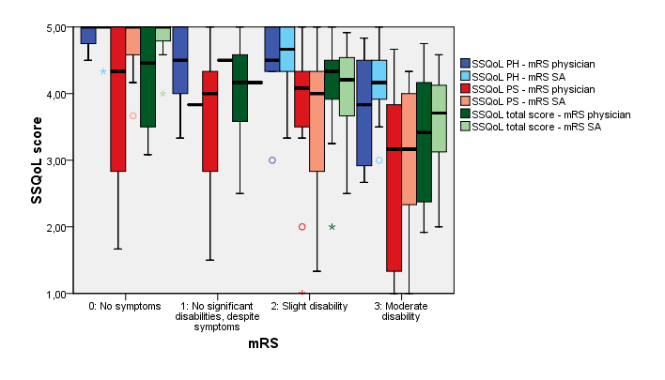

Note: the thick horizontal bar in the boxes represents the median for each mRS level. The ends of the boxes represent the first and third quartiles. The vertical line represents the minimum and maximum score (inside 1.5 IQR). The open dots represent outliers (outside 1.5IQR) and the asterisks represent extreme values (outside 3 IQR). Higher mRS scores indicate worse disability, higher scores on EQ-5D-5L, RAND-36 and SS-QoL indicate better function.
Abbreviations: IQR: interquartile range; mRS: modified Rankin Scale; PH: physical subscore; PS: psychosocial subscore; SA: self-assessment; SS-QoL: Stroke Specific Quality of Life scale.

