Appendix I: 2018-2019 tax brackets
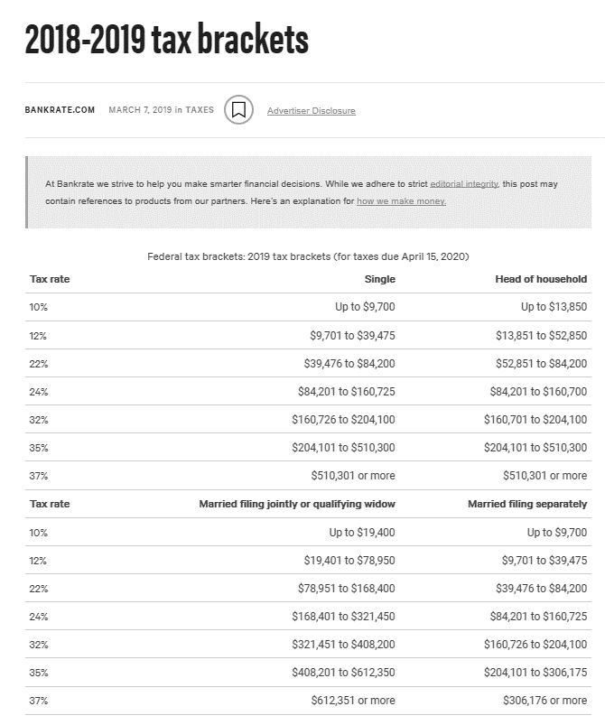
Source: Bank Rate, Ince. https://www.bankrate.com/taxes/2018-tax-bracket-rates/

APPENDIX II: 2018 federal tax brackets for 2019
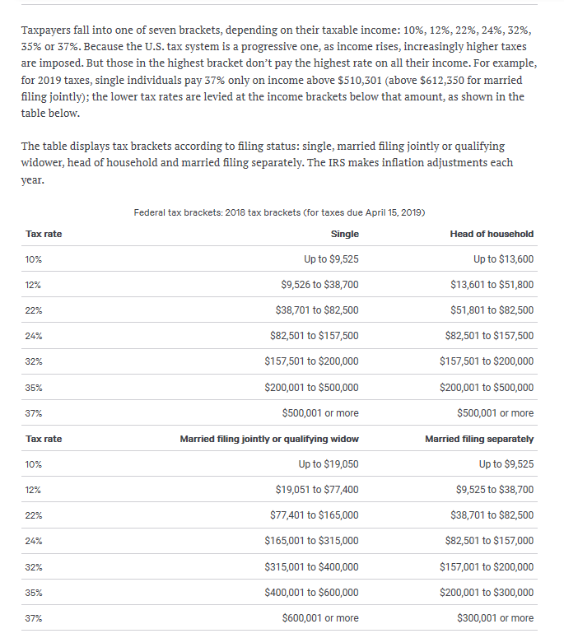
Source: Tax Foundation - https://taxfoundation.org/2019-tax-brackets/

Appendix III: state taxes across the USA
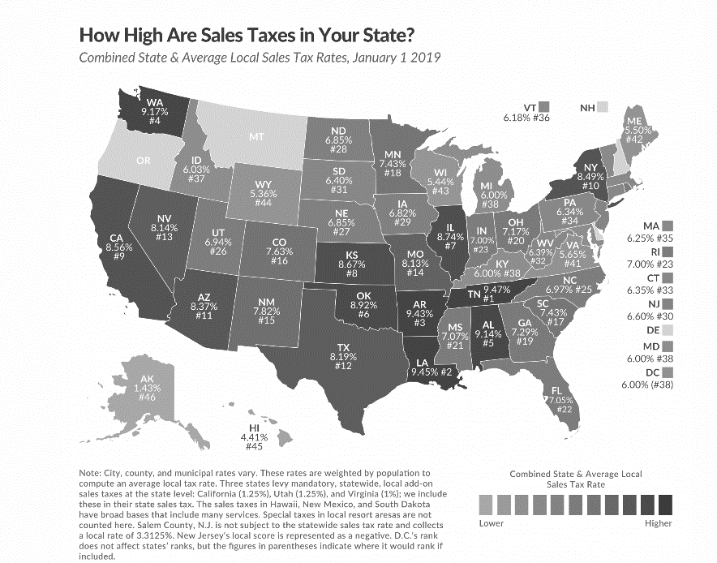
Source: Tax Foundation - https://taxfoundation.org/2019-sales-taxes/

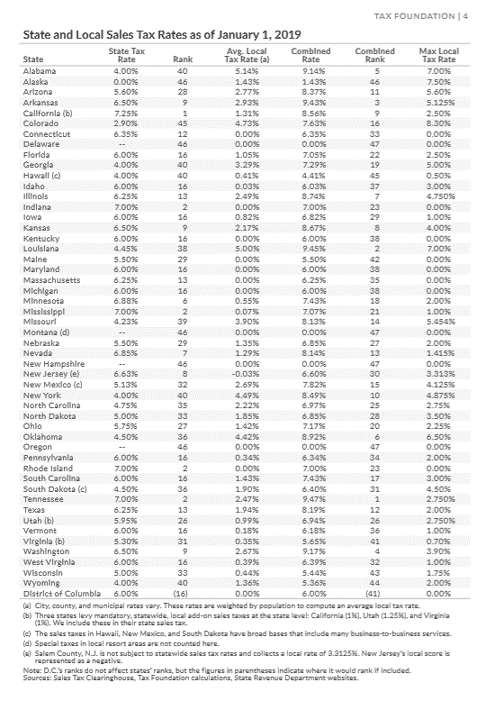
Appendix IV: state and local sales tax rates as of january 1, 2019

Source: Tax Foundation - https://taxfoundation.org/sales-tax-rates-2019/

Appendix V: Industry by Industry Multipliers - Total Requirement Table
Source: US Department of Commerce, Bureau of Economic Analysis - https://www.bea.gov/help/glossary/use-table

Appendix VI: Comparison of State Unemployment Benefits
State |  | Unemployment Rate | Max. Weeks of Benefits |  | Max. Weekly Benefits | Max. Dearness Allowance | Total Weekly Benefits
Alabama |  | 7.5 | 26 |  | $275 |  | $275
Alaska |  | 12.4 | 26 |  | $370 | $72 | $442
Arizona |  | 10 | 20 |  | $240 |  | $240
Arkansas |  | 8 | 26 |  | $451 |  | $451
California |  | 14.9 | 26 |  | $450 |  | $450
Colorado |  | 10.5 | 26 |  | $597 |  | $597
Connecticut |  | 9.8 | 26 |  | $649 | $75 | $724
Delaware |  | 12.5 | 26 |  | $400 |  | $400
Florida |  | 10.4 | 26 |  | $275 |  | $275
Georgia |  | 7.6 | 12 |  | $365 |  | $365
Hawaii |  | 13.9 | 14 |  | $648 |  | $648
Idaho |  | 5.6 | 26 |  | $414 |  | $414
Illinois |  | 14.6 | 26 |  | $471 | $178 | $649
Indiana |  | 11.2 | 21 |  | $390.00 |  | $390
Iowa |  | 8 | 26 |  | $591 | $106 | $697
Kansas |  | 7.5 | 26 |  | $488.00 |  | $488
Kentucky |  | 4.3 | 16 |  | $552 |  | $552
Louisiana |  | 9.7 | 26 |  | $247 |  | $247
Maine |  | 6.6 | 26 |  | $414.00 | $215 | $629
Maryland |  | 8 | 30 |  | $430 |  | $430
Massachusetts |  | 17.4 | 26 |  | $823 | $397 | $1,220
Michigan |  | 14.8 | 26 |  | $362 | $209 | $571
Minnesota |  | 5.6 | 20 |  | $717 |  | $717
Mississippi |  | 8.7 | 26 |  | $235 |  | $235
Missouri |  | 7.9 | 13 |  | $320 |  | $320
Montana |  | 7.1 | 26 |  | $552 |  | $552
Nebraska |  | 6.7 | 28 |  | $440 |  | $440
Nevada |  | 15 | 12 |  | $450 |  | $450
New Hampshire |  | 11.8 | 26 |  | $427 |  | $427
New Jersey |  | 16.6 | 26 |  | $696.00 |  | $696
New Mexico |  | 8.3 | 26 |  | $492 | $50 | $542
New York |  | 15.7 | 26 |  | $504 |  | $504
North Carolina |  | 7.6 | 26 |  | $350.00 | $50 | $400
North Dakota |  | 6.1 | 26 |  | $618 |  | $618
Ohio |  | 10.9 | 26 |  | $647 | $155 | $802
Oklahoma |  | 6.6 | 26 |  | $520 |  | $520
Oregon |  | 11.2 | 26 |  | $648 |  | $648
Pennsylvania |  | 13 | 26 |  | $572 | $8 | $580
Rhode Island |  | 12.4 | 26 |  | $586.00 | $144 | $730
South Carolina |  | 8.7 | 26 |  | $326 |  | $326
South Dakota |  | 7.2 | 20 |  | $414 |  | $414
Tennessee |  | 9.7 | 26 |  | $275 |  | $275
Texas |  | 8.6 | 26 |  | $521 |  | $521
Utah |  | 5.1 | 26 |  | $560 |  | $560
Vermont |  | 9.4 | 26 |  | $513 |  | $513
Virginia |  | 8.4 | 26 |  | $378 |  | $378
Washington DC |  | 8.6 | 26 |  | $425 |  | $425
Washington |  | 9.8 | 26 |  | $790 |  | $790
West Virginia |  | 10.4 | 26 |  | $424 |  | $424
Wisconsin |  | 8.5 | 26 |  | $370 |  | $370
Wyoming |  | 7.6 | 26 |  | $508 |  | $508
US Average/Participant |  |  | 24 |  | 474 |  | 507
 | Maximum Allowable per Participant |  |  |  |  |  | $ 12,378
Source: https://fileunemployment.org/unemployment-benefits-comparison-by-state

