eFigure 1. Study sample attrition
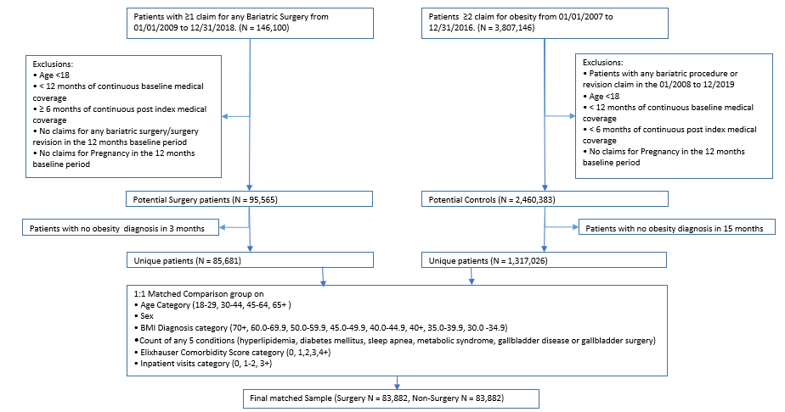

eFigure 2. Temporal trends in bariatric procedures from 2008 to 2018

Size of the bubble is proportionate to the number of patients at that time point. AGB=adjustable gastric banding; RYGB=Roux-en-y gastric bypass procedure; SG=sleeve gastrectomy

eFigure 3. Figure 1: Index date assignment for non-surgical group.
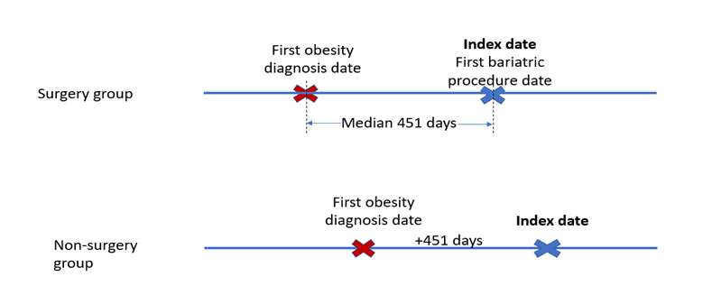

eTable1: Unadjusted Costs for Surgical and Non-Surgical Groups among members with 5 year continuous Medical and Pharmacy benefits by Follow-up Periods
Total Expenditure | Surgery |  | Non-Surgery
(medical + pharmacy) | Mean | Std | Mean | Std
Year 1 | $ 15,134 | $ 24,168 | $ 16,963 | $ 26,885
Year 2 | $ 14,684 | $ 24,555 | $ 17,711 | $ 27,485
Year 3 | $ 15,491 | $ 26,079 | $ 19,046 | $ 30,314
Year 4 | $ 15,884 | $ 26,615 | $ 19,822 | $ 31,193
Year 5 | $ 16,996 | $ 29,122 | $ 21,354 | $ 32,937

