Supplementary Information

Levosimendan inhibits disulfide tau oligomerization ameliorating tau pathology in Tau^{P301L}-BiFC mice

Figure S1. Dose-dependent inhibition of tau-BiFC response activated by FK
Figure S2. Dose-dependent inhibition of tau-BiFC response activated by tauK18^{P301L}
Figure S3. Levosimendan inhibits tau oligomerization in tau-BiFC while MB and LMTM increased tau oligomerization.
Figure S4. Effects of MB, LMTM and Levosimendan on tau kinases.
Figure S5. Anti-tau aggregation effect of levosimendan treated at various time point after tau aggregation
Figure S6. Disulfide-linked tau oligomers in wild type and Tau^{P301L} transgenic mice

Data S1. Characterization of ¹⁴C-Levosimendan
Data S2. ESI-MS analysis of tau peptides
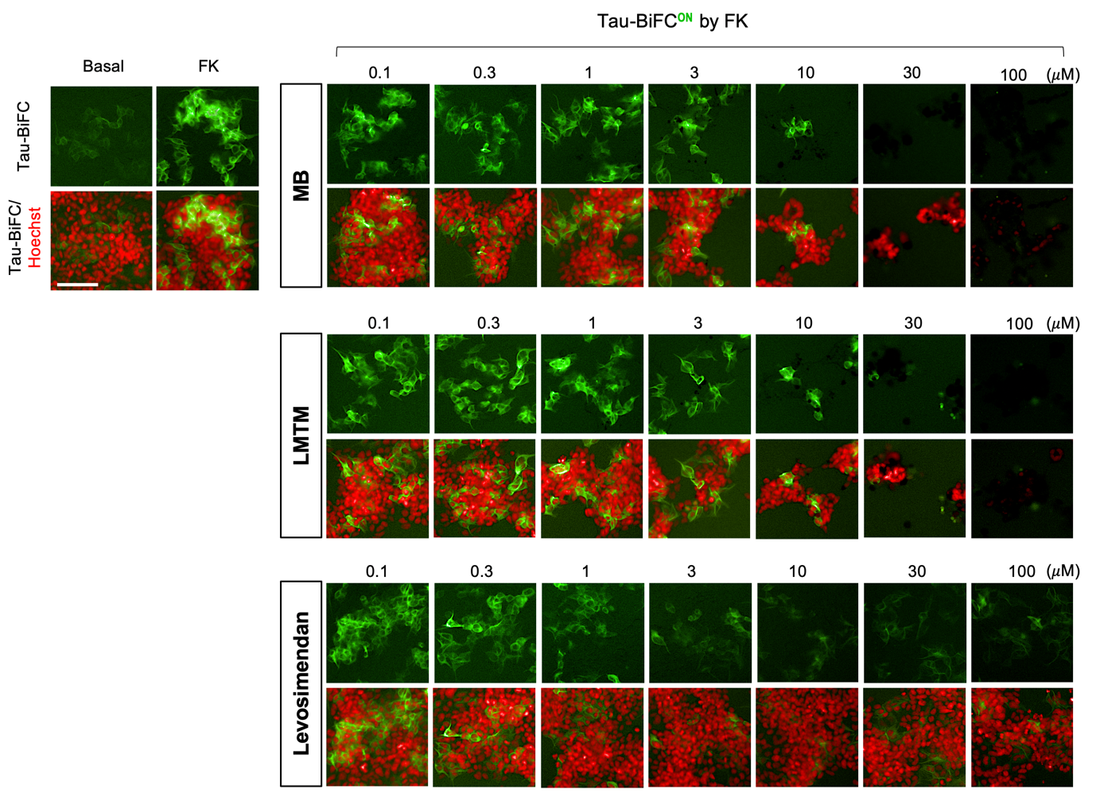

Figure. S1 Dose-dependent inhibition of tau-BiFC response activated by FK.
Tau-BiFC cells were incubated with MB, LMTM or levosimendan at various concentrations (0.1, 0.3, 1, 3, 10, 30, 100 μM) upon the activation with forskolin (30 μΜ) for 46 hrs. Nuclei were counterstained with Hoechst (red). Scale bar, 100 μm.
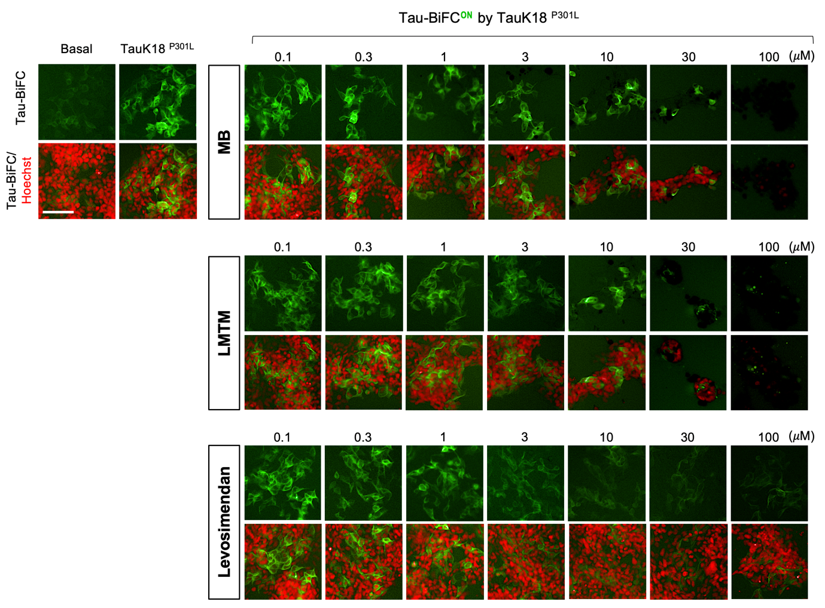

Figure. S2 Dose-dependent inhibition of tau-BiFC response activated by tauK18^{P301L}.
Tau-BiFC cells were incubated with MB, LMTM or levosimendan at various concentrations (0.1, 0.3, 1, 3, 10, 30, 100 μM) upon the activation with tauK18^{P301L} (5 μg/mL) for 46 hrs. Nuclei were counterstained with Hoechst (red). Scale bar, 100 μm.
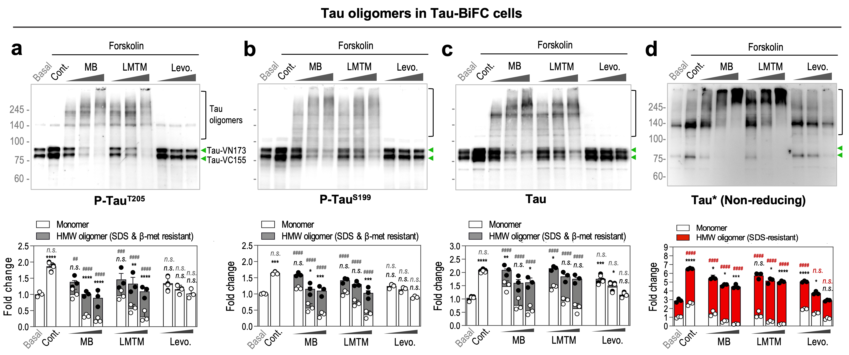

Figure. S3 Levosimendan inhibits tau oligomerization in tau-BiFC while MB and LMTM increased tau oligomerization.
(a-b) Immunoblot analysis of total and phospho-tau. For the immunoblot analysis, tau-BiFC cells were treated with MB, LMTM (0.5, 1.5, 5 µM), or levosimendan (5, 15, 45 µM) in the presence of forskolin. Green arrows indicate monomer bands of hTau-VN173 and hTau-VC155. Bands above 100 kDa indicates tau oligomers. Relative amounts of monomeric tau (white bars) and oligomeric tau (grey bars) were quantified by Image J. (c-d) Immunoblot analysis of total tau on non-reducing condition. Relative amounts of monomeric tau (white bars) and oligomeric tau (red bars) were quantified by Image J. (a-d) Data represent the mean ± S.D. of three independent experiments. To indicate significance of the results, Two-way ANOVA with Dunnett’s multiple-comparisons test was performed; *p < 0.05, **p < 0.01, ***p < 0.001, ****p < 0.0001, compared with the level of monomer in basal. #p < 0.05, ##p < 0.01, ###p < 0.001, ####p < 0.0001, compared with the level of oligomers in basal. n.s., non-significant.

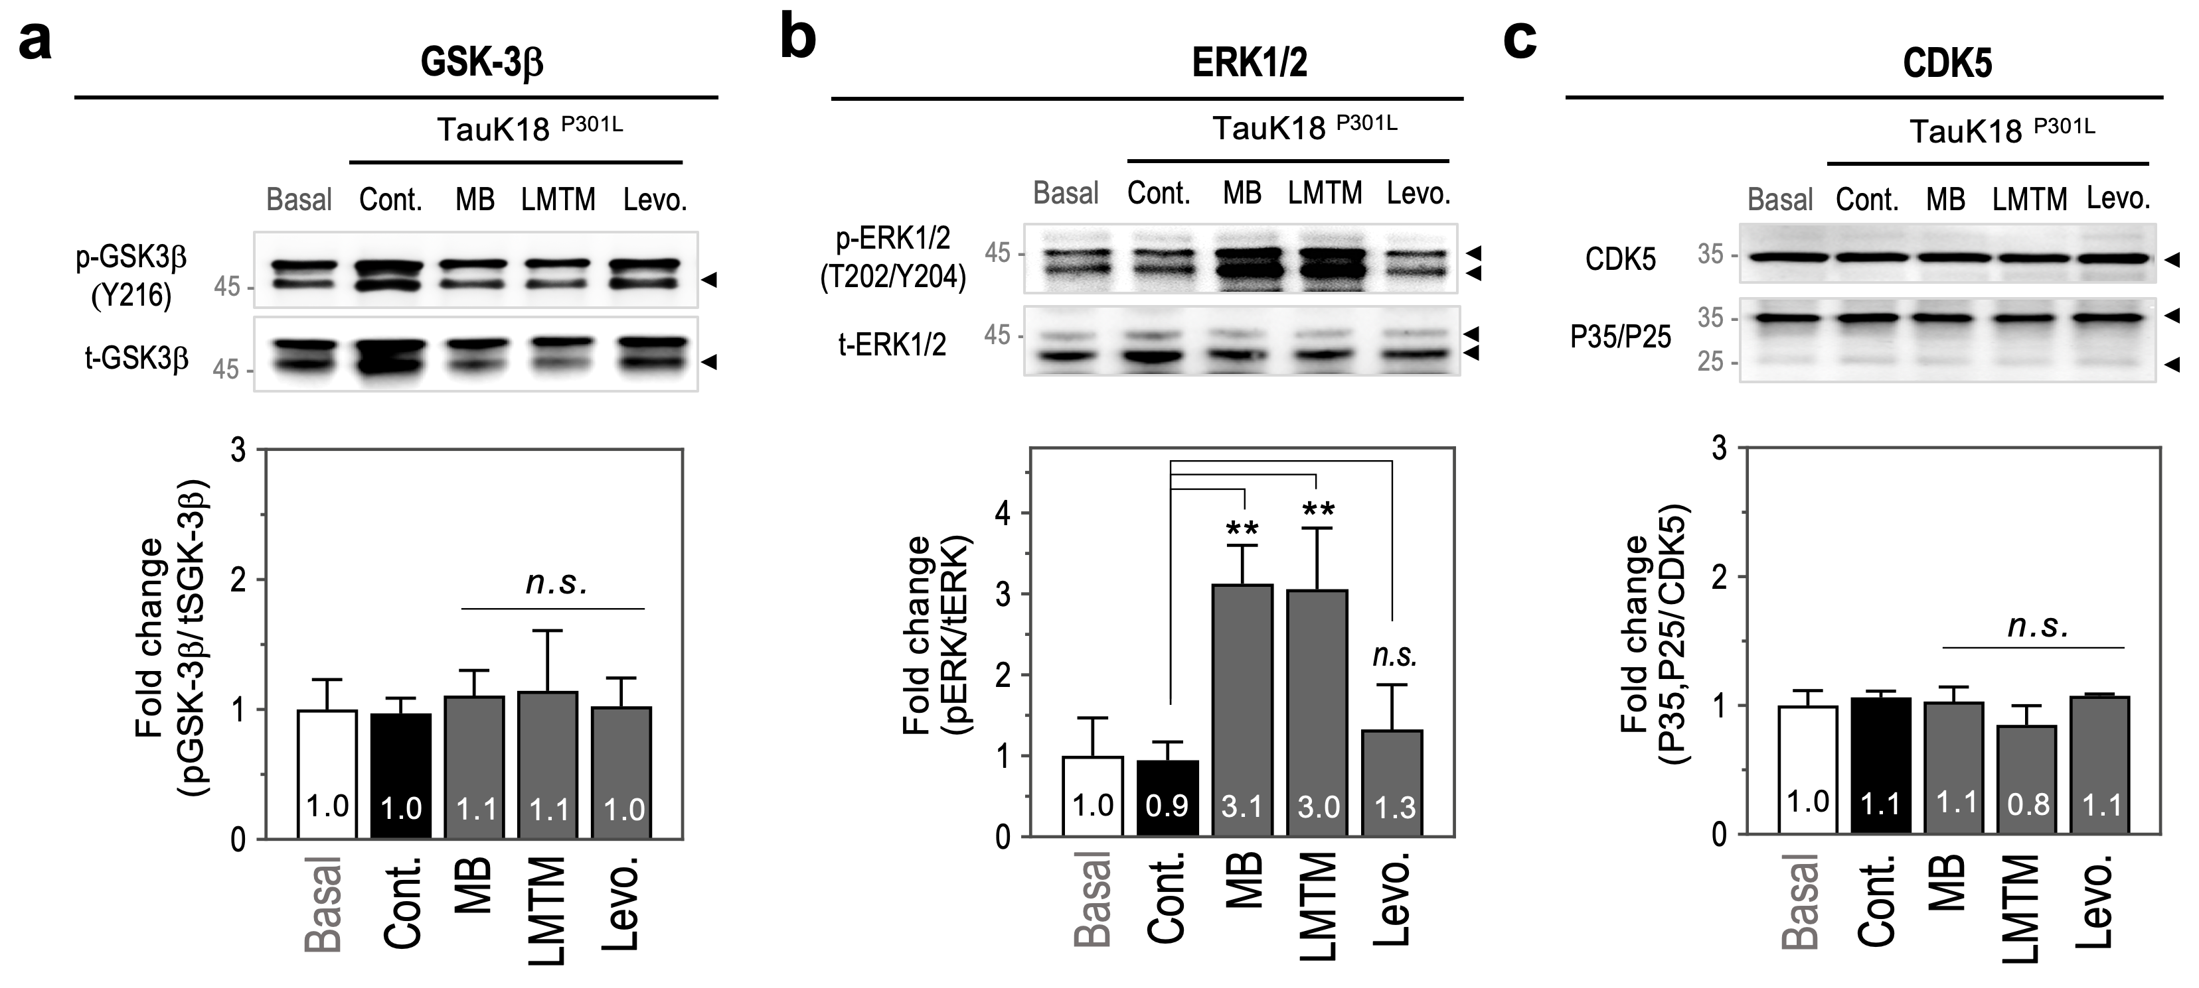
Figure. S4 Effects of MB, LMTM and Levosimendan on tau kinases.
(a-c) Immunoblot analysis of tau kinases with anti-GSK-3β, anti-ERK1/2, anti-P35/P25, and anti-CDK5 antibodies. For the immunoblot analysis, primary neurons were treated with MB, LMTM (0.5 µM), or levosimendan (10 µM) in the presence of tauK18^{P301L}. Relative amounts were quantified by Image J. One-way ANOVA with Dunnett’s multiple-comparisons test was performed; *p < 0.05, **p < 0.01, ***p < 0.001, compared with the level of control. n.s., non-significant.

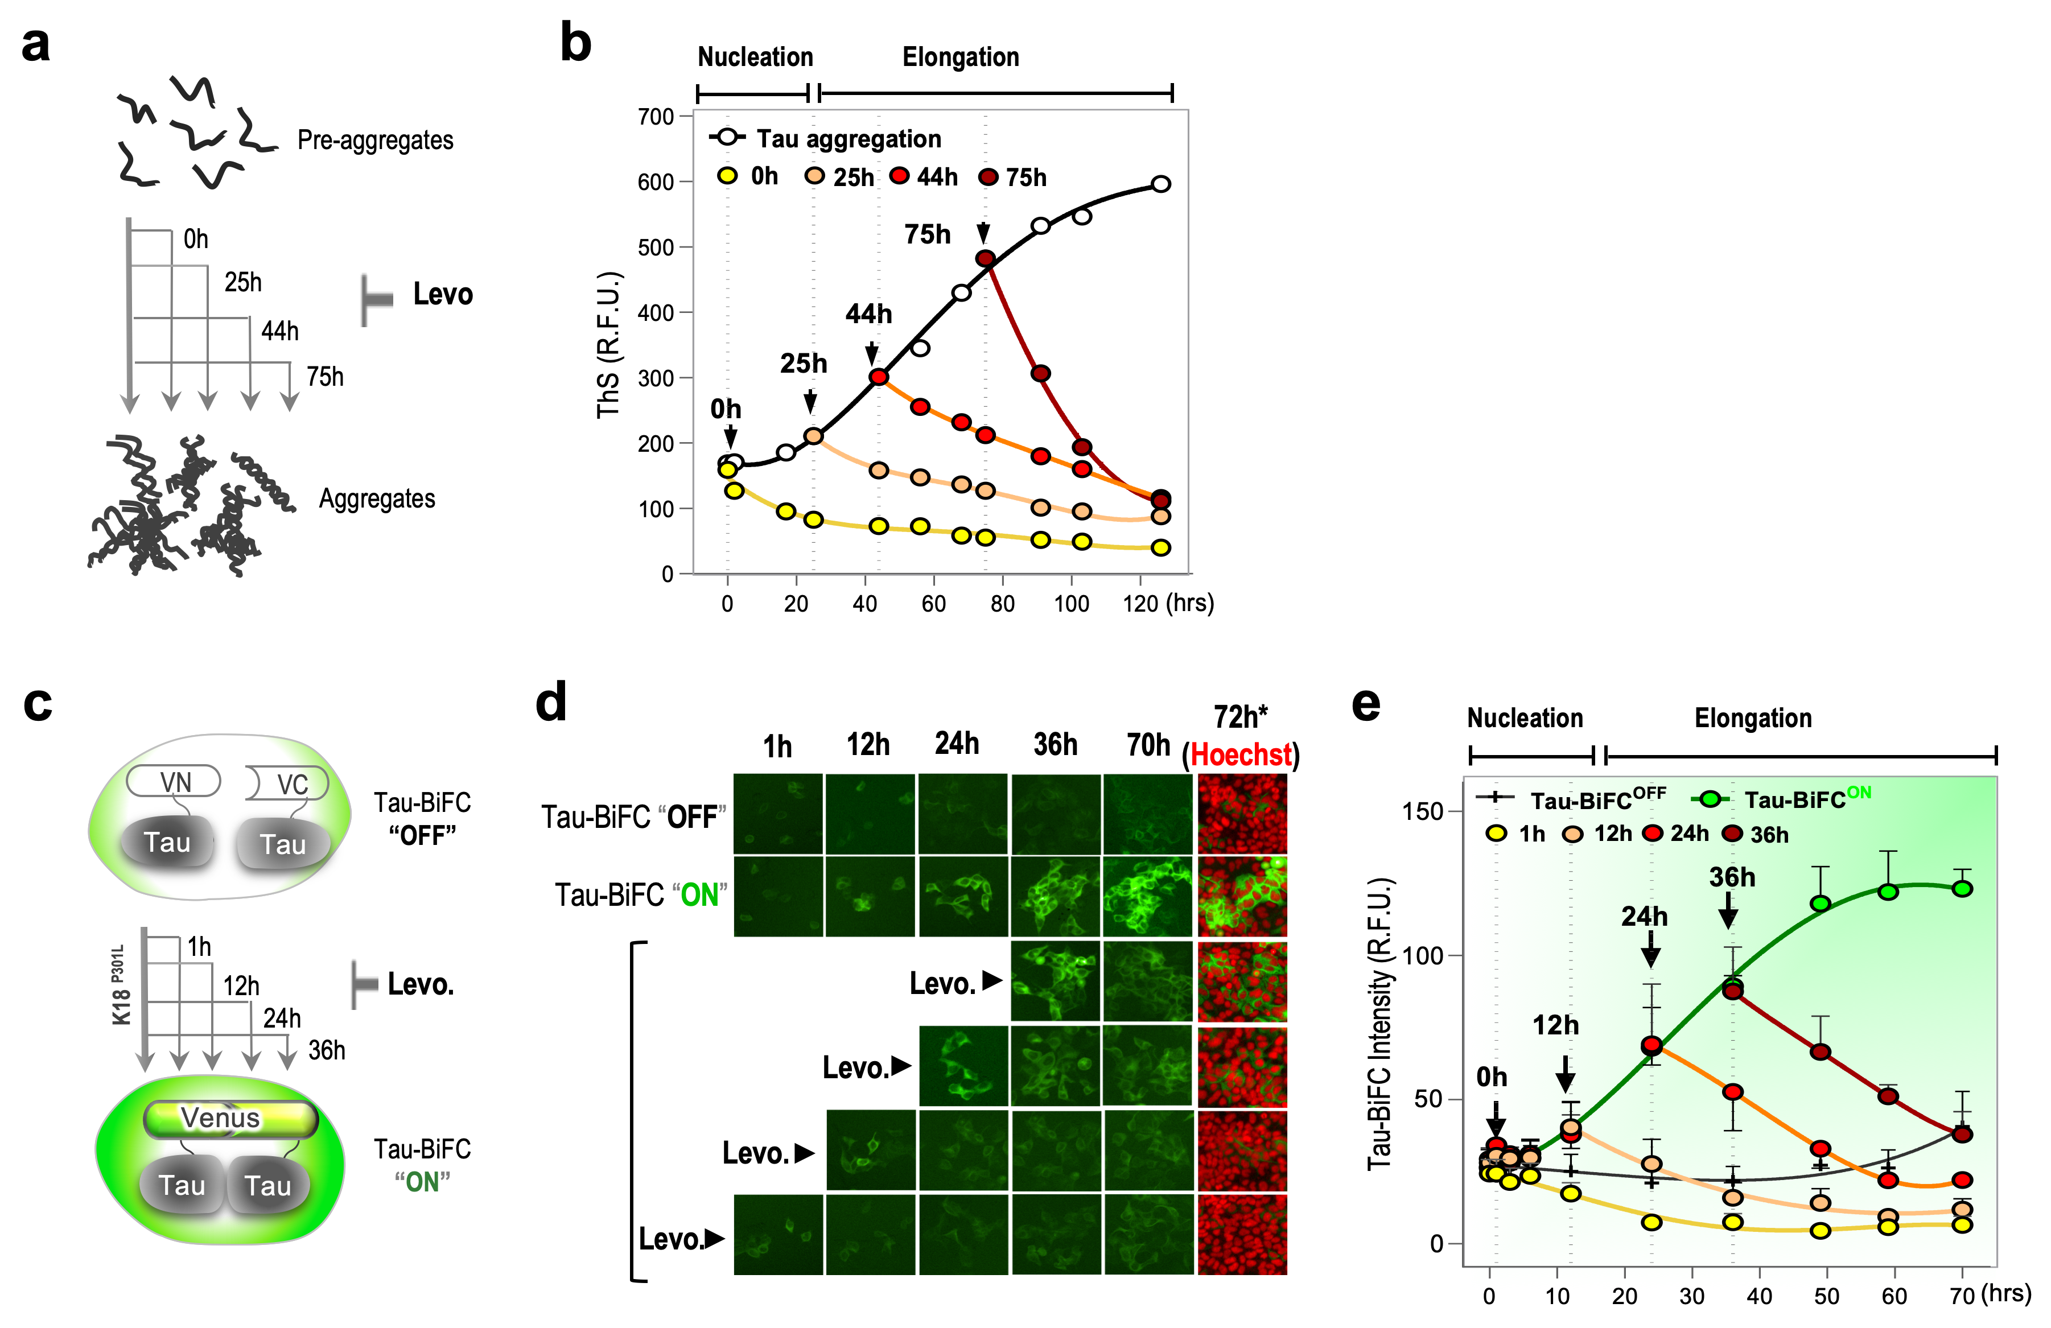
Figure. S5 Anti-tau aggregation effect of levosimendan treated at various time points after tau aggregation.
(a, b) Schematic diagram of the treatment of levosimendan at diverse time points of tau aggregation in vitro (a). Levosimendan (10 µM) was treated to an aliquot of the aggregation mixture at 0, 25, 44, and 75hr after heparin treatment. The level of tau aggregation was determined by ThS. (b) ThS-response curves indicating anti-tau aggregation effect of levosimendan in vitro. (c, e) Schematic diagram of the treatment of levosimendan at various time points of tau-BiFC aggregation (c). Levosimendan was treated to tau-BiFC cells at 1, 12, 24, and 36 hrs after the treatment of tauK18^{P301L}. (d) Tau-BiFC fluorescence images were acquired at various time points and the fluorescence intensities were quantified. After 72hrs, nuclei were counterstained with Hoechst (red). Scale bar, 100 µm. (e) Tau-BiFC responses indicating the inhibitory effect of levosimendan on cellular tau aggregation. Data represent the mean ± S.D. of four repeated measurements.

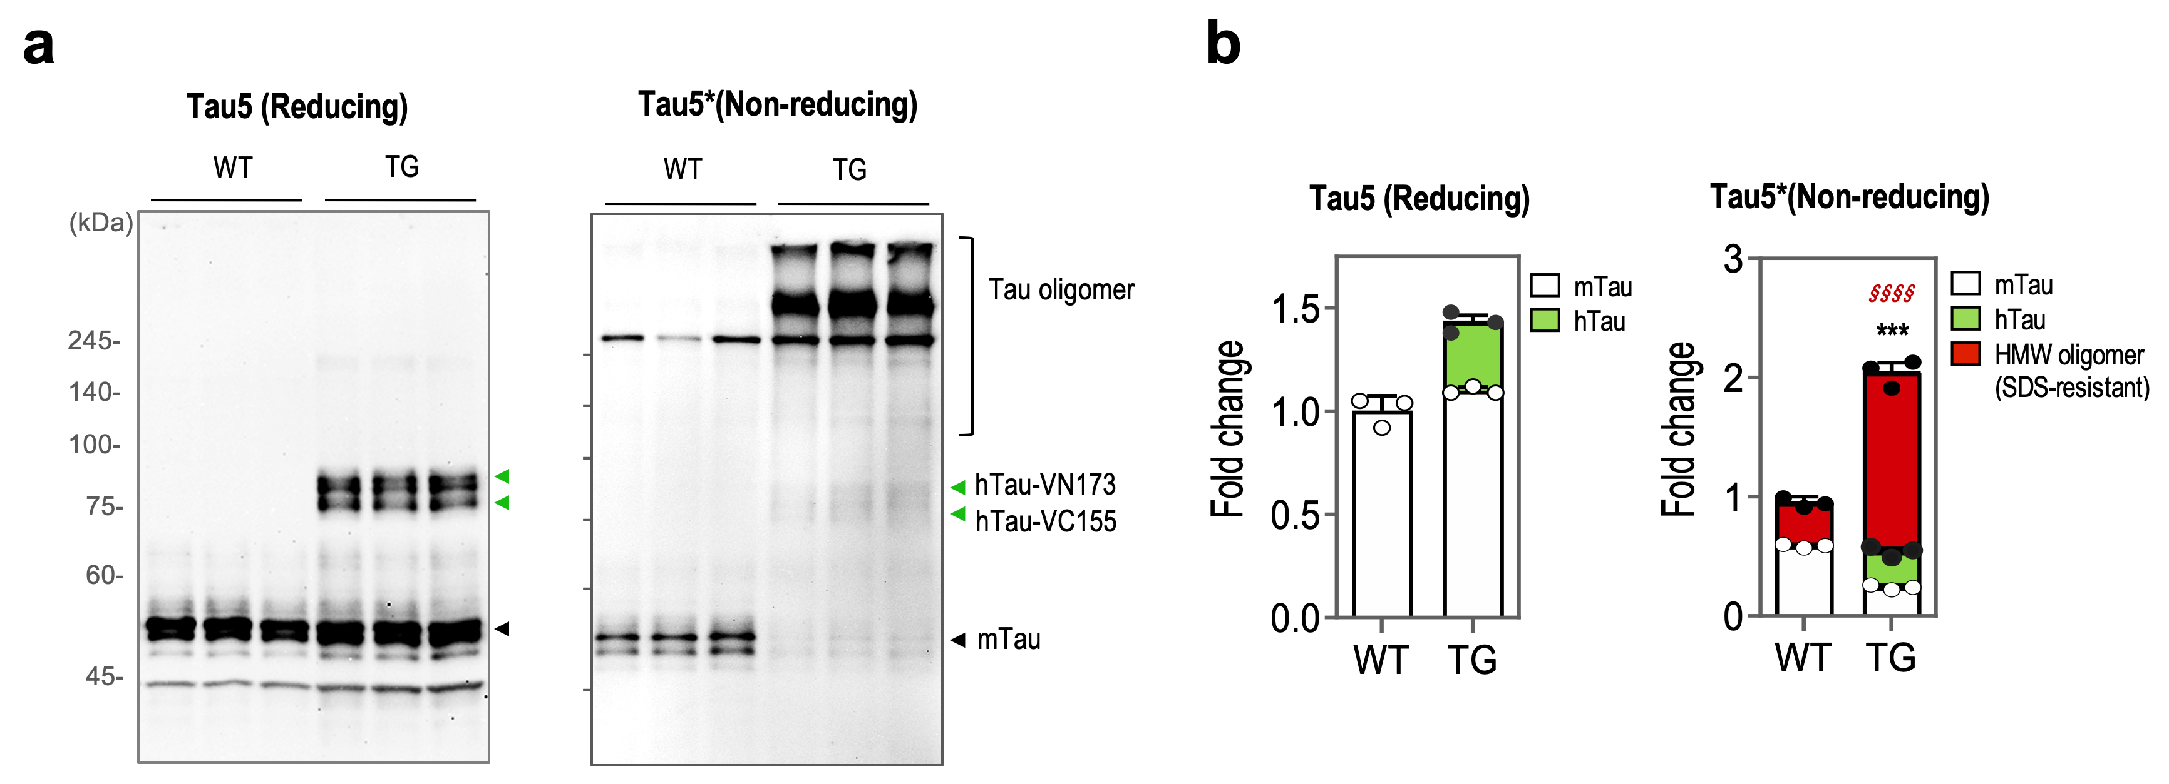

Figure. S6 Disulfide-linked tau oligomers in wild type and Tau^{P301L} transgenic mice.
(a) Tau-immunoblot analysis of WT- and TG- brain lysates. RIPA-soluble fractions of wild type and Tau^{P301L}-BiFC mice (14-month-old) were separated under reducing and non-reducing conditions. Green arrows indicate hTau-VN173 and hTau-VC155. Black arrows indicate endogenous murine tau (mTau). (b) Quantification of total tau protein (n=3 per group). Relative amounts of hTau (green bars), mTau (white bars) monomers, and oligomers (red bars) were quantified by Image J. A two-tailed t-test was performed; ***p < 0.001, compared with mTau monomer of wild type; §§§§p < 0.0001, compared with HMW oligomer of wild type mice.

Data file S1. Characterization of ¹⁴C-Levosimendan
a ¹H NMR spectrum of Levosimendan.
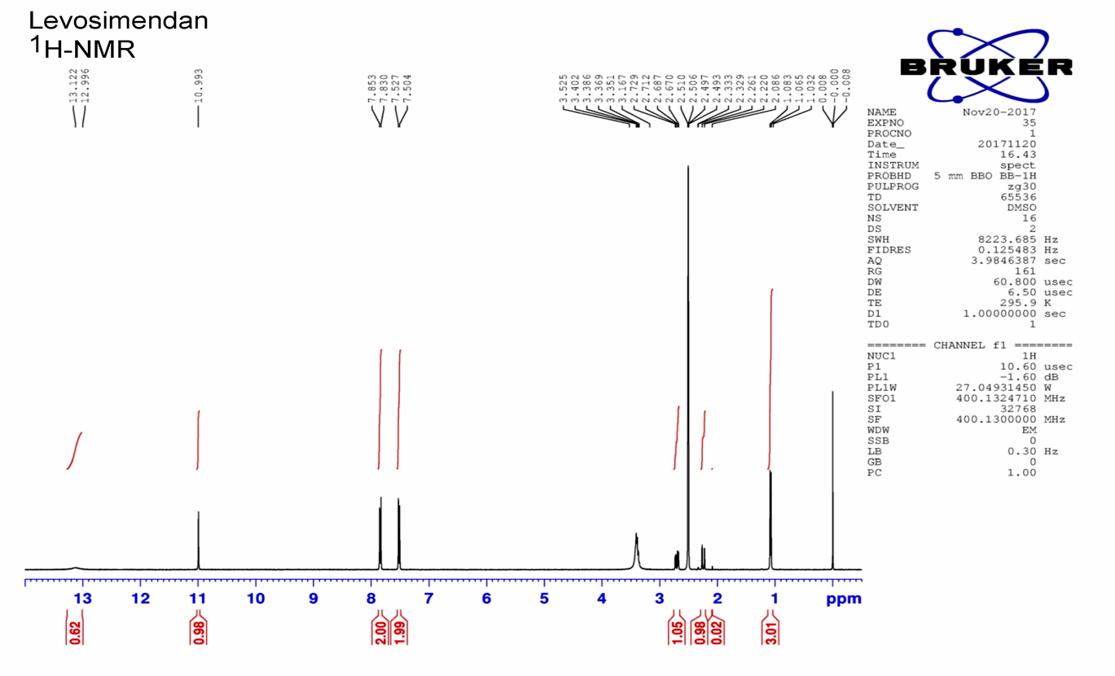
b ¹H NMR spectrum of ¹⁴C-Levosimendan.
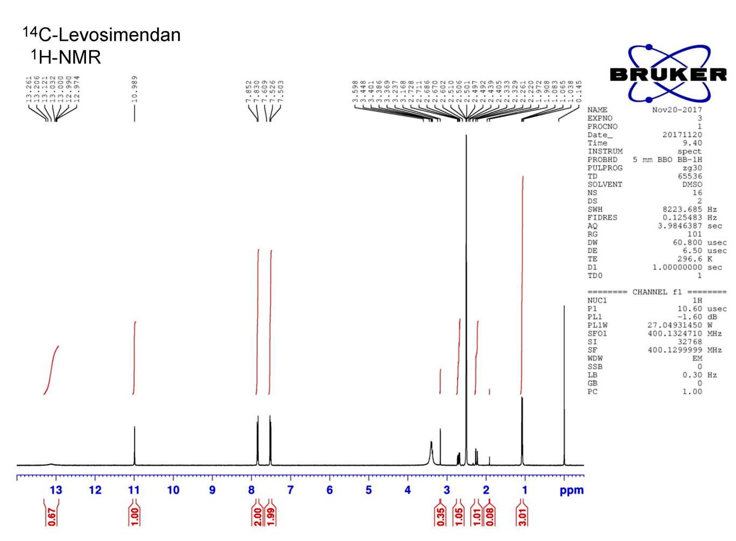
c LC/MS characterization of ¹⁴C-Levosimendan

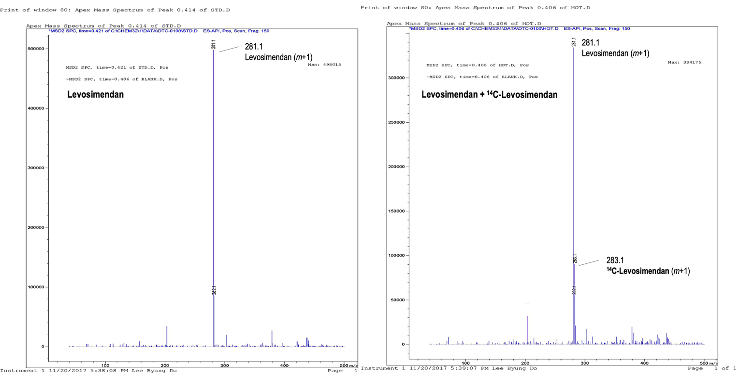

Data file S2. ESI-MS analysis of tau peptides
a ESI-MS analysis of tau repeat 1 domain (Tau R1).
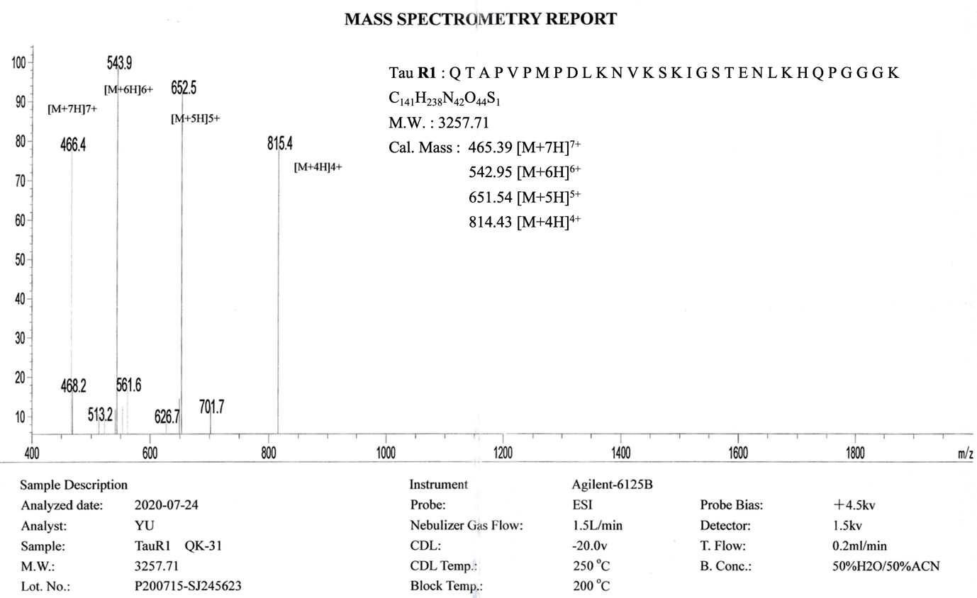

b ESI-MS analysis of tau repeat 2 domain (Tau R2).
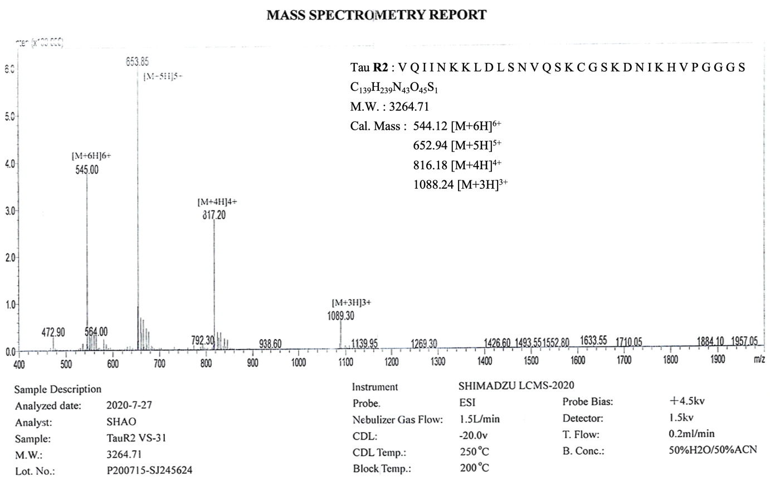

c ESI-MS analysis of tau repeat 3 domain (Tau R3).
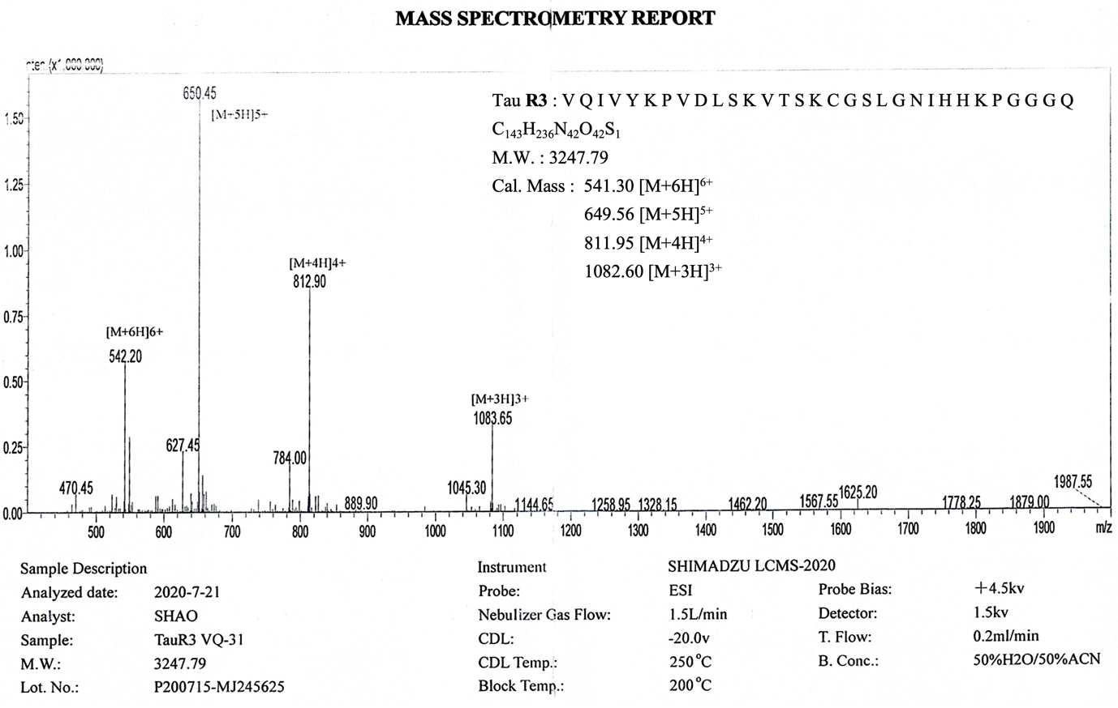

d ESI-MS analysis of tau repeat 4 domain (Tau R4).
