Supplementary data
Dual recognition factors of silver nanocluster with peroxides like activity for colorimetric detection of S. aureus bacteria in milk samples
Azam Bagheri Pebdeni ¹, Morteza Hosseini ^{1,2*}
¹ Nanobiosensors lab, Department of Life Science Engineering, Faculty of New Sciences and Technologies, University of Tehran, Tehran, Iran.
² Medical Biomaterials Research Center, Faculty of Pharmacy, Tehran University of Medical Sciences, Tehran, Iran. Email: Hosseini_m@ut.ac.ir

Figure caption
Fig. S1 a) Elemental map analysis of AgNC, b) The antibacterial activity of AgNC and vancomycin against SA bacteria
Fig. S2 The optimization of different concentration of TMB and H₂O₂ (3-20 mM)
Fig. S3 The optimization of incubation time of apt-AgNC with SA

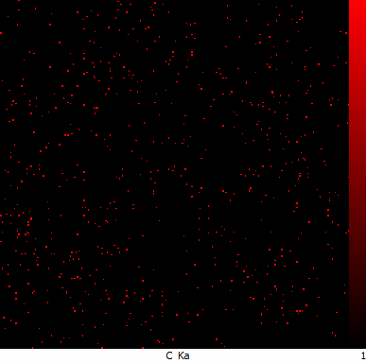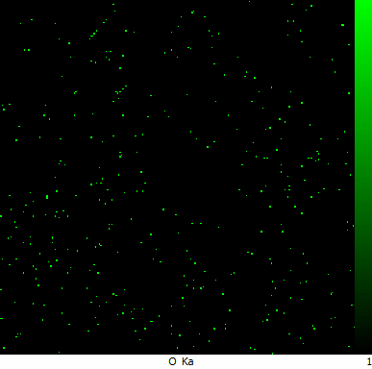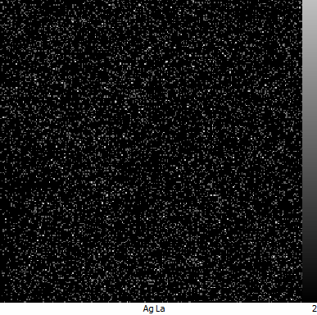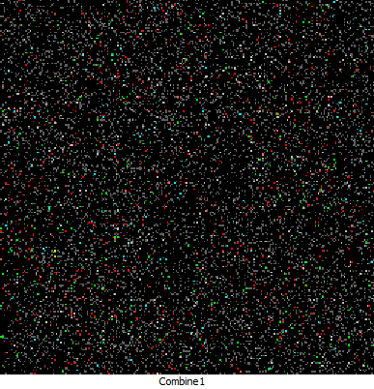
a
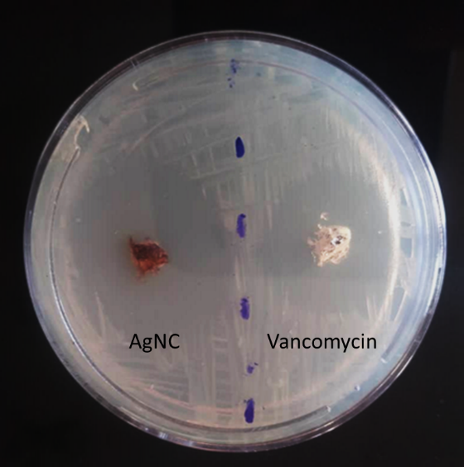
b
Fig. S1

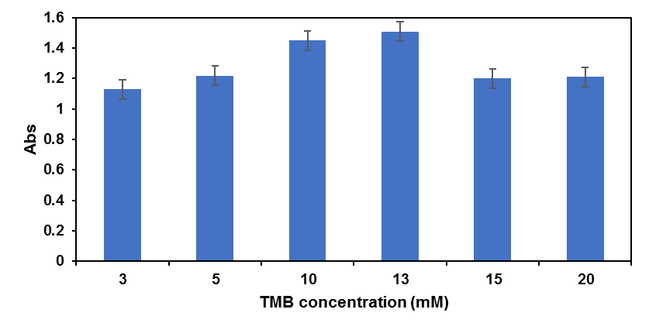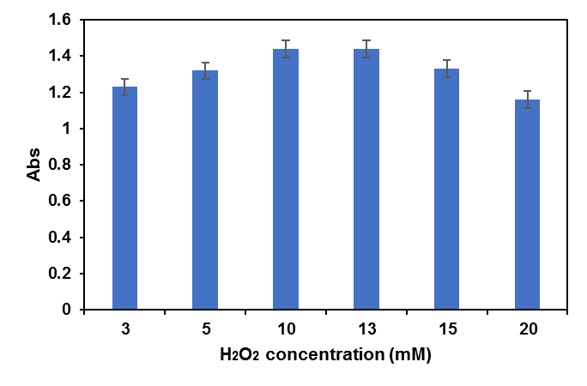
Fig. S2

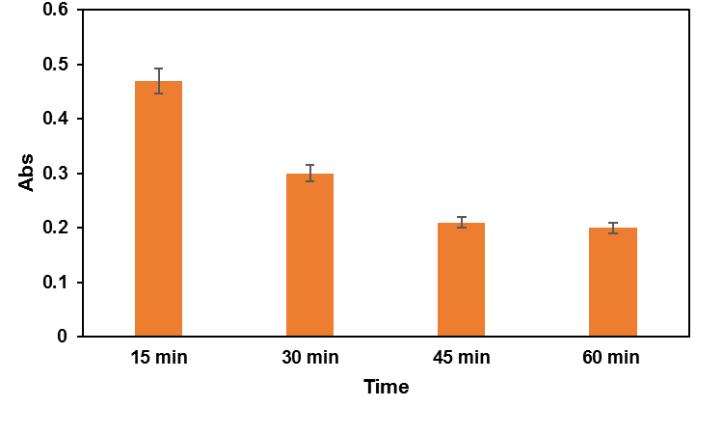
Fig. S3

