Design and synthesis of Brønsted-Lewis acidic tetraimidazolyl ionic liquids for efficient catalytic conversion of glucose to 5-hydroxymethylfurfural in water/1-octanol
Jian Zhao, Chao Li, Xiaodong Fan, Hao Liu, Ziqi Liu, Jingchao Zhang, Zhizhong Sun* and Wenyi Chu*
School of Chemistry and Materials Science, Heilongjiang University, Harbin 150080, P. R. China.
Tel: +86-451-86609135
Fax: +86-451-86609135
E-mail: sunzz@hlju.edu.cn; wenyichu@hlju.edu.cn

Contents of Supporting Information
1. Characterization of the data................................................................ S2
2. NMR spectra………………………………………………………... S7

1. Characterization of the data
Tetrakis(bromomethyl)methane
m.p. 158 ~ 160 °C; ¹H NMR (400 MHz, CDCl₃) δ 3.59 (s, 8H); (Figure S1) ¹³C NMR (101 MHz, CDCl₃) δ 43.2, 34.4; (Figure S2) FT-IR (KBr disc): v= 2953, 1421, 1269, 1187, 831, 612 cm⁻¹; HRMS (ESI): m/z calcd for C₅H₈Br₄+H⁺: 384.7438; found: 384.7439; elemental analysis calcd (%) for C₅H₈Br₄: C 15.49, H 2.08, Br 82.43; found: C 15.47, H 2.09, Br 82.44.
Tetrakis(imidazol-1-ylmethyl)methane
m.p. 156 ~ 158 °C; ¹H NMR (400 MHz, D₂O) δ 7.40(s, 4H), 6.99 (s, 4H), 6.94 (s, 4H), 4.16(s, 8H); (Figure S3) ¹³C NMR (101 MHz, D₂O) δ 139.1, 128.5, 121.5, 49.5, 42.3; (Figure S4) FT-IR (KBr disc): v= 1583, 1560, 1507, 1453, 1248, 1083, 1022, 915, 837, 742, 658, 623 cm⁻¹; HRMS (ESI): m/z calcd for C₁₇H₂₀N₈+H⁺: 337.1889; found: 337.1886; elemental analysis calcd (%) for C₁₇H₂₀N₈: C 60.70, H 5.99, N 33.31; found: C 60.68, H 5.98, N 33.34.
Tetracation propanesulfonic acid type ionic liquid onium salt (Teim-PS)
m.p. 160 ~ 162 °C; ¹H NMR (400 MHz, D₂O) δ 9.04 (s, 4H), 7.71 (s, 4H), 7.64 (s, 4H), 4.60 (s, 8H), 4.46 (t, J =6.9 Hz, 8H), 2.98 (t, J = 7.2 Hz, 8H), 2.39 (m, 8H); (Figure S5) ¹³C NMR (101 MHz, D₂O) δ 137.5, 124.4, 122.9, 51.1, 48.3, 47.3, 43.0, 24.9; (Figure S6) FT-IR (KBr disc): v= 3103, 1683, 1650, 1557, 1509, 1452, 1178, 1038, 882, 792, 690 cm⁻¹; HRMS (ESI): m/z calcd for C₂₉H₄₄N₈O₁₂S₄+H⁺: 825.2040; found: 825.2045; elemental analysis calcd (%) for C₂₉H₄₄N₈O₁₂S₄: C 42.22, H 5.38, N 13.58, S 15.55; found: C 42.24, H 5.36, N 13.57, S 15.57.
Tetracation propanesulfonic acid type ionic liquid chloride ([TeimILs]Cl₄)
m.p. 96 ~ 98 °C; ¹H NMR (400 MHz, D₂O) δ 8.78 (s, 4H), 7.73 (s, 4H), 7.61 (s, 4H), 4.43 (t, J = 6.7 Hz, 8H), 4.04 (t, J = 6.3 Hz, 8H), 2.99 (t, J = 6.8 Hz, 8H), 2.35 (m, 8H); (Figure S7) ¹³C NMR (101 MHz, D₂O) δ 136.7, 122.5, 121.1, 54.1, 49.6, 47.7, 43.0, 25.5; (Figure S8) FT-IR (KBr disc): v= 3107, 2960, 2918, 1685, 1597, 1454, 1286, 1244, 835, 796, 634 cm⁻¹; HRMS (ESI): m/z calcd for [C₂₉H₄₈Cl₄N₈O₁₂S₄-4Cl]/4: 207.0563; found: 207.0561; elemental analysis calcd (%) for C₂₉H₄₈Cl₄N₈O₁₂S₄: C 35.88, H 4.98, Cl 14.61, N 11.54, S 13.21; found: C 35.86, H 4.99, Cl 14.63, N 11.53, S 13.22.
Tetracation propanesulfonic acid type ionic liquid aluminum salt ([Teim-PS][AlCl₄]₄)
m.p. 102 ~ 104 °C; ¹H NMR (400 MHz, D₂O) δ 8.76 (s, 4H), 7.38 (d, J= 10.5 Hz, 8H), 4.33 (s, 8H), 4.16 (s, 8H), 2.69 (t, J = 5.9 Hz, 8H), 2.12 - 2.04 (m, 8H); (Figure S9) ¹³C NMR (101 MHz, D₂O) δ 137.7, 124.6, 122.4, 51.3, 48.5, 46.9, 42.3, 24.7; (Figure S10) FT-IR (KBr disc): v= 3041, 1656, 1606, 1448, 1300, 1263, 1178, 952, 810, 702, 605 cm⁻¹; HRMS (ESI): m/z calcd for [C₂₉H₄₈Al₄Cl₁₆N₈O₁₂S₄-4AlCl₄]/4: 207.0563; found: 207.0562; elemental analysis calcd (%) for C₂₉H₄₈Al₄Cl₁₆N₈O₁₂S₄: C 23.16, H 3.22, Cl 37.71, N 7.45, S 8.53; found: C 23.15, H 3.20, Cl 37.73, N 7.44, S 8.51.
Tetracation butanesulfonic acid type ionic liquid onium salt (Teim-ES)
m.p. 158 ~ 60 °C; ¹H NMR (400 MHz, D₂O) δ 8.76(s, 4H), 7.57 (s, 4H), 7.49 (s, 4H), 4.43 (t, J = 7.1 Hz, 8H), 3.01 - 2.88 (m, 8H), 2.42 - 2.28 (m, 8H); (Figure S11) ¹³C NMR (101 MHz, D₂O) δ 134.6, 121.7, 120.2, 58.5, 49.2, 47.3, 43.1; (Figure S12) FT-IR (KBr disc): v= 3089, 1670, 1601, 1508, 1458, 1240, 1055, 885, 742, 617 cm⁻¹; HRMS (ESI): m/z calcd for C₂₅H₃₆N₈O₁₆S₄+H⁺: 833.1210; found: 833.1214; elemental analysis calcd (%) for C₂₅H₃₆N₈O₁₆S₄: C 36.05, H 4.36, N 13.45, S 15.40; found: C 36.03, H 4.35, N 13.46, S 15.42.
Tetracation butanesulfonic acid type ionic liquid chloride ([Teim-ES]Cl₄)
m.p. 94 ~ 96 °C; ¹H NMR (400 MHz, D₂O) δ 7.67 (s, 4H), 7.08 (d, J = 16.1 Hz, 8H), 4.15 (s, 8H), 3.15 (t, J = 6.9 Hz, 8H), 2.33 (t, J = 7.6 Hz, 8H); (Figure S13) ¹³C NMR (101 MHz, D₂O) δ 138.9, 127.4, 121.8, 59.4, 48.7, 47.8, 42.6; (Figure S14) FT-IR (KBr disc): v= 3059, 1664, 1592, 1435, 1315, 1249, 1089, 939, 852, 758 cm⁻¹; HRMS (ESI): m/z calcd for [C₂₅H₄₀Cl₄N₈O₁₆S₄-4Cl]/4: 209.0356; found: 209.0358; elemental analysis calcd (%) for C₂₅H₄₀Cl₄N₈O₁₆S₄: C 30.68, H 4.12, Cl 14.49, N 11.45, S 13.10; found: C 30.66, H 4.12, Cl 14.48, N 11.47, S 13.12.
Tetracation butanesulfonic acid type ionic liquid aluminum salt ([Teim-ES][AlCl₄]₄)
m.p. 98 ~ 100 °C; ¹H NMR (400 MHz, D₂O) δ 7.61 (s, 4H), 7.10 (s, 4H), 7.05 (s, 4H), 4.14 (s, 8H), 3.18 (t, J = 6.4 Hz, 8H), 2.09 (t, J = 6.4 Hz, 8H); (Figure S15) ¹³C NMR (101 MHz, D₂O) δ 137.1, 121.7, 120.2, 57.9, 49.0, 47.3, 41.9; (Figure S16) FT-IR (KBr disc): v= 3035, 1666, 1602, 1429, 1303, 1242, 1157, 933, 848, 771 cm⁻¹; HRMS (ESI): m/z calcd for [C₂₅H₄₀Al₄Cl₁₆N₈O₁₆S₄-4AlCl₄]/4: 209.0356; found: 209.0351; elemental analysis calcd (%) for C₂₅H₄₀Al₄Cl₁₆N₈O₁₆S₄: C 19.86, H 2.67, Cl 37.51, N 7.41, S 8.48; found: C 19.85, H 2.65, Cl 37.53, N 7.38, S 8.49.
Tetracation butanesulfonic acid type ionic liquid onium salt (Teim-BS)
m.p. 165 ~ 167 °C; ¹H NMR (400 MHz, D₂O) δ 8.88 (s, 4H), 7.60 (s, 4H), 7.51 (s, 4H), 4.40 (t, J = 7.0 Hz, 8H), 4.28 (t, J = 6.5 Hz, 8H), 3.15 (t, J = 6.4 Hz, 8H), 2.91 (t, J = 7.3 Hz, 8H), 2.32 (dd, J = 7.1 Hz, 8H); (Figure S17) ¹³C NMR (101 MHz, D₂O) δ 137.5, 124.4, 122.9, 51.0, 48.2, 47.2, 42.9, 24.9; (Figure S18) FT-IR (KBr disc): v= 3062, 1651, 1433, 1321, 1215, 1143, 1012, 861, 735 cm⁻¹; HRMS (ESI): m/z calcd for C₃₃H₅₂N₈O₁₂S₄+H⁺: 881.2666; found: 881.2669; elemental analysis calcd (%) for C₃₃H₅₂N₈O₁₂S₄: C 44.99, H 5.95, N 12.72, S 14.56; found: C 44.98, H 5.97, N 12.74, S 14.53.
Tetracation butanesulfonic acid type ionic liquid chloride ([Teim-BS]Cl₄)
m.p. 103 ~ 105 °C; ¹H NMR (400 MHz, D₂O) δ 7.95 (s, 4H), 7.62 (s, 4H), 7.14 (s, 4H), 4.19 (s, 8H), 4.02 (s, 8H), 3.05 (s, 8H), 2.35 (s, 8H); (Figure S19) ¹³C NMR (101 MHz, D₂O) δ 137.4, 124.5, 122.9, 50.9, 48.3, 47.2, 42.9, 24.8; (Figure S20) FT-IR (KBr disc): v= 3047, 1662, 1597, 1442, 1302, 1212, 1085, 844, 731 cm⁻¹; HRMS (ESI): m/z calcd for [C₃₃H₅₆Cl₄N₈O₁₂S₄-4Cl]/4: 221.0720; found: 221.0724; elemental analysis calcd (%) for C₃₃H₅₆Cl₄N₈O₁₂S₄: C 38.60, H 5.50, Cl 13.81, N 10.91, S 12.49; found: C 38.63, H 5.48, Cl 13.82, N 10.93, S 12.48.
Tetracation butanesulfonic acid type ionic liquid aluminum salt ([Teim-BS][AlCl₄]₄)
m.p. 106 ~ 108 °C; ¹H NMR (400 MHz, D₂O) δ 8.87 (s, 4H), 7.59 (s, 4H), 7.49 (s, 4H), 4.39 (t, J = 7.2 Hz, 8H), 4.27 (t, J = 6.6 Hz, 8H), 3.13(t, J = 6.6 Hz, 8H), 2.90 (t, J = 7.2 Hz, 8H), 2.36 – 2.28 (m, 8H); (Figure S21) ¹³C NMR (101 MHz, D₂O) δ 137.4, 124.5, 123.1, 50.9, 48.4, 47.0, 42.9, 24.9; (Figure S22) FT-IR (KBr disc): v= 3068, 1670, 1560, 1458, 1419, 1188, 900, 794, 671 cm⁻¹; HRMS (ESI): m/z calcd for [C₃₃H₅₆Al₄Cl₁₆N₈O₁₂S₄-4AlCl₄]/4: 221.0720; found: 221.0722; elemental analysis calcd (%) for C₃₃H₅₆Al₄Cl₁₆N₈O₁₂S₄: C 25.40, H 3.62, Cl 36.35, N 7.18, S 8.22; found: C 25.36, H 3.63, Cl 36.36, N 7.19, S 8.20.
Tetracationic benzenesulfonic acid type ionic liquid onium salt (Teim-BD)
m.p. 169 ~ 171 °C; ¹H NMR (400 MHz, D₂O) δ 8.76 (s, 4H), 7.61 (dd, J = 17.0, 10.4 Hz, 4H), 7.50 (t, J = 1.7 Hz, 4H), 7.44 (d, J = 3.3 Hz, 4H), 7.37 – 7.17 (m, 12H), 5.98 (d, J = 6.1 Hz, 8H), 4.31 (t, J = 7.1 Hz, 8H); (Figure S23) ¹³C NMR (101 MHz, D₂O) δ 135.7, 130.3, 125.3, 124.7, 123.6, 122.7, 122.5, 121.3, 51.6, 47.3, 41.7; (Figure S24) FT-IR (KBr disc): v= 3025, 1681, 1562, 1482, 1312, 1241, 966, 893, 715, 692 cm⁻¹; HRMS (ESI): m/z calcd for C₄₅H₄₄N₈O₁₂S₄+H⁺: 1017.2040; found: 1017.2036; elemental analysis calcd (%) for C₄₅H₄₄N₈O₁₂S₄: C 53.14, H 4.36, N 11.02, S 12.61; found: C 53.16, H 4.35, N 11.00, S 12.64.
Tetracationic benzenesulfonic acid type ionic liquid chloride ([Teim-BD]Cl₄)
m.p. 109 ~ 111 °C; ¹H NMR (400 MHz, D₂O) 7.49 (s, 4H), 7.22 (dd, J = 17.0, 10.3 Hz, 4H), 7.08 (s, 4H), 6.98 (s, 4H), 6.97 – 6.81 (m, 12H), 5.50 (s, 8H), 4.56 (d, J = 5.7 Hz, 8H); (Figure S25) ¹³C NMR (101 MHz, D₂O) δ 135.8, 130.5, 125.3, 124.7, 123.7, 122.7, 122.4, 121.3, 51.6, 47.7, 41.9; (Figure S26) FT-IR (KBr disc): v= 3070, 1658, 1597, 1431, 1310, 1210, 1136, 1018, 856, 763 cm⁻¹; HRMS [C₄₅H₄₈Cl₄N₈O₁₂S₄-4Cl]/4: 255.0563; found: 255.0565; elemental analysis calcd (%) for C₄₅H₄₈Cl₄N₈O₁₂S₄: C 46.48, H 4.16, Cl 12.19, N 9.64, S 11.03; found: C 46.45, H 4.17, Cl 12.21, N 9.61, S 11.05.
Tetracationic benzenesulfonic acid type ionic liquid aluminum salt ([Teim-BD][AlCl₄]₄)
m.p. 114 ~ 116 °C; ¹H NMR (400 MHz, D₂O) δ 8.86 (s, 4H), 7.67 – 7.61 (m, 4H), 7.57 – 7.55 (m, 4H), 7.50 (t, J = 1.8 Hz, 4H), 7.43 – 7.30 (m, 12H), 5.42 (s, 8H), 4.35 (t, J = 7.1 Hz, 8H); (Figure S27) ¹³C NMR (101 MHz, D₂O) δ 137.5, 130.0, 124.4, 123.6, 122.9, 122.5, 122.3, 121.3, 51.0, 47.2, 42.9; (Figure S28) FT-IR (KBr disc): v= 3057, 1676, 1592, 1458, 1300, 1220, 1091, 855, 729 cm⁻¹; HRMS (ESI): m/z calcd for [C₄₅H₄₈Al₄Cl₁₆N₈O₁₂S₄-4AlCl₄]/4: 255.0563; found: 255.0567; elemental analysis calcd (%) for C₄₅H₄₈Al₄Cl₁₆N₈O₁₂S₄: C 31.86, H 2.85, Cl 33.44, N 6.61, S 7.56; found: C 31.86, H 2.83, Cl 33.42, N 6.62, S 7.57.

2. NMR spectra
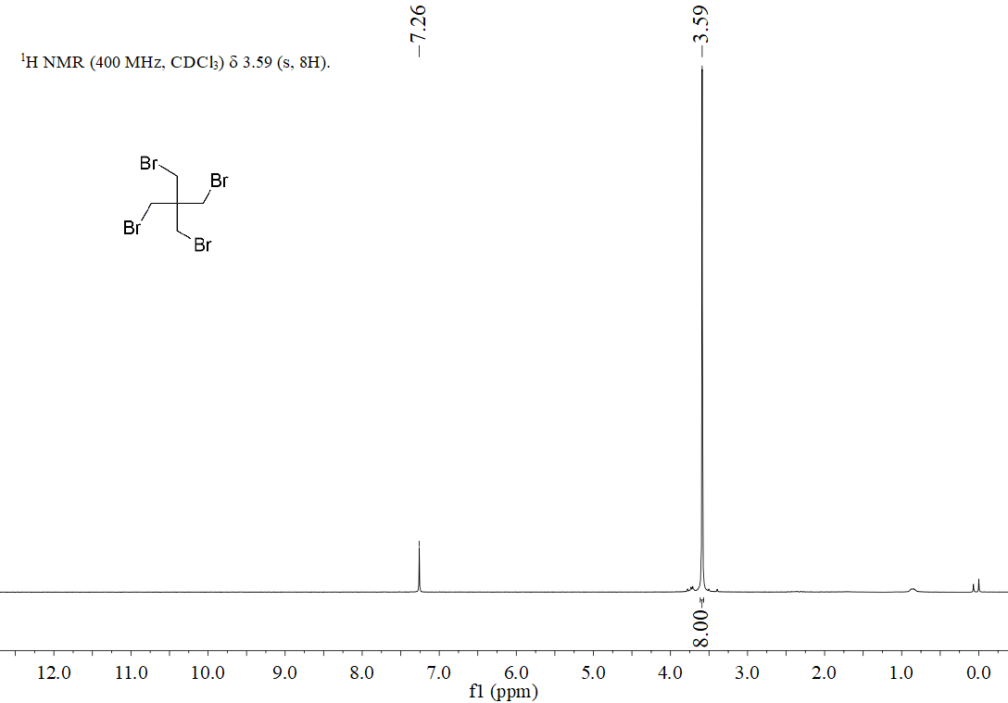
Figure S1. ¹H NMR of tetrakis(bromomethyl)methane
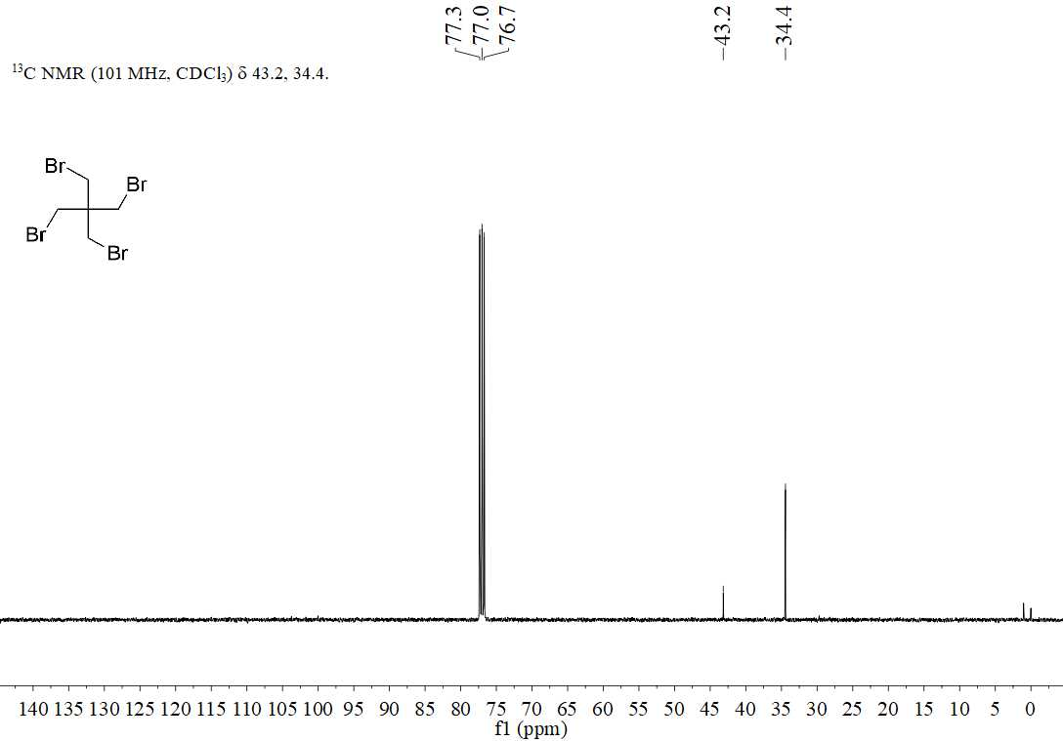
Figure S2. ¹³C NMR of tetrakis(bromomethyl)methane
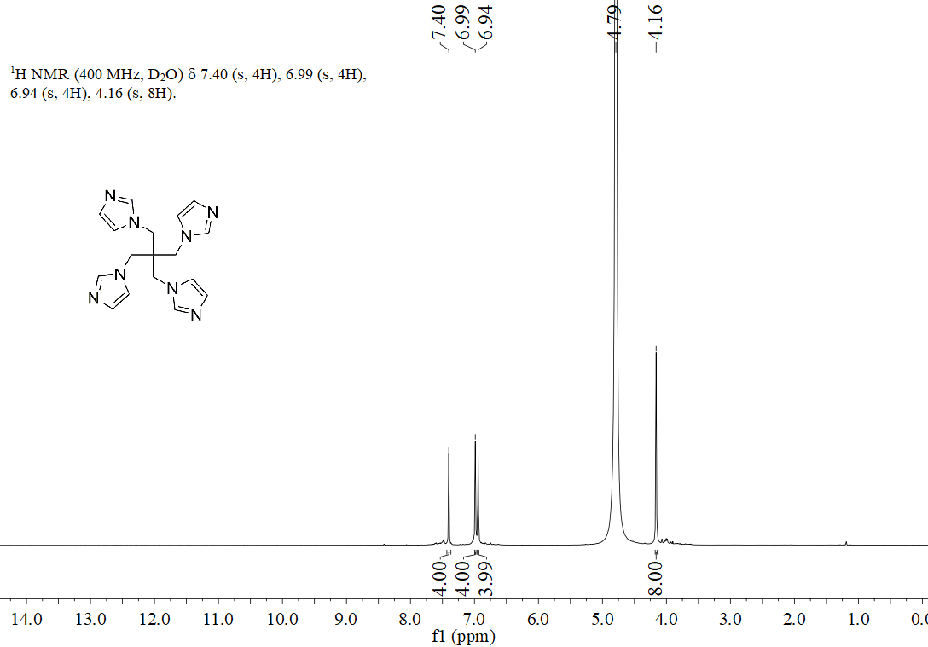
Figure S3. ¹H NMR of tetrakis(imidazol-1-ylmethyl)methane

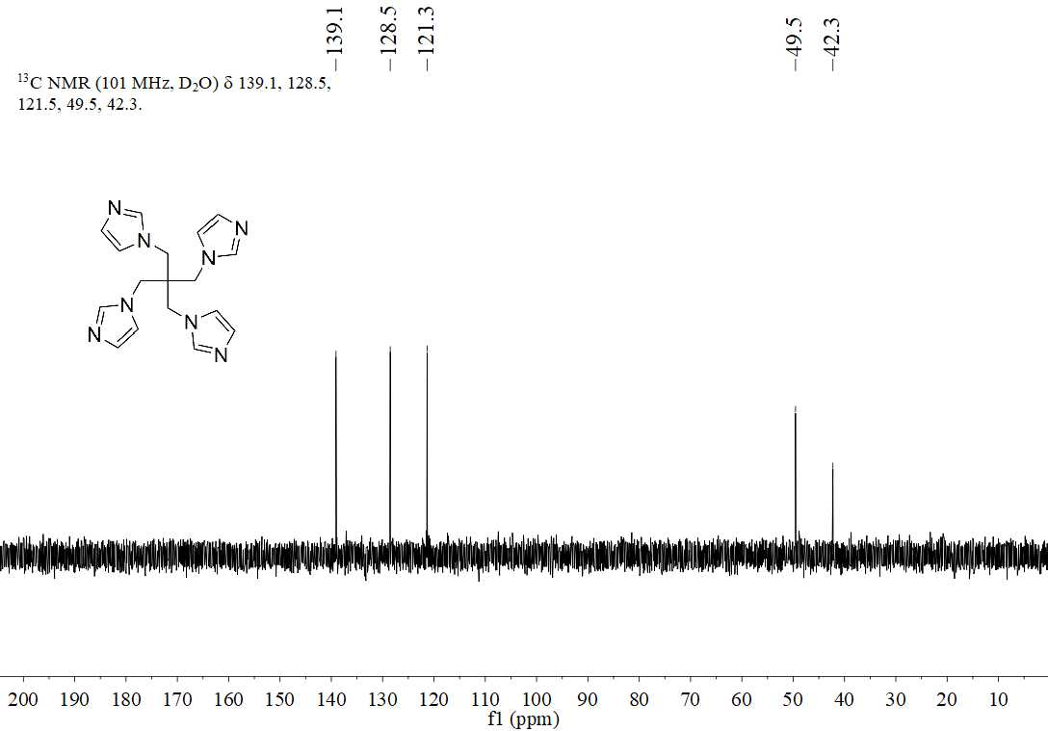
Figure S4. ¹³C NMR of tetrakis(imidazol-1-ylmethyl)methane

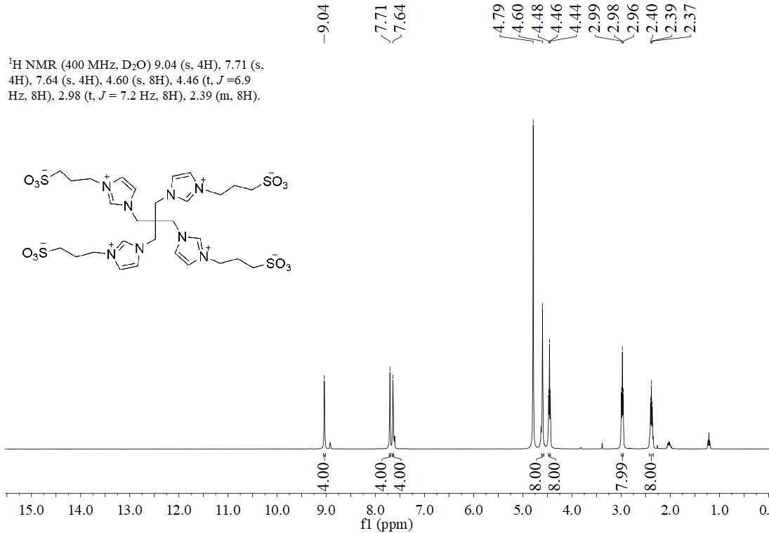
Figure S5. ¹H NMR of Teim-PS

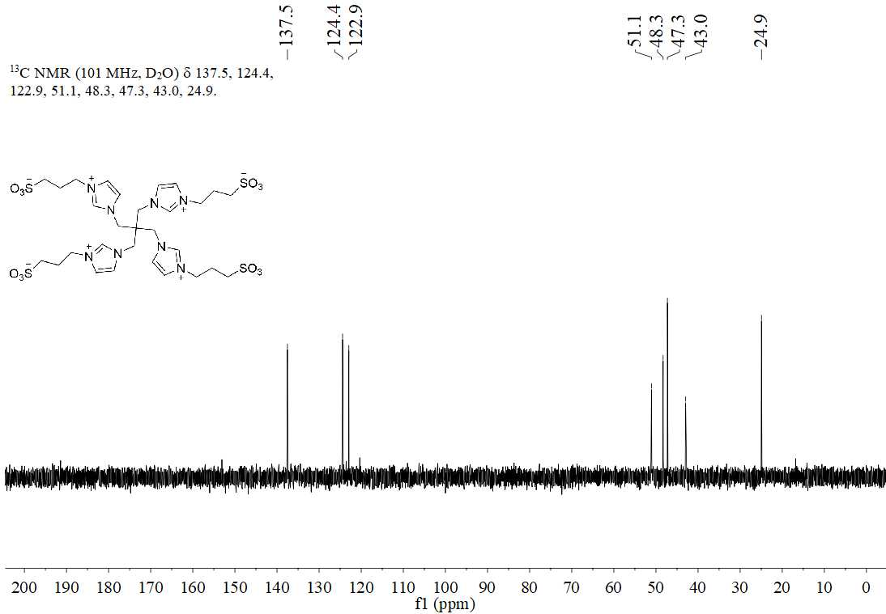
Figure S6. ¹³C NMR of Teim-PS

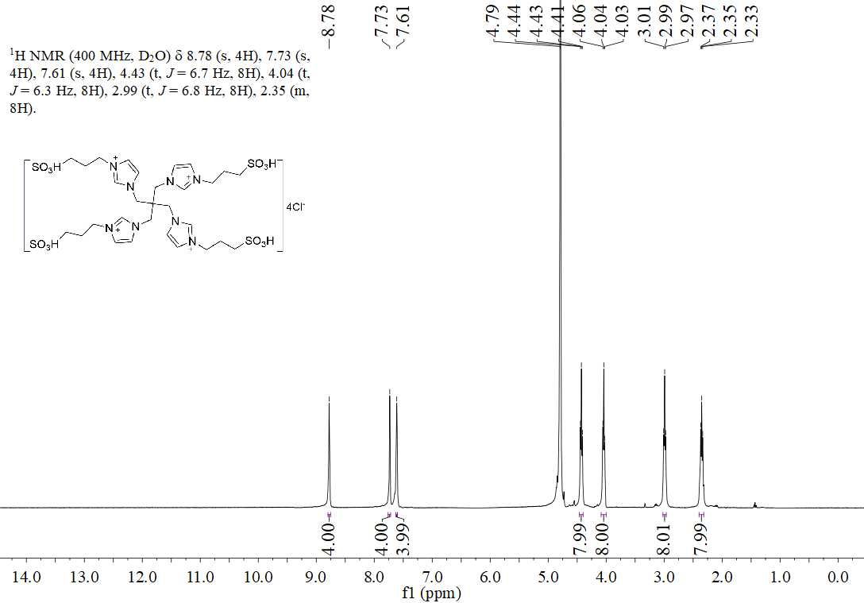
Figure S7. ¹H NMR of [Teim-PS]Cl₄

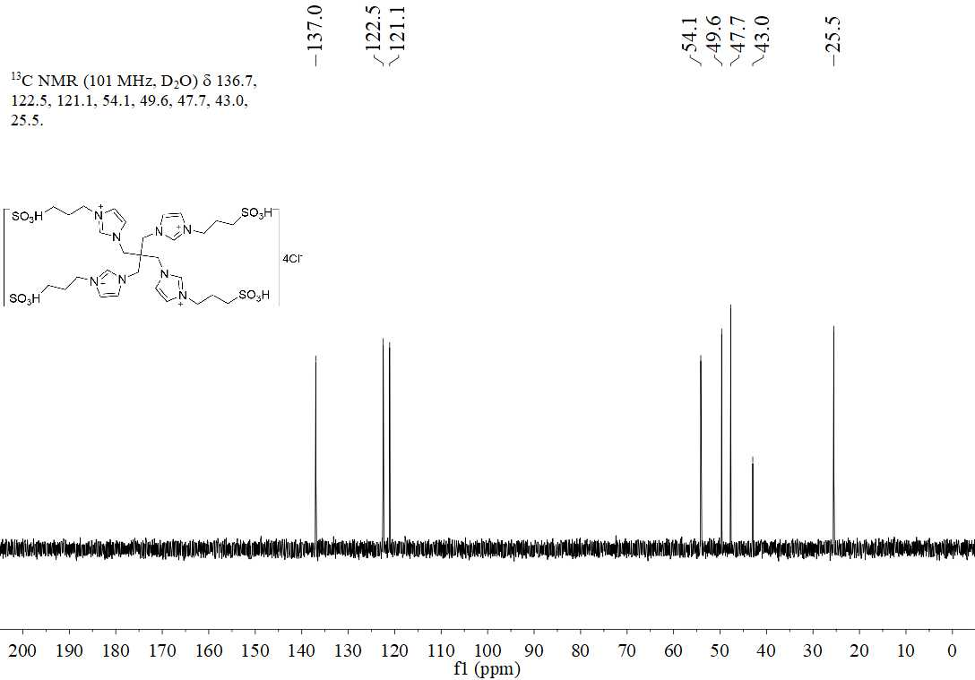
Figure S8. ¹³C NMR of [Teim-PS]Cl₄

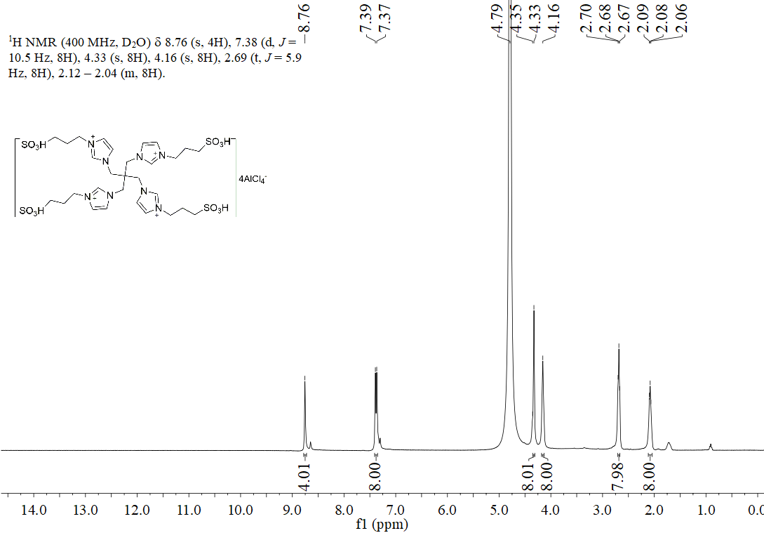
Figure S9. ¹H NMR of [Teim-PS][AlCl₄]₄

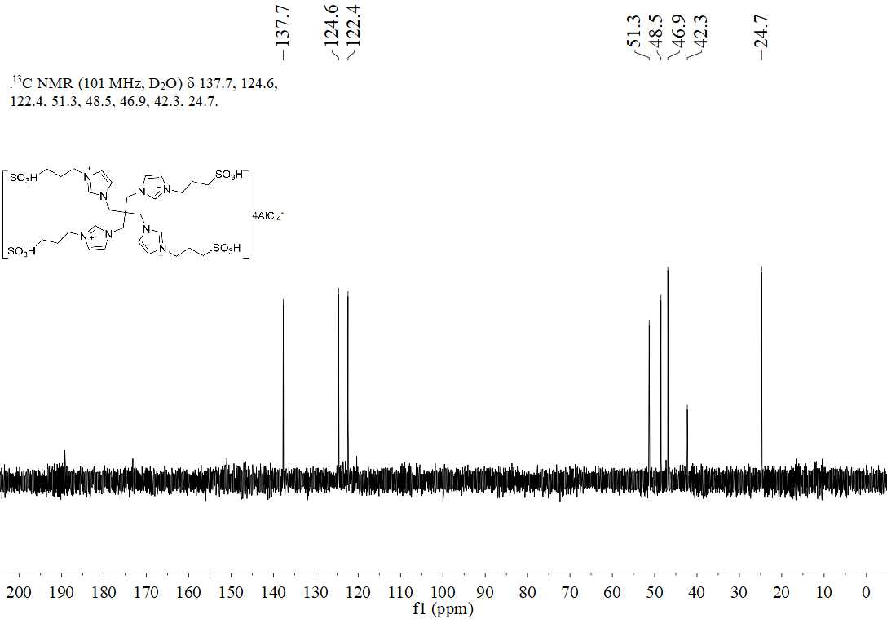
Figure S10. ¹³C NMR of [Teim-PS][AlCl₄]₄

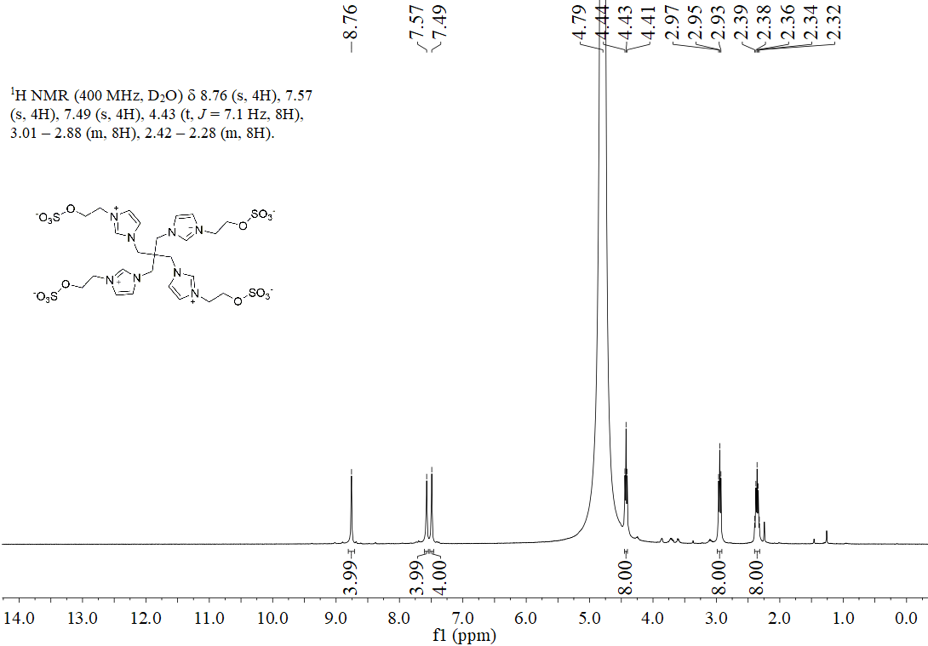
Figure S11. ¹H NMR of Teim-ES

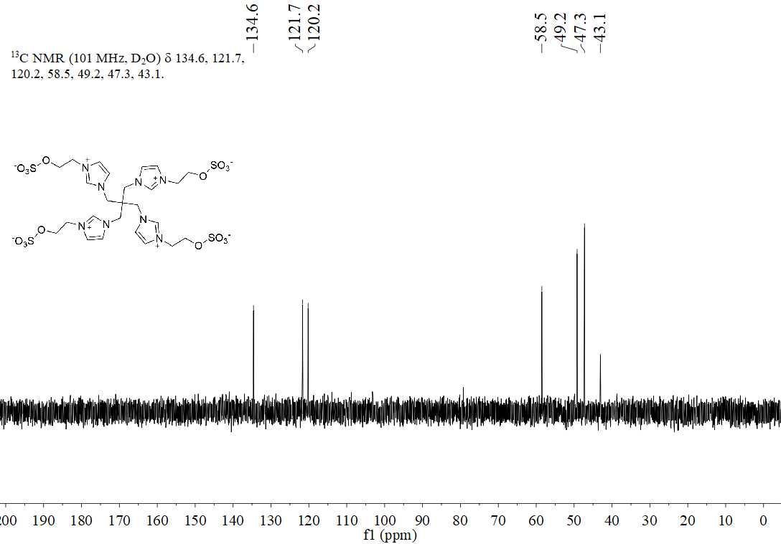
Figure S12. ¹³C NMR of Teim-ES

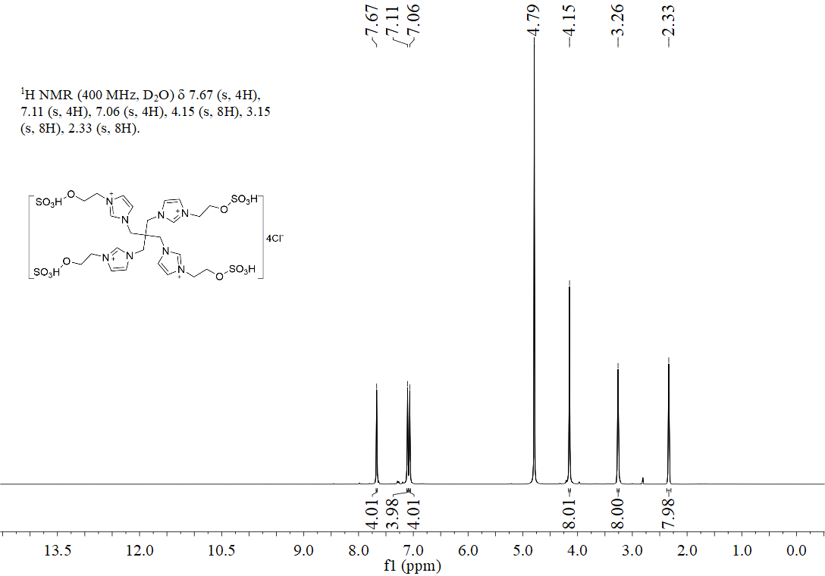
Figure S13. ¹H NMR of [Teim-ES]Cl₄

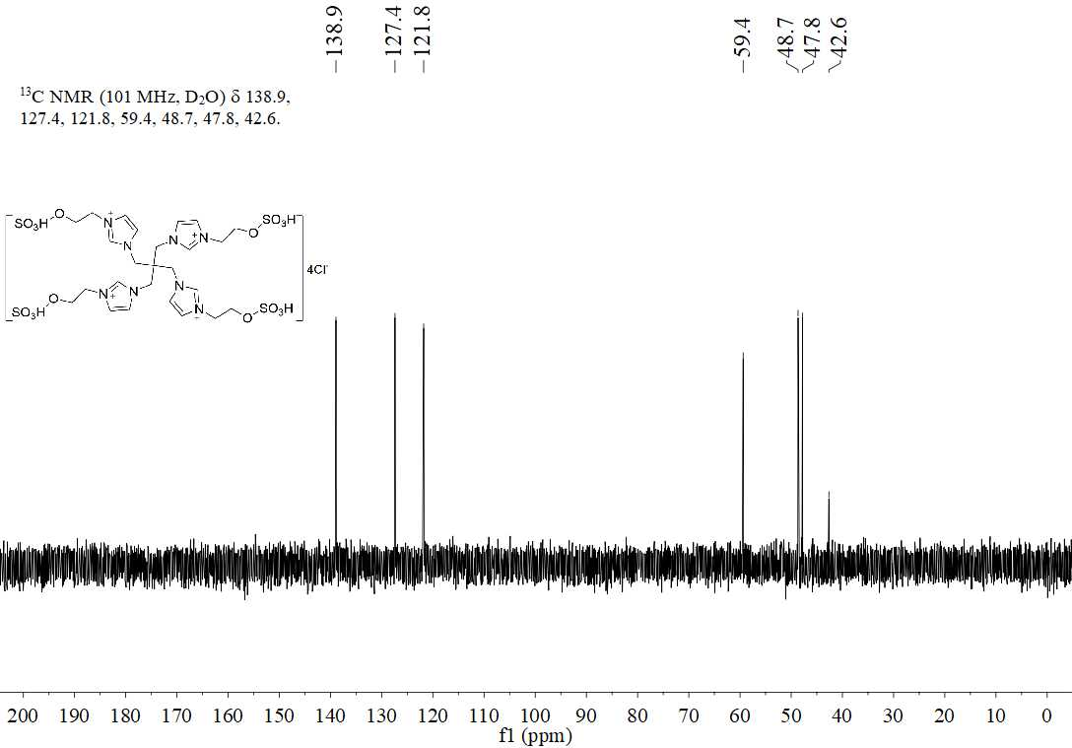
Figure S14. ¹³C NMR of [Teim-ES]Cl₄

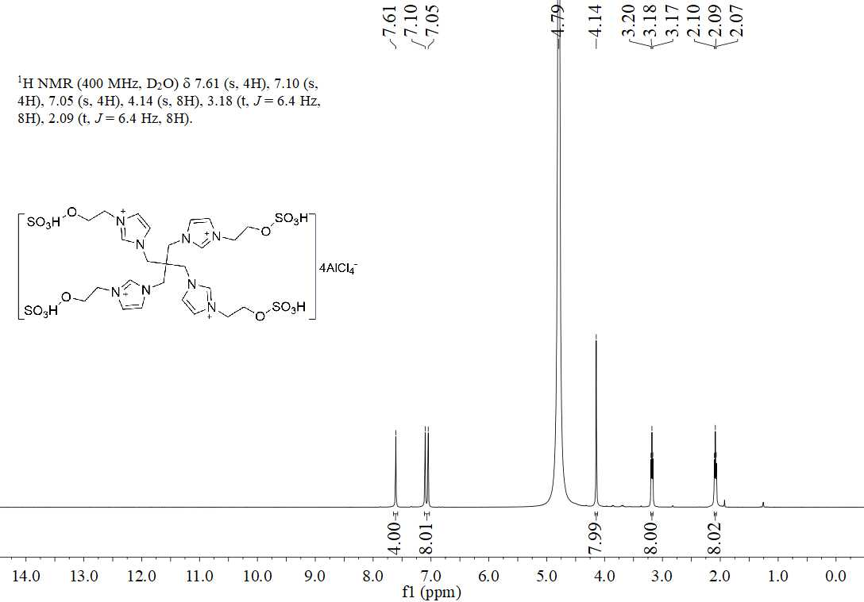
Figure S15. ¹H NMR of [Teim-ES][AlCl₄]₄

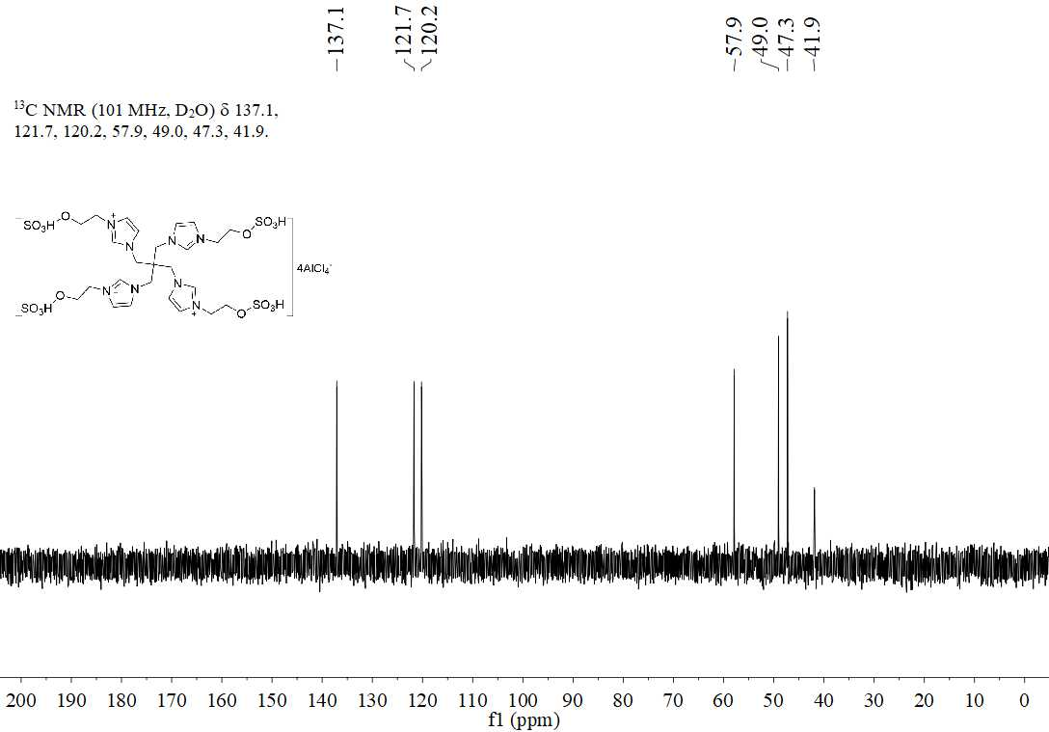
Figure S16. ¹³C NMR of [Teim-ES][AlCl₄]₄

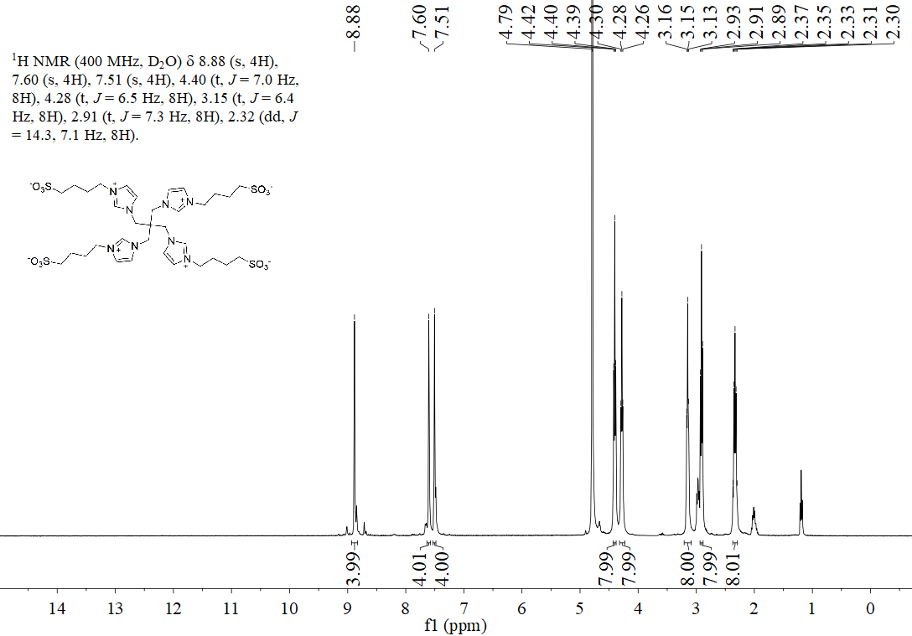
Figure S17. ¹H NMR of Teim-BS

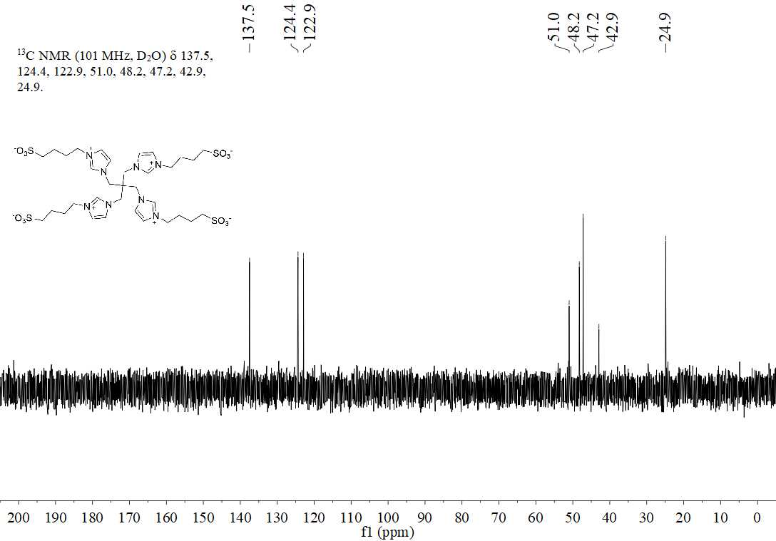
Figure S18. ¹³C NMR of Teim-BS

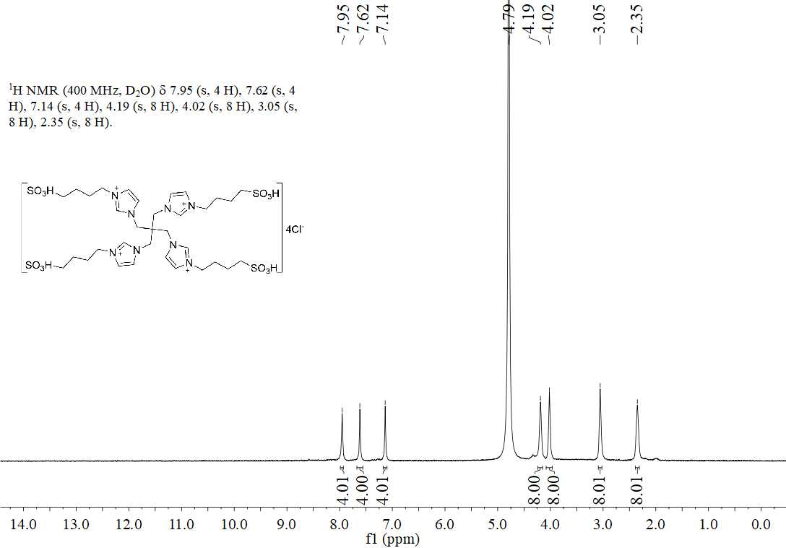
Figure S19. ¹H NMR of [Teim-BS]Cl₄

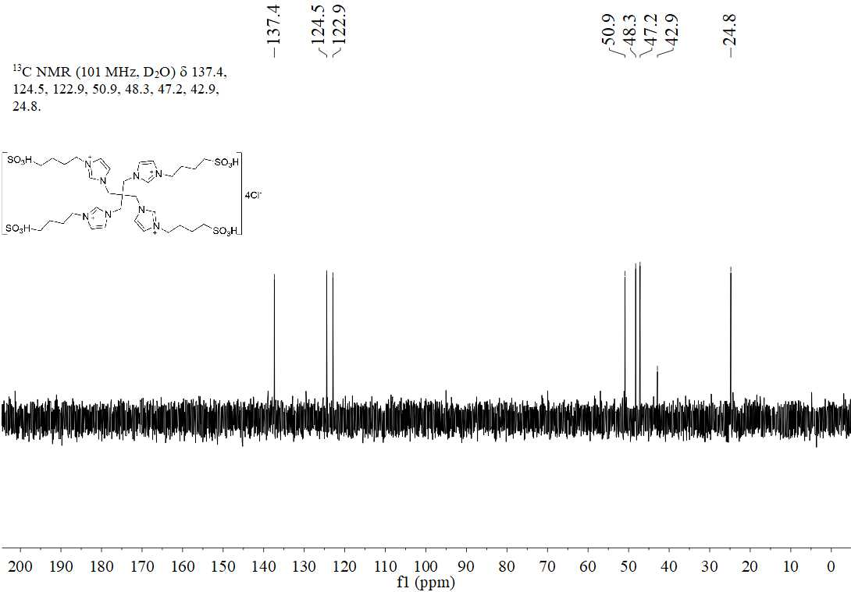
Figure S20. ¹³C NMR of [Teim-BS]Cl₄

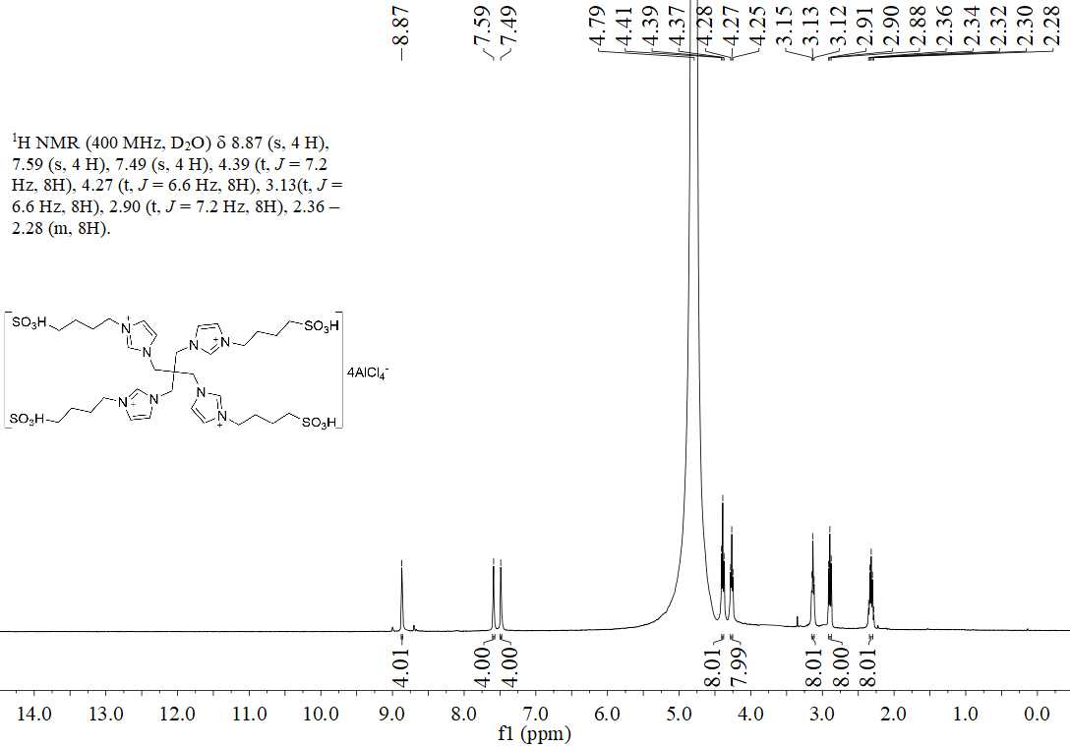
Figure S21. ¹H NMR of [Teim-BS][AlCl₄]₄

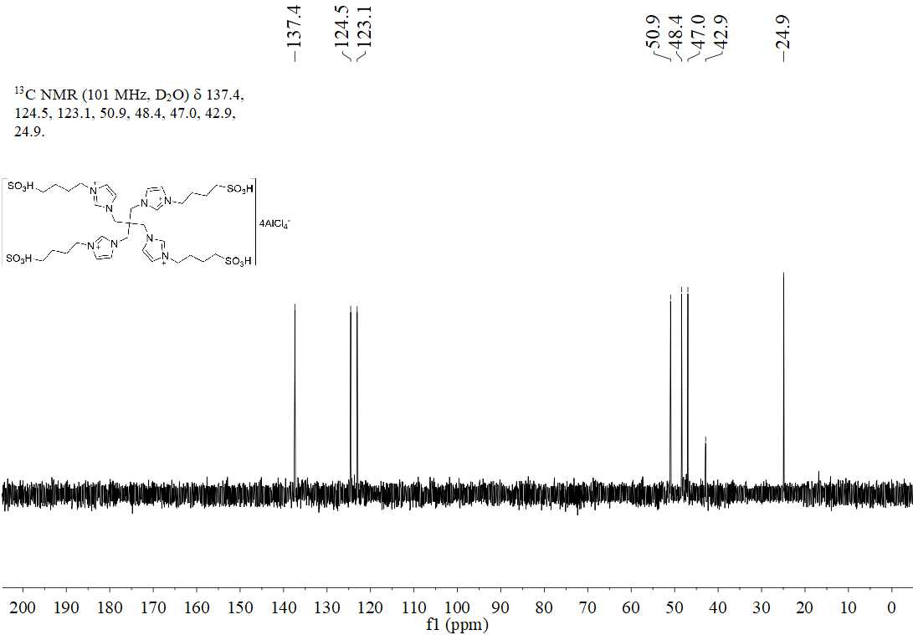
Figure S22. ¹³C NMR of [Teim-BS][AlCl₄]₄

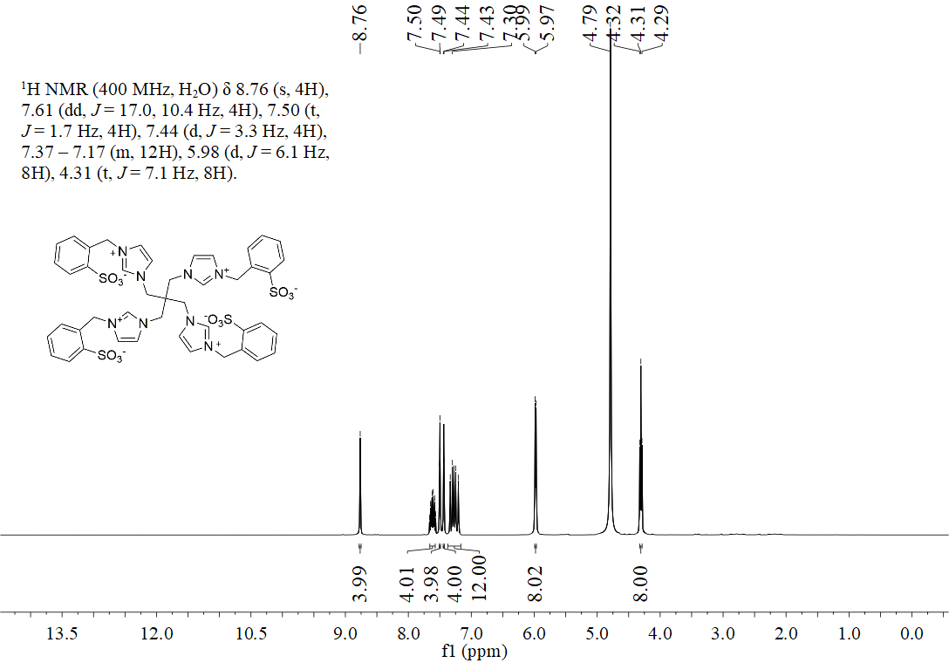
Figure S23. ¹H NMR of Teim-BD

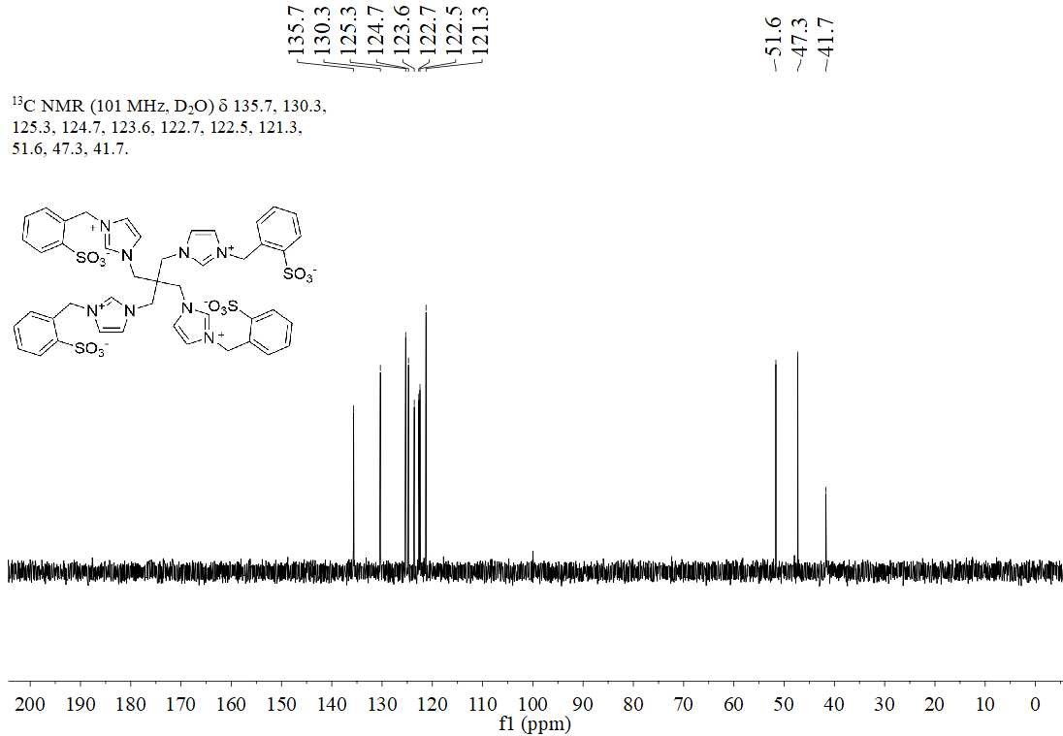
Figure S24. ¹³C NMR of Teim-BD

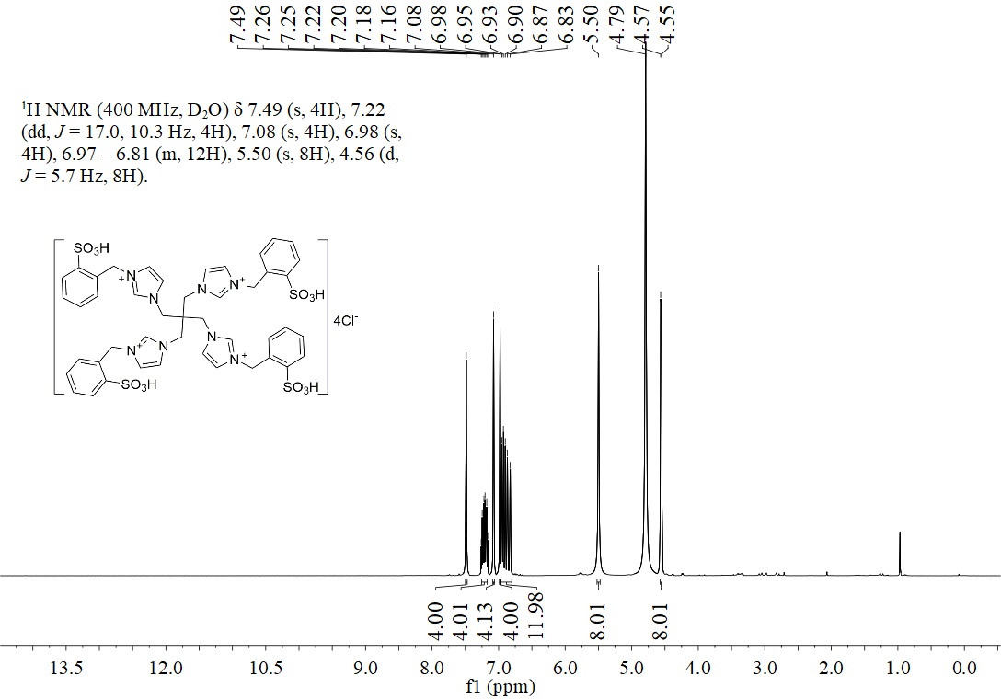
Figure S25. ¹H NMR of [Teim-BD]Cl₄

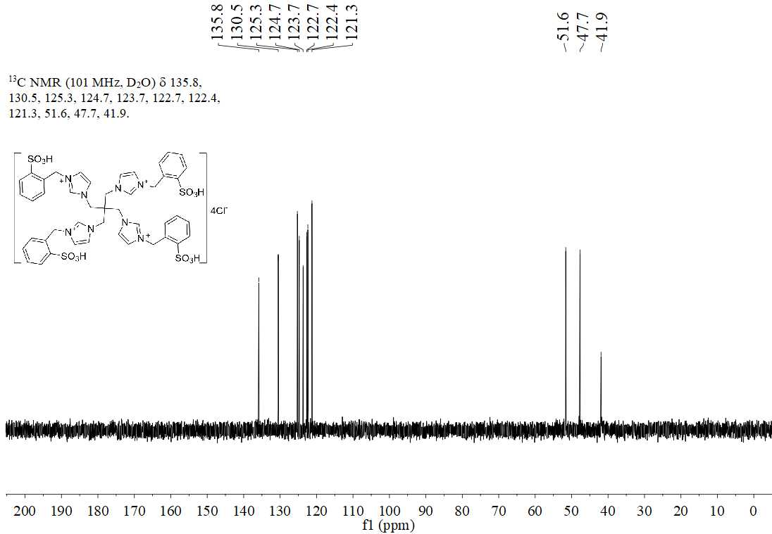
Figure S26. ¹³C NMR of [Teim-BD]Cl₄

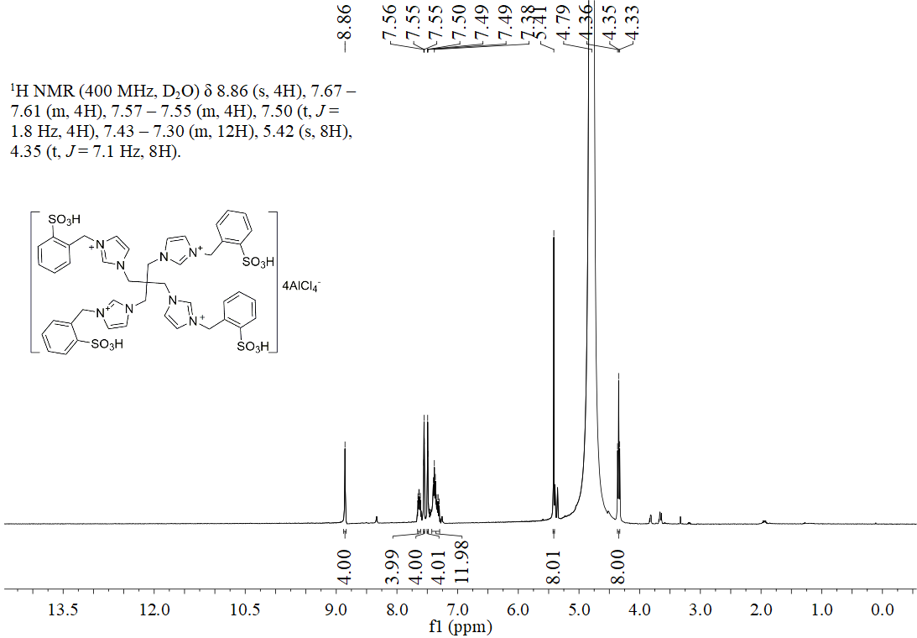
Figure S27. ¹H NMR of [Teim-BD][AlCl₄]₄

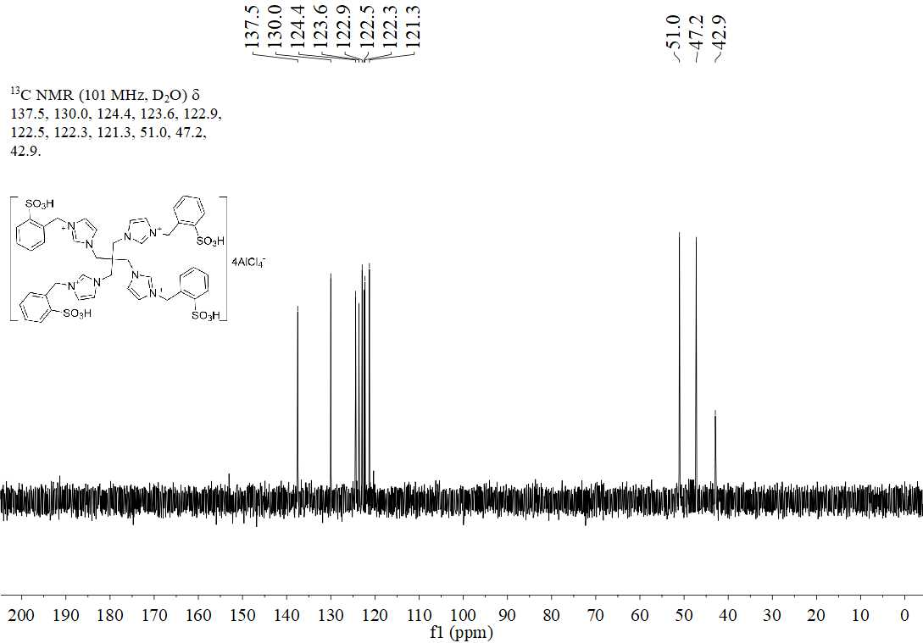
Figure S28. ¹³C NMR of [Teim-BD][AlCl₄]₄

