Table 1 The water quality of dyeing wastewater

Samples | BOD₅ (mg/L) | COD (mg/L) | BOD₅/COD | chromaticity | PH | Images of Sample
Structurally colored fabric | 27.50 | 80.30 | 0.34 | 35.00 | 7.00 | 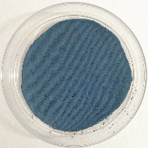
Dyed fabric | 39.40 | 141.00 | 0.28 | ≫500.00 | 11.00 | 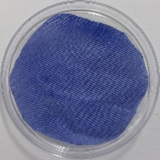
Discharge Standards | ≤30.00 | ≤100.00 | ≥0.30 | ≤50.00 | 6.00-9.00 | —

