Supporting Information
Constructing Molecular Bridge for High-Efficiency and Stable Perovskite Solar Cells based on P3HT Hole Transport Material
Dongdong Xu,ª Zhiming Gong, ª Yue Jiang, ^{a*} Yancong Feng, ^{b*} Zhen Wang, ª Xingsen Gao ª, Xubing Lu ª, Guofu Zhou, ^{b} Jun-Ming Liu, ^{c} Jinwei Gao ^{a*}

- Institute for Advanced Materials and Guangdong Provincial Key Laboratory of Optical Information Materials and Technology, South China Academy of Advanced Optoelectronics, South China Normal University, Guangzhou 510006, China.
- Institute of Electronic Paper Displays, South China Academy of Advanced Optoelectronics, South China Normal University, Guangzhou 510006, China.
- Laboratory of Solid-State Microstructures, Nanjing University, Nanjing 210093, China.

E-mail: yuejiang@m.scnu.edu.cn (Y.J.), fengyancong@m.scnu.edu.cn (Y.F.), gaojinwei@m.scnu.edu.cn (J.G.)

Contents
1. Materials
2. Experimental section
3. Computational methods and details
3.1 Perovskite/molecule systems Device Fabrication
Fig. D1. Primitive cell of FA_{0.875}MA_{0.125}PbI₃. Only one Pb–I octahedron is displayed for clarity. The arrows denote the orientations of C–H bond in FA molecule.
Fig. D2. Slab model with a vacuum of 20 Å of FA_{0.875}MA_{0.125}PbI₃ after structural optimization.
3.2 Molecular systems
4. Perovskite Solar Cells Fabrication
5. Synthesis details
Scheme S1. Synthetic routes of MDN, RDN, PDN and TDN.
6. Optical and electrochemical properties
Fig. S1. (a) UV–vis absorption spectra and (b) photoluminescence spectra of materials in THF solution and as thin films.
Fig. S2. CV curves of MDN and RDN.
Fig. S3. 2D GIWAXS patterns based on the structures of Si-wafers/Perovskite/HTMs.
Fig. S4. (a) UV–vis absorption spectra and (b) photoluminescence spectra of P3HT, M-P3HT and R-P3HT films.
Fig. S5. (a) HOMO region and (b) cut-off energy region of UPS.
Table S1. Optical and electrochemical properties.
Fig. S6. Band-edges of the stacked films in the device.
Fig. S7. Conductivities of P3HT, M-P3HT and R-P3HT films.
Fig. S8. Cross-sectional SEM images of PSCs with (a) P3HT, and (b) R-P3HT.
Fig. S9. The top view SEM images of PSCs with (a) P3HT, (b) M-P3HT, and (c) R-P3HT.
Table S2. Photovoltaic parameters of champion devices based on different HTMs measured under AM 1.5G Illumination.
Fig. S10. The statistical distributions of 20 devices with different concentrations of MDN and RDN of (a) PCE, (b) J_{SC}, (c) FF, and (d) V_{OC}.
Table S3. Comparison of the device performance obtained with different HTMs. The average values and standard deviations are calculated from 20 devices fabricated at the same conditions.
Fig. S11. J–V characteristics of the best-performing.
Fig. S12. High-resolution XPS spectra of (a) Pb 4f spectra, and (b) I 3d spectra.
Fig. S13. High-resolution XPS spectra of (a) S 2p spectra, and (b) O 1S spectra.
Fig. S14. The statistical distributions of 20 devices w/ or w/o PS interface of (a) PCE, (b) J_{SC}, (c) V_{OC}, and (d) FF.
Table S4. Comparison of the device performance obtained w/ or w/o PS. The average values and standard deviations are calculated from 20 devices fabricated at the same conditions.
Fig. S15. The J–V curves of the champion devices based on the w/ or w/o PS interface.
Table S5. Performances of the champion devices based on the w/ or w/o PS interface.
Fig. S16. The statistical distributions of 20 devices with different concentration of MDN and RDN interface of (a) PCE, (b) J_{SC}, (c) V_{OC}, and (d) FF.
Table S6. Comparison of the device performance obtained with different concentrations of MDN and RDN interface. The average values and standard deviations are calculated from 20 devices fabricated at the same conditions.
Fig. S17. The J–V curves of the champion devices based on the different concentrations of MDN and RDN interface.
Table S7. Performances of the champion devices based on the different concentrations of MDN and RDN interface.
Fig. S18. Schematic diagram of the molecular stacking with (a) PS interface and (b) MDN or RDN interface.
Fig. S19. Snapshot of PVK/MDN.
Fig. S20. Snapshot of PVK-V_{I}/MDN.
Fig. S21. Snapshot of PVK/RDN.
Fig. S22. Snapshot of PVK-V_{I}/RDN.
Fig. S23. LOL-π maps of MDN and RDN at different isosurface values. The π orbitals are displayed in green.
Fig. S24. Molecular structure of MDN, PDN and TDN.
Fig. S25. The J–V curves of the champion devices based on the different HTMs.
Table S8. Photovoltaic parameters of champion devices based on different HTMs measured under AM 1.5G Illumination.
Fig. S26. The statistical distributions of 20 devices with different HTMs of (a) PCE, (b) V_{OC}, (c) J_{SC}, (d) FF.
Table S9. Comparison of the device performance obtained with different HTMs. The average values and standard deviations are calculated from 20 devices fabricated at the same conditions.
Fig. S27. Hole mobility measurement characteristics by the space charge limited current (SCLC) method.
Fig. S28. The water contact angle of perovskite with or without different HTMs.
7. ¹H NMR, ¹³C NMR and MS spectra

1. Materials
Methylammonium bromide (MABr, ≥99.5%), formamidinium iodide (FAI, ≥99.5%), lead iodide (PbI₂, 99.999%), methylammonium chloride (MACl, ≥99.5%), Cesium iodide (CsI, 99.999%) and the poly(3-hexylthiophene) (P3HT) were purchased from Xi’an Polymer Light Technology Corp. Dimethyl formamide (DMF, 99.8%), dimethyl sulfoxide (DMSO, 99.9%), chlorobenzene (CB, 99.8%), SnCl₂·2H₂O, butanol and acetonitrile were purchased from Sigma–Aldrich. ITO glasses (ITO, 7 Ω·sq⁻¹) and FTO glasses (FTO, 7 Ω·sq⁻¹) were purchased from Yingkou You Xuan Trade Co. Ltd.
All chemicals and reagents used for synthesis were purchased commercially (Aladdin and energy chemical) and used directly without any further purification. Solvents were purified by standard methods and dried if necessary. Reactions were monitored by thin layer chromatography (TLC) and were carried out under argon atmosphere.
2. Experimental section
¹H NMR and ¹³C NMR spectra were recorded with a Bruker-600MHz spectrometer. Mass spectra were obtained by Bruker ultrafle Xtreme MALDITOF/TOF. Differential scanning calorimetry (DSC) was conducted on Mettler Toledo DSC 1 instrument at heating rate of 10 ºC·min⁻¹ under nitrogen atmosphere within temperature range of 25 ºC to 350 ºC. Thermogravimetric analysis (TGA) was conducted under N₂ atmosphere at a heating rate of 10 ºC·min⁻¹ from 50 ºC to 600 ºC.
The electrochemical cyclic voltammetry (CV) was conducted on an electrochemical workstation (CHI760D Chenhua, Shanghai) with Pt plate as working electrode, Pt slice as counter electrode, and saturated calomel electrode (SCE) as reference electrode in tetrabutylammonium hexafluorophosphate (n-Bu₄NPF₆, 0.1 M) dichloromethane solutions at a scan rate of 50 mV·s⁻¹. Ferrocene/ferrocenium (Fc/Fc⁺) was used as the reference.
UV–vis absorption spectra of MDN or RDN in THF solution (10⁻⁵ mol·L⁻¹) and thin film on quartz (spin-coated 15 mg·mL⁻¹ hole-transport material (HTM) in chlorobenzene solution, 500 rpm 3s and 3000 rpm for 60s) were recorded with a PerkinElmer lambda 950 UV/Vis/NIR Spectrophotometer. Photoluminescence (PL) spectra of MDN or RDN in solution (10⁻⁵ mol·L⁻¹) and thin film on quartz (spin-coated 15 mg·mL⁻¹ HTM in chlorobenzene solution, 500 rpm 3s and 3000 rpm for 60s) were measured with a HITACHI F-4600 spectrofluorometer.
The morphology and microstructures were investigated by FE-SEM (ZEISS Ultra-500).
The J–V characteristics of the devices were measured with a Keithley 2440 source under a simulated AM1.5G spectrum. With a solar simulator (Newport, 91160), the light intensity was calibrated using a standard silicon solar cell device by the NREL. The incident photon-to-current conversion efficiency (IPCE) curves were measured using a standard EQE system (Newport 66902), consist of a xenon light source, a monochromator, and a potentiostat. The electrochemical impedance spectroscopy (EIS) measurements were performed on the Zahner Zennium electrochemical workstation under dark condition.
Hole mobility was measured by using the space-charge-limited current (SCLC) method with the device structure of ITO/PEDOT:PSS/HTM/Ag. Space charge-limited current can be described by equation below:
$$J=\frac{9με_{r}ε_{0}V^{2}}{8D^{3}}$$
where J is the current density, µ is the hole mobility, ԑ₀ is the vacuum permittivity (8.85×10⁻¹² F·m⁻¹), ε_{r} is the dielectric constant of the material (normally taken to approach 3 for organic semiconductors), V is the applied bias, and D is the film thickness of HTMs film.
The detailed device fabrication is as follows: ITO coated glass was patterned as substrates. The substrates were carefully washed in ultrasonic baths of detergents, deionized water, acetone, isopropanol, and plasma. A PEDOT:PSS layer was deposited onto the substrates by spin coating at a speed of 4000 rpm for 1 min; then, the substrates were thermal annealed at 120 ºC for 30 min in air. Afterward, the doped HTMs (60 mM in anhydrous dichloromethane) were spun cast on the above substrates at a speed of 5000 rpm for 30 s. A Dektak 6M profilometer was used to measure the thicknesses of the films. Finally, Ag (100 nm) was thermally evaporated under high vacuum on the HTM layer. J–V characteristics of the devices were measured with a Keithley 2400 Source-Measure unit interfaced with a computer.
J–V characteristics of the devices was measured using a Keithley 2400 in the dark. The devices configuration follows: ITO/PEDOT:PSS/Perovskite/HTM /Ag for hole-only devices. The perovskite films and HTM films were made by the same protocols used in solar cell fabrication. PEDOT:PSS films were prepared by spin-coated PEDOT:PSS aqueous solution on ITO at 4000 rpm for 30 s, and then baked at 120 ºC for 15 min according to SCLC theory, the defect (trap) density can be estimated as follows:
$$N_{t}=\frac{2εε_{0}V_{TFL}}{eL^{2}}$$
where L, ε, ε₀ and e are the thickness of the perovskite film, dielectric constant of the material, permittivity of vacuum, and electronic charge, respectively.
XPS spectra was performed for films on Si wafers using a Thermo Fisher ESCALAB 250 Xi. Curve fitting was performed using the Thermo Avantage software. The curves were corrected based on the C1s peak at 284.8 eV. Ultraviolet photoelectron spectroscopy (UPS). The samples were coated on ITO substrates. UPS spectra were recorded by Thermo Fisher ESCALAB 250Xi, with a He Iα source (hυ=21.22), an ultrahigh vacuum chamber with a base pressure of ~10⁻¹⁰ torr.
Desktop constant temperature and humidity testing machine was conducted with a T-TOPH-22-C (TOTC TEST EQRATION CO., LIMITED).
GIWAXS measurements were carried out by a XEUSS WAXS/SAXS system (XENOCS, France) at the National Center for Nanoscience and Technology (NCNST, Beijing). Pilatus 3R 300K detector was used, the distance between detector and sample was 130mm, the wavelength was 1.5418 Å, the spot center was 147.93, 21.56, and the phase number was 172 um × 172 um. And the measurements were prepared by spin-coating the solutions onto Si wafers.
3. Computational methods and details
3.1 Perovskite/molecule systems
Density functional theory (DFT) calculations were performed by the Vienna ab initio simulation package (VASP). Projector-augmented wave methods implemented was adopted, and the Perdew-Burke-Ernzerhof (PBE) form of the generalized gradient approximation (GGA) was selected as the exchange-correlation potential. Primitive cell (FA_{0.875}MA_{0.125}PbI₃) was adopted basing on the result of our previous work¹. The slab models consist of (2×2×1) supercells with a vacuum of 20 Å in the [010] direction. A k-point mesh of 2×1×2 and an energy cutoff of 400 eV were used to achieve energy and force convergence of 0.1 meV and 0.02 eV·Å⁻¹, respectively. In our models, the electron withdrawing group of bridging molecules, MDN and RDN, anchor the PbI-terminated perovskite surface, respectively. Fig. D1 shows the primitive cell of FA_{0.875}MA_{0.125}PbI₃. The ratio of FA to MA is 0.875:0.125, which is close to the experimental value (0.85:0.10). Fig. D2 presents the slab model consist of (2×2×1) supercells with a vacuum of 20 Å in the [010] direction after structural optimization.
Fig. D1. Primitive cell of FA_{0.875}MA_{0.125}PbI₃. Only one Pb–I octahedron is displayed for clarity. The arrows denote the orientations of C–H bond in FA molecule.

Fig. D2. Slab model with a vacuum of 20 Å of FA_{0.875}MA_{0.125}PbI₃ after structural optimization.

3.2 Molecular systems
The calculations of molecular systems were performed using the Gaussian code. B3LYP exchange–correlation functional with Grimme’s DFT-D3(BJ) empirical dispersion correction, which is abbreviated as B3LYP-D3(BJ), and the 6-311g** basis set were adapted. The analyses of independent gradient model based on Hirshfeld partition (IGMH) and localized orbital locator (LOL) were carried out by Multiwfn code². The maps were rendered using the VMD visualization program based on the files exported by Multiwfn.

4. Perovskite Solar Cells Fabrication
SnO₂ NCs solution was prepared by our previous method. The perovskite precursor solution of Cs_{0.05}FA_{0.85}MA_{0.10}Pb(Br_{0.03}I_{0.97})₃ was prepared by dissolving 742.2 mg PbI₂, 224.4 mg FAI, 16.2 mg MABr, 20.3 mg MACl and 19.8 mg CsI in 1 mL mixed solvent of DMF and DMSO (4:1).
The optimal hole-transport material (HTM) solution was prepared by dissolving 4 mg MDN and 10 mg P3HT in 1 mL chlorobenzene (CB), and then stirred at 60 ºC to improve solubility. The remaining exploratory concentrations were 2 mg MDN (10 mg P3HT) and 6 mg MDN (10 mg P3HT), and RDN-P3HT was prepared by 4 mg RDN and 10 mg P3HT. We call P3HT with MDN as M-P3HT, and P3HT with RDN as R-P3HT.
And we call P3HT with PDN as P-P3HT, and P3HT with TDN as T-P3HT. 2-P-P3HT, 4-P-P3HT and 6-P-P3HT represent 2mg, 4mg and 6mg of PDN added to 10mg P3HT and then dissolved in 1mL CB, respectively. 1-T-P3HT, 2-T-P3HT and 3-T-P3HT represent 1mg, 2mg and 3mg of TDN added to 10mg P3HT and then dissolved in 1mL CB, respectively.
In addition, polystyrene (10 mg·mL⁻¹) interface and MDN/RDN interface by spin-coating at 3000 rpm for 30 s.
FTO substrates were sequentially ultrasonically cleaned with detergent, deionized water and isopropanol for 10 min. The substrates were further cleaned with UV ozone treatment for 15 min before used. Then the SnO₂ NCs solution was dropped on the FTO substrates and spin-coated at 500 rpm for 3 s and 3000 rpm for 30 s, followed by thermal annealing at 150 ºC for 1 h. The Cs_{0.05}FA_{0.85}MA_{0.10}Pb(Br_{0.03}I_{0.97})₃-perovskite precursor solution was spin-coated on SnO₂ layer at 1000 rpm for 10 s and 5000 rpm for 30 s. And 100 μL chlorobenzene as antisolvent was dripped onto the perovskite film 10 s prior to the end of the second spinning program. After that, the HTM solutions were deposited onto the perovskite layers by spin-coating at 3000 rpm for 30 s. Finally, 100 nm thick film of Ag was thermally evaporated under high vacuum on top of the hole transporting layer. and the active area of all devices is 0.07 cm² defined by a metal mask.

5. Synthesis details
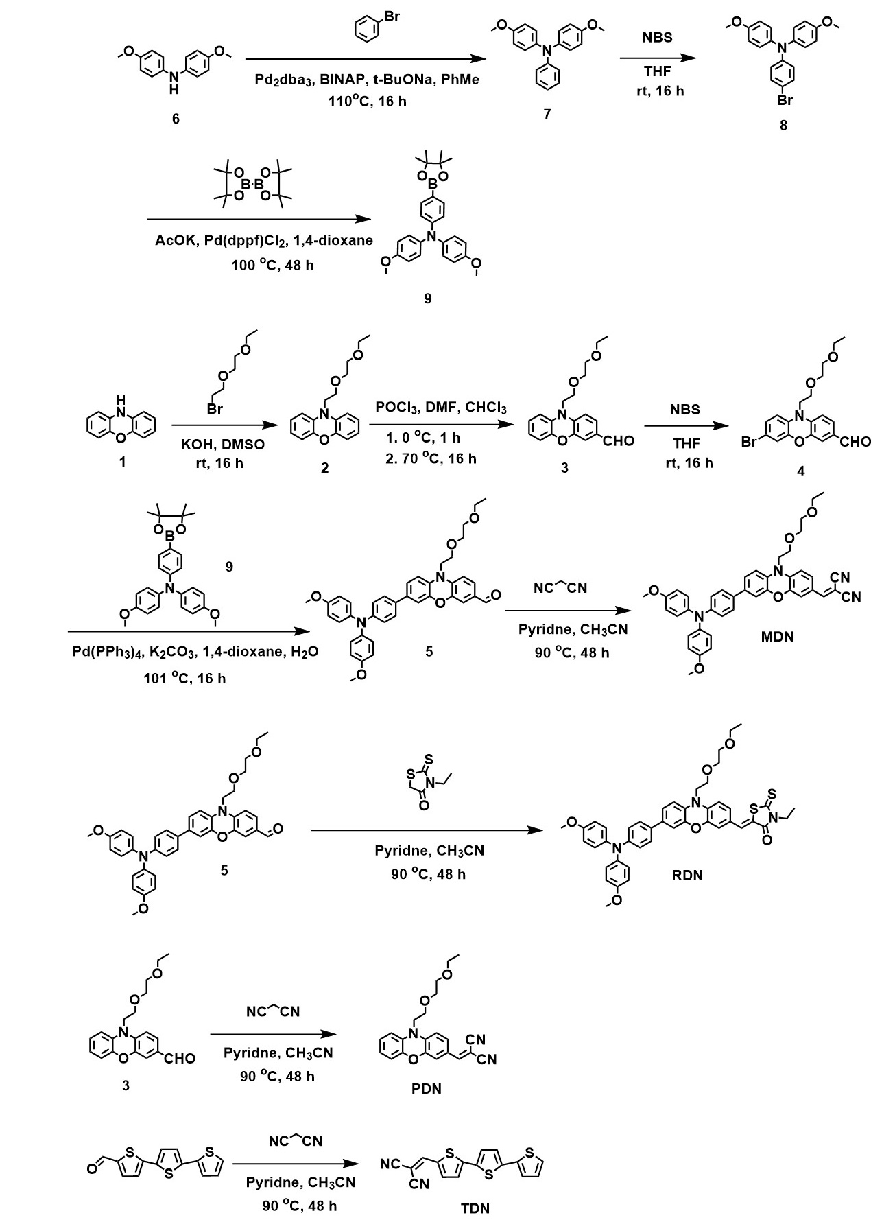
Scheme S1. Synthetic routes of MDN, RDN, PDN and TDN.

10-(2-(2-ethoxyethoxy)ethyl)-10H-phenoxazine (2):
The KOH (1.36 g, 24 mmol) was added slowly to a solution of 10H-phenoxazine (2.2 g, 12 mmol) and 1-bromo-2-(2-ethoxyethoxy)ethane (2.4 g, 12 mmol) in 30 mL tetrahydrofuran at room temperature, then the mixture was stirred for 16 hours at room temperature. The mixture was diluted with dichloromethane and washed with water. The organic layer was dried over Na2SO4 and evaporated under vacuum. The crude product was purified by column chromatography (SiO2, petroleum ether 40−60 ºC / ethyl acetate = 20/1 v/v) and to obtain compound 2 (3.1 g, 86.4 % yield) as a red oil.
¹H NMR (600 MHz, DMSO-d6): 6.83−6.80 (m, 2H), 6.75−6.74 (m, 2H), 6.67−6.63 (m, 4H), 3.76 (t, J = 6.0 Hz, 2H), 3.65 (t, J = 6.0 Hz, 2H), 3.57−3.55 (m, 2H), 3.47−3.46 (m, 2H), 3.42−3.39 (m, 2H), 1.07 (t, J = 7.2 Hz, 2H);
¹³C NMR (150 MHz, DMSO-d6):144.54, 133.58, 124.37, 121.43, 115.41, 113.00, 70.66, 69.73, 67.13, 66.10, 44.46, 15.57;
FTMS (APCI) calcd for C₁₈H₂₂NO₃ (M+H⁺): 300.1600; found: 300.1591.

10-(2-(2-ethoxyethoxy)ethyl)-10H-phenoxazine-3-carbaldehyde (3):
The POCl₃ (3.07 g, 20.1 mmol) was added slowly to a solution of compound 2 (2 g, 6.7 mmol) and anhydrous N,N-dimethylformamide (4 mL) in 20 mL anhydrous chloroform at 0~5 ºC under argon atmosphere, the mixture was stirred for 1 hours at 0~5 ºC, and then the mixture was stirred for 16 hours at 65 ºC. After the reaction completed, the mixture was quenched with sodium hydroxide solution. Then the mixture was extracted with dichloromethane for three times, and then the combined organic phase was dried over Na2SO4 and evaporated under vacuum. The crude product was purified by column chromatography (SiO2, petroleum ether 40−60 ºC / ethyl acetate = 5/1 v/v) and to obtain compound 3 (2 g, 91.3 % yield) as a yellow oil.
¹H NMR (600 MHz, DMSO-d6): 9.65 (s, 1H), 7.39 (dd, J₁ = 8.4 Hz, J₂ = 1.8 Hz, 1H), 7.00 (d, J = 1.8 Hz, 1H), 6.92 (d, J = 8.4 Hz, 2H), 6.86−6.85 (m, 2H), 6.77−6.74 (m, 1H), 6.70−6.68 (m, 1H), 3.86 (t, J = 6.0 Hz, 2H), 3.68 (t, J = 6.0 Hz, 2H), 3.57−3.55 (m, 2H), 3.46−3.44 (m, 2H), 3.41−3.37 (m, 2H), 1.05 (t, J = 7.2 Hz, 2H);
¹³C NMR (150 MHz, DMSO-d6): 190.44, 144.61, 144.21, 139.55, 131.77, 130.07, 129.02, 124.61, 123.01, 115.69, 113.97, 113.71, 112.78, 70.74, 69.71, 67.20, 66.11, 44.53, 15.56;
FTMS (APCI) calcd for C19H22NO4 (M+H⁺): 328.1549; found: 328.1528.

7-bromo-10-(2-(2-ethoxyethoxy)ethyl)-10H-phenoxazine-3-carbaldehyde (4):
The N-Bromosuccinimide (547 mg, 3.22 mmol) in tetrahydrofuran (5 mL) was added slowly to a solution of compound 3 (960 mg, 2.94 mmol) in tetrahydrofuran (5 mL) at 0~5 ºC, the mixture was stirred for 1 hours at 0~5 ºC, and then the mixture was stirred for 16 hours at room temperature. After the reaction completed, the mixture was quenched with saturated sodium bicarbonate solution. Then the mixture was extracted with dichloromethane for three times, and then the combined organic phase was dried over Na2SO4 and evaporated under vacuum. The crude product was used in next step without further purification.
¹H NMR (600 MHz, DMSO-d6): 9.65 (s, 1H), 7.40 (dd, J₁ = 8.4 Hz, J₂ = 1.8 Hz, 1H), 7.00−6.98 (m, 2H), 6.92 (d, J = 8.4 Hz, 1H), 6.86 (d, J = 2.4 Hz, 1H), 6.79 (d, J = 9.0 Hz, 1H), 3.83 (t, J = 6.0 Hz, 2H), 3.66 (t, J = 6.0 Hz, 2H), 3.55−3.54 (m, 2H), 3.45−3.43 (m, 2H), 3.39−3.36 (m, 2H), 1.04 (t, J = 7.2 Hz, 2H);
¹³C NMR (150 MHz, DMSO-d6): 190.48, 145.07, 144.21, 138.92, 131.54, 130.26, 129.13, 127.01, 118.27, 115.60, 113.96, 113.44, 113.08, 70.76, 69.71, 67.18, 66.11, 44.69, 15.54;
FTMS (APCI) calcd for C₂₆H₃₁BNO₂S₂ (M+H⁺): 464.1889; found: 464.1890.

7-(4-(bis(4-methoxyphenyl)amino)phenyl)-10-(2-(2-ethoxyethoxy)ethyl)-10H-phenoxazine-3-carbaldehyde (5):
A mixture of compound 4 (406 mg, 1.0 mmol), compound 9 (431 mg, 1.0 mmol), Pd(PPh₃)₄ (11 mg, 0.01 mmol), potassium carbonate (280 mg, 2.0 mmol) in 1,4-dioxane (5 mL) and water (1 mL) was stirred at 100 ºC under argon atmosphere for 16 hours. After the mixture was cooled to room temperature, 50 mL of water were added and water phase was extracted with dichloromethane for three times, and then the combined organic phase was dried over Na₂SO₄. After the solvent was evaporated under vacuum, the crude product was purified by column chromatography (SiO₂, petroleum ether 40−60 ºC / ethyl acetate = 5/1 v/v) to give compound 5 as a yellow solid (530 mg, 84.1 % yield).
¹H NMR (600 MHz, DMSO-d6): 9.65 (s, 1H), 7.46 (d, J = 9.0 Hz, 2H), 7.39 (dd, J₁ = 8.4 Hz, J₂ = 1.8 Hz, 1H), 7.09 (dd, J₁ = 8.4 Hz, J₂ = 1.8 Hz, 1H), 7.05−7.02 (m, 5H), 6.94−6.91 (m, 6H), 6.88 (d, J = 8.4 Hz, 1H), 6.78 (d, J = 9.0 Hz, 1H), 3.90−3.87 (m, 2H), 3.75 (s, 6H),3.70 (t, J = 6.0 Hz, 2H), 3.57−3.56 (m, 2H), 3.46−3.45 (m, 2H), 3.41−3.37 (m, 2H), 1.05 (t, J = 7.2 Hz, 2H);
¹³C NMR (150 MHz, DMSO-d6): 190.43, 156.27, 148.15, 144.54, 144.45, 140.47, 139.29, 134.74, 130.54, 130.24, 130.04, 129.08, 127.21, 126.90, 121.56, 119.92, 115.45, 114.33, 113.73, 112.82, 112.78, 70.77, 69.71, 67.26, 66.12, 55.71, 44.53, 40.53, 15.56;
FTMS (APCI) calcd for C₁₉H₂₁BrNO₄ (M+H⁺): 406.0654; found: 406.0645.

4-methoxy-N-(4-methoxyphenyl)-N-phenylaniline (7):
A mixture of bis(4-methoxyphenyl)amine (2.29 g, 10 mmol), bromobenzene (1.73 g, 11 mmol), Pd₂dba₃ (91 mg, 0.1 mmol), t-Bu₃PHBF₄ (116 mg, 0.4 mmol), sodium tert-butoxide (1.44 g, 15 mmol) in anhydrous toluene (20 mL) was stirred at 110 ºC under argon atmosphere for 16 hours. After evaporating the solvent under reduced pressure, the remaining crude product was purified by column chromatography (SiO2, petroleum ether 40−60 ºC /ethyl acetate = 25/1 v/v) to give compound 7 as a yellow oil (2.73 g, 89.5% yield).
¹H NMR (600 MHz, CDCl₃): 7.19 (t, J = 7.2 Hz, 2H), 7.08−7.05 (m, 4H), 6.96 (d, J = 7.8 Hz, 2H) , 6.89 (t, J = 7.2 Hz, 1H), 6.86−6.84 (m, 4H), 3.82 (s, 6H).

4-bromo-N,N-bis(4-methoxyphenyl)aniline (8):
The N-Bromosuccinimide (1.59 g, 8.95 mmol) in tetrahydrofuran (15 mL) was added slowly to a solution of compound 7 (2.73 mg, 8.95 mmol) in tetrahydrofuran (15 mL) at 0~5 ºC, the mixture was stirred for 1 hours at 0~5 ºC, and then the mixture was stirred for 16 hours at room temperature. After the reaction completed, the mixture was quenched with saturated sodium bicarbonate solution. Then the mixture was extracted with dichloromethane for three times, and then the combined organic phase was dried over Na2SO4 and evaporated under vacuum. The crude product was used in next step without further purification.

4-methoxy-N-(4-methoxyphenyl)-N-(4-(4,4,5,5-tetramethyl-1,3,2-dioxaborolan-2-yl)phenyl)aniline (9):
A mixture of compound 8 (3.43 g, 8.95 mmol), bis(pinacolato)diboron (2.72 g, 10.74 mmol), Pd(dppf)Cl₂ (66 mg, 0.09 mmol), Potassium Acetate (1.8 g, 17.9 mmol) in anhydrous 1,4-dioxane (30 mL) was stirred at 100 ºC under argon atmosphere for 72 hours. After evaporating the solvent under reduced pressure, the remaining crude product was purified by column chromatography (SiO₂, petroleum ether 40−60 ºC /ethyl acetate = 25/1 v/v) to give compound 9 as a yellow solid (3.63 g, 94 % yield).
¹H NMR (600 MHz, CDCl₃): 7.62 (t, J = 9.0 Hz, 2H), 7.10−7.07 (m, 4H), 6.89 (d, J = 9.0 Hz, 2H) , 6.87−6.83 (m, 4H), 3.82 (s, 6H), 1.34 (s, 12H).

2-((7-(4-(bis(4-methoxyphenyl)amino)phenyl)-10-(2-(2-ethoxyethoxy)ethyl) -10H-phenoxazin-3-yl)methylene)malononitrile (MDN):
A mixture of compound 5 (520 mg, 0.83 mmol), malononitrile (110 mg, 1.66 mmol), pyridine (200 g, 2.46 mmol) in acetonitrile (10 mL) was stirred at 90 ºC under argon atmosphere for 72 hours. After evaporating the solvent under reduced pressure, the remaining crude product was purified by column chromatography (SiO₂, petroleum ether 40−60 ºC /ethyl acetate = 2/1 v/v) to give MDN as a red solid (510 mg, 90.6 % yield) (Tg = 64 ºC, Td = 392 ºC).
¹H NMR (600 MHz, DMSO-d6): 9.65 (s, 1H), 7.46 (d, J = 9.0 Hz, 2H), 7.39 (dd, J₁ = 8.4 Hz, J₂ = 1.8 Hz, 1H), 7.09 (dd, J₁ = 8.4 Hz, J₂ = 1.8 Hz, 1H), 7.05−7.02 (m, 5H), 6.94−6.91 (m, 6H), 6.88 (d, J = 8.4 Hz, 1H), 6.78 (d, J = 9.0 Hz, 1H), 3.90−3.87 (m, 2H), 3.75 (s, 6H),3.70 (t, J = 6.0 Hz, 2H), 3.57−3.56 (m, 2H), 3.46−3.45 (m, 2H), 3.41−3.37 (m, 2H), 1.05 (t, J = 7.2 Hz, 3H);
¹³C NMR (150 MHz, DMSO-d6): 190.43, 156.27, 148.15, 144.54, 144.45, 140.47, 139.29, 134.74, 130.54, 130.24, 130.04, 129.08, 127.21, 126.90, 121.56, 119.92, 115.45, 114.33, 113.73, 112.82, 112.78, 70.77, 69.71, 67.26, 66.12, 55.71, 44.53, 40.53, 15.56;
FTMS (APCI) calcd for C₄₂H₃₉N₄O₅ (M+H⁺): 679.2920; found: 679.2924.

(Z)-5-((7-(4-(bis(4-methoxyphenyl)amino)phenyl)-10-(2-(2-ethoxyethox y)ethyl)-10H-phenoxazin-3-yl)methylene)-3-ethyl-2-thioxothiazolidin-4-one (RDN):
A mixture of compound 5 (518 mg, 0.82 mmol), 3-ethylrhodanine (264 mg, 1.64 mmol), pyridine (200 g, 2.46 mmol) in acetonitrile (10 mL) was stirred at 90 ºC under argon atmosphere for 48 hours. After evaporating the solvent under reduced pressure, the remaining crude product was purified by column chromatography (SiO₂, petroleum ether 40−60 ºC /ethyl acetate = 2/1 v/v) to give RDN as a red solid (400 mg, 63.1% yield) (Tg = 68 ºC, Td = 382 ºC).
¹H NMR (600 MHz, DMSO-d6): 7.56 (s, 1H), 7.41 (d, J = 8.4 Hz, 2H), 7.11−7.02 (m, 7H), 6.93−6.88 (m, 7H), 6.76−6.83 (m, 4H), 4.04−4.01 (m, 2H), 3.89−3.84 (m, 2H), 3.75 (s, 6H), 3.70−3.67 (m, 2H), 3.57−3.56 (m, 2H), 3.47−3.45 (m, 2H), 3.41−3.37 (m, 2H), 1.17 (t, J = 7.2 Hz, 3H), 1.04 (t, J = 7.2 Hz, 3H);
¹³C NMR (150 MHz, DMSO-d6): 171.01, 156.29, 147.67, 144.87, 144.42, 140.46, 135.45, 134.89, 132.82, 131.27, 127.24, 126.86, 121.56, 119.87, 115.46, 112.81, 70.77, 69.72, 67.32, 67.25, 66.13, 55.72, 40.52, 31.43, 22.54, 15.59, 14.44, 12.40;
FTMS (APCI) calcd for C₄₄H₄₄N₃O₆S₂ (M+H⁺): 774.2672; found: 774.2676.

2-((10-(2-(2-ethoxyethoxy)ethyl)-10H-phenoxazin-3-yl)methylene)malono-nitrile (PDN):
A mixture of compound 3 (560 mg, 1.71 mmol), malononitrile (226 mg, 3.42 mmol), pyridine (406 g, 5.14 mmol) in acetonitrile (10 mL) was stirred at 90 ºC under argon atmosphere for 48 hours. After evaporating the solvent under reduced pressure, the remaining crude product was purified by column chromatography (SiO₂, petroleum ether 40−60 ºC /ethyl acetate = 3/1 v/v) to give PDN as a blood red solid (600 mg, 93.4 % yield).
¹H NMR (600 MHz, CDCl₃-d): 7.36 (s, 1H), 7.27−7.26 (d, J = 6.0 Hz, 1H), 6.85−6.82 (t, J =9.0 Hz, 1H), 6.80−6.77 (t, J =9.0 Hz, 1H), 6.69−6.66 (m, 3H), 3.84−3.82 (t, J =6.0 Hz, 2H), 3.77−3.75 (t, J =6.0 Hz, 2H), 3.66−3.65 (m, 2H), 3.58−3.56 (m, 2H), 3.53−3.50 (m, 2H), 1.22−1.19 (t, J = 8.6 Hz, 3H);
¹³C NMR (150 MHz, CDCl₃-d): 157.04, 144.76, 144.48, 140.06, 130.85, 130.64, 124.09, 139.65, 115.96, 115.07, 113.86, 112.97, 111.75, 71.20, 69.89, 67.16, 66.81, 44.85, 29.71, 15.17;
FTMS (APCI) calcd for C₂₂H₂₁N₃O₃ (M+H⁺): 375.1583; found: 375.1687.

2-([2,2':5',2''-terthiophen]-5-ylmethylene)malononitrile (TDN):
A mixture of [2,2':5',2''-terthiophene]-5-carbaldehyde (276 mg, 1 mmol), malononitrile (132 mg, 2 mmol), pyridine (237 g, 3 mmol) in acetonitrile (15 mL) was stirred at 90 ºC under argon atmosphere for 48 hours. After evaporating the solvent under reduced pressure, the remaining crude product was purified by column chromatography (SiO₂, petroleum ether 40−60 ºC /dichloromethane = 1/1 v/v) to give TDN as a dark red solid (280 mg, 86.4 % yield).
¹H NMR (600 MHz, CDCl₃-d): 7.76 (s, 1H), 7.64−7.63 (d, J = 6.8 Hz, 1H), 7.36−7.35 (d, J = 6.0 Hz, 1H), 7.631−7.30 (d, J = 6.0 Hz, 1H), 7.26−7.25 (d, J = 6.2 Hz, 2H), 7.17−7.16 (d, J = 5.8 Hz, 1H), 7.07−7.06 (d, J =6.9 Hz, 1H);
¹³C NMR (150 MHz, CDCl₃-d): 150.05, 149.08, 140.65, 140.19, 136.16, 133.53, 133.42, 128.25, 128.21, 125.95, 124.99, 124.95, 124.37, 114.29, 113.49, 76.04;
FTMS (APCI) calcd for C₄₂H₃₉N₄O₅ (M+H⁺): 323.985; found: 323.9945.

6. Optical and electrochemical properties
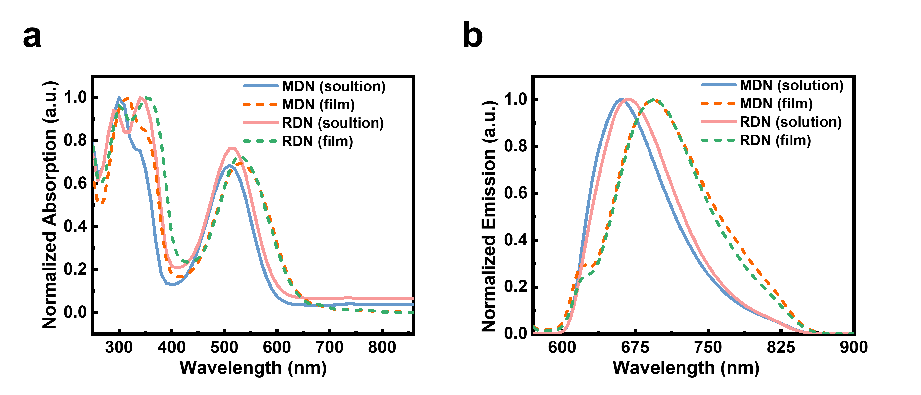
Fig. S1. (a) UV–vis absorption spectra and (b) photoluminescence spectra of materials in THF solution and as thin films.

Fig. S2. CV curves of MDN and RDN.

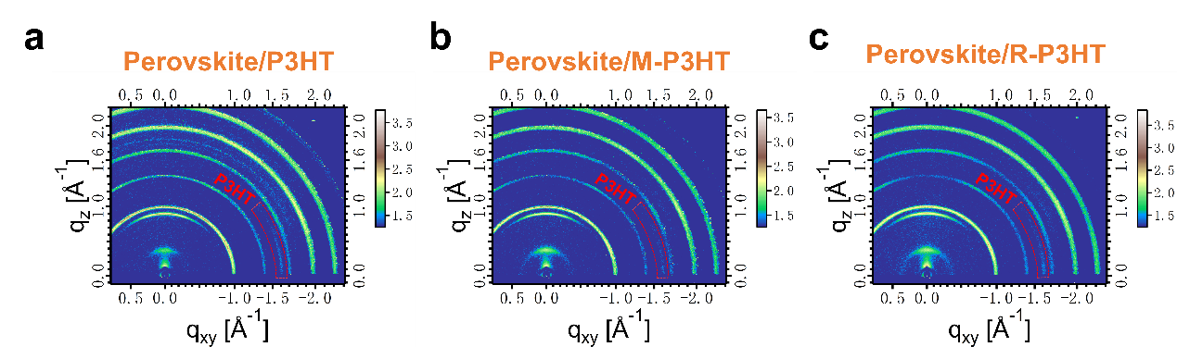
Fig. S3. 2D GIWAXS patterns based on the structures of Si-wafers/perovskite/HTMs.

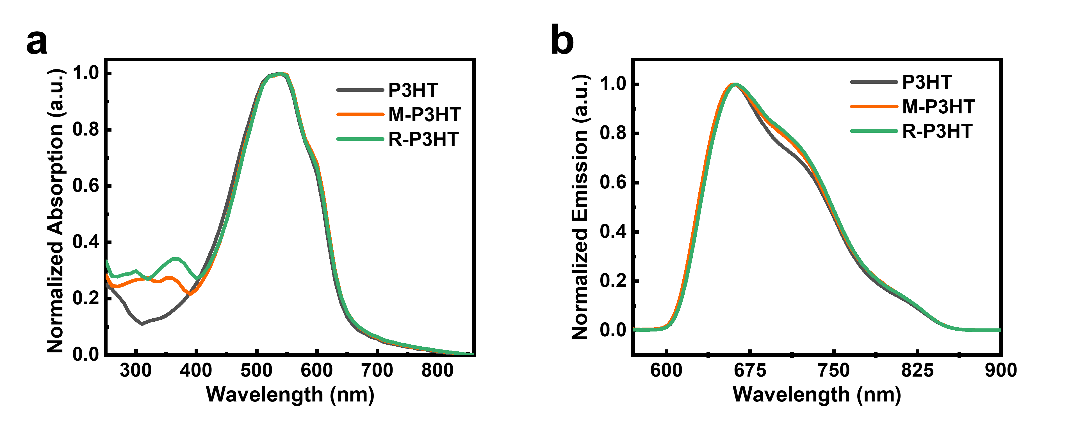
Fig. S4. (a) UV–vis absorption spectra and (b) photoluminescence spectra of P3HT, M-P3HT and R-P3HT films.

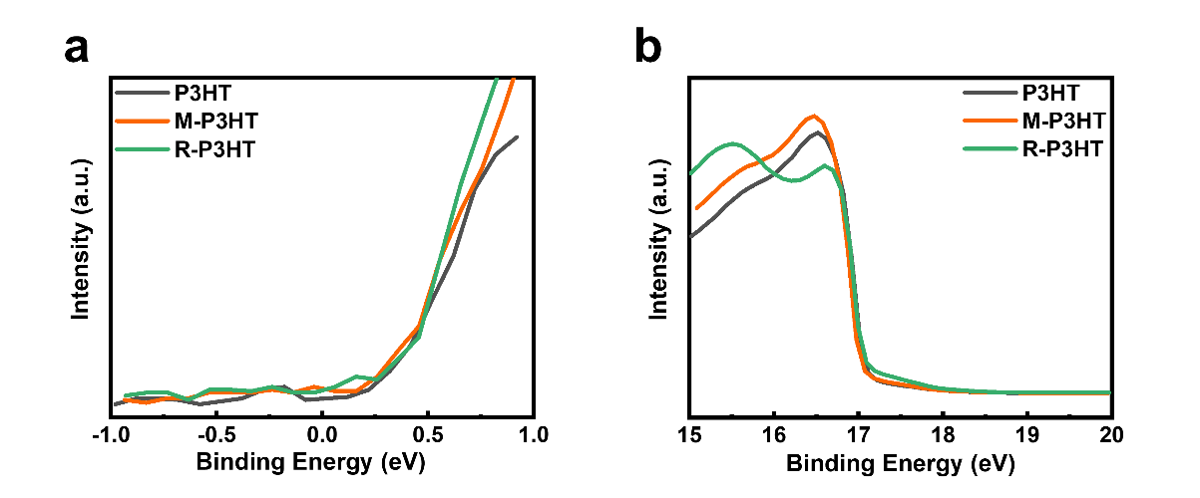
Fig. S5. (a) HOMO region and (b) cut-off energy region of UPS.

Table S1. Optical and electrochemical properties.
Sample | λ_{max} (nm) |  | λ_{em} (nm) |  | E_{g} (eV) | E_{HOMO} (eV) | E_{LUMO} (eV)
MDN | 509^{s} | 532^{f} | 661^{s} | 694^{f} | 2.03 | -5.31 | -3.28
RDN | 514^{s} | 532^{f} | 667^{s} | 694^{f} | 2.03 | -5.26 | -3.24
P3HT | 538 |  | 660 |  | 1.93 | -4.58 | -2.65
M-P3HT | 538 |  | 660 |  | 1.93 | -4.65 | -2.72
R-P3HT | 538 |  | 661 |  | 1.93 | -4.61 | -2.68
^{s}Results from absorption in THF solution. ^{f}Results from absorption of films.

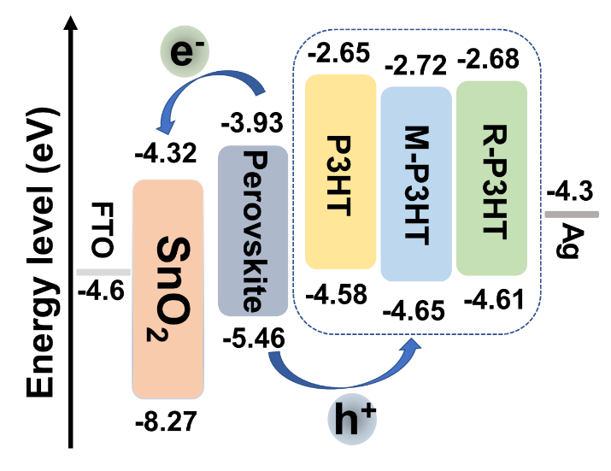
Fig. S6. Band-edges of the stacked films in the device.

Fig. S7. Conductivity of P3HT, M-P3HT and R-P3HT films.

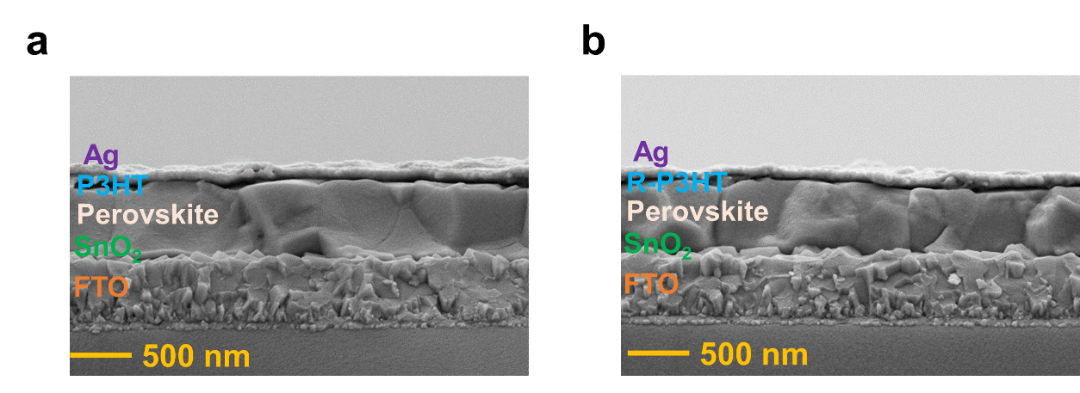
Fig. S8. Cross-sectional SEM images of PSCs with (a) P3HT, and (b) R-P3HT.

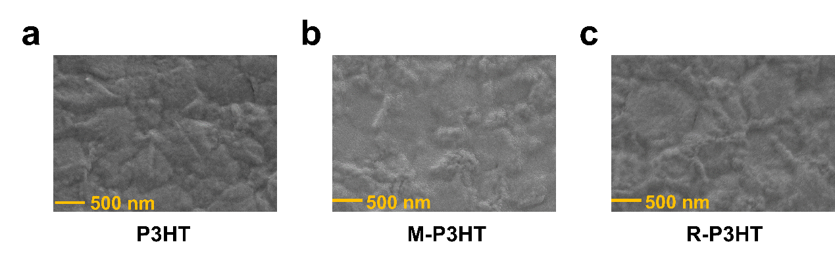
Fig. S9. The top view SEM images of PSCs with (a) P3HT, (b) M-P3HT, and (c) R-P3HT.

Table S2. Photovoltaic parameters of champion devices based on different HTMs measured under AM 1.5G Illumination.
Device | V_{OC}  (V) |  | J_{SC}  (mA·cm⁻²) | FF  (%) | PCE (%)
P3HT-REV^{a)} | 0.92 | 23.21 |  | 58.73 | 12.48
P3HT-FOR^{b)} | 0.82 | 23.04 |  | 36.75 | 6.98
M-P3HT-REV | 1.16 | 24.72 |  | 80.24 | 22.87
M-P3HT-FOR | 1.16 | 24.44 |  | 78.61 | 22.28
R-P3HT-REV | 1.05 | 23.90 |  | 66.54 | 16.66
R-P3HT-FOR | 1.00 | 23.90 |  | 58.19 | 13.87
^{a)} Reverse scan; ^{b)} Forward scan.

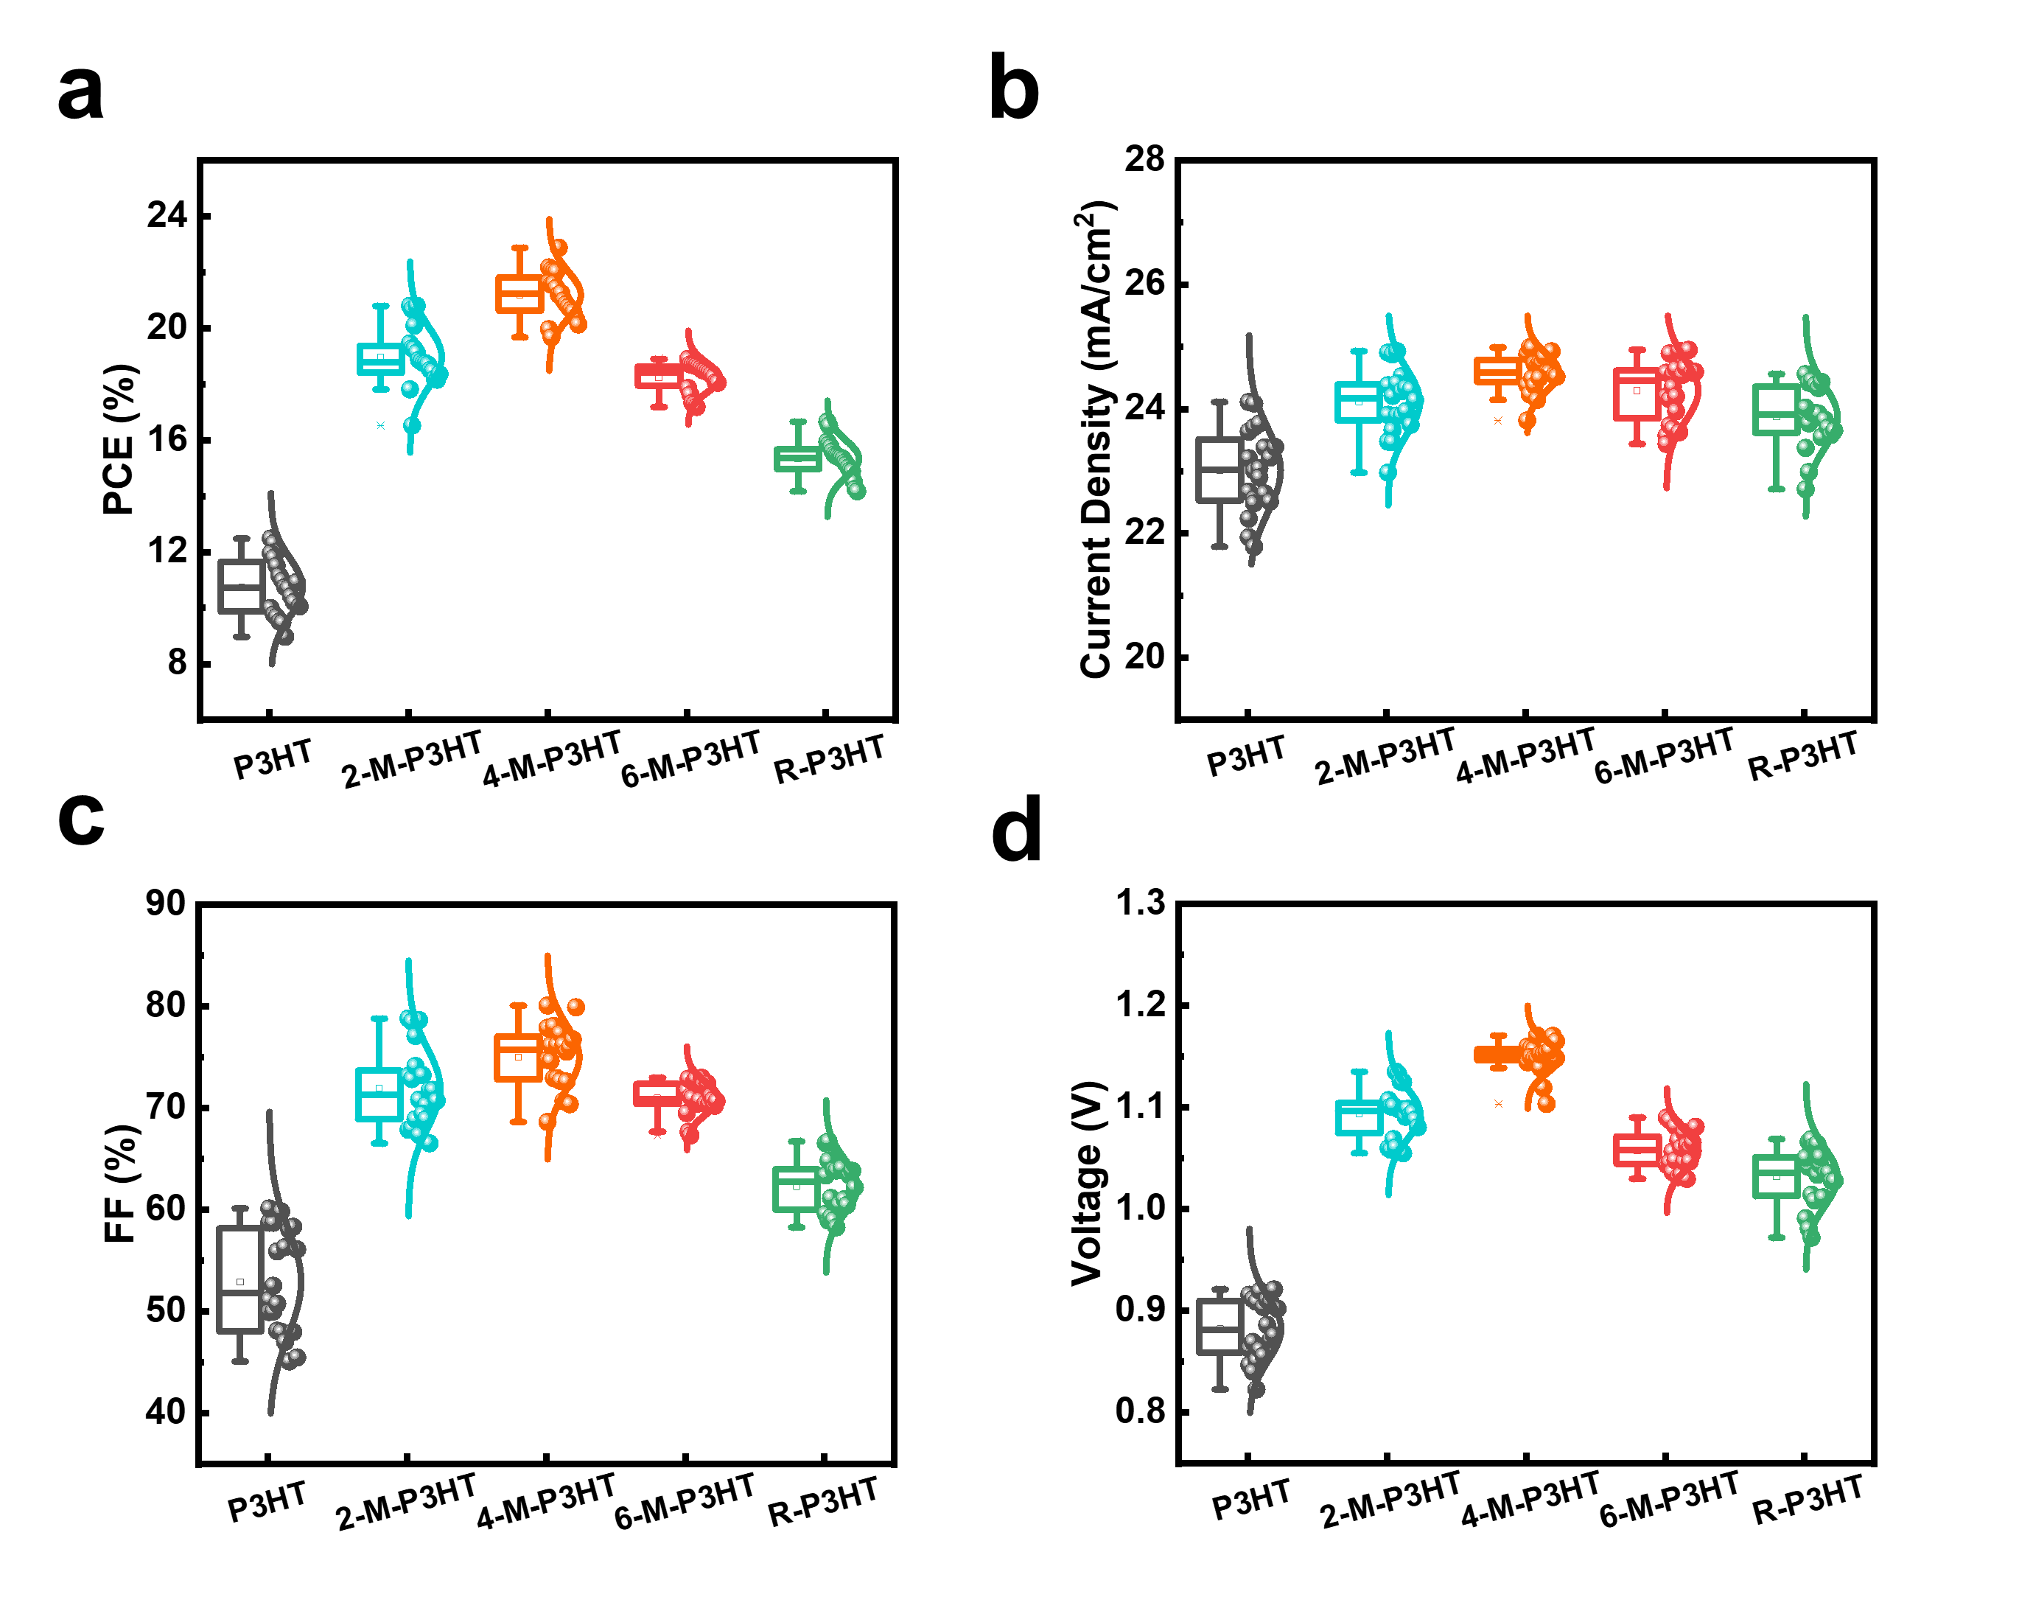
Fig. S10. The statistical distributions of 20 devices with different concentration of MDN and RDN of (a) PCE, (b) J_{SC}, (c) FF, and (d) V_{OC}.

Table S3. Comparison of the device performance obtained with different HTM. The average values and standard deviations are calculated from 20 devices fabricated at the same conditions.
Device | V_{OC}  (V) | J_{SC}  (mA·cm⁻²) | FF  (%) | PCE  (%)
P3HT | 0.88 ± 0.03 | 23.01 ± 0.67 | 52.91 ± 5.14 | 10.73 ± 1.03
2-M-P3HT | 1.09 ± 0.02 | 24.12 ± 0.51 | 71.94 ± 3.85 | 18.96 ± 1.05
4-M-P3HT | 1.15 ± 0.02 | 24.55 ± 0.32 | 75.02 ± 3.09 | 21.19 ± 0.83
6-M-P3HT | 1.06 ± 0.02 | 24.29 ± 0.48 | 70.96 ± 1.57 | 18.23 ± 0.52
R-P3HT | 1.03 ± 0.03 | 23.87 ± 0.49 | 62.30 ± 2.60 | 15.33 ± 0.64

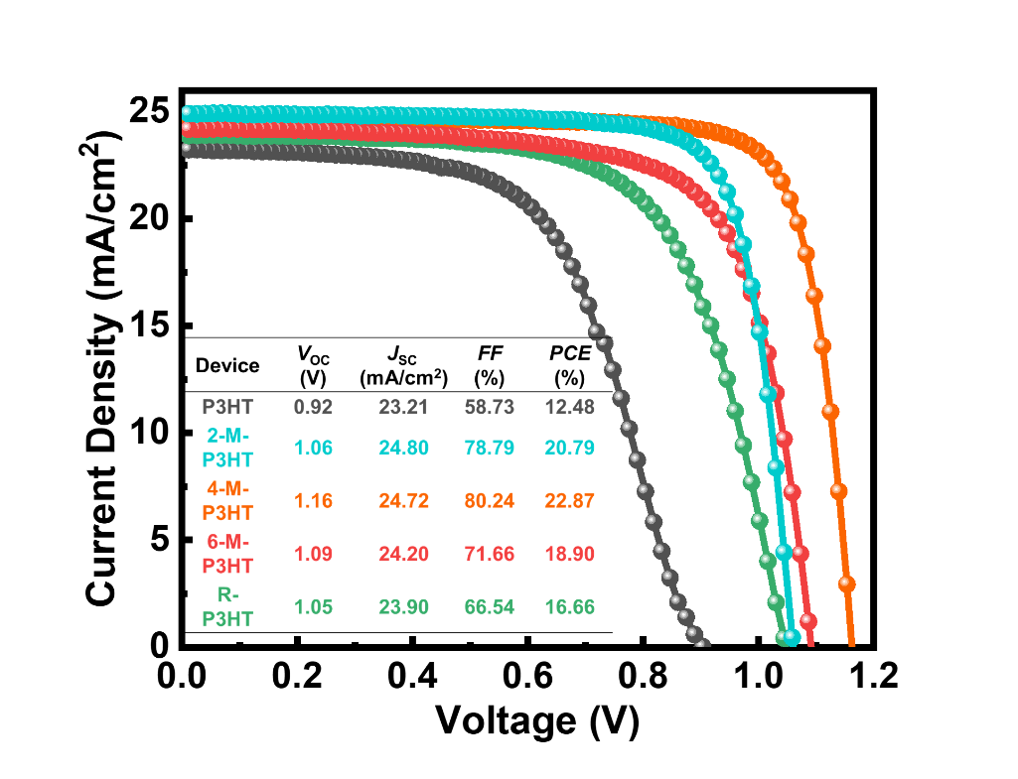
Fig. S11. J–V characteristics of the best-performing.

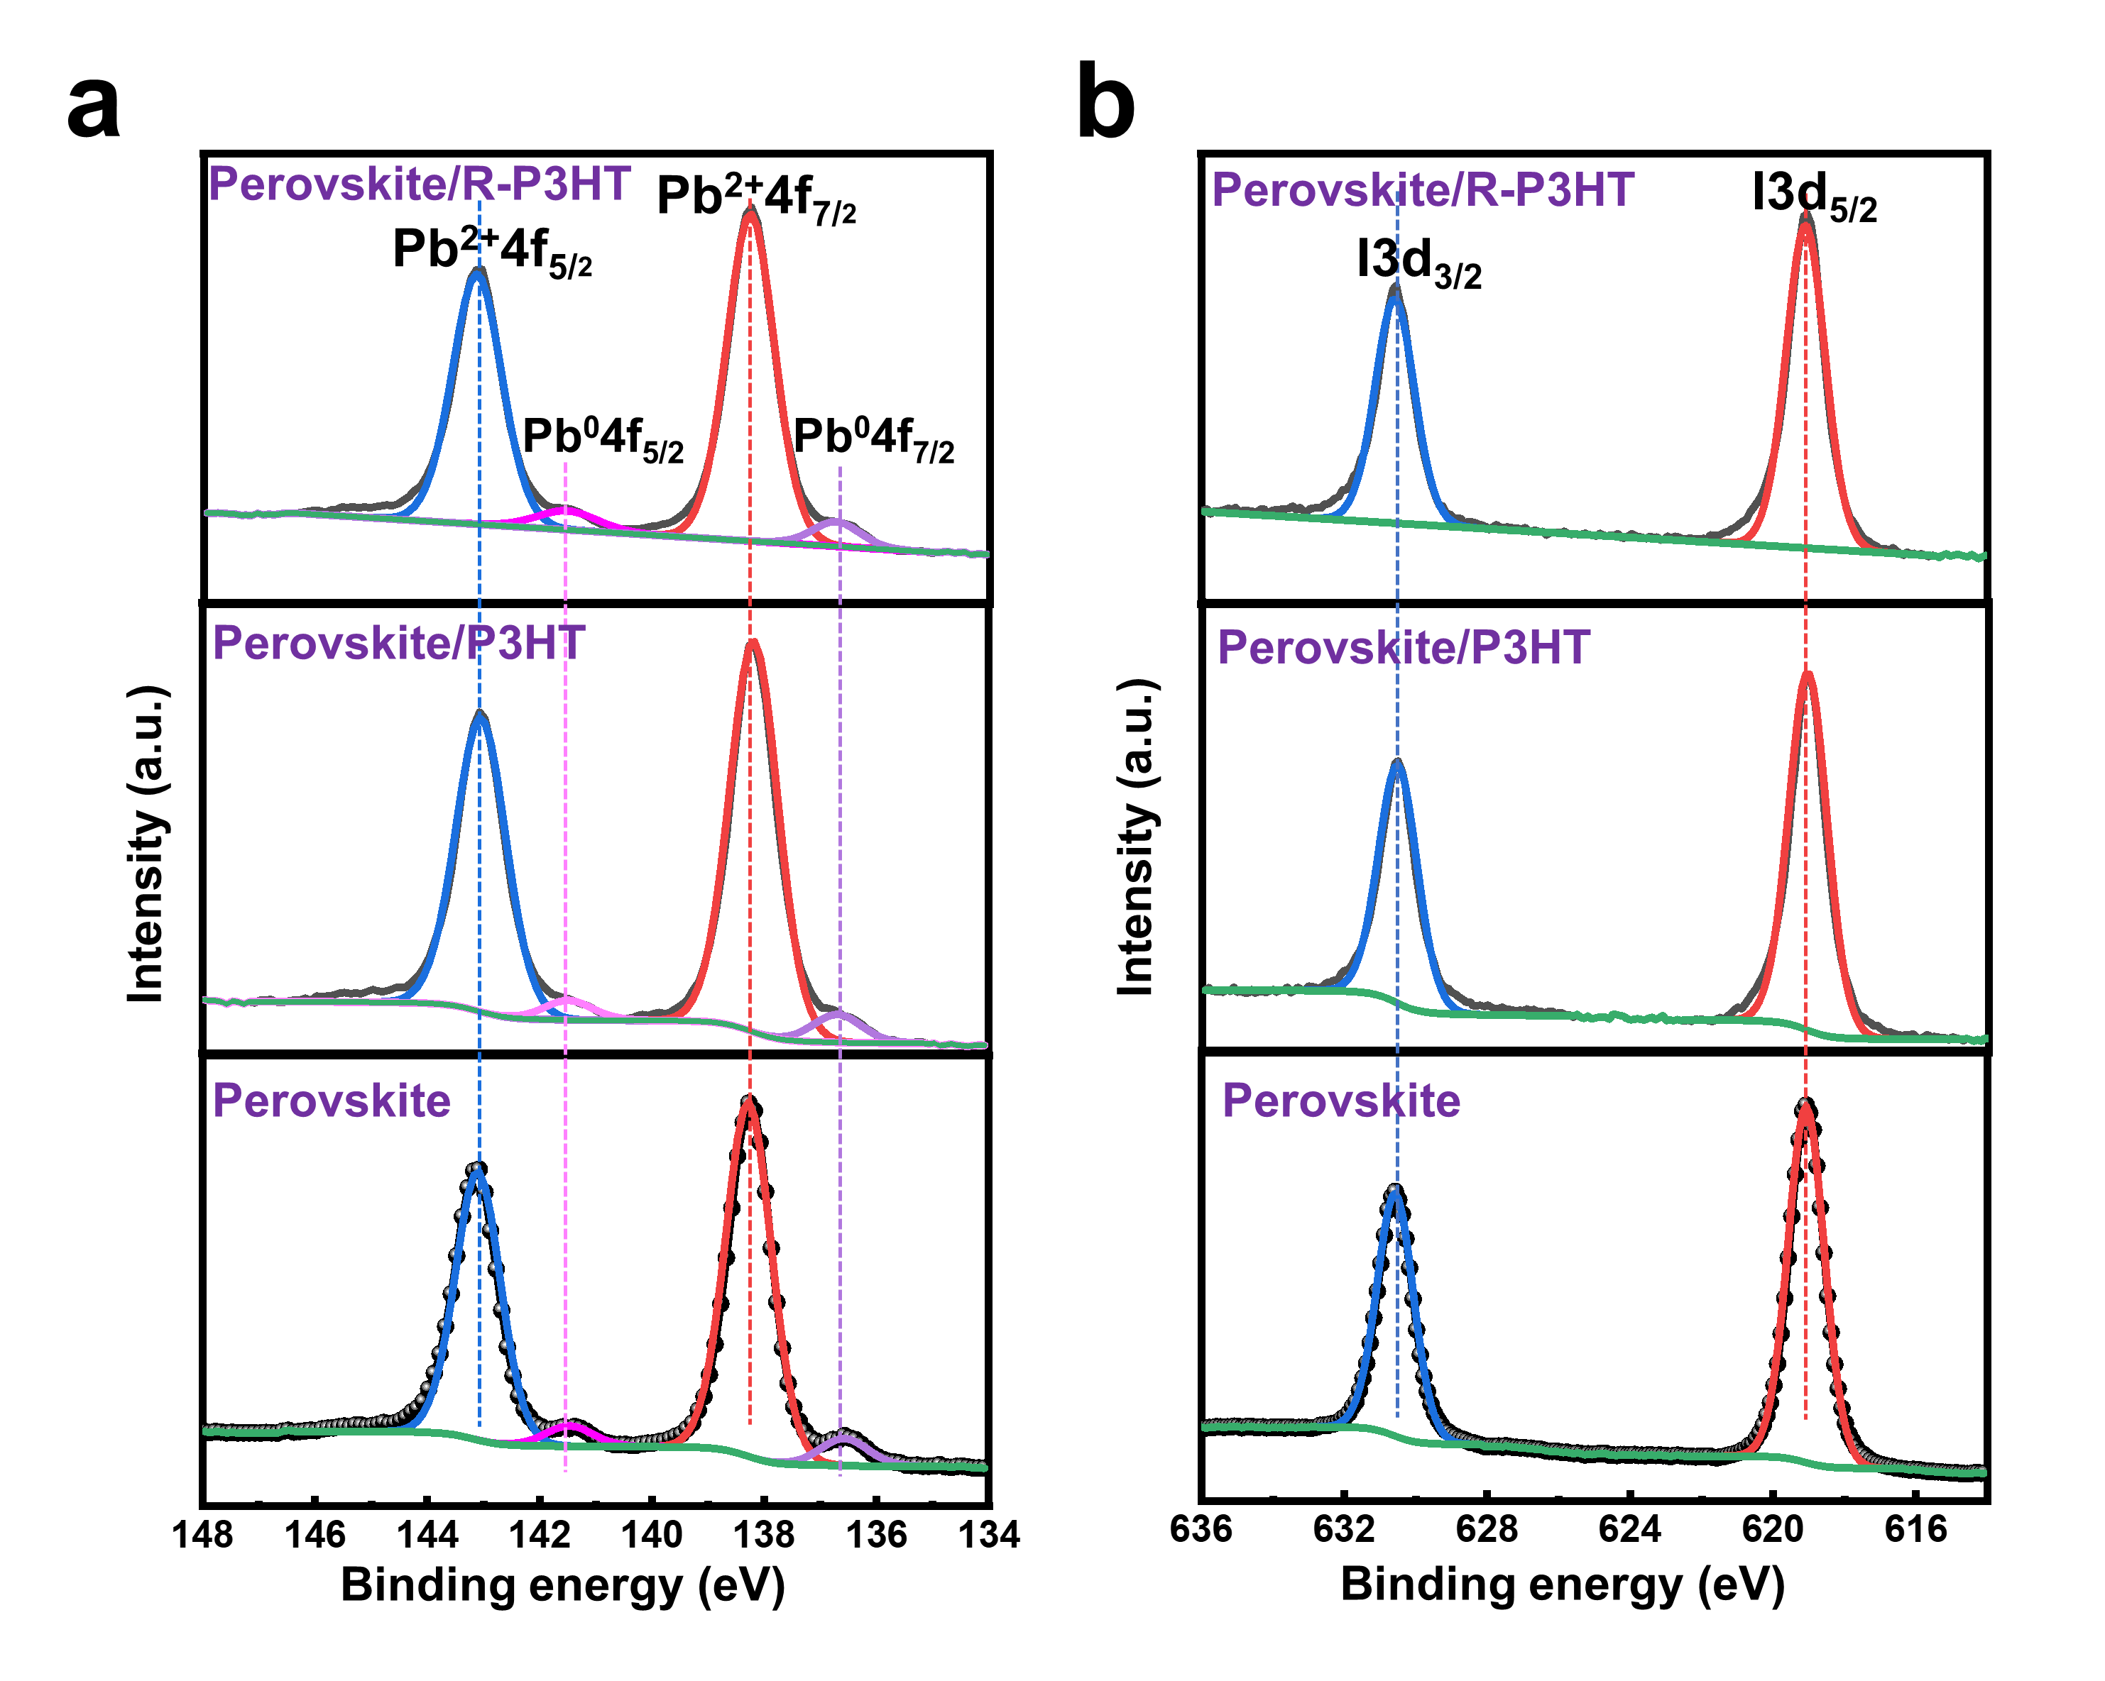
Fig. S12. High-resolution XPS spectra of (a) Pb 4f spectra, and (b) I 3d spectra.

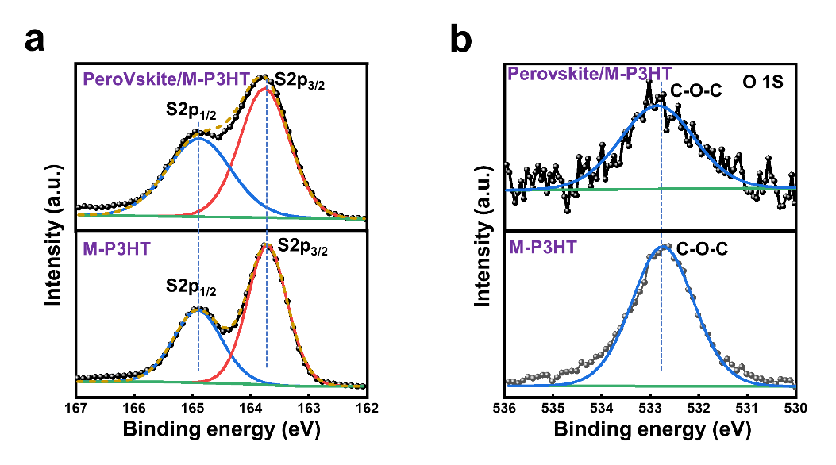
Fig. S13. High-resolution XPS spectra of (a) S 2p spectra, and (b) O 1S spectra.

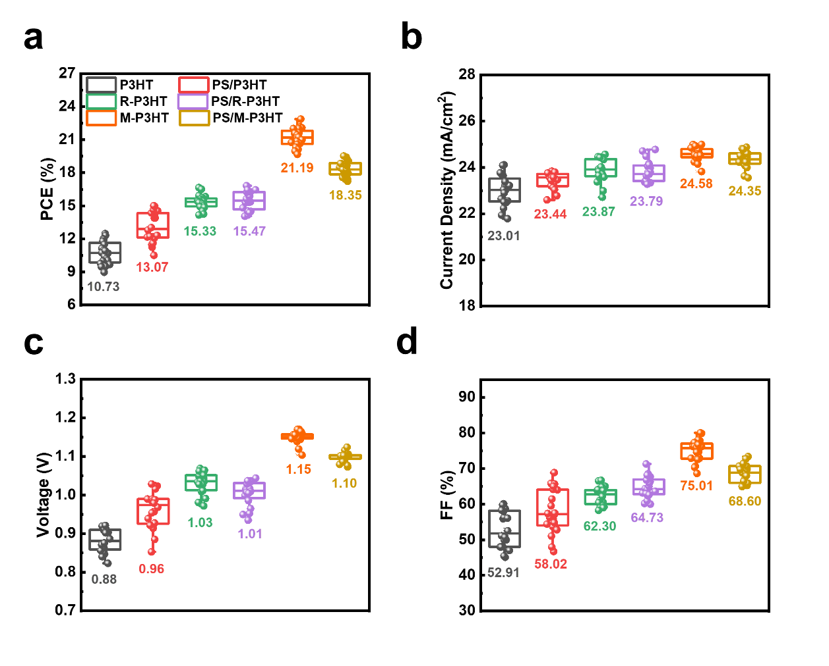
Fig. S14. The statistical distributions of 20 devices w/ or w/o PS interface of (a) PCE, (b) J_{SC}, (c) V_{OC}, and (d) FF.

Table S4. Comparison of the device performance obtained w/ or w/o PS. The average values and standard deviations are calculated from 20 devices fabricated at the same conditions.
Device | V_{OC}  (V) | J_{SC}  (mA·cm⁻²) | FF  (%) | PCE  (%)
P3HT | 0.88 ± 0.03 | 23.01 ± 0.67 | 52.91 ± 5.14 | 10.73 ± 1.03
PS/P3HT | 0.96 ± 0.05 | 23.44 ± 0.35 | 58.02 ± 6.19 | 13.07 ± 1.36
M-P3HT | 1.15 ± 0.02 | 24.55 ± 0.32 | 75.02 ± 3.09 | 21.19 ± 0.83
PS/M-P3HT | 1.10 ± 0.01 | 24.34 ± 0.37 | 68.60 ± 2.65 | 18.35 ± 0.69
R-P3HT | 1.03 ± 0.03 | 23.87 ± 0.49 | 62.30 ± 2.60 | 15.33 ± 0.64
PS/R-P3HT | 1.01 ± 0.03 | 23.79 ± 0.47 | 64.73 ± 2.98 | 15.47 ± 0.83

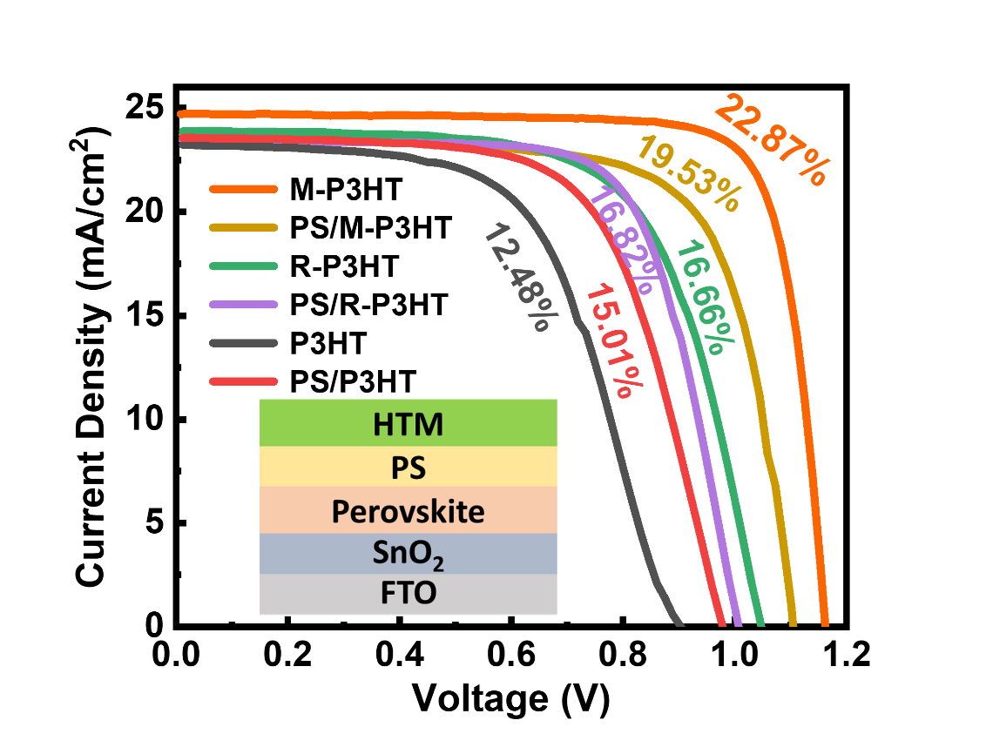
Fig. S15. The J–V curves of the champion devices based on the w/ or w/o PS interface.

Table S5. Performances of the champion devices based on the w/ or w/o PS interface.
Device | V_{OC}  (V) | J_{SC} (mA·cm⁻²) | FF  (%) | PCE (%)
P3HT | 0.92 | 23.21 | 58.73 | 12.48
PS/P3HT | 0.98 | 23.57 | 65.03 | 15.01
M-P3HT | 1.16 | 24.72 | 80.24 | 22.87
PS/M-P3HT | 1.10 | 24.79 | 71.43 | 19.53
R-P3HT | 1.05 | 23.90 | 66.54 | 16.66
PS/R-P3HT | 1.01 | 23.42 | 71.31 | 16.82

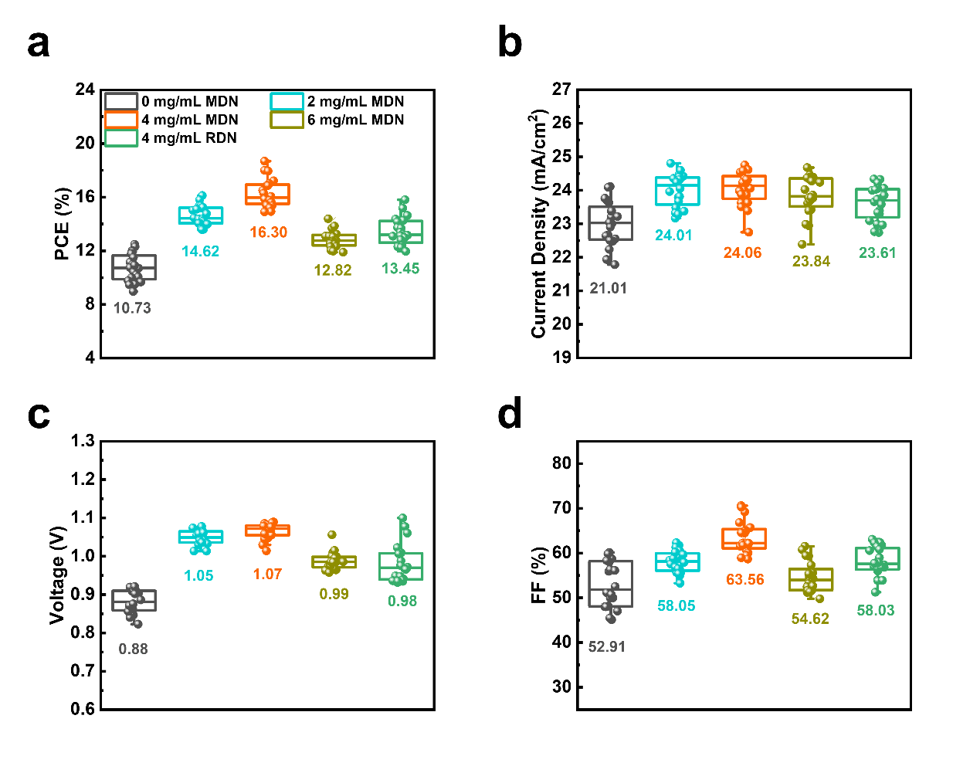
Fig. S16. The statistical distributions of 20 devices with different concentration of MDN and RDN interface of (a) PCE, (b) J_{SC}, (c) V_{OC}, and (d) FF.

Table S6. Comparison of the device performance obtained with different concentration of MDN and RDN interface. The average values and standard deviations are calculated from 20 devices fabricated at the same conditions.
Device | V_{OC}  (V) | J_{SC}  (mA·cm⁻²) | FF  (%) | PCE  (%)
P3HT | 0.88 ± 0.03 | 23.01 ± 0.67 | 52.91 ± 5.14 | 10.73 ± 1.03
2mg/ml MDN | 1.05 ± 0.02 | 24.01 ± 0.49 | 58.05 ± 2.48 | 14.62 ± 0.74
4mg/ml MDN | 1.07 ± 0.02 | 24.06 ± 0.50 | 63.56 ± 3.60 | 16.30 ± 1.06
6mg/ml RDN | 0.99 ± 0.02 | 23.84 ± 0.60 | 54.62 ± 3.43 | 12.85 ± 0.65
4mg/ml RDN | 0.98 ± 0.05 | 23.61 ± 0.51 | 58.03 ± 3.33 | 13.45 ± 1.04

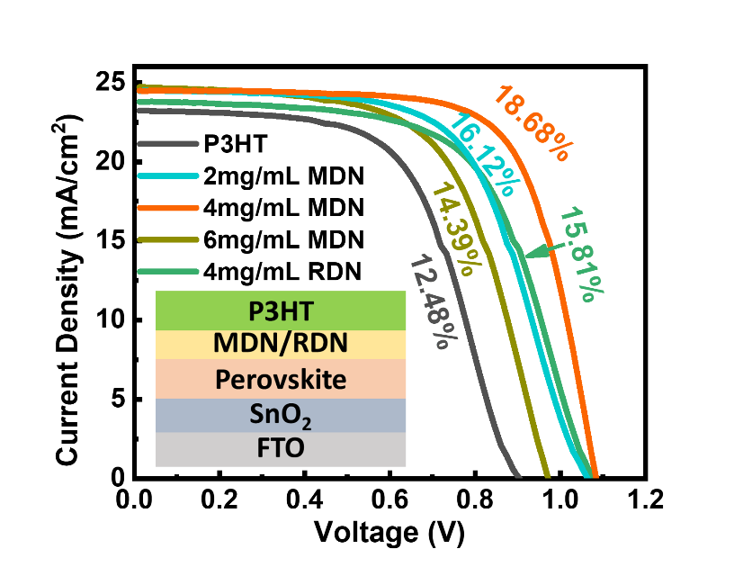
Fig. S17. The J–V curves of the champion devices based on the different concentration of MDN and RDN interface.

Table S7. Performances of the champion devices based on the different concentration of MDN and RDN interface.
Device | V_{OC}  (V) | J_{SC} (mA·cm⁻²) | FF  (%) | PCE (%)
P3HT | 0.92 | 23.21 | 58.73 | 12.48
2mg/ml MDN | 1.07 | 24.46 | 61.74 | 16.12
4mg/ml MDN | 1.09 | 24.49 | 70.27 | 18.68
6mg/ml MDN | 0.97 | 24.02 | 61.51 | 14.39
4mg/ml RDN | 1.08 | 23.77 | 61.71 | 15.81

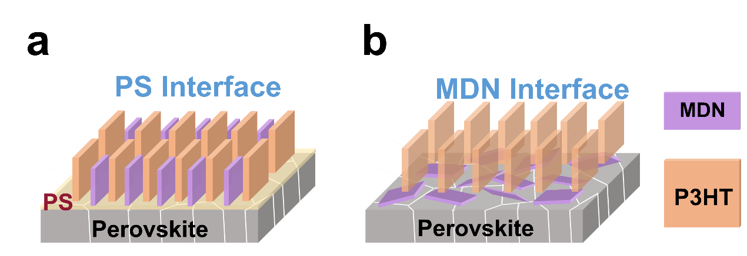
Fig. S18. Schematic diagram of the molecular stacking with (a) PS interface and (b) MDN interface.

Fig. S19. Snapshot of PVK/MDN.

Fig. S20. Snapshot of PVK-V_{I}/MDN.

Fig. S21. Snapshot of PVK/RDN.

Fig. S22. Snapshot of PVK-V_{I}/RDN.

Fig. S23. LOL-π maps of MDN and RDN at different isosurface values. The π orbitals are displayed in green.

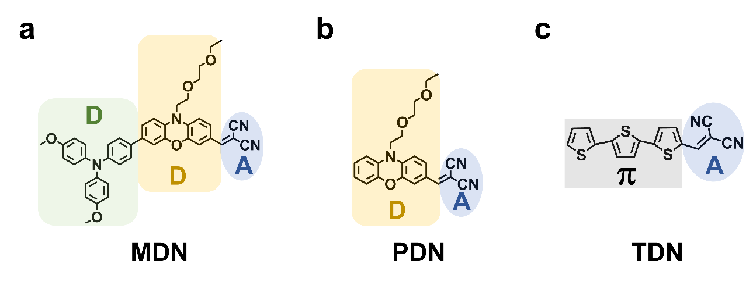
Fig. S24. Molecular structure of MDN, PDN and TDN.

Fig. S25. The J–V curves of the champion devices based on the different HTMs.

Table S8. Photovoltaic parameters of champion devices based on different HTMs measured under AM 1.5G Illumination.
Device | V_{OC}  (V) | J_{SC} (mA·cm⁻²) | FF  (%) | PCE (%)
P3HT | 1.02 | 23.07 | 56.41 | 13.29
2-P-P3HT | 1.11 | 23.39 | 66.04 | 17.22
4-P-P3HT | 1.13 | 23.84 | 76.10 | 20.47
6-P-P3HT | 1.12 | 22.49 | 63.39 | 16.01
1-T-P3HT | 1.11 | 23.92 | 70.82 | 18.73
2-T-P3HT | 1.11 | 24.47 | 71.68 | 19.53
3-T-P3HT | 1.11 | 23.08 | 62.62 | 16.09

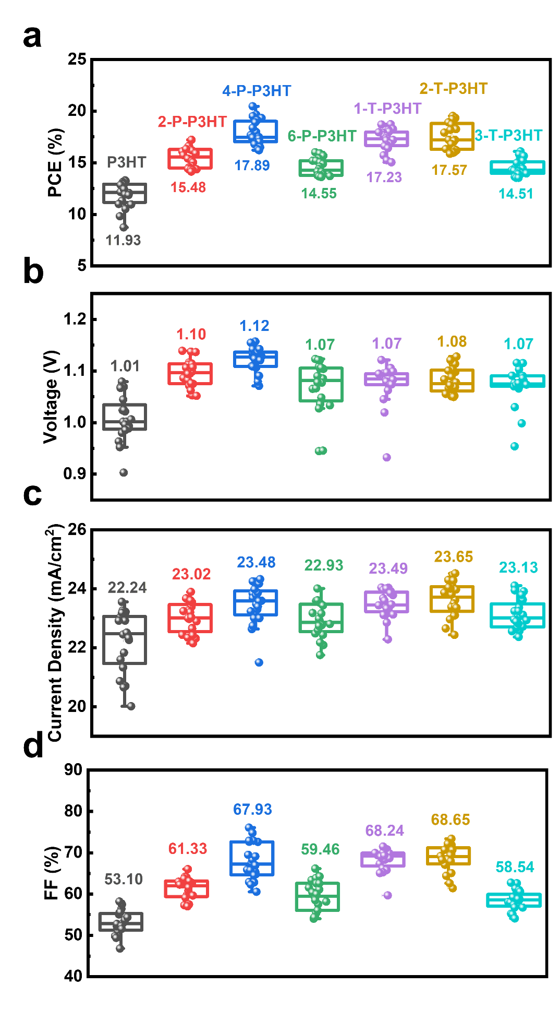
Fig. S26. The statistical distributions of 20 devices with different HTMs of (a) PCE, (b) V_{OC}, (c) J_{SC}, (d) FF.

Table S9. Comparison of the device performance obtained with different HTMs. The average values and standard deviations are calculated from 20 devices fabricated at the same conditions.
Device | V_{OC}  (V) | J_{SC} (mA·cm⁻²) | FF  (%) | PCE (%)
P3HT | 1.01 ± 0.04 | 22.24 ± 1.04 | 53.10 ± 2.90 | 11.93 ± 1.22
2-P-P3HT | 1.10 ± 0.03 | 23.02 ± 0.52 | 61.33 ± 2.66 | 15.48 ± 0.96
4-P-P3HT | 1.12 ± 0.02 | 23.48 ± 0.68 | 67.93 ± 4.51 | 17.89 ± 1.23
6-P-P3HT | 1.07 ± 0.05 | 22.93 ± 0.58 | 59.46 ± 3.70 | 14.55 ± 0.81
1-T-P3HT | 1.07 ± 0.04 | 23.49 ± 0.45 | 68.24 ± 2.74 | 17.23 ± 1.05
2-T-P3HT | 1.08 ± 0.03 | 23.65 ± 0.59 | 68.65 ± 3.27 | 17.57 ± 1.28
3-T-P3HT | 1.07 ± 0.04 | 23.13 ± 0.51 | 58.54 ± 2.36 | 14.51 ± 0.79

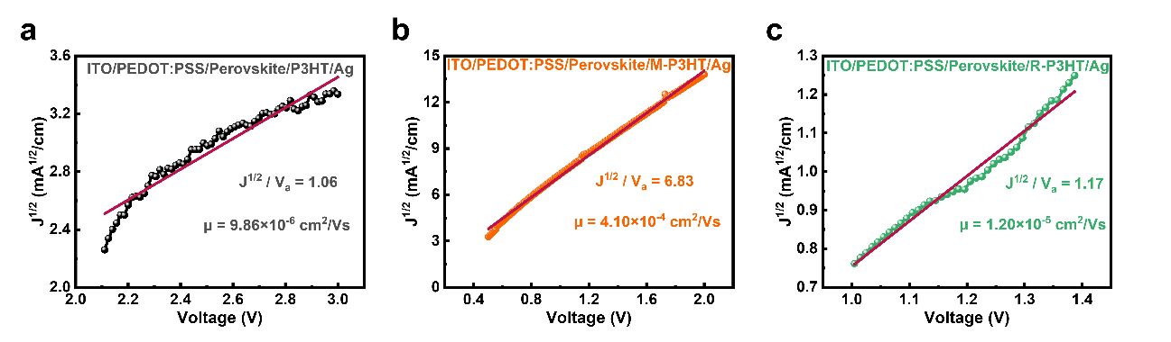
Fig. S27. Hole mobility measurement characteristics by the space charge limited current (SCLC) method.

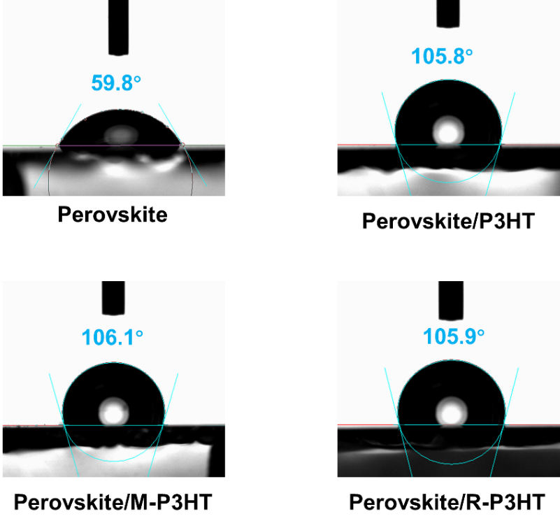
Fig. S28. The water contact angle of perovskite with or without different HTMs.

7. ¹H NMR, ¹³C NMR and MS spectra
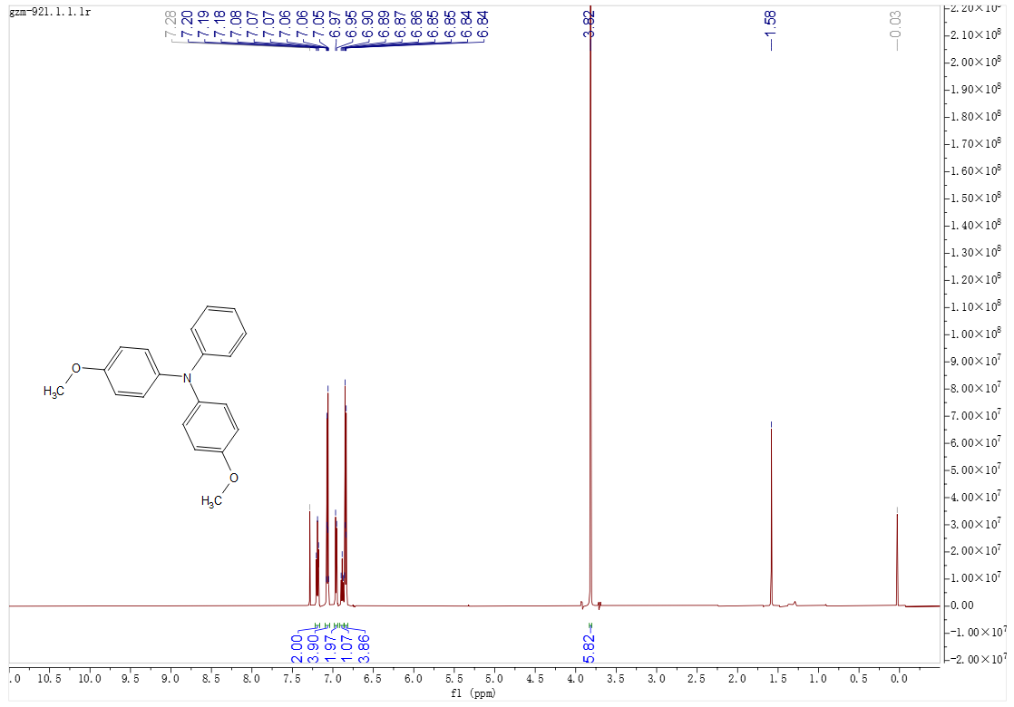
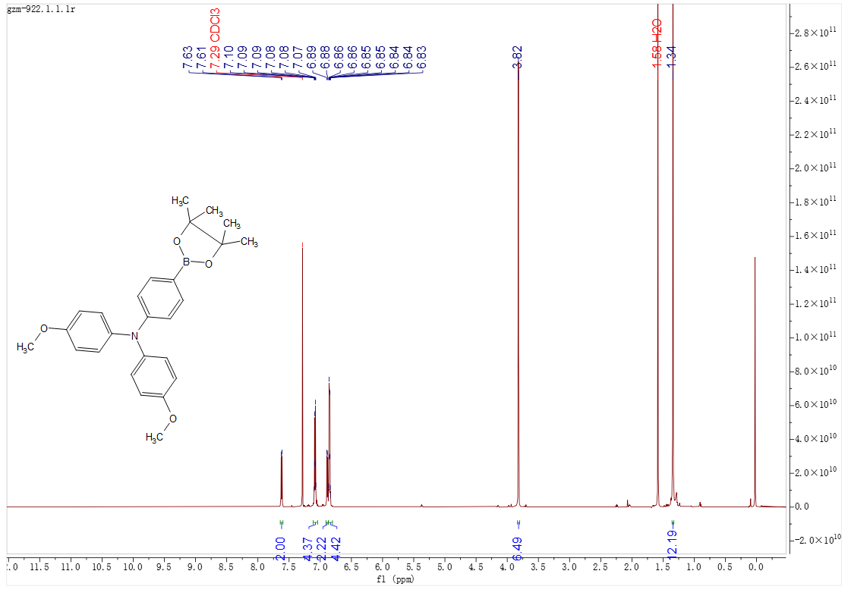
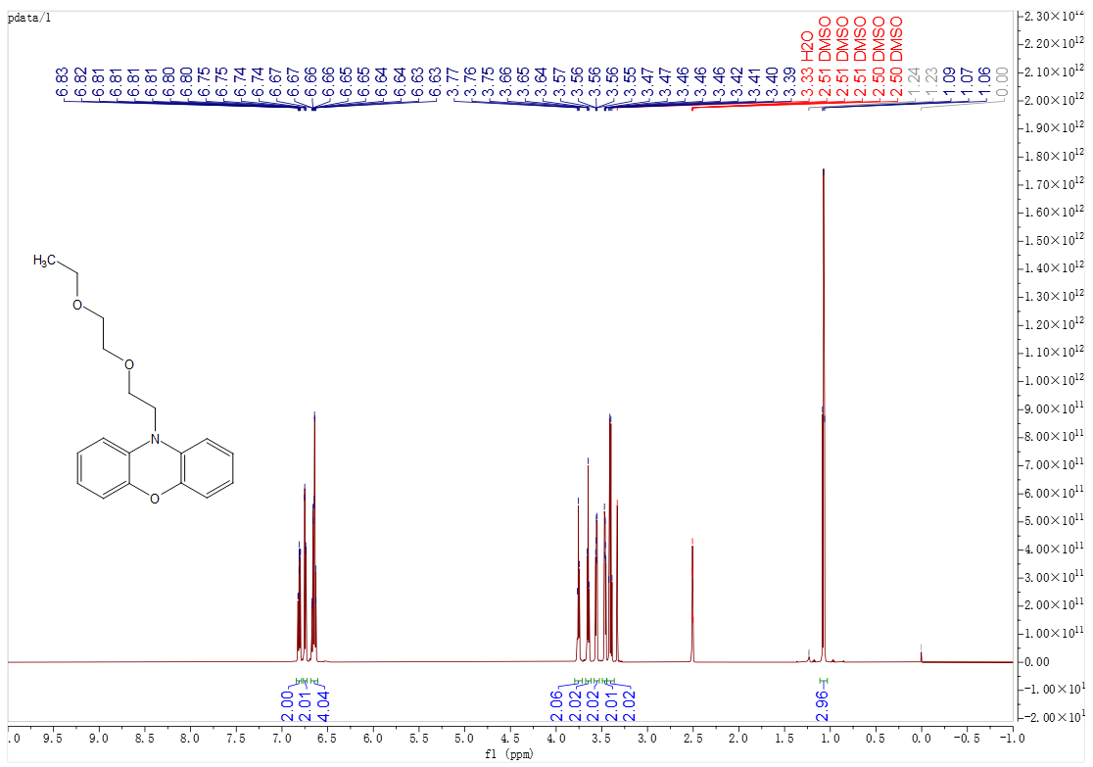
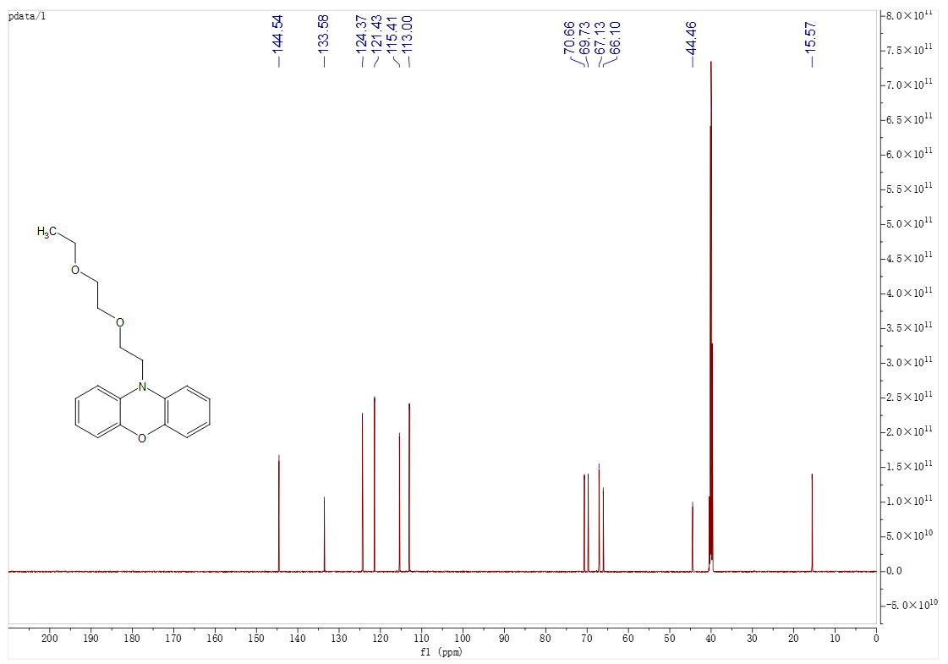
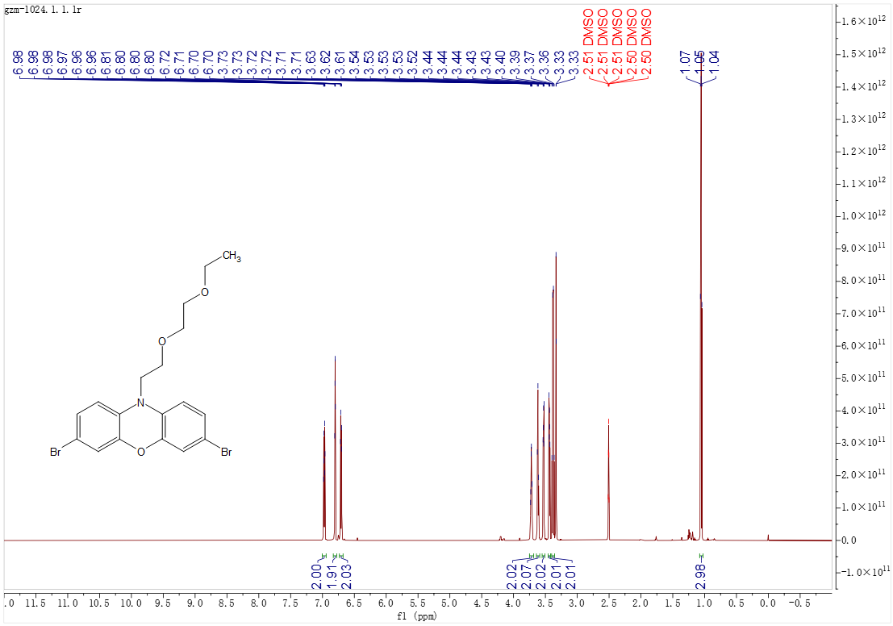
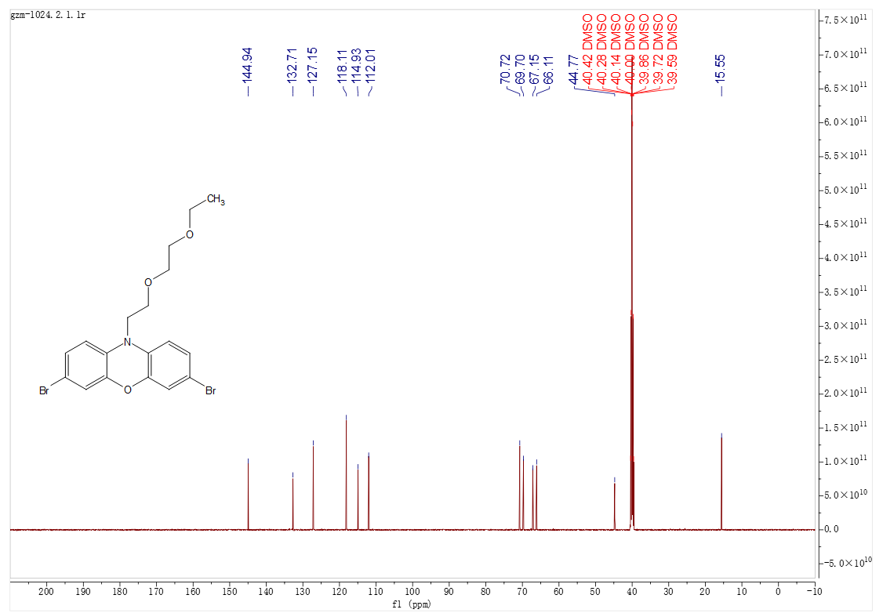
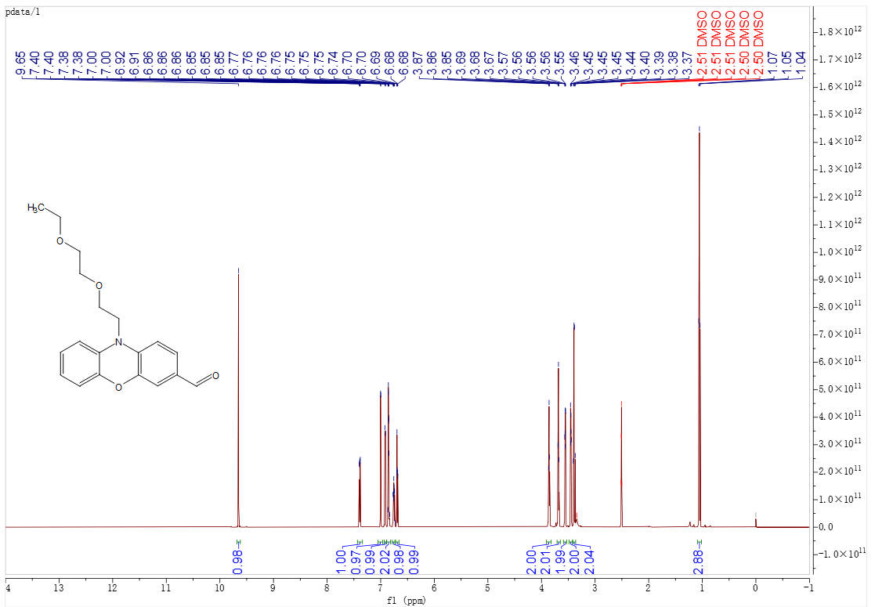
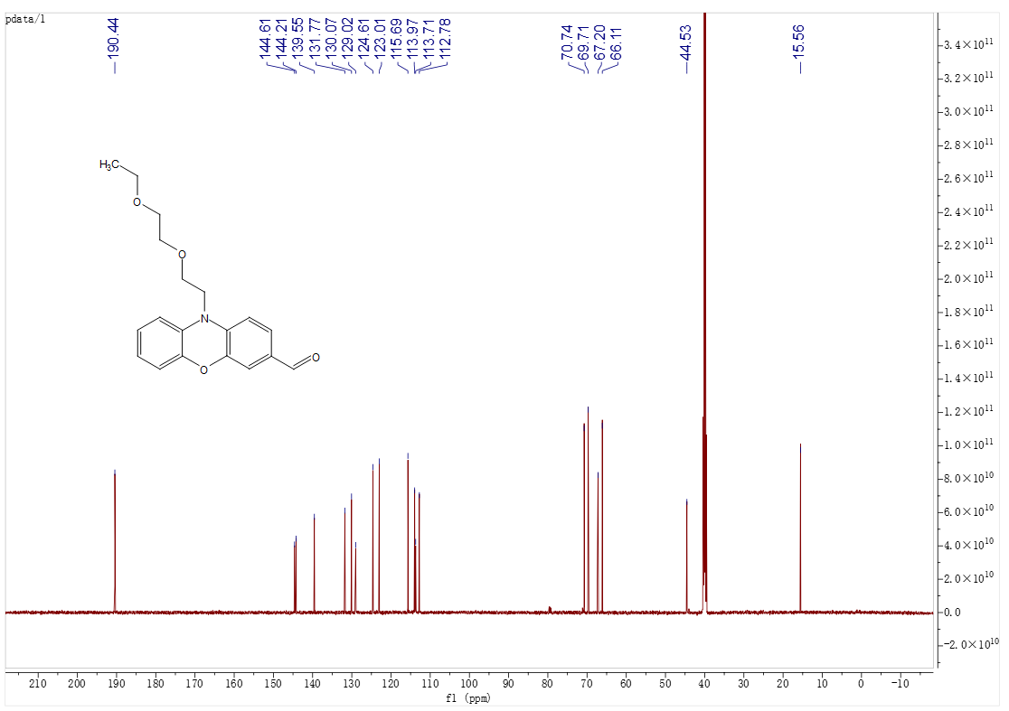
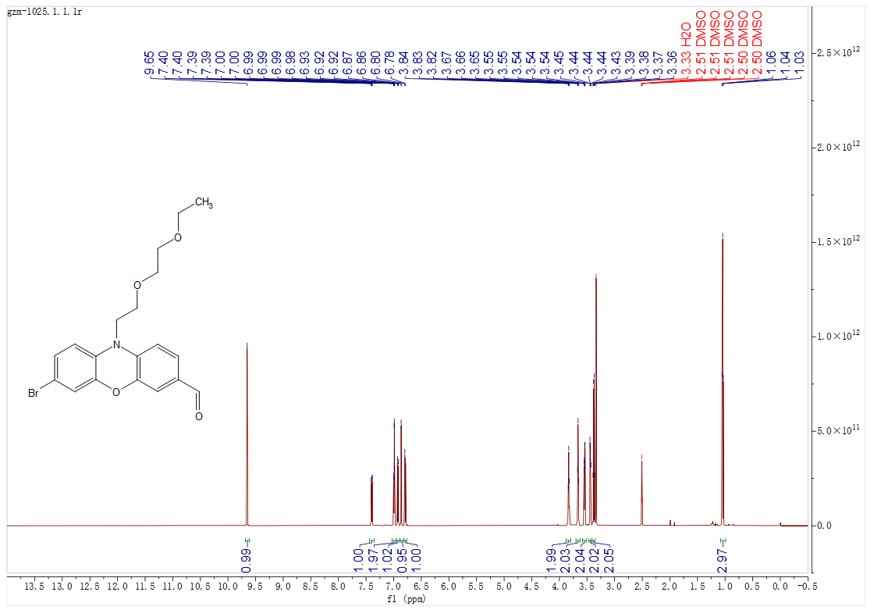
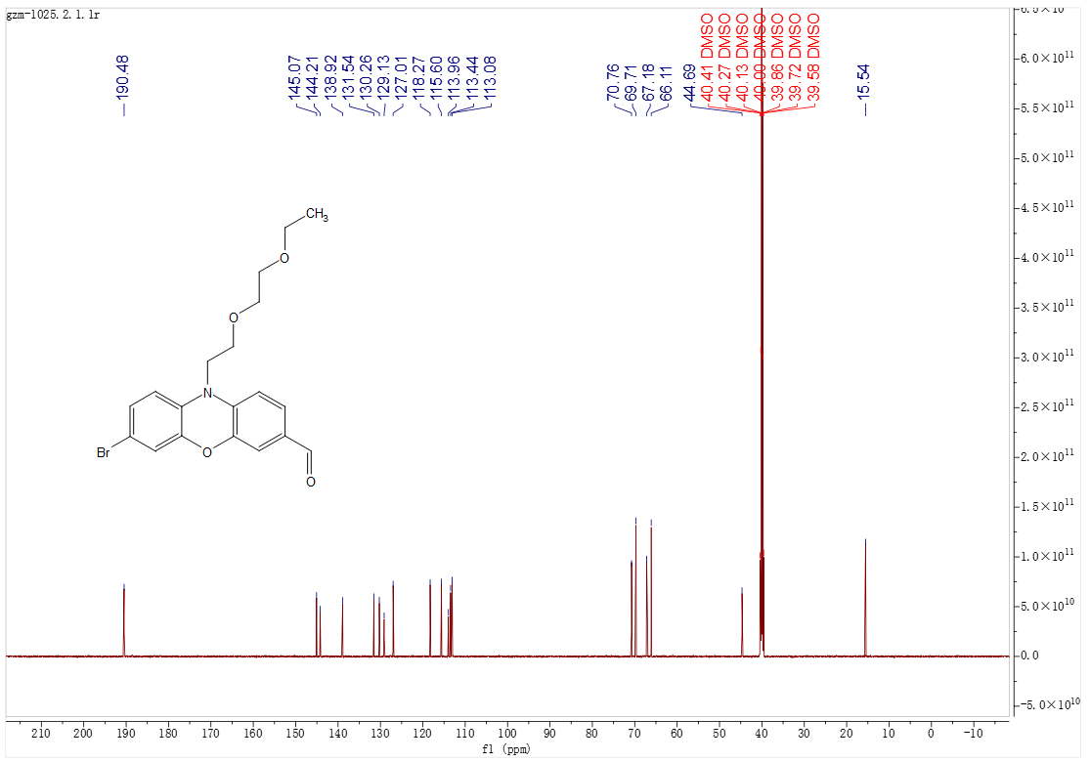
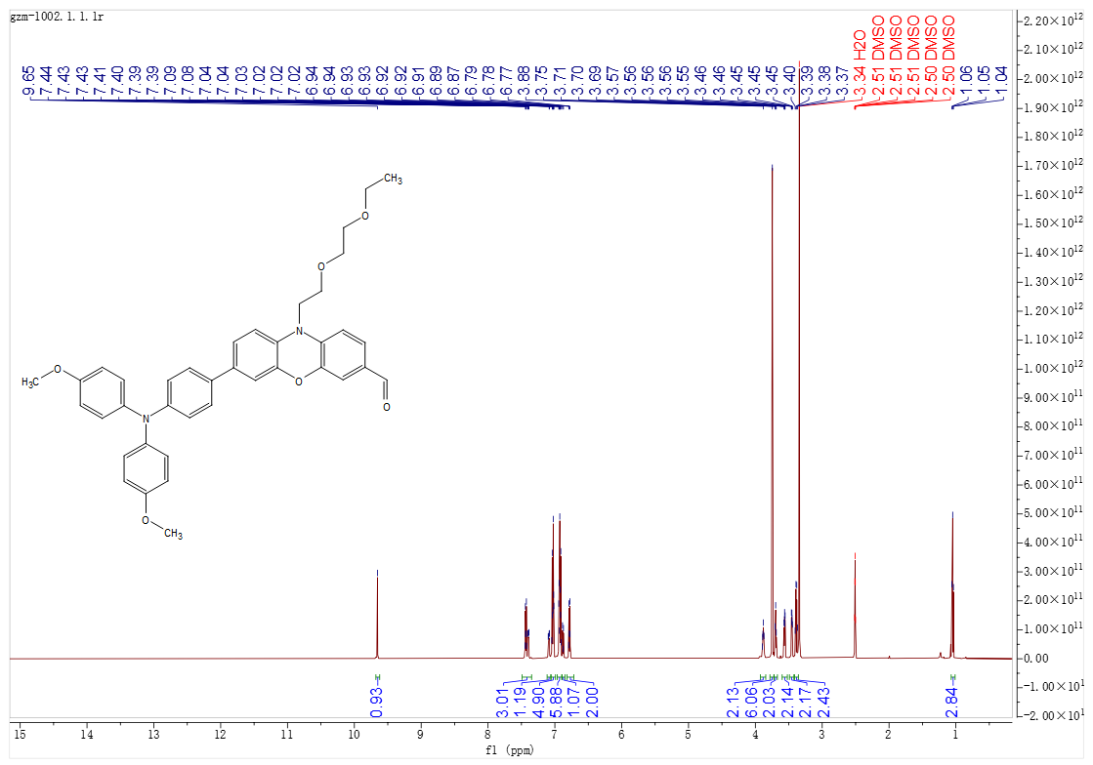
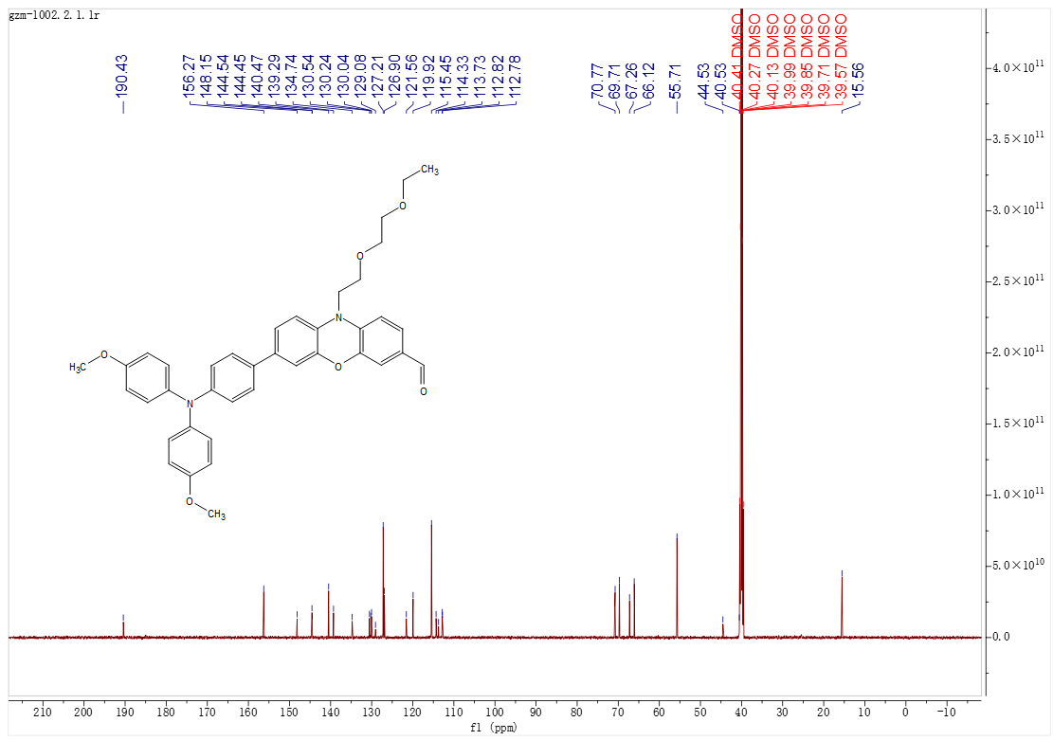
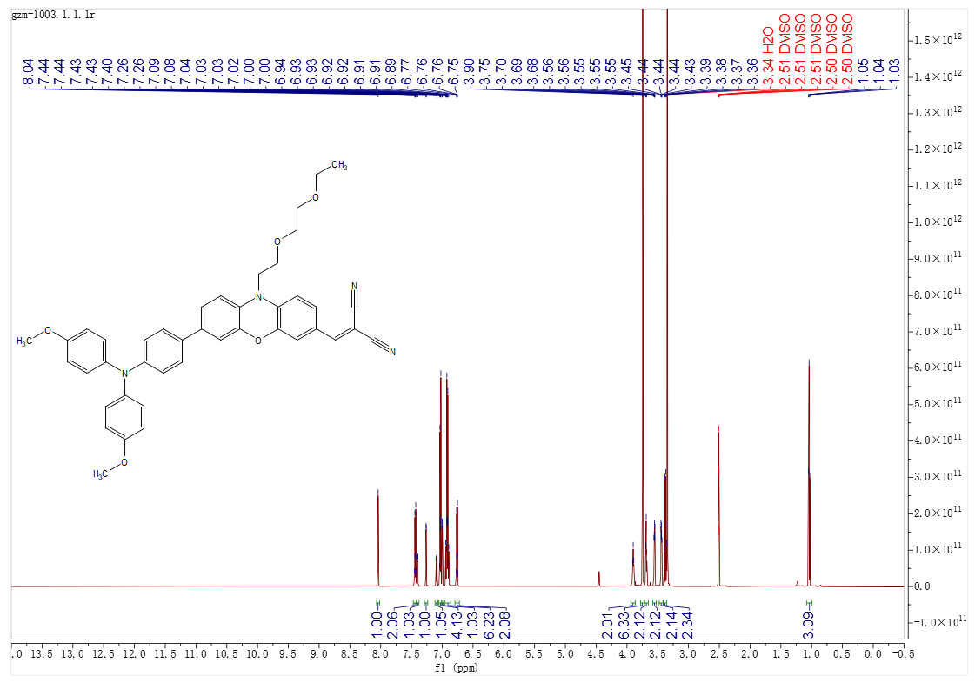
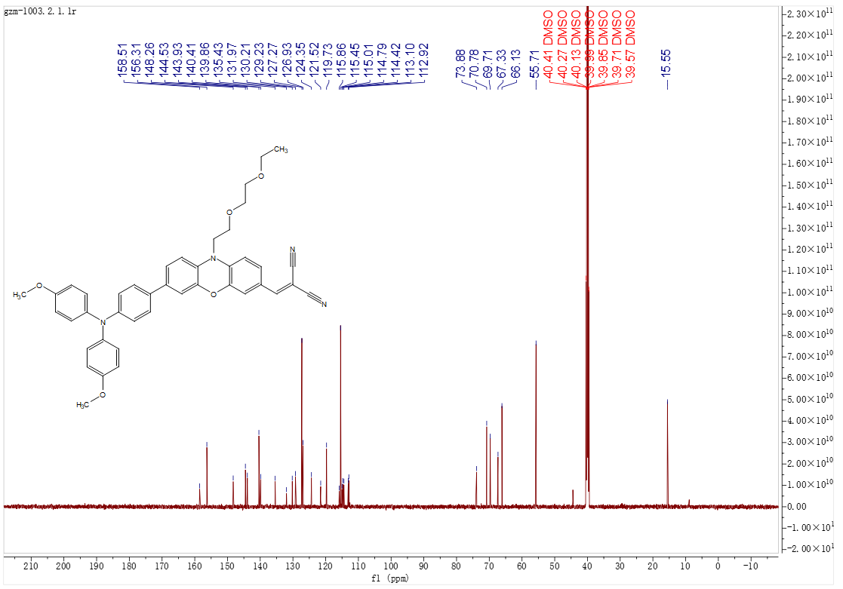
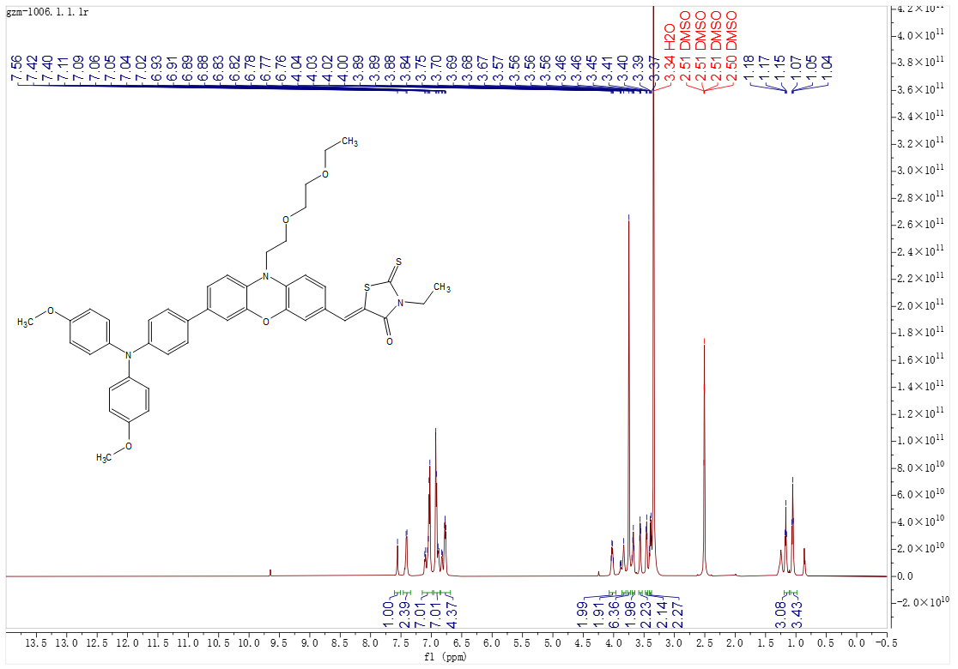
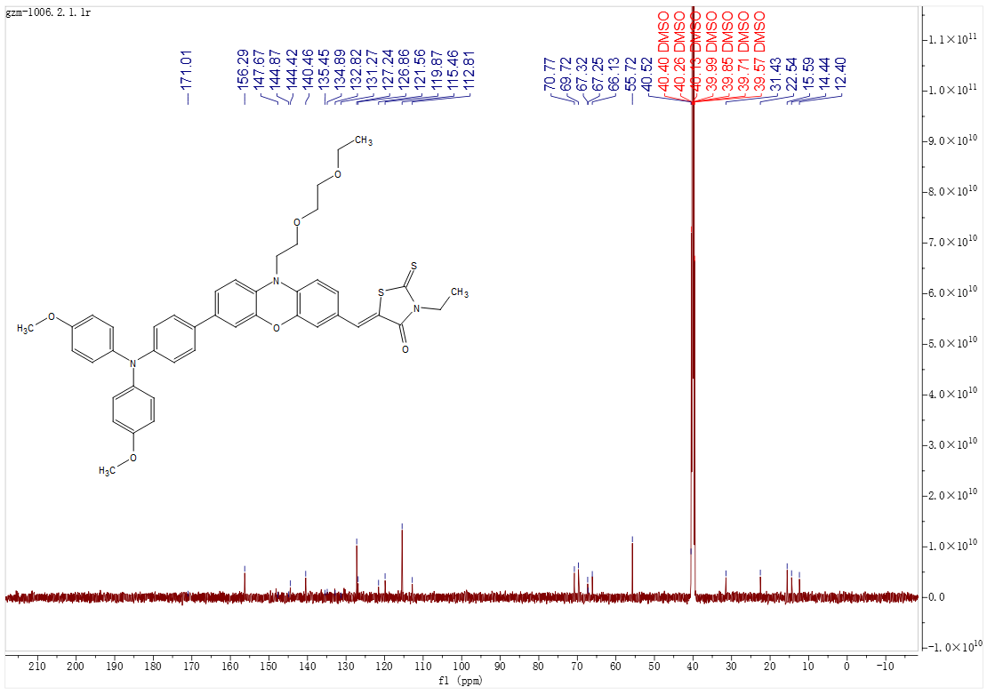
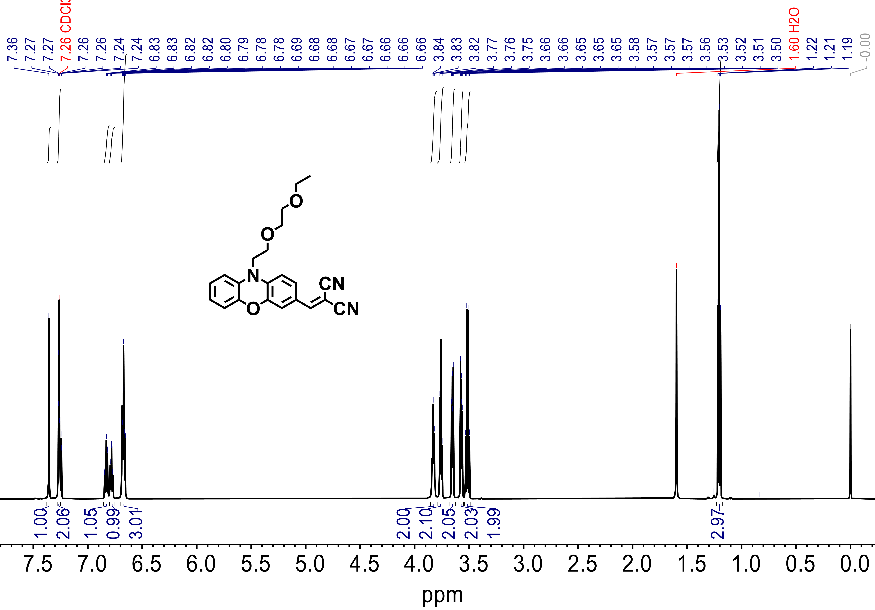
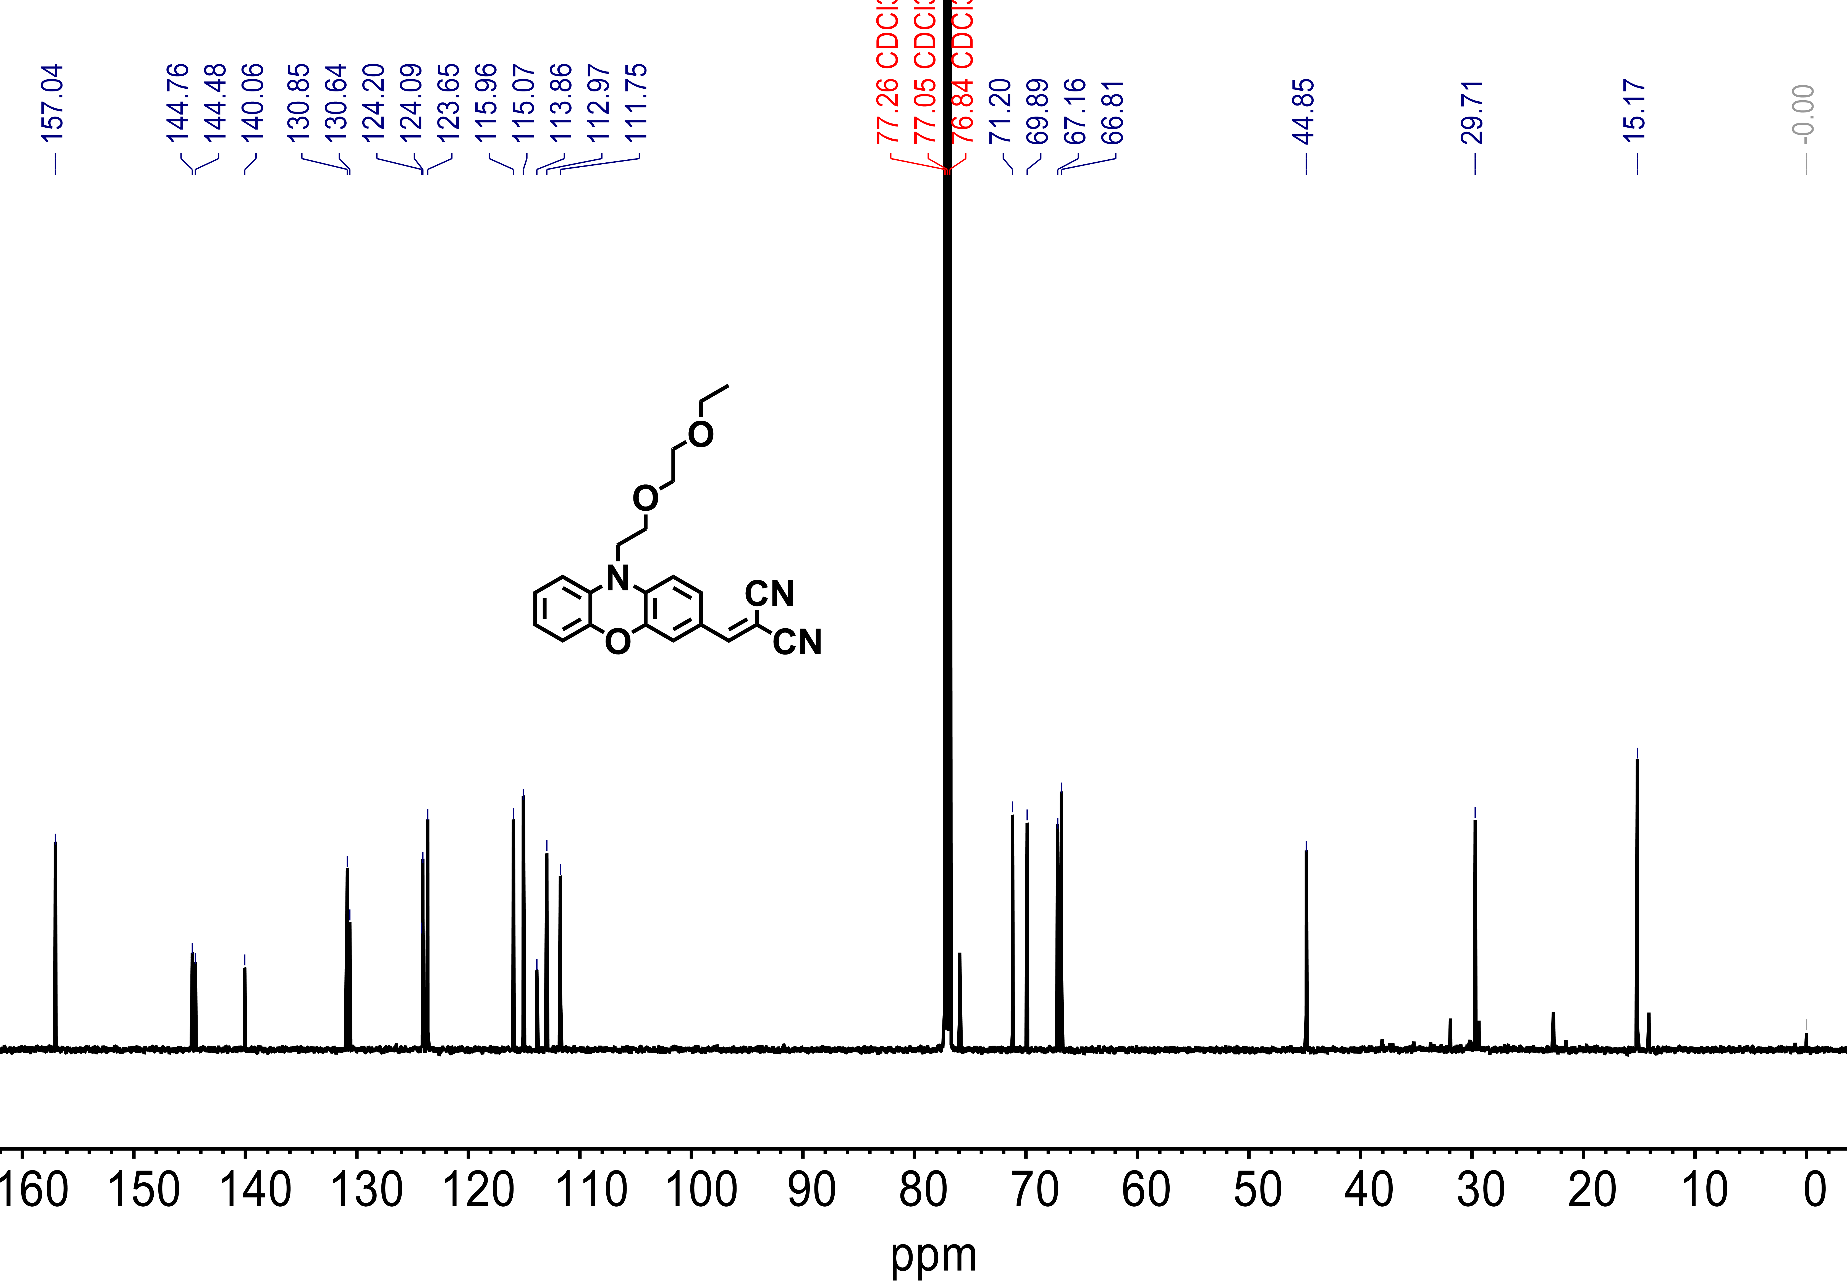
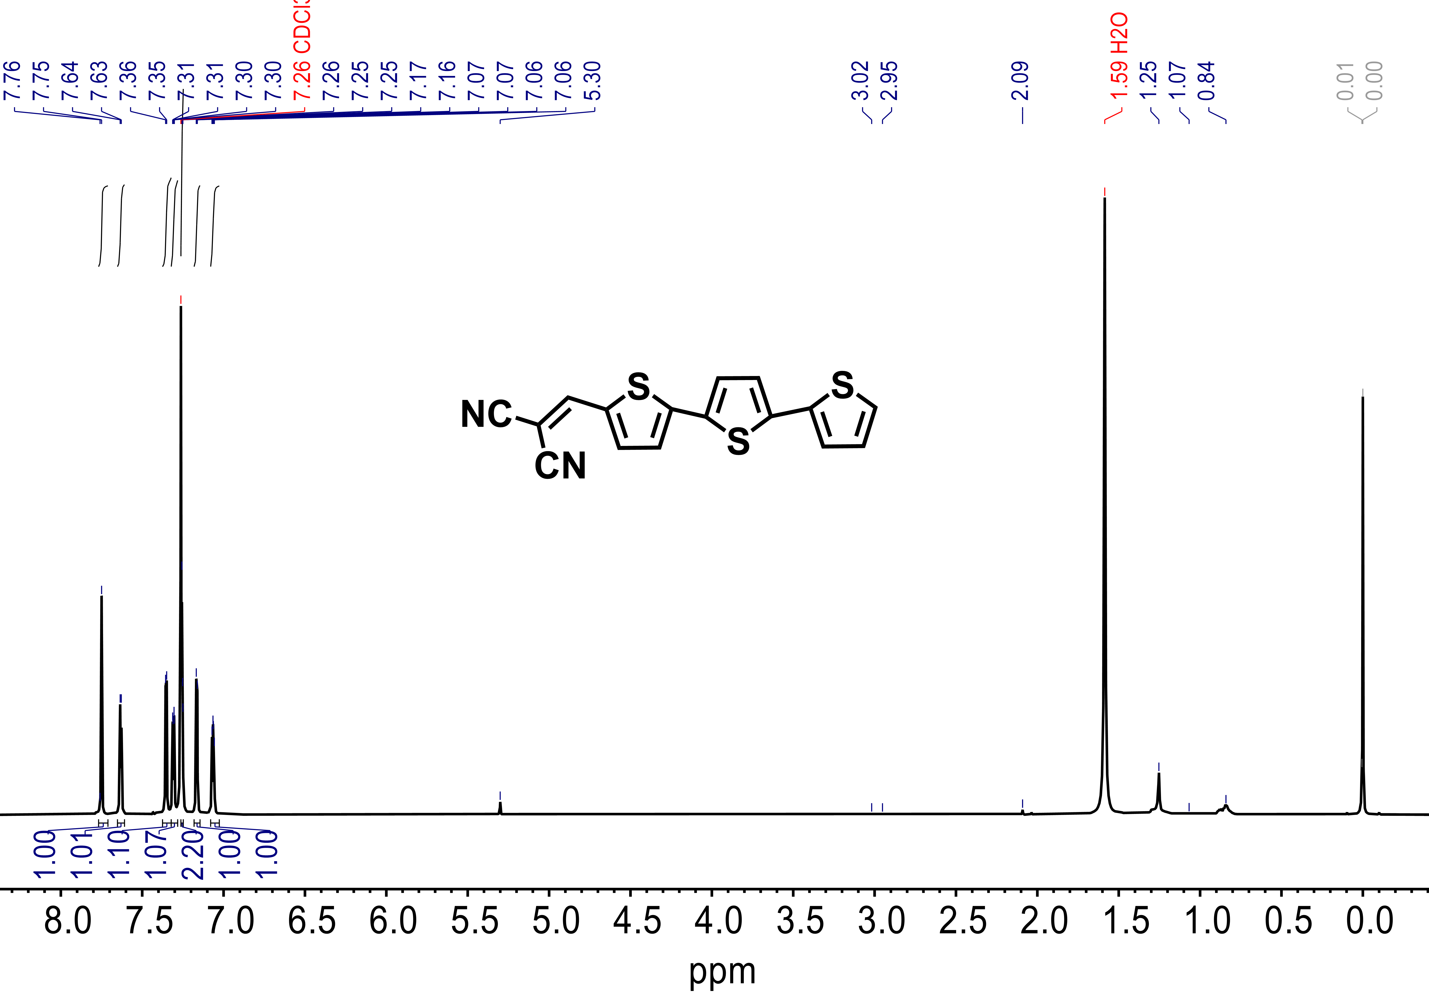
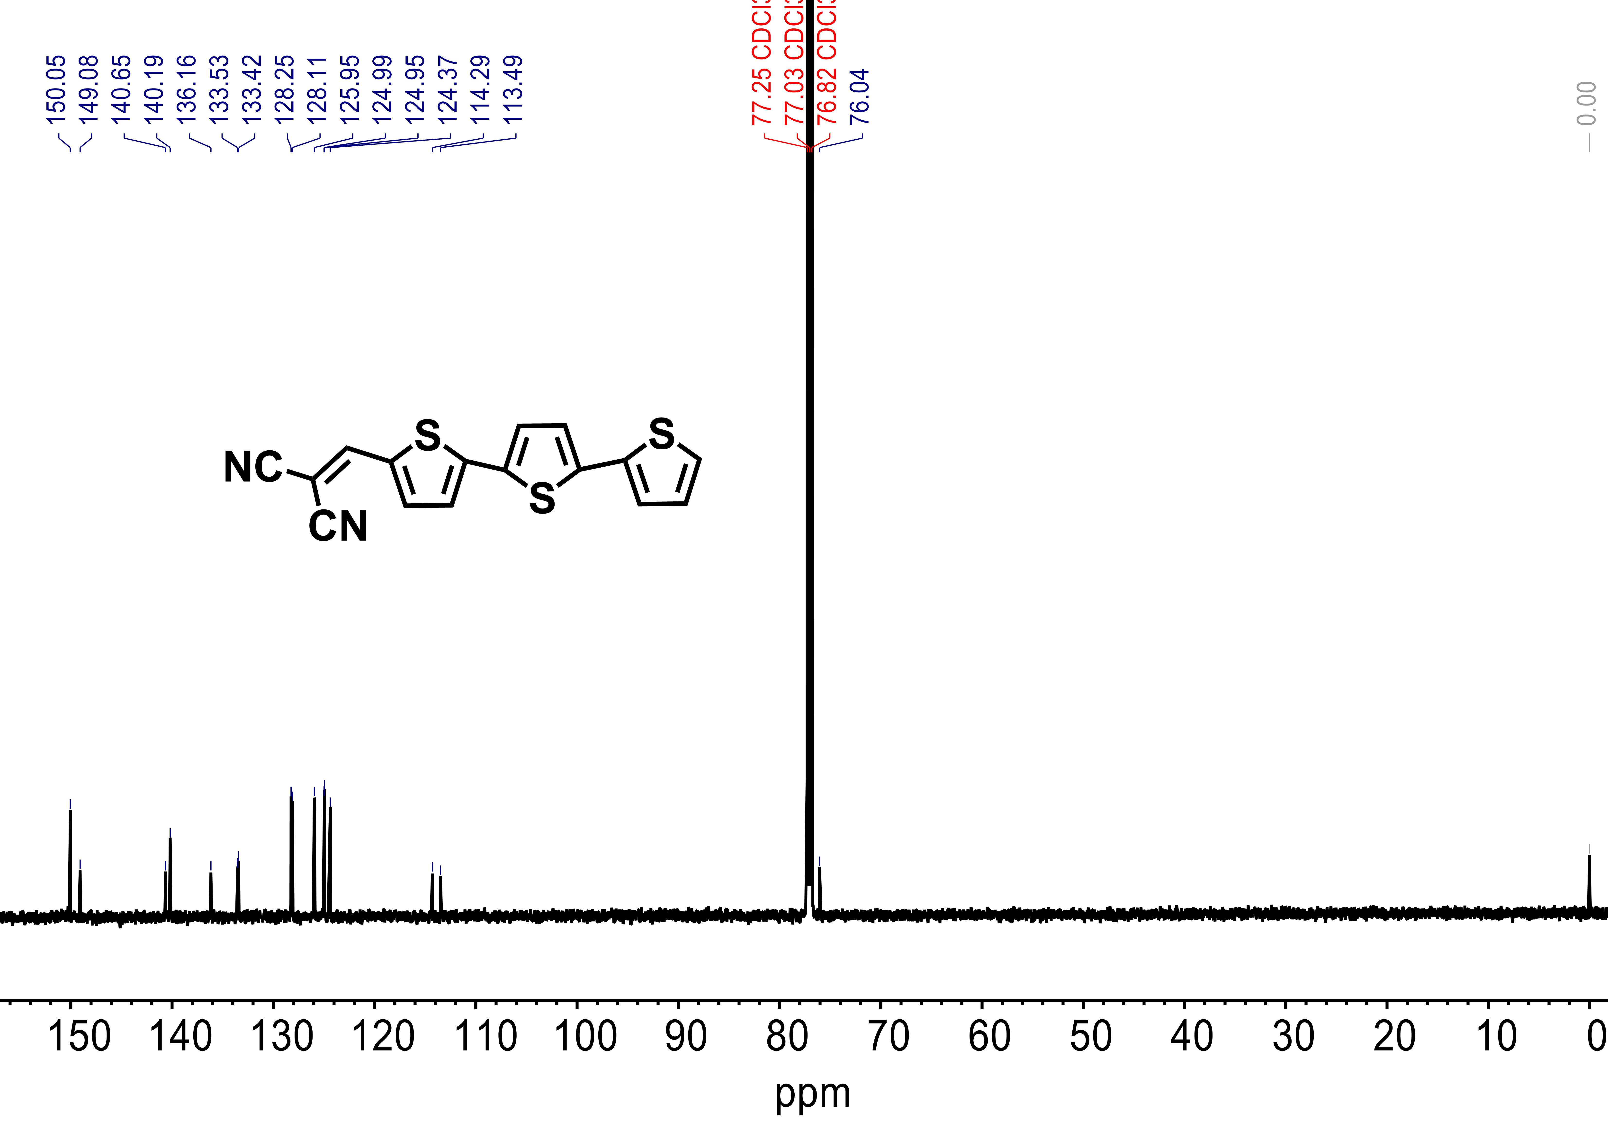

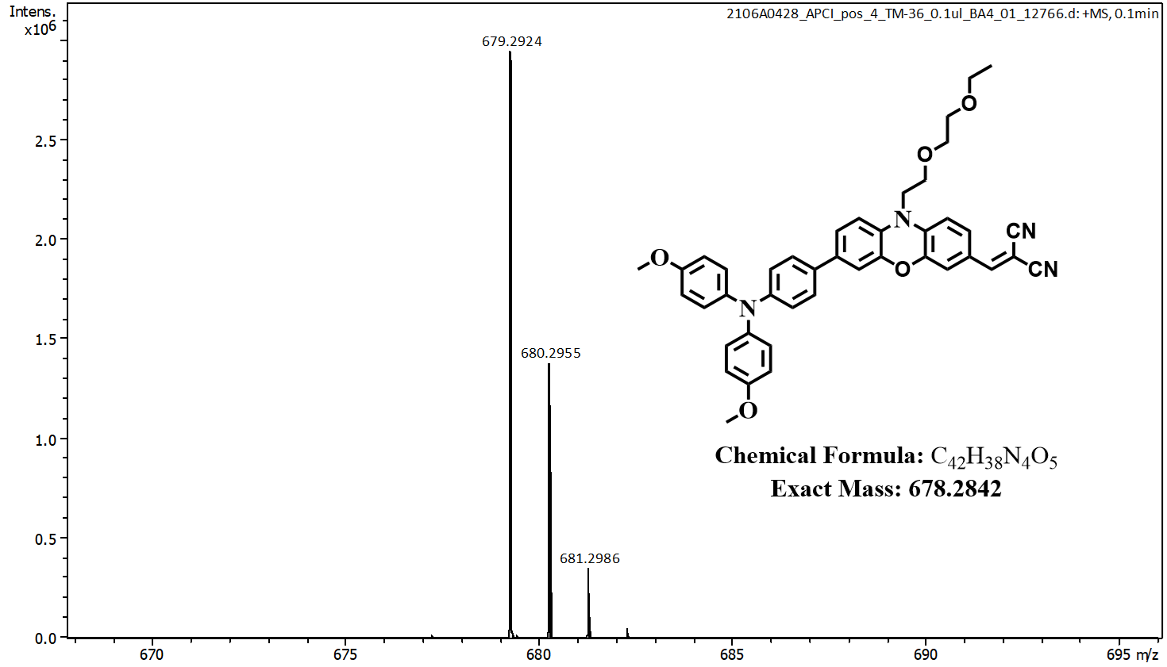

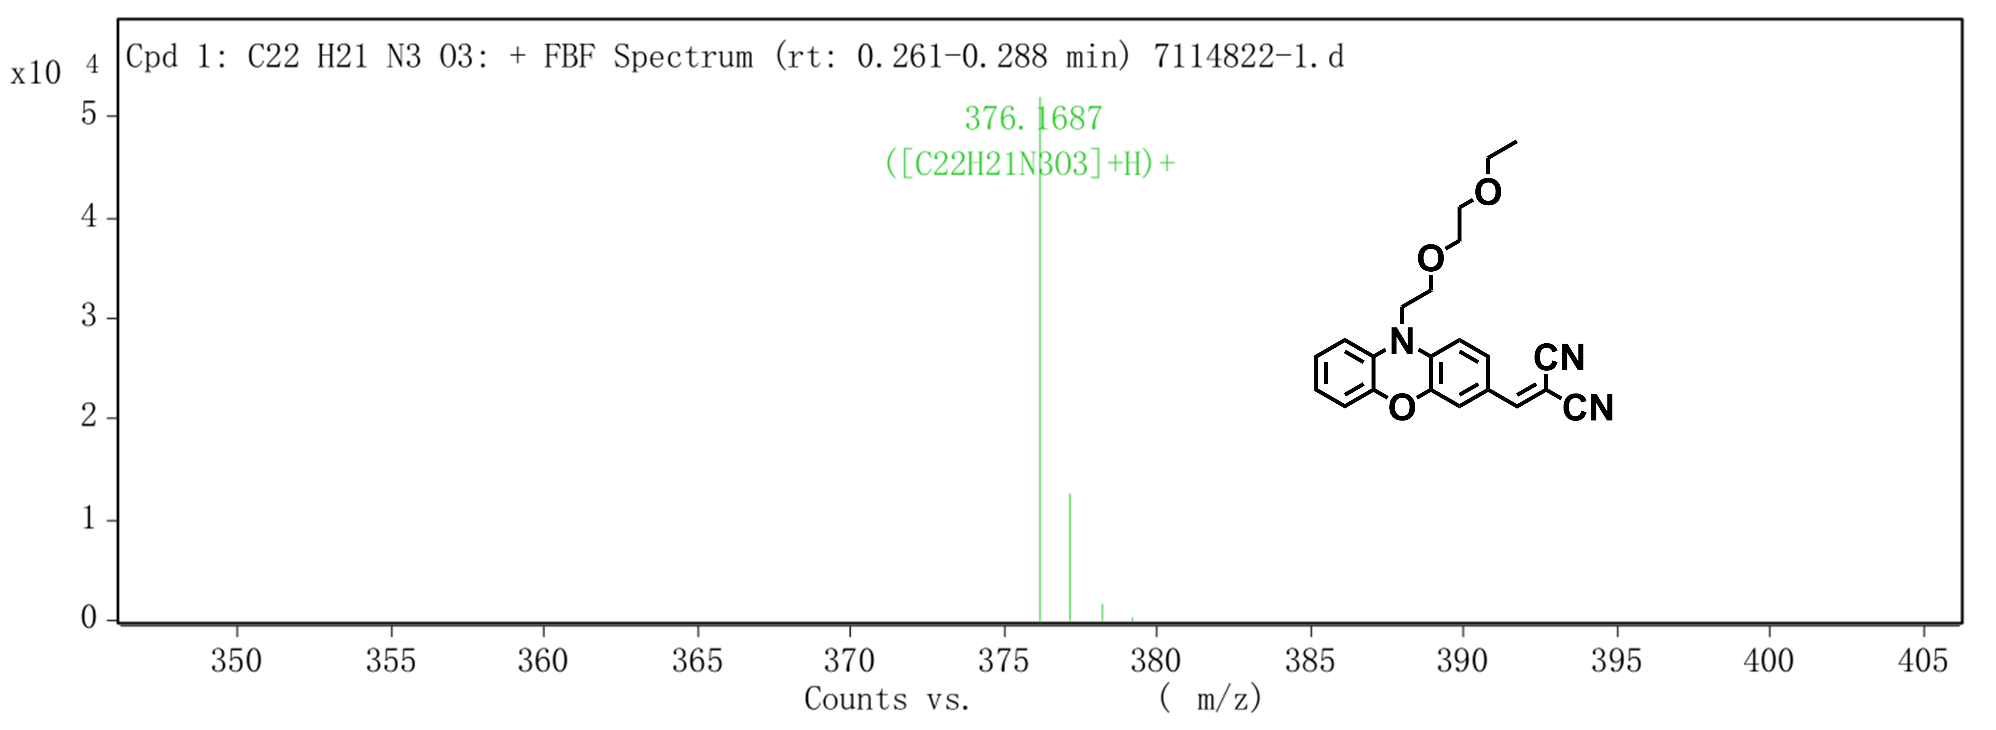

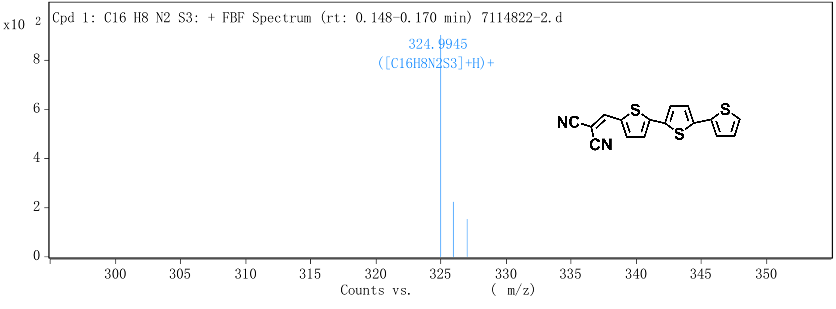

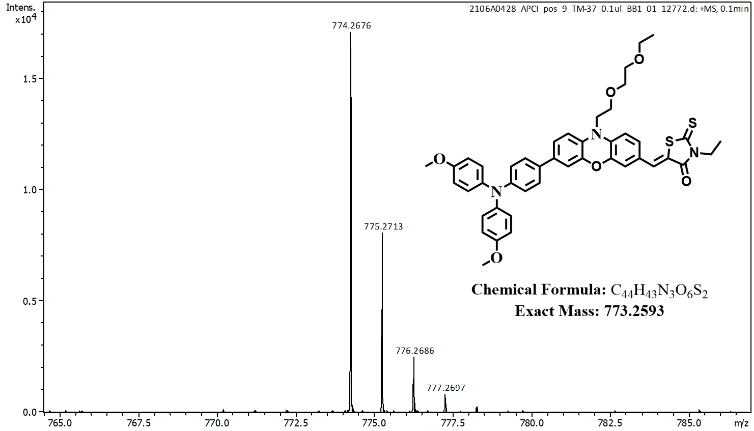

1. Wu, X. et al. Stable Triple Cation Perovskite Precursor for Highly Efficient Perovskite Solar Cells Enabled by Interaction with 18C6 Stabilizer. Adv. Funct. Mater. 30, 1908613 (2020).
2. Lu, T. & Chen, F. Multiwfn: A multifunctional wavefunction analyzer. J. Comput. Chem. 33, 580-592 (2012).

