Supplemental Material
Disulfiram Alleviates Acute Lung Injury and Related Intestinal Mucosal Barrier
Impairment by Targeting GSDMD-Dependent Pyroptosis
Jiping Zhao^{1#}, Hong Wang^{2#}, Jintao zhang ³, Fuwei Ou ⁴, Junfei Wang¹, Tian Liu¹, Jinxiang Wu^{1*}
¹ Department of Pulmonary and Critical Care Medicine, Qilu Hospital, Cheeloo College of Medicine, Shandong University, Jinan, China, ² Department of Ophthalmology, Qilu Hospital, Cheeloo College of Medicine, Shandong University, Jinan, China, ³ Department of Respiratory, Shandong Qianfoshan Hospital, Cheeloo College of Medicine, Shandong University, Jinan, China ⁴ Yanzhou Branch of Affiliated Hospital of Jining Medical University, Jining, China,
# These authors have contributed equally to this work; *Correspondence: Jinxiang Wu, wdwujinxiang@126.com
Supplementary Figure 1

Figure 4C
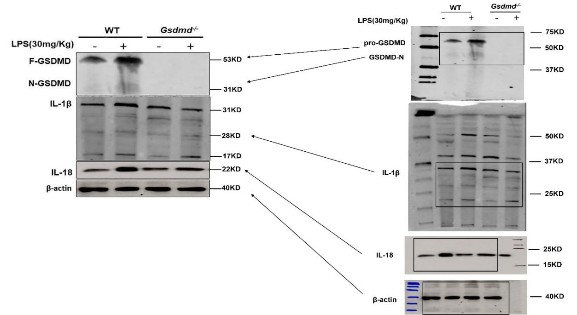

Figure 4D
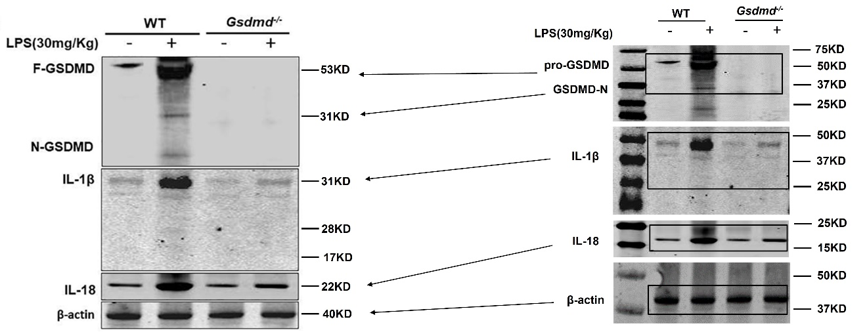

Figure 7C
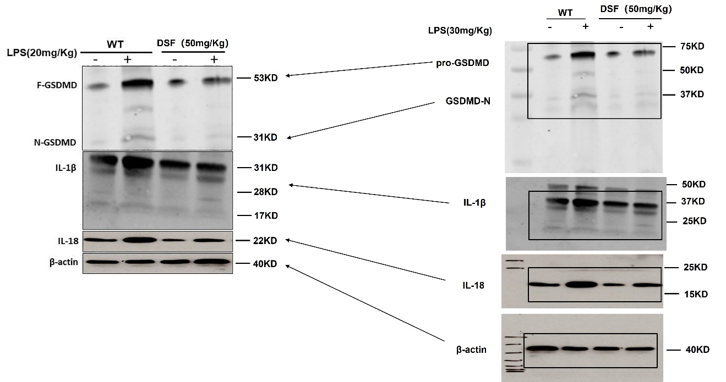

Figure 7D
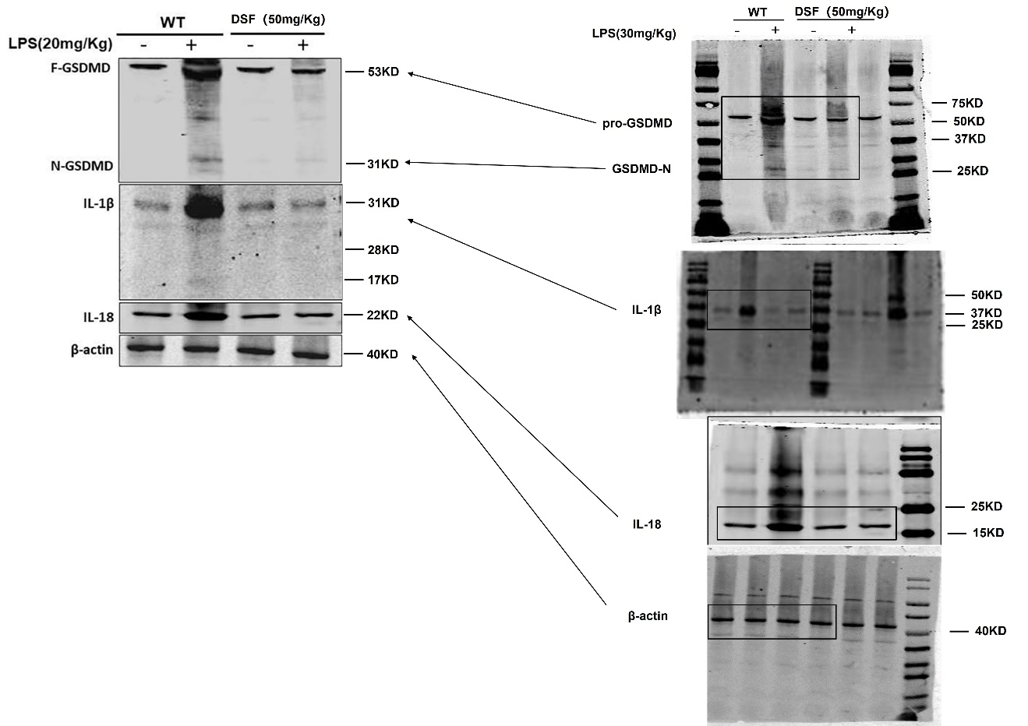
Supplementary Figure 1. Scans of the full films used to generate Western blot data for Figures 4c-4d and Figures 7c-7d.

