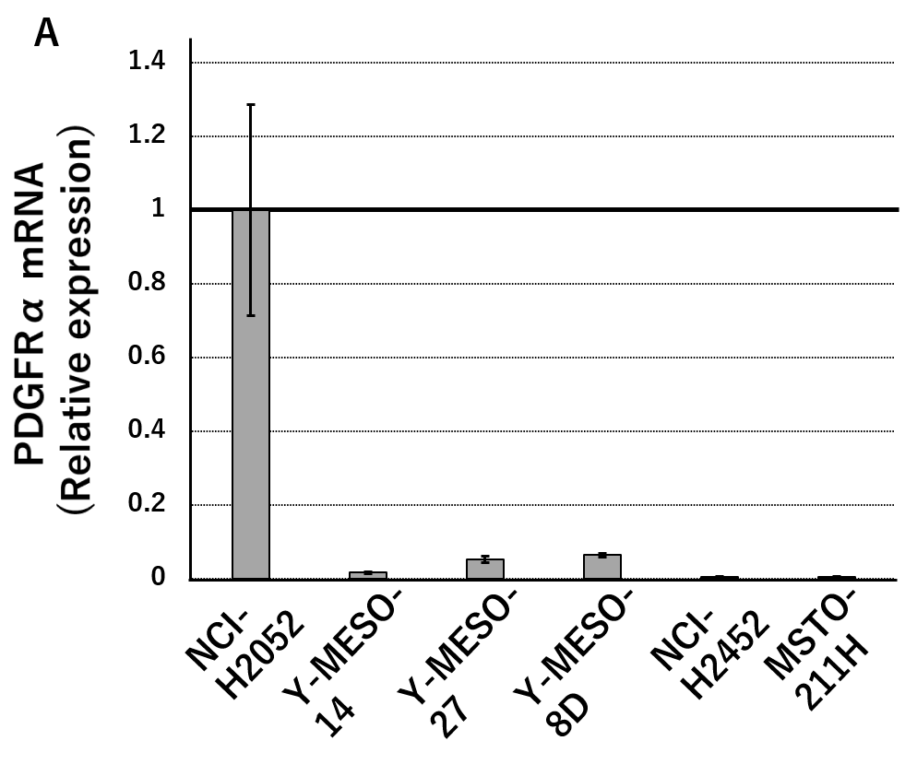
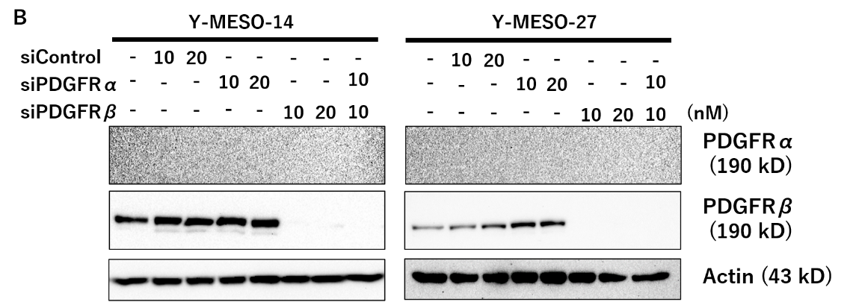
Supplementary Fig. 1
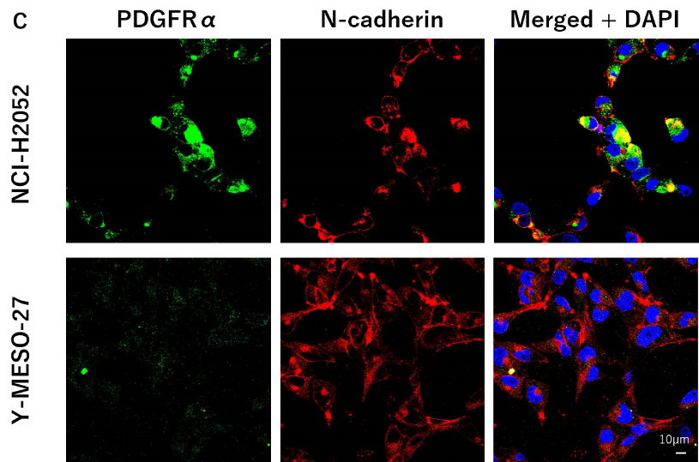

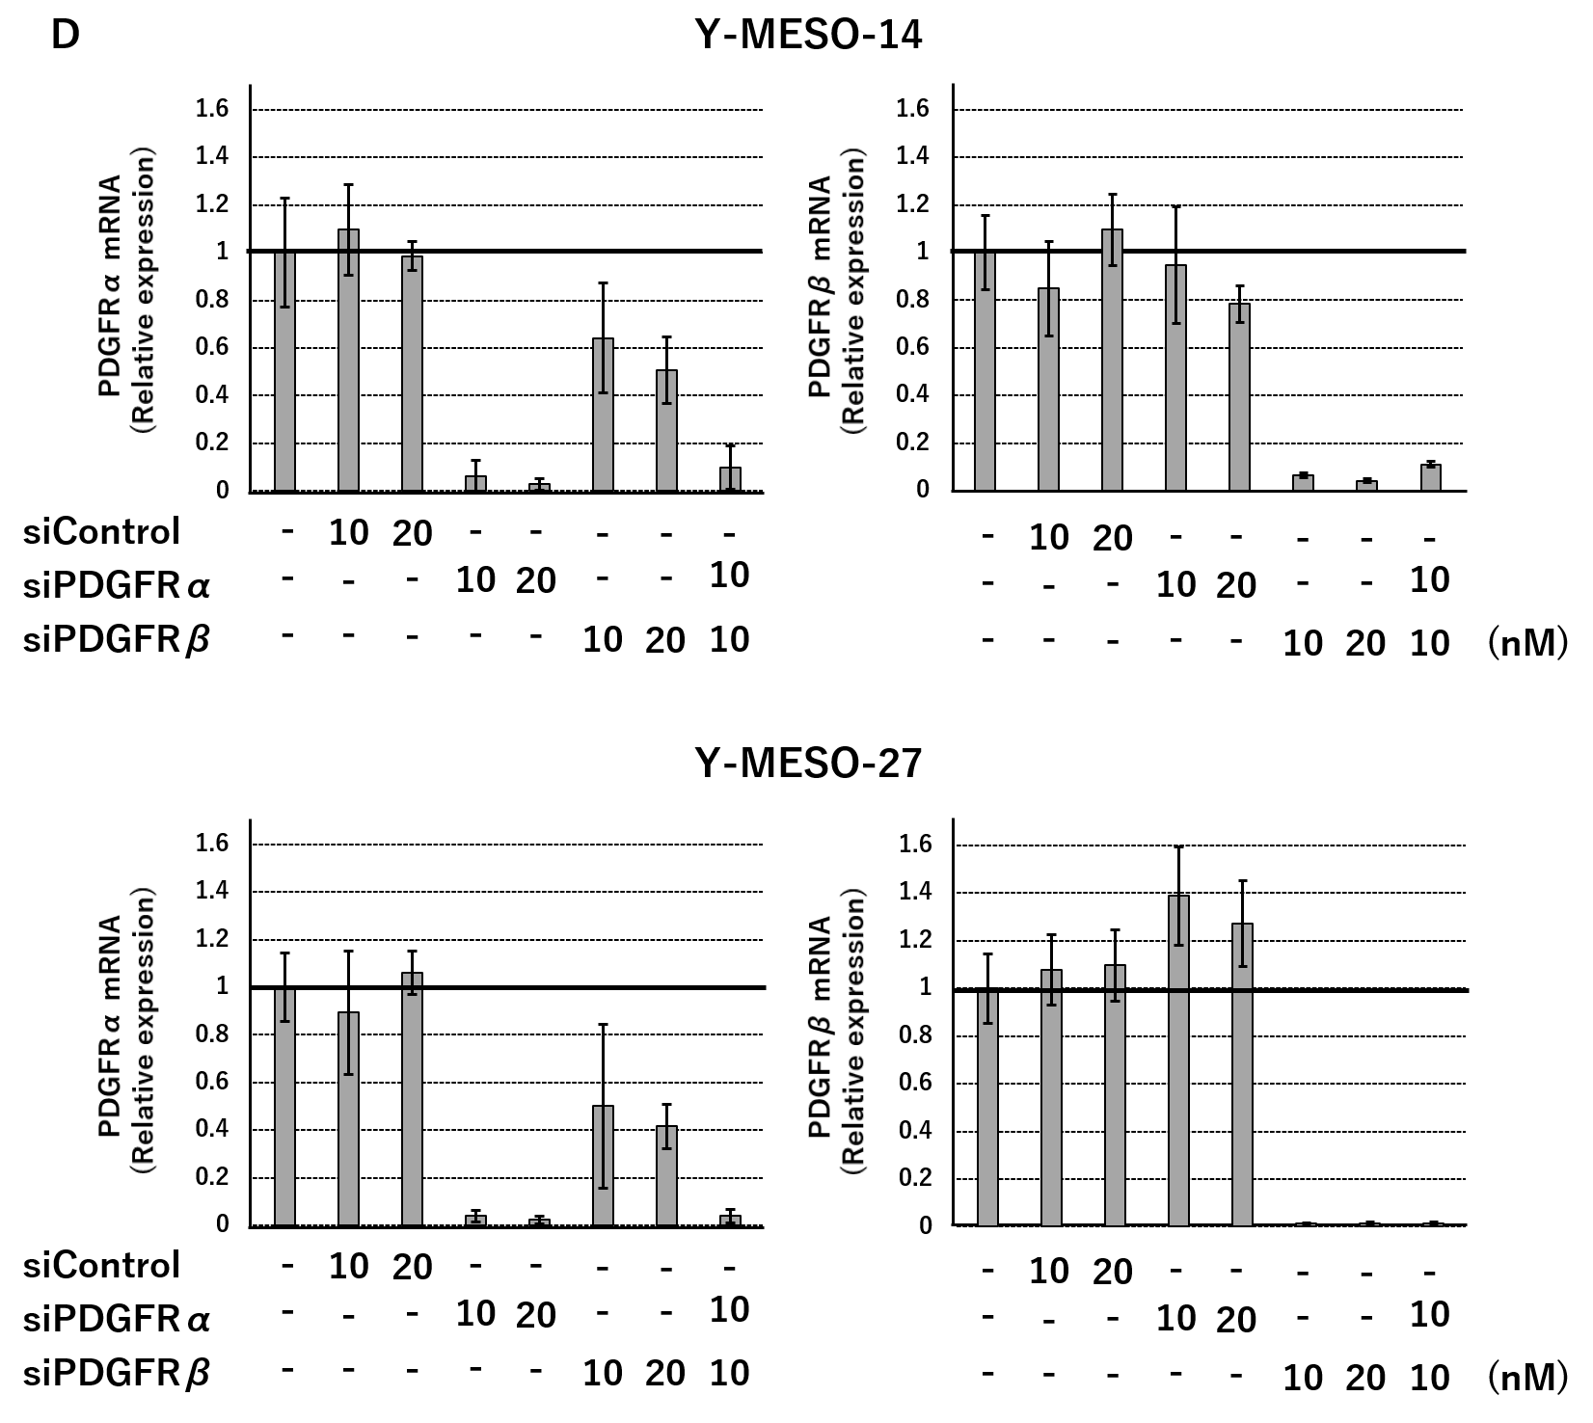

Supplementary Figure Legends
Fig. 1 Although PDGFR-α protein expression is low in MM cell lines, it is important to suppress the expression to achieve the maximum cell proliferation and CTGF expression.
- The cells were harvested when subconfluent status was reached in 24-well plates and subjected to real-time RT-PCR along with the standard protocol to detect PDGFR-α mRNA. Results shown are representative of three independent assays.
- Y-MESO-14 and Y-MESO-27 cells were transfected with siPDGFR-α and siPDGFR-β, respectively. The endogenous protein levels of PDGFR-α and PDGFR-β were detected by western blotting using the same lysate. PDGFR-β protein knockdown by transfection with siPDGFR-β was detected by an antibody, although the PDGFR-α protein was below the limit of detection in both Y-MESO-14 and Y-MESO-27 cells. The results shown are representative of three independent assays.
- Immunofluorescence staining of NCI-H2052 cells showing that the PDGFR-α protein localizes in the plasma membrane. The PDGFR-α protein could not be detected in Y-MESO-27. The nuclei were counterstained with DAPI (blue). The white arrows demarcate BAMBI expression in the cell membrane. Scale bars: 10 μm.
- Successful knockdown of PDGFR-α mRNA was detected in both Y-MESO-14 and Y-MESO-27 cells. Results shown are representative of three independent assays.

Smart pool | siRNA | Target Sequence
PDGFRα  SO-2866639G | J-003162-11 | 5’-CGAGACUCCUGUAACCUUA-3’
PDGFRα  SO-2866639G | J- 003162-12 | 5’-GAGCUUCACCUAUCAAGUU-3’
PDGFRα  SO-2866639G | J-003162-13 | 5’-GACAGUGGCCAUUAUACUA-3’
PDGFRα  SO-2866639G | J-003162-14 | 5’-GAAUAGGGAUAGCUUCCUG-3’
PDGFRβ  SO-2897046G | J-003163-10 | 5’-CAACGAGUCUCCAGUGCUA-3’
PDGFRβ  SO-2897046G | J-003163-11 | 5’-GAGCGACGGUGGCUACAUG-3’
PDGFRβ  SO-2897046G | J-003163-12 | 5’-GAAGCCACGUUACGAGAUC-3’
PDGFRβ  SO-2897046G | J-003163-13 | 5’-GGUGGGCACACUACAAUUU-3’
Control  SO-2855667G |  | 5’-UGGUUUACAUGUCGACUAA-3’
Control  SO-2855667G |  | 5’-UGGUUUACAUGUUGUGUGA-3’
Control  SO-2855667G |  | 5’-UGGUUUACAUGUUUUCUGA-3’
Control  SO-2855667G |  | 5’-UGGUUUACAUGUUUUCCUA-3’
Supplementary Table 1
Target sequences of siRNAs used in this paper

Supplementary Table2
The gene-specific primer sets used for real-time RT-PCR
Target | Reference sequence | sequence
GAPDH | NM_001256799.2 | 5'-GGA CCT GAC CTG CCG TCT AG-3'
GAPDH | NM_001256799.2 | 5'-GAG GAG TGG GTG TCG CTG TT- 3'
PDGFRα | NM_006206.6 | 5'-GTT GCC CGA GGA ATG GAG TT-3'
PDGFRα | NM_006206.6 | 5'-CGA CAC ATA GTT CGA ATC ATG CA-3'
PDGFRβ | NM_001355017.2 | 5'-GCT ACC AGG TGG CCA ATG G-3'
PDGFRβ | NM_001355017.2 | 5'-AAT TCG AGT CCC GCA TGA TG-3'
CTGF | NM_001901.3 | 5'-GCT ACC AGG TGG CCA ATG G-3'
CTGF | NM_001901.3 | 5'-AAT TCG AGT CCC GCA TGA TG-3'

Supplementary Materials and Methods
Immunofluorescence staining
Cells were grown overnight on glass coverslips coated with poly-L-lysine (P2636, Sigma-Aldrich, St. Louis, MO, USA). After washing with PBS, the cells were fixed in 4% formaldehyde/PBS for 10 min and permeabilized with 0.2% Triton X-100/PBS for 5 min at room temperature. Subsequently, the cells were blocked for 1 hr with 5% bovine serum albumin in TBS-T and incubated overnight with anti-PDGFRα (#5241, Cell Signaling Technology) and anti-N-cadherin (#14215, Cell Signaling Technology) in blocking buffer at 4°C. The cells were then washed three times in TBS-T and incubated for 1 hr with the appropriate Alexa-conjugated secondary antibodies (#A11034, #A11031, Thermo Fisher Scientific, Waltham, MA, USA) at room temperature. Coverslips were mounted on glass slides with VectaShield mounting medium (H-1000; Vector Laboratories, Burlingame, CA) containing DAPI for nuclear counterstaining. All images were captured using a FV1000-D confocal microscope (Olympus, Tokyo, Japan).

