Sample of DNA extracted from yam genotypes and its PCR product using yam 12 SSR marker

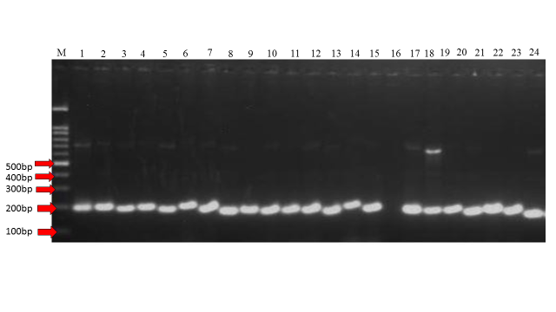

bp= base pairs, M= 100bp ladder, and number 1-24 indicated DNA extracted from yam genotypes

