Photo take during sample collection of yam from farmers’ field in Western Ethiopia, East Wollegga zone.

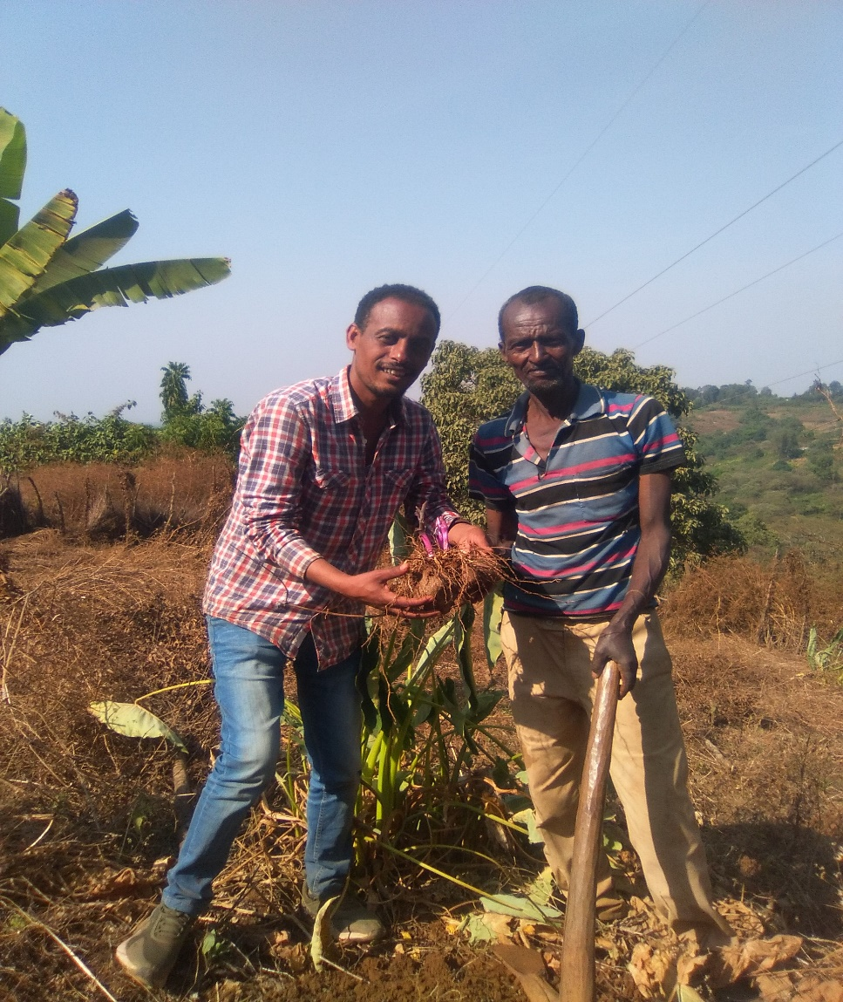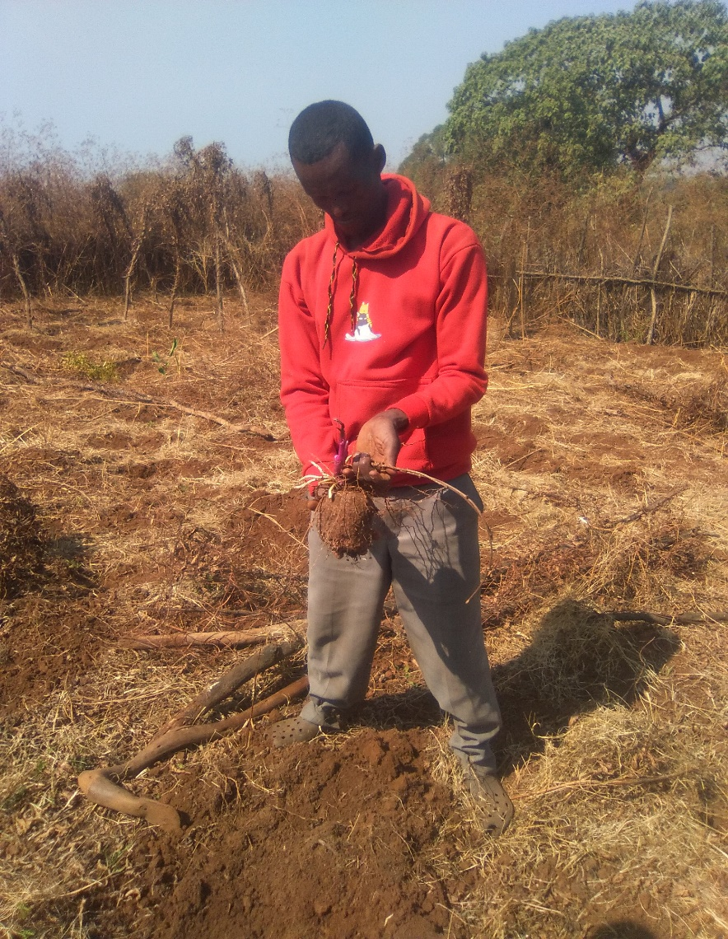

Appendix 4. Dioscorea species grown in the greenhouse of National Agricultural Biotechnology Center, Holeta, Ethiopia in 2021GC

