Biomimetic hygroscopic nanofibrous membrane with gradient honeycomb-like network structure for efficient atmospheric water harvesting

Zhang et al.

Supplementary Figure 1 a–g SEM images demonstrating the evolution of the gradient honeycomb-like architecture of PVA NFM versus time. h The average pore size distribution diagram revealing the pore size of the honeycomb-like network structure of PVA NFM gradually increases with the electrospinning time.

Supplementary Figure 2 The pore size distribution diagram of PVA NFM.

Supplementary Figure 3 After the PVA-C NFM was compressed by gravity of 200 cN for 24 h, the honeycomb-like network structure remained stable and did not collapse.

Supplementary Figure 4 Swelling property of PVA-C NFM in water and its SEM morphology after water immersion for 2 days.

Supplementary Figure 5 a N₂ adsorption−desorption isotherms and b pore size distribution curves of PVA and PVA-C NFMs.

Supplementary Table 1 BET specific surface area and pore structure parameters of PVA and PVA-C NFMs.
Sample | S_{BET}ª (m² g⁻¹) | V_{total}^{b} (cm³ g⁻¹) | V_{meso}^{c} (cm³ g⁻¹)
PVA | 6.45 | 0.0127 | 0.0118 (93)
PVA-C | 3.27 | 0.0062 | 0.0054 (87)
Notes: ªS_{BET} was calculated in the partial pressure (P/P₀) range of 0.01 to 0.1. ^{b}Total pore volume at P/P₀ = 0.99. ^{c}V_{meso} was calculated by the BJH method, the values in parentheses denote the mesopore volume fraction.

Supplementary Figure 6 The cross-linking reaction equation between PVA and GA.

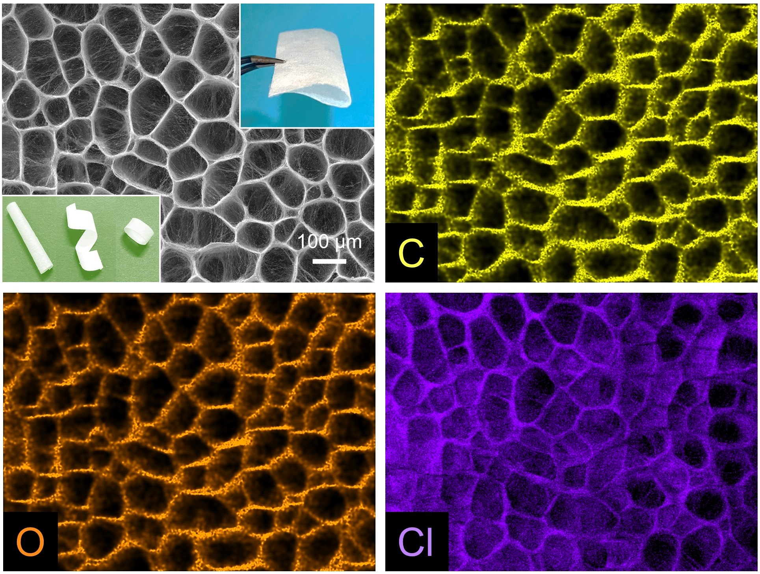
Supplementary Figure 7 SEM image of PVA-C@LiCl NFM and corresponding elemental mapping images of C, O, and Cl, respectively. The insets demonstrate the flexibility and windability of PVA-C@LiCl NFM.

Supplementary Figure 8 Cyclic tensile test under 60% strain of PVA-C NFM.

Supplementary Figure 9 a Raman image of the region from the surface to the interior (from top to bottom) for the dried PVA-C@LiCl NFM. b Bright-field image of the humped nanofibers in the middle of the dried PVA-C@LiCl nanofibrous networks. c Raman spectra obtained from point 1 in panel (a).

Supplementary Figure 10 Evolution of the total number of hydrogen bonds in PVA-C@LiCl NFM as a function of the simulation time during the molecular dynamics simulation of moisture absorption and transportation process.

Supplementary Figure 11 Geometric relationship between α and the cross-sectional configuration of the gradient honeycomb-like network structure

Supplementary Note 1
The equation of difference in Laplace pressure is as follows¹:
$ΔP=-\int_{r_{1}}^{r_{2}}{\frac{2γ}{{(r+R_{0})}^{2}}}sinβdz$ (1)
where r is the local radius of the humped nanofiber, R₀ is the water drop radius, γ is the water surface tension, β is the half apex-angle of the spindle-knot, and z is the integrating variable along the diameter of the spindle-knot.
Furmidge proposed the Furmidge equation to explain the dynamic wettability as follows²:
$mg sinα=σw(cosθ_{R}-cosθ_{A})$ (2)
where m, σ and w are the weight, surface tension and contact circle width of the liquid droplet, respectively. g is the gravitational acceleration, α is the sliding angle (SA), and θ_{A} and θ_{R} are the advancing contact angle (CA) and receding contact angle, respectively.
Typically, the geometric relationship between α and the cross-sectional configuration of the gradient honeycomb-like network structure is shown in Supplementary Fig. 11. α can be calculated by:
$tanα=2H/(D-d)$ (3)

Supplementary Note 2
The calculation of the LiCl coating ratio.
The LiCl coating ratio was obtained by the weight variation of NFM before and after impregnating LiCl, and then calculated according to the following formula:
$λ=\frac{m-m_{o}}{S}$ (4)
where, $λ$ is the coating ratio based on the area of raw PVA-C NFM (g cm⁻²), m₀ is the original weight of raw PVA-C NFM (g), m is the weight of dried PVA-C@LiCl NFM (g), and S refers to the area of raw PVA-C NFM (cm²). The average LiCl coating ratio of PVA-C@LiCl NFM obtained by five experiments was 0.0043 g cm⁻².

Supplementary Note 3
The equation of the strain recovery ratio is as follows³:
$Strain recovery ratio=\frac{\left[ε_{m}-ε_{p}(N)\right]}{ε_{m}}$ (5)
where ε_{m} is the maximum strain (ε_{m} = 60%) in the cyclic tensile test, ε_{P} (N) is the residual strain after recovery in the Nth cycle.

Supplementary Methods
Materials. Polyvinyl alcohol (PVA, M_{w} = 89,000-98,000, 99+% hydrolyzed) was purchased from Sigma–Aldrich Chemical Company. Glutaraldehyde (GA, 50% in H₂O), hydrochloric acid (36.5–38.0%), lithium chloride (LiCl, 98%), and absolute ethanol (EtOH, ≥ 99.7%) were obtained from Aladdin Biochemical Technology Co., Ltd., China. All chemicals were used as received without further purification. Pure water was produced by a water purification system (UPT-11-20T).
Water swelling test. To measure the swelling ratio in water, dried PVA-C NFM (its weight is designated as m₀) was immersed in water for 2 days at 25 ºC, after taking out, use filter paper to absorb the water on the NFM surface, and the weight of the NFM at equilibrium (m) was measured, which was calculated as follows:
$Swelling ratio (\%)=\frac{m-m_{o}}{m_{o}}*100$ (6)
It can be seen from Supplementary Fig. 4 that the water swelling ratio of the PVA-C NFM tends to be stable after approximately 24 h and the ratio is approximately 6.4%.

References
- Lorenceau, L. & Qur D. Drops on a conical wire. J. Fluid Mech. 510, 29–45 (2004).
- Furmidge, C. G. L. Studies at phase interfaces. I. The sliding of liquid drops on solid surfaces and a theory for spray retention. J. Colloid Sci. 17, 309–324 (1962).
- Hu, J. L., Ji, F. L. & Wong, Y. W. Dependency of the shape memory properties of a polyurethane upon thermomechanical cyclic conditions. Polym. Int. 54, 600–605 (2005).

