84 mm format Verification File
……Please READ……

This “…verification” file consists of one column having a width of 84 mm. This text is in Arial font size 10 for reasons of comparison. After pasting the figures into this file, the EFFECTIVE font size used in the figures should match the font size of this text.
- Make sure that the effective font size of all elements in the figures, i.e., axes labeling, tick mark labeling, and legend, is about 10.
- Use SAN SERIF font, such as Arial san serif.
- Make sure that the effective font size of all figures is consistently the same,
- Please paste all 84 mm figures in this file and submit it with the revision. The purpose is to quickly check that the font size is consistent among all figures.
- Also, do not forget to update the figures the main word document.

This is font size Arial 10: 12345 asdfg ASDFG. This is the effective font size for all figures of any width (84, 129, 174 mm) and figure elements. Make sure this size is applied consistently to all figures.
Please re-read the previous two sentences (in red) to understand the meaning of EFFECTIVE font size clearly.

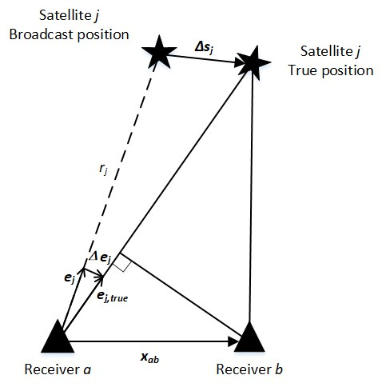

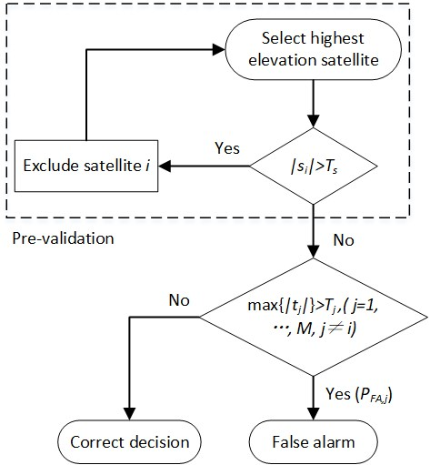

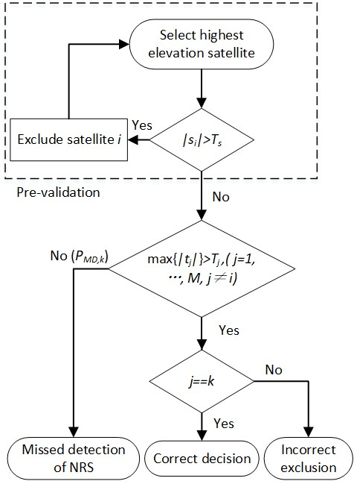

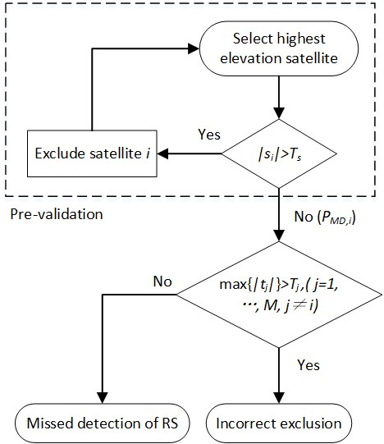

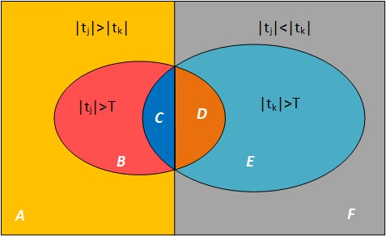
Make sure

