Supporting Information
The effect of chitosan-assembled graphene oxide on the microstructure and mechanical properties of polycaprolactone nanocomposites
Fahimeh Shahsavarª, Amir Babaeiª*
ª Department of Polymer Engineering, Faculty of Engineering, Golestan University, Gorgan, Iran.
Corresponding Author
*ªAmir Babaei
Department of Polymer Engineering, Faculty of Engineering, Golestan University, Gorgan, Iran
E-mail address: a.babaei@gu.ac.ir

Preparation of GO
Briefly, 1 g graphite flakes and 0.5 g NaNO₃ were dissolved in 70 ml of H₂SO₄ and stirred over about 1 h in an ice water bath. Then, 6 g KMnO₄ was slowly added to the mixture. The ice bath was removed and the mixture was heated at 45 °C for 24 h. Afterward, 400 mL distilled water was gradually added to the mixture, and then 15 mL of 25% H₂O₂ was added. The color of the mixture changed to bright yellow. The oxidation product was centrifuged and washed three times with 5% HCl and distilled water, subsequently dialyzed (MWCO∼3500) against DI water (for 3 days) until to achieve the pH around 6. Successively, the resulting mixture was sonicated to reach a complete exfoliation. Then, the aqueous GO was entirely solvent exchanged with DMF. (The concentration of GO in DMF was 3 mg/mL).
Preparation of Pure PCL film
The films were prepared through the solvent-casting method by dissolving PCL in DMF under continuous stirring at 75 °C for 1 hour. Then, the product was placed into a Petri dish and dried in a vacuum oven at 75 °C for 24 hr to eliminate DMF. Then, it was further dried at room temperature to remove the remaining solvent if existing.
Preparation of PCL based nanocomposites
Table S1. Sample Codes and Formulations
Code | PCL (%wt) | GO (%wt) | GO-CS (%wt)
PCL neat | 100 | - | -
PCL/GO 0.5 | 99.5 | 0.5 | -
PCL/GO-CS 0.25 | 99.75 | - | 0.25
PCL/GO-CS 0.5 | 99.5 | - | 0.5
PCL/GO-CS 1 | 99 | - | 1

UV–visible results
The successful synthesis of GO-CS was further confirmed using UV-Vis spectroscopy. Figure S1 shows the UV-Vis spectrums of GO, CS, and GO-CS. GO showed a characteristic peak at 230 nm (corresponding to π-π* transitions of C=C bonds) and a shoulder peak at 290 nm (attributed to n-π* transitions of C-O bands) and CS showed a peak at 300 nm, as expected [1-4]. It is also apparent that the absorption peak of the GO-CS exhibited a red-shifted from 230 to 274 nm and the CS peak was disappeared. It can correspond to the stacking of the GO layers arising from the hybridization and or overlapping of π-π* transition of the Graphene backbone and n–π* transition of the CS [5-7]. These results also represent another confirmation revealing that GO sheets were successfully grafted by CS.
Figure S1. UV-visible spectra of GO, GO-CS, and CS.
TEM and FE-SEM Micrographs
Figure S2 depicts the TEM micrographs of synthesized GO nanosheets and GO-CS. A transparent layer obviously illustrates the formation of a single layer for the case of GO. Furthermore, in the case of GO-CS, darker prospects reveal the accumulation of some layers due to the hybridization with CS which is in harmony with AFM results. We also studied the morphology and surface topography of GO sheets and GO-CS using FESEM, and the obtained results along with the EDX outcomes are presented in Fig. S2 and Table S2. The FESEM micrograph of GO (Fig. S3a) shows the sheet-like structure with few wrinkles. After surface grafting with CS, the morphology of GO was changed and GO-CS exhibited rough surfaces associated with attached CS ingredients.

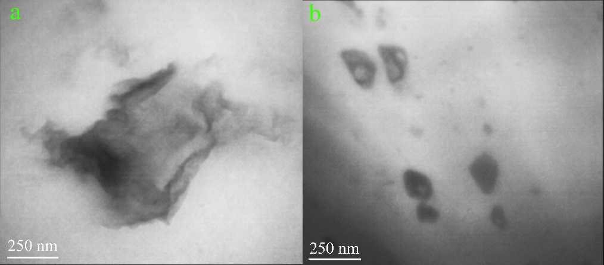
Figure S2. TEM images of (a) GO sheets and (b) GO-CS.
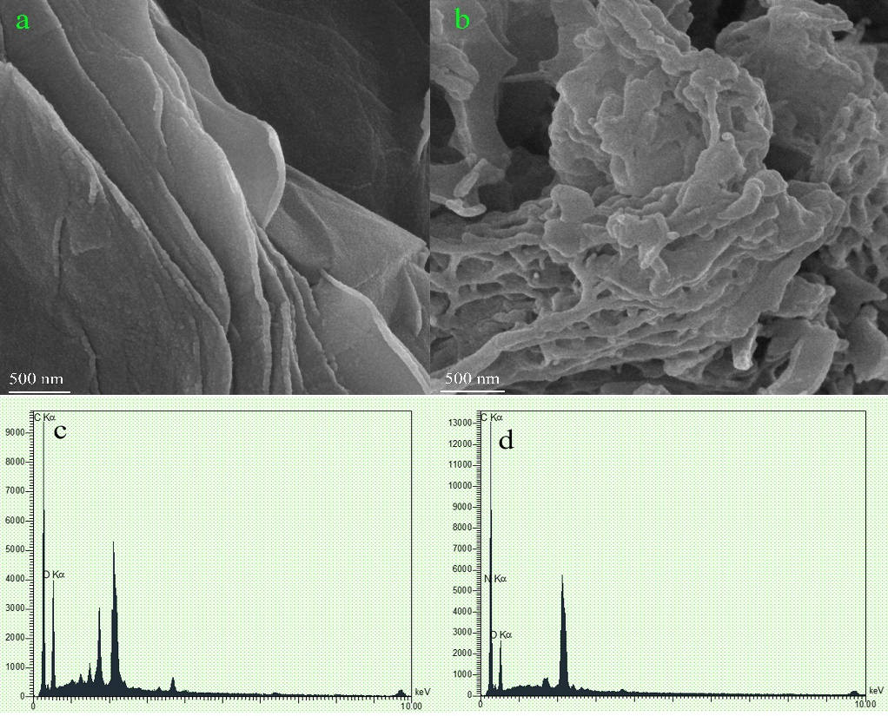

Figure S3. FESEM images of (a) GO sheets and (b) GO-CS and EDX spectra of GO (c) and GO-CS (d).
Table S2. EDX analysis of the weight percent of the elements in GO sheets and GO-CS.

Elements | GO | GO-CS
C | 47.31% | 49.29%
O | 52.69% | 33.46%
N | ……….. | 11.23%

Table S3. Mechanical properties of PCL neat and PCL based nanocomposites.
sample | Ultimate tensile strength (Mpa) | Young’s modulus (Mpa) | Elongation at break (%)
PCL neat | 19.5±0.7 | 236.68± 7.4 | 621.08±12.82
PCL/GO %0.5 | 39.75±4.57 | 365.09±6.20 | 1271.76±21.84
PCL/GO-CS %0.25 | 21.87±0.98 | 295.43±2.85 | 423.21±58.14
PCL/GO-CS %0.5 | 22.34±0.04 | 338.84±38.86 | 142.07±3.21
PCL/GO-CS %1 | 23.45±0.53 | 254.96±16.88 | 137.24±17.45

Reference
[1] A.L. Andrady, A. Torikai, T. Kobatake, Spectral sensitivity of chitosan photodegradation, Journal of applied polymer science 62(9) (1996) 1465-1471.
[2] R. Khan, M. Dhayal, Nanocrystalline bioactive TiO2–chitosan impedimetric immunosensor for ochratoxin-A, Electrochemistry Communications 10(3) (2008) 492-495.
[3] J. Paredes, S. Villar-Rodil, A. Martínez-Alonso, J. Tascon, Graphene oxide dispersions in organic solvents, Langmuir 24(19) (2008) 10560-10564.
[4] Q. Yang, X. Pan, K. Clarke, K. Li, Covalent functionalization of graphene with polysaccharides, Industrial & engineering chemistry research 51(1) (2012) 310-317.
[5] F. Emadi, A. Amini, A. Gholami, Y. Ghasemi, Functionalized graphene oxide with chitosan for protein nanocarriers to protect against enzymatic cleavage and retain collagenase activity, Scientific Reports 7 (2017) 42258.
[6] S. Kumar, J. Koh, Physiochemical and optical properties of chitosan based graphene oxide bionanocomposite, International journal of biological macromolecules 70 (2014) 559-564.
[7] R. Rajesh, E. Sujanthi, S.S. Kumar, R. Venkatesan, Designing versatile heterogeneous catalysts based on Ag and Au nanoparticles decorated on chitosan functionalized graphene oxide, Physical Chemistry Chemical Physics 17(17) (2015) 11329-11340.

