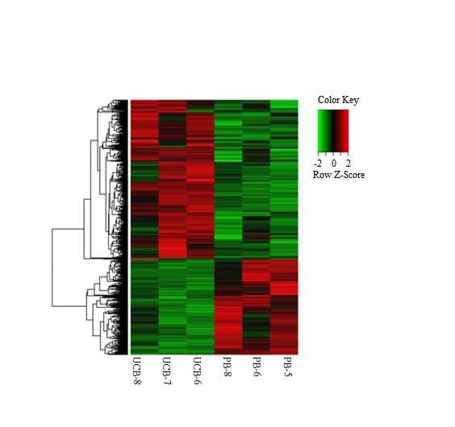
Supplementary Figure 1: Expression of differentially expressed genes (DEGs) between UCBN and PBN. n=3 donors each group.

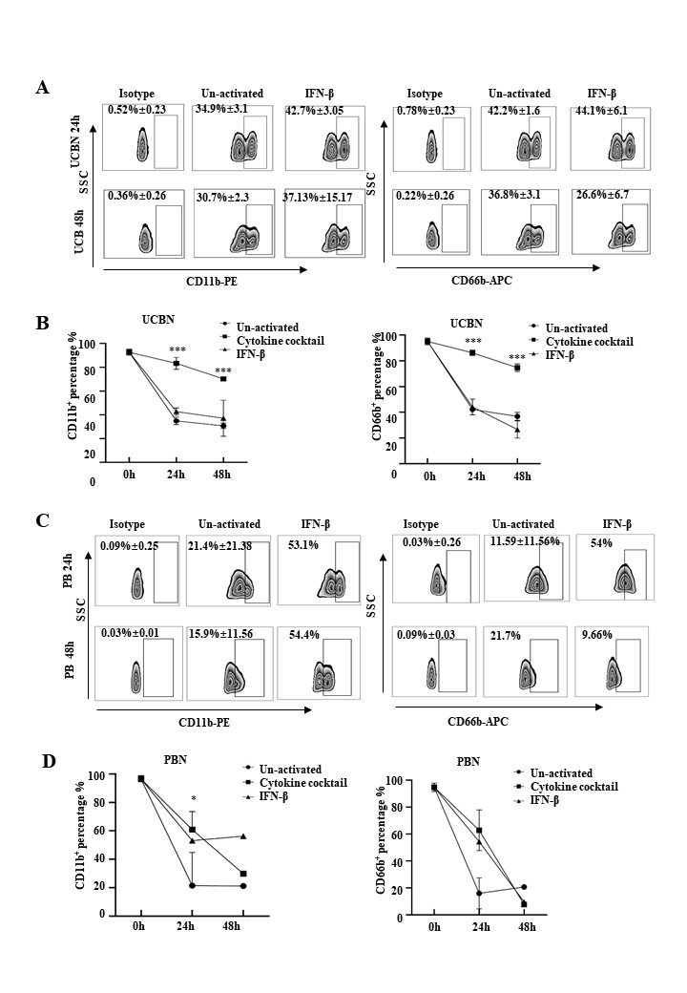
Supplementary Figure 2: Activation of UCBN and PBN by cytokine cocktail stimulation
(A): Expression of CD11b-PE and CD66b-APC in UCBN with or without IFN-β stimulation. 10ng/ml IFN-β were used to stimulate UCBN. The expression were assessed by flow cytometry at 24h and 48h after stimulation respectively.
(B): Change of CD11b and CD66b expression of UCBN after IFN-β or cytokine cocktail stimulation from 0h to 48h. n=3, ***P < 0.001
(C): Expression of CD11b-PE and CD66b-APC in PBN with or without IFN-β stimulation. 10ng/ml IFN-β were used to stimulate UCBN. The expression were assessed by flow cytometry at 24h and 48h after stimulation respectively.
(D): Change of CD11b and CD66b expression of PBN after IFN-β or cytokine cocktail stimulation from 0h to 48h. 24h (n=3), 48h (n=1), *P < 0.05

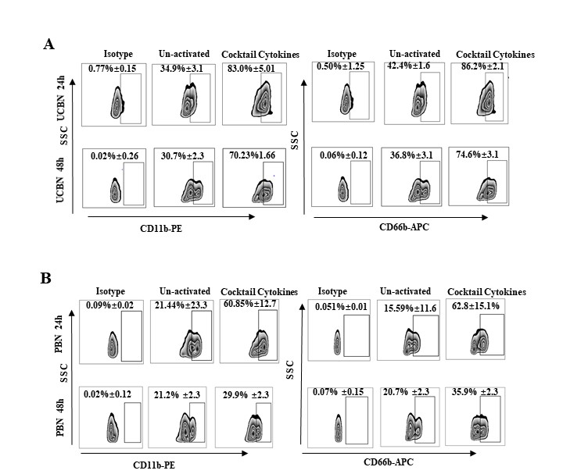

Supplementary Figure 3: CD11b and CD66b expression in UCBN or PBN after cytokines cocktail activation
(A): CD11b and CD66b expression in UCBN after cytokines cocktail activation assessed by flow cytometry at 24h and 48h after stimulation respectively.
(B): CD11b and CD66b expression in PBN after cytokines cocktail activation assessed by flow cytometry at 24h and 48h after stimulation respectively.

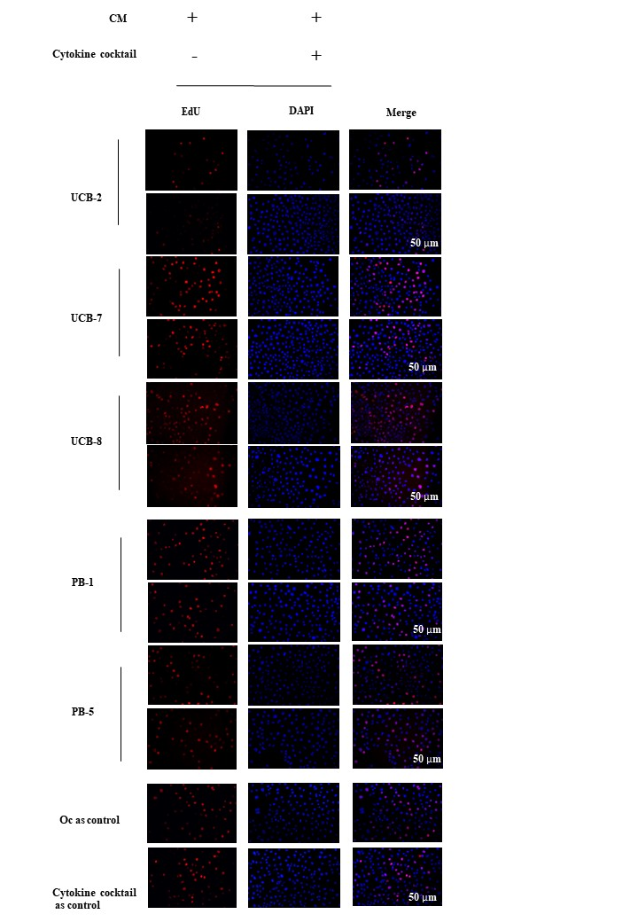
Supplementary Figure 4: Cytotoxicity of condition medium from activated UCBN and PBN determined by EdU analysis
(A): Represent images of immunofluorescence staining of EdU of ovarian cancer cells line OVCAR3 treated with conditioned medium of activated UCBN from donors UCB-2, UCB-7, and UCB-8. Bar= 50μm
(B): Represent images of immunofluorescence staining of EdU of ovarian cancer cells line OVCAR3 treated with conditioned medium of activated PBN from donors PB-1 and PB-5. Bar= 50μm

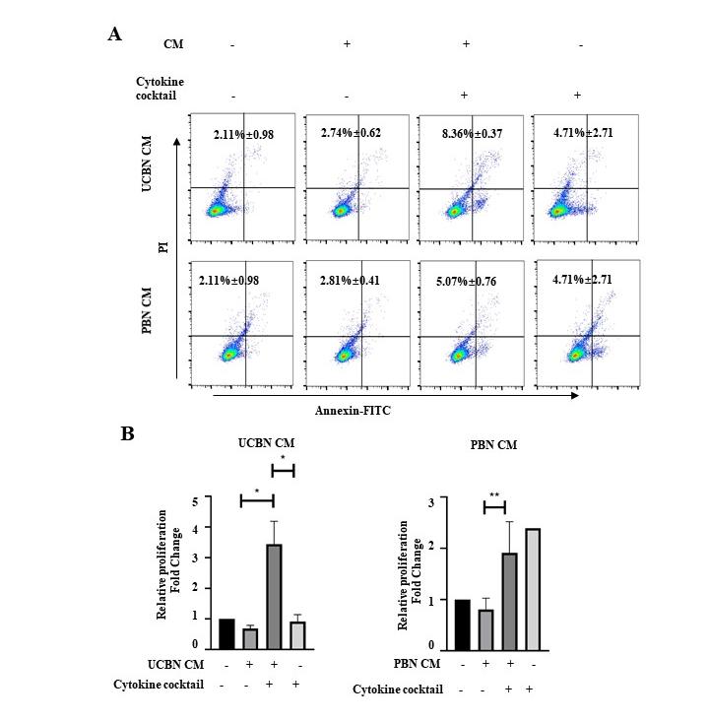
Supplementary Figure 5: Cytotoxicity of conditioned medium of activated UCBN and activated PBN determined by apoptosis analysis
(A): Representative flow chart of OVCAR3 treated with conditioned medium of activated UCBN and activated PBN staining using Annexin V-FITC/PI apoptosis detection kit.
(B): Histogram of apoptosis OVCAR3 cells treated with conditioned medium of activated UCBN and activated PBN respectively (n=5). *P < 0.05, **P < 0.01.

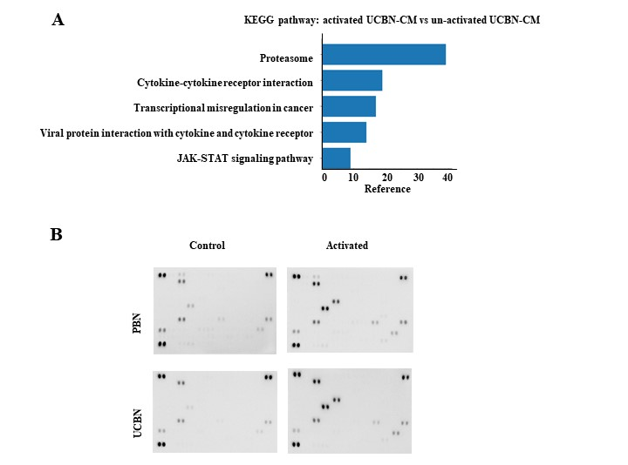
Supplementary Figure 6: Screened anti-tumor molecule CCL3 by multi-Omics analysis
(A): KEGG pathway enrichment analyses in up-regulated DEGs in activated UCBN-CM and un-activated UCBN-CM.
(B)：Lattice Diagram of Proteome Profiler TM Array.

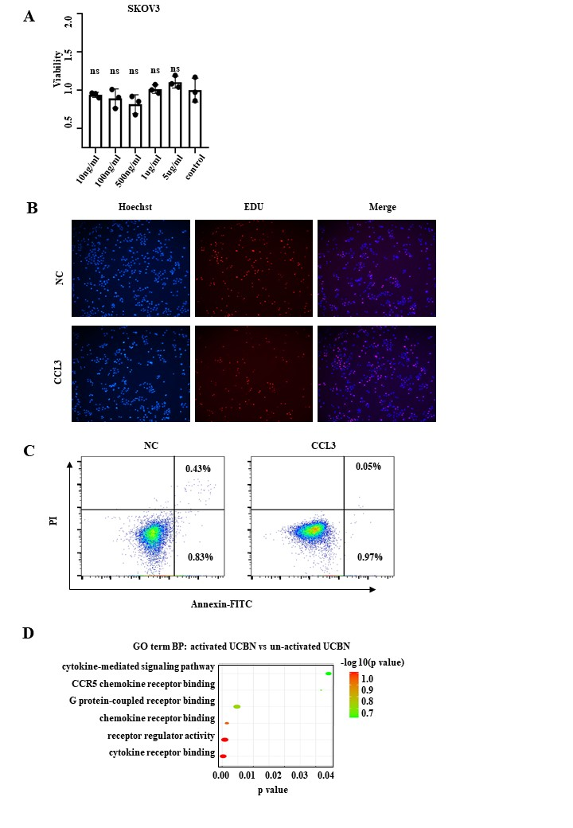
Supplementary Figure 7: CCL3 inhibited OVCAR3 proliferation by JAK/STAT pathway
(A): The viability of ovarian cancer cells line SKOV3 after treatment with CCL3. ns P ＞0.05
(B): The proliferation capacity of ovarian cancer cells line OVCAR3 treated with CCL3 assessed by EdU anaylsis.
(C): The apoptosis of ovarian cancer cells line OVCAR3 treated with CCL3 assessed by flow cytometric analysis.
(D): Gene ontology (GO) enrichment analyses of enriched BPs in up-regulated DEGs in activated UCBN-CM and un-activated UCBN-CM

Sample | sex | age | Diagnosis
UCB-1 | female | 38 | Term labor
UCB-2 | female | 29 | Term labor
UCB-3 | female | 31 | Term labor
UCB-4 | female | 32 | Term labor
UCB-5 | female | 26 | Term labor
UCB-6 | female | 30 | Term labor
UCB-7 | female | 31 | Term labor
UCB-8 | female | 30 | Term labor
PB-1 | male | 26 | Healthy adult
PB-2 | male | 27 | Healthy adult
PB-3 | male | 31 | Healthy adult
PB-5 | female | 39 | Healthy adult
PB-6 | female | 42 | Healthy adult
PB-7 | female | 38 | Healthy adult
PB-8 | female | 50 | Healthy adult
Supplemental Table 1 Characteristics of UCB and PB Samples

