Additional File 1

Reduced lysosomal activity and increased amyloid beta accumulation in silica-coated magnetic nanoparticles-treated microglia

Tae Hwan Shin* (catholicon@ajou.ac.kr)
Department of Physiology, Ajou University School of Medicine, 206 World cup-ro, 16499 Suwon, Republic of Korea
Gwang Lee* (glee@ajou.ac.kr)
Department of Molecular Science and Technology, Ajou University, Suwon-si, Gyeonggi-do 16499, Republic of Korea and Department of Physiology, Ajou University School of Medicine, Suwon-si, Gyeonggi-do 16499, Republic of Korea

*Corresponding authors:
Tae Hwan Shin, Research Fellow
Department of Physiology, Ajou University School of Medicine, Suwon-si, Gyeonggi-do 16499, Republic of Korea
Tel.: +82-31-219-4555
Fax: +82-31-219-5049
E-mail: catholicon@ajou.ac.kr

Gwang Lee, Professor
Department of Molecular Science and Technology, Ajou University, Suwon-si, Gyeonggi-do 16499, Republic of Korea and Department of Physiology, Ajou University School of Medicine, Suwon-si, Gyeonggi-do 16499, Republic of Korea
Tel.: +82-31-219-4554
Fax: +82-31-219-5049
E-mail: glee@ajou.ac.kr

Table S1. Quantitative real-time PCR primer sequences for genes encoding transcriptomic network related genes
Gene Name | Symbol | NCBI Ref. seq | Direction | Primer sequence (5’-3’)
Eph receptor B2 | Ephb2 | BC043088.1 | Forward | GGGAGTTTGCCAAGGAAATTG
Eph receptor B2 | Ephb2 | BC043088.1 | Reverse | CTTGAGGGTCTTGATGGCTAC
Arachidonate 15-lipoxygenase | Alox15 | BC081546.1 | Forward | CTGGATTGGTTCTACTGGGTTC
Arachidonate 15-lipoxygenase | Alox15 | BC081546.1 | Reverse | GTAGACTGATTAGGATTGGGCAG
Chemokine (C-C motif) ligand 2 | Ccl2 | BC055070.1 | Forward | GTAGTGTGAGTTACATACCCCG
Chemokine (C-C motif) ligand 2 | Ccl2 | BC055070.1 | Reverse | CTGTTGAGAACTGCCTTTGC
Ankyrin repeat and SOCS box-containing 2 | Asb2 | BC031161.1 | Forward | ACCCAAAGTGAGAACCTGATG
Ankyrin repeat and SOCS box-containing 2 | Asb2 | BC031161.1 | Reverse | GTTGAAGGTCTCTGGCTATGG
Haptoglobin | Hp | BC138872.1 | Forward | AAACCTCTTCCTGAACCACAG
Haptoglobin | Hp | BC138872.1 | Reverse | TTTGATTAGCCCGATATCCACC
Arginase 1 | Arg1 | AB047402.1 | Forward | GATTCCAACGACATCTACCAGG
Arginase 1 | Arg1 | AB047402.1 | Reverse | TCCATGAGTGCTTGAACAGG
Interleukin 10 | Il10 | BC137844.1 | Forward | TTGAATTCCCTGGGTGAGAAG
Interleukin 10 | Il10 | BC137844.1 | Reverse | ATGGCCTTGTAGACACCTTG
Cytochrome b-245 beta chain | Cybb | U43384.1 | Forward | TCCTATGTTCCTGTACCTTTGTG
Cytochrome b-245 beta chain | Cybb | U43384.1 | Reverse | GTCCCACCTCCATCTTGAATC
glyceraldehyde-3-phosphate dehydrogenase | Gapdh | NM_001289726.1 | Forward | GAAGACTGTGGATGGCCC
glyceraldehyde-3-phosphate dehydrogenase | Gapdh | NM_001289726.1 | Reverse | CCATGCCAGTGAGCTTCC
Ref. seq.: Reference sequence

Table S2. Ingenuity Pathway Analysis-based profiles of transcriptome of BV2 cells treated with MNPs@SiO₂(RITC)
Entrez gene name | Symbol | Ensembl ID | Location | Signal fold changeª
 |  |  |  | 0.01 μg/μl | 0.1 μg/μl
angiotensin I converting enzyme | ACE | ENSMUSG00000020681 | Plasma Membrane | 3.17 | 1.67
arachidonate 15-lipoxygenase | ALOX15 | ENSMUSG00000018924 | Cytoplasm | 1.22 | 2.39
arginase 1 | ARG1 | ENSMUSG00000019987 | Cytoplasm | -1.00 | -1.72
ankyrin repeat and SOCS box containing 2 | ASB2 | ENSMUSG00000021200 | Nucleus | -1.18 | -2.79
C-C motif chemokine ligand 2 | CCL2 | ENSMUSG00000035352 | Extracellular Space | 1.38 | 2.40
class II major histocompatibility complex transactivator | CIITA | ENSMUSG00000022504 | Nucleus |  | 2.00
C-type lectin domain family 3 member B | CLEC3B | ENSMUSG00000025784 | Extracellular Space | -1.04 | 1.63
C-type lectin domain containing 7A | CLEC7A | ENSMUSG00000079293 | Plasma Membrane | 1.03 | -1.50
cytochrome b-245 beta chain | CYBB | ENSMUSG00000015340 | Cytoplasm | -1.12 | -1.70
DNA damage inducible transcript 4 | DDIT4 | ENSMUSG00000020108 | Cytoplasm | 1.05 | -2.03
EPH receptor B2 | EPHB2 | ENSMUSG00000028664 | Plasma Membrane | 2.67 | 3.83
Fas cell surface death receptor | FAS | ENSMUSG00000024778 | Plasma Membrane | -1.08 | -1.56
fibroblast growth factor receptor 1 | FGFR1 | ENSMUSG00000031565 | Plasma Membrane |  | 2.00
gap junction protein gamma 2 | GJC2 | ENSMUSG00000043448 | Plasma Membrane | 2.00 | 2.00
haptoglobin | HP | ENSMUSG00000031722 | Extracellular Space | -1.18 | -2.69
iduronate 2-sulfatase | IDS | ENSMUSG00000035847 | Cytoplasm | -1.47 | -1.60
immunoglobulin heavy constant mu | IGHM | ENSMUSG00000076617 | Plasma Membrane | 1.13 | -2.91
interleukin 10 | IL10 | ENSMUSG00000016529 | Extracellular Space | -1.28 | -2.11
interleukin 10 receptor subunit alpha | IL10RA | ENSMUSG00000032089 | Plasma Membrane | -1.09 | -1.67
interleukin 1 receptor antagonist | IL1RN | ENSMUSG00000026981 | Extracellular Space | 1.14 | 1.64
microtubule associated protein 2 | MAP2 | ENSMUSG00000015222 | Plasma Membrane | 3.33 | 3.33
mitogen-activated protein kinase 10 | MAPK10 | ENSMUSG00000046709 | Cytoplasm | 1.00 | 4.00
microtubule associated protein tau | MAPT | ENSMUSG00000018411 | Plasma Membrane | 11.29 | 5.26
MOK protein kinase | MOK | ENSMUSG00000056458 | Plasma Membrane | 1.02 | 1.80
MYC proto-oncogene, bHLH transcription factor | MYC | ENSMUSG00000022346 | Nucleus | 1.15 | -1.51
nestin | Nes | ENSMUSG00000004891 | Cytoplasm | 1.00 | 1.64
notch receptor 1 | NOTCH1 | ENSMUSG00000026923 | Plasma Membrane | 1.02 | -1.58
notch receptor 4 | NOTCH4 | ENSMUSG00000015468 | Plasma Membrane | 2.60 | 5.00
nuclear protein 1, transcriptional regulator | NUPR1 | ENSMUSG00000030717 | Nucleus | 1.00 | -1.81
oxidized low density lipoprotein receptor 1 | OLR1 | ENSMUSG00000030162 | Plasma Membrane | -1.43 | 2.27
phosphodiesterase 3B | PDE3B | ENSMUSG00000030671 | Cytoplasm | -1.10 | -16.50
Pim-2 proto-oncogene, serine/threonine kinase | PIM2 | ENSMUSG00000031155 | Nucleus | -1.01 | -2.17
peroxisome proliferator activated receptor gamma | PPARG | ENSMUSG00000000440 | Nucleus | 1.09 | 1.82
protein kinase C beta | PRKCB | ENSMUSG00000052889 | Cytoplasm | -4.43 | -3.88
selectin P | SELP | ENSMUSG00000026580 | Plasma Membrane | 3.11 | 1.89
serpin family C member 1 | SERPINC1 | ENSMUSG00000026715 | Extracellular Space | 1.85 | 2.15
serpin family H member 1 | SERPINH1 | ENSMUSG00000070436 | Extracellular Space | 1.41 | 1.76
sestrin 2 | SESN2 | ENSMUSG00000028893 | Cytoplasm | 1.06 | -1.61
sortilin 1 | SORT1 | ENSMUSG00000068747 | Plasma Membrane | -1.91 | -1.71
transgelin | TAGLN | ENSMUSG00000032085 | Cytoplasm | 1.27 | -1.53
transforming growth factor beta receptor 3 | TGFBR3 | ENSMUSG00000029287 | Plasma Membrane |  | 7.00
TIMP metallopeptidase inhibitor 1 | TIMP1 | ENSMUSG00000001131 | Extracellular Space | 2.84 | -1.76
tribbles pseudokinase 3 | TRIB3 | ENSMUSG00000032715 | Nucleus | -1.05 | -1.68
vitamin D receptor | VDR | ENSMUSG00000022479 | Nucleus | -2.14 | 2.80
ªNormalized signal fold change of signal in treated groups with MNPs@SiO₂(RITC) to corresponding signal of control group

Table S3. Ingenuity Pathway Analysis-based profiles of proteome of BV2 cells treated with MNPs@SiO₂(RITC)
Entrez gene name | Symbol | UniProt ID | Location | Signal fold changeª
 |  |  |  | 0.01 μg/μl | 0.1 μg/μl
alpha-2-macroglobulin | A2M | Q6GQT1 | Extracellular Space | 6.23 | 2.93
arylsulfatase A | ARSA | P50428 | Cytoplasm | 2.38 | -1.31
BCL2 binding component 3 | BBC3 | Q99ML1 | Cytoplasm | -0.26 | -3.18
CD14 molecule | CD14 | P10810 | Plasma Membrane | 2.15 | 4.95
CD274 molecule | CD274 | Q9EP73 | Plasma Membrane | -2.33 | 3.42
cyclin dependent kinase 1 | CDK1 | P11440 | Nucleus | -7.91 | -2.02
cyclin dependent kinase 5 | CDK5 | P49615 | Nucleus | -2.39 | -2.31
CCAAT enhancer binding protein beta | CEBPB | P28033 | Nucleus | -7.26 | 3.35
cellular repressor of E1A stimulated genes 1 | CREG1 | O88668 | Nucleus | 2.60 | 3.43
catenin beta 1 | CTNNB1 | Q02248 | Nucleus | -1.16 | 2.44
endoplasmic reticulum oxidoreductase 1 alpha | ERO1A | Q8R180 | Cytoplasm | -0.73 | -2.37
farnesyl diphosphate synthase | FDPS | Q920E5 | Cytoplasm | -3.68 | -3.33
histone deacetylase 5 | HDAC5 | Q9Z2V6 | Nucleus | -0.02 | -2.11
heat shock protein family A (Hsp70) member 5 | HSPA5 | P20029 | Cytoplasm | -1.72 | -3.09
intercellular adhesion molecule 1 | ICAM1 | P13597 | Plasma Membrane | -3.38 | -1.63
interleukin 1 receptor antagonist | IL1RN | P25085 | Extracellular Space | 1.28 | 6.78
Jun proto-oncogene, AP-1 transcription factor subunit | JUN | P05627 | Nucleus | 2.23 | 3.02
galectin 3 | LGALS3 | P16110 | Extracellular Space | 1.41 | 3.89
lipoprotein lipase | LPL | P11152 | Cytoplasm | -2.13 | -4.86
LDL receptor related protein associated protein 1 | LRPAP1 | P55302 | Plasma Membrane | 1.39 | 2.77
nuclear factor kappa B subunit 1 | NFKB1 | P25799 | Nucleus | -3.36 | -1.81
protein disulfide isomerase family A member 3 | PDIA3 | P27773 | Cytoplasm | -0.47 | -2.71
progesterone receptor | PGR | Q00175 | Nucleus | 1.13 | 3.77
plasminogen activator, urokinase | PLAU | P06869 | Extracellular Space | 1.99 | -3.99
Rho associated coiled-coil containing protein kinase 1 | ROCK1 | P70335 | Cytoplasm | -1.18 | -2.37
sirtuin 7 | SIRT7 | Q8BKJ9 | Nucleus | 1.32 | 2.19
SRC proto-oncogene, non-receptor tyrosine kinase | SRC | P05480 | Cytoplasm | -2.47 | -2.11
transferrin | TF | Q921I1 | Extracellular Space | 6.16 | 3.08
ªNormalized signal fold change of signal in treated groups with MNPs@SiO₂(RITC) to corresponding signal of control group
Table S4. Ingenuity Pathway Analysis-based profiles of metabolome of BV2 cells treated with MNPs@SiO₂(RITC)
Symbol | ID^{b} | Location | Signal fold changeª
Symbol | ID^{b} | Location | 0.01 μg/μl | 0.1 μg/μl
acetoacetic acid | 541-50-4 | Other | -1.35 | -1.34
arachidic acid | 506-30-9 | Other | -1.45 | -1.31
arachidonic acid | 506-32-1 | Other | -1.35 | -1.51
glycine | 56-40-6 | Other | 1.40 | 1.21
L-methionine | 63-68-3 | Other | -1.26 | -1.22
L-ornithine | 70-26-8 | Other | 1.23 | 1.21
L-serine | 56-45-1 | Other | -1.05 | -1.22
lactic acid | 50-21-5 | Other | 1.74 | 1.47
malonic acid | 141-82-2 | Other | -1.38 | -1.47
stearic acid | 5281 | Other | 1.12 | 1.25
succinic acid | 110-15-6 | Other | -2.56 | -1.53
ªFold change of normalized signal in MNPs@SiO₂(RITC) treated group relative to corresponding control group. ^{b}CAS Registry Number for identifying the metabolites or PubChem CID for identifying the stearic acid.

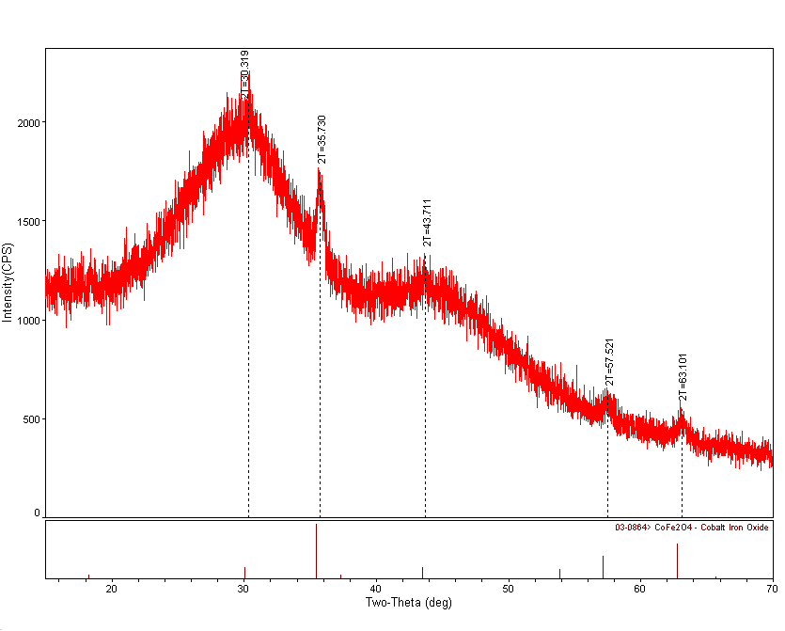
Fig. S1. XRD spectrum of MNPs@SiO₂(RITC). Peaks in 30º, 36º, 44º, 57º and 64 º are specific patterns of cobalt ferrite and the broad peak between 20º and 40º indicate the amorphous silica beads.

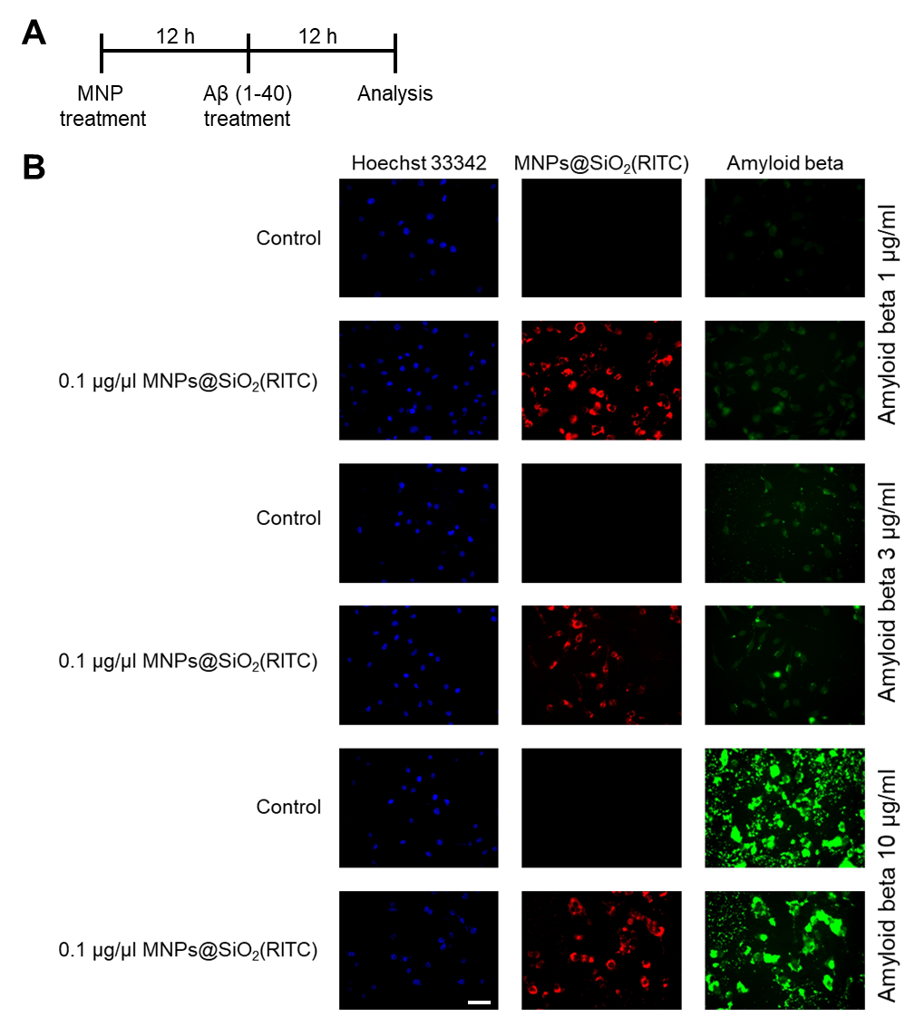
Fig. S2. (A) Analysis scheme and (B) Flourescence analsysis in MNPs@SiO₂(RITC) (red) and 1-10 μg/ml Aβ (1-40) (green) treated BV2 cells.

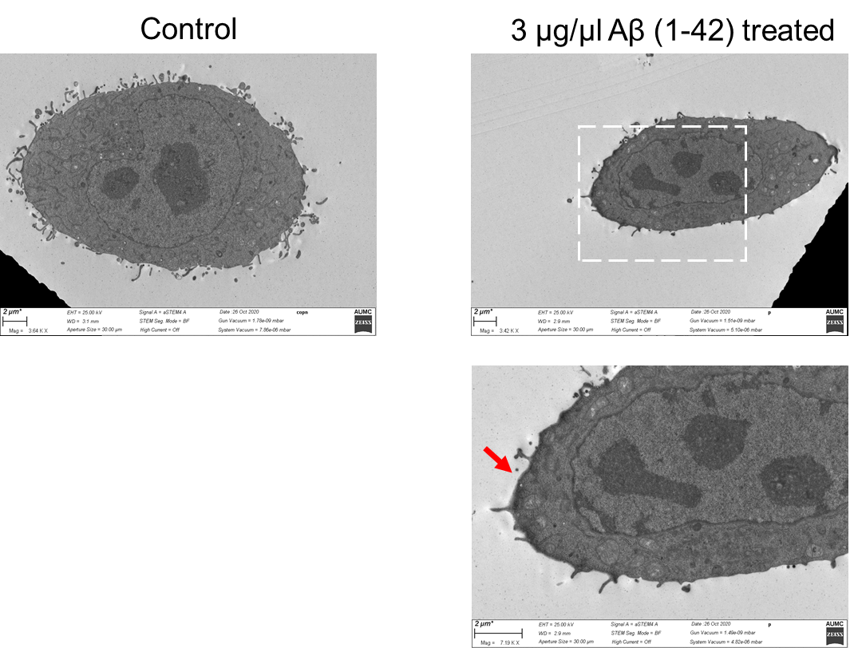
Fig. S3. Anlysis of Aβ accumulation in Aβ (1-42) treated BV2 cells using transmission electron microscopy. Magnified image of dotted square region is present in the bottom. High dense (black) region in the cell membrane of Aβ (1-42) treated BV2 cells is assumed as Aβ accumulation (red arrow).

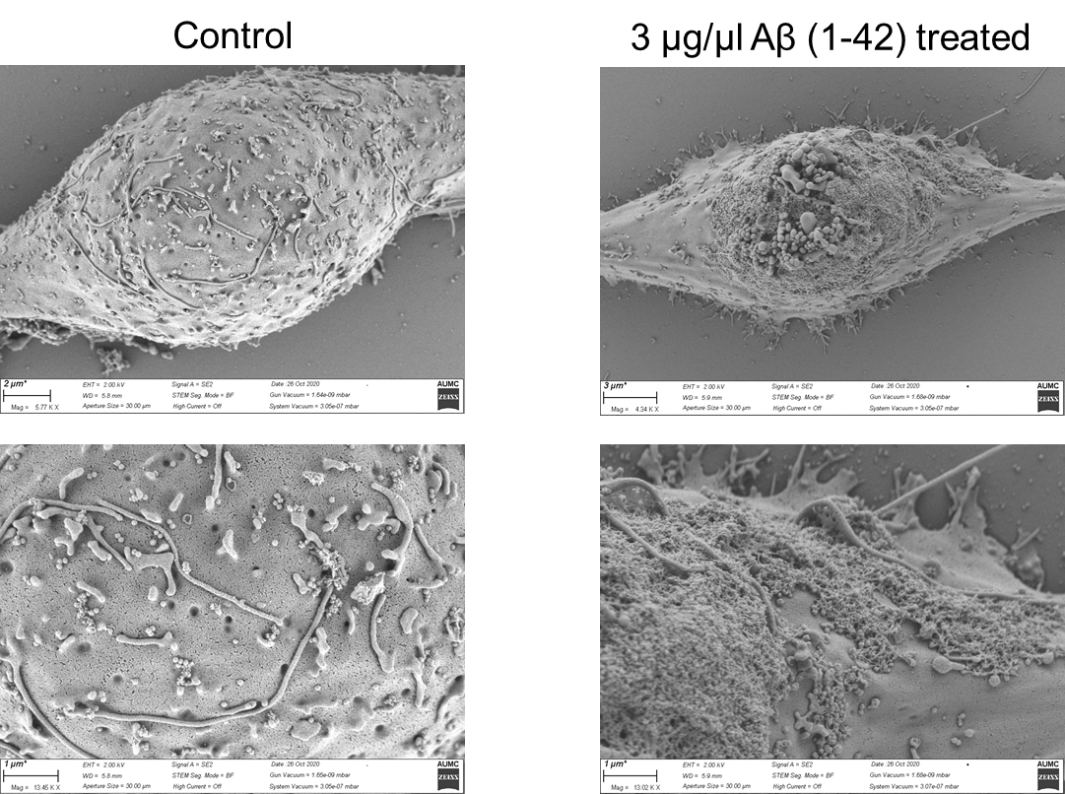
Fig. S4. Anlysis of Aβ accumulation in Aβ (1-42) treated BV2 cells using scanning electron microscopy. Magnified images are present in the bottom.

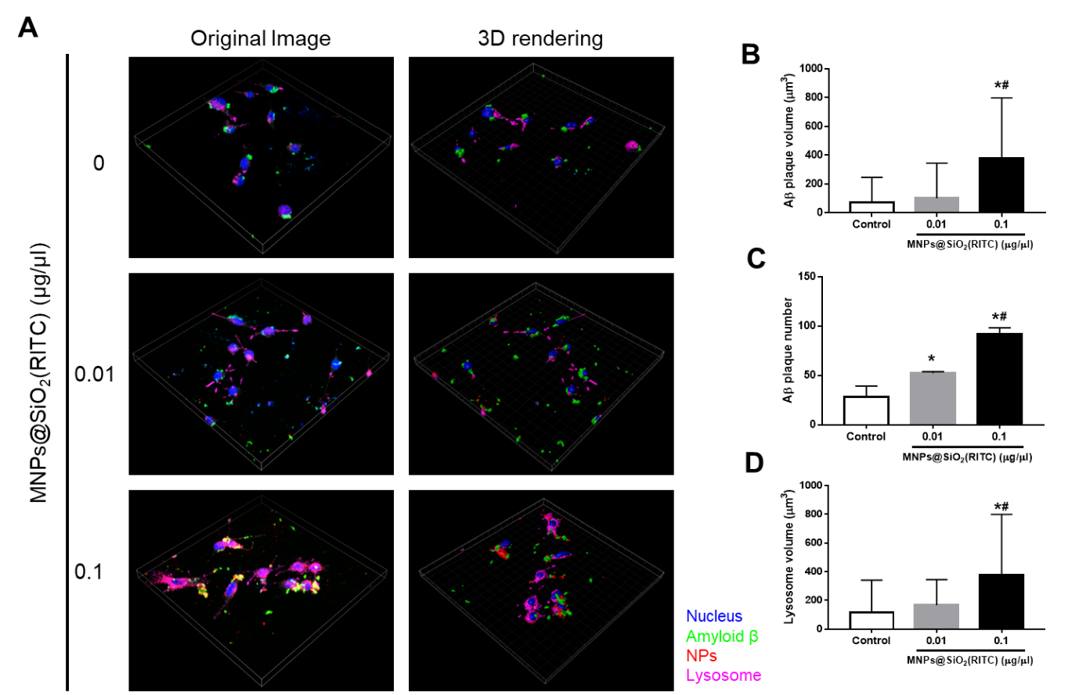
Fig. S5. Evaluation of Aβ (1-40) accumulation and lysosomal swelling in MNPs@SiO₂(RITC) and Aβ treated BV2 cells. (A) Florescence analysis of MNPs@SiO₂(RITC) and Aβ treated BV2 cells. Images are merged with florescence of Hoechst 33342 (blue), MNPs@SiO₂(RITC) (red), Lysosome (magenta), and Aβ (green) to show region-specific structure and distribution of MNPs@SiO₂(RITC) and Aβ. Scale bar = 10 µm. (B) Determination of lysosome volume in MNPs@SiO₂(RITC) treated BV2 cells. (C) Determination of Aβ plaque volume in MNPs@SiO₂(RITC) treated BV2 cells. (D) Quantification of the number of Aβ plaque in MNPs@SiO₂(RITC) treated BV2 cells. Data represent means ± standard deviation from the three independent experiments. *p < 0.05 vs. no-treatment control, #p < 0.05 vs. 0.01 µg/µl dose treatment, respectively, according to one-way ANOVA.

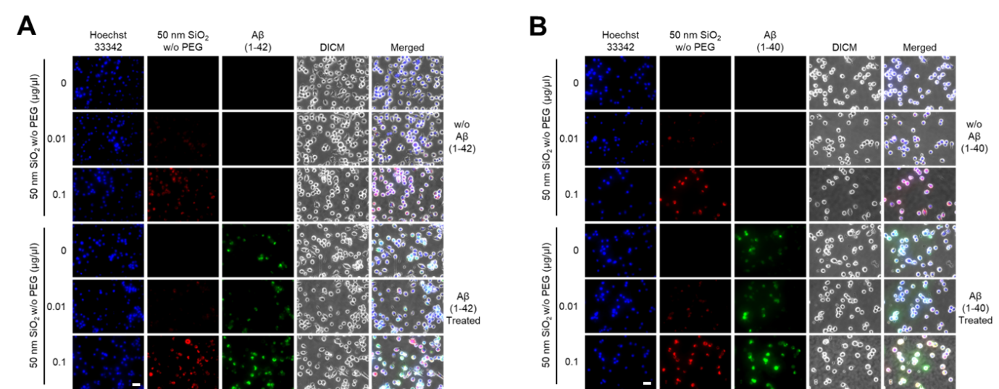
Fig. S6. Evaluation of Aβ accumulation in non-PEGylated SiO₂ NPs and (A) Aβ (1-42) and (B) (1-40) treated BV2 cells. Florescence analysis of SiO₂ NPs and Aβ treated BV2 cells. Images are merged with florescence of Hoechst 33342 (blue), SiO₂ NPs (red), and Aβ (green) to show region-specific structure and distribution of SiO₂ NPs and Aβ. Scale bar = 50 µm.

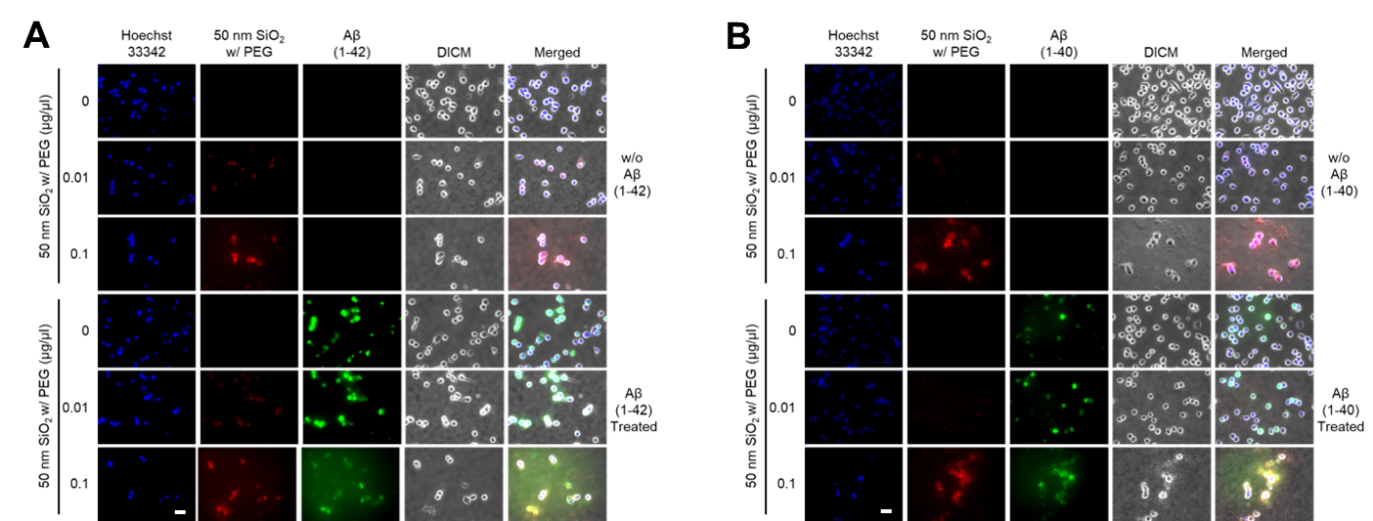
Fig. S7. Evaluation of Aβ accumulation in PEGylated SiO₂ NPs and (A) Aβ (1-42) and (B) (1-40) treated BV2 cells. Florescence analysis of PEGylated SiO₂ NPs and Aβ treated BV2 cells. Images are merged with florescence of Hoechst 33342 (blue), PEGylated SiO₂ NPs (red), and Aβ (green) to show region-specific structure and distribution of SiO₂ NPs and Aβ. Scale bar = 50 µm.

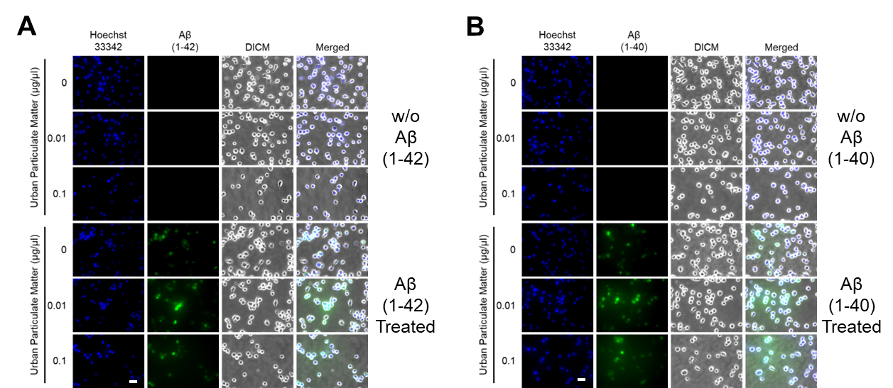
Fig. S8. Evaluation of Aβ accumulation in UPM and (A) Aβ (1-42) and (B) (1-40) treated BV2 cells. Florescence analysis of UPM and Aβ treated BV2 cells. Images are merged with florescence of Hoechst 33342 (blue) and Aβ (green) to show region-specific structure and distribution of Aβ. Scale bar = 50 µm.

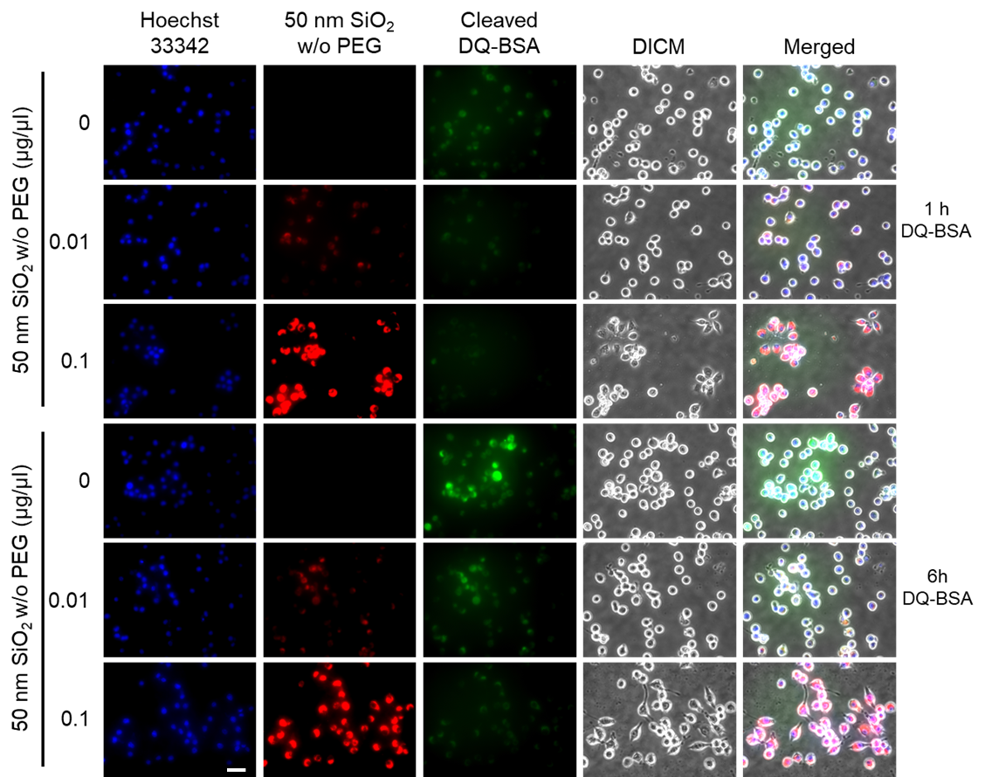
Fig. S9. Proteolytic activity analysis by DQTM-BSA incubation for 1 and 6 h in non-PEGylated SiO₂ NPs treated BV2 cells. Images are merged with florescence of Hoechst 33342 (blue), SiO₂ NPs (red), and cleaved DQ-BSA (green) and differential interference contrast microscope (DIC) image. Scale bar = 20 µm.

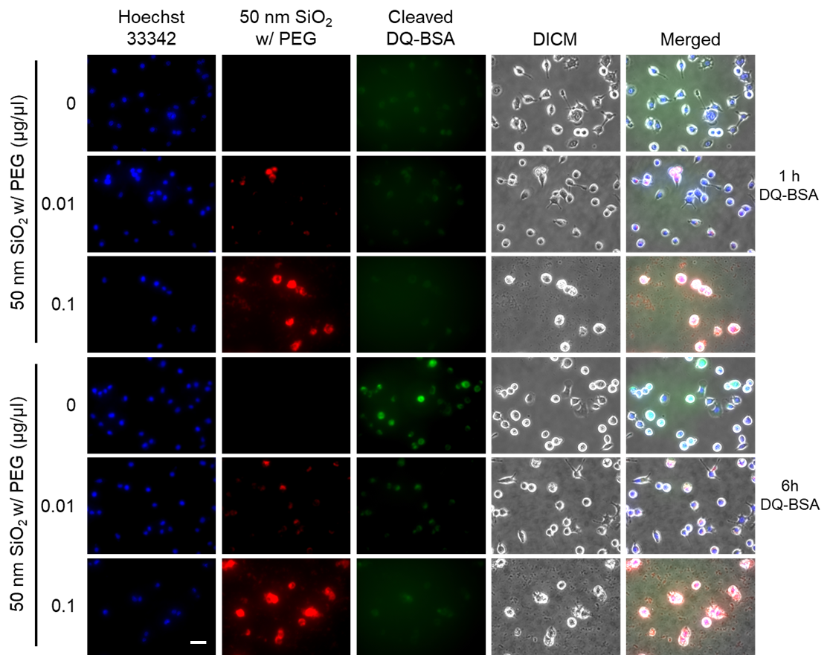
Fig. S10. Proteolytic activity analysis by DQTM-BSA incubation for 1 and 6 h in PEGylated SiO₂ NPs treated BV2 cells. Images are merged with florescence of Hoechst 33342 (blue), PEGylated SiO₂ NPs (red), and cleaved DQ-BSA (green) and differential interference contrast microscope (DIC) image. Scale bar = 20 µm.

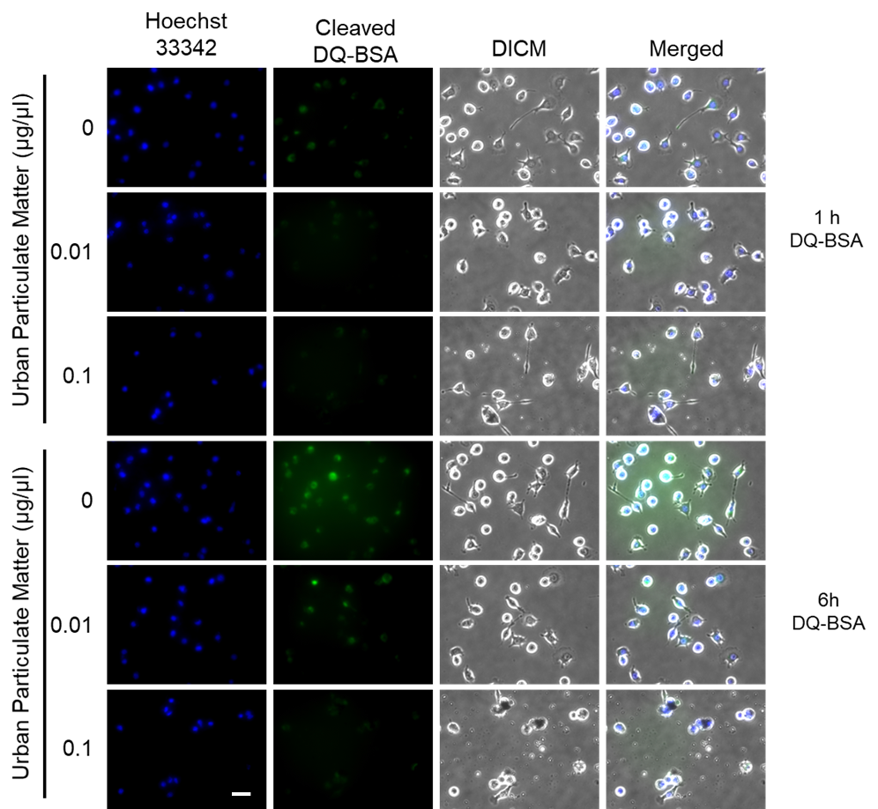
Fig. S11. Proteolytic activity analysis by DQTM-BSA incubation for 1 and 6 h in UPM treated BV2 cells. Images are merged with florescence of Hoechst 33342 (blue) and cleaved DQ-BSA (green) and differential interference contrast microscope (DIC) image. Scale bar = 20 µm.

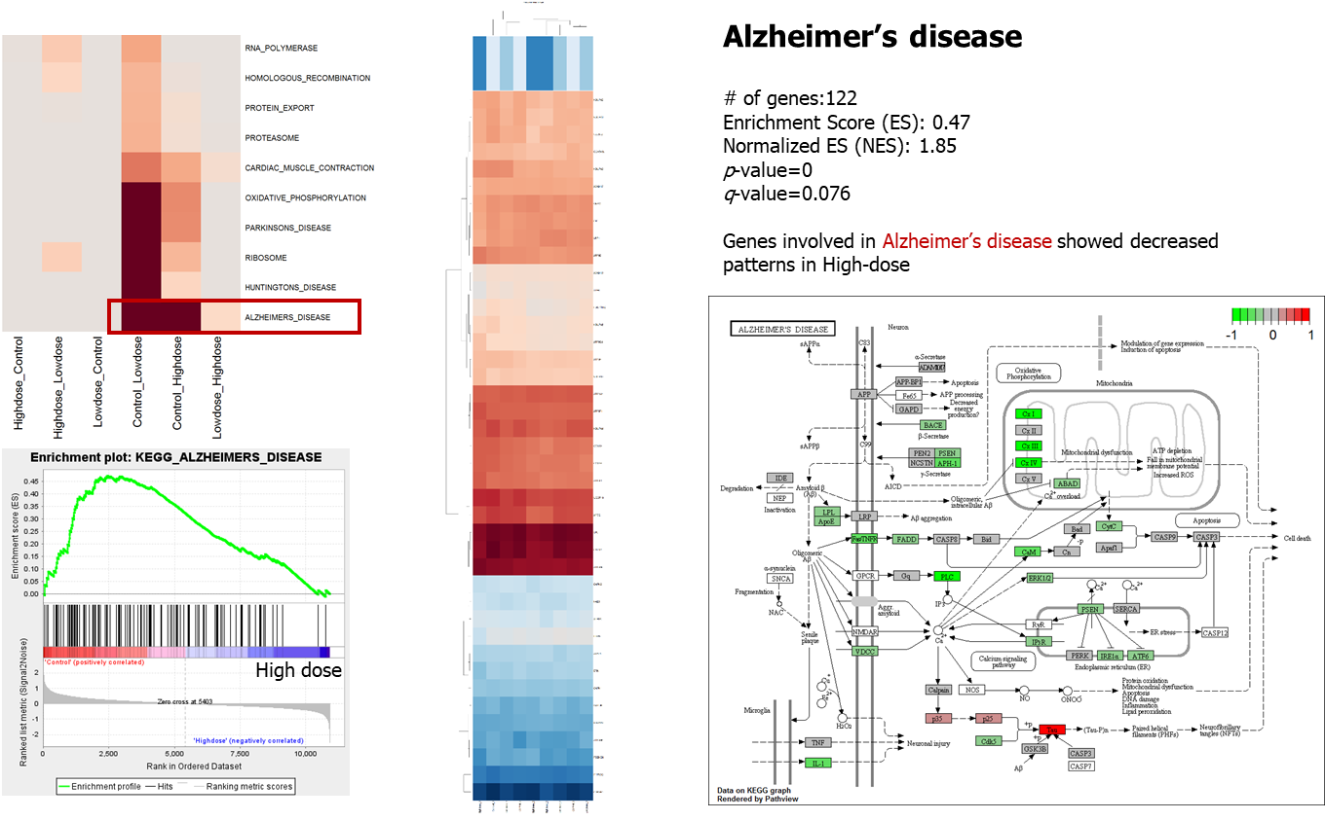
Fig. S12. Gene Set Enrichment Analysis (GSEA) [1, 2] and Kyoto Encyclopedia of Genes and Genomes (KEGG) pathway analysis [3] for Alzheimer’s disease in MNPs@SiO₂(RITC) treated BV2.

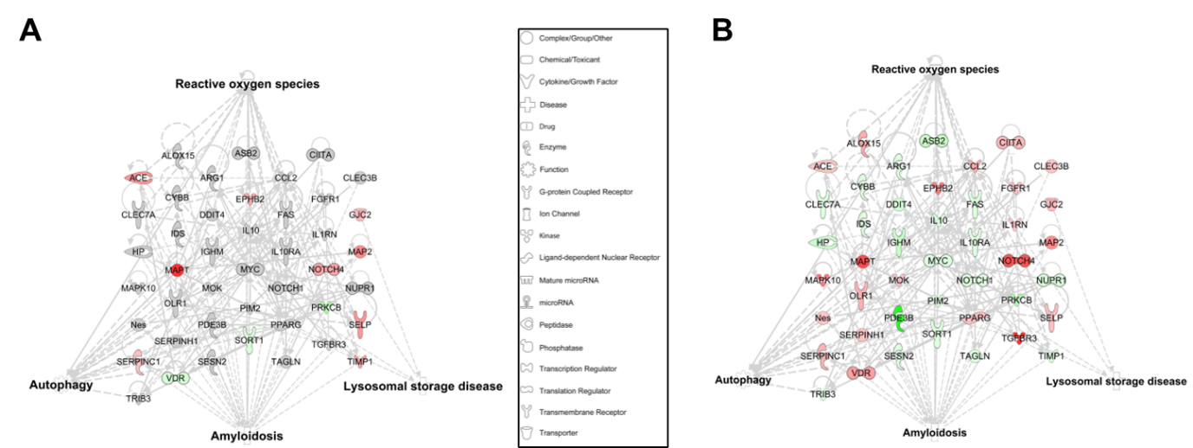
Fig. S13. Functional analysis of transcriptomic network of (A) 0.01 and (B) 0.1 µg/µl MNPs@SiO₂(RITC) treated BV2 cells using IPA. Fold change ± 1.5 was used as cut off value. Red and green areas indicate up- and downregulated genes, respectively. Path Designer Shapes are originated from Ingenuity Systems (http://www.ingenuity.com).

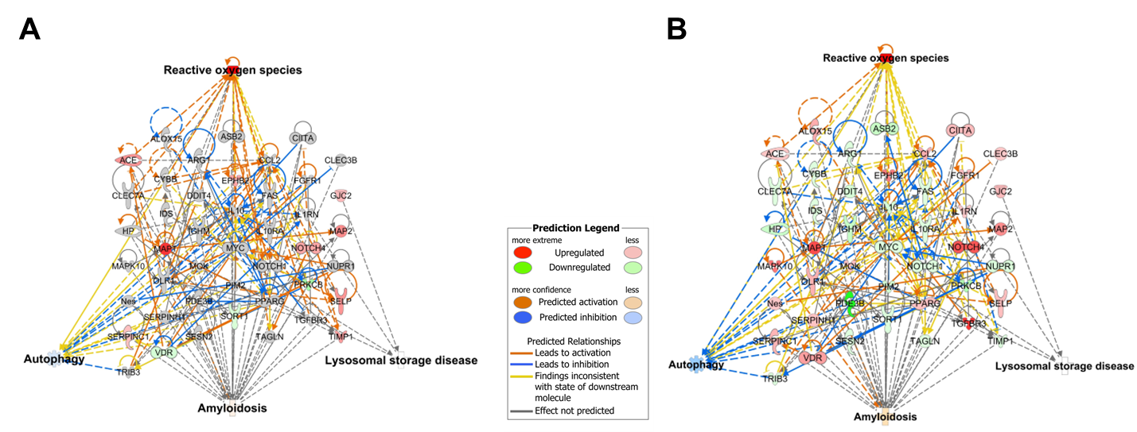
Fig. S14. Functional analysis of transcriptomic network with prediction of (A) 0.01 and (B) 0.1µg/µl MNPs@SiO₂(RITC) treated BV2 cells. Fold change ± 1.5 was used as cut off value. Red and green areas indicate up- and downregulated genes, respectively. Orange and blue areas indicate prediction as activation and inhibition, respectively. Prediction Legends are originated from Ingenuity Systems (http://www.ingenuity.com). Symbols are described in the legend of Fig. S13.

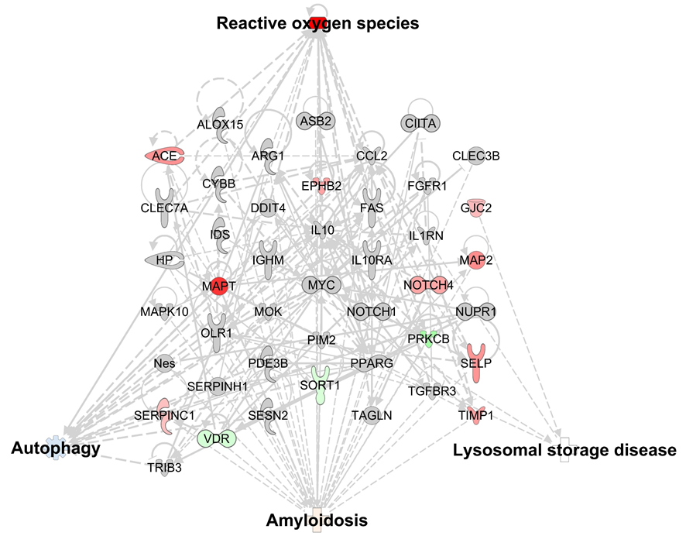
Fig. S15. Functional analysis of transcriptomic network with prediction analysis for biological functions of 0.01 µg/µl MNPs@SiO₂(RITC) treated BV2 cells. Fold change ± 1.5 was used as cut off value. Red and green areas indicate up- and downregulated genes, respectively. Orange and blue areas indicate prediction as activation and inhibition, respectively. Details for shape and color are provided in Fig. S13 and S14.

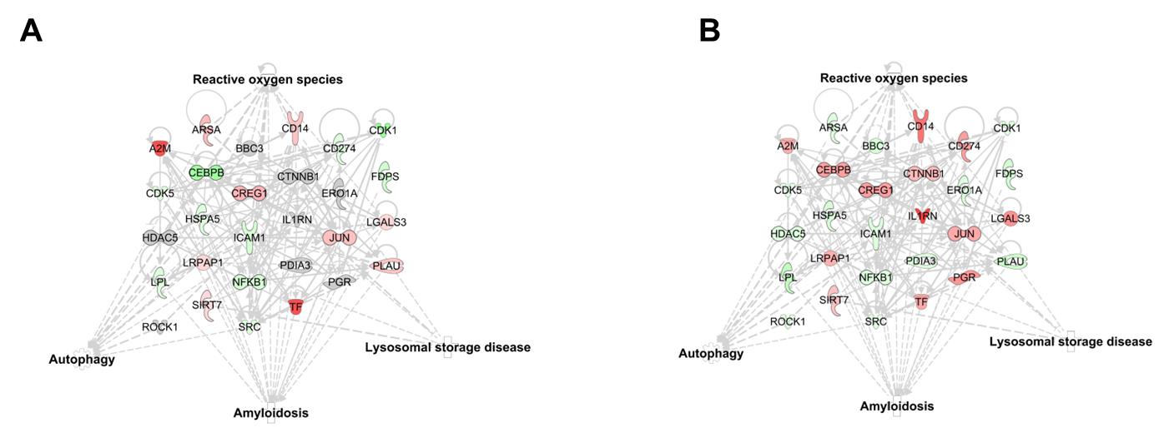
Fig. S16. Functional analysis of proteomic network of (A) 0.01 and (B) 0.1 µg/µl MNPs@SiO₂(RITC) treated BV2 cells. Fold change ± 1.3 was used as cut off value. Red and green areas indicate up- and downregulated proteins, respectively. Symbols are described in the legend of Fig. S13.

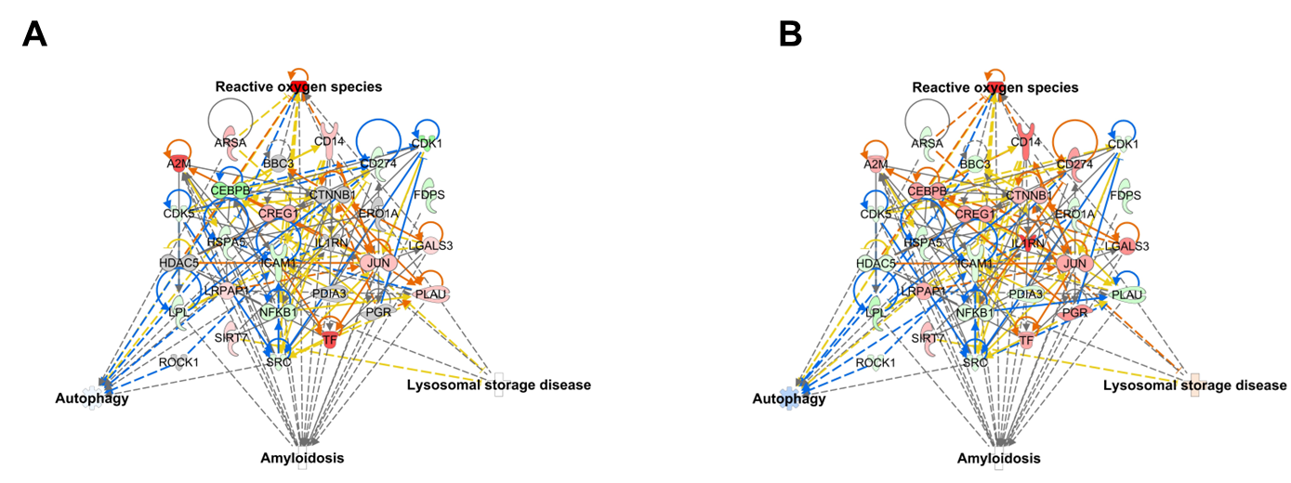
Fig. S17. Functional analysis of proteomic network with prediction of (A) 0.01 and (B) 0.1 µg/µl MNPs@SiO₂(RITC) treated BV2 cells. Fold change ± 1.3 was used as cut off value. Details for shape and color are provided in Fig. S13 and S14.

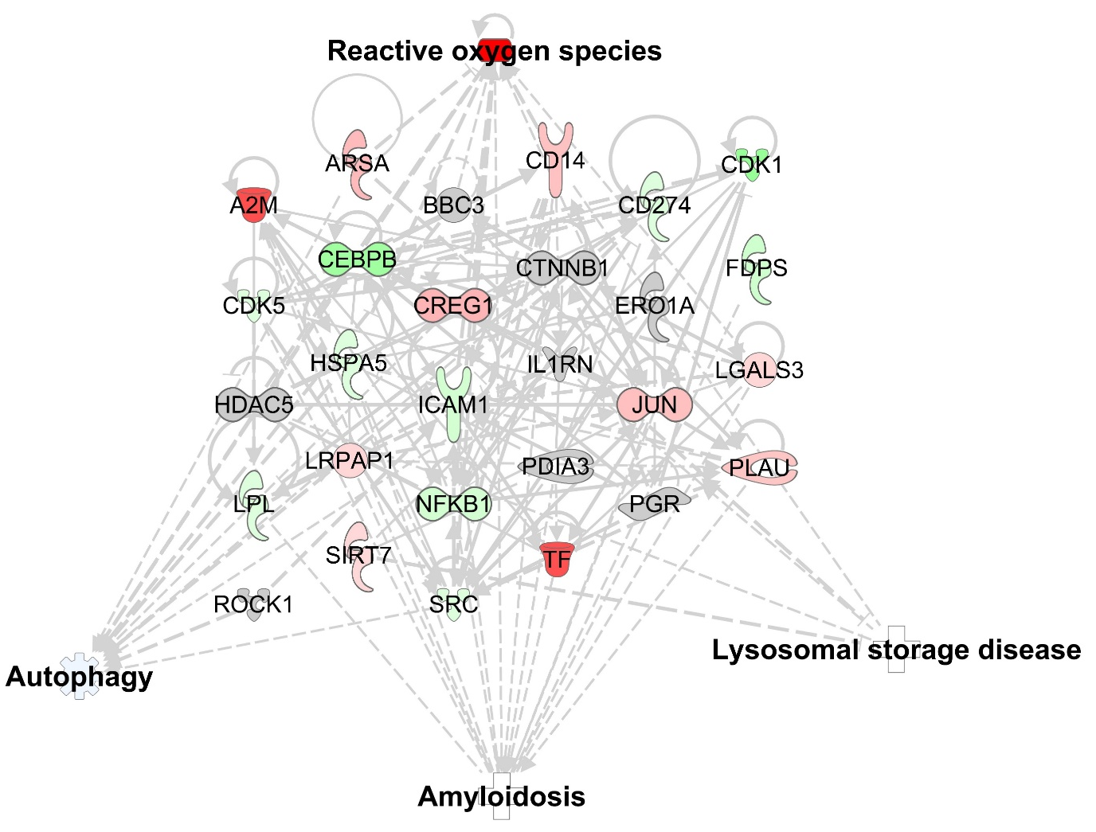
Fig. S18. Functional analysis of proteomic network with prediction analysis for biological functions of 0.01 µg/µl MNPs@SiO₂(RITC) treated BV2 cells. Fold change ± 1.3 was used as cut off value. Red and green areas indicate up- and downregulated genes, respectively. Orange and blue areas indicate prediction as activation and inhibition, respectively. Details for shape and color are provided in Fig. S13 and S14.

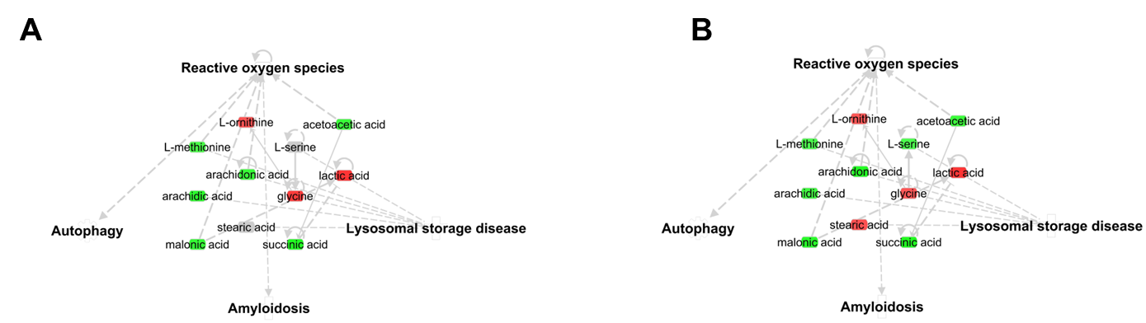
Fig. S19. Functional analysis of metabolomic network of (A) 0.01 and (B) 0.1 µg/µl MNPs@SiO₂(RITC) treated BV2 cells. Fold change ± 1.2 was used as cut off value. Red and green areas indicate up- and downregulated proteins, respectively. Symbols are described in the legend of Fig. S13.

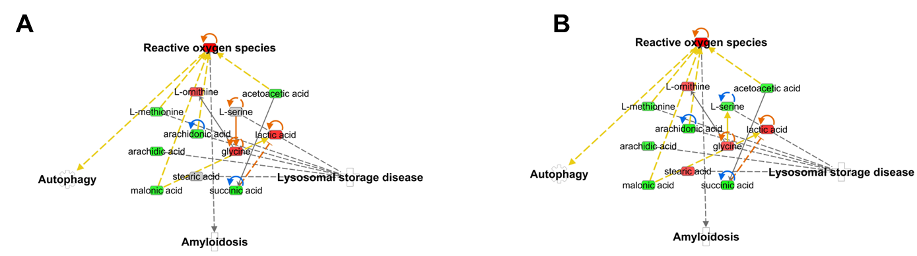
Fig. S20. Functional analysis of metabolomic network with prediction of (A) 0.01 and (B) 0.1 µg/µl MNPs@SiO₂(RITC) treated BV2 cells. Fold change ± 1.2 was used as cut off value. Details for shape and color are provided in Fig. S13 and S14.

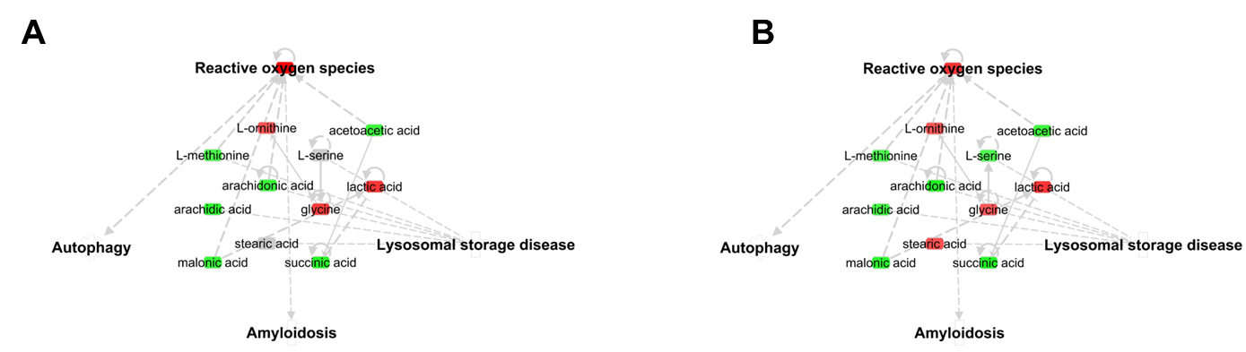
Fig. S21. Functional analysis of metabolomic network with prediction analysis for biological functions of (A) 0.01 and (B) 0.1 µg/µl MNPs@SiO₂(RITC) treated BV2 cells. Fold change ± 1.2 was used as cut off value. Red and green areas indicate up- and downregulated genes, respectively. Orange and blue areas indicate prediction as activation and inhibition, respectively. Details for shape and color are provided in Fig. S13 and S14.

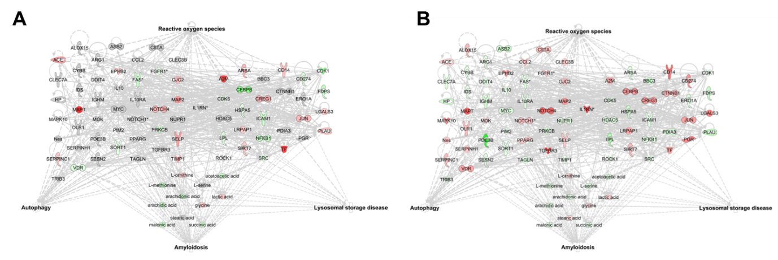
Fig. S22. Functional analysis of triple omic network of (A) 0.01 and (B) 0.1 µg/µl MNPs@SiO₂(RITC) treated BV2 cells. Fold changes ± 1.5 for genes, ± 1.3 for proteins, and ± 1.2 for metabolites were used as cut off value. Red and green areas indicate up- and downregulated proteins, respectively. Symbols are described in the legend of Fig. S13.

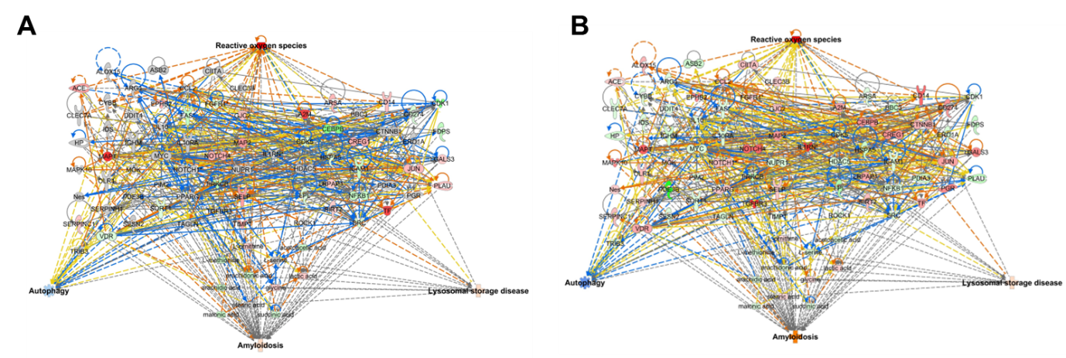
Fig. S23. Functional analysis of triple omic network with prediction of (A) 0.01 and (B) 0.1 µg/µl MNPs@SiO₂(RITC) treated BV2 cells. Fold changes ± 1.5 for genes, ± 1.3 for proteins, and ± 1.2 for metabolites were used as cut off value. Details for shape and color are provided in Fig. S13 and S14.

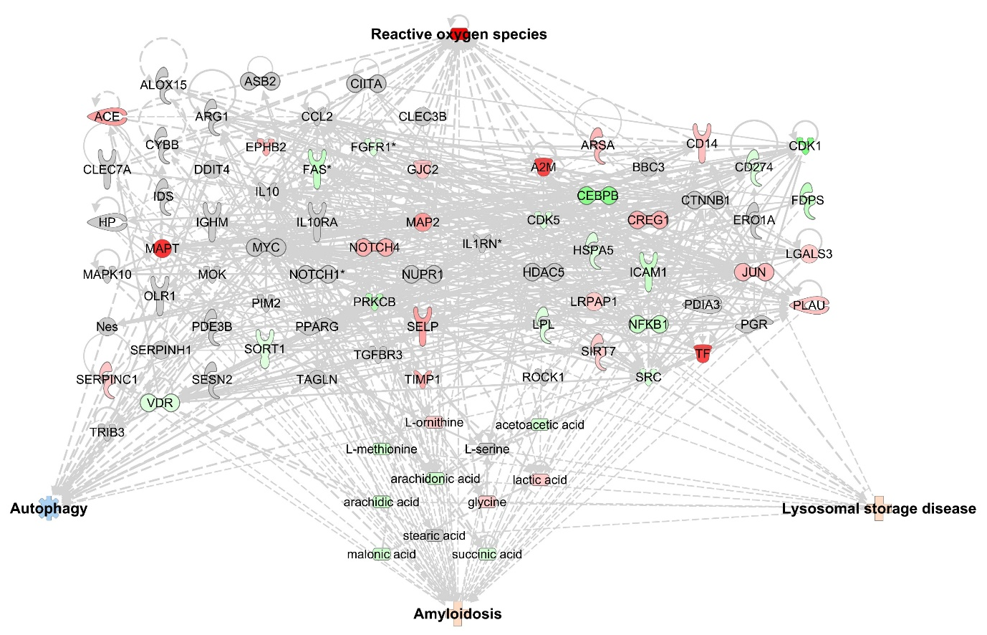
Fig. S24. Functional analysis of triple omic network with prediction analysis for biological functions of 0.01 µg/µl MNPs@SiO₂(RITC) treated BV2 cells. Fold changes ± 1.5 for genes, ± 1.3 for proteins, and ± 1.2 for metabolites were used as cut off value. Red and green areas indicate up- and downregulated genes, respectively. Orange and blue areas indicate prediction as activation and inhibition, respectively. Details for shape and color are provided in Fig. S13 and S14.

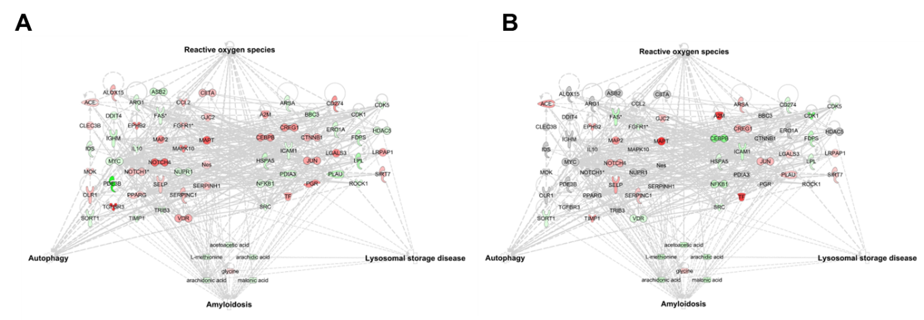
Fig. S25. Functional analysis of trimmed triple omic network of (A) 0.01 and (B) 0.1 µg/µl MNPs@SiO₂(RITC) treated BV2 cells. Fold changes ± 1.5 for genes, ± 1.3 for proteins, and ± 1.2 for metabolites were used as cut off value. Red and green areas indicate up- and downregulated proteins, respectively. Symbols are described in the legend of Fig. S13.

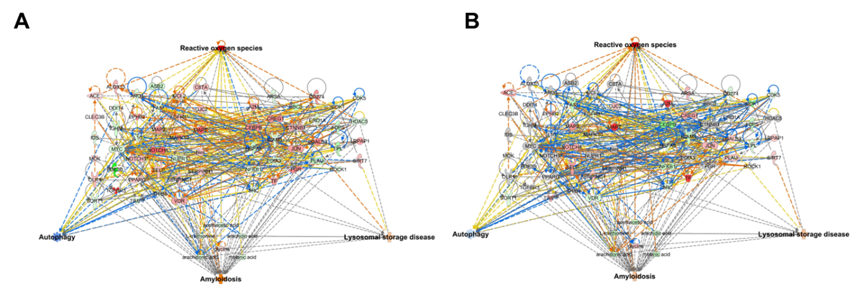
Fig. S26. Functional analysis of trimmed triple omic network with prediction of (A) 0.01 and (B) 0.1 µg/µl MNPs@SiO₂(RITC) treated BV2 cells. Fold changes ± 1.5 for genes, ± 1.3 for proteins, and ± 1.2 for metabolites were used as cut off value. Details for shape and color are provided in Fig. S13 and S14.

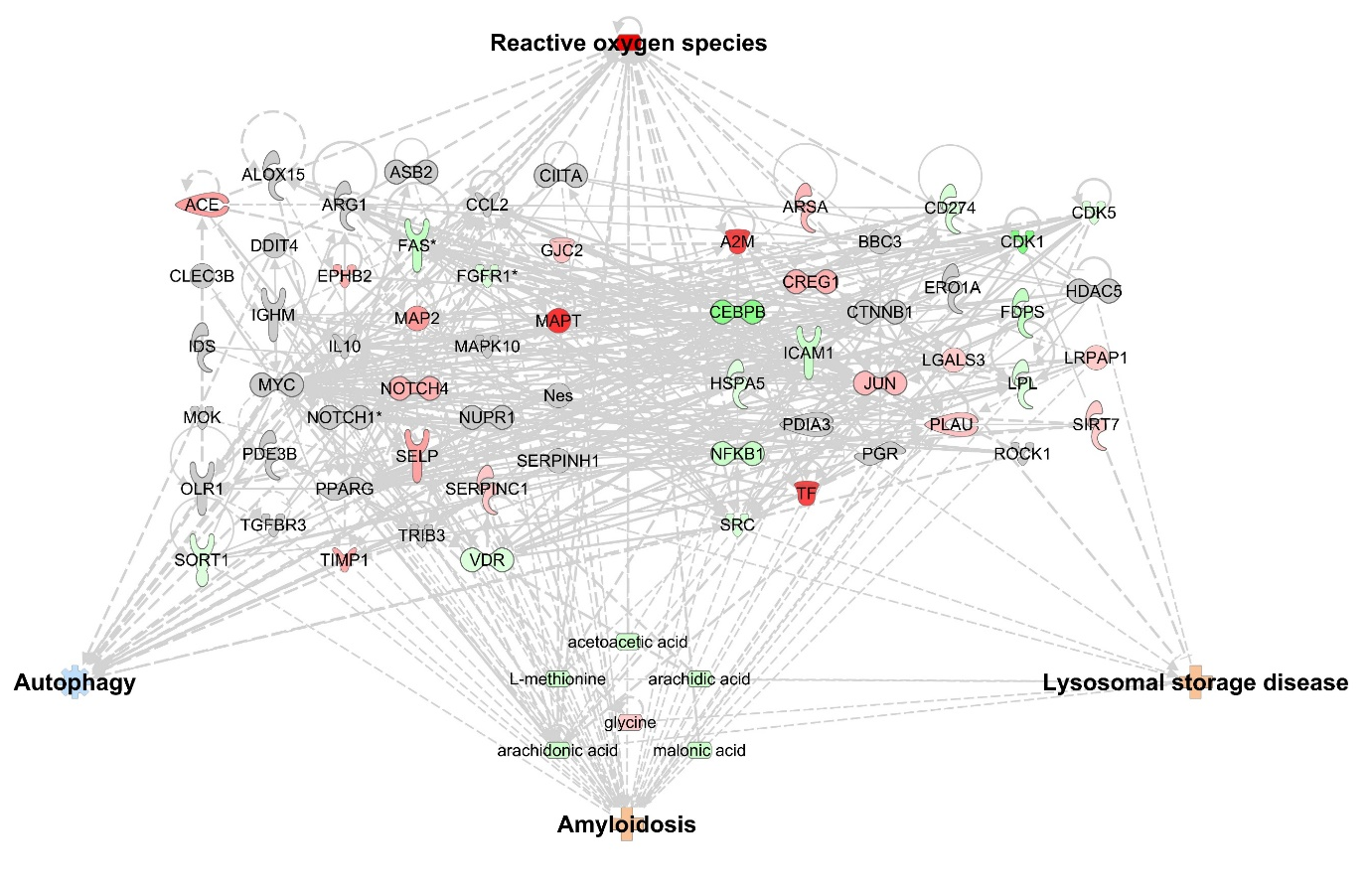
Fig. S27. Functional analysis of trimmed triple omic network with prediction analysis for biological functions of 0.01 µg/µl MNPs@SiO₂(RITC) treated BV2 cells. Fold changes ± 1.5 for genes, ± 1.3 for proteins, and ± 1.2 for metabolites were used as cut off value. Red and green areas indicate up- and downregulated genes, respectively. Orange and blue areas indicate prediction as activation and inhibition, respectively. Details for shape and color are provided in Fig. S13 and S14.

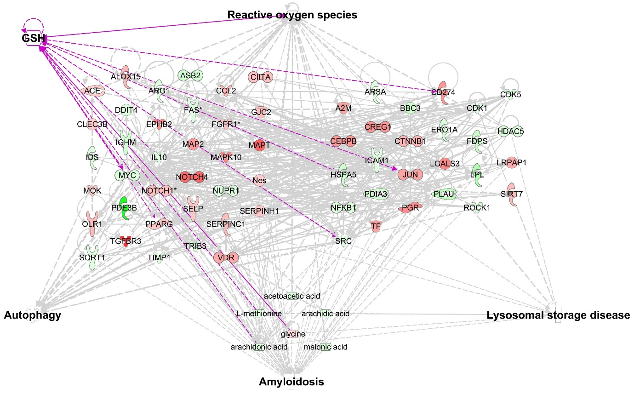
Fig. S28. Functional analysis of trimmed triple omic network with 0.1 µg/µl MNPs@SiO₂(RITC) treated BV2 cells in the presence of GSH. Fold changes ± 1.5 for genes, ± 1.3 for proteins, and ± 1.2 for metabolites were used as cut off value. Red and green areas indicate up- and downregulated genes, respectively. Orange and blue areas indicate prediction as activation and inhibition, respectively. Details for shape and color are provided in Fig. S13 and S14.

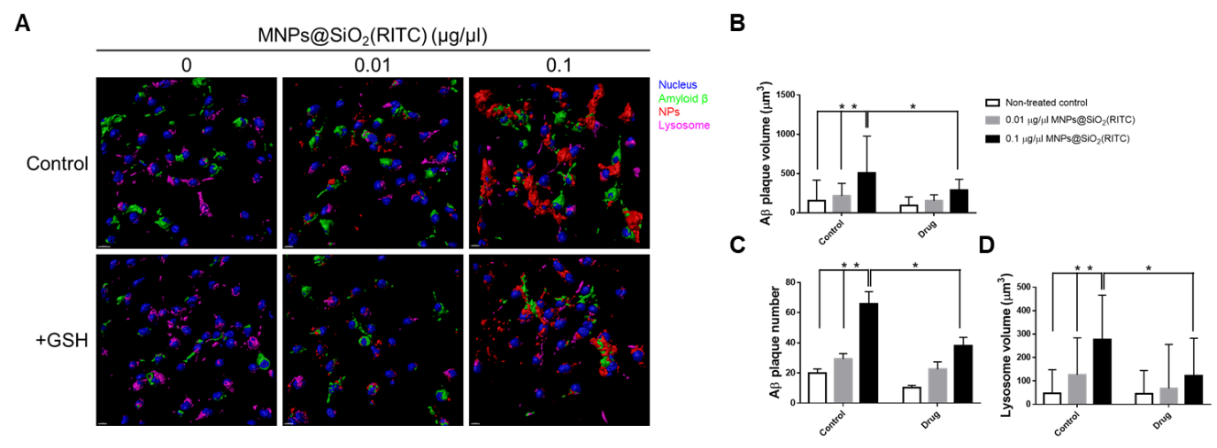
Fig. S29. Evaluation of Aβ accumulation and lysosomal swelling and and effects of GSH in MNPs@SiO₂(RITC) and Aβ treated BV2 cells. (A) 3D rendering images from z-stack-acquried florescence images of the MNPs@SiO₂(RITC) and Aβ treated BV2 cells. Images are merged with florescence of Hoechst 33342 (blue), MNPs@SiO₂(RITC) (red), Lysosome (magenta), and Aβ (green) to show region-specific structure and distribution of MNPs@SiO₂(RITC) and Aβ. Scale bar = 10 µm. (B) Determination of lysosome volume in MNPs@SiO₂(RITC) treated BV2 cells. (C) Determination of Aβ plaque volume in MNPs@SiO₂(RITC) treated BV2 cells. (D) Quantification of the number of Aβ plaque in MNPs@SiO₂(RITC) treated BV2 cells. Data represent means ± standard deviation from the three independent experiments. *p < 0.05 vs. no-treatment control, #p < 0.05 vs. 0.01 µg/µl dose treatment, respectively, according to one-way ANOVA.

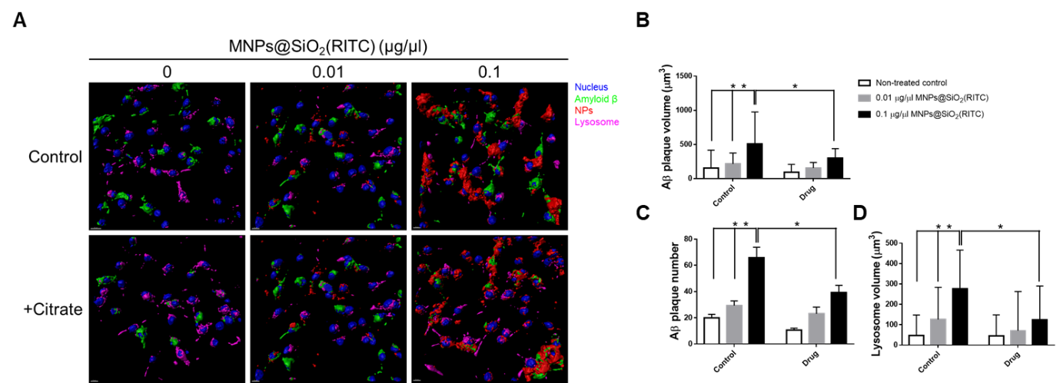
Fig. S30. Evaluation of Aβ accumulation and lysosomal swelling and and effects of citrate in MNPs@SiO₂(RITC) and Aβ treated BV2 cells. (A) 3D rendering images from z-stack-acquried florescence images of the MNPs@SiO₂(RITC) and Aβ treated BV2 cells. Images are merged with florescence of Hoechst 33342 (blue), MNPs@SiO₂(RITC) (red), Lysosome (magenta), and Aβ (green) to show region-specific structure and distribution of MNPs@SiO₂(RITC) and Aβ. Scale bar = 10 µm. (B) Determination of lysosome volume in MNPs@SiO₂(RITC) treated BV2 cells. (C) Determination of Aβ plaque volume in MNPs@SiO₂(RITC) treated BV2 cells. (D) Quantification of the number of Aβ plaque in MNPs@SiO₂(RITC) treated BV2 cells. Data represent means ± standard deviation from the three independent experiments. *p < 0.05 vs. no-treatment control, #p < 0.05 vs. 0.01 µg/µl dose treatment, respectively, according to one-way ANOVA.

References

1. Subramanian A, Tamayo P, Mootha Vamsi K, Mukherjee S, Ebert Benjamin L, Gillette Michael A, Paulovich A, Pomeroy Scott L, Golub Todd R, Lander Eric S, Mesirov Jill P. Gene set enrichment analysis: A knowledge-based approach for interpreting genome-wide expression profiles. Proceedings of the National Academy of Sciences. 2005, 102:15545-15550.
2. Mootha VK, Lindgren CM, Eriksson K-F, Subramanian A, Sihag S, Lehar J, Puigserver P, Carlsson E, Ridderstråle M, Laurila E, et al. PGC-1α-responsive genes involved in oxidative phosphorylation are coordinately downregulated in human diabetes. Nature Genetics. 2003, 34:267-273.
3. Kanehisa M, Sato Y, Kawashima M, Furumichi M, Tanabe M. KEGG as a reference resource for gene and protein annotation. Nucleic Acids Research. 2016, 44:D457-D462.

