TABLE 1
Performance of Unetvgg16 after Adding Different Modules
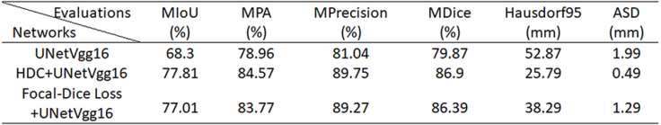
TABLE 2
Performance Comparison between SCU-Net and Several
