Supplementary Information S for Färber Lorda and Färber Data 2021.
Autumn Vertical distribution of zooplankton in the Oxygen Minimum Zone of the Eastern Tropical North Pacific.
Supplementary Information S
S1a. Oxygen vs. temperature; oxygen also shown in color scale. Depth vs. oxygen for the entire cruise; salinity also shown in color scale. A layer of about 1000 m of low-oxygen waters was observed, starting at the depth where temperature was ~11°C.
S1b. Depth of oxygen concentrations of 45 µmol kg⁻¹ and 4.5 µmol kg⁻¹. Different color scales were used for the two figures. Fixed points of continuous sampling are shown for stations B11 and D03.
S2a, 2b. a) Total abundance of all other euphausiids species. b) Total abundance of furcilia stages, including all species.

a)

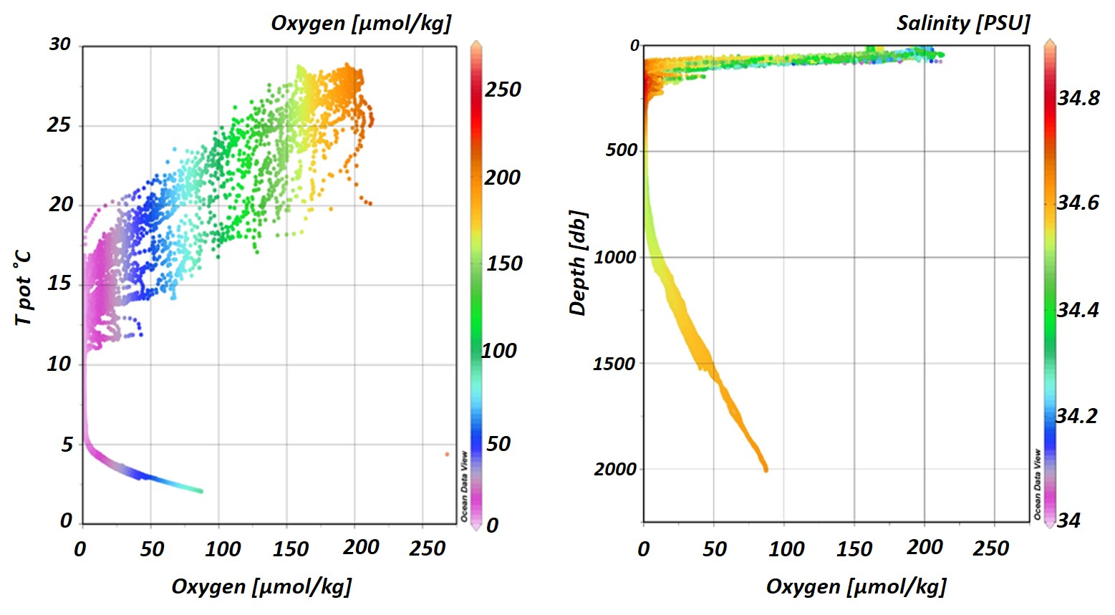

b)
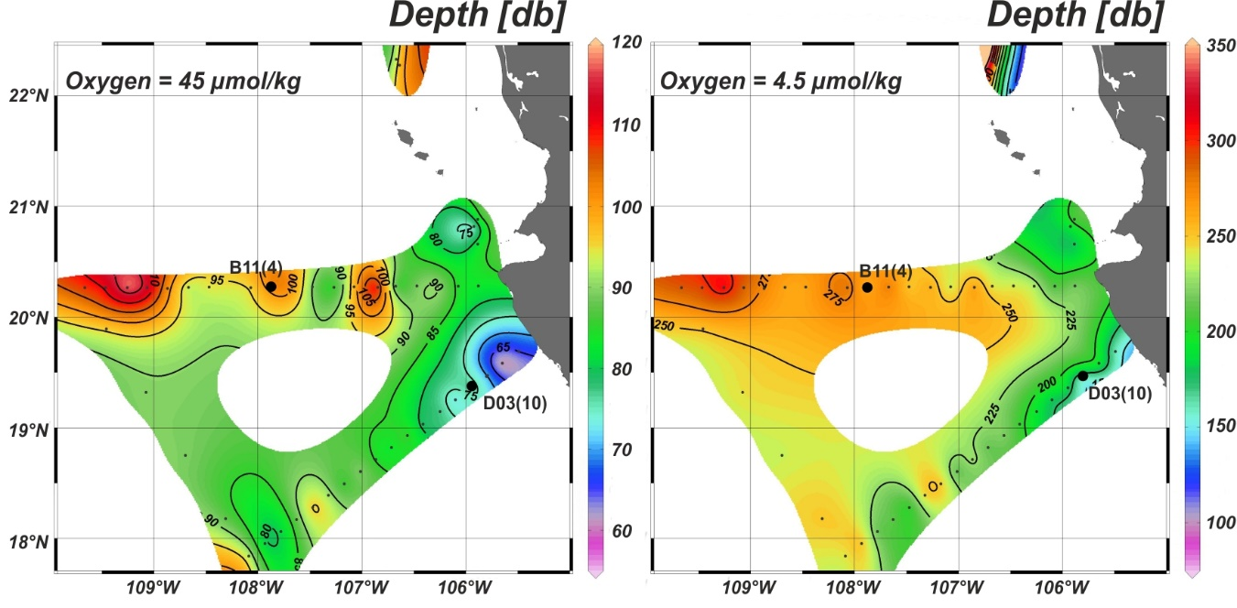

S1a. Oxygen vs. temperature; oxygen also shown in color scale. Depth vs. oxygen for the entire cruise; salinity also shown in color scale. A layer of about 1000 m of low-oxygen waters was observed, starting at the depth where temperature was ~11°C. Figure plotted with the ODV program version 4.
S1b. Depth of oxygen concentrations of 45 µmol kg⁻¹ and 4.5 µmol kg⁻¹. Different color scales were used for the two figures. Fixed points of continuous sampling are shown for stations B11 and D03. Figure plotted with the ODV program version 4.

a)

b)
S2a, 2b. a) Total abundance of all other euphausiids species. b) Total abundance of furcilia stages, including all species.

