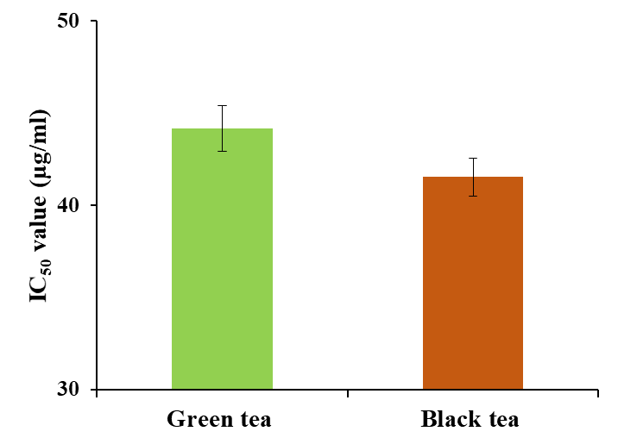
Supplementary Fig. S Comparative analysis of IC₅₀ values (mg/mL) between green tea extractive and black tea extractives. Values are represented as mean ± SD where n = 3. The mean’s differences were compared in one-way analysis of variance followed by Duncan’s multiple range test (DMRT) with significant difference at P ≤ 0.05. Mean values with same alphabetical letters are not significantly different at P ≤ 0.05.

