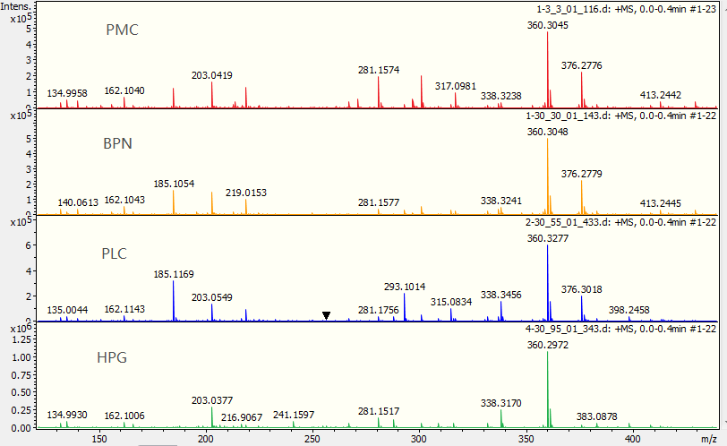
Fig. S1 From top to bottom are the typical peak spectra of samples from PMC, BPN, PLC, and HPG, respectively. The X-axis represents the m/z value, which can be understood as the molecular weight of the substance, different m/z values represent different low-molecular metabolites; the Y-axis represents the absolute intensity value of the substance contained in the sample. Comparing the four groups visually, it can be seen that most of the low-molecular metabolites are present in the four groups, but the absolute intensity values are different in different samples. There are some low-molecular metabolites that are unique to a certain sample, or not present in a certain sample. The main reason is that the absolute intensity value is too low, causing the peak height too low to be identified in the figure.

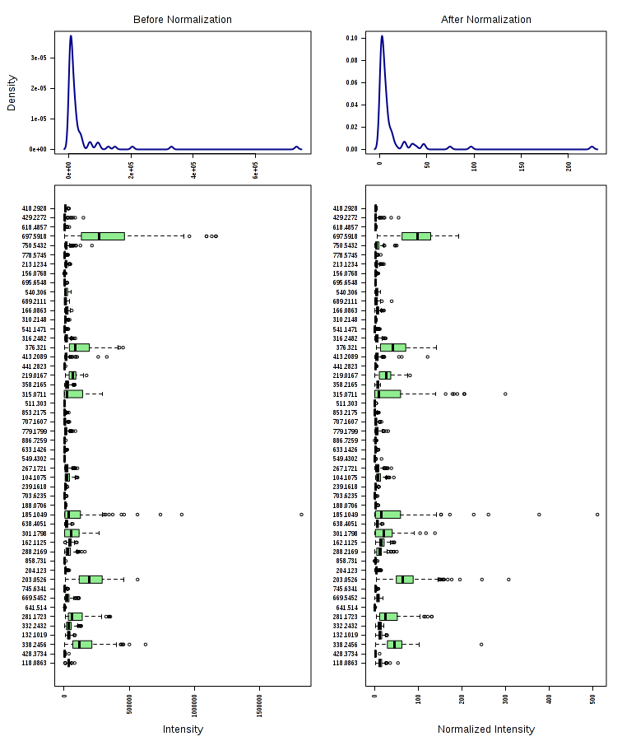
Fig. S2 Kernel density plots and box plots before and after the normalization of data from the four groups are shown. The density plots are based on all samples. Box plots show up to 50 molecular-weight features due to space constraints.

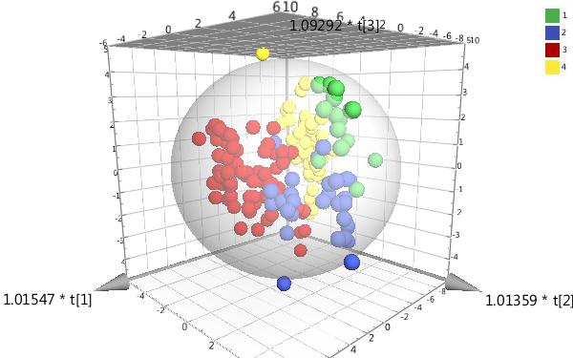

Fig.S3 Three-dimensional graphic is obtained after statistical analysis of multivariate variables in four groups. It can be seen that the spatial distribution of samples in different groups have a clear trend of dispersion. The spatial distribution of samples in the same group have a trend of aggregation, indicating that the level of low-molecular metabolites in different groups are apparently different.

Fig.S4 Permutation test of the three pulmonary nodule groups. The number of tests is 200, the X-axis represents the correlation between the random group Y and the original group Y, and the Y-axis represents the scores of R2 and Q2. The rightmost is the real value, the left is the simulated value. The Q2 value of all the blue on the left is lower than the original point on the right, the R2 value of all the green on the left is lower than the original point on the right, and the intercept of the regression line of Q2 is <0.05.

Fig.S5 After OPLS-DA analysis, the predicted values of all low-molecular metabolites are calculated in the overall comparison of the three pulmonary nodule groups. The larger the VIP value is, the greater the role of identifying the difference among groups is.

