Antimicrobial evaluation:

In this work, eighteen new compounds were screened for their in vitro antibacterial and antifungal activity as mentioned in Table 1.
The antimicrobial evaluation was carried out using Agar-diffusion method [32]. The MIC (µg/mL) and inhibition zone diameters values are reported in Table 1.
From table 1, it was found that, compounds containing chromene, thiazolopyridine, pyran and pyridine group's exhibit antibacterial activities better than compounds containing pyrazole, pyrimidine, benzodiazepin and thiazolopyrimidine moieties.
With respect to, SAR of pyridine derivatives against Gram-positive bacteria, the results showed that compounds 32, 33, 34, 35 and 39 having high antibacterial activity against the tested organisms. Pyridines derivatives which contain carbonyl, cyano, and aldehyde groups exhibited higher activity than compounds 18, 30, 31 and 36. In this view, compound 32, 33, 34, 35, and 39 having a similar activity to chloramphenicol in inhibiting the growth of B. subtilis (MIC 3.125 µg/mL), while its activity against B. thuringiensis was found to be 50% lower than of chloramphenicol and in the same time its similar to cephalothin in inhibiting the growth of
B. thuringiensis (MIC 6.25 µg/mL).

Compounds 14, 15, 16, 25, 27, 29, 37 and 38 was recorded to have mild antibacterial activity against Gram-positive as showed from their MIC values (12.5-25 µg/mL). From these compounds 14, 15, 25, 29 and 37 it was found that such compounds have good antibacterial activity against B. subtilis (MIC 12.5 µg/mL) and in the same time they have 25% of chloramphenicol activity and 50% of cephalothin activity against the same organisms. In addition, it's obvious that, compounds 32, 33, 34, 35 and 39 have similar activity to chloramphenicol against B. subtilis (MIC 3.125 µg/mL). Together with a significant activity against B. thuringiensis (MIC 6.25 µg/mL).
On the other hands, compounds 15, 32, 36 and 38 showed weak antimicrobial activity against Gram-negative bacteria (MIC 50 µg/mL). While, compounds 18 and 39 revealed similar activity to chloroamphenicol and cephalothin against E. coli and P. aeruginosa.
Regarding to antifungal activity it was found that compounds 34 and 39 having 50% lower than cycloheximide activity against B. fabae and F. oxysporum (MIC 6.25 µg/mL) while activity of compounds 23, 32 and 28 were 25% lower than cycloheximidine against F. oxysporum (MIC 6.25 µg/mL).

Table 1. Minimal inhibitory concentration (MIC, µg/mL) and inhibition zone (mm) of some new synthesized compounds.

Compound  No. | MIC in µg/mL , and inhibition (mm)
Compound  No. | Bacteria |  |  |  | Fungi
Compound  No. | Gram-positive bacteria |  | Grame-negative bacteria
Compound  No. | B. subtilis | B.  thuringiensis | E.coil | P.  aerugunosa | F.  oxysporum | B.Fabae
14 | 12.5(31) | 50 (19) | 100 (15) | 12.5 (29) | 100 (16) | 50 (18)
15 | 12.5(33) | 50 (20) | 50 (18) | 100 (15) | 100 (15) | 100 (17)
16 | 25 (26) | 50 (17) | 12.5 (25) | 100 (16) | 50 (19) | 100 (14)
18 | 6.25 (36) | 12.5 (27) | 6.25 (36) | 6.25 (36) | 100 (15) | 50 (19)
23 | 6.25 (35) | 12.5 (26) | 12.5 (23) | 100 (14) | 50 (20) | 12.5 (32)
25 | 12. 5 (32) | 25 (22) | 100 (15) | 12.5 (31) | 25 (27) | 100 (15)
27 | 25 (27) | 50 (19) | 25 (27) | 100 (15) | 100 (16) | 100 (16)
29 | 12.5 (31) | 25 (18) | 100 (15) | 100 (16) | 50 (21) | 50 (20)
30 | 6.25 (36) | 12.5 (22) | 100 (14) | 100 (17) | 100 (16) | 25 (26)
31 | 6.25 (37) | 12.5 (27) | 100 (15) | 100 (16) | 50 (19) | 100 (16)
32 | 3.125(40) | 6.25 (36) | 50 (20) | 50 (19) | 12.5 (33) | 50 (20)
33 | 3.125 (39) | 6.25 (35) | 100 (15) | 100 (15) | 12.5(33) | 12.5 (32)
34 | 3.125(42) | 6.25 (37) | 6.25 (35) | 100 (16) | 100(16) | 6.25 (38)
35 | 3.125 (37) | 6.25 (35) | 12.5 (28) | 12.5 (33) | 25 (25) | 100 (16)
36 | 6.25 (33) | 12.5 (27) | 100 (14) | 50 (20) | 25 (22) | 50 (19)
37 | 12.5 (32) | 25 (27) | 100 (15) | 100 (16) | 50 (19) | 50 (20)
38 | 25 (27) | 50 (20) | 50 (21) | 100 (15) | 100 (16) | 100 (16)
39 | 3.125 (43) | 6.25 (38) | 12.5 (26) | 6.25 (38) | 6.25 (38) | 6.25 (36)
Chloramphenicol | 3.125 (44) | 3.125 (44) | 6.25 (37) | 6.25 (38) | NT^{b} | NT
Cephalothin | 6.25 (36) | 6.25 (37) | 6.25 (38) | 6.25 (37) | NT | NT
Cycloheximide | NT | NT | NT | NT | 3.125(43) | 3.125(42)

MIC: Minimal inhibitory concentration values with SEM = 0.02.
^{b}NT: Not tested

Molecular Modeling:
The low electron densities of ring systems have good correlation with the obtained biological activity. It was found that the calculated theoretical data was in agreement with the biological experimental results via determining the energy gap [34-36].
Therefore, the energy gap of compound 34 (highest antimicrobial activity) and compound 36 (moderate antimicrobial activity) (Table 1) were determined (Table 2). The energy gap of compound 34 (Figures 1) were smaller than that of compound 36 (Figure 2) which indicating the ease of charge transfer in compound 34 which enhanced it's biological activity than compound 36 and both are in agreement with the experimental biological activity data in Table
1. Table 2 showed the HOMO-LUMO Energy gap, dipole moment and binding energy of compounds 34 and 36 computed using DFT utilizing BLYP energy functional and the basis set DNP.
Compound 34 has the most potent activity against E. coliand P. aeruginosaas gram-negative bacteria. This could be attributed to the lowest value of dipole moment of compound 34 than compound 36. The inverse correlation between the dipole moment and the biological activity of the compound 34 could be clarified in the concept that decreasing the dipole moment will decrease the polarity and increase the lipophilic nature of the compound which favored its permeation more efficiently through the lipid layer of the microorganism [37].
While, the negative results can be attributed either to the inability of these compounds to diffuse through the cell wall of the bacterium and hence unable to interfere with its biological activity or they can diffuse and inactivated by unknown cellular mechanism i.e. bacterial enzymes [38]. Also, the isolated compound 34 showed large values of binding energy than the compound 36 that improved the stability of this compound [39].

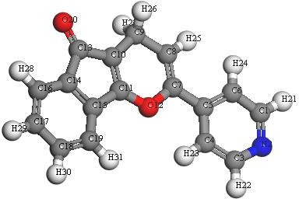
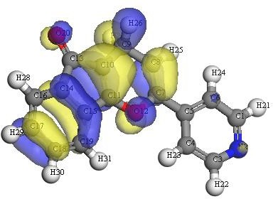
- (a)

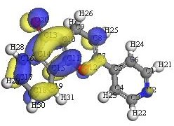

(c)
Figure 1: (a) molecular geometry of compound 34, (b) calculated HOMO superimposed on the isosurface of the molecular geometry of compound 34 and (c) calculated LUMO superimposed on the isosurface of the molecular geometry of compound 34.
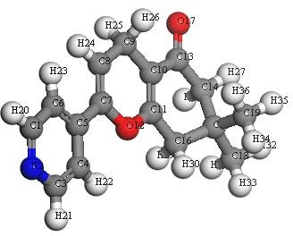
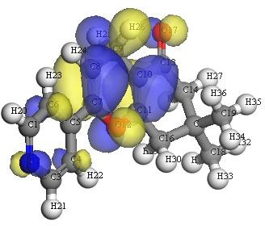
  - (b)
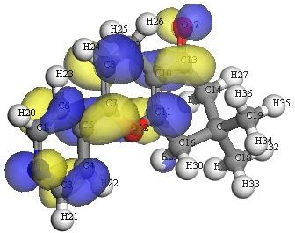

(c)

Figure 2: (a) molecular geometry of compound 36, (b) calculated HOMO superimposed on the isosurface of the molecular geometry of compound 36 and (c) calculated LUMO superimposed on the isosurface of the molecular geometry of compound 36.
Table 2: Calculated total energy and binding energy (BLYP/DNP) for compounds (34 and 36 using DFT).

Compound No. | EHOMO(eV) | ELUMO(eV) | HOMO-LUMO  Energy gap (eV) | Dipole moment Debye | Binding energy, Hartree
34 | -5.260 | -3.111 | -2.149 | 1.1795 | -6.11927
36 | -5.307 | -2.479 | -2.828 | 2.7460 | -6.45660

In conclusion, the objective of the present study was to synthesize and investigate the antimicrobial activities of some new functionalized thienopyrimidine and thiazolylidine with the hope of discovering new structure leads serving as antimicrobial agents. The obtained results clearly revealed that compounds derived from chromeneand thiazolopyridinexhibited better antimicrobial activity than indenopyrane and primidine derivatives.

EXPERIMENTAL:

Synthesis and Instruments:

Melting points and all spectroscopic data and elemental analyses were recorded according to the instruments mentioned in previous work [32].
Synthesis of 3-(dimethylamino)-1-(pyridin-4-yl)prop-2-en-1-one (14). : [22]
To a solution of 1- (pyridin-4-yl)ethan-1-one (0.5 ml, 4 mmol) in dry xylene (15 ml), an equimolar amount of DMF/DMA (0.49 ml, 4mmol)was added and the mixture was refluxedfor 6-8 hcotroled by TLC. After cooling the solid product collected and washed by petrolim ether and recrystallized from ethanol to give compound 14. Yellow powder; yield (85%); m.p. 117°C; IR (KBr): υ/cm⁻¹= 1639 (C=O);¹H-NMR (300 MHz, DMSO-d6) δ (ppm): 2.95 (s, 3H, CH3), 3.18 (s, 3H, CH3), 5.66 (d, 1H, CH), 7.68 (d, 1H, CH), 7.85 (dd, 2H, Pyridine), 8.70 (dd, 2H Pyridine); ¹³C-NMR (75 MHz, DMSO-d6) δ (ppm):44.3, 44.5, 92.3, 123.3, 123.2, 141.3, 151.3, 151.3, 155.5,189.2;MS (EI, 70 ev): m/z (%)=176.06 (M⁺, 36), 139 (73), 98 (100), 80 (64), 64 (56), 55 (62). Anal. Calcd. for C10H12N2O(176.22): C, 68.16; H, 6.86 %.Found: C, 68.18; H, 6.88 %.

Reaction of enaminone 14 with N-nucleophiles

  - Synthesis of compounds 15 and 16

General procedure: To a solution 14 (0.17 g, 1 mmol) in ethanol (15 ml), an equimolar amount of the appropriate hydrazine hydrate(.05 ml, 1mmol) and/or phenyl hydrazine (0.1 ml, 1mmol) was added and the mixture was refluxed in the presence of few drops of triethyl amine for 8 hr. After cooling to room temperature, the obtained solid material was recrystallized from ethanol to give compounds 15 and 16.
    - 4-(1H-pyrazol-5-yl)pyridine (15): Brawn powder; yield (80%); m.p. 156°C; IR (KBr): υ/cm⁻¹ = 3320 (NH); ¹H-NMR (300 MHz, DMSO-d6) δ (ppm): 7.43 (d, 1H, CH pyrazole), 7.57 (d, 1H, CH pyrazole), 7.82 (dd, 2H, Pyridine), 8.01 (dd, 2H Pyridine), 9.97 (s, 1H, NH); ¹³C- NMR (75 MHz, DMSO-d6) δ (ppm):6.5, 7.7, 8.00, 8.00, 8.78, 8.78, 13.9; MS (EI, 70 ev): m/z

(%)=145 (M⁺, 53), 127 (100), 117 (42), 101 (60), 87 (62), 83 (36), 64 (97), 55 (21). Anal.Calcd.
for C8H7N3 (145.17): C, 66.19; H, 4.86; N, 28.95 %. Found: C, 66.10; H, 4.82; N, 28.88 %.

    - 4-(1-phenyl-1H-pyrazol-5-yl)pyridine (16): Yellow crystal; yield (82%); m.p. 179°C; IR (KBr): υ/cm⁻¹ = 1612 (C=N); ¹H-NMR (300 MHz, DMSO-d6) δ (ppm): 6.91 (d, 1H, CH pyrazole), 7.59 ( d, 1H, CH pyrazole), 7.59_7.65 (m, 5H, Ar_H), 8.05 (dd, 2H, CH pyridine), 8.85 (dd, 2H, CH pyridine); ¹³C-NMR (75 MHz, DMSO-d6) δ (ppm): 110.5, 113.00, 121.5, 121.5, 121.5, 121.5, 125.3, 129.5, 129.5, 133.9, 138.7, 140.5, 150.00, 15.00; MS (EI, 70 ev): m/z (%) = 221 (M⁺, 34) , 208 (33), 185 (36), 176 (42), 159 (50), 110 (100), 81 (44), 65 (32), 51 (62). Anal.Calcd. For C14H11N3 (221.26): C, 76.00; H, 5.01; N, 18.99 %. Found: C, 75.95; H, 5.19; N, 19.02 %.

Synthesis of compounds 18, 23, 25, 27, 29 and 33

General procedure: To a solution of enaminone 14 (0.17 g, 1mmol) in ethanol (15 ml), an equimolar amount of thiourea (0.07 g, 1mmol) ,urea (0.06g, 1mmol), guanidine nitrate (0.12 g, 1mmol),2-aminothiazole (0.1g, 1mmol),o-phenylenediamine (0,12 g, 1mmol) and 2- aminoprop-1-ene-1,1,3-tricarbonitrile (0.13 g, 1mmol) was added ,respectively, and the mixture was refluxed for 8 hr in ethanol in the presence of sodium ethoxide (0.02 g, 1mmol) (formed from Na 0.02 g metal and ethanol 20 ml). After cooling to room temperature the obtained solid material was recrystallized from ethanol to give compounds 18, 23, 25, 27, 29 and 33.
6-(pyridin-4-yl)pyrimidine-2(1H)-thione (18): Yellow crystal; yield (82%); m.p. 250°C;IR (KBr): υ/cm⁻¹ = 3160 (NH), 1320 (C=S);¹H-NMR (300 MHz, DMSO-d6) δ (ppm): 6.89 (d, 1H, CH pyrimidine), 7.07 (d, 1H, CH pyrimidine), 7.20 (dd, 2H, CH Pyridine), 7.56 (dd, 2H, CH Pyridine), 9.44 (s, 1H, NH) ; ¹³C-NMR (75 MHz, DMSO-d6) δ (ppm): 91.4, 120.5, 120.5, 144.1, 149.8, 149.8, 163.6, 176.2, 180.5 ; MS(EI, 70 ev): m/z (%)=189 (M⁺, 40), 117 (44), 101 (43), 59 (100). Anal.Calcd. For C9H7N3S(189.24): C, 57.12; H, 3.73; N, 22.21 %. Found: C, 57.17; H, 3.68; N, 22.26 %.

    - 6-(pyridin-4-yl)pyrimidin-2(1H)-one (23): Brown powder; yield (65 %); m.p. >300
°C; IR (KBr): υ/cm⁻¹ = 3265 (NH), 1659 (C=O); ¹H-NMR (300 MHz, DMSO-d6) δ (ppm):
6.59 (s, 1H, CH pyrimidine), 7.45 (dd, 2H, CH pyridine), 8.48 (d, 1H, CH pyrimidine);8.53 (dd, 2H, CH pyridine), 11.01 (s, 1H, NH); ¹³C-NMR (75 MHz, DMSO-d6) δ (ppm): 93.5, 121.00, 121.00, 144.5, 149.5, 149.5, 153.6, 163.3; MS (EI, 70 ev): m/z (%)=173 (M⁺, 48), 148

(26), 119 (34), 101 (100), 88 (25), 75 (43), 59 (35). Anal.Calcd. for C9H7N3O(173.18): C,
62.42; H, 4.07; N, 24.27 %. Found: C, 62.44; H, 4.04; N, 24.29 %.

    - 6-(pyridin-4-yl)-1,4-dihydropyrimidin-2-amine (25): Pale brawn crystal; yield (70%); m.p. 240°C; IR (KBr): υ/cm⁻¹ = 3450 (NH2), 3160 (NH);¹H-NMR (300 MHz, DMSO-d6) δ (ppm): 2.90 (d, 2H, CH2), 6.92 (t, 1H, CH),7.22(s, 2H, NH2), 7.82 (dd, 2H, CH pyridine), 8.12 (dd, 2H, CH pyridine), 10.70 (s, 1H, NH);¹³C-NMR (75 MHz, DMSO-d6) δ (ppm): 39.4, 102.00, 121.00, 121.00, 144.5, 149.5, 149.5, 149.2, 153.1; MS (EI, 70 ev): m/z (%) = 174 (M⁺, 65), 128 (37), 117 (56), 101 (66), 87 (64), 73 (34), 59 (100). Anal.Calcd. For C9H10N4 (174.21): C, 62.05; H, 5.79; N, 32.16 %. Found: C, 62.00; H, 5.75; N, 32.20 %.
    - 5-(pyridin-4-yl)-7H-thiazolo[3,2-a]pyrimidine (27): Black powder; yield (65 %); m.p. 150°C; IR (KBr): υ/cm⁻¹ =1612 (C=N), 1600 (C=C);¹H-NMR (300 MHz, DMSO-d6) δ (ppm):
2.38 (d, 2H, CH2 pyrimidine), 5.25(t, 1H,CH, pyrimidine), 6.94 (d, 1H, CHthiazole), 7.23 (d,
1H, CH thiazole), 7.56 (dd, 2H, CH pyridine), 7.80 (dd, 2H, CH pyridine);¹³C-NMR (75 MHz, DMSO-d6) δ (ppm): 46.5, 95.7, 98.2, 121.00, 121.00, 134.5, 138.4, 144.5, 149.4, 149.4, 158.5;
MS(EI, 70 ev): m/z (%) = 215 (M⁺, 23), 207 (38), 191 (43), 169 (40), 163 (82), 125 (53), 111
(100), 97 (99), 83 (78), 57 (56), 55 (42). Anal.Calcd.for C11H9N3S (215.27): C, 61.37; H, 4.21;
N, 19.52 %.Found: C, 61.35; H, 4.24; N, 19.50 %.

    - 4-(pyridin-4-yl)-2,5-dihydro-1H-benzo[b][1,4]diazepine (29): Yellow powder; yield (68%); m.p. 160°C;IR (KBr): υ/cm⁻¹ = 3265, 3137 (NH);¹H-NMR (300 MHz, DMSO-d6) δ (ppm): 3.80 (d, 2H, CH2), 4.62 (s, 1H, NH), 5.45 (t, 1H, CH), 7.62-7.89 (m, 4H,Ar), 7.29 (dd, 2H, pyridine), 7.32 (dd, 2H, pyridine), 10.30 (s, 1H, NH);¹³C-NMR (75 MHz, DMSO-d6) δ (ppm): 45.00, 99.9, 115.5, 118.1, 119.2, 120.00, 121.00, 121.00, 128.8, 134.1, 144.5, 149.8; MS (EI, 70 ev): m/z (%)=223 (M⁺, 35), 221 (46), 207 (43), 183 (49), 125 (68), 111 (76), 97 (100), 87 (68), 57 (62). Anal.Calcd. For C14H13N3 (223.28): C, 75.31; H, 5.87; N, 18.82 %. Found: C, 75.34; H, 5.82; N 18.79 %.
    - 2-(5-cyano-[2,4'-bipyridin]-6(1H)-ylidene)malononitrile (33): Reddish brawn crystals; yield (55%); m.p. 260°C; IR (KBr): υ/cm⁻¹ = 2295, 2197, 2159 (3C=N);¹H-NMR (300 MHz, DMSO-d6) δ (ppm): 7.18 (d, 1H, CH pyrimidine), 7.47(dd, 2H, pyridine), 7.70 (d, 1H, CH pyrimidine), 7.98 (dd, 2H, pyridine ), 9.90 (s, 1H, NH), ¹³C-NMR (75 MHz, DMSO-d6) δ (ppm): 49.7, 102.3, 112.7, 113.8, 113.8, 155.9, 121.00, 121.00, 144.2, 144.5, 149.5, 149.5, 158.6, 175.5; MS (EI, 70 ev): m/z (%)=245 (M⁺, 18), 221 (99), 220 (84), 57
(58), 51(36), 40 (39). Anal.Calcd.for C14H7N5 (245.25): C, 68.57; H, 2.88; N, 28.56 %. Found: C, 68.52; H, 2.92; N, 28.59 %.

Reaction of enaminone 14 with carbon nucleophiles:

General procedure: To a solution of enaminone 14 (0.17 g, 1mmol) in glacial acetic acid (25 ml), barbituricacide (0.11g, 1mmol), thiobarbeturic acide (0.14g, 1mmol), acetyl acetone (0.1ml, 1mmol), 1.3indandione (0.14g, 1mmol), 2-cyanomethylbenzothiazole (0.17g, 1mmol)
, dimedone (0.14g), α-naphthol (0.09 g, 1mmol), resorcinol (0.09g, 1mmol) and 2-hydroxy-1- naphthaldhyde (0.17g, 1mmol) was added and the mixture was refluxed for 10-16 hr, then the solvent was evaporated in vacuo. After cooling to room temperature, the reaction mixture was pourd onto ice cold water (50 ml). The obtained solid was filtered and recrystallized from ethanol to give compounds 30, 31, 32, 34, 35, 36, 37, 38, and 39 respectively.
    - 7-(pyridin-4-yl)-1,5-dihydro-2H-pyrano[2,3-d]pyrimidine-2,4(3H)-dione (30): Red powder; yield (82%); m.p. >300°C; IR (KBr): υ/cm⁻¹ = 3250, 3159 (NH), 1659 (C=O), 1150 (C-O-C);¹H-NMR (300 MHz, DMSO-d6) δ (ppm): 3.70 (d, 2H, CH2), 4.66 (t, 1H, CHpyran),
7.44 (dd, 2H, CH pyridine), 7.63 (dd, 2H, CH pyridine), 8.51 (s, 1H, NH), 9.20 (s, 1H, NH);
);¹³C-NMR (75 MHz, DMSO-d6) δ (ppm): 20.00, 79.3, 98.00, 121.00, 121.00, 140.5, 144.5,
149.4, 149.4, 151.00, 160.5, 163.4;MS (EI, 70 ev): m/z (%)=243 (16), 236 (36), 204 (79), 117
(51), 101 (49), 59 (100). Anal.Calcd.forC12H9N3O3 (243.24): C, 59.26; H, 3.73; N, 17.28
%.Found: C, 59.28; H, 3.70; N, 17.30 %.

    - 7-(pyridin-4-yl)-2-thioxo-1,2,3,5-tetrahydro-4H-pyrano[2,3-d]pyrimidin-4-one (31): Brownish powder; yield (75%); m.p. >300°C; IR (KBr): υ/cm⁻¹ = 3250, 3159 (NH), 1659 (C=O), 1340 (C=S), 1150 (C-O-C); ¹H-NMR (300 MHz, DMSO-d6) δ (ppm): 3.66 (d ,2H, CH2 pyran), 4.20 (t, 1H, CH pyran), 7.49 (dd, 2H, CHpyridin), 7.55 (dd, 2H, CHpyridine), 8.77 (s, 1H, NH), 9.7 (s, 1H, NH);¹³C-NMR (75 MHz, DMSO-d6) δ (ppm): 20.00, 82.1, 98.00, 121.00, 121.00, 140.5, 144.5, 149.4, 149.4, 162.5, 168.4, 170.00; MS (EI, 70 ev): m/z (%) = 259 (M⁺, 48), 233 (33), 209 (70), 127 (43), 59 (100). Anal.Calcd.forC12H9N3O2S (259.28): C, 55.59; H, 3.50; N, 16.21 %. Found: C, 55.57; H, 3.52; N, 16.23 %.
    - 1-(2-methyl-6-(pyridin-4-yl)-4H-pyran-3-yl)ethan-1-one (32): Brownish powder; yield (65%); m.p. >300°C;IR (KBr): υ/cm⁻¹ = 1700 (C=O);¹H-NMR (300 MHz, DMSO-d6) δ (ppm): 2.13 (s, 3H, CH3), 2.40 (s, 3H, CH3), 2.86 (d, 2H, CH2 pyran), 5.44 (t, 1H, CH pyran),
7.31 (dd, 2H, CH pyridine), 8.00 (dd, 2H, CH pyridine);¹³C-NMR (75 MHz, DMSO-d6) δ (ppm): 17.9, 21.00, 22.8, 97.9, 115.5, 121.00, 121.00, 140.5, 144.5, 149.4, 149.4, 154.00, 196.8; MS

(EI, 70 ev): m/z (%)=215 (M⁺, 27), 211 (52), 209 (60), 193 (73), 125 (38), 111 (44), 97 (42), 80
(44), 57 (100), 55(82). Anal.Calcd.for C13H13NO2 (215.25): C, 72.54; H, 6.09; N, 6.51 %. Found:
C, 72.51; H, 6.07; N, 6.54 %.

    - 2-(pyridin-4-yl)indeno[1,2-b]pyran-5(4H)-one (34): Brown powder; yield (80%); m.p. 125°C;IR (KBr): υ/cm⁻¹ = 1655 (C=O);¹H-NMR (300 MHz, DMSO-d6) δ (ppm): 2.79 (d, 1H, CH pyran), 5.84 (t, 1H, CH pyran), 7.07-7.24 (m, 4H, Ar-H); 7.35 (dd, 2H, CH pyridine), 7.75 (dd, 2H, CH pyridine);¹³C-NMR (75 MHz, DMSO-d6) δ (ppm): 21.5, 97.9, 102.3, 121.00, 121.00, 123.5, 126.00, 128.6, 134.5, 136.8, 137.8, 140.00, 144.5, 149.4, 149.4, 171.00, 192.3; MS (EI, 70 ev): m/z(%)=261(M⁺, 23), 247 (48), 201 (65), 172 (29), 146 (35), 117 (49), 101 (45), 87, (35), 59 (100). Anal.Calcd.for C17H11NO2 (261.28):C, 78.15; H, 4.24; N, 5.36
%.Found: C, 78.13; H, 4.26; N, 5.38 %.

    - 1-(pyridin-4-yl)-3H-benzo[4,5]thiazolo[3,2-a]pyridine-4-carbonitrile (35): Dark brown powder; yield (80%); m.p. 180°C; IR (KBr): υ/cm⁻¹ = 2220 (CN); ¹H-NMR (300 MHz, DMSO-d6) δ (ppm): 4.23 (d, 2H, CH2), 6.07 (t, 1H, CH pyridine), 6.82 (dd, 2H, CH pyridine),
7.12 (dd, 2H, CH pyridine), 7.47-7.87 (m, 4H, Ar-H);¹³C-NMR (75 MHz, DMSO-d6) δ (ppm): 25.5, 68.00, 110.1, 117.5, 119.3, 121.00, 121.00, 121.4, 123.1, 123.3, 126.5, 144.00, 144.5, 145.8, 149.4, 149.4, 162.8;MS(EI, 70 ev): m/z(%) = 289 (M⁺, 49), 277 (29), 130 (27), 108 (22), 78 (100). Anal.Calcd.for C17H11N3S (289.36): C, 70.57; H, 3.83; N, 14.52 %. Found: C, 70.59; H, 3.85; N, 14.50 %.
    - 7,7-dimethyl-2-(pyridin-4-yl)-4,6,7,8-tetrahydro-5H-chromen-5-one (36): yellow powder; yield (60%); IR (KBr): υ/cm⁻¹ = 1659 (C=O); ¹H-NMR (300 MHz, DMSO-d6) δ (ppm): 0.90 ( s, 3H, CH3), 1.01( s, 3H, CH3), 1.99 (s, 2H, CH2), 2.17 (s, 2H, CH2), 3.66 (d, 2H, CH2), 4.69 (t, 1H, CH chromen), 6.72 (dd, 2H, CH pyridine), 7.07 (dd, 2H, CH pyridine); ¹³C- NMR (75 MHz, DMSO-d6) δ (ppm): 21.00, 27.7, 27.7, 32.6, 38.9, 47.00, 98.00, 113.9, 121.00, 121.00, 140.5, 149.4, 149.4, 155.3, 155.3, 184.6; MS (EI, 70 ev): m/z (%) = 255(M⁺, 35), 274 (30), 235 (41), 219 (41), 193 (42), 191 (41), 179 (49), 165 (52), 151 (80), 80 (100), 64 (28). Anal.Calcd.for C16H17NO2 (255.32): C, 75.27; H, 6.71; N, 5.49 %. Found: C, 75.29; H, 6.73; N, 5.47 %.
    - 4-(4H-benzo[h]chromen-2-yl)pyridine (37): Dark brown powder; yield (70%); m.p. 240°C; IR (KBr): υ/cm⁻¹ = 1612 (C=C), 1148 (C-O-C); ¹H-NMR (300 MHz, DMSO-d6) δ (ppm): 3.70 (d, 2H, CH2), 6.23 (t, 1H, CH pyran), 7.20 (dd, 2H, CH pyridine), 7.29 (dd, 2H, CH pyridine), 7.48-7.88 (m, 6H, Ar-H);¹³C-NMR (75 MHz, DMSO-d6) δ (ppm): 27.00, 100.1,

117.5, 121.00, 121.00, 123.6, 126.00, 126.9, 127.9, 127.9, 128.5, 132.6, 151.3, 149.4, 149.4,
151.3; MS (EI, 70 ev): m/z (%) = 259 (M⁺, 68), 245 (31), 226 (40), 199 (27), 182 (100), 127
(22). Anal.Calcd.for C18H13NO (259.31) : C, 83.37; H, 5.05; N, 5.40 %. Found: C, 83.35; H,
5.07; N, 5.43 %.

    - 2-(pyridin-4-yl)-4H-chromen-7-ol (38): Brown powder; yield (81%); m.p. > 300°C; IR (KBr): υ/cm⁻¹ = 3447 (broad OH), 1164(C-O-C) ; ¹H-NMR (300 MHz, DMSO-d6) δ (ppm): 3.65 (d, 2H, CH2), 5.92 (t, 1H, CH), 6.99 (d, 1H, Ar-H), 7.07 (d, 1H, Ar-H), 7.23 (s, 1H, Ar- H), 7.48 (dd, 2H, CH pyridine), 7.89 (dd, 2H, CH pyridine), 9.95 (s, 1H, OH); ¹³C-NMR (75 MHz, DMSO-d6) δ (ppm): 26.5, 100.1, 110.3, 121.00, 121.00, 123.5, 131.6, 144.5, 149.4, 149.4, 151.2, 155.7, 162.4; MS (EI, 70 ev): m/z (%) = 225 (M⁺, 24), 222 (40), 184 (43), 178 (35), 159 (45), 110 (84), 51 (100). Anal.Calcd. for C14H11NO2 (225.25): C, 74.65; H, 4.92; N, 6.22 %. Found: C, 74.67; H, 4.90; N, 6.25 %.
    - 2-(pyridin-4-yl)-4H-benzo[g]chromene-10-carbaldehyde (39): Faint brawn; yield (63 %); m.p. 86 °C; IR (KBr): υ/cm⁻¹ =2850 (C=O aldehyde); ¹H-NMR (300 MHz, DMSO-d6) δ (ppm): 3.99 (d, 2H, CH2), 5.79 (t, 1H, CH), 6.99 (dd, 2H, CH pyridine), 7.19 (dd, 2H, CH pyridine), 7.48-7.92 (m, 3H, Ar-H), 10.74 (s, 1H, CHO);¹³C-NMR (75 MHz, DMSO-d6) δ (ppm): 26.5,100.1, 121.00, 121.00, 123.6, 128.00, 130.2, 131.4, 137.6, 144.5, 149.4, 149.4, 151.2, 157.9, 189.8;MS (EI, 70 ev): m/z (%) = 287 (39), 105 (78), 78 (82), 64 (43), 54 (96). Anal.Calcd.for C19H13NO2 (287.32): C, 79.43; H, 4.56; N, 4.88 %. Found: C, 79.40; H, 4.59; N, 4.85 %.

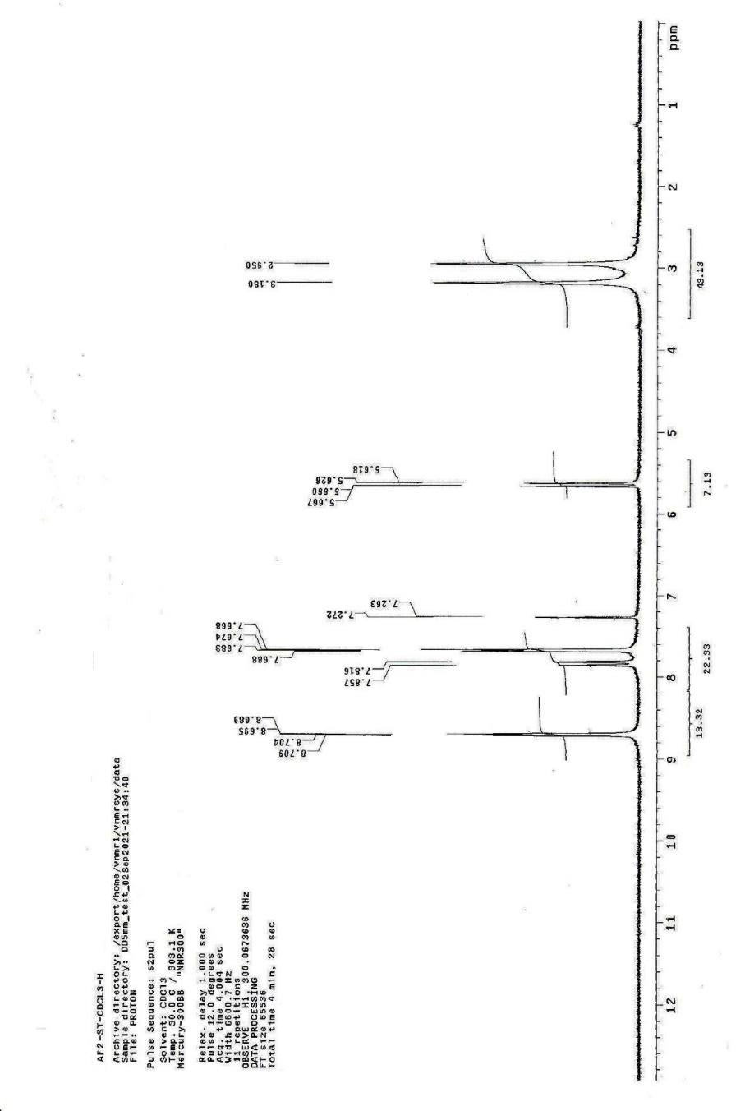

Figure 3: ¹H-NMR of Comp 14

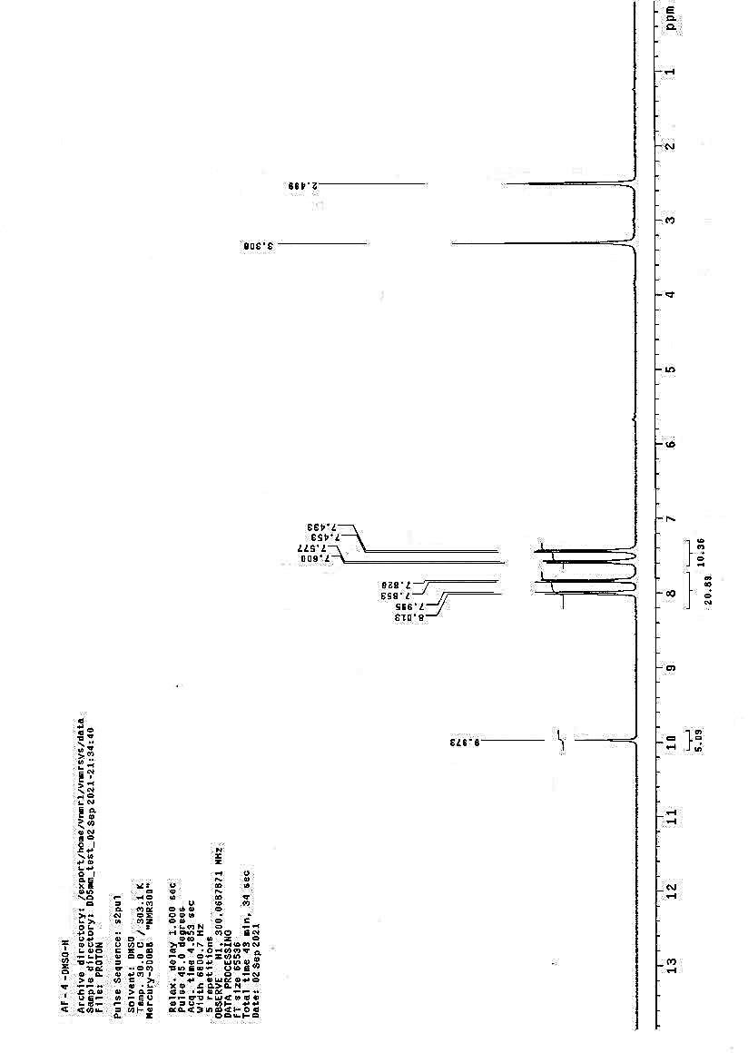

Figure 4: ¹H-NMR of Comp 15

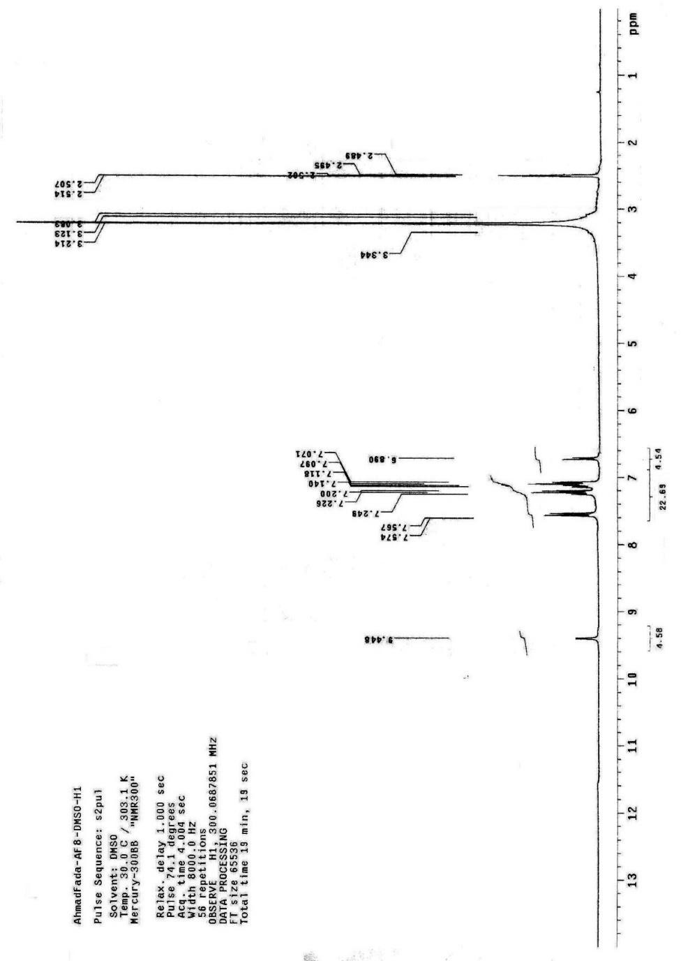

Figure 5: ¹H-NMR of Comp 18

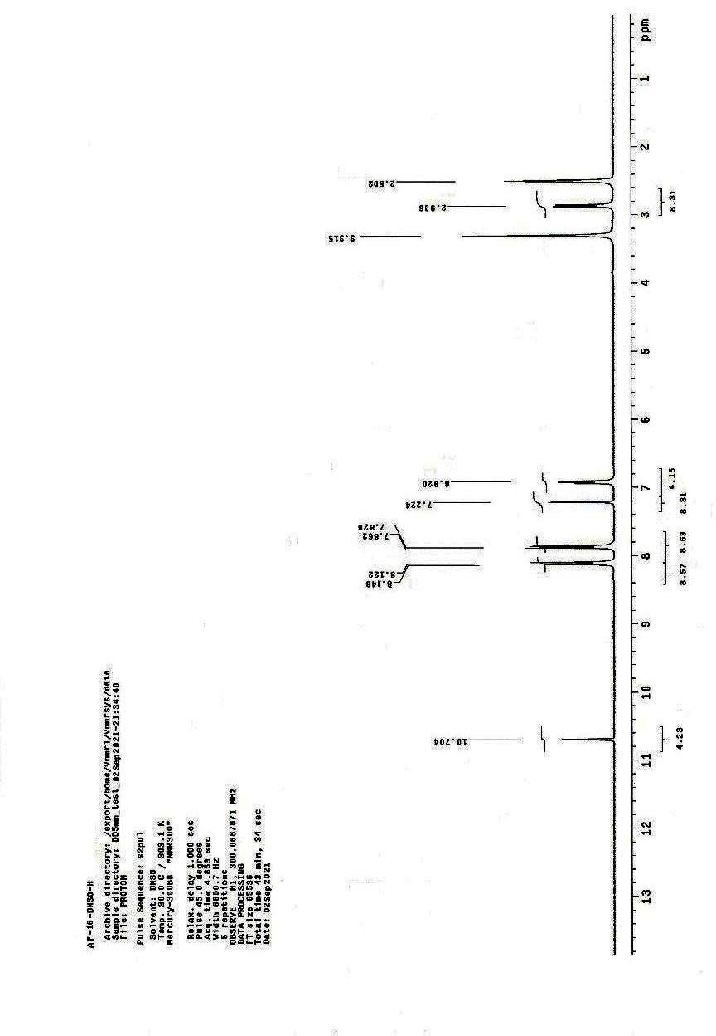
Figure 6: ¹H-NMR of Comp 25

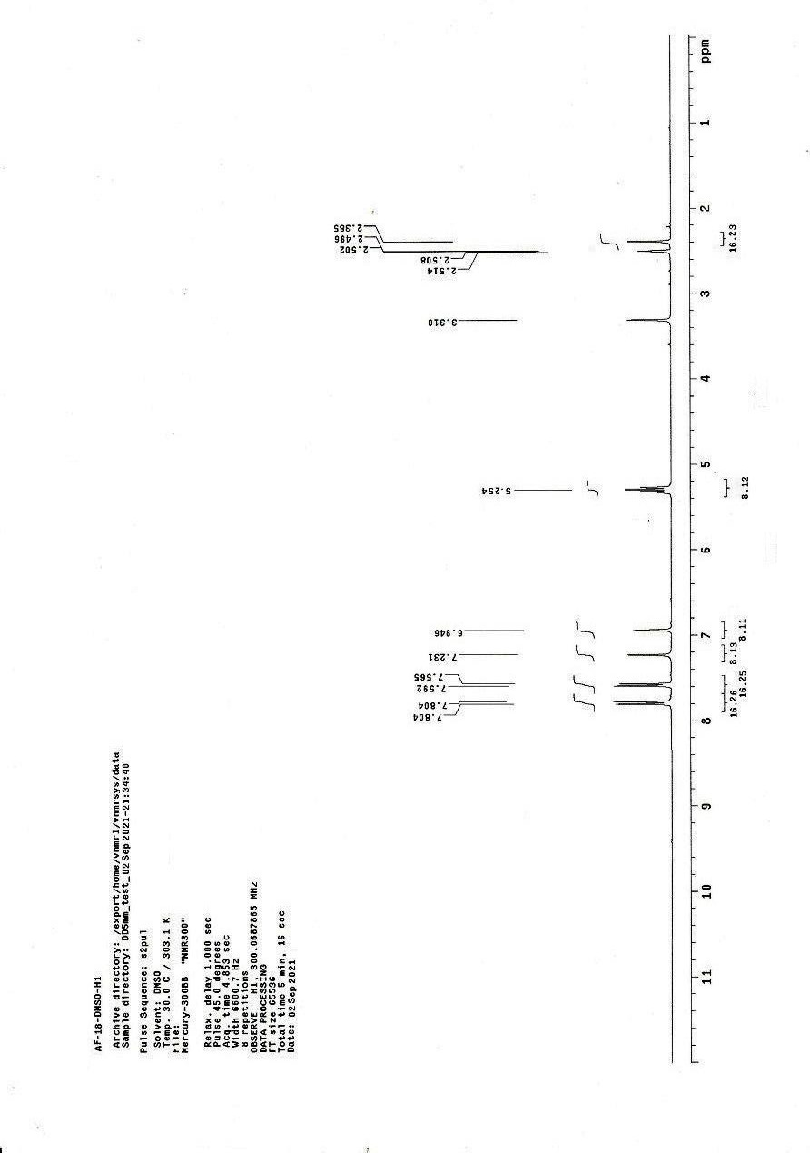
Figure 7: ¹H-NMR of Comp 27

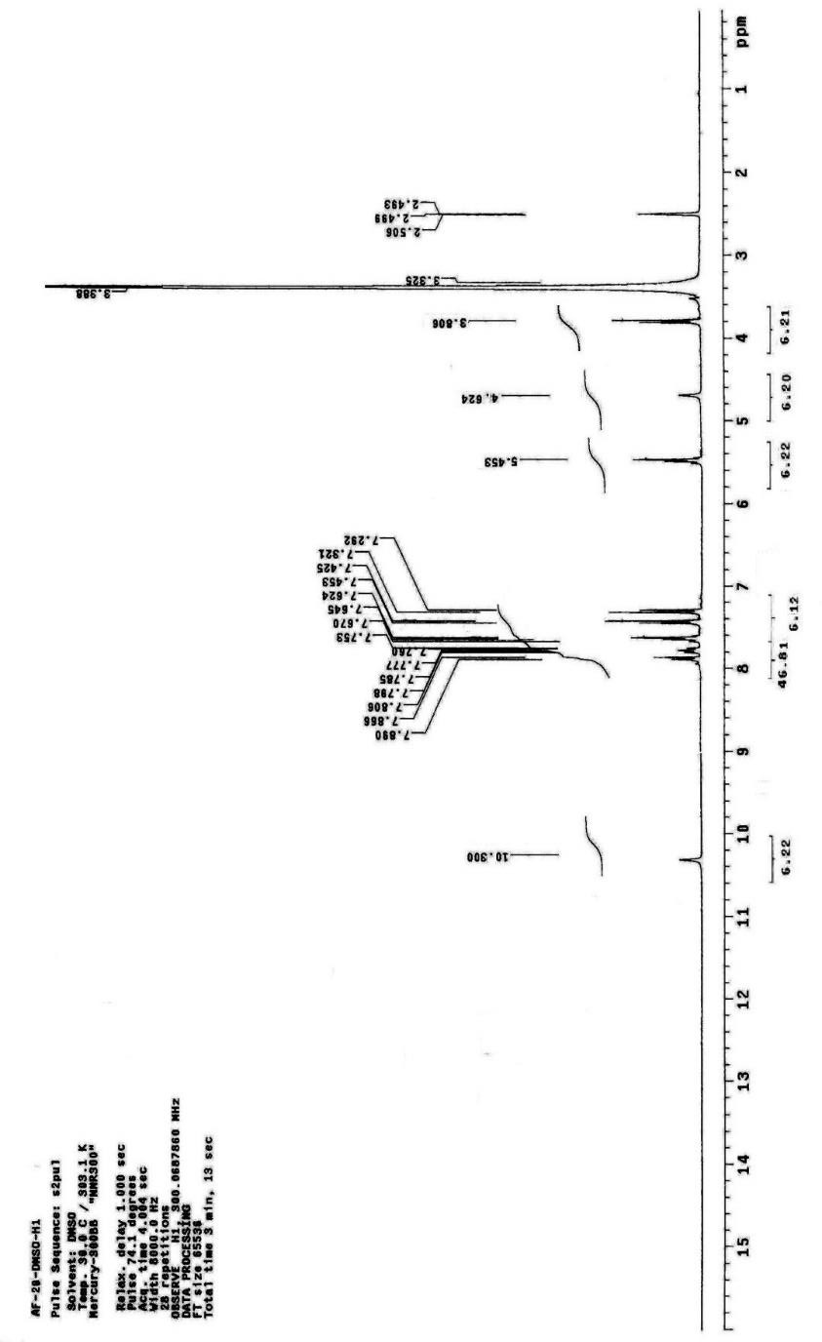

Figure 8: ¹H-NMR of Comp 29

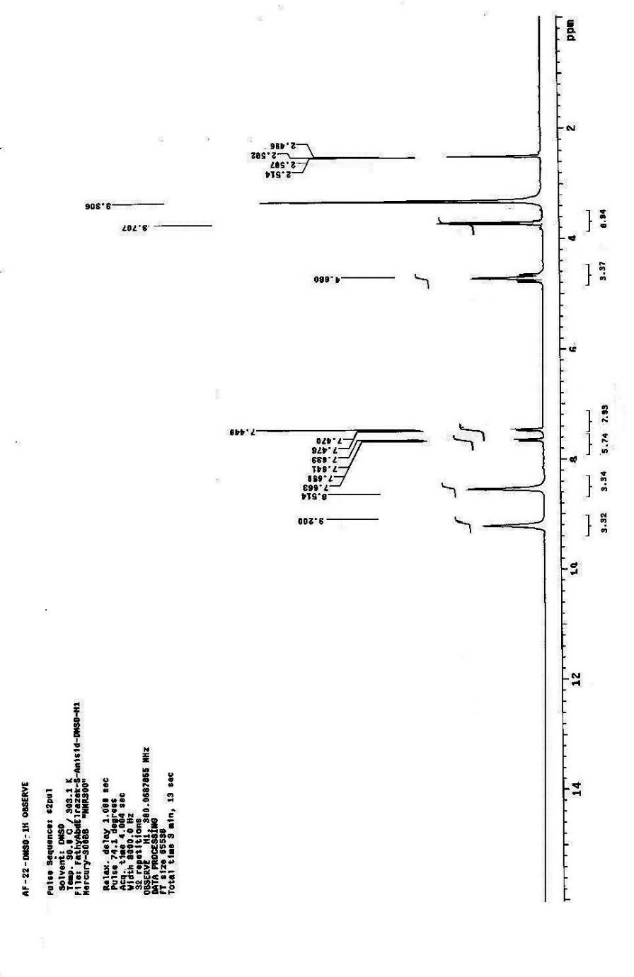
Figure 9: ¹H-NMR of Comp 30

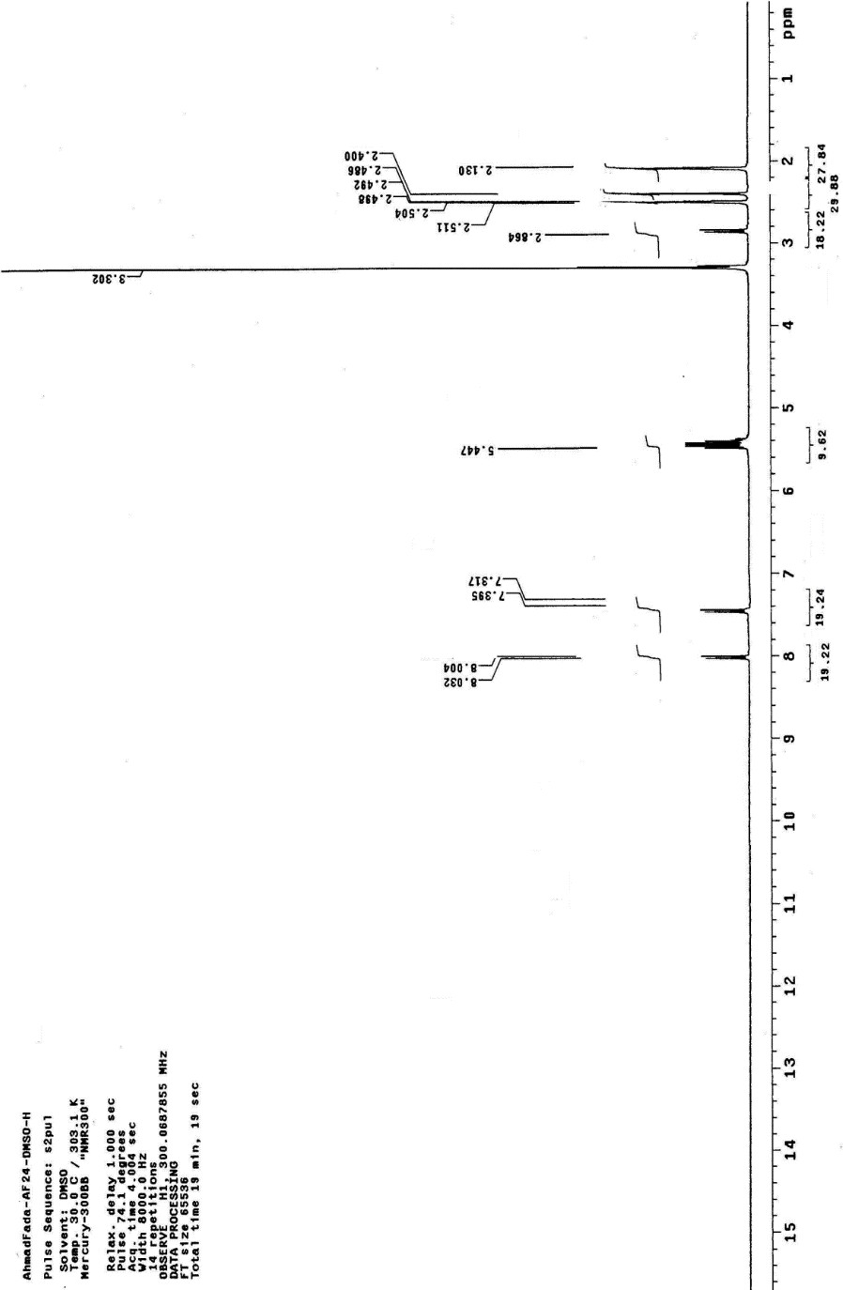

Figure 10: ¹H-NMR of Comp 32

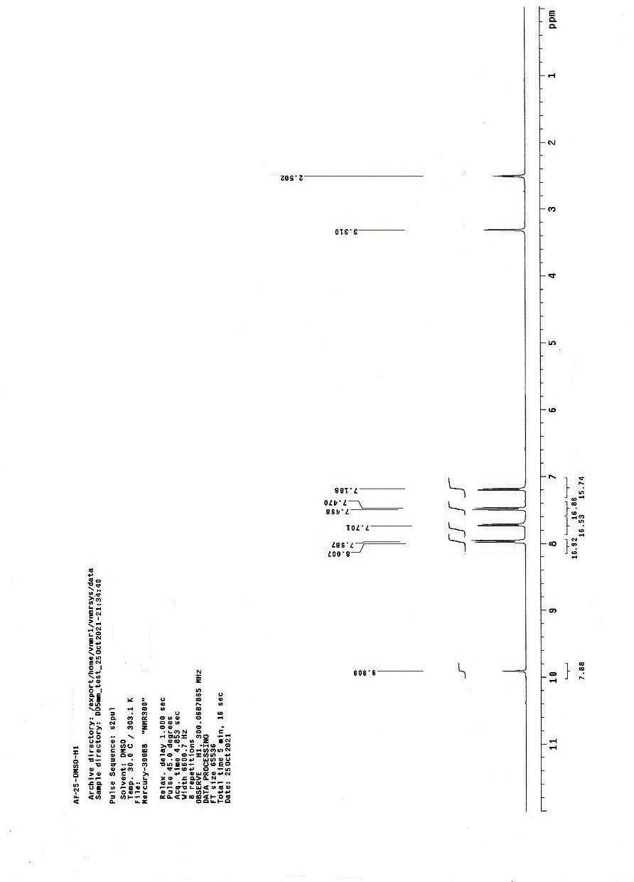
Figure 11: ¹H-NMR of Comp 33

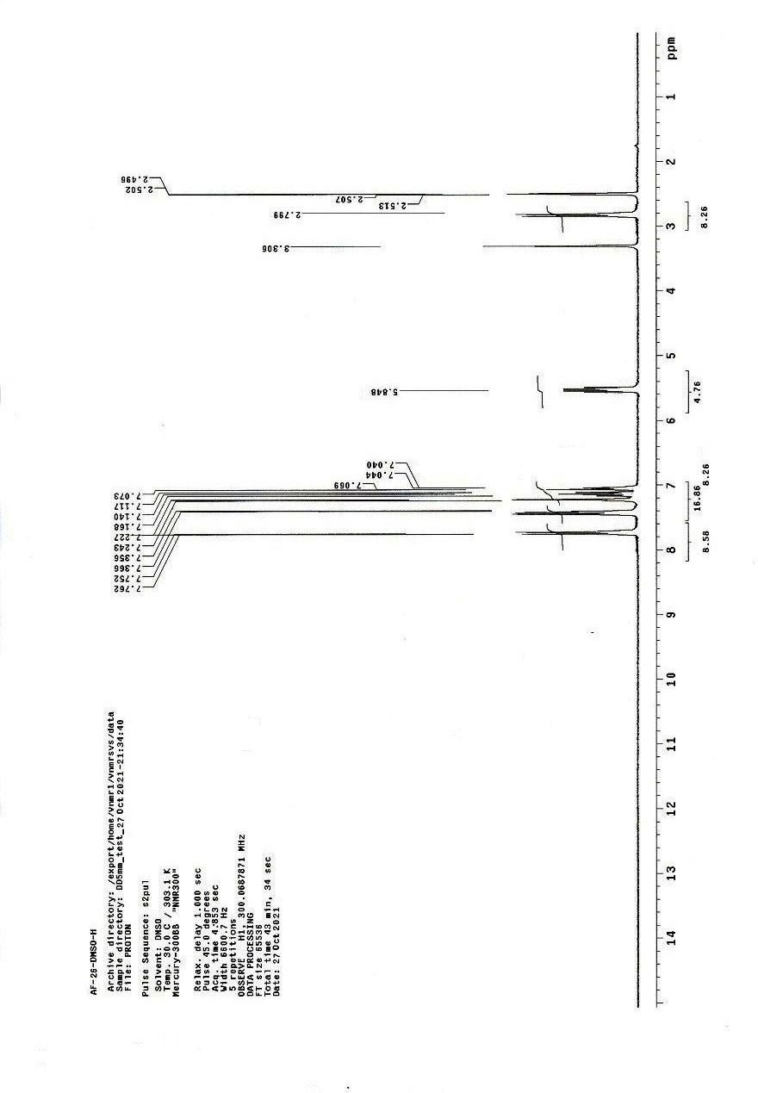
Figure 12: ¹H-NMR of Comp 34

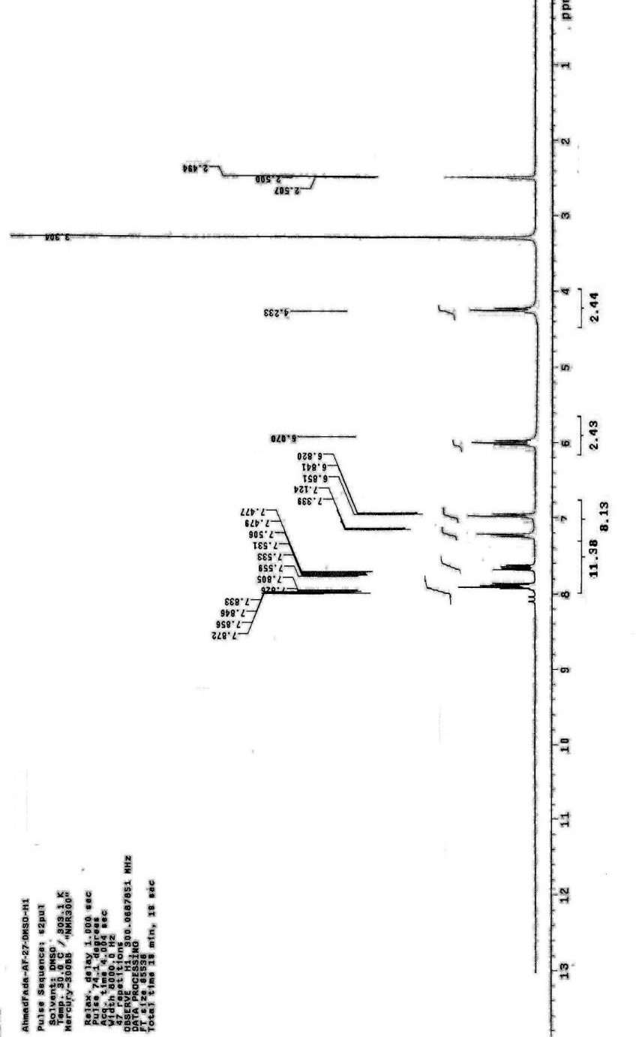

Figure 13: ¹H-NMR of Comp 35

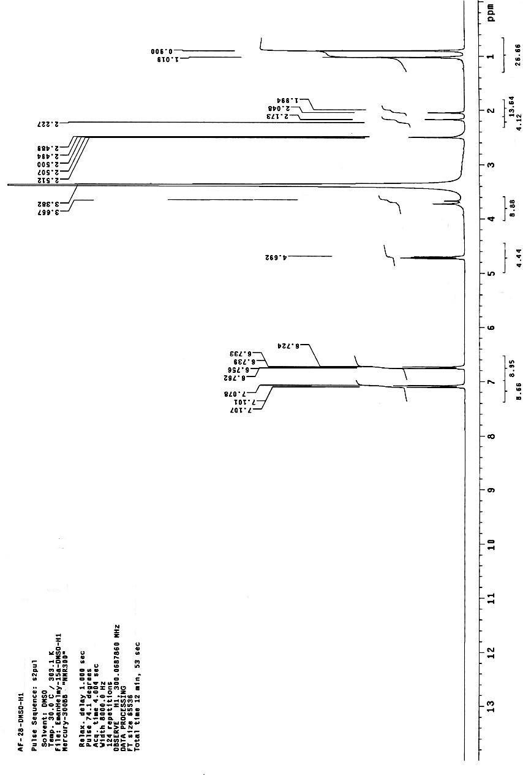

Figure 14: ¹H-NMR of Comp 36

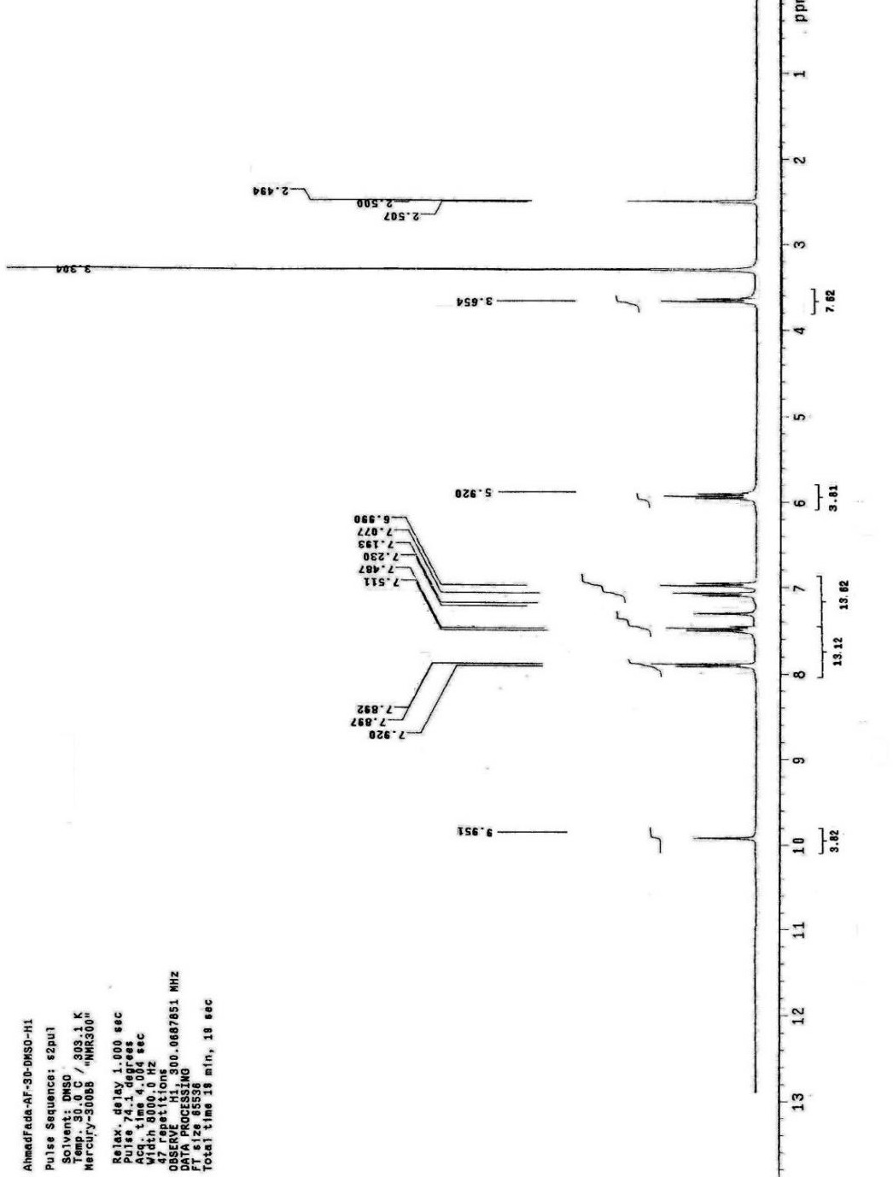

Figure 15: ¹H-NMR of Comp 38

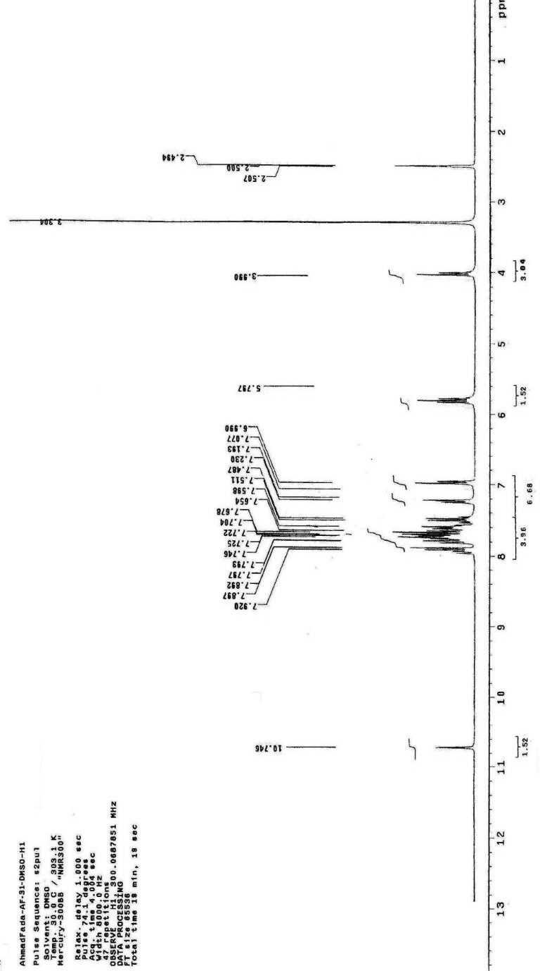

Figure 16: ¹H-NMR of Comp 39

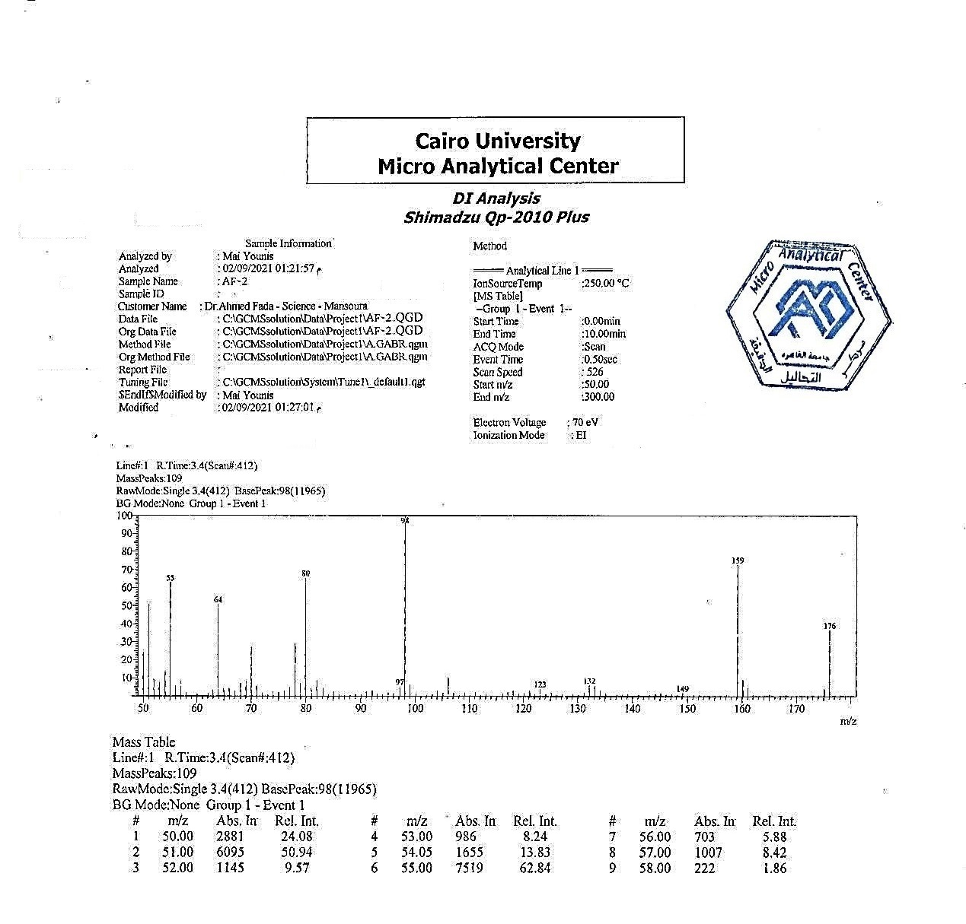

Figure 17: Mass Spectra of comp 14

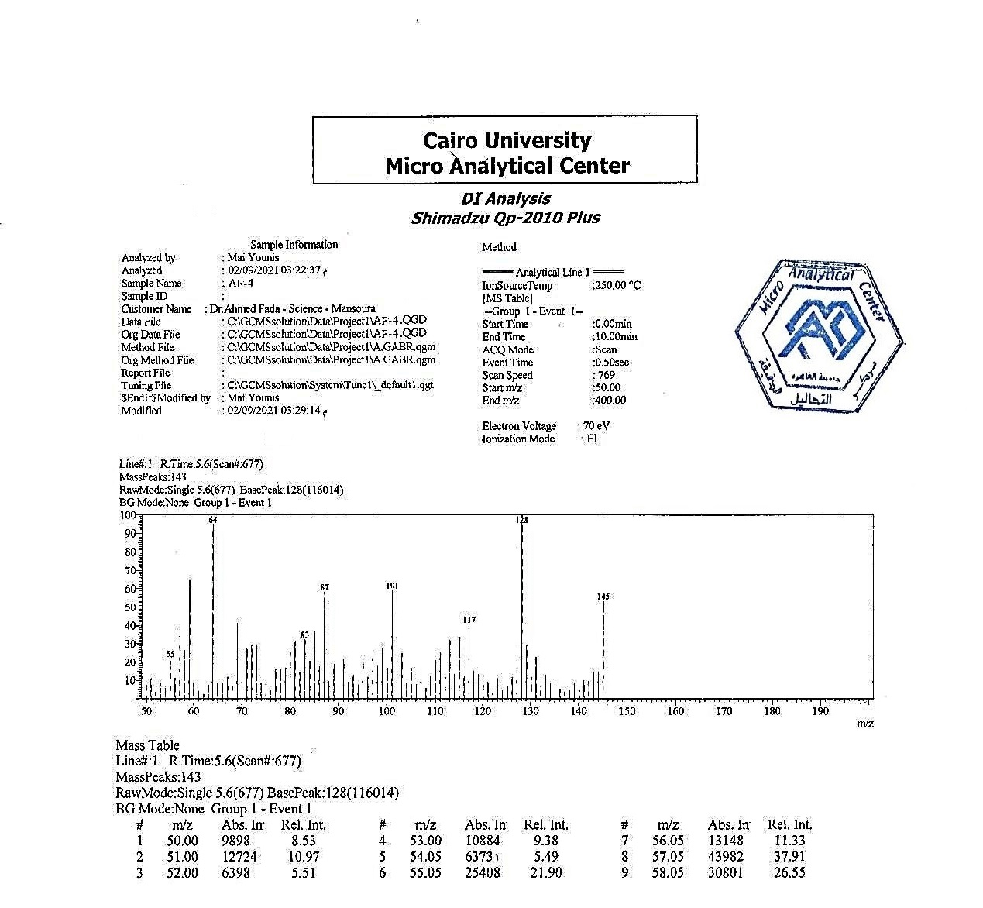

Figure 18: Mass Spectra of comp 15

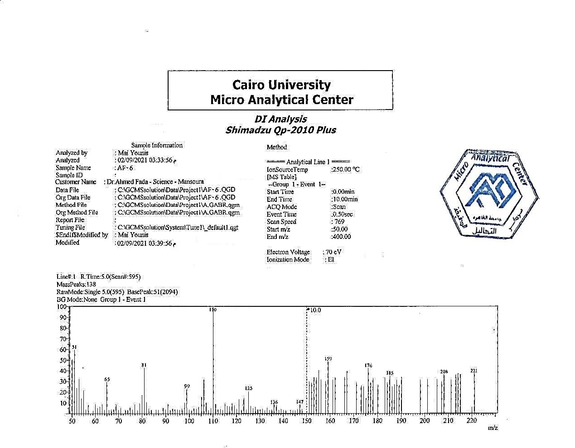

Figure 19: Mass Spectra of comp 16

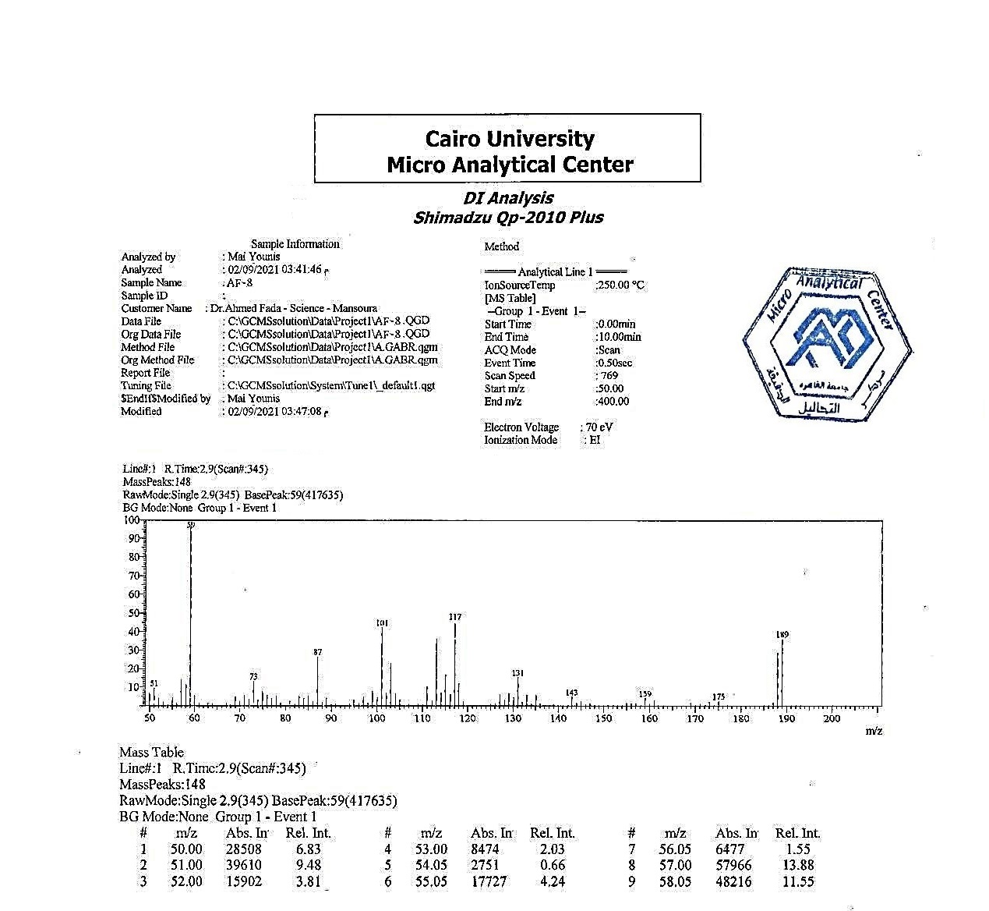

Figure 20: Mass Spectra of comp 18

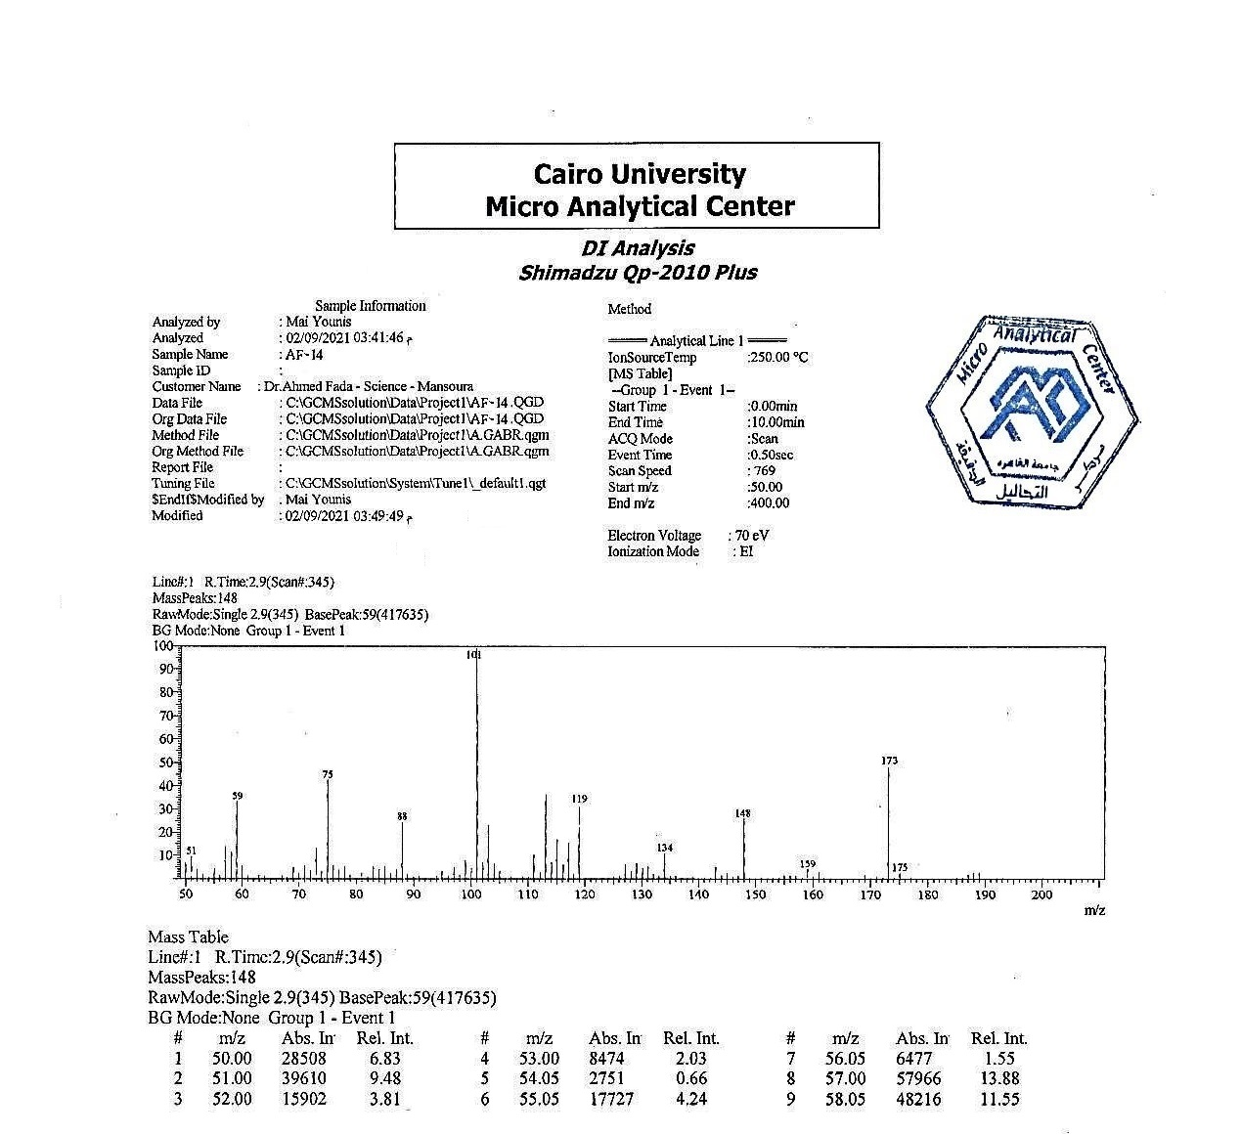

Figure 21: Mass Spectra of comp 23

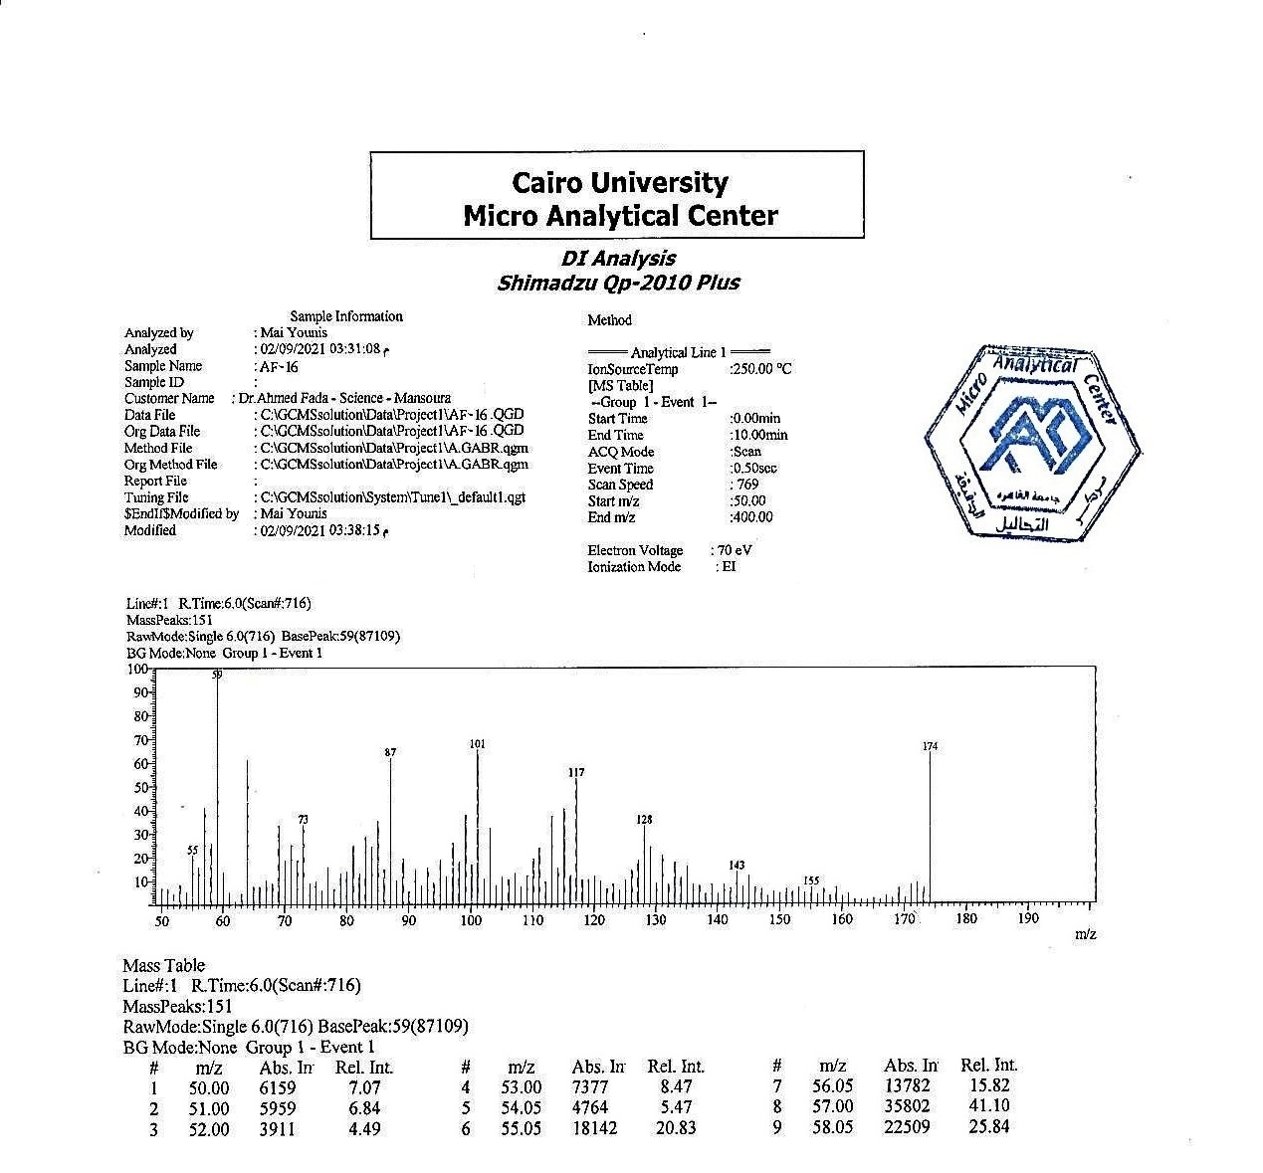

Figure 22: Mass Spectra of comp 25

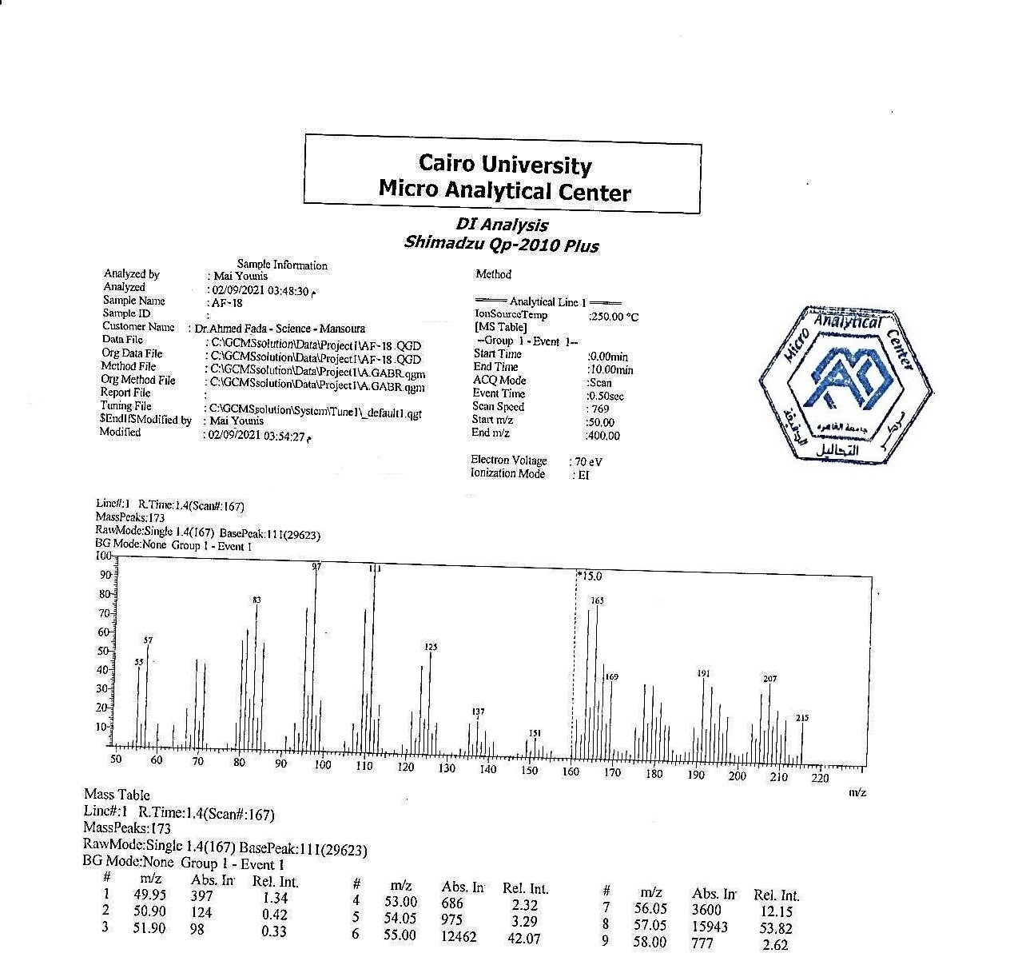
Figure 23: Mass Spectra of comp 27

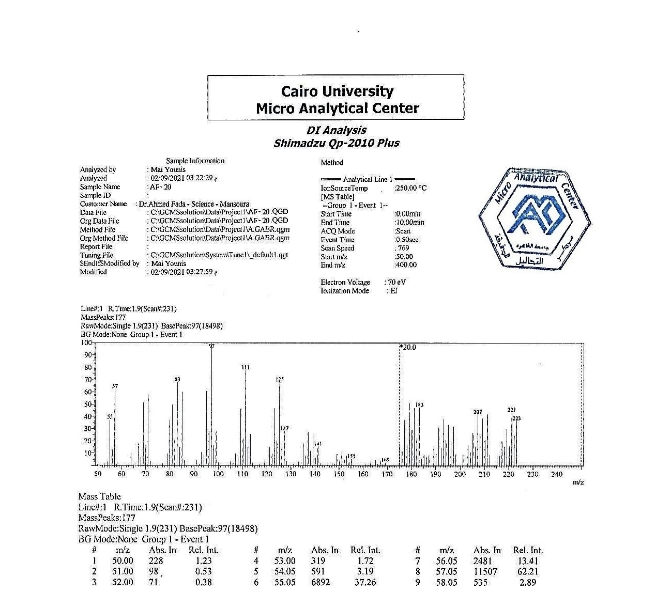

Figure 24: Mass Spectra of comp 29

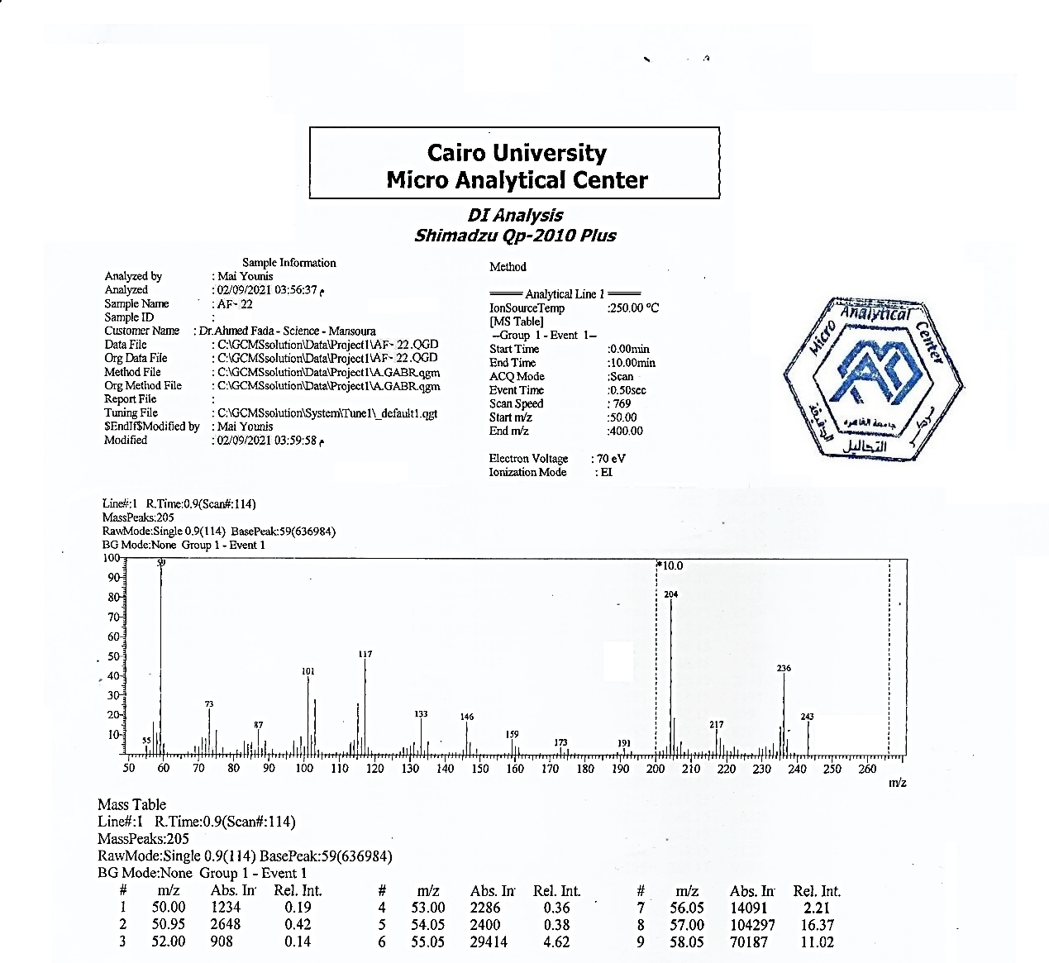

Figure 25: Mass Spectra of comp 30

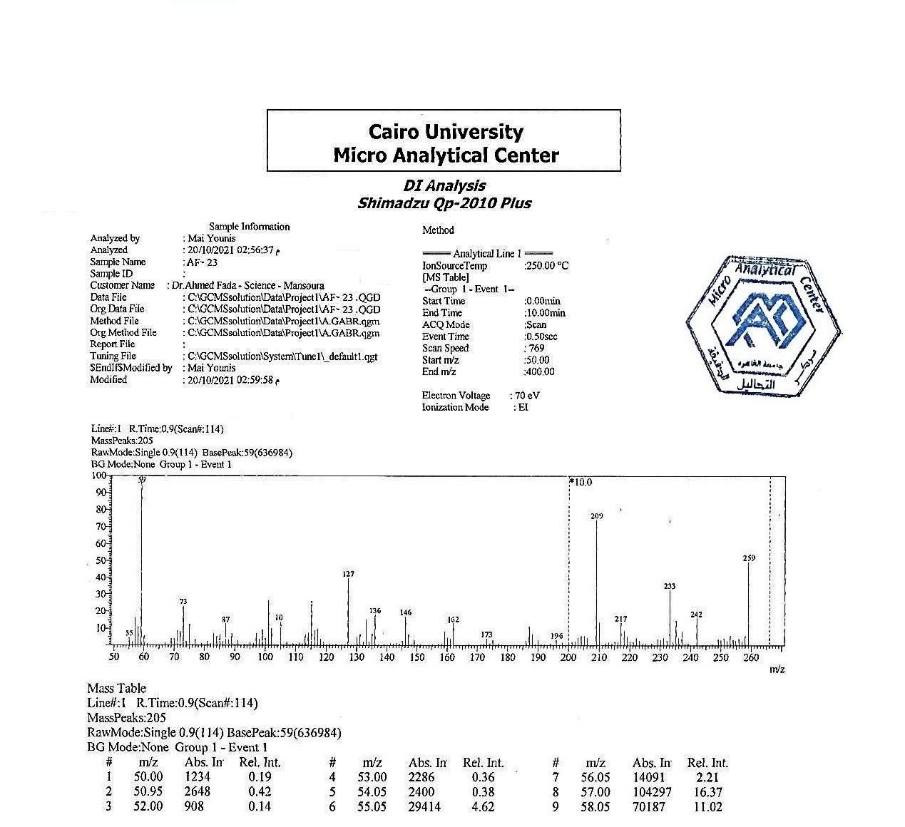

Figure 26: Mass Spectra of comp 31

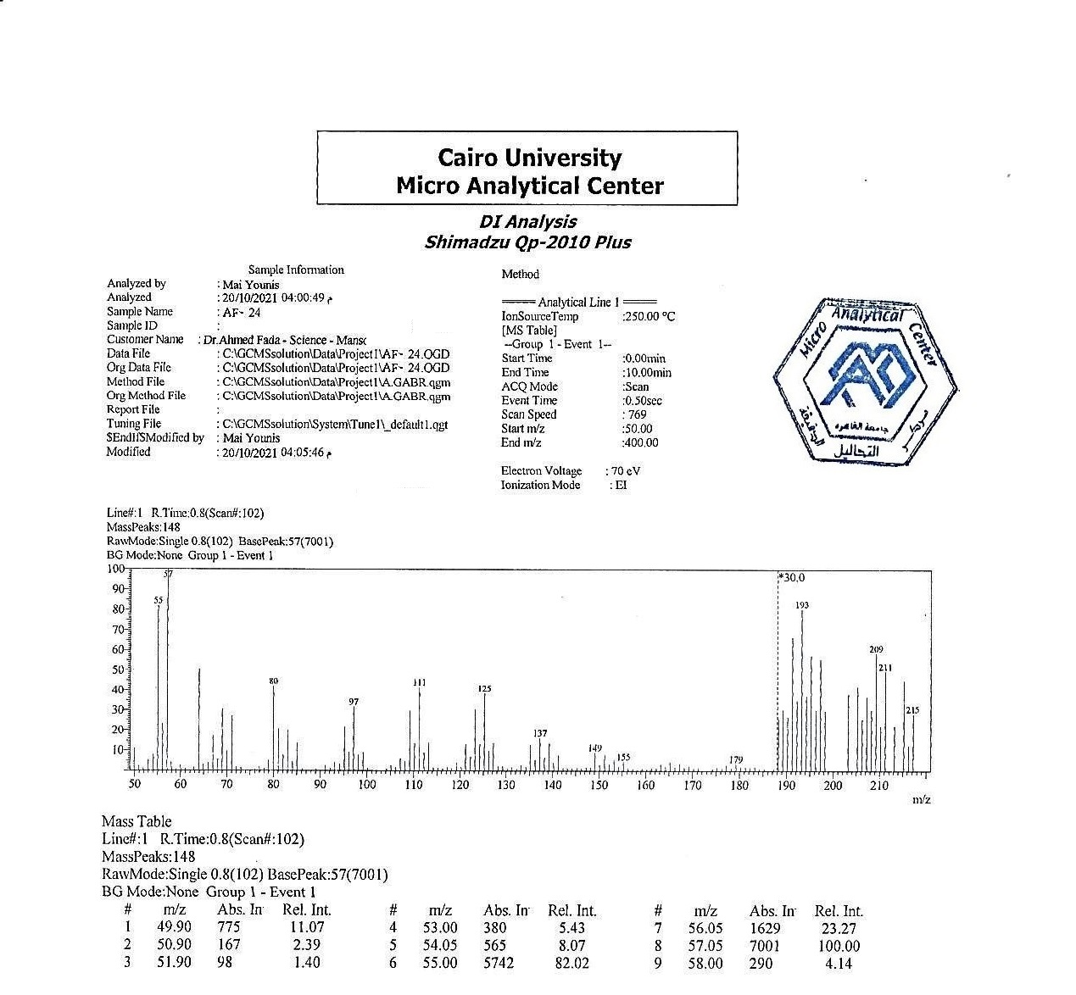

Figure 27: Mass Spectra of comp 32

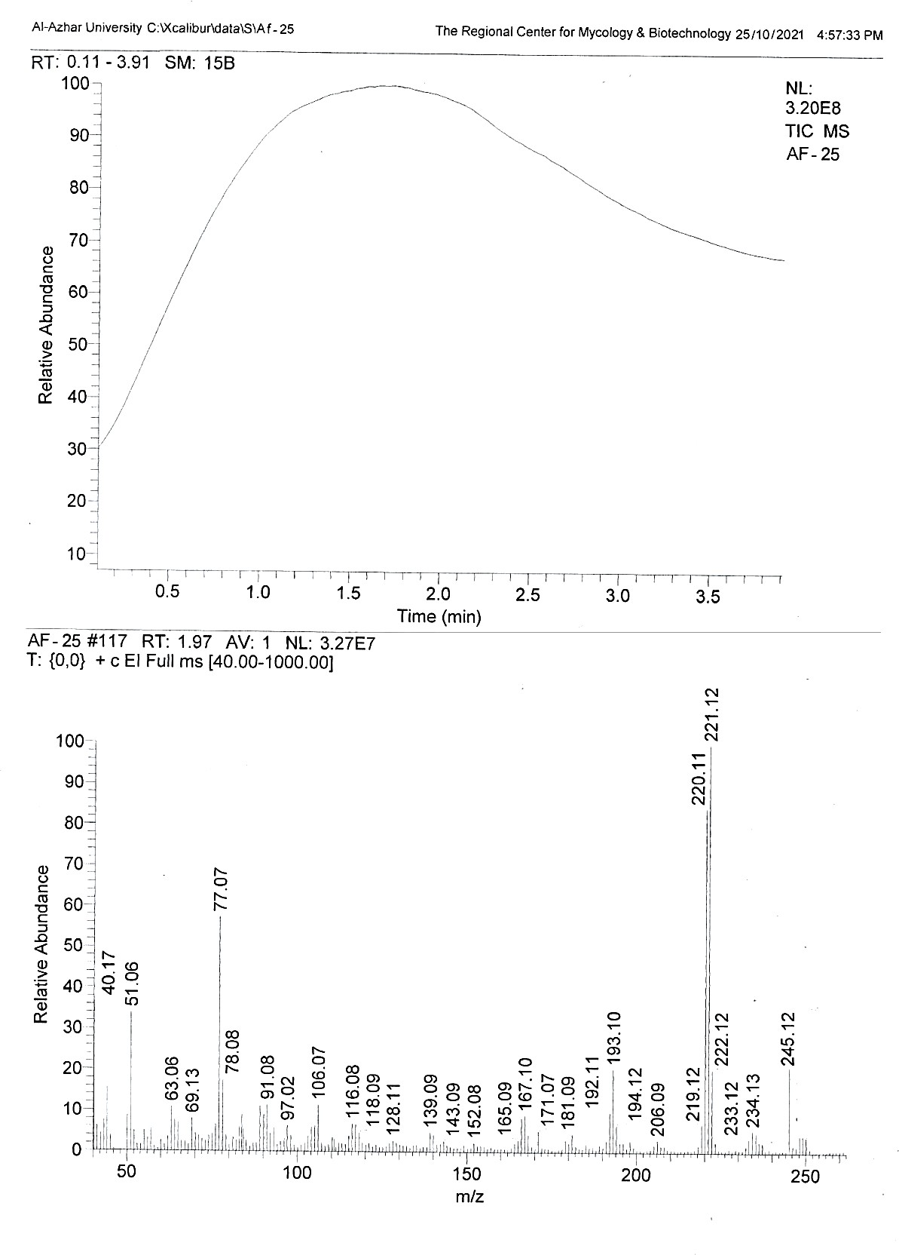
Figure 28: Mass Spectra of comp 33

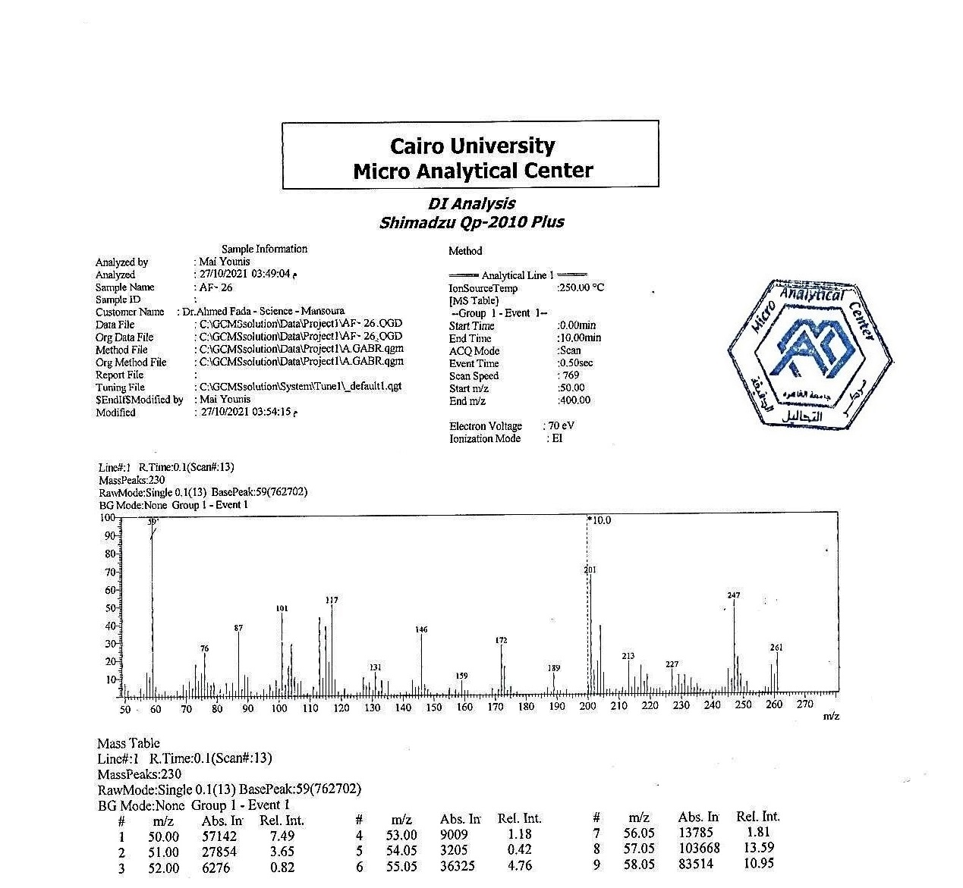

Figure 29: Mass Spectra of comp 34

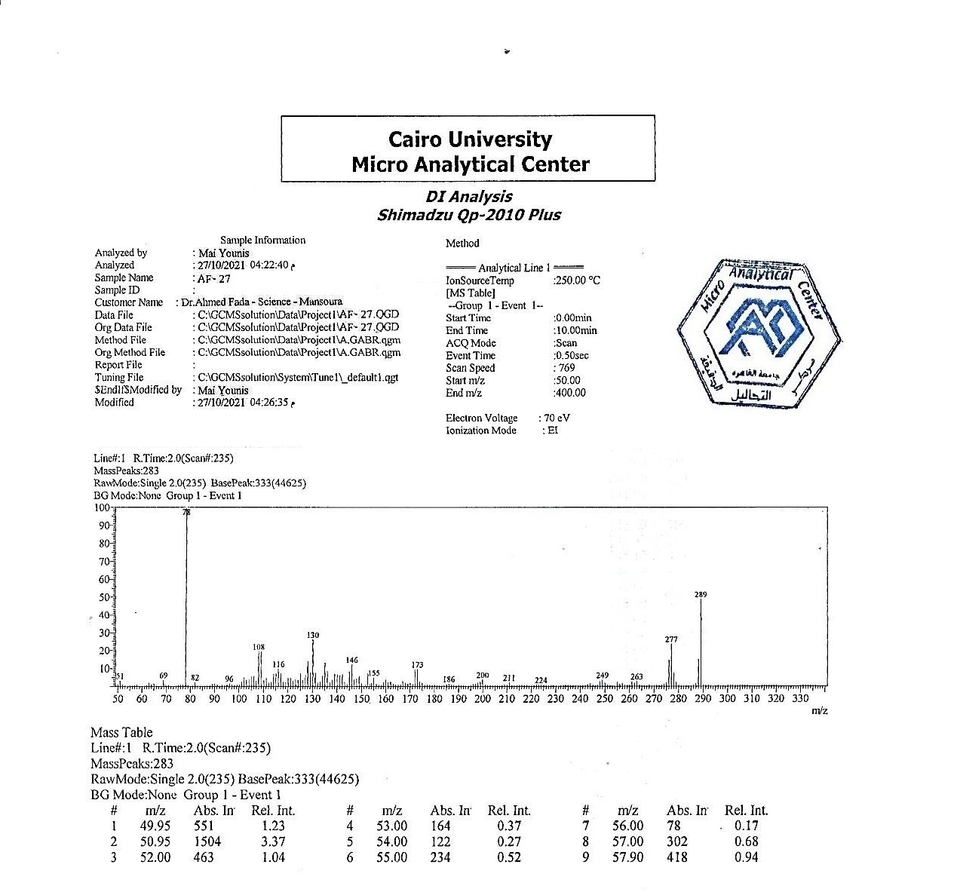
Figure 30: Mass Spectra of comp 35

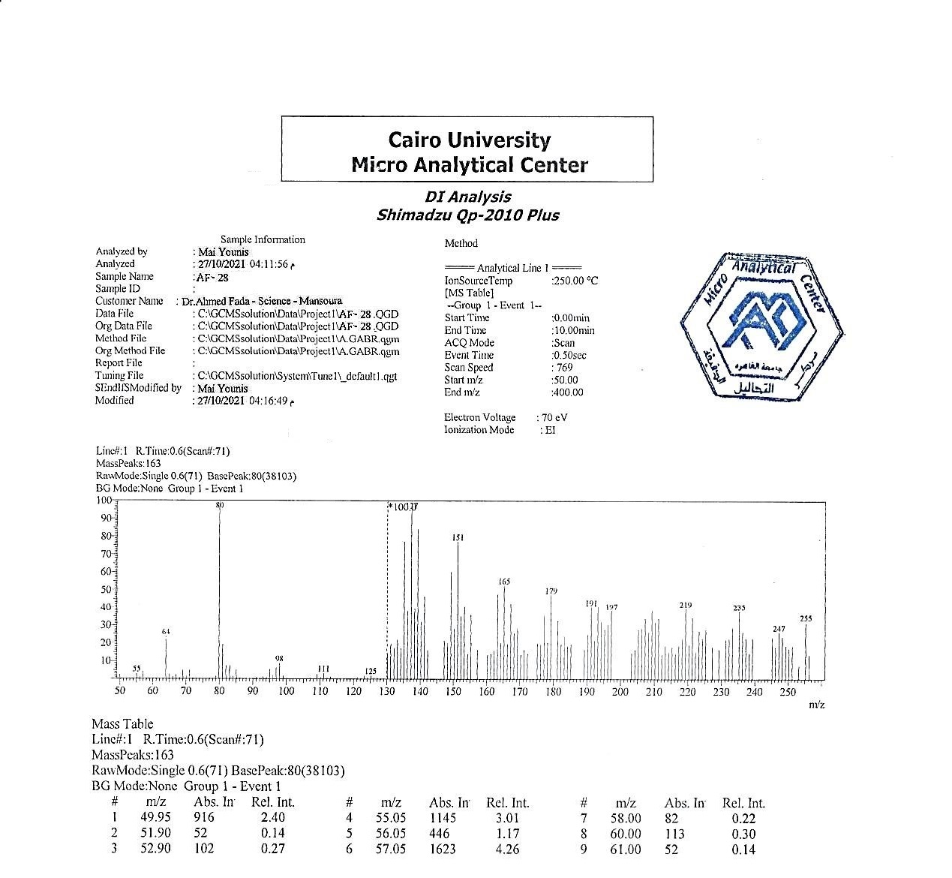

Figure 31: Mass Spectra of comp 36

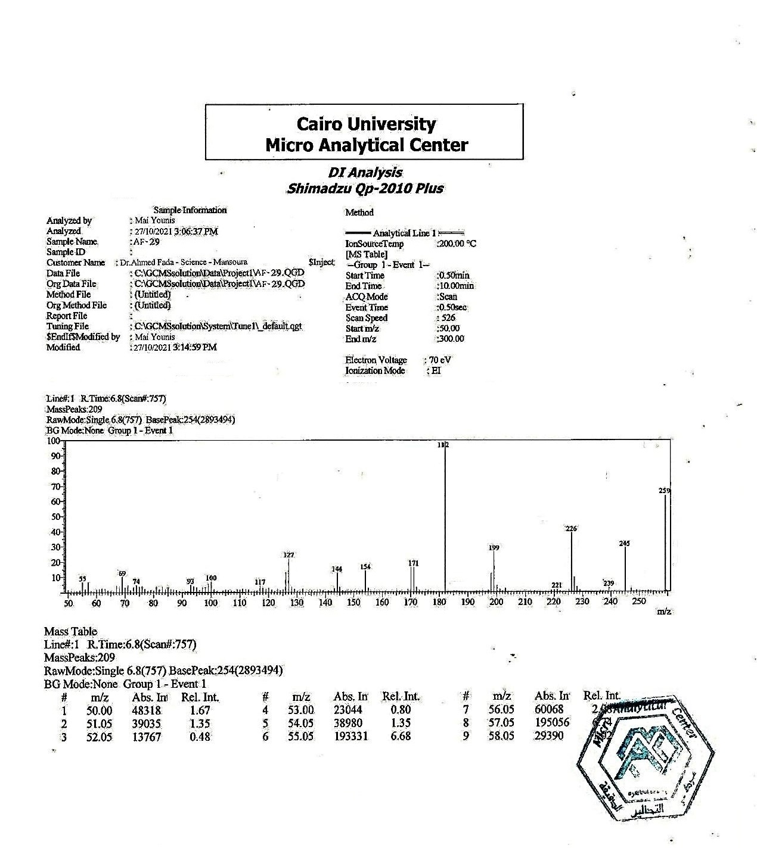
Figure 32: Mass Spectra of comp 37

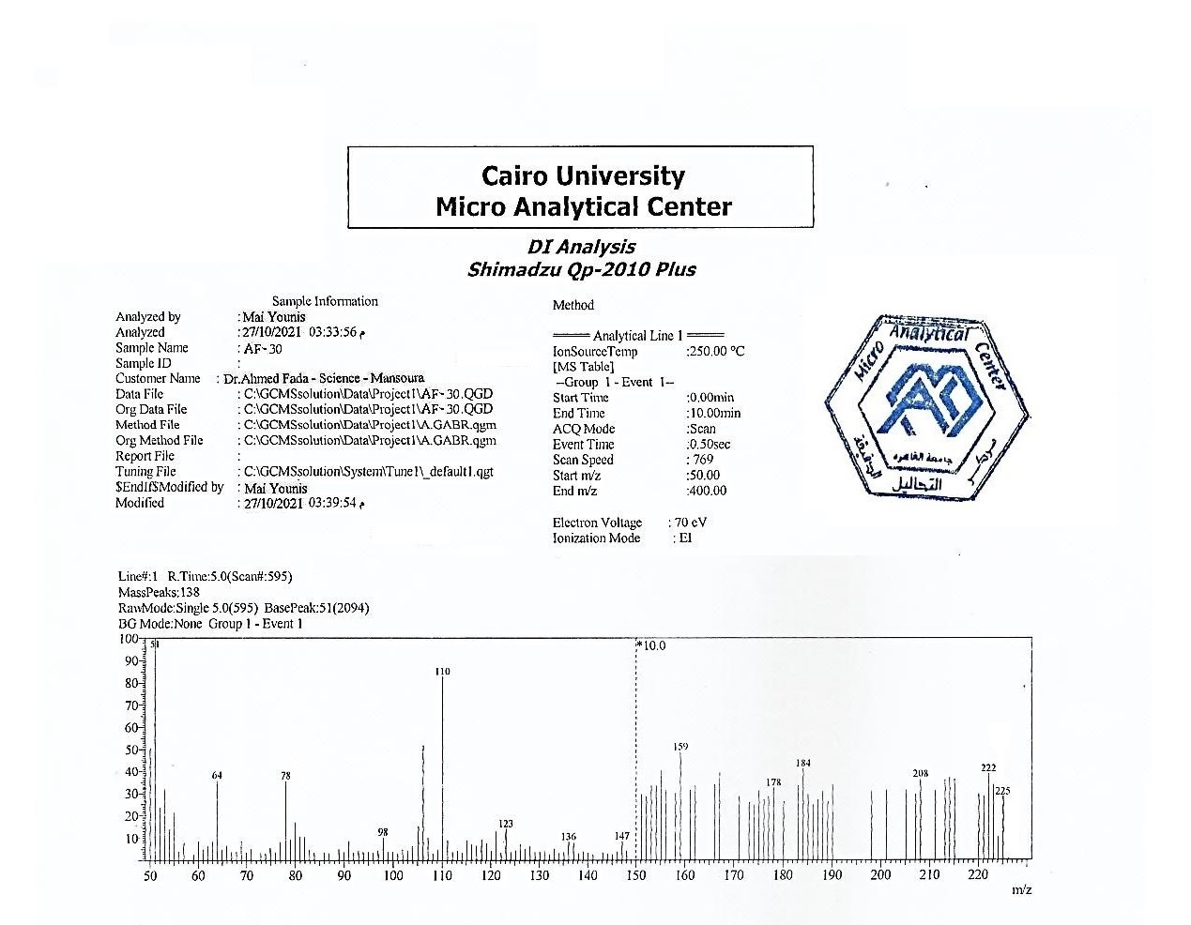

Figure 33: Mass Spectra of comp 38

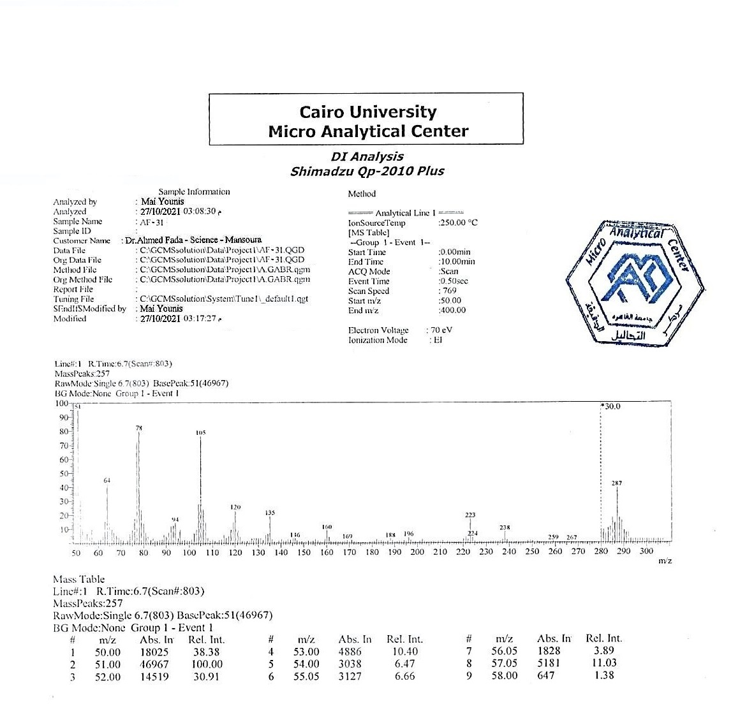

Figure 34: Mass Spectra of comp 39

