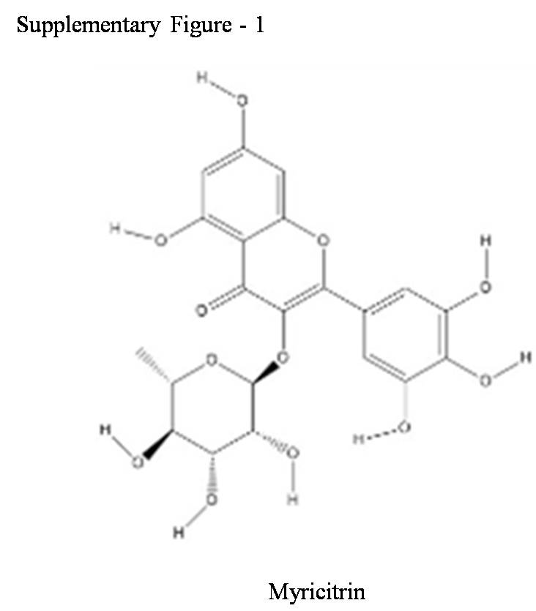

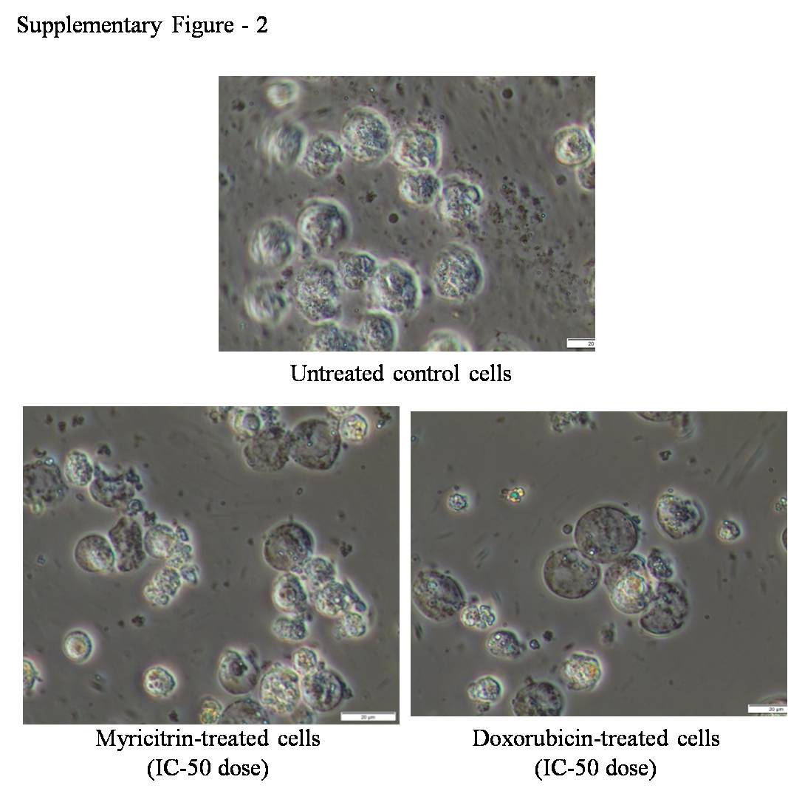

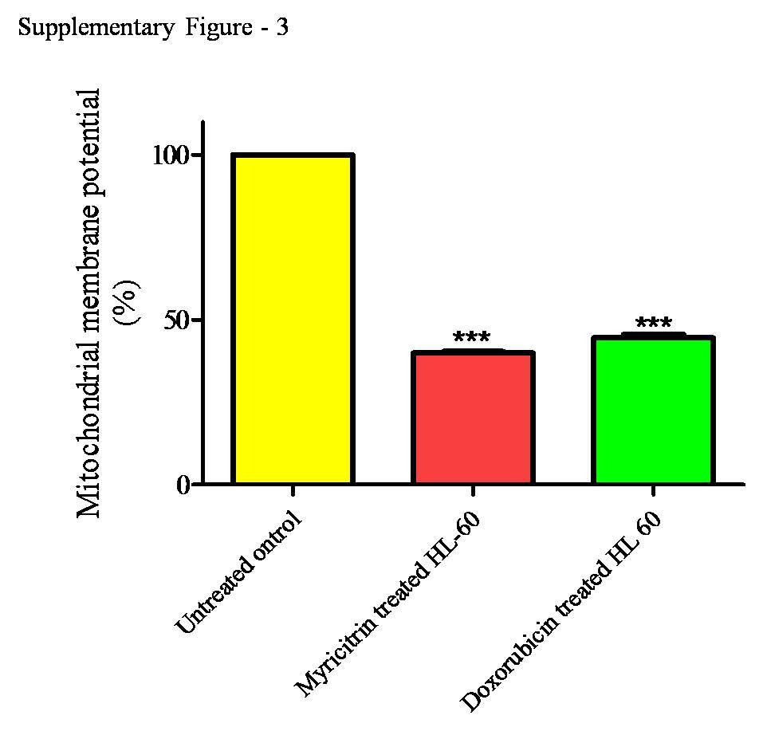

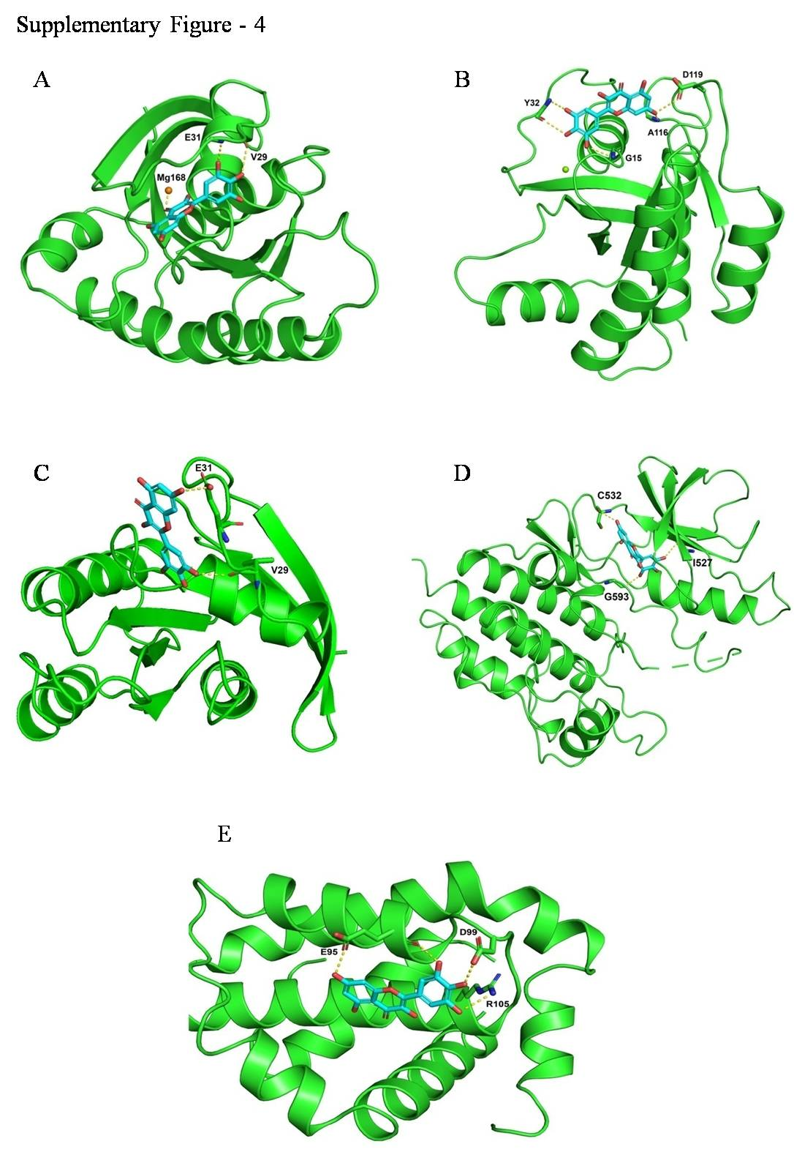

Supplementary Table 1: Number of cells and percentage of gated cells used in TUNEL assay to analyze DNA fragmentation in HL-60 cells treated with myricitrin.

Region | Untreated control HL-60 cells |  | Myricitrin treated HL-60 cells
Region | Number of cells | % of gated cells | Number of cells | % of gated cells
All | 4457 | 100 | 2061 | 100
Fragmented DNA | 58 | 1.30 | 1864 | 90.44
Intact DNA | 4399 | 98.69 | 197 | 9.56

Supplementary Table 2: In silico docking results of myricitrin with leukemia target proteins H-RAS, K-RAS, N-RAS, B-RAF and BCL2.

Compound name | Target | PDB ID | Binding energy (Kcal/mol)
Myricitrin | H-RAS | 2CL7 | - 7.289
 | K-RAS | 4OBE | - 6.309
 | N-RAS | 3CON | - 4.756
 | B-RAF | 4MBJ | - 10.482
 | BCL2 | 6QGG | - 4.771

